Student name: Mohammed Uddin
Student number: 160 6011
Module Title: Managing Project in Organisations
Assignment Title: Assignment 1
Module Lecturer’s Name: Rexon Niting

Table of Contents
What this report is about 3
Section 1 – Background Theory on Project Management 3
Meaning of Scope in a Business Project 3
Product Scope 3
Project Scope 3
Importance of Stakeholders in a Project 4
Qualities of a Good Project Manager 4
Analysis Tools for Project Management and Planning 5
Importance of Risk Management in Business Projects 6
Importance of Good Communication During a Project 7
Section 2- My Project 7
Section 3 – Feedback I received from my peers 9
Works Cited 10

What this report is about
This report is about project management, how to do it effectively and how much of an impact it can have on a business.
In class we have learned a lot about how project managers work. For example, we learned how a scope document is important before starting a business project or it can lead to legal complication down the line, or that risk management can be done much better via mathematical models and thus allow to estimate cost and impact of risk much more accurate.
In the following report I will discuss the key aspects of project management that we learned and how these can be applied to real businesses. This will be done in two parts: 1st I will talk about the background theory into project management and 2nd I will provide an example of a simple project I have carried out.
A third section will follow where I will try to gather feedback from my colleagues and co-workers on my project management skills and the things I can improve on.

Section 1 – Background Theory on Project Management

Meaning of Scope in a Business Project
In the context of a business setting, scope refers to a combined amount of objectives and requirements that have been set for a given project. In many cases where the client is investing large sums of money, the scope tends to be a legal document to which the client will refer to later if they feel that the job done was below standard.
Delving a bit deeper, scope in a business sense can be broken down into two varieties: product scope and project scope.

Product Scope
A product scope sets the requirements and characteristics of the product being developed. For example, a company producing smartphones would have in its product scope information such as the size of the display, battery life, presence or absence of features such as head phone jacks, finger print scanners, cameras, the material the phone will be built out of, water resistance, etc. Any other functional details of the product would likely be included in the product scope. (Venkatraman, 1995)
The product scope focuses on the details of the deliverable and can help the client or the project team keep track of the design process meeting the requirements of the client.

Project Scope
A project scope takes a broader view of the project planning that will be needed to produce the deliverable. While the product scope is a description of the product, a project scope is a description of the route taken to develop that product.
A project scope would document information such the projects main goal, a list of the deliverables/products, tasks needed to produce the deliverable, a list of project members, milestones at which the project status is to be reviewed, a breakdown of the work structure and deadlines.
The project scope also includes documents on the limits of the project. This is this document will have a list of things that the client cannot or has not requested from the project team and as such these tasks or requirements are not a legal requirement to be provided for. In professional services such as construction, exclusions from the original scope are often a point of tension between the builders and the client. Because of this, it is important to provide sufficient detail on what things the project is scope for and which things are excluded. The list of exclusions also has a significant impact on the bill that will be sent to the client. (Hubble, 2018)
Some changes to the project or product scope are likely to happen as a project develops. These changes can be due to internal pressures such as shorter or longer deadlines, or external market pressures that have changed the profitability margins since the original conception of the project.
It is the responsibility of the project manager to predict any such changes ahead of time and thus minimize the impact on the project. This process involves clear and regular communication between all the stakeholders involved.

Importance of Stakeholders in a Project
Stakeholders are people who have an active or passive interest in the project. Often stakeholders can also be other organisations or businesses who will be affected by the project. Examples of such stakeholders are employees, costumers, clients, unions, activist groups, governments, other businesses making money off the projects, communities, investors, etc.
Stakeholders generally have varied amount of influence of the project. There are three distinct levels that we studied in class.
They can be key stakeholders such as the design team, clients and investors who are directly interested in the well being of the project.
They can be primary stakeholders such as the community or other businesses involved such as suppliers. They will be ultimately affected by the project but often will not have a direct impact on the daily operations of the project.
Lastly, they can be secondary stakeholders such the local planning or approving authorities. They have a limited interest in the project, but will not make put forward any design requirements to the original scope. (Freeman, 2010)
For a smooth operation of the project stakeholders should be consulted regularly before and during the project. This way any potential conflict can be solved directly between the project team and the stakeholders. And effective stakeholder engagement plan should include guidelines on how to best communicate project updates with different stakeholder and a detailed list of which stakeholder has what interest in the project. It is important to actively seek stakeholder engagement as often they might not aware of critical design characteristics but protest them on the delivery date when they see those characteristics.

Qualities of a Good Project Manager
A project manager needs to be very good at communicating to succeed in his job. Studies have found that project manager spend as much as 90% of their time talking to stakeholders the remaining 10% of their time is devoted to technical work. So it is very important that they be able to articulate their ideas clearly to stakeholders.
Project managers, those specially working in more complex fields such as finance or large construction sites should also have a good understanding of management tools such as work breakdown schemes, influence and important matrices used to carry out stakeholder analysis.
Their jobs will require a certain degree of leadership as they will often have to make difficult decisions on which avenues to follow and which ones to discard. They need to be able to communicate these decisions to their teams in clear but firm manner so that everyone follows on with the decision.
Aside from communication and delegation, a good project manager should also be good problem solver. Despite having dedicated team members to solve the technical issues he should be able to grasp the general concept behind the technical work that goes on. Otherwise this can lead to asking either too much or too little from the team and thus miss using human resources. (Fisher, 2010)

Analysis Tools for Project Management and Planning
During a project a project manager has to keep track of the everyday events and make sure they are heading in the direction that the client wants. To help him in there are some analytical tools that he can use.
For project tracking and monitoring purposes a project manager can use tools such as Gantt Charts, Activity Graphs or tabulated deadlines for all the tasks that need to be completed. More advanced project management tools can include things such as Critical Path Analysis resource histograms. Following are general examples of a project or a list of tasks can be organised using the analysis tools mentioned.
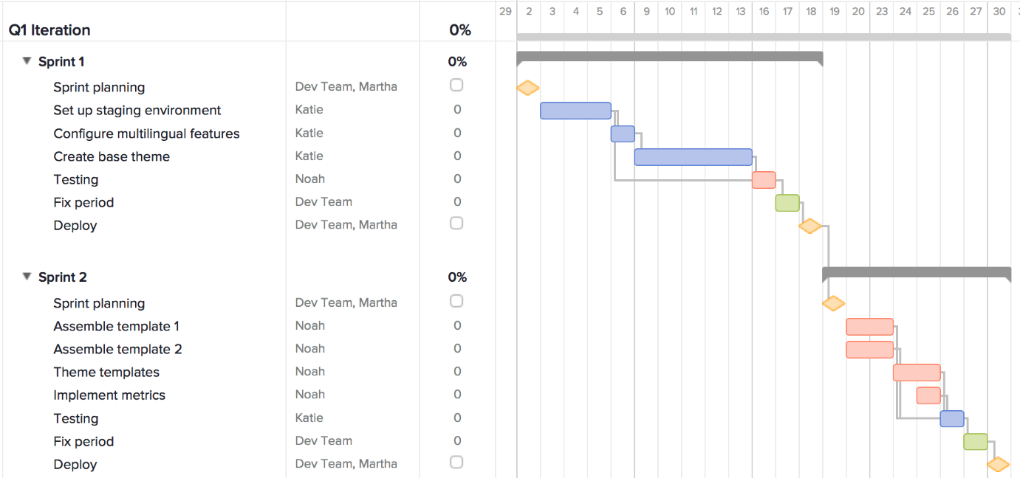
Example of Gantt Chart (Gilmore, 2012)
A Gantt Chart can be used to visualize on a timescale or calendar when tasks need to be completed. Using software based Gantt Charts allows further live interaction with the schedule, such as displaying the percentage of a task is done as the team members input their work updates.
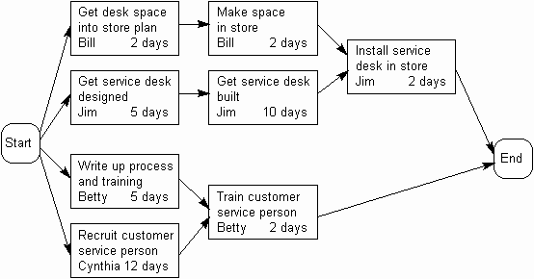
Activity Network Diagram (Syque, 2018)
While a Gantt Chart displays a time based activity schedule, a activity diagram can help show the interconnectivity and the reliance on other tasks. This is helpful for cases when the manager is trying to find out where subsequent problems will arise due to a delay with one task.
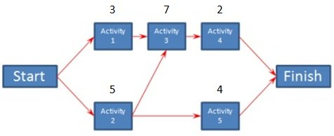
Critical Path Analysis Example (Skills, 2018)
A critical paths graph is similar to an Activity Network Diagram with added detail. The main benefit of carrying out a critical path analysis is that it will show the tasks which cannot be delayed at all. Otherwise, the whole project will be delayed. However, for a critical path analysis to serve its purpose the project manager will need detailed information of each task, such as what tasks it depends on leads to and how much time and resources it should take. And there is the mathematical complexity of calculating it.
For simple project, a brief yet detailed activity graph would be sufficient to keep on top of all the daily activities. However, in larger more complex project where there are lots of tasks and many staff engaged with the project. More sophisticated and mathematical models might be needed.
Also to note, the complexity of the project planning it self and sophistication of the tools used should not be exaggerated if the project does not require it. Otherwise, this can add a massive delay to the whole process.

Importance of Risk Management in Business Projects
During a project there will be many sources of risk, these should be analysed in the planning stages to make sure adequate strategies can be developed to counter or mitigate them during the project.
Often, in smaller projects, risk is considered to be a simple guessing process and not given much though. This can have bad consequences later on if things actually go wrong. In larger projects, the project manager might himself or assign a department to carry out a detailed mathematics analysis of possible risks to quantify a monetary cost of the risk and use this for insurance purposes.
Among some of the benefits of risk management are that a thorough analysis will allow the project manager to anticipate future problems and have solutions on standby when they do arise. This will help prevent surprises to the project workflow and prevent any unnecessary delays later on. Knowing how and when and what the risk might cost also allows to better negotiate the project costs in when presenting a scope to the client. Ultimately, the goal of a risk management study is to reduce the overall cost of the project, both in terms of monetary costs and delays. (Stein, 1993)
When a project manager makes a risk assessment study the main stages he should consider are the following: planning risk management, identifying risks, performing qualitative risk analysis and then a quantitative analysis followed by planned risk responses.
This process starts with deciding the general risk management strategy that the project will use. If they will try avoid risk or face risk while having good backup plans. This is, sometimes a risky strategy might wield better and faster results than a safer one. In such case, it needs to be decided at an overall level how to approach it.
Once the overall strategy is decided, risks that each task poses needs to studied and listed. The tasks should be then classified in terms of given a ranking system that takes into account the likelihood of that risk occurring and the larger impact it might have on the project.
A quantitative analysis should follow. This analysis will provide a numerical value for the total risk in terms of monetary cost to the project. This metric can then be used to compare different strategies to find out which one presents the smallest chances of cost overruns.
Once the detailed strategy is chosen, steps should be taken to decide on a course of action for each risk that can occur. Lastly, as the project is ongoing the risk of tasks and activities should be monitored.
As mentioned earlier in this section, in small project risk is often not taken seriously. However, when it is taken seriously techniques such as Decision Trees can be used to get to a numerical value for risk. Often in larger projects the managers have access to software the makes the task of carrying out these kinds of numerical analysis much simpler. (Theil, 2002)

Importance of Good Communication During a Project
Communicating well with the stakeholders of a project is vital for any project manager. In fact, approximately 90% of their time could be spent on simply talking to other team members of investors and making sure that everyone is well informed about the status of a project and that they are happy.
As we studied in previous modules, communication can happen in many forms other than verbal. For example, it can be body language or written text. Given that there is such a large focus on communication skills for project managers, companies often hire people with limited technical knowledge if they can demonstrate strong soft skills and communications skills.
The key factors that make a good project manager are being able to distinguish between types of communication needed to work with different groups. For example, when leading a project team the manager would need to use a informal communication style and be a little bit assertive. When communicating with stakeholders and investors the manager would have to be more formal and be receptive to new ideas from the clients.
Another key factor that makes or breaks a good project manager is the timing of his communications. He should be able to get the right information to the correct stakeholders at the correct times. For example, he should be able to inform the design team of any changes to the scope before they finalise their work. Alternatively, he should have a plan to let investors know if there are any critical changes to the project that they need to know such as changes in the team or legislation that might affect the project. (Allen, 1980)
In the current work environment, technology is increasingly used to communicate. A good project manager should be sufficiently knowledgeable of technologies such as PowerPoint or similar software and make good use of them.

Section 2- My Project
For the part of talking about a project I was personally involved, I will my experience as a senior member of the company where I work. It is a taxi company and I am responsible for some of the administrator work, for example making schedules, organising dispatches, dealing with new job applications, etc.
This company was started many years ago when computers and digital technology was not very frequent. During a meeting with other senior staff at the company we talked about what our competitors were doing differently. Among other things we found that many taxi companies had moved on to using more and more software systems to manage their business. We looked into this and decided we needed an update as well. I was assigned to take care of upgrading our dispatch software and training the staff on how to use the new technology that attached the smartphones of everyone to the company software.
The other senior staff and I decided at an early stage who would do what and fixed boundaries on how much of the business each of us would be allowed to change and how much money each of us would be allowed to put into buying software. We should had, but did not write these boundaries down on paper. If we had done we would had something similar to a product and project scope for this project that tells each team member what they are expected to do and what limits they need to be within. My responsibility was limited to making dispatching drivers better and stay limited to a two thousand pound budget.
The stakeholders in this project were mostly the people within the company. The senior staff could be considered the key stakeholders as this project directly affected their income and jobs. As for secondary stakeholders, to some extent our costumers could be considered secondary stakeholders who would be able to benefit from any lowered prices that we could get.
My part of the project was one that would have some overlaps with the other software changes, so we decided to have regular meetings two times a week, to make sure everyone was on the same line and not bringing in or testing software that would be counter to the features of other software. I had to make sure I communicated what I was doing clearly to the rest of them team. I did not want to be the reason for delays for everyone else. We decided to allow everyone some freedom with what software they used for their parts as long as all the important data could be copied onto a separate main file where we would accumulate all the information on clients, costs, revenue, drivers, etc. To make sure the softwares I was testing I checked if they had features that allowed to export information from the format which the software used to a more basic text based format that could then be used by other software as well.
This part of the project required a reasonable amount of communicating and managing time with others. We told each other updates on how we were preparing data for the main file and asked them when they could give us some time to check if both softwares were able to use the data on the main file.
After having tested and decided on what software I was going to recommend for dispatching drivers, I had to train the other staff on how to use it as I would not be the one using it everyday. There would be days and shifts where I would be out on holidays and the others needed to know to do the job. Not only that, but drivers needed to be shown how to use the software along with their smartphones. The new software that I recommended allowed the control staff to see where the drivers were on a google maps website and it could display the location of any costumers who had called us asking for a ride. The software had many other advanced features such allowing to plan fares in real time, for example drop of one costumer and pick up another costumer immediately. This information had an option to be displayed as a Gantt chart like format where I could easily see how much time would it be until the driver could reach the next costumer after dropping off the first costumer.
However, to use all these new options of the software the drivers needed to be trained on how to update the system with their smartphones. For example, their availability, if the car was showing any problem, if fuel was low or if they wanted a break. This was all submitted from the smartphones and updated directly on the main system.
I designed a training plan for the drivers. I made short videos on my phone showing step by step how to use each feature. I decided to do videos because it is the easiest way to get a message across to someone also they can then see watch it over many times if needed. On top of the videos I made regular checks on the drivers to make sure they were feeling comfortable using the new apps and features and also to make sure they were developing it as a normal habit so that it became as normal as washing their hands.
My concern when taking responsibility for this project was that it would end up not working, that the software I choose would not be able to do all the things I needed it do, or that people would not like it and against using it because it was too complicated. If this happened a very important part of the update to the whole company would be held back and it would have been my fault. I also would have spent a lot of company money on things that were not necessary or not working.
To reduce the risk of that happening, I made sure I checked the software very well, sometimes even taking it on my laptop back home and working on it during weekends. This was a project affecting not only me but the whole company so I wanted it to best. When testing the softwares I made sure to always ask the software vendor for a free trial version for a week or two this was money spent would be limited until I decided on a good software. Thankfully in this project there were no major losses as everything ended up working.

Section 3 – Feedback I received from my peers
One thing I learned during this project was that communicating what you are doing is very important. It is easy to get carried away and go in a direction that others will not agree with, specially if you are doing something for the first time and are not sure exactly how to do a job. The other staff told me that the effort I put into making sure everyone knew which direction I was heading and also making sure that my software was compatible with others, was a very good attempt at keeping everyone informed. But they also said that I communicated a bit too much sometimes. For example, they told me that when I gave them information on the cost of the software I was buying it was not relevant for their projects and that I also talked about other things that were not directly relevant. My colleagues suggested that in the future I try to avoid giving people too much information as it can be confusing.
With the training videos I made I was given congratulations as everyone who watched them found them very useful and easy to learn from. My colleagues made jokes about how I was more efficient at explaining things on the video that when I am speaking in person, that there was a lot extra information and that I did not go in circles with take the same topic too many times.
The feedback I got about my communication skills are very useful. I can reflect on it realise that when I am speaking in person I am likely to say a lot things that irrelevant or repeat myself, but when I prepare and have a written copy of what to say or a little mind map of what I want to do, I manage to speak a lot less. This is something that in the future I will have to make effort in. I will have to find ways to create a mind map of what I want to say before I say it.
Lastly, about my risk management. I asked for their opinion on how I did on that. They did not have many comments about it. They all agreed that I stayed within my budged so it was ok.

Works Cited
Allen, T. J. (1980). R&D performance as a function of internal communication, project management, and the nature of the work. IEEE Transactions on Engineering Management, 2-12.
Fisher, E. (2010). What practitioners consider to be the skills and behaviours of an effective people project manager. International Journal of Project Management, 994-1002.
Freeman, R. E. (2010). Strategic Management: A Stakeholder Approach. New York: Cambridge Press.
Gilmore, N. (2012). Retrieved from https://www.teamgantt.com/blog/gantt-chart-example
Hubble, A. (2018). Retrieved from https://aspetraining.com/resources/blog/understanding-product-vision-and-project-scope
Skills, P. M. (2018). Retrieved from https://www.project-management-skills.com/critical-path-method.html
Stein, K. A. (1993). Risk Management: Coordinating Corporate Investment and Financing Policies. The Journal of Finance, 1629-1658.
Syque. (2018). Retrieved from http://www.syque.com/quality_tools/toolbook/Activity/example.htm
Theil, M. (2002). The role of translations of verbal into numerical probability expressions in risk management: a meta-analysis. Journal of Risk Research.
Venkatraman, N. (1995). IT-Enabled Business Transformation: From Automation to Business Scope Redefinition. Sloan Management Review, 35.

