PERCEPTION OF GRIEF AND LOSS IN LAMPETER, STRATA FLORIDA, AND ST. FAGAN’S

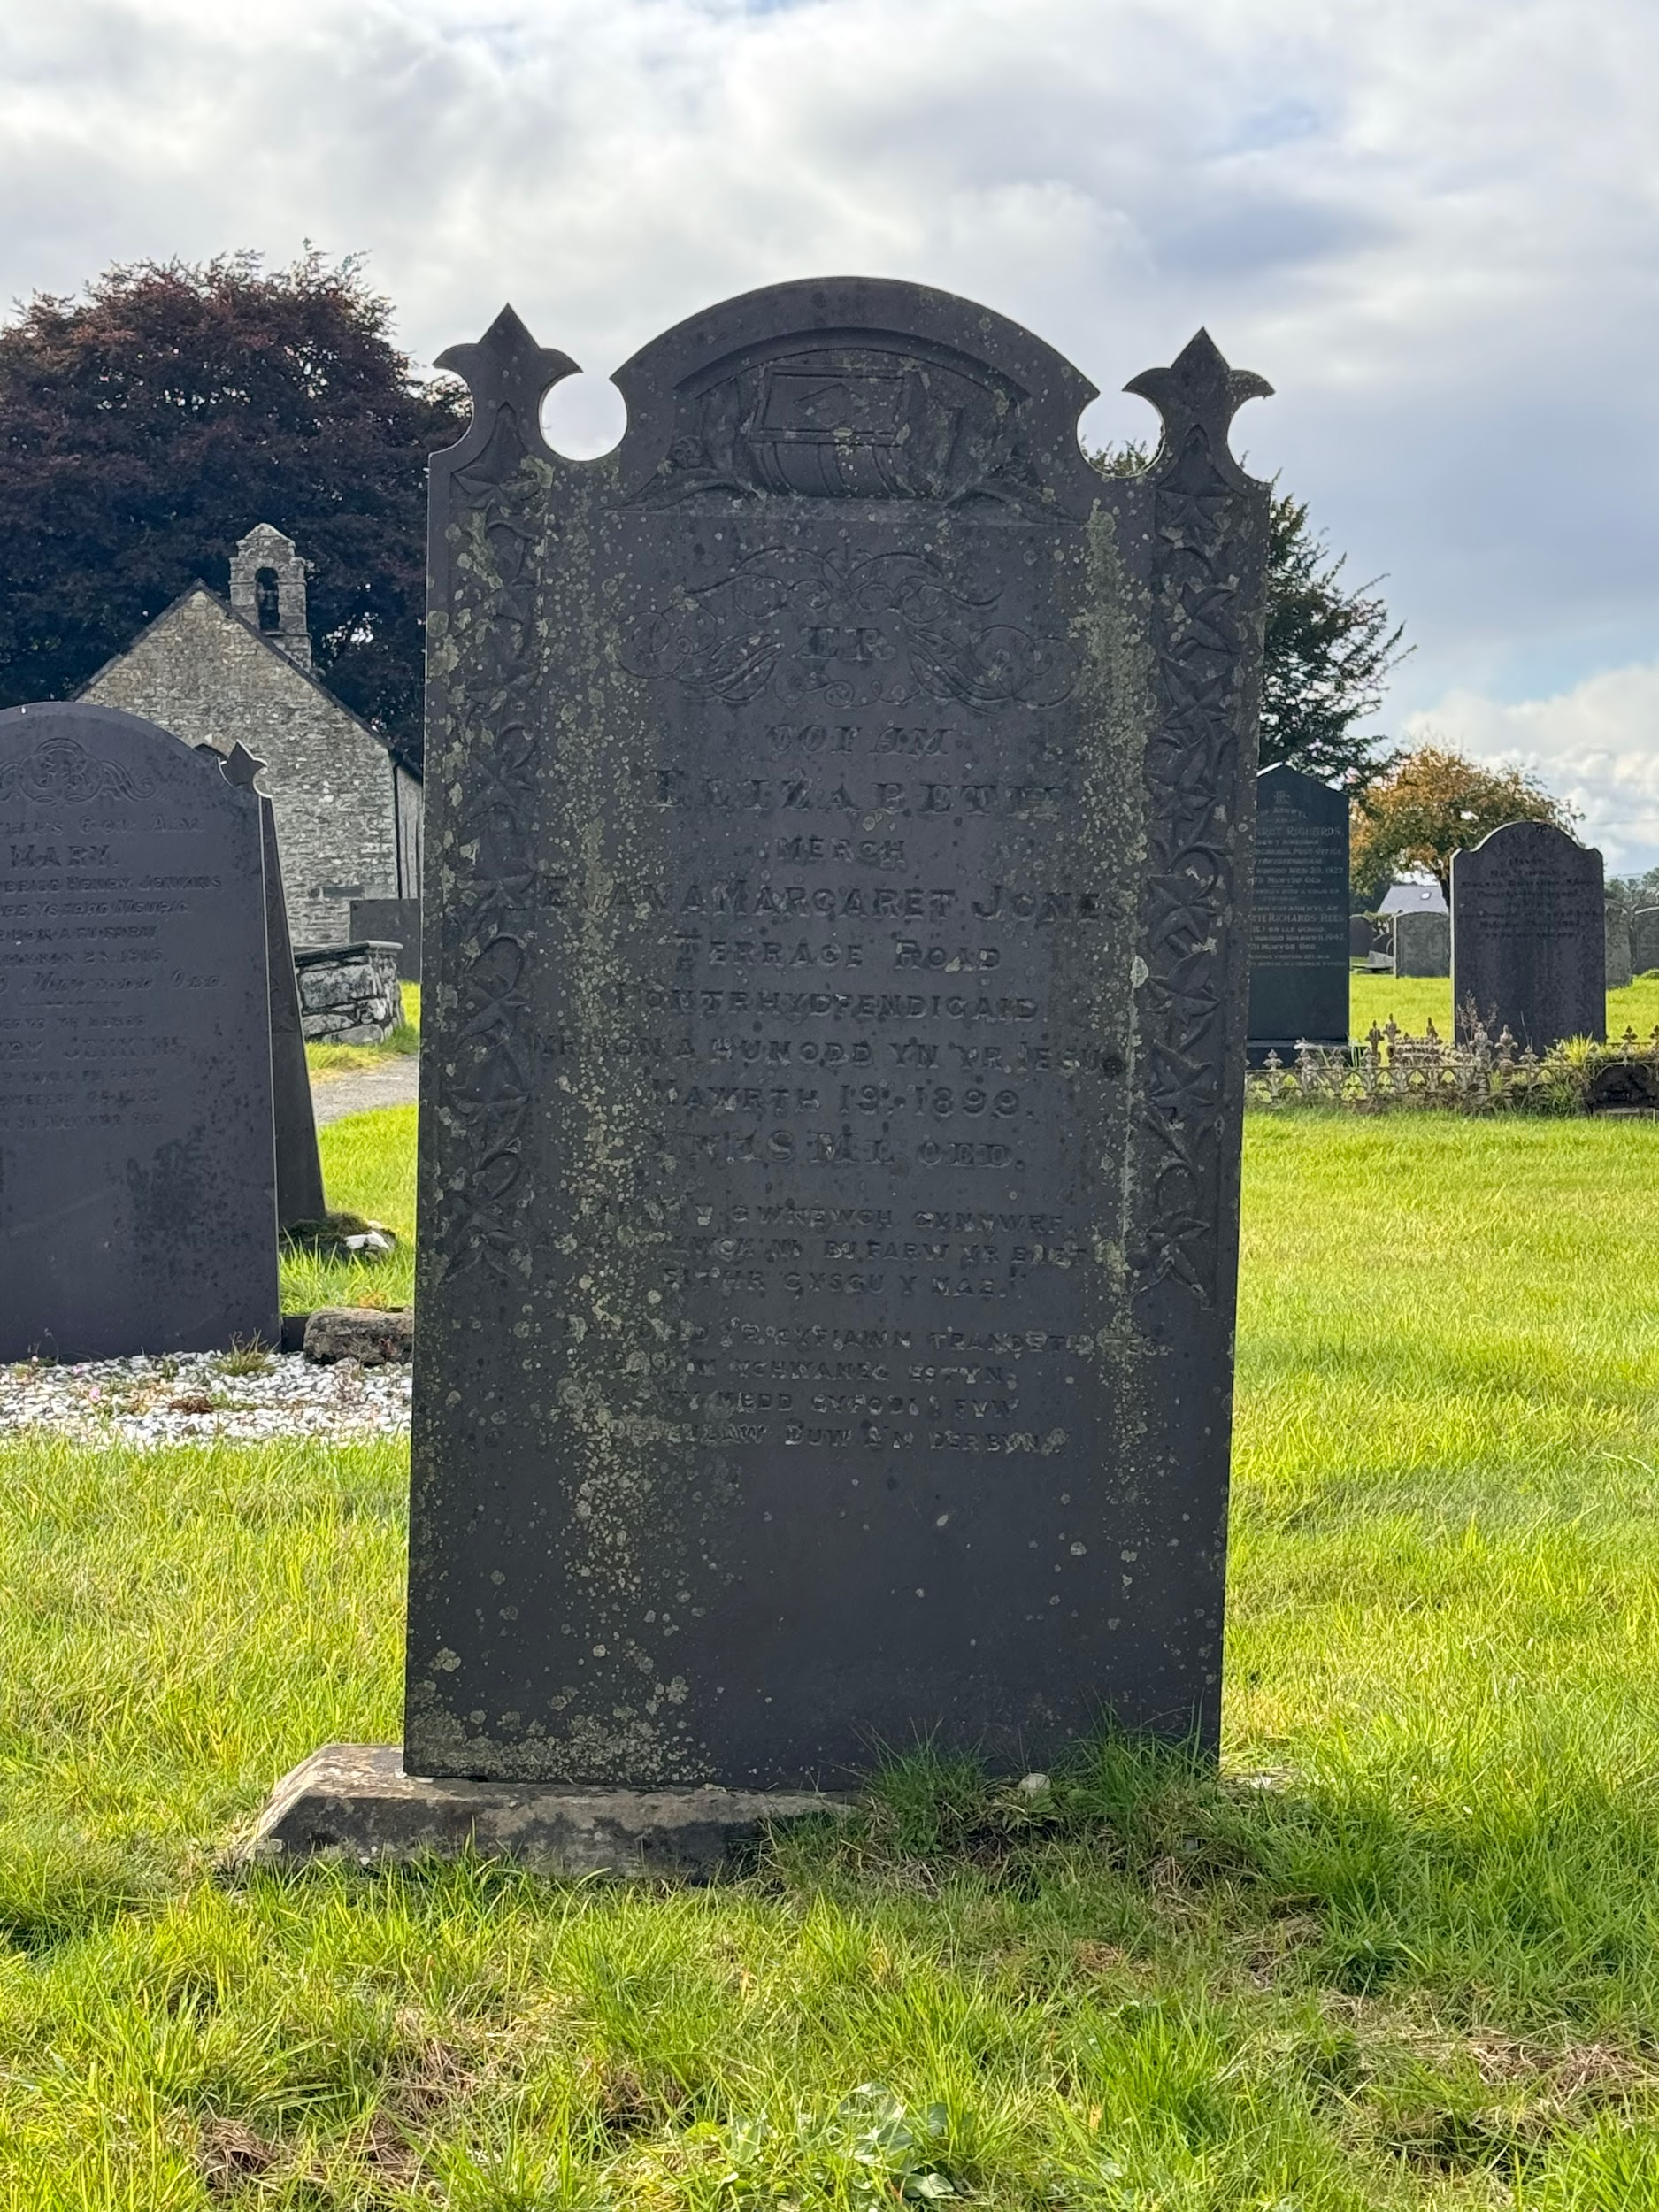
During our walk around Lampeter, the topic of grief and loss was mentioned. An offhanded comment about agriculture and former railway links spiralled into the realisation of the loss of a whole culture, language, and way of life. This feeling followed us for the rest of the day and cemented itself in the flowerbeds at the war memorial. It had me considering the difference between a grave and a memorial. What makes them different? Can a grave be considered that if there is no one buried there? And more importantly, how do memorials reflect the people who created it and the people it was created for?

The first instance of graves that we came across was in the churchyard of St. Mary’s in Strata Florida. The cemetery and church here were, to me, of far more importance than the abbey. The abbey’s ruins stand as a reminder and the history of Strata Florida, but I was drawn to the church. Unlike the abbey, the church still stands today and is overlooked by three priests in charge and two associate priests. Its cemetery has headstones from the 17th century, potentially some older, and is still used for burials today.

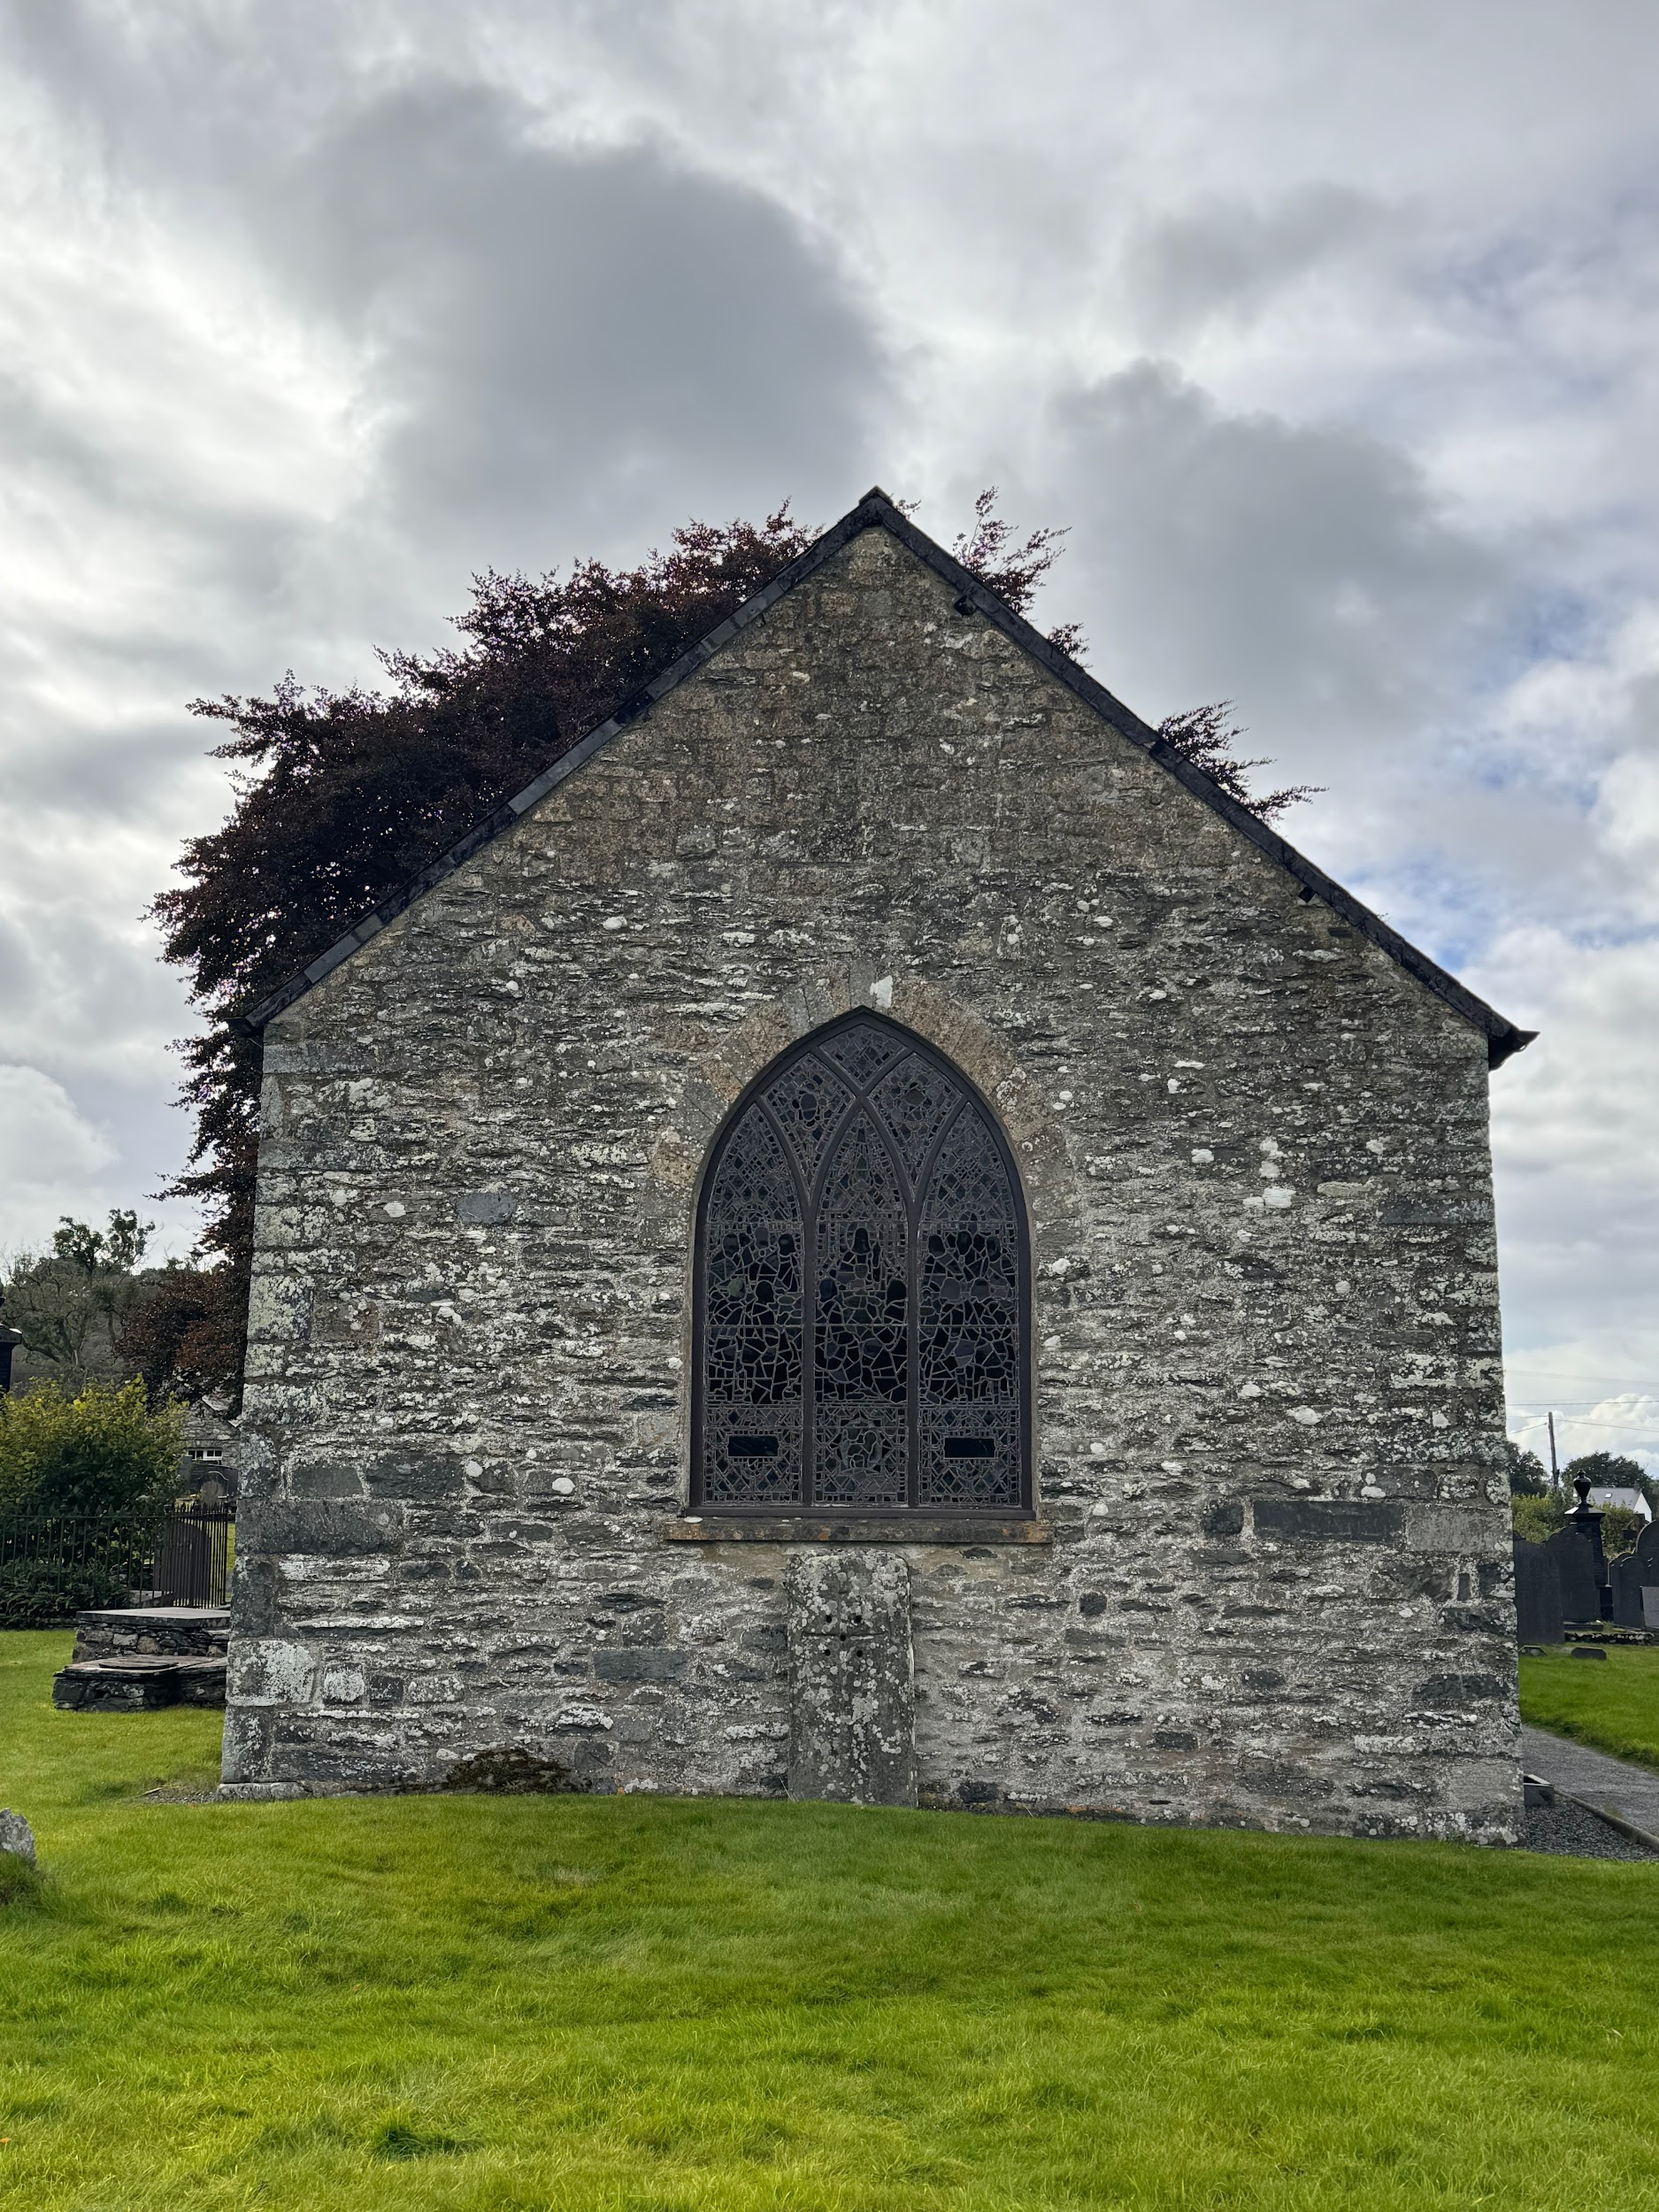
St. Mary’s church is first referenced in historical documents in 1539 (Austin, D., Parry, G. and Aldous-Hughes, C. (2022)). It was visited in 1535, four years before the first official documentation, by Henry VIII’s official antiquary John Leland (National Churches Trust, no date). The cemetery in the surrounding grounds was larger than expected. The church itself is only a small building with a simpler silhouette than other churches I have visited, though it boasts four impressive stained glass windows.

A grave is defined as ‘a place in the ground where a dead person is buried’ (Cambridge Dictionary). The cemetery of St. Mary’s is the resting place of a singular limb - the leg belonging to Henry Hughes, who lost it in 1756 to a ‘farming accident’ (Eye on the Past, 2022). Considering that Hughes survived and later emigrated to America, is the remaining stone dedicated to his leg now a grave or a memorial? Was it a grave from the beginning? Perhaps the loss of a limb and the grief experienced afterwards was enough for it to be considered a grave, a final resting place if only for part of a man. It’s these feelings that I wanted most to explore in Lampeter, Strata Florida, and St. Fagan’s.

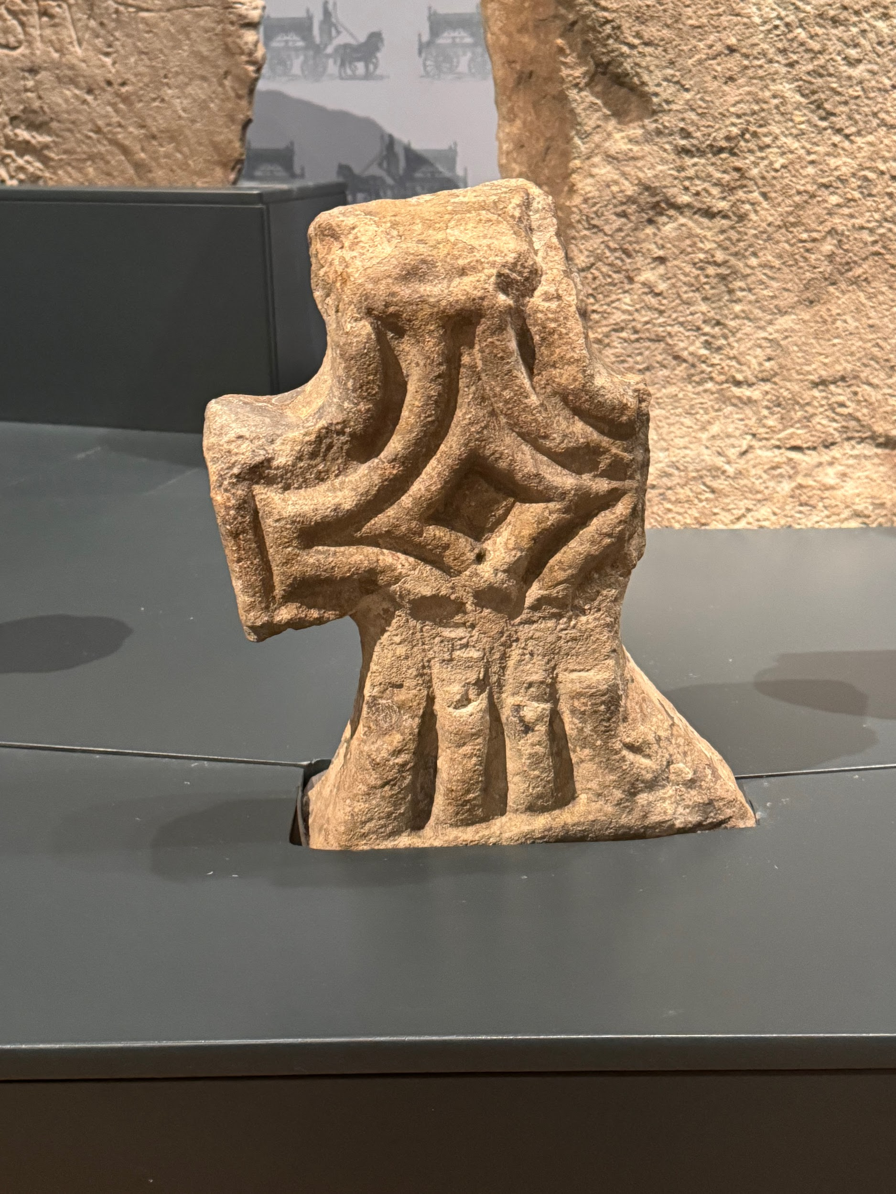
I see St. Fagan’s National Museum of History as a reaction to loss. The erasure of Welsh culture and language in years past calls for retaliation, and following retaliation, the celebration of the things that were once torn from people. Much of this included headstones, tombs, memorials, and 19th-century funeral wear. Within the exhibitions were medieval grave markers from Strata Florida, moved a hundred miles away, and displayed in an open-air museum. Is there no loss associated with the removal of these stones? I was thinking about burials and graves a lot during these visits, as each place we went had some kind of marker for the deceased, or at the very least a reference to one.

Regardless of the relocation of the stones, there is again the feeling of grief that emerges when you view them. They are dated 1200-1250CE and despite their age, it still makes the viewer think. When confronted with the idea of loss in these places, it encourages a lot of questions. Who buried them? How were they buried? What rites did their friends and family perform in their memory? Who hand-carved their headstones? Who were they, both as individuals and within their community?

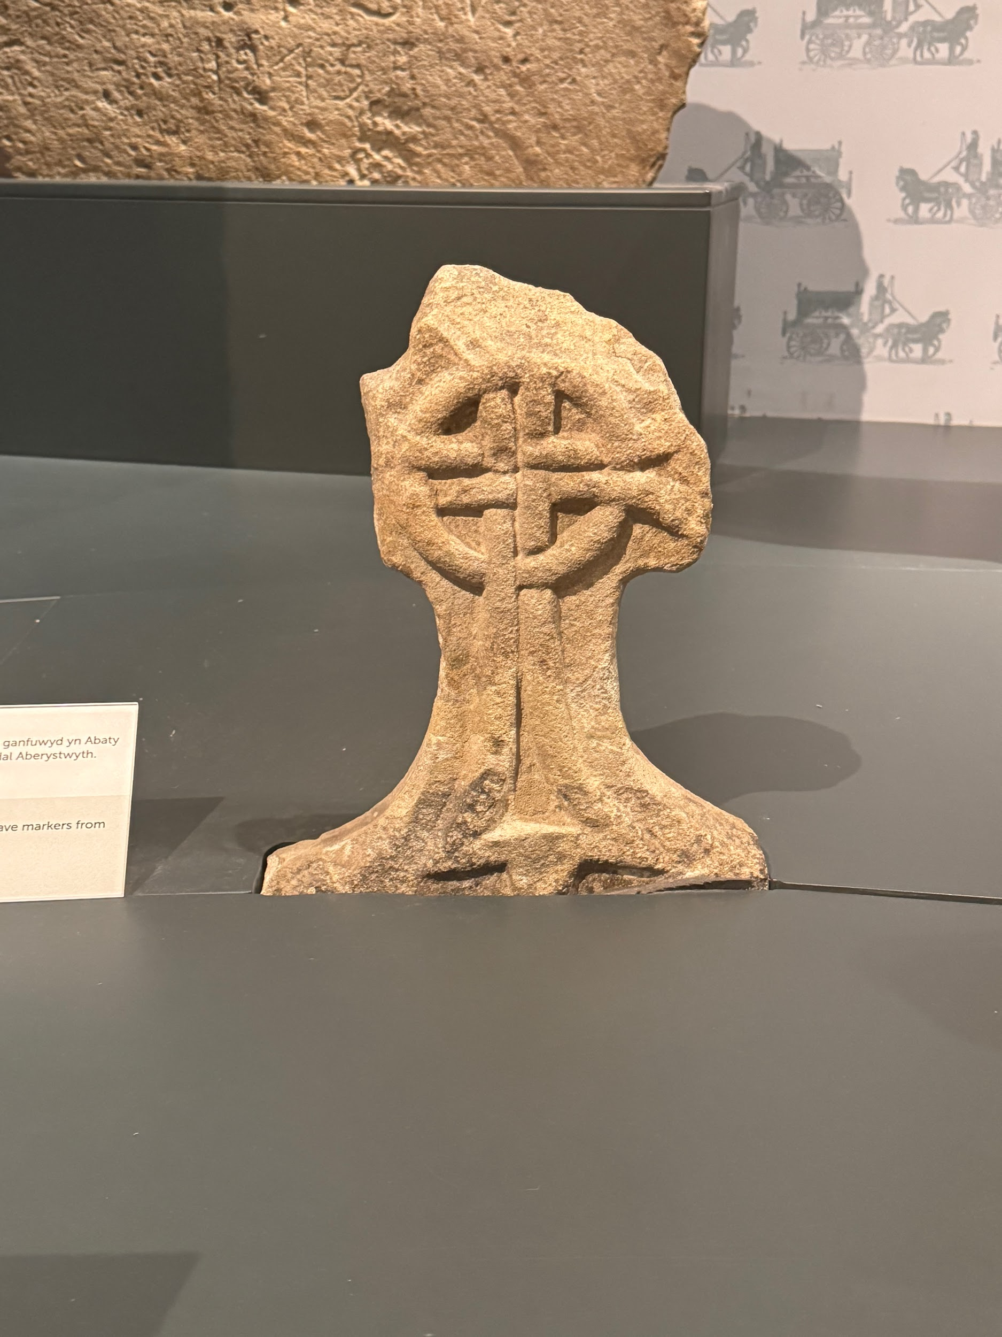
The intersection of individuality and community within the exhibitions was notable throughout St. Fagan’s. Each headstone has an owner, belonging to just one person, but the style and imagery remains consistent throughout. It is easy to identify them as being from the same time-period and location even without information placards. This continuity between headstones over multiple decades showcases the devotion and care of an entire community and their relationship with the deceased.

Headstones and memorials, to me, do not immediately instil those feelings of grief. While yes, oftentimes grief is the main emotion that comes up when looking at a grave, the care and attention to detail on these headstones arouses a sense of kinship and community; people coming together to memorialise the life of someone they loved, putting their time and effort into making sure they are not forgotten and labouring over a marker for their burial place.

It is the act of memorialising that is essential to overcoming feelings of grief. The war memorial in Lampeter is a brilliant example of this. The memorial is tribute to those who died during the Great War, mostly male soldiers with the exception of one female nurse who died after contracting pneumonia towards the end of the war.
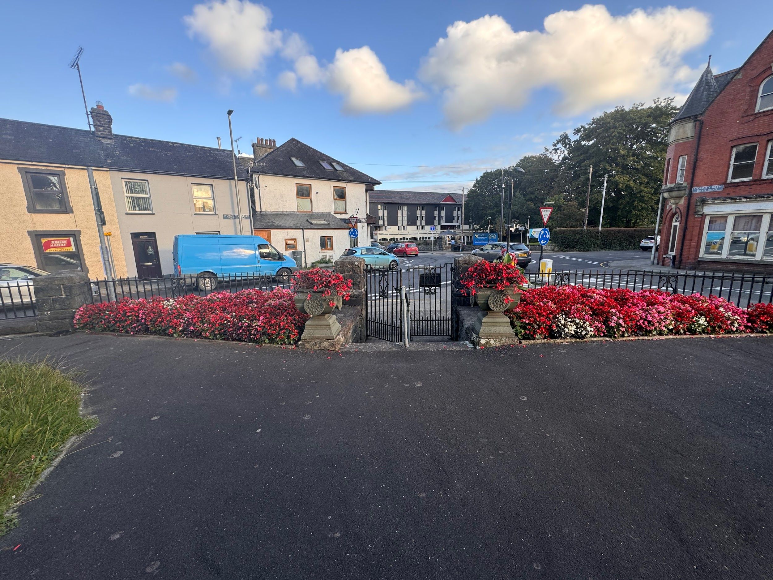
The memorial is set on a raised area above street level and surrounded by a wall and iron fence. Immediately, it is made important - the geography of where the memorial sits makes it so. Here, grief is elevated to an experience. Four benches line the back wall and besides each path is a flowerbed. The paths lead you slowly around the memorial, looping from the gated entrance until you sit before it.

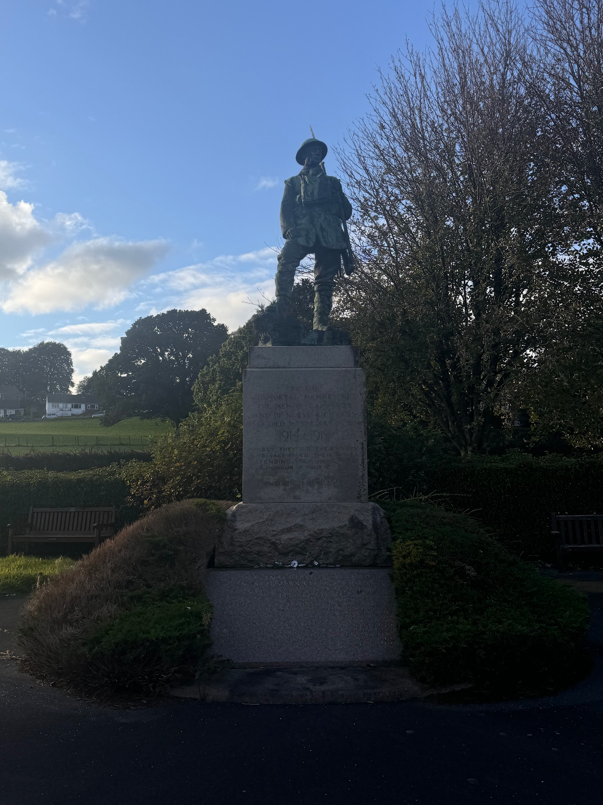
No one is buried here. So, by previously established definitions of what a ‘grave’ is, this is not one. Even the feelings it arouses are different. There are tens of names carved into the stone. You do not sit down and individually read each name, consider them as a single person, and then move on to the next. You glance, quickly, over the list and contemplate the deceased as a group. Again, a sense of community is fostered. These people all shared a commonality and were memorialised as such.

Overall, it was enlightening to be able to see how community is maintained even beyond the grave - between both the deceased and living - and how grief tied into this. Not every grave or memorial brings up feelings of melancholy. Instead, you are faced with inevitability and mortality, and how those who lived past a loss ensured that a short life would not be the end of another’s legacy.

BIBLIOGRAPHY

Austin, D., Parry, G. and Aldous-Hughes, C. (2022) Saint Mary’s Church, Strata Florida: A History and Guide (4 vols). Strata Florida: Strata Florida Trust Ltd (Strata Florida Books).
Grave | English Meaning (no date) Cambridge Dictionary. Available at: https://dictionary.cambridge.org/dictionary/english/grave (Accessed: 08 October 2024).
Lampeter War Memorial (no date) WW1.Wales. Available at: https://ww1.wales/ceredigion-memorials/lampeter-war-memorial/ (Accessed: 10 October 2024).
St Mary (no date) National Churches Trust. Available at: https://www.nationalchurchestrust.org/church/st-mary-strata-florida (Accessed: 07 October 2024).
St Mary, Strata Florida (no date) The Church in Wales. Available at: https://www.churchinwales.org.uk/en/structure/church/3603/ (Accessed: 07 October 2024).
The left leg of Henry Hughes (2022) Eye On The Past. Available at: https://eyeonthepast.com/the-left-leg-of-henry-hughes/ (Accessed: 08 October 2024).

