Student name: Yasmin Bibi (1808879)
Module: Public Health Policy (BMHP 5013- Birmingham)
Assignment 2: Public Health Policy Report (2500 words)
Tutor: Besty Jose
Cohort 1. Group 1.

Contents page.
Title page……………………………………………………………………. Page 1.
Contents page……………………………………………………………... Page 2.
Introduction and Background…………………………………………… Page 3.
Issues frontline workers faced……………………………………........, Page 4,5,6.
Strategies used to measure, monitor, and control incidence……… Page 6,7,8.
Current Public Health Approaches to reduce/control incidences… Page 8,9.
Health Belief Model…………………………………………………………. Page 10.
Research and Vaccines……………………………………………………. Page 10,11.
Recommendations and Conclusion……………………………………… Page 11,12.
References …………………………………………………………………… Page 13.

Introduction
This report is being conducted based on the frontline keyworkers during the outbreak of COVID-19. This report will look at the numerous methods and approaches which are put in place to monitor and control the spread of the virus. It will look closely at the policies, strategies and systems applied by the government to tackle the current situation and also the development of any breakthrough research and vaccine development which is the main effort of all clinical research organizations. This report will closely examine the publics behaviours, attitudes and lifestyles and then relate it to theories and models of behaviour and health change. The impact of policies, legislations on frontline and also other keyworkers health and wellbeing will be added and also recommendations.
Background (250 words)
According to Public Health England, (2020a) The World Health Organization was notified on the 31^{st of} December, of group of pneumonia cases, without knowing the causes of it in the city of Wuhan, China (GOV. UK, 2020a). World Health Organization (WHO), is a managing and supervising organization which, is a part of United Nations system. This organizations main values are to maintain high level of health and wellbeing of all public around the world (World Health Organization (WHO), 2020a). It was revealed on 12th January 2020 that the novel corona virus has been discovered from the test samples which were obtained from the infected cases. This virus is suggested to be from SARS-CoV-2, and the disease linked to it is named COVID-19. Coronaviruses are a big family of viruses in which some cause common colds, but some trigger very serious illnesses known as Middle East Respiratory disease (MERS) and Severe Acute Respiratory Syndrome (SARS) (GOV UK, 2020b). Majority people may only experience mild symptoms but older people with underlying health issues can face life threatening situations or face complications and die (World Health Organization, 2020b). This virus is easily spreading by breathing in droplets of people nearby. Wearing a mask, frequent washing of hands with alcohol based handwash or hand sanitizers and increasing distance amongst others can calm the situation down. Common symptoms are a continuous cough, high temperature, difficulty in breathing, loss of smell and taste, tiredness, sore throat, and vomiting (GOV UK, 2020c). Public Health England which is an executive agency of Department of Health and Social care responsible for the health and well-being, gathered all official agencies to work together in the fight against this invisible virus (Public Health England, 2020b). The prime minister Boris Johnson announced for a lockdown in the whole of England on March 23rd, 2020 to minimise the spread of covid-19. Only essential shops and food supermarkets were open to the public (Gov UK, 2020c).
A study conducted by (Scally et al. 2020) suggests that the UK government and all officials thought they were ready to face the pandemic but in reality, they were not prepared as with so little time and pandemic spreading so fast. Resulting in hospitals being overwhelmed with patients. Doctors and nurses struggled with shortage of personal protective equipment (PPE).

Issues frontline workers witnessed
Frontline keyworkers such as Doctors and Nurses, Paramedics, Care workers and other frontline health and social staff, Teaching staff and Cleaning workers all worked very hard in:
- bringing the pandemic under control and kept the country running. They played a critical role in the fight against the pandemic.
- They risked their own lives and the loved ones which they lived with. They saved thousands of lives and brought the pandemic under control at the time when hospitals could not cope.
- They showed full commitment, bravery, and dedication in their roles in this pandemic never seen before (GOV UK, 2020d; BBC News, 2020).
This is how NHS staff was affected from the covid-19 breakout as sown below:
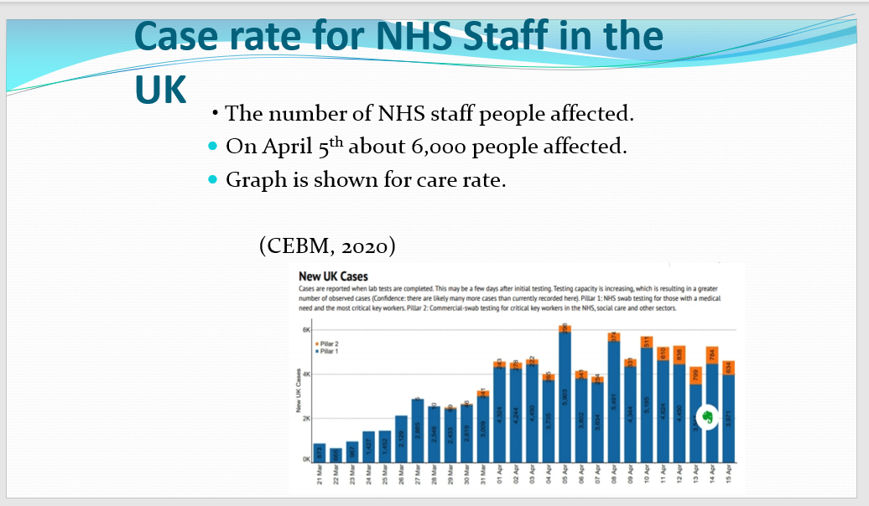

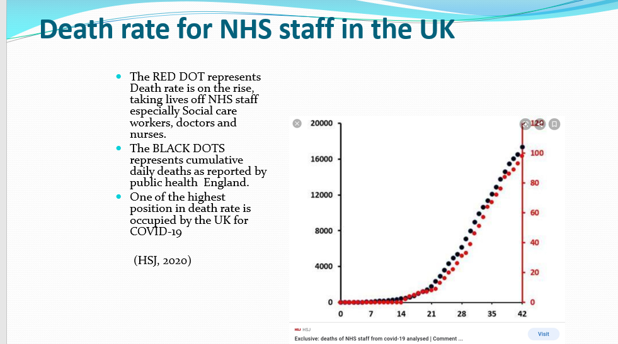

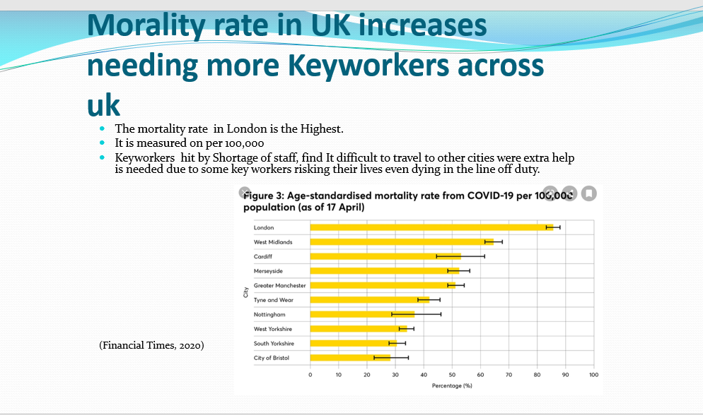

The Government of England issued policies to support the UK against the fight of covid-19 and assist the keyworkers to stay working as frontline workers.
Policy 1- Critical workers who can access schools or educational settings.
Policy 2- Corona testing extended to all essential workers in England who have symptoms
Both these policies supported the frontline keyworkers to some extent along with Public Health England and World Health Organization support in such desperate times. Many frontline workers lost their lives as shortage in Personal Protective Equipment. They were working over -time risking their lives and also worrying of catching the virus and taking it home to loved ones. Staff shortage and hospitals full of Covid patients was impacting mental health and causing stress and anxiety (GOV UK, 2020e).

Strategies used to measure, monitor, and control the incidences
General Surveillance Strategy
According to Public Health England, (2017a) The key purpose of surveillance is to offer information which can be used in the purpose of taking action by public health groups, government officials and the society in aiding of public health policy and intervention programmes. All requirements and talents are put into the framework which are the main focus. Surveillance events in Public Health England follow key rules planned in the general model of health surveillance as below:

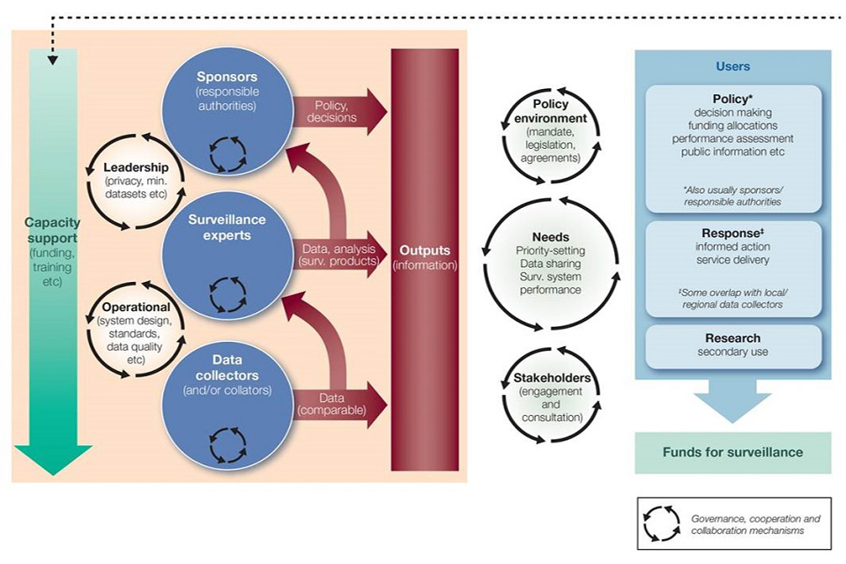
Source: Public Health England. Model of Surveillance, (2017b).
There are 3 parts that support the process of surveillance and information as shown above in the diagram.
- Data collectors- They are responsible to provide and make similar data for the surveillance team.
- Surveillance experts- They make sure the data is examined and clarified so findings can be explained to improve service.
- Sponsors- Their duty is to make sure correct information is in place to avoid any issues regarding people’s health and wellbeing in the final stage (Public Health England, 2017b).

Strategy for Surveillance and monitoring of coronavirus
Public Health England and UK government put in place some strategies in place to monitor the spread of COVID-19 as:
Test and Trace
This is an app introduced by the NHS and can easily be downloaded from google play or iPhone app. This was launched in October to make sure people with symptoms or if they been in contact with someone positive, they can be alerted through email. This strategy helps in tracking close contacts with others if they are positive and also alerts them if they need to self-isolate at home. NHS Test and Trace will help in controlling the R rate of infections and the spread. By following the guidelines, public can support in lessening the spread of the virus. UK Government believes this is a safe and easy strategy to avoid the spread and get to normal life and less burden on NHS to cope with. This strategy helps lessen the spread and also informs of following:
- Whether one has been close contact with someone positive.
- The area where app was registered and if any changes have occurred.
- Tests can be requested via this app.
- It informs of how long isolation should be done for (GOV UK, 2020).

This strategy is proving to measure and monitor the incidence of Covid-19 as the government is calculating the numbers which are positive. It is important for the general public to follow guidelines in order to decrease the spread as the government can then ease the restrictions of lockdown.

Self-isolation
Test and trace app alerts public of close contact with someone who is positive. Those people must self-isolate at home and try to avoid contact with household people. This technique helps from the virus spreading further. It is a legal necessity to isolate yourself if tested positive or been informed by track and trace to do so. If someone ignores and does not self-isolate, they can be fined. We must self-isolate if body temperature is very high, have an ongoing cough and loss of smell and taste. Someone In the same household has tested positive or even someone in same support bubble has symptoms, we must self-isolate. If someone flies back from a country where cases were high then, they must self-isolate for 14 days (NHS UK, 2020)
This strategy is helping in controlling the spread of covid-19.

Current public health policy approaches to reduce or control incidences
UK government and Public Health England put in place some policies to reduce pr control incidences as:
- Face covering
Face covering means using a face mask, bandana or a scarf which reduces the risk of coronavirus. Face coverings protects other people than the person wearing it. The purpose is to stop the spread of the virus which is easily transmitted through the nose and mouth. Masks must be worn in public transport such as buses, trains, taxis and also in shopping centres, supermarkets, barbers, and hospitality providing places such as restaurants and cafes. Face masks must also be worn in any indoor place where keeping a safe distance from others is hard. People can be fined up to £200 if masks are not worn in these places. Children under the age of 11 are exempt from wearing face masks. People with disabilities or have difficulty in breathing or who find it hard to put on and take off mask are also exempt from wearing masks. After the use of face mask, it should be taken off from the ear hoops and safely placed in a bag and then thrown in the bin. Hands must be washed after safe disposal of used mask (GOV.UK, 2020h)

Impact of face covering on individual’s lifestyle
Although many people follow the governments guidelines, but some disagree or act stubborn in wearing face mask. They think they look less attractive or feel stuck behind a mask. However, it can also mean they have difficulty in breathing (Mniszewski, et al. 2013).
- Shielding
Shielding is for people who are at risk with underlying health problems. They are advised by the government to stay at home and only go out if it is very urgent. They must not mingle with other household people at all but are only allowed to meet with other person from same support bubble as to perform outside walk or jogging but this must be done in a safe way. To stay safe, it is important for these people to keep the 2 meters distance amongst the household people if anyone is experiencing signs of coronavirus or are advised to self-isolate in order (GOV UK, 2020i). Clinically proven vulnerable people must be extra cautious as Autumn has arrived and the COVID-19 cases have significantly risen dangerously. These people must follow the new guidelines set by the government (Roberts, 2020).
Impact of shielding on individuals lives
A survey conducted by the Office for National Statistics discovered that thirty five percent of people which were shielding said their mental health and depression levels worsen during the pandemic and elderly people over 70 were hit very bad (BACP, 2020).

- Two Meter social Distancing
In March, this policy came into action as UK Government urged people to stay 2 meters apart from each other. Main purpose was to stop the increasing rate of coronavirus from spreading as when coughing and sneezing, the droplets stay in the air and can easily enter in other people around. In November as the infection rate has gone high, government has announced to avoid mass gatherings and stay in your bubble (Bunn, 2020).
Impact of social distancing on individuals lives
According to Miller, (2020) social distancing has brought on the stress and anxiety levels on people’s lives which has triggered heart disease and mental disorders. Coping alone, away from others is increasing stress levels.

Health Belief Model (HBM)
There are many Models and theories of health behaviour change when any disease or illness has struck the general public. One of them is, The health Belief Model. The government of UK have put in place safety guidelines as the virus is life-threatening and no vaccine is available. The UK public have understood the severity of the virus and are taking safety precautions such as wearing masks, frequent hand wash, shielding and keeping safe distance in order to keep themselves and others safe and also reduce the spread (Smith, V. 2020).
The main beliefs of the theory are:
- Recognised vulnerability
- Apparent of the severity of illness
- Barriers facing to take actions
- Benefits of taking a protective action
- Self- effectiveness
- Taking appropriate action (Alsulaiman and Rentner, 2018)
A research performed by Tang and Wong, (2004) indicates that 61.2% wore face masks religiously from which majority were women.
A study conducted by Kasemy and Barakat, (2020) states the study has 3 phases as the beginning of lockdown the middle phase and the last phase in which, public followed the rules strictly in the first phase and in the last phase as these were the times of high spread of covid-19.
According to a study by Natarajan and Williams, (2020) Young adults tend to follow the social distancing rules more than people aged 0ver 40. The health belief model to some extent has worked positively for some but further research is needed.

Research and Vaccine
UK government has announced 14.1 million funding for the research of covid-19, treatments, vaccines, and epidemiology and further 21 new studies into the research for corona virus have been funded by the National Institute of Health Research (NIHR) and UK Research and Innovation (UKRI) (National Institute for Health Research, 2020).
There are hundreds of vaccines being developed but 2 vaccines are the main ones as:

Pfizer/BicTech
This vaccine has proved to be 90% effective after phase 3 trials and the UK government has ordered 40 million doses for now and future years (GOV UK, 2020). This vaccine sends messages to the cells produce proteins. This vaccine uses mRNA to fight against the virus and the body makes antibodies to kill the virus. Testing’s have indicated that people who received 2 injections within 3 weeks period experienced 90% fewer cases than who received placebo (Lord, 2020) The 43000 volunteers from 6 countries took part in trial of covid-19 vaccine, have reported minor side effects as headache and muscle aches. However, as time passes, and more research is done, covid-19 might be under control but only time can reveal this (Ritschel, 2020).
Oxford/AstraZeneca
This vaccine is developed by scientists at University of Oxfords Jenner Institute and Oxford vaccine group. The Oxford vaccine is made by taking virus from infected chimpanzees and getting rid of 20% of the virus instructions and when this is transmitted in humans, their bodies fight the virus as its pre-trained and ready to fight back. This vaccine is doing everything as expected by the specialists and further development will be seen in 2021(University of Oxford, 2020).

Recommendations
It is essential for organizations to acknowledge and Know how to support the mental wellbeing of NHS staff and specially those who are facing distressing working conditions and are unexperienced or are students (Local Government Association, 2020).
- Frequent breaks should be put in place for traumatic workers
- Managers should make time to talk to staff how they are feeling and ask them to be more open of their feelings.
- Put supporting notes in staff rooms, toilets and on the main board.
- British Association of Social workers ethical support for frontline workers who are facing to make difficult decisions in these desperate times
- Any concerns regarding staff, should be dealt fast.
- Managers to stay connected with the staff all time.
- To reduce the stresses and worries, more local childcare arrangements should be considered for frontline workers.
- They can take onboard the support from RCN Member Support services team.
- Organizations must set up 24/7 hotlines or enlarge the teletherapy in order to gain virtual support.
- More staffrooms to be made available where covid-19 related talk is not allowed.
- Providing frontline workers with low or free-living places away from loved ones to reduce the worry of spreading virus to them.
- Government has arranged (Frontline 19) which is a service to support keyworker emotional wellbeing (Local Government Association, 2020; McKenzie, 2020; Royal College of Nursing, 2020).

Conclusion
As Covid-19 is a new and very fast spreading virus which is transmitted from human to human, the government of UK with support of World Health Organization, Public Health England and other organizations put in place many strategies and policies in place in order to control the spread of this virus. To some extent, these strategies and policies have worked but it really depends on people’s behaviours, their thinking, and beliefs. Many vaccines are being developed and some are known to be very effective and some are still going through trials, but more research is still going on.

References
Alsulaiman, S. and Rentner, T. L. (2018) ‘The Health Belief Model and Preventive Measures: A Study of the Ministry of Health Campaign on Coronavirus in Saudi Arabia’. ResearchGate. Available at: https://www.researchgate.net/publication/323743145_The_Health_Belief_Model_and_Preventive_Measures_A_Study_of_the_Ministry_of_Health_Campaign_on_Coronavirus_in_Saudi_Arabia. (Accessed on 11th November 2020)
BACP, (2020) ‘Coronavirus: The impact of shielding on the mental health and wellbeing’. [Online] Available at: https://www.bacp.co.uk/news/news-from-bacp/2020/19-june-coronavirus-the-impact-of-shielding-on-mental-health-and-wellbeing/. (Accessed on 10th November 2020)
BBC NEWS, (2020) ‘Coronavirus: Keyworkers revealed ahead of school shutdown’. [Online] BBC NEWS, 20th March. Available at: https://www.bbc.co.uk/news/uk-51972793. (Accessed on 29th October 2020.
Bunn, S. (2020) ‘Covid-19 and social distancing: the 2-metre advice’.UK Parliament. [Online] Available at: https://post.parliament.uk/covid-19-and-social-distancing-the-2-metre-advice/. (Accessed on 7th November 2020)
Cook, T., Kursumovic, E. and Lennane, S. (2020) ‘Exclusive: deaths of NHS staff from covid-19 analysed’. For Healthcare Leaders HSJ. Available at: https://www.hsj.co.uk/exclusive-deaths-of-nhs-staff-from-covid-19-analysed/7027471.article. (Accessed on 27 October 2020).
Financial Times, (2020) ‘NHS hit by staff shortages due to lack of COVID-19 tests’. Available at: https://www.ft.com/search?q=nhs+hit+by+staff+shortages+due+to+lack+of+covid+19+tests. (Accessed on 29th October 2020).
GOV. UK (2020a) ‘COVID-19: epidemiology, virology and clinical features’. [Online] Available at: https://www.gov.uk/government/publications/wuhan-novel-coronavirus-background-information/wuhan-novel-coronavirus-epidemiology-virology-and-clinical-features. (Accessed on 27th October 2020).
GOV. UK (2020b) ‘COVID-19: epidemiology, virology and clinical features’. [Online] Available at: https://www.gov.uk/government/publications/wuhan-novel-coronavirus-background-information/wuhan-novel-coronavirus-epidemiology-virology-and-clinical-features. (Accessed on 27th October 2020).
GOV. UK (2020c) ‘Coronavirus Outbreak FAQs’: What You Can And Can’t Do. Available at: https://www.gov.uk/government/publications/coronavirus-outbreak-faqs-what-you-can-and-cant-do. (Accessed on 27th October 2020).
GOV UK, (2020) ‘Prime ministers’ statement on Corona virus (covid-19): 23rd March 2020. Prime minister Boris Johnson addressed the nation on coronavirus’. [Online] Available at: https://www.gov.uk/government/speeches/pm-address-to-the-nation-on-coronavirus-23-march-2020. Accessed on 21st October 2020).
GOV. UK (2020g) ‘Get a free NHS test to check if you have coronavirus’. [Online] Available at: https://www.gov.uk/get-coronavirus-test. (Accessed on 31st October 2020).
GOV. UK, (2020h) ‘Face coverings: When to wear one, exemptions, and how to make your own’? [Online] Available at: https://www.gov.uk/government/publications/face-coverings-when-to-wear-one-and-how-to-make-your-own/face-coverings-when-to-wear-one-and-how-to-make-your-own. (Accessed on 5th November 2020).
GOV UK, (2020) ‘How NHS Test and Trace helps fight virus’. Available at: https://www.gov.uk/guidance/nhs-test-and-trace-how-it-works. (Accessed on 01 November 2020)
GOV UK, (2020i) ‘Guidance on shielding and protecting people who are clinically extremely vulnerable from COVID-19’. https://www.gov.uk/government/publications/guidance-on-shielding-and-protecting-extremely-vulnerable-persons-from-covid-19/guidance-on-shielding-and-protecting-extremely-vulnerable-persons-from-covid-19. (Accessed on 5th November 2020).
GOV UK, (2020)’ UK government response to Pfizer/Biotech’s publication of efficacy data of their COVID-19 vaccine’. [Online] Available at: https://www.gov.uk/government/news/uk-government-response-to-pfizerbiontechs-publication-of-efficacy-data-of-their-covid-19-vaccine. (Accessed on 14th November 2020).
Heneghan, C., Oke, J. and Jefferson, T. (2020). ‘Covid-19 How many Healthcare workers are infected’. The Centre for Evidence-Based Medicine, (CEBM). Available at: https://www.cebm.net/covid-19/covid-19-how-many-healthcare-workers-are-infected/. (Accessed on 25 October 2020)
Kasemy, Z. and Barakat, A.M. (2020) ‘Preventive health behaviours during coronavirus disease 2019 pandemic based on the Health Belief Model among Egyptians. Middle East Current Psychiatry, Ain Shams University. Available at: https://www.ncbi.nlm.nih.gov/pmc/articles/PMC7535951/. doi: 10.1186/s43045-020-00051-y 27 (1):43. P 1. (Accessed on 10th November 2020)
Local Government Association, (2020) ‘Well-being for frontline staff. Protecting the mental health of front-line staff and keyworkers during covid-19’. [Online] Available at: https://local.gov.uk/our-support/workforce-and-hr-support/wellbeing/wellbeing-front-line-staff. (Accessed on 15th November 2020)
Lord, D. (2020) ‘Corona virus vaccine: How does the Pfizer vaccine work and when will it be available to everyone?’. Cox Media Group National Content Desk. [Online] Available at: https://www.kiro7.com/news/trending/coronavirus-vaccine-how-does-pfizer-vaccine-work-when-will-it-be-available-everyone/DI3CMCUAZVCRLNZJ2HEWTDC62U/. (Accessed on 14th November 2020).
McKenzie, L. (2020) ‘Tips for Improving Staff well-being During COVID-19’. Institute for Healthcare Improvement. [Online] Available at: http://www.ihi.org/communities/blogs/tips-for-improving-staff-wellbeing-during-covid-19. (Accessed on 13th November 2020)
Miller, G. (2020) ‘Social distancing prevents infections, but it can have unintended consequences’. ScienceMag. Available at: https://www.sciencemag.org/news/2020/03/we-are-social-species-how-will-social-distancing-affect-us. (Accessed on 10th November 2020)
Mniszewski, S. M., Del Valle, S. Y., Priedhorsky, R., Hyman, J. M. and Hickman, K. S. (2013) ‘Understanding the Impact of Face Mask Usage Through Epidemic Simulation of Large Social Networks’. Theories and Simulations of Complex Social Systems. [Online] Available at: https://www.ncbi.nlm.nih.gov/pmc/articles/PMC7120816/. (Accessed on 10th November 2020)
Natarajan, M. and Williams, S. (2020) ‘Compliance with social distancing to combat COVID-19 in the context of the Health Belief Model’. International Journal of Scientific Research. [Online] Available at: https://www.worldwidejournals.com/international-journal-of-scientific-research-(IJSR)/article/compliance-with-social-distancing-to-combat-covid-19-in-the-context-of-the-health-belief-model/MjUxMTc=/?is=1&b1=365&k=92. V:9 (5) P 1. (Accessed on 8th November 2020)
National Institute for Health Research, (2020) ‘£14.1 million funding announced for new COVID-19research on treatments, vaccines and epidemiology’. [Online] Available at: https://www.nihr.ac.uk/news/141-million-funding-announced-for-new-covid-19-research-on-treatments-vaccines-and-epidemiology/24628. (Accessed on 15th November 2020)
NHS UK, (2020b) ‘When to self-isolate and what to do’. [Online] Available at: https://www.nhs.uk/conditions/coronavirus-covid-19/self-isolation-and-treatment/when-to-self-isolate-and-what-to-do/. (Accessed on 2nd November 2020).
NHS COVID-19, (2020a) ‘NHS COVID-19 App, test and trace: who it is suitable for and how it works’. [Online] Available at: https://www.nhs.uk/apps-library/nhs-covid-19/. (Accessed on 28th October 2020).
Public Health England, (2020a) ‘What Public Health England does’. [Online] Available at: https://www.gov.uk/government/organisations/public-health-england. (Accessed on 20 October 2020).
Public Health England, (2020b) ‘What public health England does, Roles’. [Online] Available at: https://www.gov.uk/government/organisations/public-health-england. (Accessed on 19th October 2020).
Public Health England, (2017a) ‘Approach to Surveillance’. [Online] Available at: https://www.gov.uk/government/publications/public-health-england-approach-to-surveillance/public-health-england-approach-to-surveillance. (Accessed on 16th October 2020).
Public Health England, (2017b) ‘Approach to Surveillance, Scope of this document’. [Online] Available at: https://www.gov.uk/government/publications/public-health-england-approach-to-surveillance/public-health-england-approach-to-surveillance. (Accessed on 29th October 2020).
Public Health England, (2017c) ‘Approach to Surveillance, Scope of this document’. [Online] Available at: https://www.gov.uk/government/publications/public-health-england-approach-to-surveillance/public-health-england-approach-to-surveillance. (Accessed on 29th October 2020).
Ritschel, C. (2020) ‘Volunteers Who Underwent Pfizer Vaccine Trial Report Side Effects Like A ‘Sever Hangover’. Independent News. Published 12th November. [Online] Available at: https://www.independent.co.uk/life-style/health-and-families/pfizer-vaccine-side-effects-symptoms-coronavirus-volunteers-b1721376.html. (Accessed on 14th November 2020)
Roberts, M. (2020) ‘Coronavirus: Do people still have to shield and what are the rules?’. BBC News, 3rd November. [Online] Available at: https://www.bbc.co.uk/news/health-51997151. (Accessed on 4th November 2020)
Royal College of Nursing, (2020) ‘COVID-19 (CORONAVIRUS) and your well- being’. [Online] Available at: https://www.rcn.org.uk/get-help/member-support-services/counselling-service/covid-19-and-your-mental-wellbeing. (Accessed on 12th November 2020)
Scally, G., Jacobson, B. and Abbasi, K. (2020) ‘The UKs public health response to covid-19, too little, too late, too flawed’. The BMJ. [Online] Available at: https://www.bmj.com/content/bmj/369/bmj.m1932.full.pdf. P 1. (Accessed on 25 October 2020).
Smith, V. (2020) ‘The Use of the Health Belief Model to Determine the differences in employees, beliefs and Perceptions about hand washing, mask wearing and social distancing to prevent the spread of the Covid-19 Virus in a Higher institution in Trinidad and Tobago, Using the Health Belief Model to determine health behaviour change in the time of covid-19 pandemic’. International Journal of Sciences: Basic and Applied Research. [Online] Available at: https://www.researchgate.net/publication/344166788_The_Use_of_the_Health_Belief_Model_to_Determine_the_Differences_in_Employees%27_Beliefs_and_Perceptions_About_Hand_Washing_Mask_Wearing_and_Social_Distancing_to_Prevent_the_Spread_of_the_COVID-19_Virus_. V 54. (1) P 150. (Accessed on 11th November 2020)
Tang, C. S. and Wong, C. (2004) ‘Factors influencing the wearing of face masks to prevent the severe acute respiratory syndrome among adult Chinese in Hong Kong’. Preventive Medicine. [Online] Available at: https://www.ncbi.nlm.nih.gov/pmc/articles/PMC7133369/. 39 (6). P 1187. Doi 10.1016/j.ypmed.2004.04.032. (Accessed on 11 November 2020)
University of Oxford, (2020) ‘Oxford COVID-19 vaccine follows its programme genetic instructions, independent analysis finds’. [Online] Available at: https://www.ox.ac.uk/news/2020-10-22-oxford-covid-19-vaccine-follows-its-programmed-genetic-instructions-independent. (Accessed on 15th November 2020)
World Health Organization, (2020a) ‘About WHO, who we are and what our values are.’ [Online]. Available at: https://www.who.int/about/who-we-are/our-values. (Accessed on 10 October 2020).
World Health Organization, (2020b) ‘Overview of Coronavirus’. [Online]. Available at: https://www.who.int/health-topics/coronavirus#tab=tab_1. (Accessed on 17 October 2020)

