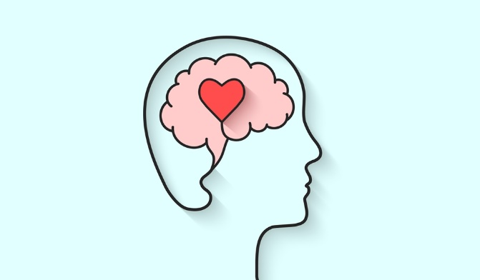
Mental Health Awareness

TV DOCUMENTARY PROPOSAL

Importance of Proposal

Mental Health Awareness has now reached a peak of importance as the pandemic marches on with no seeming end in sight. This year alone there has been a massive 29% increase in psychosis referrals (Pidd, 2021). This increase demands a renewal in the everlasting legacy of mental health awareness. Through the proposal of a TV programme on Mental Health Awareness during such testing times, I hope to encourage and enlighten the general public on the significant importance of Mental Health and the vast outreach of help that is available such as the NHS recommended helplines (NHS, 2021). The people need, more than ever, greater awareness of the rising issues and to realise that there is no shame in reaching out for a hand if the suffering becomes too much to bear or the loss of loved ones to COVID-19 weighs you down.

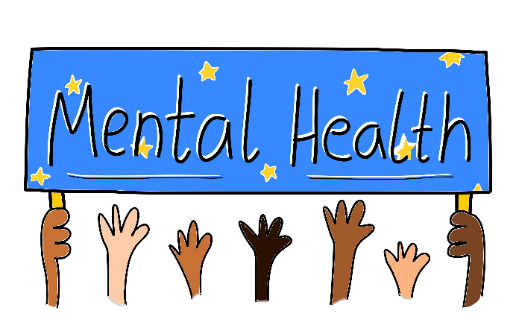

The concept of this proposal is to allow a wider audience to become more able to speak about the uncomfortable nature of mental health during dire times. In a survey completed by Rethink (mental health charity) over 80% of patients reported worsening of their mental health condition due to a lack of response in the pandemic (Molodynski et al, 2020). Furthermore, there has been a growing reluctance to call out for help as shown in the . There has also been a lack of attention towards student mental health which has been adversely affected due to interruptions to education. YoungMinds reported an 83% increase in mental health in students during a recent survey (Grubic, Badovinac, Johri 2020). Part of the key focus will be on helping the very foundation for the future of this country. This proposal is built around removing the young minds stigma towards mental health and telling them there is help out there even in such demanding conditions. That there will be someone waiting for them just a call away if they need a shoulder to cry on, lean on or seek shelter on.

Proposal Concept

PROPOSAL CONTENT

I propose that the contents of this TV Documentary Series will go through starting with the personal experiences of families and students who have experience the great stress and difficulties of Mental Health during the Pandemic. The viewer will experience a journey with the family and students. On this journey they will learn and become more aware of the increasing danger of neglecting mental health and cry with, cheer for and become immersed with the journeys to a better state of mind and being. As the journey continues, there will be help from family and friends along the way as well as professional intervention with a positive end result for everyone. This will demonstrate that are there is help out there and positively encourage people suffering to come out of their inner shell and seek this help. Positive reinforcement will play a major role in allowing the viewer to become more confident and get out there. This was shown in a study in 2017 where it was demonstrated that there is a significant increase in confidence and wellbeing (Gill, Kane, Mazzucchelli 2017). The conclusion of the series will show the powerful impact that being vocal in regards to the state of your mental wellbeing can have for not only you, but those around you.

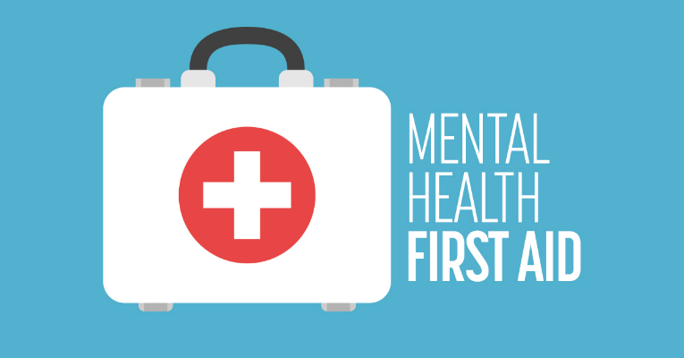

With everyone having access to TV’s and streaming devices, there will a be a wider reach in terms of audience. The relevance of this documentary applies not only to those who have a mental health condition but everyone else too. This will dramatically increase awareness and help remove the stigma associated with mental health which has been show to play a major role in a lack of seeking help when its genuinely needed. This was shown in a study completed in 2011 where 76% of the individuals agreed that there was significant stigma (Iversen et al, 2011). This can also be seen in students where a survey showed 42% used derogatory terms for people with a mental illness (Pinfold et al, 2018). Now is the time when this TV documentary series will have the most significant impact and show the most results. This proposal is for the betterment of awareness and treatment for those with mental health.

WHY NOW?

- Helen Pidd (2021) Psychosis cases rise in England as pandemic hits mental health URL: https://www.theguardian.com/society/2021/oct/18/psychosis-cases-soar-in-england-as-pandemic-hits-mental-health Date Accessed: 09/12/2021
- NHS (2021) 9 tips to help if you are worried about COVID-19 URL: https://www.nhs.uk/every-mind-matters/coronavirus/covid-19-anxiety-tips/?WT.tsrc=Search&WT.mc_id=BHEMMOct21Covid&gclid=CjwKCAiA78aNBhAlEiwA7B76p40c8wbjCjOF-VJku82N-WFe3rB9Y_jRNHmmugHajVdiEh6AdB5R8xoCv1gQAvD_BwE&gclsrc=aw.dS Date Accessed: 09/12/2021
- Molodynski, McLellan, Craig, Bughra (2020) What does COVID mean for healthcare? International Journey of Social Psychiatry 67 (7) 823-825
- Grubic, Badovinac, Johri (2020) Student mental health in the midst of the COVID-19 Pandemic: A call for further research and immediate solutions International Journal of Social Psychiatry 66 (5) 517-518
- Gill, Kane, Mazzucchelli (2017) Activation, Avoidance, and Response-Contingent Positive Reinforcement Predict Subjective Wellbeing Journal of Happiness studies 20 (2) 331-349
- Irven, van Staden, Hughes, Greenberg et al (2011) The stigma of mental health problems and other barriers to care in the UK Armed Forces BMC Health Services Research 11 (1)
- Pinfold, Toulmin, Thornicroft, Huxley (2018) Reducing psychiatric stigma and discrimination: evaluation of educational interventions in UK secondary schools The Birtish Journal of Psychiatry 182 (4) 342-346
Images
Figure 1 (Title Image) International Students House (2020) ISH’s Mental Health Information for Students URL: https://www.ish.org.uk/mental-health-information-for-students/ Date Accessed: 09/12/2021
Figure 2 (Mental Health) NHS (2021) Problems CAMHS can help with URL: https://www.derbyshirehealthcareft.nhs.uk/services/childrens-mental-health-services-camhs-derby-and-southern-derbyshire/problems-camhs-can-help Date Accessed: 09/12/2021
Figure 3 (Mental Health First Aid) Martin (2018) Mental Health First Aid – CWK002 URL: https://www.kidspeace.org/mental-health-first-aid-cwk002/ Date Accessed: 09/12/2021

Reference List

