LECTURER: Nishi M. Namsurrun

Elisabeta-Alexandra Badea (2011897)
ABSOLUT CARE
PERSONAL DEVELOPMENT AND EXPECTATIONS
PROGRAM: BA (HONS) LEADERSHIP AND MANAGEMENT LEVEL 5
MODULE:DEVELOPING RELASHIONSHIPS AND WORKPLACE ACHIEVEMENT
MODULE CODE: BMSW_5102_LON
GROUP: 2

TABLE OF CONTENT

Table of Contents
PERSONAL DEVELOPMENT NEEDS AND EXPECTATIONS 2
The 360-degree feedback theory 2
The 360-degree feedback applied on Absolut care 3
Case study: Jennifer- team leader at Absolut Care 3
Application of MBO in Absolut Care 4
Pros and Cons of MBO 6
Best practice to employ the MBO concept within Absolut Care: 7
PERSONAL DEVELOPMENT PLAN 8
References 9

PERSONAL DEVELOPMENT NEEDS AND EXPECTATIONS

The purpose of the report is to critically evaluate different development vehicles employing academic models, methods and theories studied within the module “ Developing relationships and workplace achievements” and to develop a plan to meet personal development needs and expectations of the employees within Absolut care Ltd. The reports analyse the 360-degree feedback and the Management by Objectives (MBO), vehicles used by Absolut Care to assess and evaluate the employees work performance and to find their expectations and future development needs and wishes. The report structure will provide :
- An overview of the company
- Their performance appraisal tools, an evaluation of the vehicles
- Recommendations for Absolut care Ltd. on this specific area
Absolut care is an organisation that provides highly trained medical and administrative support for different establishments such as residential, nursing homes and hospitals. Absolut Care is based in Kent, Tunbridge Wells on Pentiles Chamber. The mission and vision of the organisation are to provide high-quality Health and Social Care Services, helping the vulnerable to live their life at their full potential and to provide a safe and comfortable
environment for them.

The 360-degree feedback theory

Source self made 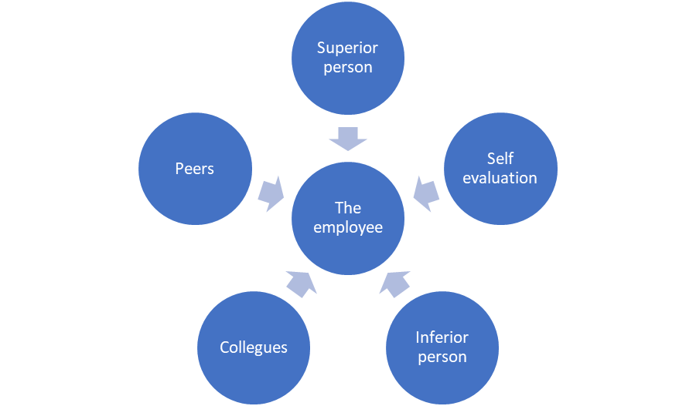

The 360 degree, also known as the multi-rater feedback is the method of appraisals where the employees can receive anonymous feedback from the people on different departments within the company. The purpose of this type of appraisal is to identify the strengths and areas of improvement of the employees from different perspectives, including themselves. Also promotes a culture of performance and increases self-awareness.

The 360-degree feedback applied on Absolut care

Since being implemented in the company, the 360-degree feedback has proven to be efficient and effective in discovering the skills and aptitudes of the employee. As the theory suggested, the 360-degree feedback analyses the employees' strengths and weaknesses, enables the organisation to plan and overcome weaknesses, to achieve and to build trust across the teams.
The 360-degree feedback enabled the manager to have a sincere dialogue with the employee, to discuss the findings of the feedback and to promote honesty and transparency. Since using the 360-degree feedback, the manager responsibilities is been easy by having a coach and HR representative as part of the appraisal process.

Case study: Jennifer- team leader at Absolut Care
Before implementing the 360-degree feedback, the appraisals at Absolut Care were effectuated by a formal dialogue between the manager only and the employee. Feedback used to be given based on that day meeting discussion, but mostly by the manager observation during the year.
Once implementing the new procedure of feedback, Absolut Care started to discover the feedback results of the same employee but from different methods of appraisals. Based on the analysis of the first method of appraisal, Jennifer was considered to be not confident about the leadership and leading the team appropriately, was considered to lack teamwork skills, to guide the team, very good on job knowledge but not as interested to participate in the businesses development or growth, Based on the one to one appraisals Jennifer has shown lack of commitment/ engagement.
An analysis of the same employees based on 360-degree feedback principles shows a very different perspective of Jenifer. The team reported that Jenifer is very supportive and takes her time in listening to the team concerns or personal problems that decrease their work performance and that she is strict when it comes to respecting the high quality standards of services. Another department reported that Jenifer was seen crying at times because she feels overwhelmed with the workload. The other team leaders reported that Jenifer is afraid she would not meet the manager demands and she cannot work at full potential while the manager is around. Many other statements of the appraisee suggest that Jenifer is passionate about the sector, appreciates and values the team, but due to workload cannot be part of their team most of the time, Jenifer has good planning skills, is organised, is accountable, but needed more encouragement and training to build up her confidence.
In conclusion, the 360 degree feedback enables you to meet the employees and assess them from different perspectives, you can see for example that they are good team players or enthusiastic or struggle with time management, many things that a manager would not have time to assess for a long period, therefore the accuracy of the appraisal might be sometimes wrong due to lack of data.
Although the 360 appraisals seem to be useful and professional for the company appraisals process, there are some downs on it, that can affect the result of the appraisals, therefore work performance and development of the employees. As well as creating a culture of performing, it can create trust issue problems, by knowing what people that you work with thinks about you and you received negative feedback 60%, employees can reprime emotions or bad feelings towards the people that potentially would have given them feedback. The accuracy of the feedback will be affected, collecting feedback from people that are not necessarily skilled in assessing other people can give you wrong data, employees can take advantage of that and resolve conflicts or arguments by providing wrong feedback or favouriting specific employees and rate over their aptitudes and being subjective. Small friendly teams won’t be critical in assessing their team members. The fact that the 360-degree feedback is anonymous is impossible to track and easy to speculate while you are not fully responsible for the overall rate. The procedure itself is time-consuming and the 360-degree feedback is focused on the strengths and weaknesses of an employee, often enough, after conducting this type of appraisals, appraisers tend to talk more about weaknesses. The 360-degree feedback takes place once a year, which does not seem to work in building trust and developing
a good and strong relationship between the manager and the employee, plans and development across the company. Going back to the weaknesses, having a year gap in assessing the areas of improvement, can decrease the work performance, due to lack of action in overcoming the weaknesses.
The 360-degree feedback is way better than the many types of appraisals the company used in the past. However, due to the many risks that have been discovered in the report, Absolute care should reconsider their company appraisal type.

Application of MBO in Absolut Care

One of the other vehicles of Absolut Care in evaluating the work performance and training needs and development is Management by Objectives (MBO)
According to the theory, having a democratic approach as a leader increases performance. By giving the employees a chance to express themselves in regards to action plans and goal setting, as a leader, you are promoting the employees' participation, therefore, they will show more commitment by feeling included and valued. The Management by Objective is the strategic management model used to increase and improve the organisation performance by clearly defining the goals and objectives agreed by both parties-the organisation and the employee. Having set the goals by both parties- employer-employee.

To use the Management by Objective in practice, Absolut care follows a rule of 5 steps.
The first step is to define the organisational as well as the employees' objectives aligning with the mission and vision of the company.
Step two- the SMART objectives. Absolutes define their goals using the SMART objective tool. The techniques enable the company to set appropriate objectives and create appropriate plans.


Gorge T. 1981- SMART theory

Step three is stimulating. Encourage and support the employees to remain focused and committed to the objectives plan after they have been established in detail and shared with all levels of the organisational-strategic-functional-operational. In step 3, Absolut care has the responsibility to encourage and assist (when needed) the employees to create their individual or groups strategy to achieve the organisational objectives. By applying the third step, Absolut empowers the employees to be creative, to choose their strategy and also to make decisions. Empowerment is motivation and the employees must always be motivated to perform.
Step four is all about monitoring the progress of the employees. Absolut Care carries regular audits to monitor the progress of the objective achievement. This is a great opportunity to observe the employees skills of planning and executing as well as critical thinking, decision making, risk measures capabilities and teamwork capabilities.
The fifth step is the evaluation of employee progress, followed by honest feedback of what was achieved and what was not for each individual. Reflection( what went well, what went wrong, how could it possibly do this in another way, how can this be applied in the future processes). Absolut care rewards the employees' achievement and the effort of trying. It is important for each employee to be awarded, regardless of what the outcome of their progress is. If they did well, they will feel knowledgeable and valued but if they did not, they will feel encouraged and supported. The rewards can come in different variants, depending on the nature of the progress and employees culture and beliefs.

Pros and Cons of MBO

Using the Management by Objective Absolut Care aim is to increase the employees' motivation and performance by setting specific goals, promoting better communication between the employees and the management, increase the confidence and self-esteem of the employees by seeing their accomplishments obtaining the goal set. To be successful, the objectives must be carefully set. It takes time, knowledge and experience of the manager, mainly, but also it is important to have the same assets from the employee side. For example, setting the objective being overoptimistic and not necessarily conducting an analysis (refer to SMART tool), the risk of the objective achievement failure is high. Giving people too much or more than they can understand or undertake won’t take you anywhere, most probably is that the objective set will not be achieved, which ultimately, decrease the motivation of the employees and their confidence to undertake future objectives plans. If the employee does not achieve, ultimately, the organisation won’t achieve. These failures can be something the company can handle or the employee, but think of financial targets, or, as Absolut care provides health and social care services, imagine they fail into delivering something they planned when impacts the patients' health and the wellbeing. This is something that the employee or the organisation cannot fully control or assume as a failure due to the high and important impact of the stakeholders. When practising the Management By Objectives. The organisation must know very well the concept, if not, get appropriate training for successful implementation across the company. The MBO takes time and requires several meetings in the process of achievement. The employees should understand their role and importance across the company, and, besides the organisational goal setting, there must be employees individual objectives set. By taking this approach a set of skills such as critical thinking, personal development will be developed in individuals involved in MBO. A successful MBO must be a systematic approach. The objectives set must align with the company mission and vision and it must bring market value (revenue for the company). Even talking about building confidence, personal development, areas of improvement, communication of the employees, they all sound individual achievements of the employee. However, better skills, knowledge and behaviour increase work performance. The work performance leads to the company progression, overall development of and growth.
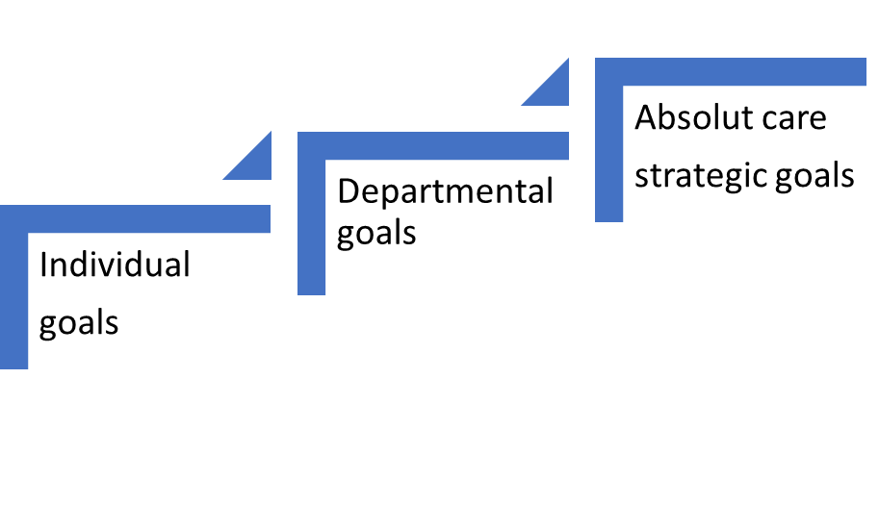
Source: self-made

Overall, the MBO is a great tool to measure performance, allows better communication, increases motivation, development and confidence, as well as strengthens other skills, awareness of the company goals and it is a result-oriented process. However, the concept has disadvantages as well such as:
The MBO is a top to bottom concept, therefore it focuses on the organisation objectives, which makes it harder for the operational levels to achieve. As proposed above in image 1, the managers should start creating goals for their employees to achieve the organisation goal, rather than set the organisation goal and pressure employees to get along with, which might be beyond their understanding and ability to handle. The MBO cannot be applied in times of change. The MBO requires a stable environment, not reconnected for a dynamic or a moving forward company, if a sudden change should occur, changes are difficult to be made following the MBO concept. Time-consuming. In order to set, follow and achieve, the MBO requires a lot of meetings between managers and employees. Increasing documentation load.

Best practice to employ the MBO concept within Absolut Care:

Training on the MBO, time management, critical thinking and decision making, problem-solving, developing workplace achievement. Allow plenty of time and resources, regular feedbacks review and progress. It is essential to set goals in order to achieve and progress. However, ideally, MBO must be implemented after the company has a stable environment or it is successful. Do not use the reward-punishment process, only support and reward the employees as per their efforts. If serious conflicts arise in obtaining the organisation set goals, the first approach before punishment is to evaluate and see the patterns of the failure. It may be that the employees did not understand the concept or they do not they have the appropriate knowledge and skills to achieve the target. Always look to improve the overall running of the business when a problem arises, rather than resolve the actual problem or have people assume the consequences and experience the same problem again and again.

PERSONAL DEVELOPMENT PLAN

Development  Objectives | Priority | Activities to be undertaken | Resources | Target start date | Target end date | Criteria for success
Leadership | High | -Enrol leadership courses and workshops  -Talk to successful leaders  -Practice within the work place | Time  Focus  Money | 20.09.2021 | 20.09.2023 | To be able to lead
HR know how | High | -Complete a course about the HR and practice within the department | Money;  Found the institute for training;  Focus  Motivation | 05.02.2022 | 05.12.2021 | Improve efficiency in HR procedures
Motivation | High | Identify my motivational factors and give my time a and rewards | Peace of mind, wisdom,  Practice relaxation | Immediate effect | Keep practising | Better performance;  Better team  Work performance
Critical thinking | High | Training and progress | Focus  Knowledge  Money | In progress | 20.09.2023 | Improving decision making
In order to progress, the company and the employees must have all the necessary resources to grow and develop. The development of the employees means the development of the organisation. Based on the appraisals conducted this year, some aspects of the job performance needs improvement. The table above shows the area of improvement and the plan to overcome them and develop them.

In conclusion, Absolut Care shows and perform great care supporting the employee's personal development and expectations. However, their operational systems support improvements, especially on the performance of the appraisal to obtain achievement at the workplace and to encourage the employees' personal development. The report concludes that Absolut care is yet, using the 360-degree feedback format and the Management by Objectives. Which, is aligning with the regulations in place. However, for the best performance, the 360-degree feedback format can be upgraded to the 540-degree feedback which, is based on the same principles and has all the elements but has an addition of the appraisee which, allows you to have a clear vision of the employee. The appraisals must be always planned ahead as this can be time consuming for the strategic level, as well as operational. Keep records of it, review and improve after each experience.

References

AbsolutCare. (n.d.). Absolut Care - Here for you. [online] Available at: http://absolutcare.co.uk/ [Accessed 3 Jan. 2022].
Armin Trost (2020). #32 Does Pay for Performance really motivate? YouTube. Available at: https://www.youtube.com/watch?v=0D1JAPTda9c [Accessed 16 Dec. 2021].
Armstrong, M. (2022). ARMSTRONG’S HANDBOOK OF PERFORMANCE MANAGEMENT : an evidence-based guide to delivering high... performance. 6th ed. S.L.: Kogan Page.
Armstrong, M. and Taylor, S. (2014). Armstrong’s handbook of human resource management practice. 13th ed. London, United Kingdom ; New York, Ny: KoganPage.
Pardee, R.L. (1990). Motivation Theories of Maslow, Herzberg, McGregor & McClelland. A Literature Review of Selected Theories Dealing with Job Satisfaction and Motivation. [online] Ed.gov. Available at: https://eric.ed.gov/?id=ED316767.
Rodger, Robert, Hunter and E, J. (n.d.). APA PsycNet. [online] psycnet.apa.org. Available at: https://psycnet.apa.org/buy/1991-25999-001 [Accessed 10 Dec. 2021].
Scheuer, S. (2000). Social and economic motivation at work : theories of work motivation reassessed. Copenhagen: Copenhagen Business School Press.
Voices (2015). The 360-Degree Performance Review. [online] www.youtube.com. Available at: https://www.youtube.com/watch?v=b5BKa7Pj-w4.

