How social and digital midia can be used to reach a wider customer base

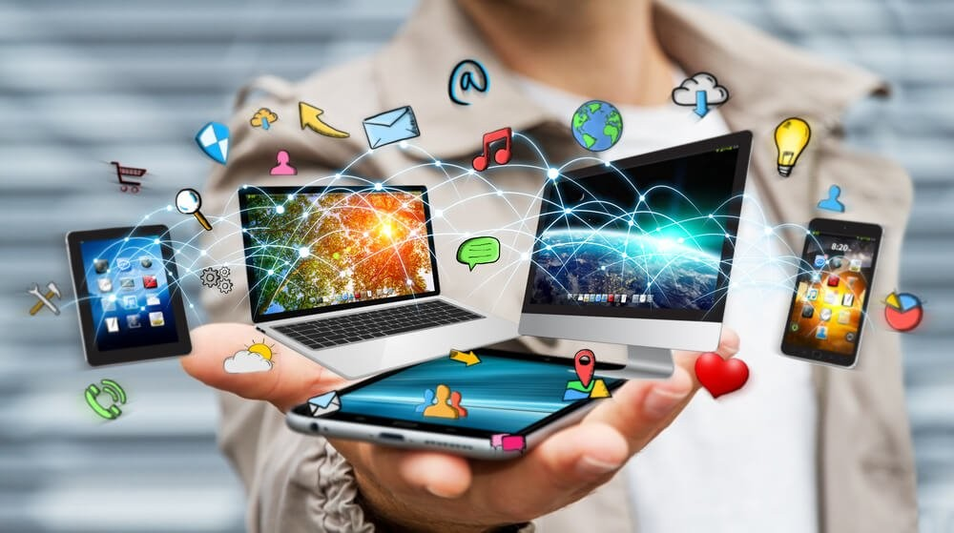

Module Name: Digital skills
Module code: LCLM 4002
Student Name: Maribel Soares
Student ID: 2326528
Lecturer´s Name: Amitave Banik

index
INTRODUCTION 3
HOW SOCIAL AND DIGITAL MIDIA CAN BE USED REACH A WIDER CUSTOME BASE 4
Conclusion 5
reference 6

INTRODUCTION

In this work I come to explain, through my knowledge and studies, how important digital media is nowadays, not only for sales, but also for any type of objective. And through the expansion of information technology, and the speed at which it spreads, the internet emerged, being practically the main form of global communication, and driving the search for information on a multitude of subjects. In this way, organizations saw an opportunity to expand their business through the internet and marketing.

HOW SOCIAL AND DIGITAL MIDIA CAN BE USED REACH A WIDER CUSTOME BASE
Digital platforms are a fundamental support for marketing strategies,as they enable a closer relationship with the consumer. THE digital marketing has become a broader tool because it is accessible and able to reach different types of people and groups, in addition to being a cheaper form of marketing, but it requires of company’s good strategies and a good positioning to retain their consumers and expand the brand. With the expansion of information technology, and the speed at which it propagates, the internet emerged, being practically the main form of global communication, and boosts search of information on a multitude of topics. In this way, organizations saw an opportunity to expand your business through the internet, not only by carrying out advertising campaigns, but also, transforming your products into sales through virtual communication.
Therefore, organizations had to adjust and reorganize the way how the organization should communicate with its customers, as the consumer environment changed completely, becoming more direct and personal, that is, the relationship with the Consumers must be intimate so that they feel loyal to the company. Organizations sought to understand consumer behaviour in the environment virtual, identifying great potential in social networks, where the main friends and family members of the consumer in question, where the influence is clearly perceived through of the relationship that exists in the social circle in which the individual is inserted. Therefore, companies joined social networks, to establish a more intimate and informal relationship with the consumer, gaining their loyalty, and transforming the company into a type of influencer, where your customers identify with the brand.

Conclusion

The rapid development of communication technologies is currentlytransforming many processes in modern society. The Internet, as the most accessible and convenient system of global exchange of information between users has not only proven its viability but is also beginning to displace other forms and channels of communication, dueat the lowest cost of services, high data transfer speed, greatervariety of information presented and transmitted.
The E-commerce in general and Internet marketing in particular playcommunication functions and provide the opportunity to complete transactions, make purchases and make payments. Also, the Internet marketing and advertising segment is growing both in the consumer sector, as evidenced by the emergence of newonline stores every day, as well as the objectives of this work were achieved.

reference

https://semanaacademica.com.br/system/files/artigos/artigo_cira_e_cristiano_0.pdf
https://www.marketveep.com/blog/how-to-use-social-media-marketing-to-grow-customer-base
https://iimskills.com/social-media-strategies-business-growth/ https://repositorio.pgsscogna.com.br/bitstream/123456789/30390/1/GABRIEL_BARBOSA_VIEIRA_AT4.pdf
https://www.investopedia.com/use-social-media-to-grow-business-8391642
https://www.linkedin.com/pulse/social-media-marketing-why-its-key-expanding-your

