Database Assignment
Module Code : ACCA4023
Tyler Williamson

The users that I identify as potentially using the Database Management System and requiring access are: Managers, Accounts, Various staff members ( such as admins, equipment co-ordinators, cleaners, maintenance and sales people ) and also the Customers themselves to update their details.

Whilst I have created a login form to do this and masked the password input text box I have unfortunately not been able to make this successfully function. However this is the general idea and solution to this problem: To allow specific users have specific access to certain tables and pieces of the databases. Some users will have full access such as Managers where as Customers will have very limited access to just their own personal information and perhaps the branch information form alongside parts of the Event Information form (not all as they do not need to know information about suppliers and patrons etc).

I have created numerous amounts of tables to reflect the various parts of the company and its requirements. Using the form option I have created a flagship front page access to the login page then to menu which will give Macro buttons which opens into a Sub-form page with more options for viewing the relevant forms using more macros. On each form there are navigation buttons to go back and forth between records as well as further options to add new records and delete records. Also the option to print the current form page via another macro button. I have also given access to open these forms in a Report to view the data in its entirety. The accounts department have access to all invoice related forms and reports. I have also created on forms which contain currency values, a formula to total the amount in currency generated by things such as Ticket purchases, event gross profit amount etc.

In the ERD Diagram following this page I have Identified the crow foot notions for the Database such as One to Many, One to One and Many to Many. The database has been designed in such a way that it is in third normal form meaning the database has been broken down into smaller tables.
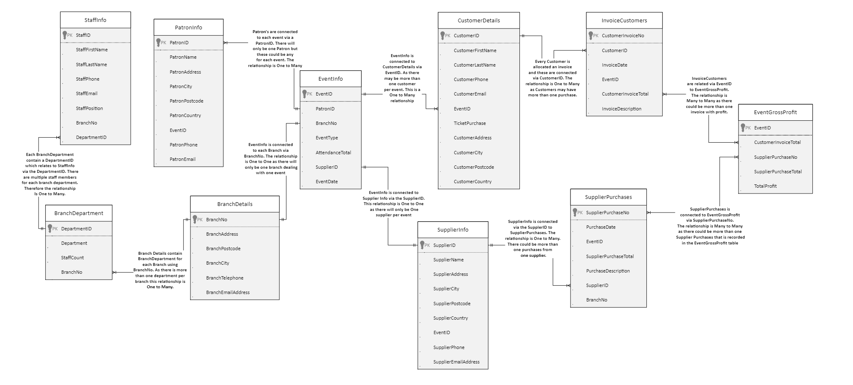
ERD DIAGRAM

I have an understanding that membership class within database systems is relating to the users access level to the database. For example in this database the membership class for a customer would be that the customer would have a very low level access to the database such as only being able to view their own information and perhaps changing their details and booking information or making a new request. Where as the top level membership class would be for a manager who has access to everything within the database.

Screenshots of the database
Login:
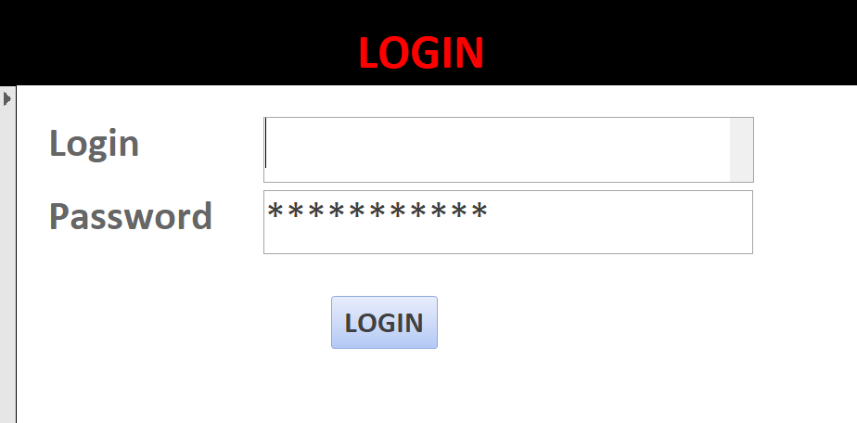

This would be the first page to open when accessing the database and ideally would provide the user who has logged in with their details access to the permitted areas of the database.
As you can see above the password has been masked so the passwords entered are hidden from other viewers.

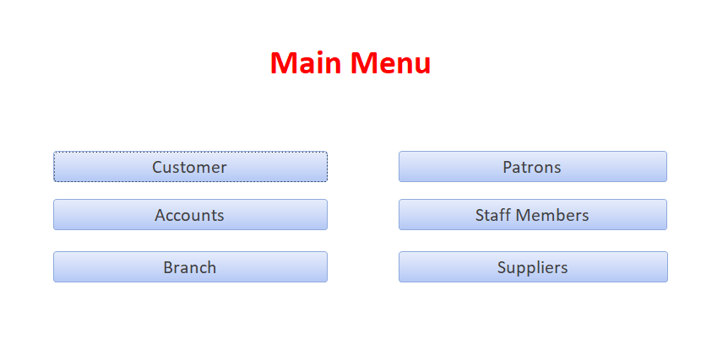
Main Menu:
I have created a form as the Main Menu with Macros for access to all forms.
I have set this main menu form to open first when accessing the database. However this would be the sub-form to the login page if this was fully operational. The buttons in blue with different categories are Macros to allow other forms to open.

Customer Forms:
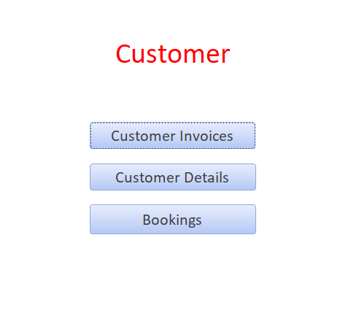

Within this category and the same for all others inside the main menu form, are containing further macros which, again will open into another form accessing the main information of the Database. As follows:
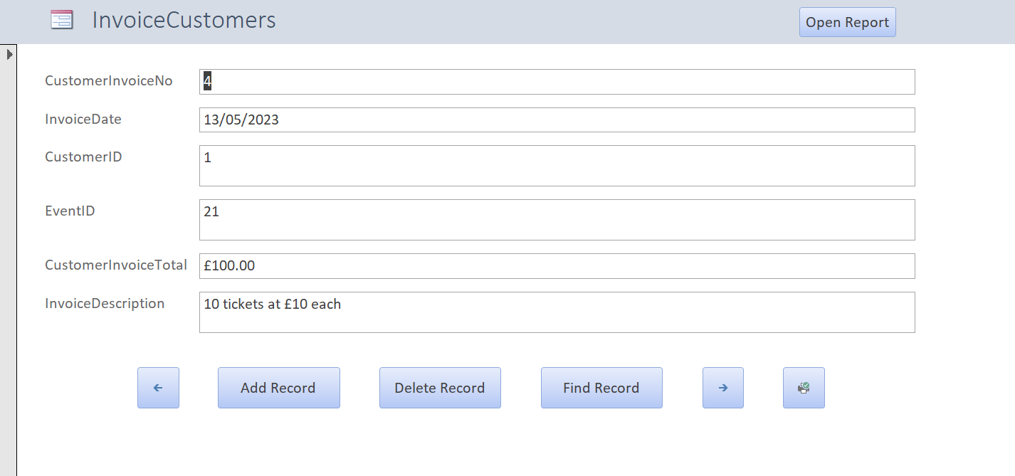

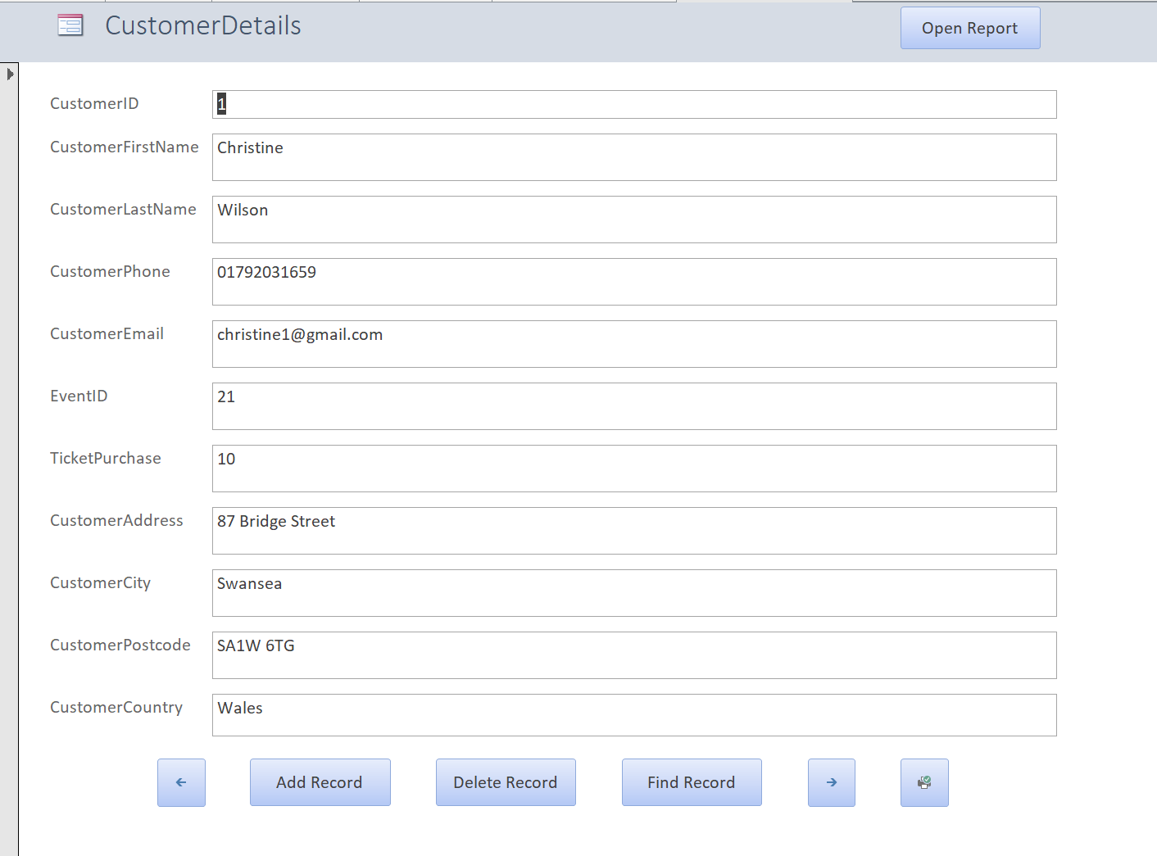

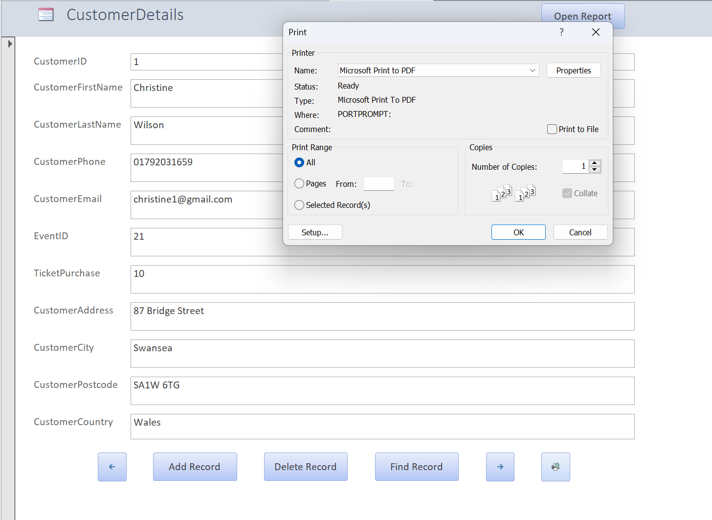

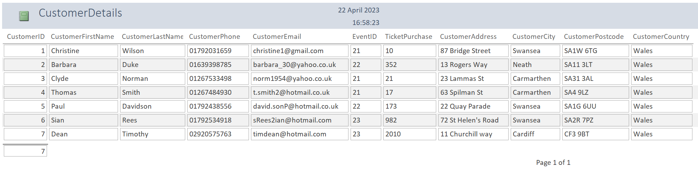
The print button demonstrated as working, which is a Macro button has given the command to print only the current form page. This is found on all forms within the database containing records.
The open report button as shown in previous screenshot opens this report, which shows all records held in the database.
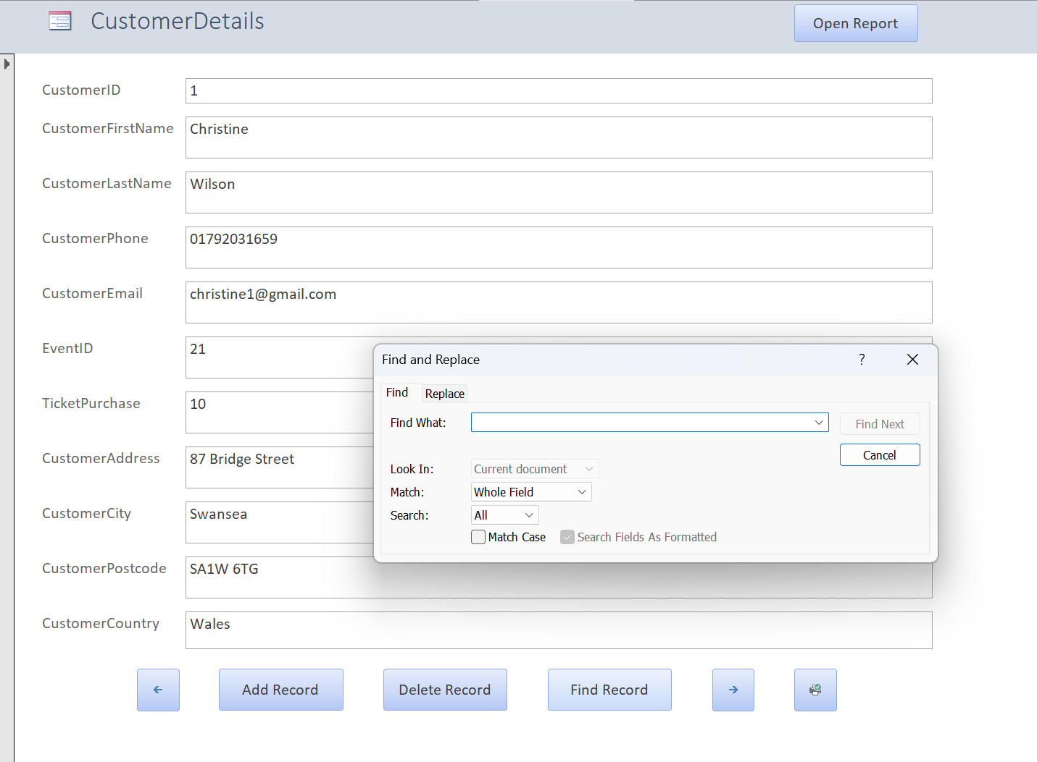

This screenshot is showing the Find Record Macro working to find a record.
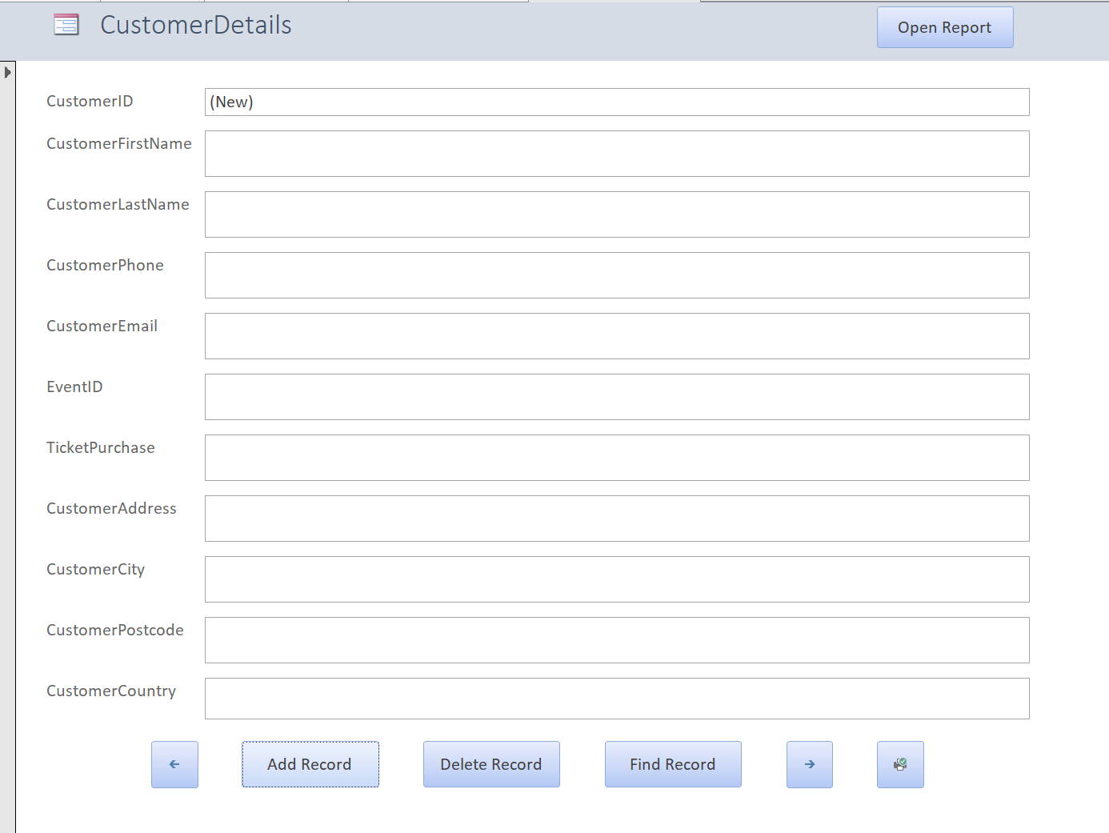

Add record button opens up a new blank form for the user to add to the database.
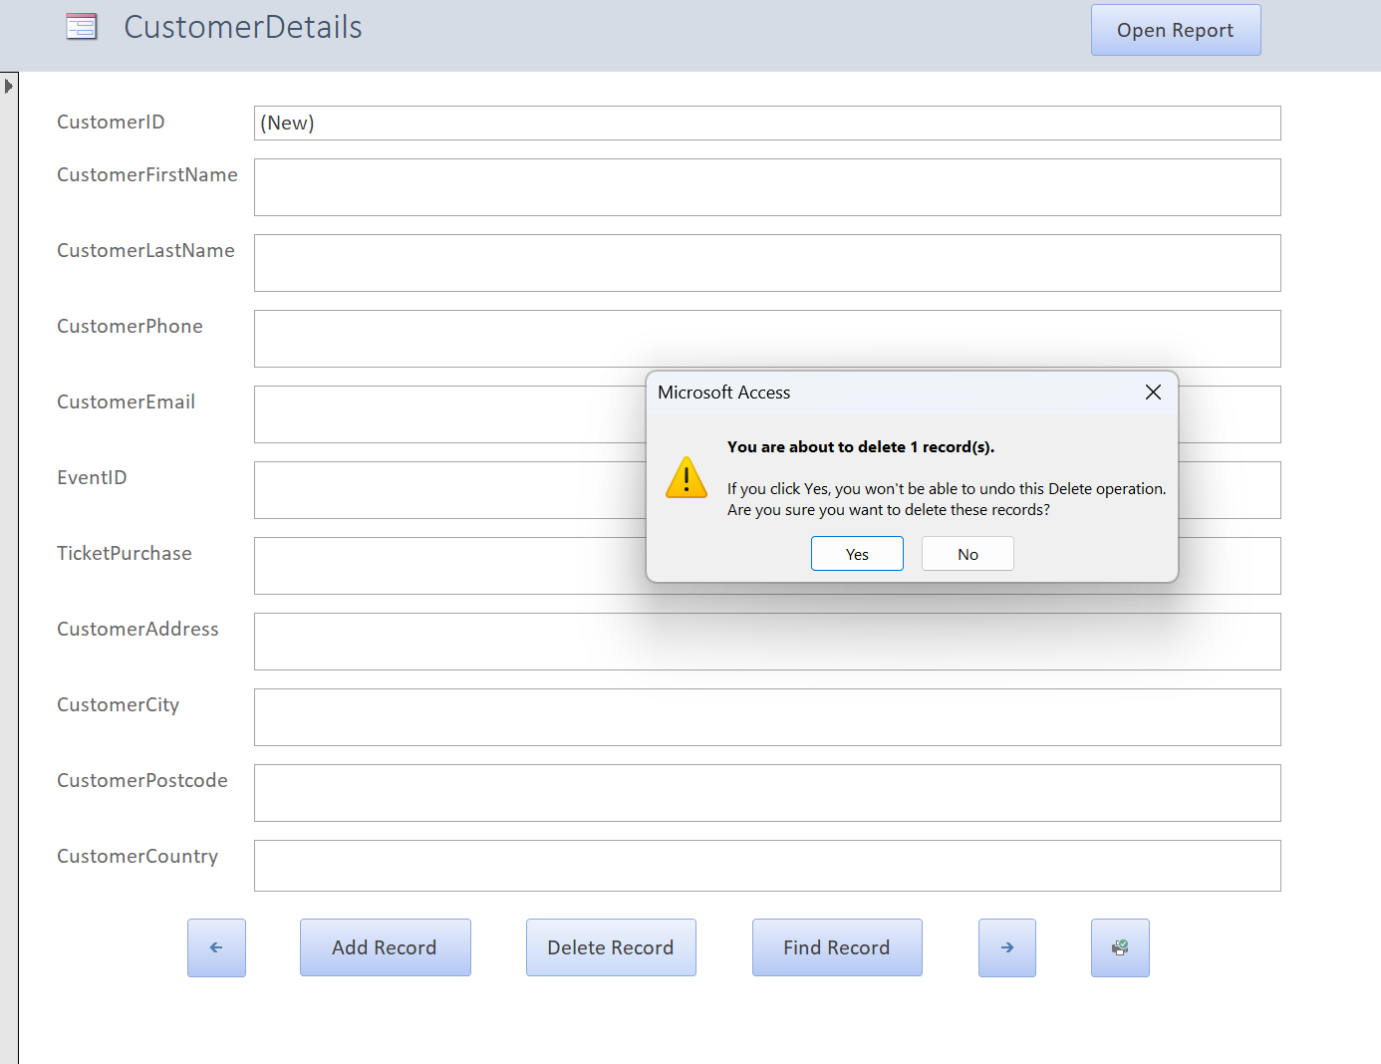

The above screenshot is showing the delete record button being used to remove a record and with prompt to double-check this was intentional before removing the record.
The arrow buttons shown are also fully functioning to navigate between records going backwards or forth.

All of the actionable macros shown above are the same for all forms.

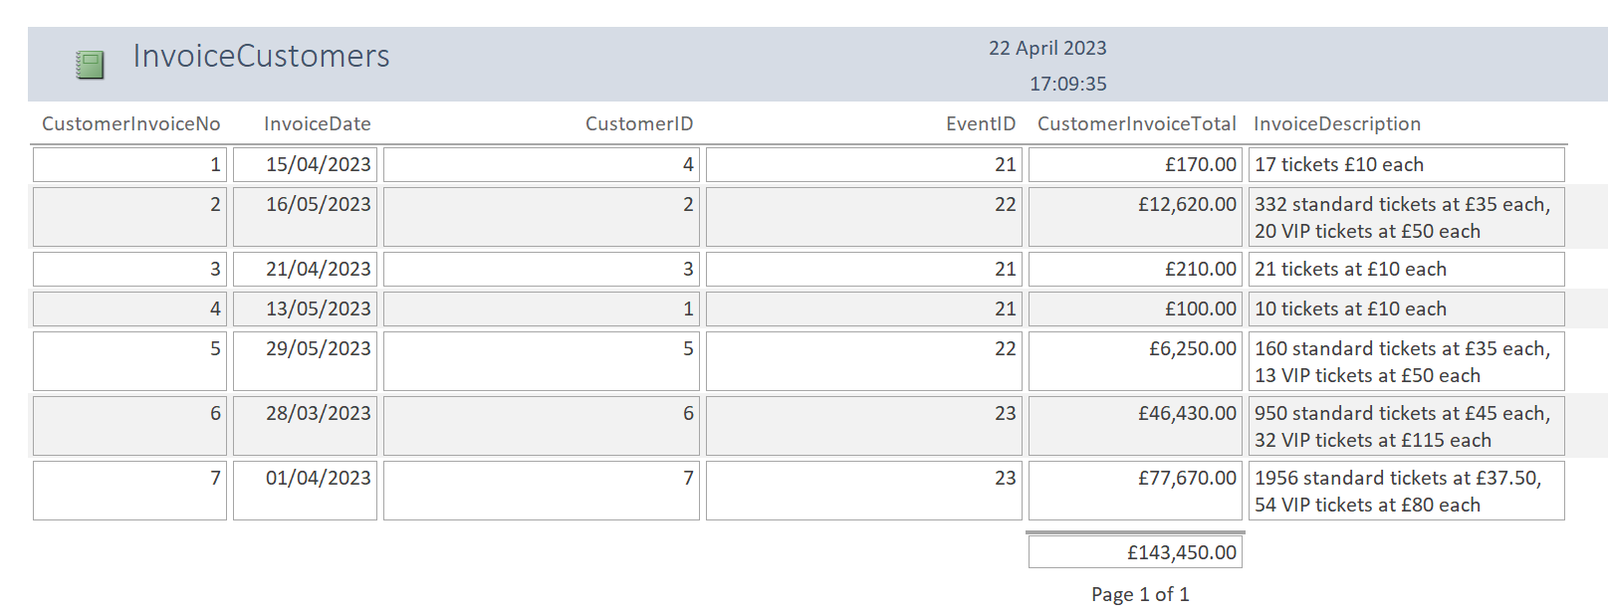
As you can see the above report opened from the InvoiceCustomers form it is containing a summary formula to calculate the Invoice Total.

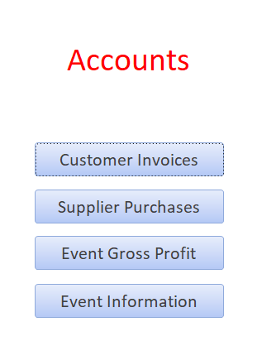
Accounts form:

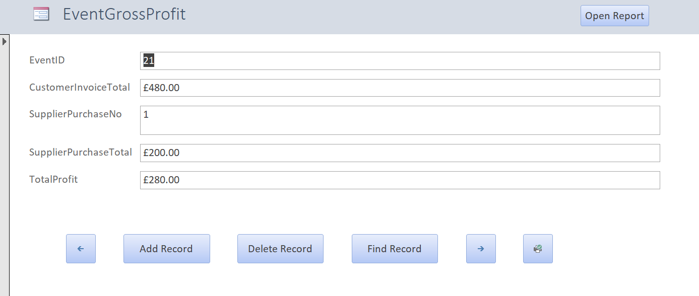

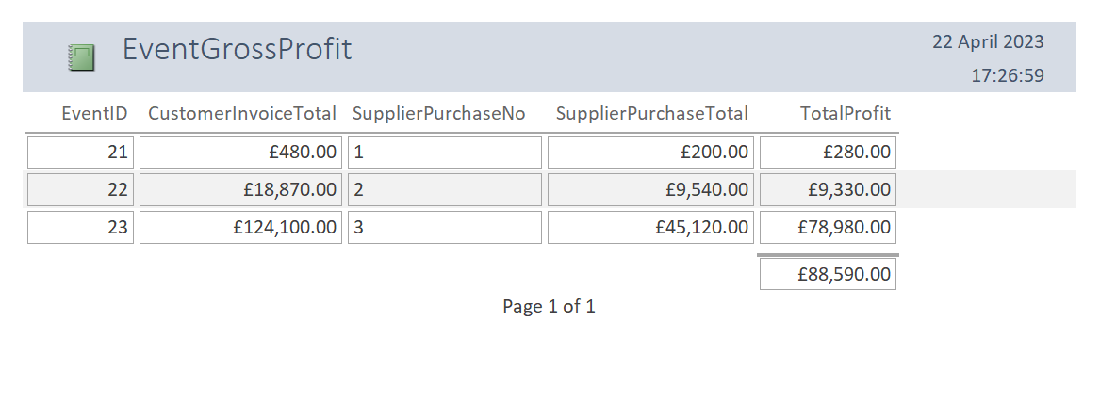

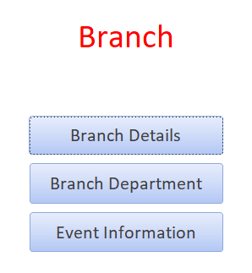
Branch:

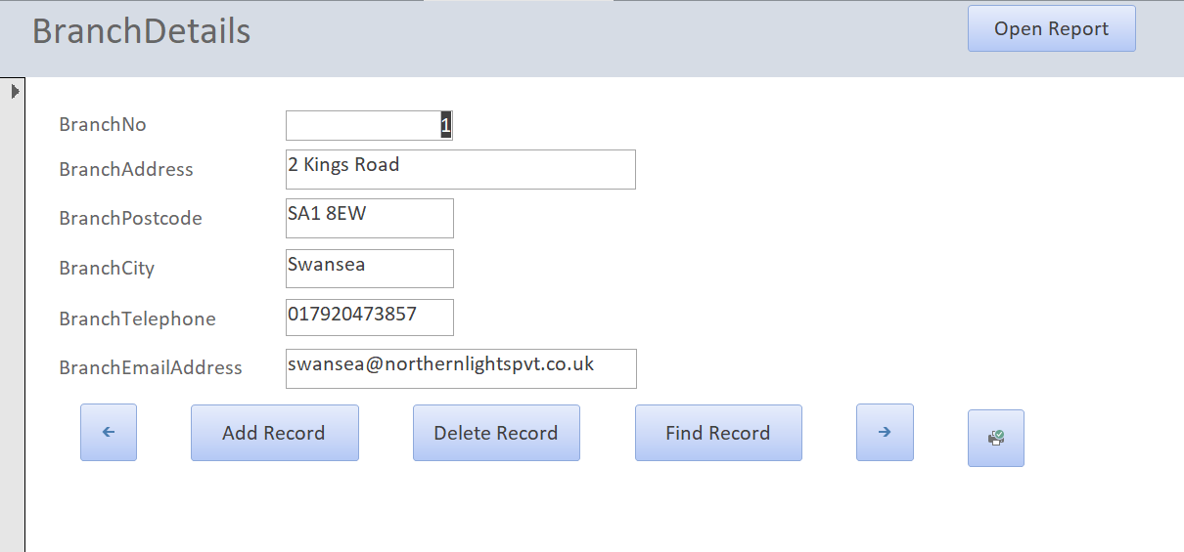

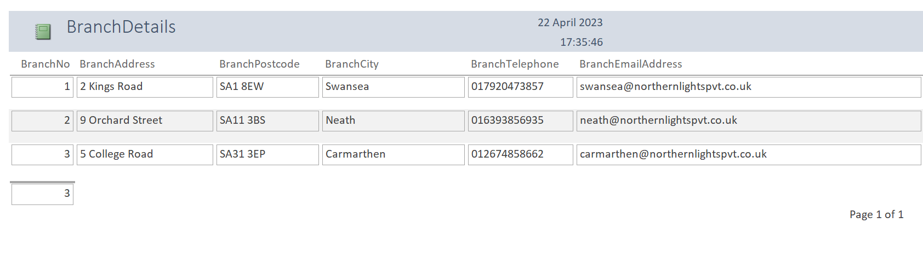

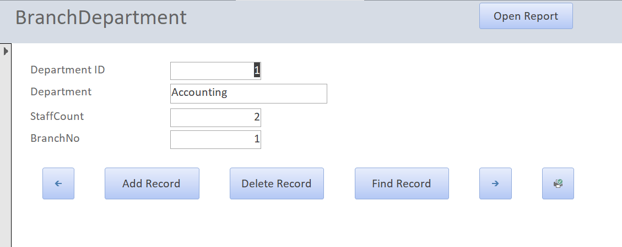

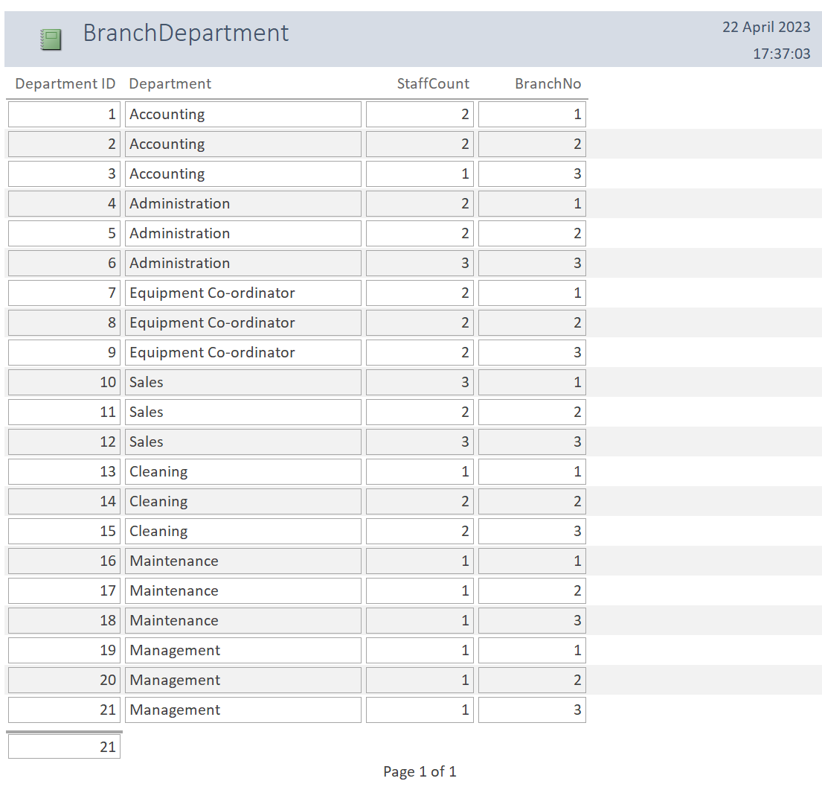

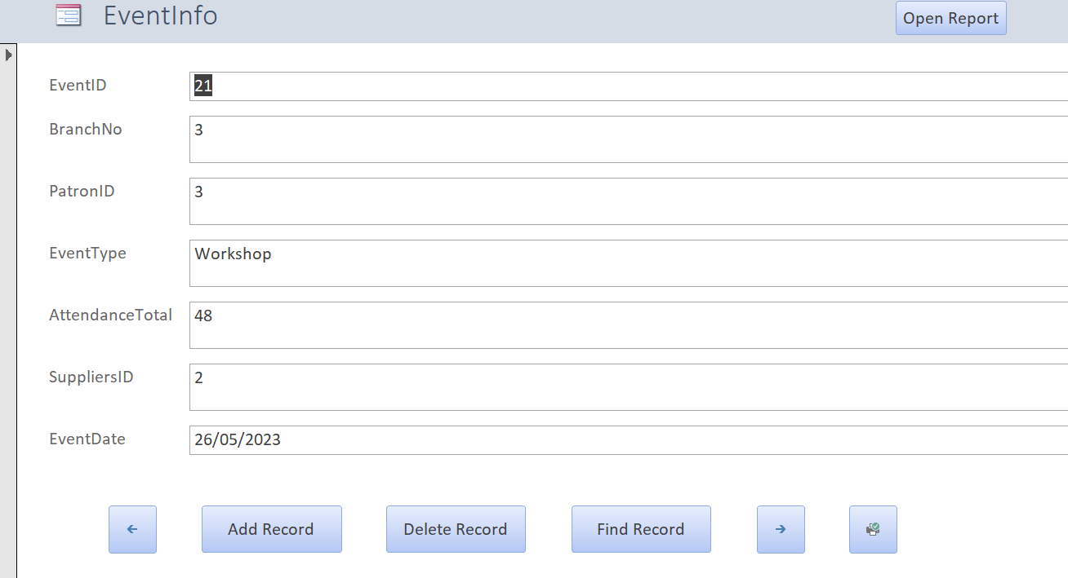

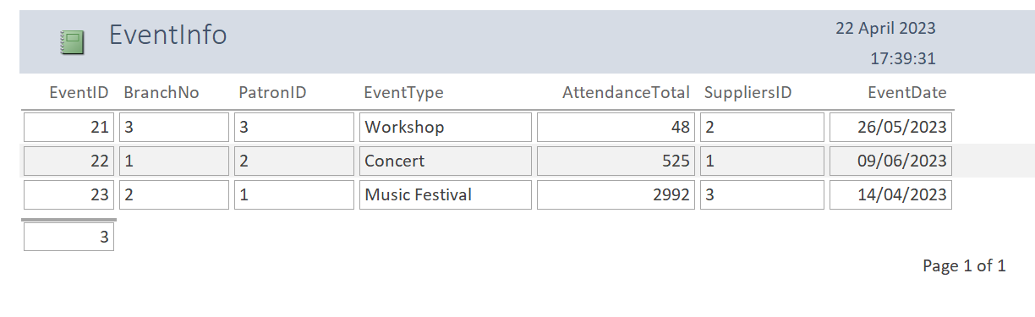

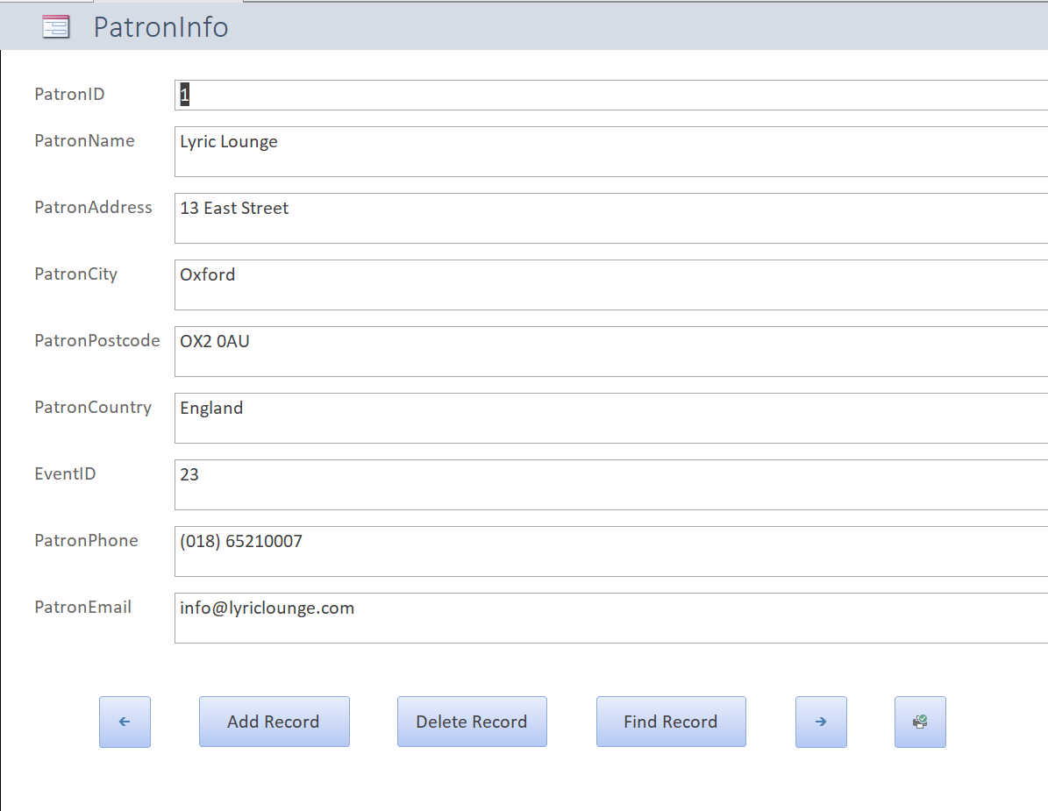
Patron Form:

Staff Forms:
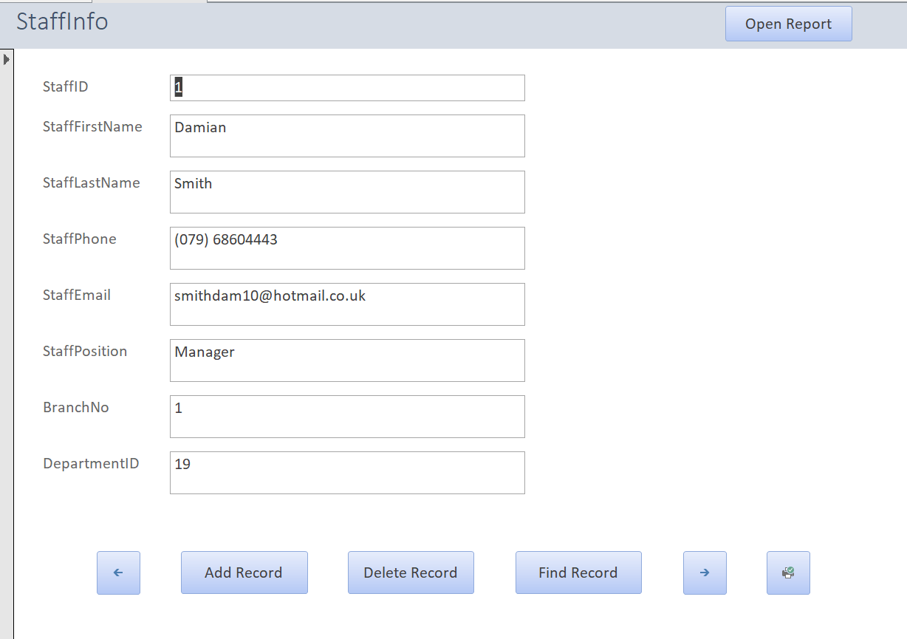

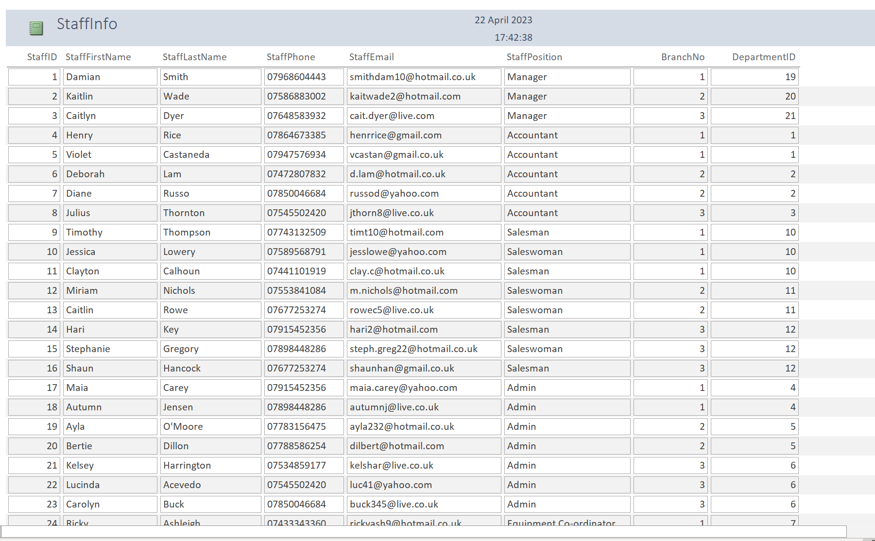

Suppliers Forms:
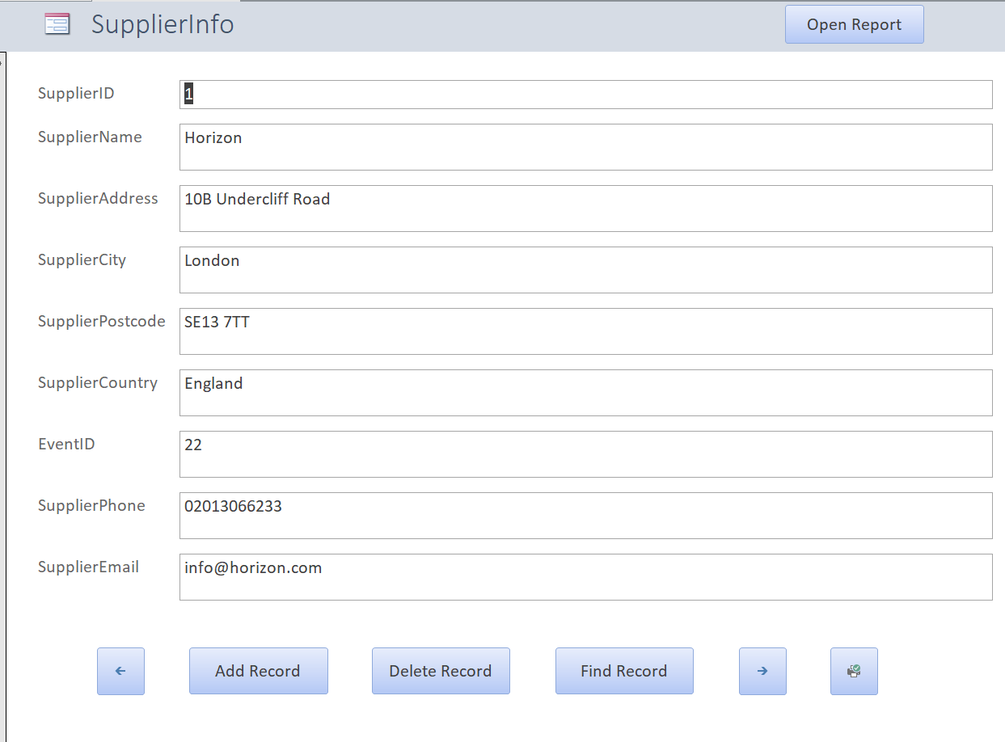

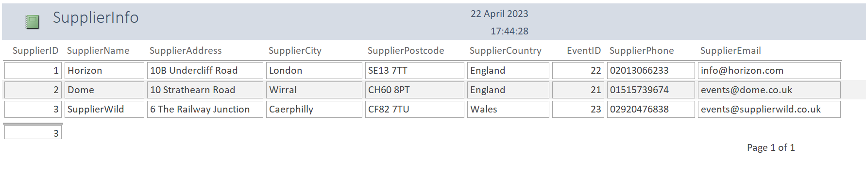

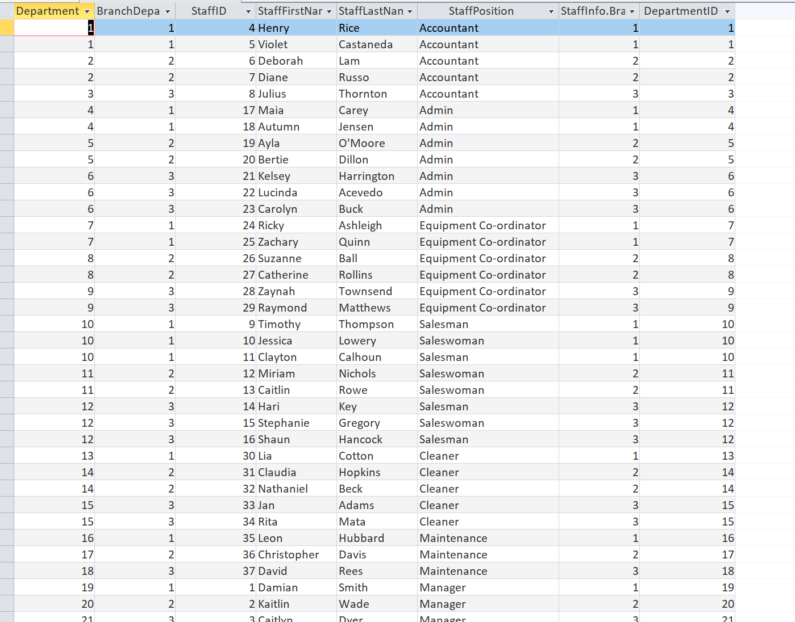
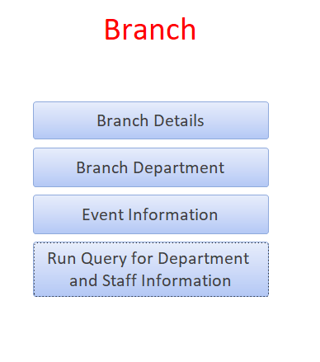
Run Query buttons:

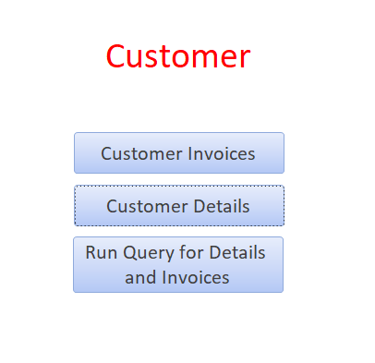

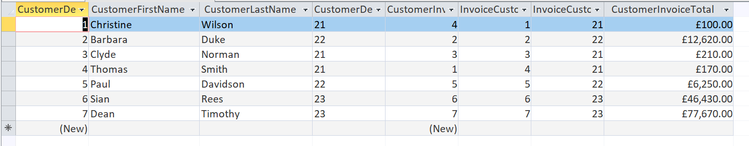

The above macros in the forms have been created to allow Queries to be run from the click of these buttons.

