

LOCATION: Swansea | LLEOLIAD: abertawe
LEVEL 6 | LEFEL 6
EXAMINATION PERIOD | CYFNOD ARHOLIADAU
May 2021 | MAI 2021

MODULE CODE: ACCA6023
COD Y MODWL: ACCA6023
ENTERPRISE NETWORKING, SECURITY, AND AUTOMATION

TIME: 2 HOURS
answer all questions
Equipment or materials required – Packet Tracer 7.3.1
Adnoddau neu ddefnyddiau sydd eu hangen - Packet Tracer 7.3.1

Name :

Student ID :

Date & Time :

This paper is marked out of 100.

Topology
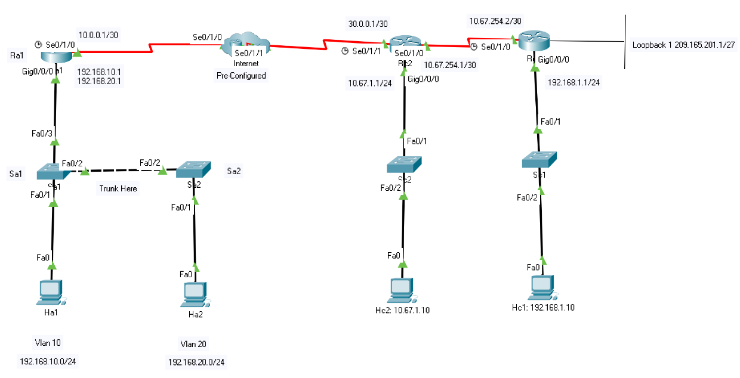

Addressing Table: IPv4 Address
Device | Interface | IP Address | Subnet Mask | Default Gateway
Ra1 | Gi0/0/0.10 | 192.168.10.1 | /24 | N/A
 | Gi0/0/0.20 | 192.168.20.1 | /24 | N/A A
 | Se0/0/0 | 10.0.0.1 | /30 | N/A
Rc1 | Gi0/0/0 | 192.168.1.1 | /24 | N/A
 | S0/1/0 | 10.67.254.2 | /30 | N/A
 | Lo1 | 209.165.201.1 | /27 | N/A
Rc2 | Gi0/0/0 | 10.67.1.1 | /24 | N/A
 | S0/1/0 | 10.67.254.1 | /30 | N/A
 | S0/1/1 | 30.0.0.1 | /30 | N/A
Ha1 | NIC | DHCP | DHCP | DHCP
Ha2 | NIC | DHCP | DHCP | DHCP
Hc1 | NIC | 192.168.1.10 | /24 | 192.168.1.1
Hc2 | NIC | 10.67.1.10 | /24 | 10.67.1.1

VLAN Table

Device | VLAN Number and Name | Vlan Interface | IP Address | Subnet Mask | Default Gateway
Sa1 | 10 - Top , 20 - Mid | 10 | 192.168.10.2 | 255.255.255.0 | 192.168.10.1
Sa2 | 10 - Top , 20 - Mid | 20 | 192.168.20.2 | 255.255.255.0 | 192.168.20.1
Sc1 | 1 | 1 | 192.168.1.2 | 255.255.255.0 | 192.168.1.1
Sc2 | 1 | 1 | 10.67.1.2 | 255.255.255.0 | 10.67.1.1

Note: All the Passwords, Banners, Names and Device Names etc are Case Sensitive

Task 1: - Device Configuration (10 marks)

- On all devices,
  - Configure hostname on all devices.
  - Set the minimum length for passwords as 10.
  - Set privilege EXEC password.
  - Set banner “Authorized Users Only!”.
  - Disable DNS lookup.
  - Configure line console password.
  - Set logging synchronous.
  - Configure VTY line (Restrict with 3 active lines) and configure password.
  - Allow only SSH.
  - Set password encryption.

Task 2: - Configure Company A (Comp-A) (40 marks)

- On Sa1 and Sa2 switches, create VLAN's 10, & 20 and assign Names respectively.
- Configure IP Address and Default Gateways on switches Sa1 and Sa2 as per the VLAN Table details.
- Based on the topology, set access mode to appropriate ports and trunk appropriate ports in switches Sa1 and Sa2 allowing networks in VLAN 10 & 20 to communicate.
- On Sa1 and Sa2 switches, shut down all unused ports. Enable port security.
- Based on the Addressing Table, configure 802.1Q Subinterface .10 / .20 on Gi0/0/0 in Router Ra1 and activate the interface.
- Configure RIP v2 Protocol by advertising directly connected networks in Router Ra1 and Configure the LAN interfaces as Passive in Router Ra1.
- Disable automatic Summarization in Router Ra1.
- Configure Ra1 as a DHCP Server. Reserve the 1st 10 usable IP Addresses in network 192.168.10.0, & 192.168.20.0 for Static Configurations.
- Create a DHCP Pool for network 10, and 20 with the following details:
Network: As per Table; Default Router: As per Table; DNS-Server: 209.165.201.1
Network 10:- Name: Top; Network 20:- Name: Mid;
- In Ra1, Create a local database with 2 user accounts.
  - Username: user1, Encrypted Password: user1, Privilege Level: 10.
  - Username: admin1, Encrypted Password: ciscoadmin123, Privilege Level: 15.
- Enable DHCP settings in hosts Ha1 and Ha2.
- From Ha1, ping Ha2. Is it successful? _________________
From Ha2, ping Ra1. Is it successful? _________________

Task 2: - Configure Company C (Comp- C) (50 marks)

Host Machines (Hc1 and Hc2)
- Configure the hosts with appropriate IP address, subnet mask and default gateway.
Switches (Sc1 & Sc2)
- Configure www.compcospf.com as Domain name is switches Sc1 and Sc2.
- Shut down all unused ports.
- Create an administrative users with
  - Username: admin, Encrypted Password: ciscocisco123, Privilege Level: 12.
  - Username: admin1, Encrypted Password: ciscoadmin123, Privilege Level: 15.
- Configure Management Interface (SVI) for Vlan 1 with IP Address and Default Gateways on switches as per the Vlan Table details.
- Generate RSA Crypto key with 1024 bits modulus.
Routers (Rc1 & Rc2)
- Configure IP Address and activate all the interfaces (including loopback).
- Configure the OSPF routing process with the process id 15
- Configure the Router Id for Rc1 with 1.1.1.1 and Rc2 with 5.5.5.5
- Configure the network statement for each locally attached networks using a wild card mask matching the network’s subnet mask.
- Configure all interfaces that are not directly connected to an OSPF neighbor to be passive
- Configure the reference bandwidth to 1Gigabit
- Ping Hc1 and Hc2 Is it successful? _________________
Ping 209.165.201.1 from Hc1 using SSH. Is it reachable? _________________
Ping 209.165.201.1 from Hc2 using SSH. Is it reachable? _________________
Ping 209.165.201.1 from Ha1 using SSH. Is it reachable? _________________
Ping 209.165.201.1 from Ha2 using SSH. Is it reachable? _________________
- Create an access control list
Name: Rc1_Restrict
Conditions:
SSH is not allowed to the address 209.165.201.1 from any network other than Rc1.
All other traffic, regardless of protocol, is allowed
Apply the ACL: Create suitable ACL and place it in a suitable/recommendable interface to satisfy the above condition.
- Ping 209.165.201.1 from Hc1 using SSH. Is it reachable? _________________
Ping 209.165.201.1 from Hc2 using SSH. Is it reachable? _________________
Ping 209.165.201.1 from Ha1 using SSH. Is it reachable? _________________
Ping 209.165.201.1 from Ha2 using SSH. Is it reachable? _________________
- Configure NAT
Translate 192.168.1.0 network to its interface.
  - Remove the appropriate network statement at Rc1.
  - Create an ACL to identify hosts allowed to be translated.
  - Configure Port Address Translation on the outside interface of Rc1.
  - Specify inside or outside on the appropriate interfaces
- Ping and Test the Network.

Submission Requirement
The packet tracer file should be saved as “studentname_id” and uploaded onto Moodle. In addition to packet tracer file, you must also submit

- A word document with the answers for the questions 13, 26 and 28 along with the screenshot of the packet tracer activity “Assessment Items” tab showing the status, components, items and scores.

All documentation for your solution should be submitted electronically on Moodle.
It is your responsibility that you submit all the outputs and files correctly.

