UWTSD
The Design of an Autonomous Lawnmower
Systems Engineering ACDA 6006
Jennifer Louise Mungham (1810444)
3-7-2022

Abstract

A systems engineering approach was undertaken for the design of two potential concepts for an autonomous lawn mower required by a golf club. The list of requirements from the golf club was expanded on to capture as many requirements as possible using an iterative method of working through numerous tools such as stakeholder maps and use cases. The requirements were fed into more tools, a Quality Function Deployment (QFD) to generate key requirements, users and functions ahead of building two designs. These designs were compared using another set of tools to find the optimal design to feed into another QFD to find the key structures. Potential sources of noises and variation were also explored to identify what the key stages of the manufacturing process would be and to identify the necessary controls to ensure that the final product met the requirements in a verification and validation process.
There are many more tools available than those used here and whilst some requirements and stakeholders may have been missed, more were identified than those given in the initial brief leading to a higher chance of success in the final design.

Contents
Abstract 1
Table of Figures 3
Table of Tables 3
Introduction 4
Method 6
Generating Requirements 6
Stakeholders 6
Stakeholder map 7
Use Case 9
Functional Analysis 9
Critical System Functionality 11
QFD1 12
Concept derivation and design choices 13
Functional Means Analysis 13
Pugh Matrix 16
Critical Design Features 17
QFD 2 17
Potential Failure Modes 18
P(arameter) Diagrams 18
What-Why 18
Manufacturing 21
QFD 4 21
Conclusion 22
References 23
Annexe 24

Table of Figures
Figure 1 Kolb Learning Cycle [5] 5
Figure 2 Stakeholder map for Super-mow 8
Figure 3 Components of a lawn mower [6] 10
Figure 4 Requirements Affinity Diagram 11
Figure 5 QFD 1 Results 12
Figure 6 Results of QFD1 Showing Importance of Different Functions 13
Figure 7 Function Means Analysis 15
Figure 8 P-Diagram for the cutting sub system of the super-mow 18
Figure 9 What-Why Diagram 19
Figure 10 Control Factors from What-Why Diagram 20
Figure 11 Noise Factors Used in What-Why Diagram 21

Table of Tables
Table 1 Groups of Stakeholders 7
Table 2 Table of Initial Requirements 8
Table 3 Functional Requirements from Use Case and Functional Analysis 10
Table 4 Pugh Matrix for Super-Mow Design Solutions 16

Introduction
The International Council on Systems Engineering (INCOSE) which was formed in 199, defines systems engineering as follows.
“Systems Engineering is a transdisciplinary and integrative approach to enable the successful realization, use, and retirement of engineered systems, using systems principles and concepts, and scientific, technological, and management methods.” [1]
More simply, systems engineering is an approach to the design and manufacture of system which aims to limit negative emergent behaviour through the use of tools. Systems engineering was being followed in the Bell Telephone Laboratories in the 1940s before being adopted by the RAND corporation, founded by the United States Air Force, in 1946 who developed systems analysis. The systems engineering approach was then used by the US Department of Defence when initially developing missiles and missile defence systems [2]. It is still used by government departments, such as NASA who describe systems engineering below, as well as commercial entities such as car manufacturers.
Whilst systems engineering’s origins were firmly in the physical manufacture and production design world, the approach has been adopted in all areas including software design. Therefore, in modern systems engineering a system has a wide definition; a collection of elements that work together to fulfil a function or need [3] [1].
The processes and tools aid the design team in building a better design which has considered the entire lifecycle of the system; from manufacture to destruction. Using the tools throughout the design can ensure that a design is being made to the users’ actual requirements by identifying incorrect assumptions and missing information. It can also ensure that the system design can then be manufactured, used and disposed of properly, reducing the likelihood of problems occurring later. It assumes issues in a design are easier and cheaper to solve the earlier in the process they are found. Making changes to a design after the initial runs have been manufactured is more expensive than redesigning whilst the system is still in the conceptual phase.
There is no single method for undertaking systems engineering, there is a variety of tools available. There are however, three general approaches; top-down, middle-out and bottom-up [4]. Top-down engineering is an approach which starts with high level conceptual designs and works down to component level and the physical implementation. This is the method used in this work for the sign of an autonomous lawnmower and is often used for engineering new or unprecedented systems [4]. Middle-out engineering is widely used for improving an existing system particularly when starting from scratch with a top-down approach is not feasible [4]. The bottom-up approach is used mainly for reverse engineering systems such as upgrading a legacy solution [4]. After the designer has decided on the most appropriate approach tools are used to encourage thinking in the four main domains; requirements, behaviour, physical and verification & validation [4]. Each of these domains is worked through iteratively to work to an optimal design and manufacture solution and can be depicted with the Kolb learning cycle, shown in Figure 1. Where a design is conceptualised, tested with models, verified and reflected on for the improvement of the design.
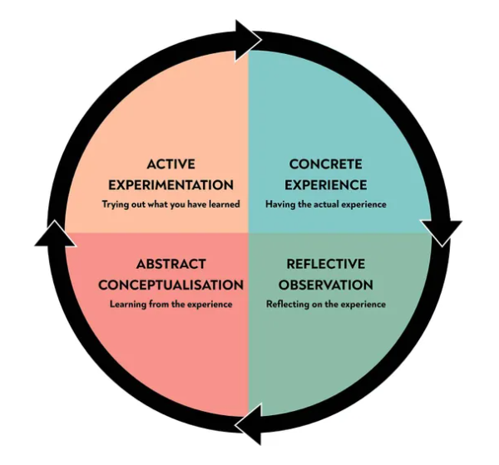
Figure 1 Kolb Learning Cycle [5]
Using the tools of systems engineering can help identify emergent behaviour in the earlier planning stages. This might be negative emergent behaviour which causes problems to the user, manufacturer or at lifecycle disposal, but it can also help control the positive emergent behaviour; the behaviour we want from the system, to make sure that it does occur.

Method

Systems engineering is best done with a team of people who represent the range of stakeholders and who have input of the different aspects of the system. As well as iterating through the following tools to gain more information, the tools are used to cover the system as a whole, then again for subsystems and again for each component. Some of the tools are repeated to then cover manufacturing option for the system, sub systems and components.
Typically, the first stage in a top-down systems engineering approach is the collection and collation of requirements. A short list of requirements will have been given with the task; these are the initial requirements and not the whole picture. Requirements can be split into four sections; expressed, delighters, basic and assumed. The initial requirements will be expressed requirements and so the requirements for the other three groups need to be found and categorised. It also needs to be re-written to be clear, concise, consistent, complete, correct and confirmable. There are a series of tools available for eliciting the full list of requirements for a system and then categorising them.
It may be necessary to create an operation requirement if one hasn’t been given or if the one given isn’t specific enough. For example, the operation requirement created for the autonomous lawnmower can be seen below.
“To cut the grass on the greens at night with a reduced manual labour and cost to the golf club”
This is generated from the user requirements that have been expressed by the different stakeholders. It defines the boundaries of the system – only cutting the greens – and some potential areas that that be tested such as level of manual labour and cost.

Generating Requirements
A good place to start to find requirements is to identify the stakeholders; anyone who has an interest or a function to play with the system. For the autonomous lawnmower, “Super-Mow”, the stakeholders were identified from the people engaged in generating the initial requirements and in thinking about the lifecycle of the system.

Stakeholders
- Groundskeepers
- programmer
- Lady captain
- Captain
- Greens Committee
- Secretary
- Environmental lead
- Manufacturer
- Parts supplier
- Maintenance engineer
- Course neighbours
- Nearby courses
- Energy suppliers
- Designers
- General public
- Non-playing visitors
- Competition players
- Course owner
- Waste management
- Environment, health and safety regulators
- Casual players
- Club members
Once a list of stakeholders has been identified they can be grouped into similar areas using an affinity diagram; these groups can then be used as the nodes in a stakeholders’ map.
Table 1 Groups of Stakeholders
Group | Stakeholder
Manufacture | Manufacturer
 | Parts suppliers
 | designers
Maintenance | Maintenance engineer
 | Parts suppliers
 | Energy suppliers
SHEF | Waste management
 | Environment, health and safety regulators
Users | Groundskeepers
 | Programmers
Club Leadership | Lady captain
 | Captain
 | Greens committee
 | Environmental lead
 | Course owner
Players | Club members
 | Non-playing visitors
 | Competition players
Wider Community | Course neighbours
 | Nearby courses
 | General public

Stakeholder map
A stakeholder map finds the links between different groups where there is a flow of information which can identify non-functional requirements of the system. It will also show which are the key stakeholders whose requirements may need more prioritising to gather fully. A stakeholder map may also generate non-functional system and performance requirements, such as the secretary will negotiate with the manufacturer about the costs which raises a requirement for it to have a maximum initial cost and a requirement for its maximum maintenance or running costs. The generated non-functional requirements can be fed into the QFD1.
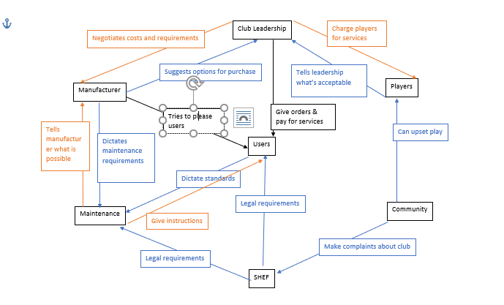
Figure 2 Stakeholder map for Super-mow
Once the requirements have been generated, they need to be written in non-solution, clear and concise language. Where possible the requirement should also include some sort of metric against which a success or failure can be measured. Some re-written requirements can be seen in Table 2.
Table 2 Table of Initial Requirements
Requirement | Re-written Requirement
Mow area of 500m by 50m | The groundsman requires that the device shall be able to mow area of 500m by 50m.
Cut from 8" length down to 3.5mm | The groundsman requires that the system shall deliver a cut from 8" length down to 3.5mm.
Cut fairways, light rough, rough and greens to set plan | The groundsman requires that the system shall cut fairways, light rough, rough and greens to set plan.
Perform tasks autonomously | The Golf club requires that the system shall perform tasks autonomously.
18-hour operational cycle | The groundsman requires that the system shall have an 18-hour operational cycle.
6-hour recharge / refuel / programme cycle | The power service providers require that the system shall have a 6-hour recharge / refuel / programme cycle
Day / night / low light capability | The golf club required that the system shall have a day/night/low light capability
Near silent operation | The Environmental Lobby requires that the system shall have a near silent operation (x db TBD)
Low light pollution | The Environmental Lobby requires that the system shall operate with low light pollution (y Lux TBD)
All weather capability | The groundsman requires that the system shall have an all-weather capability (Precipitation and windspeed limits TBD)
Avoid standing water | The product safety representatives require that the system shall avoid standing water.
No damage to wildlife | The environmental lobby requires that the system shall operate without damage to wildlife.
navigation around fixed objects / hazards/ marker posts | The grounds man requires that the system shall navigate around fixed objects / hazards/ marker posts
Avoid injury to humans | The Product safety representatives require that the system shall cause no injury to humans
Non-interference in golf games | The golf club playing membership requires that the system shall not interfere with golf games
No damage to balls | The golf club playing membership require that the system shall cause no damage to their balls.
No damage to golf equipment (Rakes, bags, clubs etc.) | The golf club playing membership require that the system shall cause no damage to golf equipment (Rakes, bags, clubs etc.)
Must not enter bunkers | The groundsman requires that the systems shall not enter bunkers
Must not enter water hazards | The groundsman requires that the systems shall not enter water hazards
Operate in teams | The groundsman requires that where multiple units are used that these shall be able to operate as a co-ordinated team
Understand attitude/cope with slopes | The groundsman requires that the system shall understand its attitude/cope with slopes
Maintenance cost to be minimised (See business case.) | The Golf Club requires that the maintenance cost for the selected system shall be minimised

Use Case
The full user case for the super-mow can be seen in the Annexe, it consists of a list of actors; these are anyone and anything that interacts with the system, pre- and post-conditions; what must be true before the system performs it task and what must be true after, basic flow; what will happen to accomplish the task if everything runs as planned, and exceptional flow; what happens if something goes wrong. Doing a use case generates functional requirements, what must the system have or do to perform the task as planned and what must be in place to prevent exceptional flow occurring.

Functional Analysis
Another process to generate the non-expressed requirements is a functional analysis. This is only possible where an existing system with a similar purpose exists. For the autonomous mower, there was not another autonomous system to study, but there are numerous lawn mowers available to study. This sort of analysis generates architectural, solution-based, legislation and emergent functions.
For example, looking at the key components in the lawn mower design in Figure 3 each component can be identified as well as its function. This might show gaps in the design requirements where functions haven’t been accounted for yet, such as speed controls.
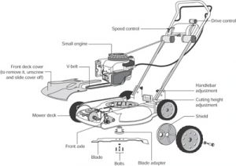
Figure 3 Components of a lawn mower [6]
As with the earlier generated requirements, the new functional, architectural, solution-based requirements need to be written into suitable language such as in Table 3.
Table 3 Functional Requirements from Use Case and Functional Analysis
Functional Requirement | Re-written Requirement
Store energy | The system is required to store enough energy to complete mowing
Deliver energy | The system will deliver energy to the system with a greater than 50% efficiency
input boundaries | The system will have a method of inputting boundaries
store mission details | The system will store mission details
decode mission details | The system will decode the mission details from input
detect current position | System will be able to detect current position within 5m
perform function checks | System will be able to perform self-diagnostics
detect weather conditions | System will be able to determine if weather conditions fit parameters
detect ground conditions | System will be able to determine if ground conditions fit parameters
request authorisation | System will have a means of requesting authorisation remotely from a user
receive authorisation for mission | System will have a means of receiving authorisation remotely from a user

After all the analysis tools have been used, a significant list of requirements should have been generated which will need sorting with an affinity diagram. The affinity diagram groups the requirements into similar sections. The aim should be to have no more than 9 items in each section; this prevents areas getting too large and complicated. An example of requirements split into groups using an affinity diagram method can be seen in Figure 4.
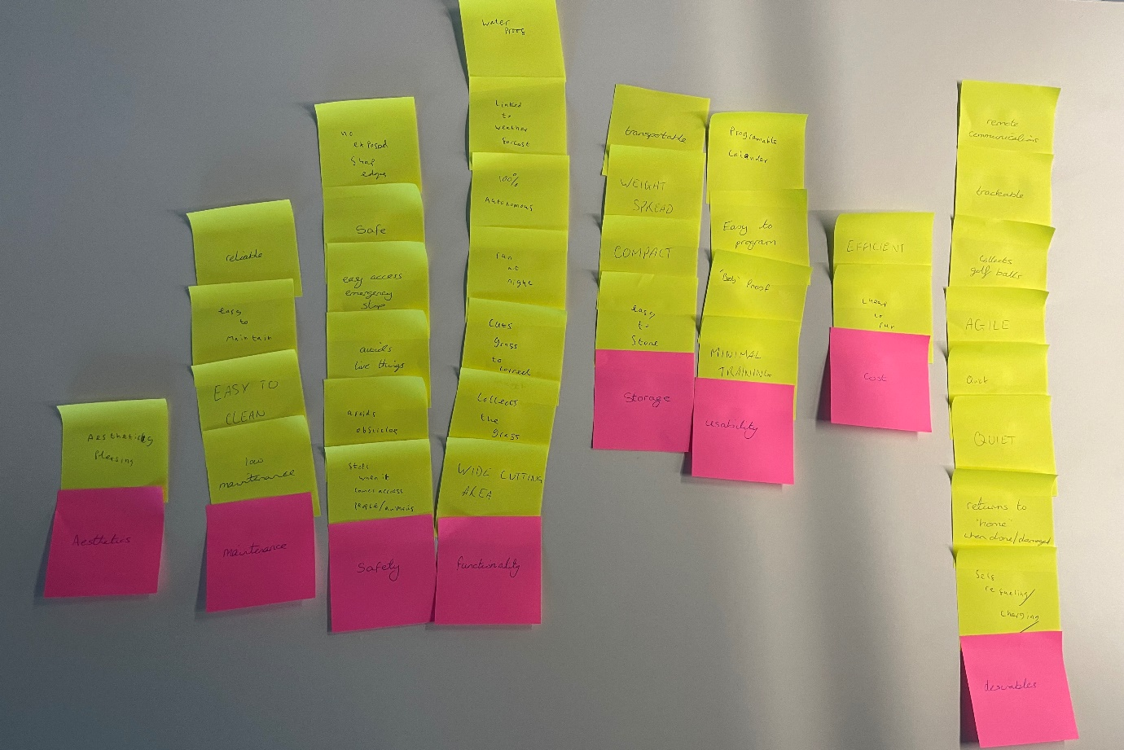
Figure 4 Requirements Affinity Diagram
The pink squares in Figure 4 hold the requirement group headings and the yellow squares contain the requirements. Duplicates have been removed to reduce the number of requirements.

Critical System Functionality
Once a list of requirements has been generated it can be put into a QFD1 to identify missing requirements and functions.

QFD1
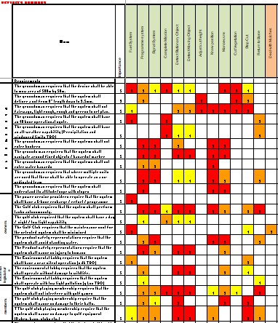
Figure 5 QFD 1 Results
The scoring of the requirements can show missing requirements and functions, if one function (across the top of the QFD) has significantly more red (high scores) than the others this may show a function which needs breaking down into smaller, better specified functions. Similarly, a requirement (down the left-hand side) with a high number of red squares may indicate missing requirements. Conversely a function or requirement with all white squares shows that corresponding requirements or functions are missing. A requirement with no scores shows there is no function which affects that requirement and so the requirement isn’t likely to be met. A function with all white squares shows it is not affecting any of the requirements and is either unnecessary or the requirement for that function hasn’t yet been found and defined.
Filling gaps in the requirements and functions may require the earlier tools to be reiterated through numerous times.
As well as identifying missing requirements and functions the QFD can highlight key requirements and functions; these are functions and requirements that affect the majority, if not all of the parts of the system. For example, Figure 6 shows that the detect stationary objects, manoeuvre, know position and programme system are key functions in the super-mow.
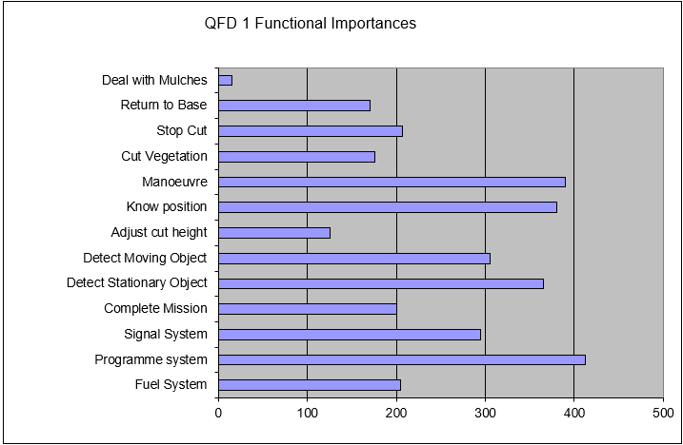
Figure 6 Results of QFD1 Showing Importance of Different Functions
Lastly the QFD can help generate metrics and tests to meet requirements if the requirements have been written in the correct type of language.

Concept derivation and design choices

Functional Means Analysis
With a list of requirements generated and key functions which must be met, solutions to the requirements and functions can be planned. This can be done using a design functional means analysis. The functions identified through QFD1 are plotted down the left-hand side of a table and all the different possible solutions to carry out that function are plotted across the row as in Figure 7. Every idea is included in the initial stage which is purely creating with no editing, the lists are edited and ideas discarded later.
Ideas may be discarded for numerous reason; cost, practicality or maturity of the technology, etc. For example, in Figure 7 Artificial intelligence (AI) was discarded as a solution for the programme system function due to the immaturity of the technology and fire was discarded as an option to deal with the mulches on health and safety grounds.
Different designs can then be generated from the remaining solutions to each function. In Figure 7, red squares are discarded solutions, and the other colours show the different design ideas; green, blue and purple. Yellow squares are where designs share the same solution for a particular function. White squares are solutions that were discarded as being unusable but also weren’t chosen for a solution. Numerous solutions can be created this way each with different routes through the solution matrix.
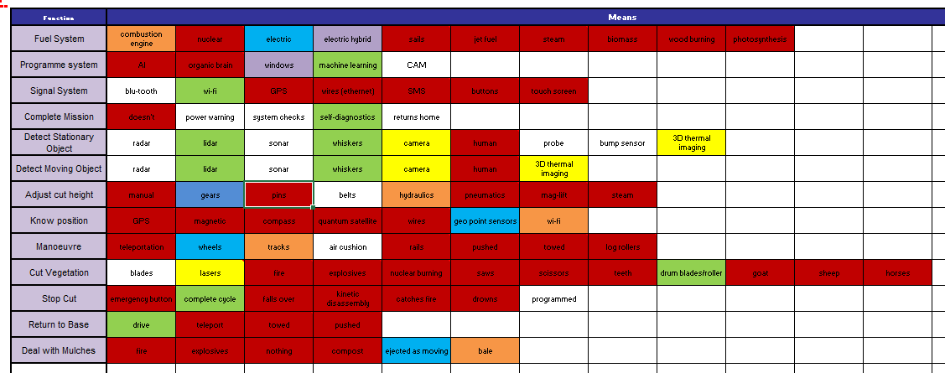
Figure 7 Function Means Analysis

Pugh Matrix
Once the possible solutions have been generated, they need to be empirically compared to determine the best solution out of the options. This can be done using a Pugh matrix such as Table 2. The solutions are compared to the existing solution; in this case a manually driven ride on lawn mower. A score of 0 means that the design is equal to the existing solution, 1 is slightly better 2 is a significantly better solution to meet the requirement. -1 is a slightly worse solution and -2 is a significantly worse solution.
Table 4 Pugh Matrix for Super-Mow Design Solutions
 | current system | combustion engine | electric engine | mechanical goat
 | 0 | 12 | 13 | 7
The groundsman requires that the device shall be able to mow area of 500m by 50m. | 0 | 1 | 1 | -2
The groundsman requires that the system shall deliver a cut from 8" length down to 3.5mm. | 0 | 1 | 2 | -2
The groundsman requires that the system shall cut fairways, light rough, rough and greens to set plan. | 0 | -1 | -1 | -2
The Golf club requires that the system shall perform tasks autonomously. | 0 | -1 | -1 | -2
The groundsman requires that the system shall have an 18-hour operational cycle. | 0 | 2 | 2 | 2
The power service providers require that the system shall have a 6-hour recharge / refuel / programme cycle | 0 | 2 | 2 | 2
The golf club required that the system shall have a day/night / low light capability | 0 | 2 | 2 | 2
The Environmental Lobby requires that the system shall have a near silent operation (x db TBD) | 0 | 0 | 2 | 1
The Environmental Lobby requires that the system shall operate with low light pollution (y Lux TBD) | 0 | 2 | 2 | 2
The groundsman requires that the system shall have an all-weather capability (Precipitation and windspeed limits TBD) | 0 | 2 | 1 | 1
The product safety representatives require that the system shall avoid standing water. | 0 | -1 | -1 | -2
The environmental lobby requires that the system shall operate without damage to wildlife. | 0 | -1 | -1 | 0
The grounds man requires that the system shall navigate around fixed objects / hazards/ marker posts | 0 | 0 | 0 | 0
The Product safety representatives require that the system shall cause no injury to humans | 0 | 1 | 1 | 2
The golf club playing membership requires that the system shall not interfere with golf games | 0 | 0 | 0 | 0
The golf club playing membership require that the system shall cause no damage to their balls. | 0 | 1 | 1 | 2
The golf club playing membership require that the system shall cause no damage to golf equipment (Rakes, bags, clubs etc.) | 0 | 1 | 1 | 2
The groundsman requires that the systems shall not enter bunkers | 0 | 0 | 0 | 0
The groundsman requires that the systems shall not enter water hazards | 0 | 0 | 0 | 0
The groundsman requires that where multiple units are used that these shall be able to operate as a co-ordinated team | 0 | 1 | 1 | 1
The groundsman requires that the system shall understand its attitude/cope with slopes | 0 | 1 | 1 | 2
The Golf Club requires that the maintenance cost for the selected system shall be minimised | 0 | -1 | -2 | -2

In Table 4, two of the solutions have a similar score, this implies they are equally good solutions to the requirements. It might then be that the best solution is a mixture of the two; one design that uses elements from both high scoring designs to create an even higher score. Some of the requirements showed a negative result for each of the new solutions; this could suggest that a different solution to one of the functions in the function means analysis should be reconsidered. It might be that better solutions don’t currently exist or aren’t mature enough but could be considered for future designs and upgrades.

Critical Design Features
Once the design solutions have been decided upon and the design optimised through iteration, key elements of the design can be identified by using QFD2.

QFD 2
A QFD2 compares the solutions against functions to identify critical solution components. It also highlights overloaded functions, which might need more solutions to fulfil them or overloaded sub systems which need breaking down further. A QFD2 can also start to show the architecture of a system through the clusters and nodes that appear in the scores.

Potential Failure Modes
Identifying the potential failure modes of each system, sub system and component means preventative measures can be designed in, rather than corrective measures having to be added to the design later. This approach is generally cheaper and prevents reputational damage.

P(arameter) Diagrams
A P diagram identifies the noises in a system which can affect the output of the system and might produce negative emergence or side effects.
They can be caused by external factors, deterioration from use or in variation in manufacture and supply of items. External factors for a lawn mower can be things like weather, deterioration factors would be things like blade sharpness and noise factors from manufacturing might be blade size.
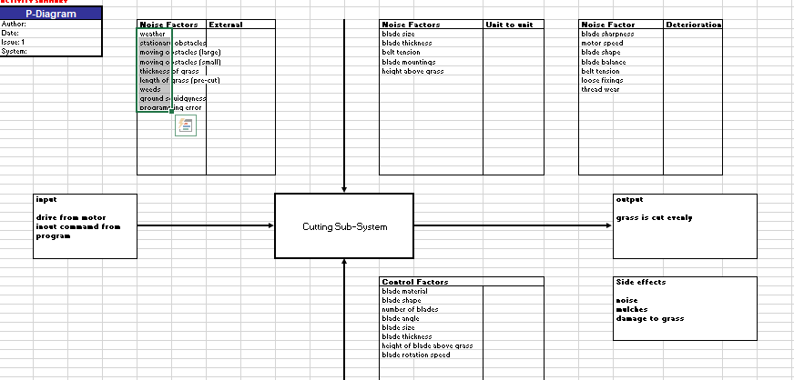
Figure 8 P-Diagram for the cutting sub system of the super-mow

What-Why
In a what-why diagram, such as in Figure 9, the control factors from a P diagram are put on the left-hand side and the noise factors across the top. Scores are then given to gauge the impact of each control factor on each noise.
These scores then identify critical control factors, depicted in Figure 10, or noises (Figure 11) which have large effects across a range of controls. These are then areas where more control and investment are required to reduce negative emergence.
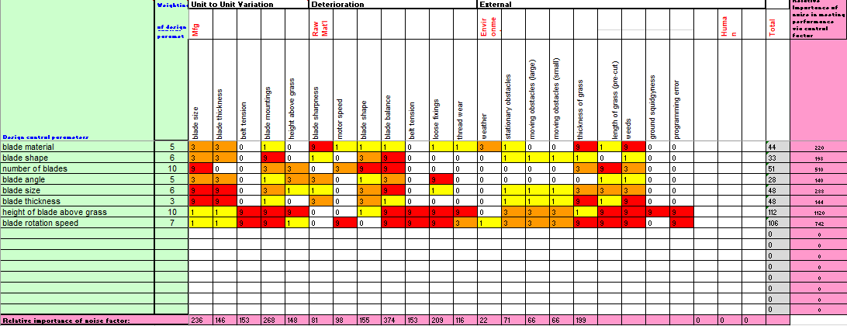
Figure 9 What-Why Diagram

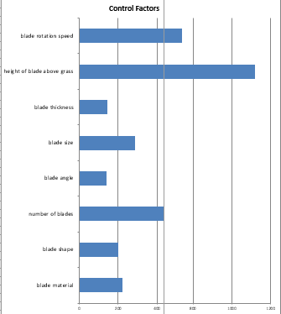
Figure 10 Control Factors from What-Why Diagram

Figure 11 Noise Factors Used in What-Why Diagram

Manufacturing
To design a manufacturing process the steps covered to design the system are re-done but to assess different manufacturing solutions as opposed to design solutions. Once one manufacturing process has been identified it can be fed into a QFD3 which compares critical features against the processing solutions. This process identifies the critical processing steps within the chosen solution. More investment can then be applied to those processing steps to ensure as few problems in the manufacture happen as reasonably possible.

QFD 4
Once the critical process steps have been identified a QFD can be used to compare the process steps with control measures to identify the critical control measures in the manufacturing process which should receive the most investment. It also creates a series of production verification and validation targets and their relative importance. For example, it may show that it is more important to have a tight control over the blade sharpness but that the blade thickness needs less stringent controls as it has a lower impact on the overall performance of the system.

Conclusion
To fully utilise a systems engineering approach to design it is essential to use a wide group from different backgrounds throughout the process and to take the time to iterate through each step. This can make the initial design process seem slow and unwieldly but pays off down the process.
Using a systems engineering approach, a fuller list of requirements for a system can be found than is initially given. This reduces the likelihood of making an item which doesn’t fulfil the users’ needs and needs redesigning or correcting which can be costly both financially and reputationally. It goes on to identify the most likely areas to produce unwanted behaviour which will cause the design to fail and again need correcting.
There are a variety of tools which feed into one another, creating requirements, function, processes and controls which can then be verified and validated using small manufacturing runs allowing for confidence in the design before committing to large runs and outlay. However, if not fully committed to the process it can create a false sense of security in the design if iterations are not carried out sufficiently.

References

[1] | INCOSE, “Systems Engineering Definition,” INCOSE, 2019. [Online]. Available: https://www.incose.org/about-systems-engineering/system-and-se-definition/systems-engineering-definition#:~:text=Systems%20Engineering%20is%20a%20transdisciplinary,%2C%20technological%2C%20and%20management%20methods.. [Accessed 26 February 2022].
[2] | D. Buede, “About Systems Engineering,” INCOSE, 2000. [Online]. Available: https://www.incose.org/about-systems-engineering/history-of-systems-engineering. [Accessed 26 Febrary 2022].
[3] | NASA, “2.0 Fundamentals of Systems Engineering,” NASA, 12 December 2019. [Online]. Available: https://www.nasa.gov/seh/2-fundamentals. [Accessed 26 February 2022].
[4] | S. Summer, “The Three Systems Engineering Approaches: Top-down, Middle-out and Bottom-up,” Vitec, 16 April 2015. [Online]. Available: https://community.vitechcorp.com/the-three-systems-engineering-approaches-top-down-middle-out-and-bottom-up/. [Accessed 27 February 2022].
[5] | S. McLeod, “Kolb's Learning Styles and Experiential Learning Cycle,” Simply Psychology, 2017. [Online]. Available: https://www.simplypsychology.org/learning-kolb.html. [Accessed 23 February 2022].
[6] | Nelson, “Essential Lawn Mower Parts,” LawnEQ.com, 29 December 2012. [Online]. Available: https://blog.lawneq.com/essential-lawn-mower-parts/. [Accessed 27 February 2022].

Annexe

Use Case for “Super-mow”
Use Case: A clear verb/noun or actor/verb/noun that communicates the scope of the use Case
Use case for “Super-mow” green keeping system
Author J.Mungham, G.Godard, L.Groom | Issue – 1 | Reviewed 0 | Date 12/11/2021
Actors:- A list of actors who can engage in the activities described in the use case:-
Greensman, Secretary, environmentalists, mowers control system, golf union, maintenance staff.

Pre-conditions:- Anything that can be assumed to be true when the use case begins :-
The grass needs cutting, the mower is in working condition, sufficient energy for mower to operate, approval for cutting to take place, ground condition are appropriate for mowing,

Post-Conditions:- Anything that must be true when the use case is complete.

Grass is of required length, no harm has been done (damage), mower is in designated area, waste management is complete (grass has been emptied), energy re-supply is accessible.

Basic Flow:- The set of steps the actors take to accomplish the goal of the Use Case. A clear description of what the system does in response to each user action.
- Mower receives command to start cutting
- Software updates are checked
- Mower Diagnostics are checked
- Mower path routes are checked and optimise
- Mower leaves storage area
- Signal for start is sent
- Settings are checked for grass cutting hight
- Cutting begins
- Feedback is sent in regular intervals
- Cutting finishes
- Clippings are emptied
- Mower diagnostics are checked
- Mower returns to storage area
- Signals task is complete

Alternative Flow:- Captures alternative user/system interactions, such as what happens if data is entered incorrectly.
- Mower doesn’t leave
- Bunny’s are murdered
- People are unaware mower is active
- Mower is in incorrect area
- Fire
- Undesirable weather conditions
- Life

