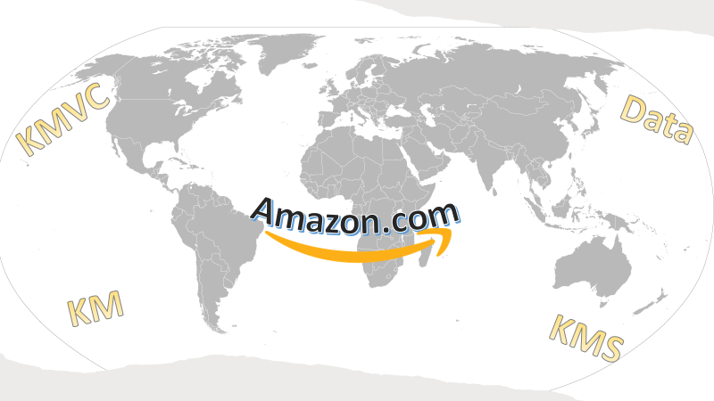

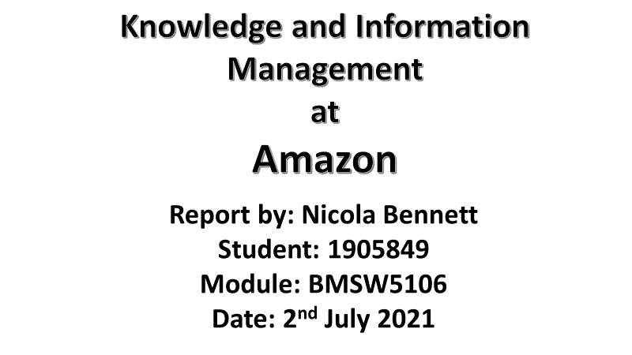
Contents
Executive Summary…………………………………………………………..…….…Page 2
Introduction …………………………………………………………….…………..……Page 3
Knowledge Management, information and Data…………………….....Page 4
History and development of Knowledge Management .…………..…Page 4
Knowledge Management Drivers ………………………………..……………..Page 5
Organisational profile of Amazon.com ……………………………………….Page 6
What does Amazon do and what are their primary activities?......Page 6
What sector/industry does Amazon operate with? …………………….Page 7
Locations of Organisations …………………………………………………………Page 8
VROI Framework ……………………………………………………………………….Page 9
RBV Framework …………………………………………………………………….…..Page 10
SECI Model …………………………………………………………………………….….Page 11
SWOT Analysis ………………………………………………….………………….……Page 13
Knowledge Management Value Chain ………….…………………….…….Page 16
Conclusion …………………………………………………………………………...……Page 20
Recommendations ……………………………………….………………………..….Page 22
References ………………………………………………….…………………………….Page 23

Executive Summary
Amazon.com (2021) is the biggest e-commerce organisation worldwide, their knowledge management strength has progressed and evolved into a superior, technological online shopping experience.
Amazon.com has evolved from a small garden garage to a legendary online retailer. Their departments and employees maintain tight schedules and confront energetic and prompt techniques that help to develop exceptional knowledge and information.
Ensuring employees have the right coverage, connectivity and technology to keep the business connected and successful is a cultured necessity.
“The most important contribution management needs to make in the 21st century is similarly to increase the productivity of KNOWLEDGE WORK and the KNOWLEDGE WORKER” (Drucker, 2007, p.116).

Introduction
The purpose of this report is to conduct a thorough analysis of Amazon.com and its global network to Rachel Cook on Friday 2nd July 2021.
The research conducted is a brief history on how the organisation had started, where Amazon.com categorise and operate within the Industry sector and the company’s primary activities that capture their audience. It defines Knowledge Management, Knowledge Management drivers and where in the world the locations that Amazon.com, have set up their business structures and fulfilment centres. Relevant tools and typologists will be used to demonstrate and define the Knowledge Management Value Chain, the process of sharing knowledge and why it is shared. The typologists used, are:
- Quinn (1993)
- Nevis (1995)
- Armidon and Sykrme (1997)
- Nonaka and Tekuchi (1995)
- Draker (2007)
The tools and models used within this report are:
- Valuable, Rare, Imitable and Organised (VROI)
- Resource- based View (RBV)
- Socialisation, Externalisation, Combination and Internalisation (SECI)
- Strengths, weaknesses, Opportunities and Threats analysis (SWOT)

Knowledge Management, Information and Data
Koenig (2018) describes Knowledge Management (KM) as the process of capturing, distributing and effectively using knowledge, whilst Cross (1998) defines KM as the discipline and focus of the value and personalisation of products, data and sharing information.

According to Sanchez (2003, p.4) Data is the representation of events that stakeholders notice and bring to the attention of others. He describes it as a qualitative and quantitative approach, some are presumptions, some are facts. Whilst Surbhi (2018) explains that Data and KM are important concepts of Knowledge Management Systems (KMS), relevant data is collected and processed (refined Data) then formed into information. Once filtered, it is known as knowledge (useful information). Processing Data improves the representation of an organisation and the knowledge increases understanding.
History and development of Knowledge Management
Drucker (2007) briefly explains the history of Management, he goes on to say that Taylor (1915) was the inventor of Science Management. Following on to Fayol (1920) who coined the phrase “One right way, for organisations” he founded organisational strategy.
Haradhan (2017) commented on the fact that decades ago, knowledge resided within the memory of workers, then it moved on to storing knowledge in filing cabinets and then to written and typed formats of storing the Data. During the 21st century, technology has drastically evolved and KM has become an essential and sustainable development. Koenig (2018) points out, that KM erupted in the management community, with the establishment of the internet. Organisations realised the internet could geographically disperse information and share Data, to effectively enhance business needs.

Knowledge Management Drivers
Skyrme Associates (2011) claims that drivers are strategic priorities. Strategies are implemented in a business to make them communicatively successful, this starts during the initiation stages of business planning, other drivers used to continue success are:
- Improving levels of customer service
- Improving product and quality (sharing best practice)
- Using know-how approaches (training staff with experienced hierarchy)
- Achieving faster deliveries and services (Networking and communities of practice)
- Motivation and providing best tools to employees (incentives and portals for job role information)
- Carbon footprint (Waste and environment)
- Risk Analysis’ (minimising risks, adhering to regulations and laws).

Organisational Profile of Amazon
Amazon History
Armstrong (2021) reports, Amazon.com was founded by Jeff Bezos in 1994. His small company sold books and was run from his garage in Washington USA. With investments from two sources to help with technology systems, he was able to create an online community of retail to customers worldwide. Armstrong (2021) went on to say that in 1997 his company went public and demand jolted Bezos to earn the company $54 million dollars in the first three years of trading. Fast forward to 2021, statistics from Sabanoglu (2021) show that Amazon.com has more than 800,000 employees all over the world by 2020.

What does Amazon do and what are the Primary Activities?
Amazon.com (2021a) manufacture, sell and deliver a diversity of products and groceries to customers all over the world. They use over 1.7 million small businesses under the umbrella of the company name in order to offer a variety of products that customers want, making this convenient and personal, with a fast efficient delivery time.
Jassy (2021) reported that the primary activities at Amazon.com, involve a variety of roles such as:
- Merchandising
- Development, Design and Optimisation
- Manage supply chain and logistics
- Secure and build partnerships
- Supporting Production Platforms
- Acquiring new venture to support its ecosystem.

What sector/industry does Amazon.com operate with?
According to Kambhatla (2020) Amazon.com is a giant of logistics, payments, hardware, data storage and media. Their main source of income is online subscriptions, deliveries, music and many web services they provide.
Amazon.com have developed their business through their Primary (raw materials), secondary (manufacturing), tertiary (service sector) and quaternary (technology knowledge-based) industries which include:
- Cloud Computing
- E-Commerce
- Artificial Intelligence
- Grocery Stores
- Advertising
Amazon.com operate through two of the above sectors, tertiary and quaternary, but mainly deal with quaternary sectors due to their E-commerce organisation. McClelland (2020) and BBC (2021) refer to tertiary sector as transportation, retail and tourism. Quaternary is associated with substantial growth, both sectors go hand in hand at Amazon.com as labour productivity, improves because of technological advancements. They also say that quaternary sector involves information, communication technologies and science research, it stipulates certain education programmes, which link to the employee training and how employees rely on systems to improve their job role performances. Within the Knowledge Management Value chain dissemination is used to share the knowledge within the relevant departments needed to convey certain roles of work and tasks involved.

Locations of Organisations
They engage and operate through three major segments:
- North America
- International
- Amazon Web Services (AWS) (Kambhatal, 2021).
Amazon.com has a main head office is Seattle, Washington D.C but have many fulfilment centres around the world that are held in:
- Czech Republic
- Germany
- France
- Italy
- Poland
- Spain
- UK
Each country holds, a main logistics site, hubs for warehouse stock, delivery services, distribution depot, goods in warehouse and services.
Diversity Inc (2014) reported that the company’s global workforce held 37 percent women within the workforce. In 2020 Amazon.com (2021b) had reached a percentage of 44.6 UK based and 46.9 in the United States. All ages of work are from 16 years old, but Amazon has a preferable ages of generation education within the workplace for ages 18-35.
The Objective outlook (2020) lists the Hierarchy is within 12 levels. Bezos (2021) being 12.
Levels:
- 11 CEO’s
- 10 Vice Presidents
- 9 Board of Directors
- 8 Directors
- 7 Senior Managers
- 6, 5 & 4 Managers
- 3,2 &1 support staff.

VRIO, RBV and SWOT Analysis of Amazon’s Knowledge Management System
Using a SWOT analysis identifies main areas of capabilities within Amazon.com. It is a framework that simplifies their strengths, weaknesses, opportunities and potential threats. The Knowledge Management System is used as a strategic tool that can help to operate the workforce structure (Total Assignments Help, 2020; Vishwal, 2021).

Valuable, Rare, Inimitable and Organised (VRIO) (VRIN -Non- Substitutable) Framework
Smith (2021) and Thomas (2018) both describe the VRIO four question framework as a strategic tool that provides sustained competitive advantages to organisations. They say it is used towards implementing a value, creating strategies that competitors are NOT using which can create superior performances.
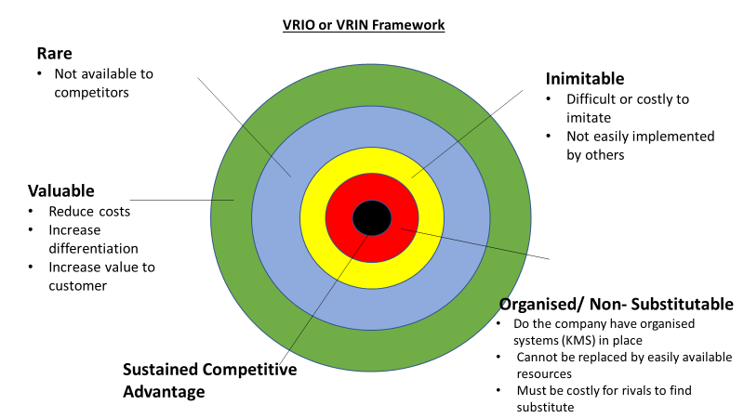

Fig. 1, (Smith, 2021 and Thomas, 2018).

Resource Based View (RBV)

RBV was recognised in the early 1900’s and was served to, internally and externally focus on Tangible and Intangible resources. RBV focused on the activities and human factors that result in organisational behaviours. RBV helps to structure knowledge management, culture and the information shared within an organisation (Wilkinson and Johnstone, 2016, p.377).
Thomas (2018) and Bhasin (2020) both mentioned that heterogeneous is the first primary assumption of a RBV theory. It refers to work structured capabilities and skills that is transferable from one place to another. Data and information can be passed or shared, which will result in a competitive disadvantage for Amazon.com.
Thomas (2018) continues to say that Immobile assumptions cannot move from Amazon to any another organisation. This secures all knowledge and technologies from competitors as they would be unable to rapidly replicate or imitate them (Non substitutional).
The limitations to using this method would be new or evolved technology. The technology systems can be upgraded, but with a major cost to amend products, employee training and keeping internal and external stakeholders up to date. Therefore, organisations rely heavily on internal sources and employees with their knowledge and information that has been taught using the know-how approach. 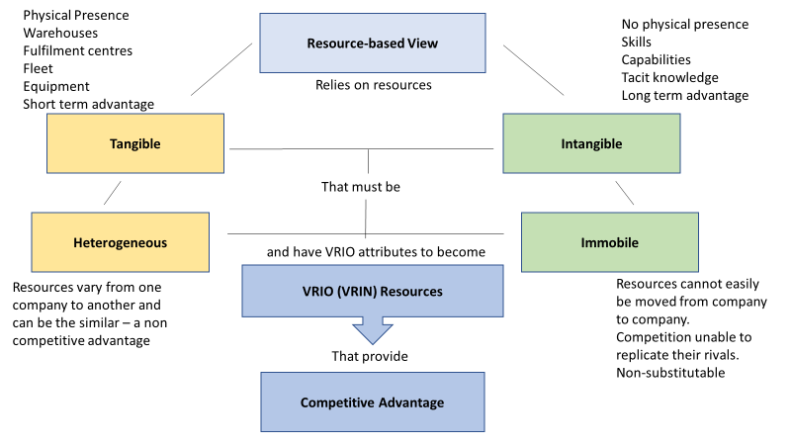
Fig2, Thomas, 2018 and Bhasin, 2020).
SECI MODEL
The Socialisation, Externalisation, Internalisation and combination (SECI) model is made to be a continuous process that should take place within an organisation. Knowledge is transferred and converted to help with collaboration and interacting whilst learning (Nonaka and Tekuchi, 1995).
Socialisation (tacit to tacit) is the primary process between individuals, it is experimental in the fact that new knowledge can be created and converted through shared experiences and communities of practice with employees it can be known as a rare and imitable process (Bhasin, 2020).
Externalisation (tacit to explicit) is when tacit knowledge is codified and placed into documents (Amazon.com website, aps, social media, emails,) so it can easily be shared through organisations and to stakeholders. In this case, systems capture the relevant data from customers and Amazon.com use this through each department to personalise the customers shopping experiences, this can also be classed as valuable and non- substitutional information (Nonaka and Tekuchi, 1995).
Combination (explicit to explicit) many sources of stored information are combined to create new knowledge/upgrades within the organisation (Nonaka and Tekuchi, 1995). It is helpful within a company as big as Amazon.com, as their departments differentiate, but come together to get the goals intended. By communicating and disseminating relevant information needed within Amazon.com and using the VROI and Quinn’s (1993) know-why approach it will be classed as an organised ‘systematic’ process.

Internalisation (explicit to tacit) is the concept of understanding the knowledge via systems and interpreting it into a personal tacit knowledge to the employee or individual that is learning a specific role. Depending on how the individual can learn and using methods such as visual, practical and theory and even socialisation, this can be classed as Heterogeneous within the RBV model (Nonaka and Tekuchi, 1995; Cook, 2021; Thomas, 2018).

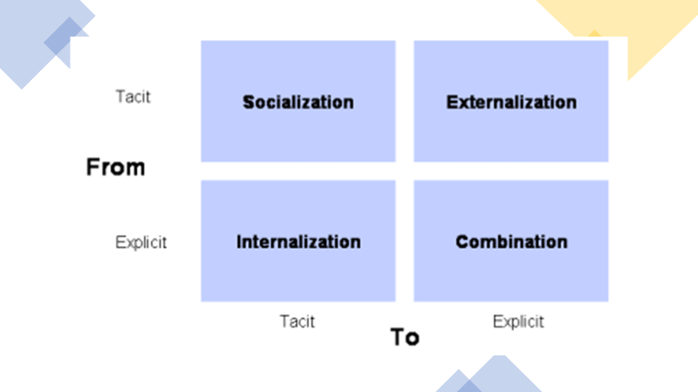
Fig 3, (Nonaka and Takeuchi – The SECI model, 1996)

SWOT Analysis
Strengths
Amazon.com have global trade and many different types of equipment and systems to accommodate the fast effective trade. Thomas (2018) explains that ‘tangible’ is to have physical resources, such as, buildings, warehouses and fulfilment centres, fleets of vehicles to ship and deliver goods, modern technology and operations equipment.
Thomas (2018) continues to explain that Intangible has no physical presence. This is where the organisation has taken time to develop. Their in-house operation strategy, has many skills and capabilities from experienced employees, sustaining a methodological framework as a cultural development used by Quinn’s (1993) Know How approach (Valuable are Rare Resources). Amazon.com use strategic and categorised methods extremely well within their departments.
Weaknesses
Nonaka and Tekuchi (1995) Model helps to focus on the KM creation for innovation and elaborate different types of knowledge. To have the quality of the knowledge shared, the employees need to be motivated, enjoy their work by having conversations and socialise (tacit to tacit). Without employee morale and with work production being too fast or busy, can have a negative influence on the systematic approach to tacit knowledge (Praxis Frameworks Limited, 2019).
Opportunities
Introducing new industries within the organisation can take time to develop (intangible) but could enhance wider experiences to the organisation and external companies involved. New jobs would be created for the wider community and new integrated systems will be designed, delivering a cohesive relationship to primary sectors. If the right technologies are adapted correctly and the right employees have been assigned, this may amplify the KM’s value, presenting new apps and services (Inimitable) (APQC, 2021).

Threats
Employee turnover is a big issue within Amazon.com, due to fast work methods and possible inabilities to upskill and train effectively. To know the job well enough, Intangible resources, skills and knowledge should be implemented, without it, a high turnover of employees will continue.
With the current pandemic and customer’s wanting easier, quicker convenient service and delivery, the systematic procedures may become strenuous and not enough staff to deliver goods.
This may lead to logistical errors or smaller businesses unable to keep up with the demand of the KM systems and Amazon.com, may lose their competitive advantages.
Government, Law regulations and procedures have changed drastically, especially with Brexit and EU laws. This has had an effect on global markets everywhere, therefore will have stressful impacts on Knowledge Management Systems and future updates (tangible resources). Leading to knock-on effects to all stakeholder if systems are not corrected throughout their training and upskilling processes (intangible resources).
Whilst Amaozn.com rely on KMS to succeed in capturing all data, information and confidential details about stakeholders, there is always a possibility of a breach in information or a system malfunction, which could halt the process of business. The systems will need to be expertly fixed and corrected as this system is unique and non-substitutable.
The limitations of using a SWOT analysis within KMS is that it may be over simplified and data may be used as assumptions rather than facts. The SWOT may lack detailed structure for KMS and strategies, meaning key elements of useful information may be lost (CIPD, 2020).
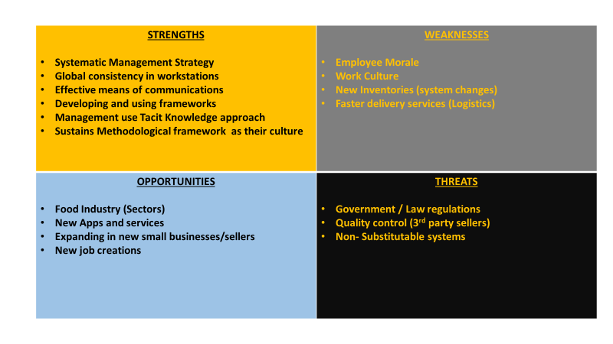
Fig 4, (Pestle Analysis, 2020).

Knowledge Management Value Chain (KMVC)
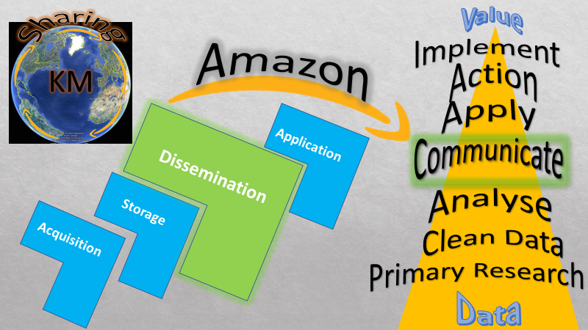
Fig 5, Bennett, N. (2021) Knowledge Management Value Chain.

Acquisition
Data acquisition is the secondary research process of examining potential value, that measure physical change. This Data can be obtained from external sources, such as books, stakeholders and communities of practice. Acquiring, processing, understanding and recalling new information can been gained from all different experiences using different systems and understanding the process. At this point a mission statement is made to plan out objectives and targets of goals in mind. For Amazon.com, transactional Data, trends and customer preferences are significantly researched (KMT, 2018; Wisen, 2021; The Knowledge Agency, 2010). Amidon and Skyrme’s (1997) framework; Know- that approach is used here. Pulling facts from learning and experiences and learning throughout the process of data given.
Storage
Nonaka and Takeuchi (1995) discuss, that when information has been filtered and the relevant documents received, an electronic database is usually created to securely store the information. Information is analysed and relevant details are utilised into software and hardware for both human and organisational processes, as this way it is easier to be retrieved from anywhere within the company. The stored documents create a framework for employees to follow, this will enhance knowledge building effectively throughout departments. Information is preserved for future employees for them to maintain performances with Amazon’s work culture. Amazon.com use Amazon Web Services (AWS) as their cloud computing storage system. One of their back up systems that offers integrated solutions for primary storage, archive and general backup and restore, blockchain, cloud migration, containers and content delivery, is called the Simple Storage Service (S-3) (AWS, 2021a).

However, these systems that are classed as artificial intelligence systems, will reduce socialisation within the workplace. Meaning (Amidon and Skyrme’s (1997) know-how approach method) tacit knowledge will not be made explicit, therefore information can be withheld and not externalised to progress knowledge into codified documents.

Dissemination
Dissemination is when facts that are stored in Amazon’s data, are shared to the public at a large scale, directed to an intended audience.
Effective information directs towards, social media and Smart Apps providing the most effective means of communications.
Amazon share this knowledge via their online sources, emails, portals, instant messaging and sharing calendars, using explicit knowledge is a valuable asset or organisations to have, as it can give them a competitive advantage against another.
Using the workstation portals, provides collaboration, consistency and flow, which is used for a cognitive understanding, this will prevent knowledge gaps from being present in the knowledge management value chain between stakeholders (Learning Solutions, 2020; Cross, 1998).
Organising and delegating a chain throughout the company, using one portal of communication develops a framework to disseminate their knowledge. This adds to the culture that Amazon.com are committed to, providing a quality service by utilising data processes, internally and externally (AWS, 2021b).
Nevis (1995) demonstrated that dissemination is communicating specific and relevant learning systems by experienced employees, using socialisation and Intangible form which can take time to develop, and valuable resources from
Information of the purchaser, the product, which small business they are buying from and when it will be delivered is a chain of experience that maintains a high-performance rate regardless of the change to their employees turn over.

Application
Knowledge Application is defined as making decisions and performing them through various tasks and routines. It is used as a purpose to create and capture information and categorised accordingly to what outcome is valued (Garfield, 2018). Once the knowledge has been shared, it is then applied and actioned to varieties of sources, implementing methods, discussions and negotiations to trade off business or try out new inventions. Specific wants and needs to perform and achieve goals and targets intended. Armidon and Skyrme’s (1997) Know-why is used as contextual knowledge and vision. At this point through the KMVC, Positioning strategies are in place and responses to stakeholder needs are actioned.
These actions demonstrate the success of failure of a project, new organisation or upgrade to a system that has come from a line of decisions, facts and resources (The Knowledge Agency, 2010).

Conclusion
Reflecting each of the tasks within this report and researching Amazon.com, Knowledge Management and Knowledge Management value Chain, reveals a mass of strengths that Amazon.com have acquired over the years.
With their unique, non-substitutional technology and logistical workforce, the organisation illustrates great competitive advantage against other online retailers. Employees are the backbone behind the company’s structure, they collaborate together, sustain incredible workflow and understanding of the tasks they carry out. Amazon.com use the KMVC throughout their everyday working life, the value chain is used as a continuous cycle. By storing customer information, keeping on top of trends and customer preferences, measures quantitative data. With their valuable, efficient customer service, communication skills and product delivery, reports a positive and qualitative measure, powered by customer satisfaction. Amazon.com mobilise a powerful culture and initiative, to continue their systematic cycle of work around the clock, accomplishing aims and objectives they set out.
Sharing best practice through a hierarchy chain and teaching system procedures from top down, can minimise risks within the workplace and build rapport. By using AWS, S3 portals and KM drivers, employees will demonstrate high performances throughout. Having a combination of tacit to explicit knowledge can implement further competitive advantages and build tangible resources.
However, as market leaders within the e-commerce sector, their weaknesses are their employee numbers and annual turnover. This suggests that Amazon.com may not have the employee satisfaction or morale they should. Internalisation concept may be used within many areas of the company as artificial intelligence systems are the main source of data, information and knowledge.
But due to explicit knowledge that remains within their systems and their profitability of the organisation growing exponentially, it may be deemed that staff turnover is acceptable, sufficient and sustainable.

Recommendations
Providing better staff training and employing more staff, so that socialisation is encouraged. This may reduce staff turnover because, if employees are happy where they work, they will remain for a longer timescale, this will save money, time and effort to train new employees and build a stronger workforce.
Morale needs to be uplifted and maintained by management, due to the type of structured and systematic work tasks that is involved.
To enhance knowledge value within the company, face to face customer services may be key to building better rapport. Whilst delivering products, generating conversation and acquiring feedback through community of practice may be essential. This will maintain human contact, improve social skills (even from a distance with the current pandemic), whist actively working on their general knowledge of the company. Bringing quality and value to, both the employee and the customer.

References
Amazon.com (2021a) What We Do. Available at: https://www.aboutamazon.com/what-we-do (Accessed: 26 June 2021).

Amazon.com (2021b) Our Workforce data. Available at: https://www.aboutamazon.com/news/workplace/our-workforce-data (Accessed: 28 June 2021).

Armstrong, C. (2021) The History of Amazon. Available at: https://www.techwalla.com/articles/the-history-of-amazoncom (Accessed: 25 June 2021).

AWS (2021a) Amazon S3: Object Storage Built to Store and Retrieve any amount of Data from anywhere. Available at: https://aws.amazon.com/s3/ (Accessed: 30 June 2021).

AWS (2021b) Amazon Workspaces - Administration Guide. Available at: https://docs.aws.amazon.com/workspaces/latest/adminguide/workspaces-port-requirements.html (Accessed: 26 May 2021).

BBC (2021) Role of Business in Society: Sectors of Industry. Available at: https://www.bbc.co.uk/bitesize/guides/zmx47nb/revision/2 (Accessed: 27 June 2021).

Bennett, N. (2021) ‘Knowledge Management Value Chain’ BMSW5106: Knowledge and Information Management: UWTSD. Unpublished.

Bhasin, H. (2020) Resourced Based View: Theory, Types and Assumptions. Available at: https://www.marketing91.com/resource-based-view/#:~:text=This%20is%20the%20first%20primary%20assumption%20of%20resource-based,strategies%20will%20not%20be%20employed%20by%20different%20companies. (Accessed: 29 June 2021).
Cook, R. (2021) ‘Week 8: Nonaka and Tekuchi, Explicit and Tacit Knowledge Conversion, The SECI Model’ [PowerPoint presentation]. BMSW5106: Knowledge and Information Management. University of Wales Trinity Saint David. Available at: https://moodle.uwtsd.ac.uk/course/view.php?id=7827 (Accessed: 30 June 2021).

Cross, R. (1998) Knowledge and Knowledge Management in Organizations: A Literature Review. United States: Boston University School of Management, Systems Research Center.

David Skyrme Associates (2011) Strategic Priorities: Drivers. Available at: https://www.skyrme.com/kmroadmap/drivers.htm (Accessed: 25 June 2021).

Diversity Inc (2014) Amazons Demographic Data: More of the Same. Available at: https://www.diversityinc.com/amazons-demographic-data/#:~:text=Amazon%20became%20the%20latest%20technology%20giant%20to%20release,Asian%2C%204%20percent%20Latino%20and%204%20percent%20Black. (Accessed: 28 June 2021).

Drucker, Peter. (2007) Management Challenges for the 21st Century. Collection edn. Germany: Butterworth-Heinemann.

Garfield, S. (2018) Where are the Applications of Knowledge Management. Available at: https://stangarfield.medium.com/what-are-the-applications-of-knowledge-management-fcc97da622d4 (Accessed: 30 June 2021).
Haradhan, M. (2017) ‘The Roles of Knowledge Management for the Development of Organizations’, Journal of Scientific Achievements, 2, pp.1-27. Available at: https://mpra.ub.uni-muenchen.de/83038/1/MPRA_paper_83038.pdf (Accessed: 24 June 2021).

Helpie, W. P. (2021) Knowledge Management: Unleashing Innovation. Available at: https://helpiewp.com/knowledge-management-models/ (Accessed: 2 June 2021).

Jassy, A. (2021) Amazon Business Model/How does Amazon Make Money: Key Activirties of Amazon. Available at: https://bstrategyhub.com/how-does-amazon-makes-money/#:~:text=Amazon%E2%80%99s%20key%20activities%20are%20as%20follows%3A%201%20Merchandising,6%20Acquire%20new%20ventures%20to%20support%20its%20ecosystem (Accessed: 28 June 2021).

Kambhalta, G. (2020) What is Amazon’s Industry? Available at: https://findanyanswer.com/what-is-amazons-industry (Accessed: 27 June 2021).

KMT (2018) Knowledge Acquisition. Available at: https://www.knowledge-management-tools.net/knowledge-acquisition.php (Accessed: 30 June 2021).
Koenig, E. D. (2018) What is KM? Knowledge Management Explained. Available at: https://www.kmworld.com/Articles/ReadArticle.aspx?ArticleID=122649 (Accessed: 24 June 2021).

Learning Solutions (2020) The Knowledge Management Genius of Amazon.com. Available at: https://learningsolutionsmag.com/articles/1480/the-knowledge-management-genius-of-amazoncom (Accessed: 21 May 2021).

McClelland, J. (2020) Primary, Secondary, Tertiary and Quaternary Sectors. Available at: https://www.managersinformation.com/2020/10/primary-secondary-tertiary-and.html (Accessed: 27 June 2021).
Objective Outlook (2020) Amazon Works Because of its Orgs Structure. Available at: https://medium.com/@objoutlook/amazon-works-because-of-its-org-structure-22efc8ed1002#:~:text=Amazon%20employees%20are%20organized%20across%2012%20levels%20of,Level-10%20are%20all%20the%20VPs%20%28a%20few%20hundred%29. (Accessed: 28 June 2021).

Praxis Framework Limited (2019) Nonaka and Takeuchi. Available at: https://www.praxisframework.org/en/library/nonaka-and-takeuchi (Accessed: 28 June 2021).

Pestle Analysis (2020) Amazon SWOT Analysis: 2020 a Year Remember. Available at: https://pestleanalysis.com/amazon-swot-analysis/#:~:text=%20In%20this%20Amazon%20SWOT%20analysis%2C%20we%E2%80%99ve%20analyzed,Threat%3A%20External%20factors%20retarding%20Amazon%E2%80%99s%20progress%20More%20 (Accessed: 28 June 2021).

Smith, R. (2020) What is VRIO Analysis? Available at: https://www.clearpointstrategy.com/vrio-framework/ (Accessed: 28 June 2021).

Sabanoglu, T. (2021) Number of Amazon.com Employees 2007-2020. Available at: https://www.statista.com/statistics/234488/number-of-amazon-employees/#:~:text=With%20its%202019%20headcount%20of%20798%2C000%20employee%2C%20Amazon,online%20e-commerce%20retailers%20must%20find%20a%20way%20to (Accessed: 25 June 2021).

Sanchez, R. (2003) Knowledge Management and Organizational Competence. Oxford: Oxford University Press.
Smith, R. (2021) What is VRIO Analysis? Available at: https://www.clearpointstrategy.com/vrio-framework/ (Accessed:29 June 2021).

Surbhi, S. (2018) Difference Between Information and Knowledge. Available at: https://keydifferences.com/difference-between-information-and-knowledge.html#:~:text=These%20two%20are%20important%20concepts%20of%20knowledge%20management,collected%20is%20filtered%2C%20it%20turns%20out%20as%20information. (Accessed: 25 June 2021).

The Knowledge Agency (2010) Introduction to the Knowledge Value Chain. Available at: https://www.youtube.com/watch?v=AphqOF5-YHU&t=123s (Accessed: 30 June 2021).

Thomas, R. (2018) Business Strategy Review – Resource- Based View: L3. Available at https://www.youtube.com/watch?v=5cDOpGNK24s (Accessed: 28 June 2021).
Total Assignments Help (2020) Amazon Case Study. Available at: https://www.youtube.com/watch?v=nJZGEeDoZHA (Accessed: 22 May 2021).

Transporteca (2020) Amazon Fulfilment Centre Locations. Available at: https://transporteca.co.uk/amazon-fulfillment-center-locations/ (Accessed: 28 June 2021).

Trees, L. (2020) How Can KN Benefit from a SWOT Analysis in 2020. Available at: https://www.apqc.org/blog/how-km-can-benefit-swot-analysis-2020 (Accessed: 29 June 2021).

Vishwal, S. (2021) SWOT Analysis of Amazon (Detailed). Available: https://www.superheuristics.com/swot-analysis-of-amazon/#:~:text=%20SWOT%20Analysis%20of%20Amazon%20%201%20Strengths,challenge%20the%20company%2C%20derail%20its%20progress...%20More%20 (Accessed: 28 June 2021).

Wilkinson, A. and Johnstone, S. (2016) Encyclopedia of Human Resource Management. Cheltenham: Edward Elgar Publishing Incorporated.

Wisen, G. (2021) What is Knowledge Acquisition? Available at: https://www.infobloom.com/what-is-knowledge-acquisition.htm#:~:text=Knowledge%20acquisition%20typically%20refers%20to%20the%20process%20of,are%20able%20to%20understand%20the%20world%20around%20them (Accessed: 30 June 2021).

Images Reference List
Fig.1 Thomas, R. (2018) and Smith, R. (2021) Business Strategy Review- Resource- Based View: L3.
Fig. 2 Thomas, R. (2018) and Bhasin, H. (2020) Resourced Based View: Theory, Types and Assumptions.
Fig.3 Nonaka and Takeuch (1996) – The SECI Model.
Fig.4 Pestle Analysis (2020) Amazon SWOT Analysis: 2020 a Year Remember.
Fig 5, Bennett, N. (2021) Knowledge Management Value Chain.

