Management & Organisational Behaviour

Assessment 2 – Written Report

Student name: Roxana Mihaela Roman
Student ID number: 2129008
Module Title: Management & Organisational Behaviour
Module code: BMIH5004
Lecturer Name: Maggie Lan Zang

Table of Contents
Introduction 3
Organisational Background 3
Discussion 4
Organisational Structure and organisational performance: 4
Organisational culture and organisational performance 6
Recent change initiatives, their impact 7
The organisation’s strategic direction and current business performance 7
Critically analysing the role of leadership in effective management: 9
Critical evaluation of the competitors and behaviour management: 10
Comparison with its competitors: 10
Conclusion 11
References 12

Introduction
Organisational structure and organisational culture are significant factors in the context of organisational performance. According to Pedersen et al. (2018), organisational structure, organisational culture and management style of the leaders and other senior executives are the most relevant key internal factors of a business organisation. These factors help to maintain the relationship between the employees and the organisation. Scholars have suggested that minimal loopholes in these factors may affect the mental well-being of the employees which may further affect their productivity. Eventually, it deteriorates the organisational performance (Boddy, 2014). In this situation, this report aims to critically analyse the relevance of organisational structure and culture in organisational performance, and the role of leadership in effective management with the help of relevant theories. It also aims to evaluate behavioural approaches to management that affect an individual's behaviour in an organisation. In this context, this report will elaborate on the instance of Hyatt Hotel Groups.

Organisational Background
Hyatt Hotels Corporation is one of the leading American hospitality companies which is headquartered in the United States. This hotel company was established in 1957 by Jay Pritzker and his brothers. It has executed its business operation across more than 70 countries with more than 130,000 colleagues from multiple regions, cultural groups, races, ethnic groups, sexual orientations, and others (Hyatt, 2024). This hospitality company aims to provide the best hospitality experience to its customers, maintaining social harmony in its business operation. According to Statista (2023), in 2022, this hospitality has generated approximately 5.89 billion pounds by operating across the globe. Considering the report of Statista, it has been noted that this organisation plays a significant role in the global economy by contributing a large amount.
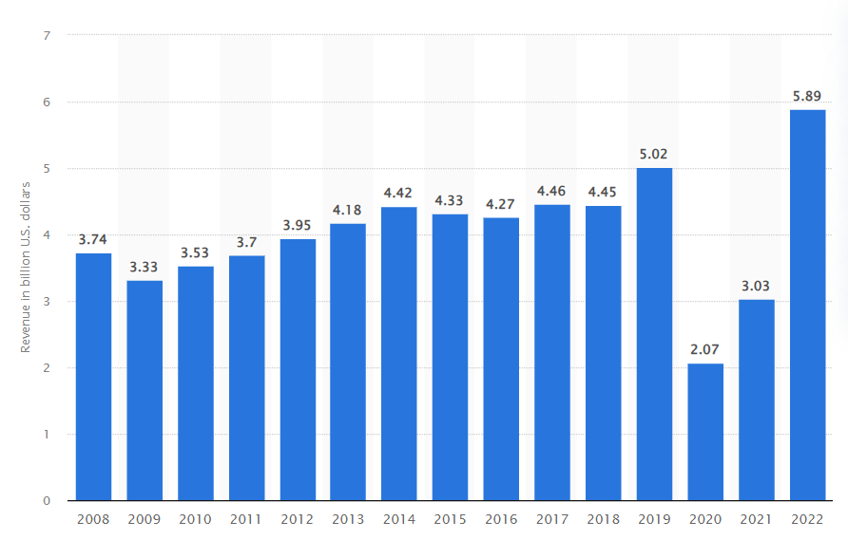
Figure 1: Annual revenue of Hyatt Hotel Corporation
Source: (Statista, 2023)

Discussion

Organisational Structure and organisational performance:
The organisational structure and culture are closely related to each other. In terms of Hyatt Hotel groups, the organisational culture, structure, and people play the most crucial role in their organisational performance.
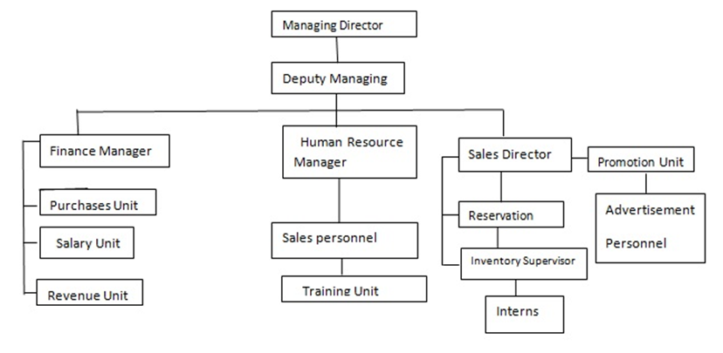
Figure 2: Hyatt Hotel Group Organisational structure
(Source: Hassan et al. 2022)
The structure of Hyatt Hotel Group plays the most crucial role in managing global operations. The organisation focuses on regional autonomy and employs a decentralised structure. It helps to allow the individual hotels to adapt to the condition of the local market while getting benefit from the centralised standards of the brand (Hassan et al. 2022). Their flexible organisational structure helps to influence responsiveness and innovation to the diverse needs of the customers and contributes to the operational efficiency and satisfaction of guests. In terms of culture, Hyatt is well known for its commitment to the customer-centric culture. Apart from that the organisation places a high value on service excellence, continuous improvement, inclusivity and promoting a culture of empathy. They strive to create a sense of community and belonging (Ruiz Molina et al. 2022). The philosophy of Purpose of care shows that they drive the employee's creativity, integrity and innovativeness to create the best services for the guest. The customer-centric culture of Hyatt has helped to develop the employee morale and engagement. Moreover, Hyatt invests highly in the development of employee knowledge and experience through the training and development and well-being on a regular basis. The Initiative of Hyatt Thrive is the most crucial for enhancing community engagement and social responsibility practices (Čelić et al. 2021). The close relationship between the organisational structure and culture has been helping Hyatt to meet its organisational goal over the years. The well-trained and engaged employees have been contributing to the delivery of high-quality services to the customers. The organisation has the ability to balance regional autonomy and the global brand consistency which helps to foster a good work environment.

Organisational culture and organisational performance
Organisational culture is another significant aspect of the internal environment of a business organisation. Tran (2021) has defined the organisational culture as an internal environment of the organisation that encompasses the values, and norms that are practised within the organisation. In other words, it determines the way an employee should behave within the organisation. As it shapes the behaviour, and attitudes of an employee, within the organisation, it significantly influences the well-being of the employees within the work environment (Etalong and Chikeleze, 2023). The concept of organisational culture can be analysed by illustrating Edgar Schein’s model of organisational culture. Neto et al. (2020) have stated that this model consists of three levels of organisational culture such as artefacts, espoused values and lastly underlying assumptions. The former level determines the way the employees should behave within the work environment. It has been reported that Hyatt Hotels Groups have their own employee policies that make the employees maintain certain dress codes along with respecting their superiors and others (Hyatt, 2024). On the other hand, the other two levels of this model of organisational culture suggest that people have their values and norms which are reflected in their behaviour. However, the execution of business operations in a multicultural environment has made Hyatt deal with people having different kinds of thoughts, values and norms which may create conflict. As a result, following the notion of the second level of this model, values, it has been explored, Hyatt has its own policies regarding maintaining dignity, respect as well as Harassment policy (Hyatt, 2024). It prevents the occurrence of any kind of racial discrimination or gender discrimination within the workplace ensuring the mental well-being of the employees within the organisation. Eventually, it has helped this organisation become the safest workplace which has further increased the job satisfaction of the employees (Mullins, 2020). Consequently, employee engagement increased over the years due practising certain organisational culture which has further enhanced the organisational performance of this hospitality company.
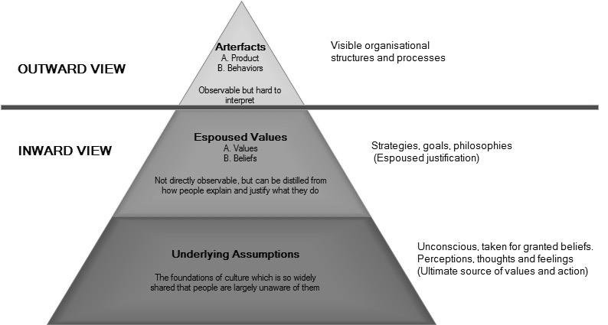
Figure 3: Edward Schein’s model of Organisational Culture
Source: (Wang and Lounbury, 2021)

Recent change initiatives, their impact
The global business environment has been dramatically dynamic due to multiple factors over the past few years which require implementation of appropriate changes in order to sustain. In this situation, Burnes (2020) has analysed this phenomenon with the help of Lewin’s Three-step model of change. These stages are unfreezing, moving the process and lastly, refreezing the process. Scholars have suggested that the former phase of this model helps the business organisation to identify the factors that affect the organisational performance so that those can be changed in order to improve the same. On the other hand, the second phase of this model defines the necessary process such as planning, and communication to design the necessary changes. Lastly, the refreezing stage of this model indicates the implementation of the change within the work environment in order to escalate the business operation (Edwards et al. 2020). In the case of Hyatt Hotels Group, it has been reported that recently Hyatt has experienced a drastic fall of 70% in its net income which might be an indication of a lack of engagement of the employees within the organisation (Hotel Management Network, 2023). Experiencing such devastating financial loss, this hospitality company decided to conduct extensive research to identify the issues that are affecting the employees in this organisation. In this regard, this organisation has collaborated with PwC’s account and HR consulting team which has further evolved a multi-year effort to transform Hyatt’s talent strategy (PwC, 2024). Eventually, it has enabled Hyatt to implement certain changes such as rewarding the competent employees properly and developing training programs for the employees. Such changes in human resource management have enabled this organisation to increase employee job satisfaction as well as engagement (Armstrong, 2012). Eventually, it has enhanced organisational performance by increasing the employees’ productivity.
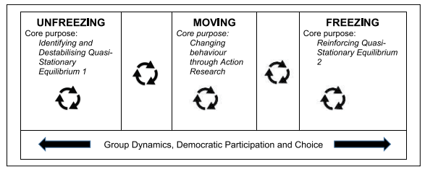
Figure 4: Lewin’s three step model of change
Source: (Burnes, 2020)

The organisation’s strategic direction and current business performance
The strategic direction: The strategic direction of Hyatt is focused on the portfolio expansion, loyalty program and sustainability initiatives. The organisation has been following the strategy of portfolio expansion through the continuous addition of new properties both through management agreements and acquisition (Bloisi et al 2007). It helps to cater their services to the global customers according to their preferences (Manoharan et al. 2021).
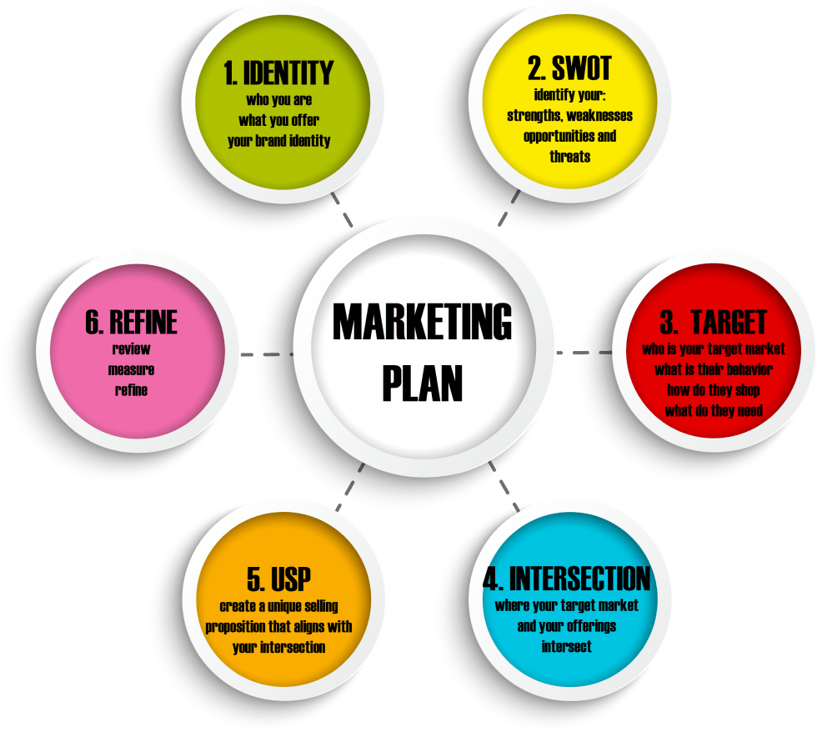
Figure 5: Strategic Direction of Hyatt Hotel Group
(Source: Self-generated)
Hyatt also has been investing in the World of Hyatt loyalty program and aiming to increase brand loyalty and deepen customer engagement. In terms of sustainability initiatives, they are in commitment to integrating the eco-friendly practices in their operations (Adair, 2009).
Current business performance: The Hyatt Hotel Group’s net income reported £53,743,800 GBP in the third quarter of the year 2023. It is a substantial increase from the previous year in the same quarter from £22,132,600 GBP (ETTravelWorld 2023). Apart from that they also implemented the metrics related to customer satisfaction, loyalty programs, and the brand reputation. These can help to identify the organisational performance and retain loyal customers (Mullins and Dosser, 2013). The Hyatt Hotel group has the ability to navigate the market conditions, deliver memorable guest experiences and embrace innovation in this changing landscape. Hence, they are most focusing on providing good quality services and experience to the customers. Technology integration is the most effective part of the Hyatt Hotel Group (Hyatt Newsroom, 2023).
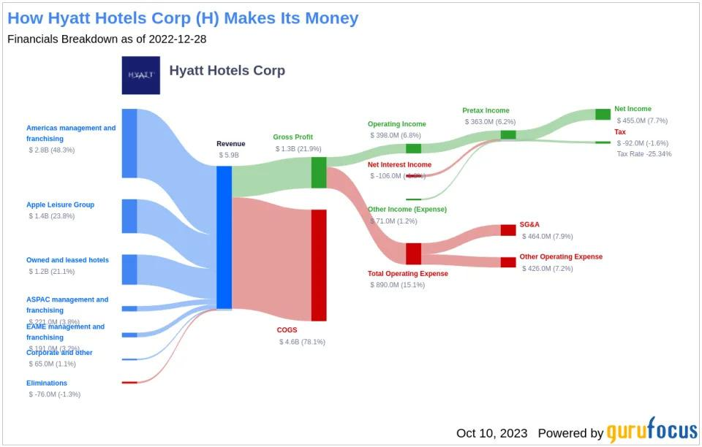
Figure 6: Figure business performance of Hyatt Hotel Group
(Source: Yahoo! Finance 2023)
They have been focusing on developing their brand reputation and reaching a wide range of customers through their effective communication and services. They prioritise sustainability by aligning with the growing traveller consciousness and trying to create a positive brand image. It has helped them to achieve competitive growth.

Critically analysing the role of leadership in effective management:
Leadership is a significant component in executing effective management. The role of leadership can be analysed with the help of Transformational Leadership Theory. According to Reza (2019), transformational leadership serves as the ideal leader to the employees who possess effective values such as integrity, empathy, peace, equality, respect and others along with emphasising new ideas in order to achieve organisational goals. Following the concept of this leadership theory, it can be stated that the leaders of Hyatt Hotels Groups have contributed immensely to maintaining the well-being of the employees within the workplace. It has been reported that this organisation has introduced RiseHy, a training program for its employees in order to develop their skills. It has been portrayed as an investment in the development of the employees to achieve the organisational goals. In other words, it has been portrayed as the growth of both parties, employees and the organisation. The openness, honesty, and integrity of the leaders of this organisation are other significant approaches to their leadership styles which have further motivated the employees significantly (Hyatt, 2024). Eventually, it has helped to strengthen the trustworthy relationship between the employees and this organisation.

Critical evaluation of the competitors and behaviour management:

Comparison with its competitors:
Hyatt acknowledges that people are not only rational economic beings but also influenced by several social, psychological and emotional factors. The management of the Hyatt Hotel group understands the significance of influencing and understanding individual behaviour in the workplace (Mullins, 2016). They believe in effective teamwork and collaboration and thus focus on developing employee behaviour to motivate them through effective transformational leadership styles (Arnold, 2005). Moreover, it helps to differentiate in this competitive market of the hospitality industry. The main competitors of Hyatt are Marriott and Hilton.

Hyatt | Marriott | Hilton
It has a Stronger focus on luxury with the Park Hyatt brand | It is the Wider hotel selection | It is Easier to achieve top-tier status
More transparent redemption system | Lower resort fees | Wider brand variety
Higher guest satisfaction score | It boasts a large footprint and wide brand range | It uses the dynamic pricing

Table 1: Comparison of Hyatt with its competitors
(Source: Self-Generated)
Through the comparative analysis, it has been identified that Hyatt Hotel Group competes properly with the larger chains by focusing on leveraging strengths and strategic pillars such as luxury offerings, transparency and guest experiences. As the market is highly competitive thus it is necessary for Hyatt to focus on innovation and strategic partnerships (Buchanan and Huczynski, 2007).

Recommendations:
• Hyatt has to tailor the customised training program in order to address the specific behavioural factors related to the context of the organisation. It is necessary to focus on the areas like emotional intelligence, conflict resolution and communication.
• It is also necessary to promote inclusive leadership which helps to encourage the leaders to adopt values and recognise the diverse perspectives. It helps to foster a positive organisational culture and develop employee engagement.
• Regular feedback and recognition can help to motivate the individuals and to increase their job satisfaction.
• It is necessary to design team-building activities and exercises that promote effective communication, trust and collaboration (Schmidt et al. 2023). This can help strengthen the interpersonal relationships and to enhance the cohesion of the team.

Conclusion
Through the analysis it has been identified that Hyatt Hotel Group has been developing their business with their effective leadership and management practices. They are focused on the innovation and creativity in delivering the good quality services to their customers. Apart from that their strategy and leadership styles are crucial in driving workforce in the competitive landscape. They can also implement conflict resolution training which can help to address the interpersonal issues effectively. This can help in preventing escalating team dynamics.

References
Adair, J. (2009) The Inspirational Leader (2nd Ed), London: Kogan Page.
Armstrong, M. (2012) Armstrong’s Handbook of Management and Leadership (3rd Ed), London: Kogan Page.
Arnold, J. (2005) Work Psychology (4th edition) Harlow: Prentice Hall.
Bloisi, W. et al (2007) Management and Organisational Behaviour, (2nd edition) Maidenhead: McGraw-Hill.
Boddy, D. (2014) Management: An Introduction (6th Ed), Harlow, Pearson
Buchanan, D. and Huczynski, A. (2007). Organisational Behaviour: An Introductory Text (6th edition), Harlow: Prentice Hall.
Čelić, I., Milićević, S. and Đorđević, N., (2021). Staff training and development: A comparative analysis of national hotels in Serbia and international hotel chains. Megatrend revija.
Edwards, K., Prætorius, T. and Nielsen, A.P., (2020). A model of cascading change: Orchestrating planned and emergent change to ensure employee participation. Journal of Change Management, 20(4), pp.342-368.
Etalong, T.A. and Chikeleze, F.O., (2023). Effect of Organizational Culture on Employee Performance: A Survey of Selected Public Sector Organizations in Enugu. European Journal of Business and Innovation Research, 11(7), pp.73-86.
ETTravelWorld, (2023). Hyatt reports total fee revenue of USD 250 mn in Q3; 1,23,000 rooms in pipeline - et travelworld. Available at: https://travel.economictimes.indiatimes.com/news/hospitality/hyatt-reports-total-fee-revenue-of-usd-250-mn-in-q3-123000-rooms-in-pipeline/105085631#:~:text=In%20terms%20of%20net%20income,USD%2072%20million%20in%202022 (Accessed: 13 February 2024).
Hassan, M.K., Abdulkarim, M.E. and Ismael, H.R., (2022). Risk governance: exploring the role of organisational culture. Journal of Accounting & Organizational Change, 18(1), pp.77-99.
Hyatt Newsroom (2023). Hyatt reports fourth quarter and full year 2022 results. Available at: https://newsroom.hyatt.com/news-releases?item=124350 (Accessed: 13 February 2024).
Manoharan, A., Madera, J.M. and Singal, M., (2021). Walking the talk in diversity management: Exploring links between strategic statements, management practices, and external recognition. International Journal of Hospitality Management, 94, p.102864.
Mullins, L (2020) Organisational Behaviour in the Workplace (12th edition) Harlow:Pearson
Mullins, L and Dosser, P. (2013) Hospitality Management and Organisational Behaviour (5th Ed) Harlow, Pearson.
Mullins, L. (2016) Management and Organisational Behaviour (11th edition) Harlow: Pearson
Pedersen, E.R.G., Gwozdz, W. and Hvass, K.K., (2018). Exploring the relationship between business model innovation, corporate sustainability, and organisational values within the fashion industry. Journal of business ethics, 149, pp.267-284.
Ruiz Molina, M.E., Belda-Miquel, S., Hytti, A. and Gil-Saura, I., (2022). Addressing sustainable food management in hotels: proposing a framework and examining hotel groups. British Food Journal, 124(2), pp.462-492.
Schmidt, J.M., Porter, J.T., Rivera-Amill, V. and Appleyard, C.B., (2023). Promoting crucial team building, collaboration, and communication skills in graduate students through interactive retreats. Advances in Physiology Education, 47(4), pp.919-929.
Yahoo! Finance (2023). Hyatt Hotels (H): An undervalued gem or a Mirage? A comprehensive guide to its valuation. Available at: https://finance.yahoo.com/news/hyatt-hotels-h-undervalued-gem-153848833.html?guccounter=1&guce_referrer=aHR0cHM6Ly93d3cuZ29vZ2xlLmNvLmluLw&guce_referrer_sig=AQAAAFLAcyityNtWrHTfEuPa9KgnkI12pZsUZvMprznZvJqJfgcC4V_FUYMlh0uqCF-Wt8QYV_U-U8oQrfCG5SH3OZTXGFXIK_xcBVd4utZz2VbpB6oAgJh-R1O1xVlsTOChaKyJvgtcThuxCvqGd_N2VK13ALD-3MdyCR2heyftr-Pe (Accessed: 13 February 2024).

