
the celtic manor resort audit report
Clyde Carmelo Seisun (2220481)


Submission Date: 05/05/2023
Module: Cotemporary Challenges - Making a Difference (BMTP4013)
Lecturer: Deborah Jenkins
Word Count: 1282 / 1500 (±10%)

Contents
Introduction 3
Methodology 3
Audit Report 3
Recommendations 5
Conclusion 6
Bibliography 7

Introduction
This audit report is for The Celtic Manor Resort in Newport. The purpose of this report is for the auditor to give their recommendation and judgement to The Celtic Manor Resort in order to aid further success. The author will do this by outlining possible problems, possible opportunities for development in a comprehensive and systematic format. This report will be independently written with no feedback from Celtic Manor Resort staff or directors.

Methodology
This report will follow the following methodology in order to make the audit as reliable and concise as possible; there will be a criteria for the auditor to follow while making the report. There will also be a summary of the condition of the property. On top of that, there will be a piece written for the consequences if the property fails to take these recommendations into account. To conclude the report, there will also be a recommendation written from the auditor themselves in to help the property make corrective action plans for the future. (Tuovila, 2022)

Audit Report
The Celtic Manor Resort is a luxury five-star property in Newport – it features several floors of guest rooms situated at the heart of the resort. (The Celtic Manor Resort, 2023)
The resort offers a whole range of rooms starting from superior rooms all the way to a presidential suite. The naming of the rooms is a very smart idea as the cheapest and most widely available room is called the “Superior Room”, it makes the guest feel good because if they take (Saul Mcleod, 2023)’s interpretation of Maslow’s Hierarchy of Needs theory, this helps the guest get onto the esteem part just before self-actualization. In order to be able to reach the self-actualization The Celtic Manor will need to “pamper” and treat every guest like they are the only guest in the resort.
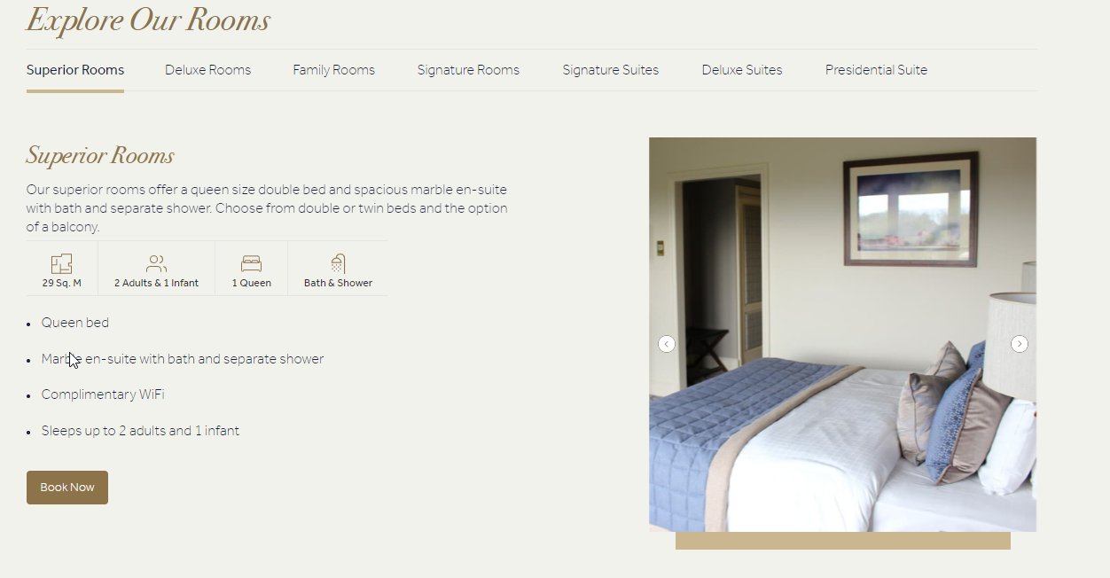

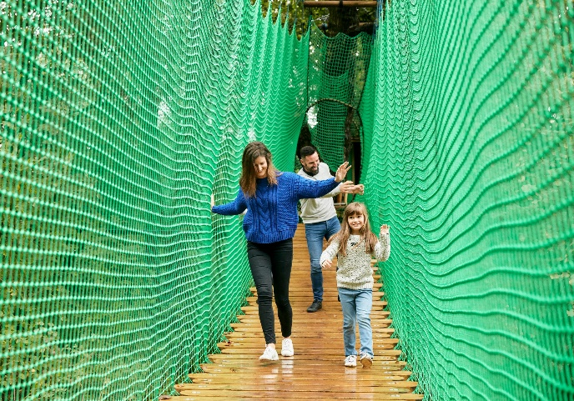
On top of these rooms, The Celtic Manor Resort also offers guests a large range of activities for all ages and guest types. This includes half term exclusive activities for family guests while also having archery and swimming for adult guests. (The Celtic Manor Resort, 2023) These activities are very good as they are able to make guests who have decide to have lazy days on their holiday to do activities within the resort itself and not having to travel outside of the area. While these activities do have an additional cost to them, the resort also offers a couple of free activities including swimming sessions and a fitness centre. These activities have no time restriction and are free for all guests staying at the Resort. All the guest has to do is go down to the situated floor and speak to the 24/7 reception staff and say what you want to do. They will then give you a locker key for your belongings and a towel so you can enjoy your sessions. However, the swimming session is limited to two 45 minute sessions. The reasoning behind this is to limit the amount of time guests are in the pool at one time as that could lead to injury and in worst case scenarios fatal accidents.
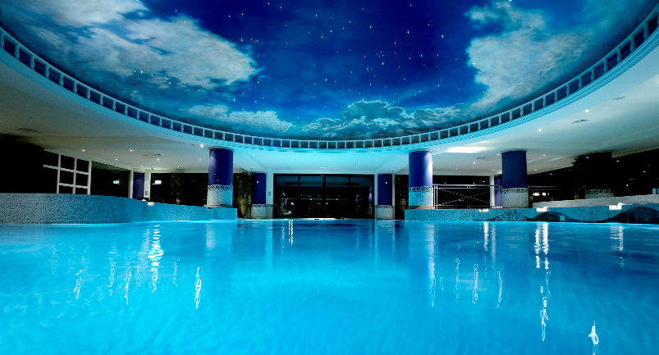

Another feature the resort has is three world class championship golf courses. This includes a golf academy and two luxurious golf clubhouses. (The Celtic Manor Resort, 2023) The reason these golf courses are world-class is because the Celtic Manor Resort was in fact home to the 38th Ryder Cup in 2010. These golf course are sadly not free for guests but are relatively priced in making it a great activity for all guests to participate in during their stay.


The Celtic Manor Resort doesn’t stop there with the features it heartly boasts! Another great feature the resort offers is the physical connection between the resort and the ICC Wales (International Convention Centre Wales). The ICC is just a couple minute walk from the reception of the Celtic Manor Resort. This conference centre is a very popular venue for events and meetings from all around the UK and the world. A couple of examples of events that have happened at the ICC include graduation ceremonies for all the students and delegates at the University of South Wales. Another event that has happened at the ICC include the 2014 NATO Summit in Wales which included guests such as former Prime Minister David Cameron and former US President Barack Obama. The Celtic Manor Resort has been voted M&IT Best UK Hotel for nine years within the last ten years – in 2011-2014 and 2016-2020 (The Celtic Manor Resort, 2020). The ICC has also been a home location for many movies and TV series. These include BBC’s His Dark Materials, The War of the Worlds and Sky’s A Discovery of Witches. The ICC is also perfectly situated as a two-hour train and a three-hour drive from London. This makes the ICC a very valuable asset for the Celtic Manor Collection to own as on top of their many locations across Wales as many global events could be held there making people visit Wales.
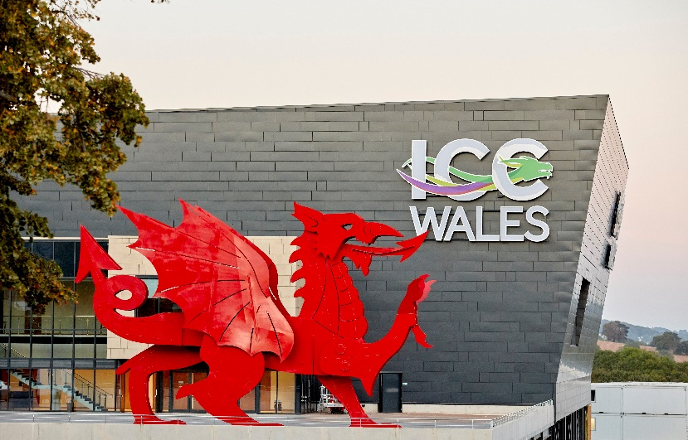

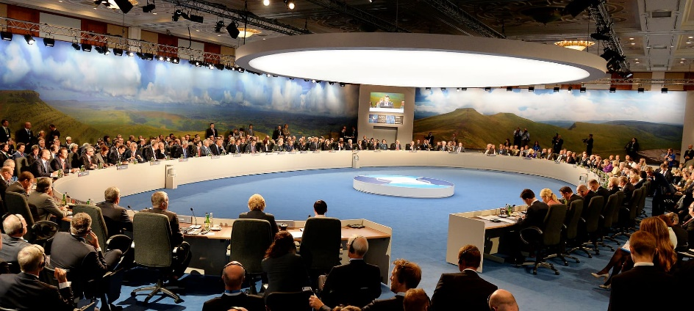

Recommendations
The Celtic Manor Resort is a brilliant five-star luxury resort. However there are a couple of recommendations that the auditor would give which include giving guests a rundown on restaurant and food recommendations within the resort and telling them that it’s a shuttle bus away from the main reception area. As this is not properly relayed to the guest leaving them disappointed and hungry. Limiting them to the standard restaurant at reception area. The reason this is important is because the guest may want some specific cuisine and not being told that they will require a booking and a shuttle bus to get to the restaurant may disappoint the guest.
Another recommendation the auditor will recommend is letting the guest know all the rules of the resort and venue at arrival including all the areas where they are allowed to walk into and where they are not allowed to walk into. The guest will sometimes come into the resort feeling overwhelmed and confused especially if they have never stayed at a five-star resort before and because of this may walk the wrong direction. Without proper signage, the guest will feel like they are walking into labyrinth. This can easily be amended by having a sign stating where the reception desk and the concierge desk are located. The reason this is important is to allow your guests to have a seamless and efficient entry to the resort.
One final recommendation that the auditor recommends is reminding the guest that the room service and concierge service is not available 24 hours a day. So the guest can not order room service during the night if they want to. This could be changed by either allowing 24/7 room service or by simply reminding the guest of the time windows. The reason this is important is because during the night when the guest does not feel like sleeping or have trouble sleeping they may want to order a drink or potentially something to eat to help them sleep and not being able to may ruin the guests time.

Conclusion
To conclude this audit report, the auditor wrote about The Celtic Manor Resort in a detailed manner outlining many of the facilities and amenities that the resort has as well as the ICC which is connected to the resort. The auditor also wrote recommendations that will help the Celtic Manor in the future with explanations of why they are important and what will happen if they are continued to be ignored.
This audit report will help the Celtic Manor Resort in the future by being periodically audited at random intervals to prevent the resort from knowing when the auditor will come back.

Bibliography
Saul Mcleod, P., 2023. Maslow’s Hierarchy Of Needs. [Online]
Available at: https://www.simplypsychology.org/maslow.html
[Accessed 01 05 2023].
The Celtic Manor Resort, 2020. Caltic Manor Meetings & Events. [Online]
Available at: https://www.celtic-manor.com/home/meetings-events/
[Accessed 01 05 2023].
The Celtic Manor Resort, 2023. Celtic Manor Activities. [Online]
Available at: https://www.celtic-manor.com/home/activities/
[Accessed 01 05 2023].
The Celtic Manor Resort, 2023. Celtic Manor Golf. [Online]
Available at: celtic-manor.com/home/golf/
[Accessed 01 05 2023].
The Celtic Manor Resort, 2023. Celtic Manor Resort | 5-Star Luxury. [Online]
Available at: https://www.celtic-manor.com/
[Accessed 01 05 2023].
Tuovila, A., 2022. Internal Audit: What It Is, Different Types, and the 5 Cs. [Online]
Available at: https://www.investopedia.com/terms/i/internalaudit.asp#:~:text=What%20Are%20the%205%20C's,%2C%20consequence%2C%20and%20corrective%20action.
[Accessed 01 05 2023].

