


Valentine’s Menu of Trinty Hotel
Maria Mihaly
2210756
Hotel Placement-Food and Beverage Operations (BMIH4002)
Tristan Hawkins
17.02.2023

Valentines’ menu of Hotel Trinity 
ity Hotel
Available: 10-19.02.2023. Fix price menu£75 per person. Preservation is required.
We make Your occasion special, unforgettable. Candlelit dinner with live violin music. Include welcome drink on glass of Giusto Rosalia Prosecco.
Additional Wine pairing for £ 45
Glass of (150 ml) Reserve Merlot, Stellenbosch
Glass of Cabernet Sauvignon 2020 Mc Manis
Glass of Collection 2016 Cuvelier Los Ande
Glass of Chablis Chardonnay 2019 Domanie des Marronniers
Starter:
Smoked Duck liver pate with crispy baguette: Smoked crashed smoothly pate, served with crispy homemade baguette. 
Seafood share plate for two: Chilli & feta king prawn, smoked haddock bonbons, preserve lemon and with aioli, Szechuan pepper squid, and toasted bruschetta. 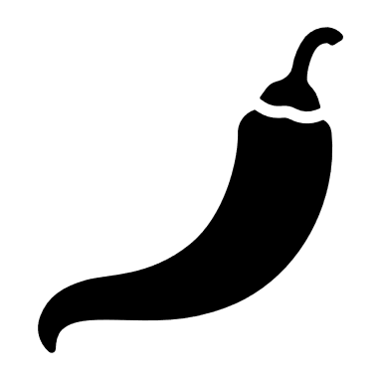
Cheese Heaven plate: Including Goat cheese, Perl wen, Celtic promise, Montgomery cheddar and Perl las. Garnished with grapes, celery, red onion chutney, olive fruit and crackers.
Backed Cheddar Mushrooms: Creamy mixed cheddar and mushrooms sauce, served with homemade focaccia.
Main:
Roast Saddle of Venison: Served on Potato bed and steamed apple cabbage with blackberry sauce.
Trinity Sirloin Beef Steak: Special seasoning Grilled steak with mini potato with asparagus creamy sauce.
Pan fry Chicken: Marinated chicken with baked cheesy baked broccoli potatoes.
Wild Mushroom Risotto: Smoothly cooked risotto with dried tomato, mushrooms pieces and parmesan.
Dessert:
Valentine’s sharing plate: Chocolate brownie pieces, waffles, mini pancakes and 2 spoon vanilla ice cream with chocolate sauce.
Heart Shape Chocolate Destiny: Decanted Belgium chocolate dome with raspberry mousse.
Lemon Meringue Cheesecake: Lemon cream cheesecake topped with layers of lemon mousse and meringue.
Warning: If you have any allergies, Please Inform our staff, before you order!

Sources:

Best Valentine’s Day Restaurants Menu, (2023) Chocolate Dome with Rose water mousse
Available at: 28 of the best Valentine's Day restaurants in London serving special menus (squaremeal.co.uk)
(Accessed: 07 February 2023)

Birmingham Restaurant, (2023) Valentine’s Dinning 3 courses: Pan Chicken supreme
Available at: Valentine’s Dining: 3 Courses & Wine - Stourport - Birmingham - Wowcher
(Accessed: 07 February 2023)

Castle Hotel, (2023) Valentine Menu: Smoked Chicken liver parfait, Seafood Sharing Plate
Available at: Sample Dinner Menu |The Castle Hotel | Shropshire (thecastlehotelbishopscastle.co.uk)
(Accessed: 11 February 2023)

Cheesecake and Special Desert, (2023) Lemon meringue Cheesecake
Available at: Lemon Meringue Cheesecake | Cheesecakes & Specialty Desserts | Global Menu | Menu - Order Online The Cheesecake Factory
(Accessed: 08 February 2023)

Duchess, (2023) Valentine’s Day Lunch and Dinner: Sharing Platter
Available at: Book Valentine's Day Lunch & Dinner in London (theduchesspub.co.uk)
(Accessed: 07 February 2023)

Miller and Carter Steakhouse, (2023) Valentine Menu: Baked Mushrooms
Available at: Valentine’s Day 2023 | Miller & Carter (millerandcarter.co.uk)
(Accessed: 08 February 2023)

The Inn on the Leek, (2023) Valentine Menu: Cheese Plate
Available at: Valentine’s Day 2023 at The Inn On The Lake
(Accessed: 07 February 2023)

Lilleshall Haus, (2023) Tree Courses Valentine Menu: Roast Saddle
Available at: a-la-carte-menu.pdf (dj52908b123td.cloudfront.net)
(Accessed: 07 February 2023)

Vivino, (2023) Wines
Available at: Riesling, between £5 and £20, rated 3.8 or more (vivino.com)
(Accessed: 11 February 2023)

