Student name: Sadaf Hassan
Student id: 2247725
Module: Changemakers: Creativity and Value Creation
Assignment Title: Component 2: Written Assignment (Report) BMHP5014
Lecturer: Raheela Shaikh

Poster
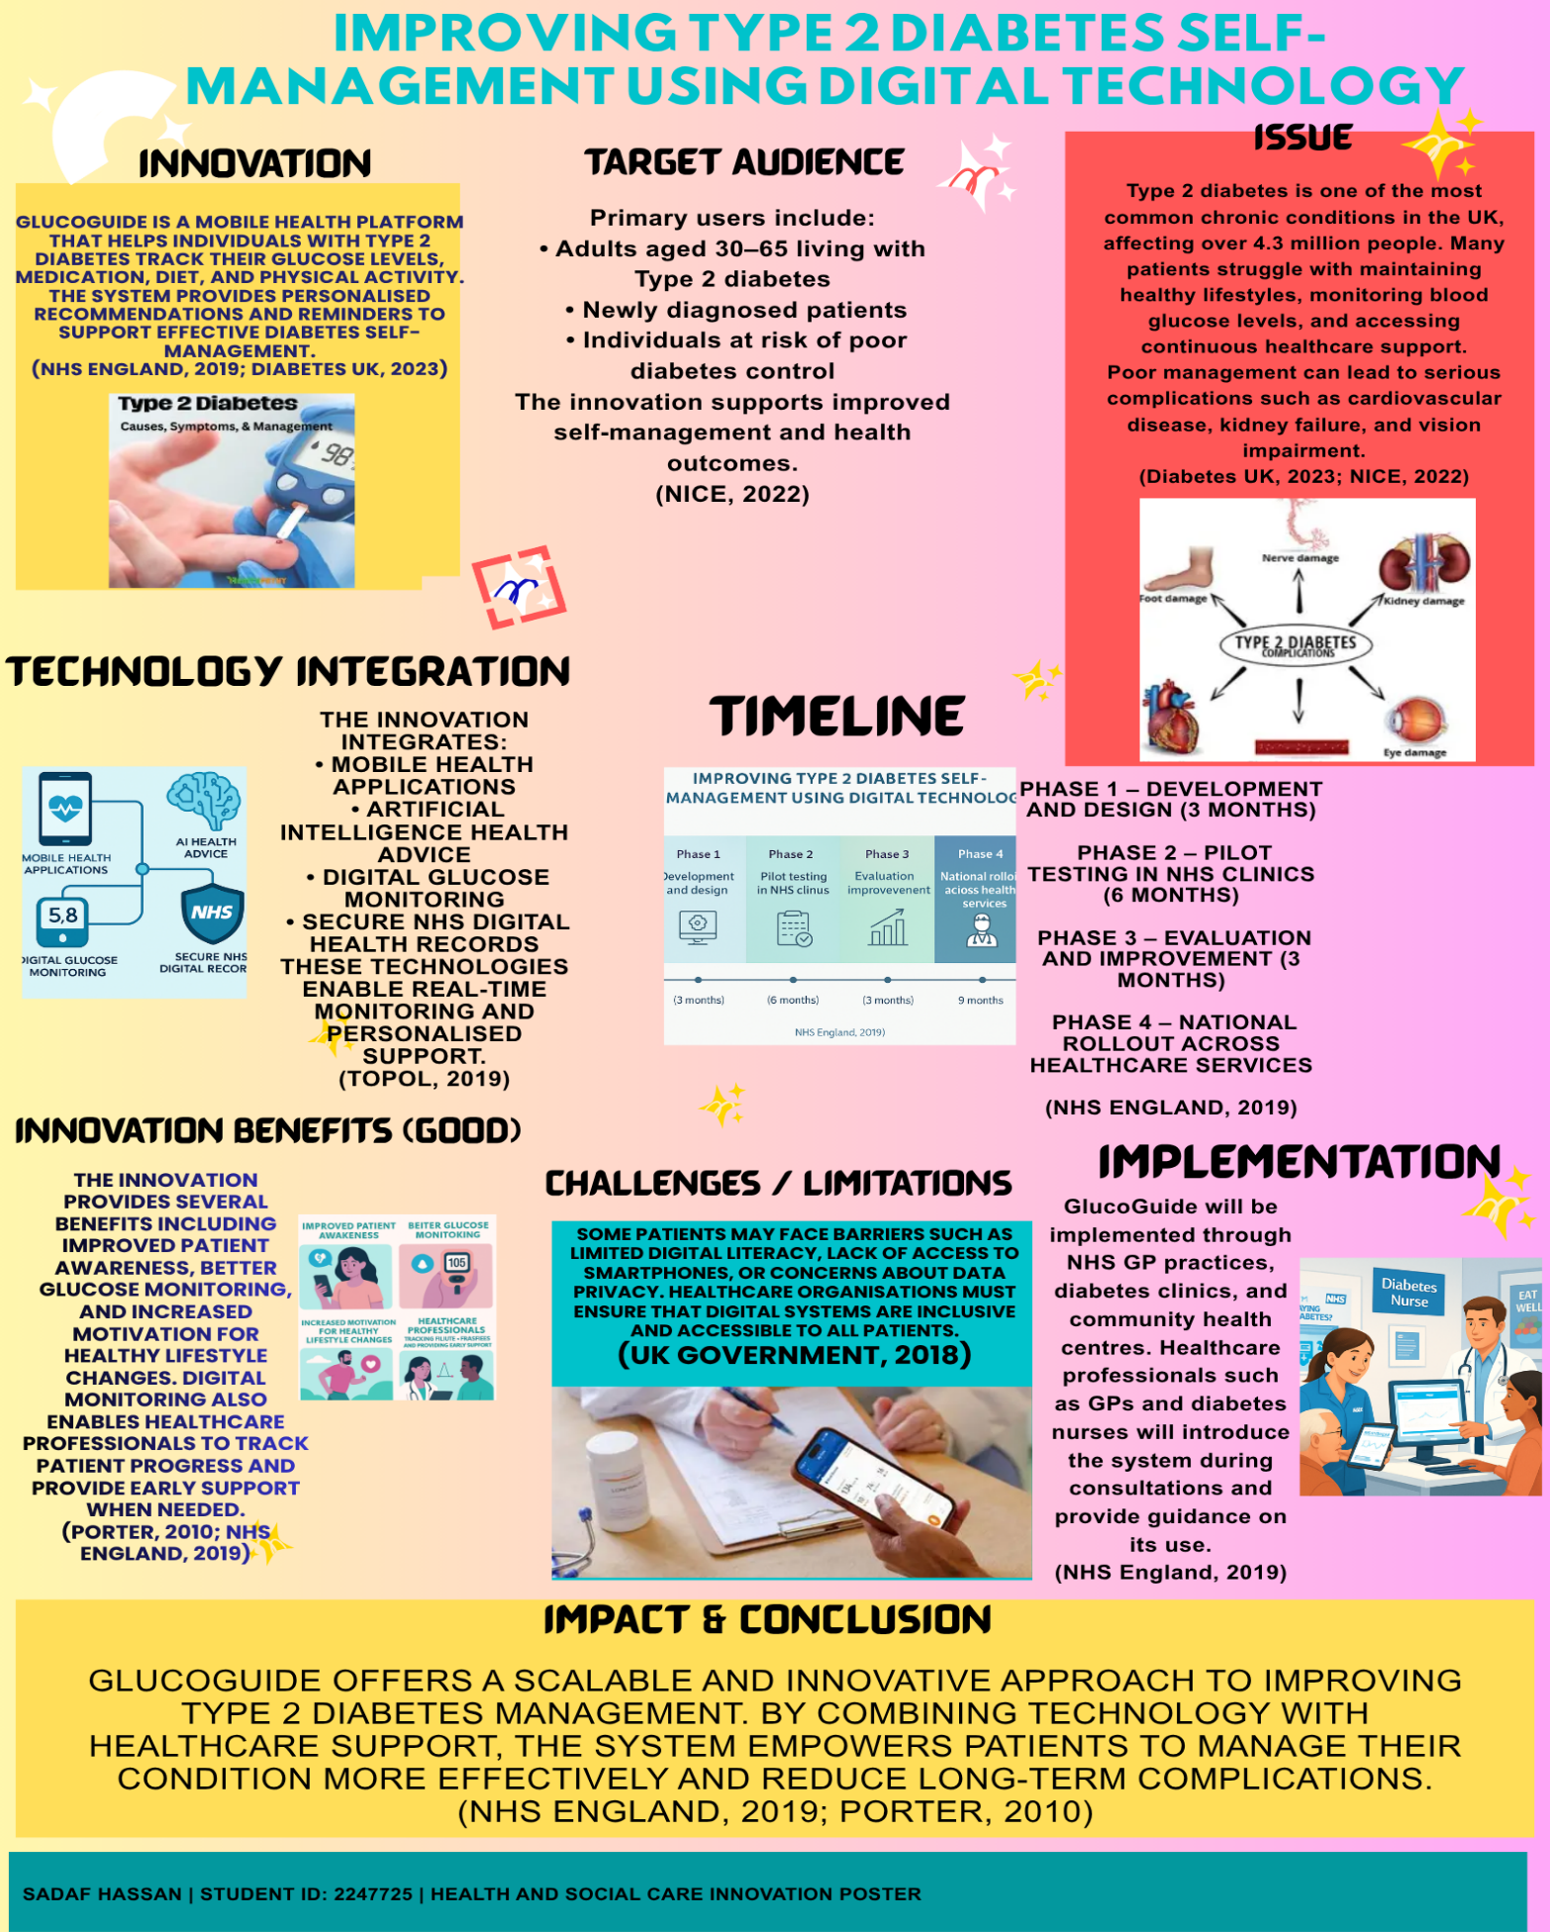

Pitch

Introduction:

Type 2 diabetes is one of the most prevalent long-term health conditions in the United Kingdom. Millions of people suffer from diabetes and its strain on health and social care services is substantial. There are over 4.3 million people living with diabetes in the UK – with the majority of those being Type 2 diabetes – Diabetes UK 2023 reported. Lifestyle choices such as poor diet, sedentary lifestyle and obesity are frequently the factors that contribute to the disease. If uncontrolled, Type 2 diabetes may result in potentially severe complications such as heart disease, kidney impairment, nerve injury and vision loss.
Type 2 diabetes management involves checking blood glucose, nutritious food intake, dietary control, medications, proper medication use, and regular exercise. Because of inadequate education, insufficient access to follow-up and ongoing psychological support, and with no ongoing advice, patients often face difficulty continuing to act like this in daily life. This led to the demand for new tools that help people cope with their condition in a natural setting. This pitch introduces GlucoGuide, a form of digital health innovation set to revolutionise diabetes self-management, facilitating a healthier lifestyle.

The Problem in Health and Social Care:
The Challenge in Health and Wellbeing Care. In fact, patients with Type 2 diabetes still have difficulties in controlling their disease despite advancements in healthcare services. According to research poor self-management behaviours are a significant cause of diabetes complications and admissions (NICE, 2022). Patients may not be adequately guided after diagnosis due to limited time available during appointments to provide ongoing lifestyle support. Social and environmental elements can also play a role in diabetics’ self-management efforts. Individuals from lower income communities find it difficult to find the benefits of health and have limited access to healthy food, education and the level of healthcare involvement to increase, and so forth. Such threats have led to the need for continuing, accessible access to support by giving patients more autonomy in managing their own health. Digital health technologies can help fill in the gaps by providing personalised support, education and monitoring tools that would go beyond the traditional healthcare settings (NHS England, 2019).

Proposed Innovation:
GlucoGuide is a digital health platform specifically designed to improve the care for Type 2 diabetes in affected individuals. Using this mobile app plus personalized health guidance, users can keep a record of their blood sugar levels and the dosage of medicines needed for their medications, exercise and food habits. An app will deliver daily reminders, educational materials and tailored lifestyle suggestions using your health-related data. The system might also remind the patient to take their medication, keep track of their blood sugar and practice exercise regularly. It can also prescribe meals to those with diabetes that are healthful and diabetes friendly. GlucoGuide supports patients in their everyday activities to encourage good behaviours and ultimately help in improving long-term management of diabetes. Digital monitoring can also help health care professionals to check on the patient progress and provide additional support when needed.

Target Group and Local Outcomes:
Adults aged 30-65 with Type 2 diabetes as the central focus of this innovation. Most people in this demographic live a life balancing work with family responsibilities and maintaining health. GlucoGuide provides support at your fingertips, anytime via smartphone. Secondary beneficiaries also include health professionals like GPs, diabetes nurses and dietitians, who can utilise that platform for monitoring progress and providing a more personalised care to their patients. Better diabetes management also has wider community-wide benefits. If patients keep more control on blood sugar management, then the risk of serious complications is less. This could help to reduce hospital admissions and therefore save NHS health care costs as well. The public health objective of improving diabetes care is also supported if it can drive people toward healthier lifestyles, help prevent any long-term disease later.

Policy and Legislation:
What is more, the proposed innovation is in line with many different health policies which exist in the UK. The NHS Long Term Plan places a great role on digital health technologies to bring out better things in patient care and make healthcare systems more efficient (NHS England, 2019). Digital tools, such as mobile health apps, can help patients manage long-term conditions more independently:
it can also reduce the burden on healthcare services. Furthermore, this innovation will be aligned to NICE guidelines for diabetes treatment and monitoring, which will advise patient education, lifestyle changes and self-management resources for Type 2 diabetes individuals (NICE, 2022). There are also important data security and privacy considerations. The GlucoGuide system will comply with General Data Protection Regulation (GDPR) safeguards to protect and care for patient information and secure patient information store and use (UK Government, 2018). Implementation Strategy. The GlucoGuide system will be implemented via NHS primary care services, diabetes clinics and community health centres. Healthcare providers will be required to introduce the app at diabetes consultations and advise patients on the interface.

The implementation process should consist of four main stages:

1. Development phase: The initial formulation of the digital platform with input from healthcare stakeholders
2. Pilot Phase: A few diabetes patients from selected NHS clinics who will be tested the system.
3. Evaluation Phase: Patient/healthcare provider feedback (to improve the system).
4. Phase of Expansion: extending the innovation across more healthcare facilities in the UK.
This systematic methodology also minimises implementation failures, allowing the system to be evaluated and enhanced prior to scaling.

Public Mobilisation and Community Membership:

We will get the public's involvement to make this innovation successful. Fostering awareness of diabetes prevention and control helps raise awareness and ultimately help people look for help sooner and start implementing better lifestyle behaviours. In addition to that, GlucoGuide will be supported by social media campaigns, community health knowledge sessions and working with organisations including Diabetes UK to develop a GlucoGuide campaign. Public health campaigns can also emphasise the need for healthy meals, regular physical activity and regular health checks. By empowering people and inviting everyone to participate, to share their stories about and help address feelings of sadness that may exist about those with diabetes, and to promote those suffering and others who might be alone or have limited social connections or who don't feel supported.

Conclusion:

Type 2 diabetes is a major public health challenge requiring new and innovative approaches to effective, long-term management. Without regular help and education, there is a substantial number of individuals who find it difficult to continue engaging in healthy living behaviours. We propose an innovation -- GlucoGuide -- that can provide an accessible digital resource for patients to track their health and lifestyle choices based on their individualised needs. This allows users to assess their health journey, set goals and track progress. GlucoGuide can enhance health by marrying together digital with information technology support to enhance patient outcomes with less health complications and a new sustainable health care system. Patient benefit: helping people to manage their own health will enhance overall health and social care services in the UK.

Reference:
Diabetes UK (2023) Diabetes statistics in the UK. London: Diabetes UK.
Davenport, T. and Kalakota, R. (2019) ‘The potential for artificial intelligence in healthcare’, Future Healthcare Journal, 6(2), pp. 94–98.
George, A.S. and George, A.H. (2023) ‘The rise of artificial intelligence in medicine and its implications’, Partners Universal International Innovation Journal, 1(6), pp. 38–54.
Hong, Y.A., Hossain, M.M. and Chou, W.Y.S. (2020) ‘Digital interventions to facilitate patient–provider communication in healthcare’, Psycho-Oncology, 29(4), pp. 591–603.
Hunter, I., Lockhart, C., Rao, V., Tootell, B. and Wong, S. (2022) ‘Enabling telehealth for older adults in underserved communities’, JMIR Formative Research, 6(11), p. e35864.
Kayser, L. and Phanareth, K. (2023) ‘Digital health literacy and patient empowerment’, Digital Respiratory Healthcare, pp. 79–94.
Keshta, I. and Odeh, A. (2021) ‘Security and privacy of electronic health records: Challenges and concerns’, Egyptian Informatics Journal, 22(2), pp. 177–183.
NHS England (2019) The NHS Long Term Plan. London: NHS England.
NHS England (2023) Artificial intelligence in healthcare. London: NHS Transformation Directorate.
NICE (2022) Type 2 diabetes in adults: management. London: National Institute for Health and Care Excellence.
Nuffield Trust (2023) Diabetes and NHS pressures in the UK. London: Nuffield Trust.
Porter, M.E. (2010) ‘What is value in health care?’, New England Journal of Medicine, 363(26), pp. 2477–2481.
Saeed, S.A. and Masters, R.M. (2021) ‘Disparities in health care and the digital divide’, Current Psychiatry Reports, 23, pp. 1–6.
Topol, E. (2019) The Topol Review: Preparing the healthcare workforce to deliver the digital future. London: NHS Health Education England.
World Health Organization (2021) Global report on diabetes. Geneva: WHO.

