Report on: Market Research and Developing Digital Content
Word Count- 1553

Module: Digital Skills and Research Methods
DATE: 9TH December 2022

Submitted by

Muhammad Rahim
Student ID: 2118650

Website:
Login: 2118650@student.uwtsd.ac.uk
Password: muhammadrahim123

Introduction

In this report we have discussed about the importance of market research. We have also discussed about the impact of research on small business. We have conducted a primary research for our new business by setting up a set of questions. This primary research eventually gave us the idea to select the key words and helped us to design the web page for this new business. Overall we can understand that primary research can reduce risk factors and helps to set up the strategy for start-up of a small business.

Market Research Importance in Business

Market research helps to identify opportunities and risks. It is possible to make wise decisions to deal with the problems based on the research. Failures can be avoided by conducting effective research as it can give the idea if the time is right to launch its product/solution and also if the target customers are right.

Research on factors affecting organizational performance in start-ups is very limited, and most studies focus on factors affecting organizational performance in SMEs(HASANI, T. and O'REILLY, N., 2021, p110).

Advantages of Market Research:
- Business research helps to identify opportunities and threats.
- It helps to understand customers better
- Risks and uncertainties can be minimized by conducting business research in advance.
- Financial investments that will be needed can be planned effectively

Disadvantages of Market Research:
- Business research can be a high-cost affair
- Most of the time, business research is based on assumptions
- Business research can sometimes give inaccurate information because of a biased population

Research often involves gathering information but it's more than just reading a few books or articles, talking to a few people and asking questions. Data collection may be part of the research process, but it is not considered research unless it is done in a systematic way and without a clear purpose (Saunders, Mark, et al., 2019, p4).

So without proper research it’s not possible to launch a business with confidence. It's easy to understand that success is very difficult, even for small businesses. In the UK only half of SMEs are still in business after three years since their initial set up(John Kirwan, 2009, p10).

Analysis of the Questionnaire

We have created a set of questions to conduct our primary research for the business. To complete these questions it took on an average of 3-5 minutes. Questions and their responses are given below:

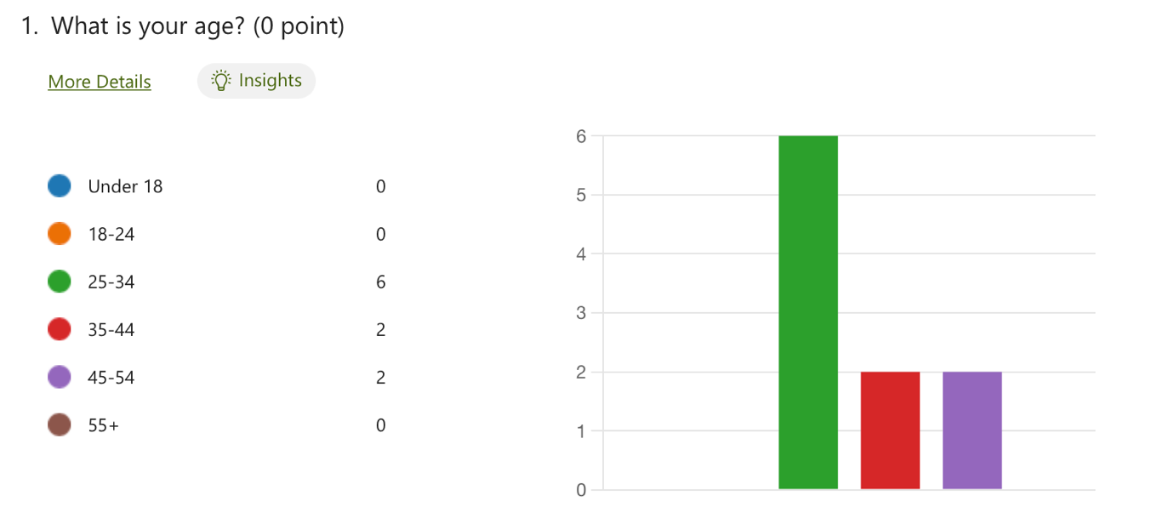
In this question we gave different age range to find out target customers age. We have started with this question and from our responses we can see 6 people are at the age range of 25-34 years, 2 people from 35-44 years and 2 people from 45-54 years. So we can conclude that most of our customers are between 25 till 55 years old.

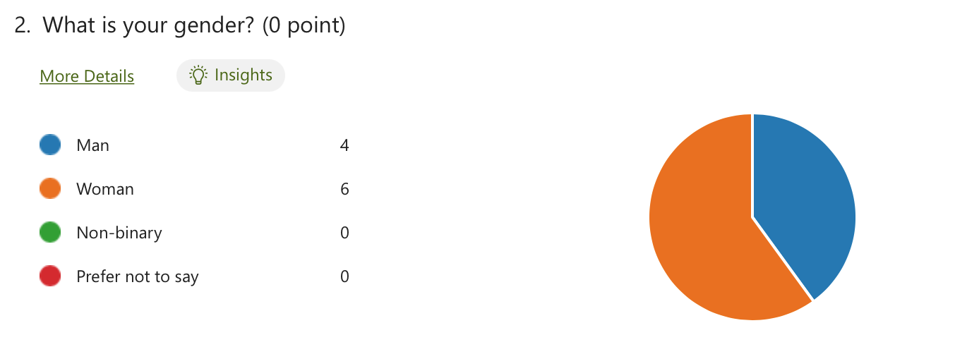

Our second question was what is your gender. This is also very important for the market research because we needed to know our target customers gender. From the responses we can see six people were women and 4 of them were men. So we can see our target customer can be both men and women though women are slightly higher than men.
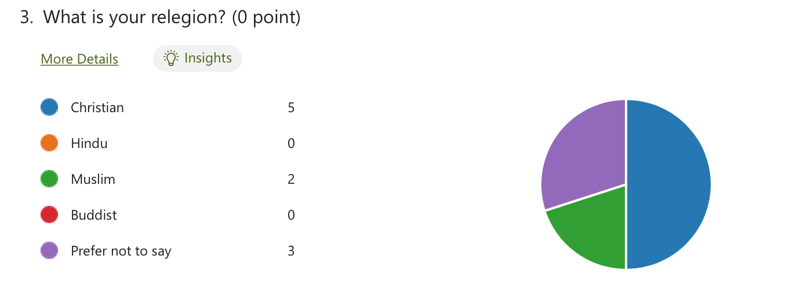
This was the question about people’s belief. As vegan health and beauty products are new to the market, it is important to know how this can affect people belief. We never want to offer a product that can create adverse situation to any particular belief. However from the responses we have received we can conclude that this product can be acceptable to all religious perspective.

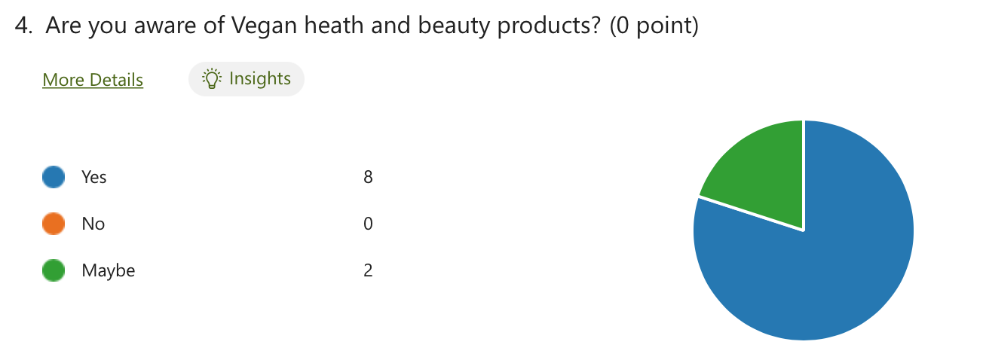
Above question about the awareness of vegan product is very important to set up the marketing strategy. We can see in the response chart that 80% people already know about the vegan health and beauty products. But still 20% people are not sure about this item. So we have a huge area where we need to educate people about the vegan items, their benefits and how it can create a sustainable development from environmental pollution.

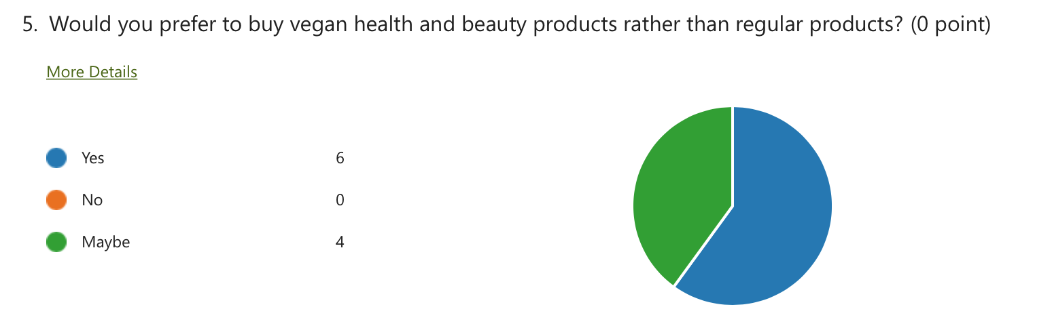
Our fifth question was would you prefer to buy vegan health and beauty products rather than regular? We have set up this question to understand the opportunity lies ahead of us with item. The response we have received is overwhelming as there is not a single negative answer. From the response chart we can see 60% agrees and 40% percent not sure yet. So we have the task to convert these people to buy vegan products.

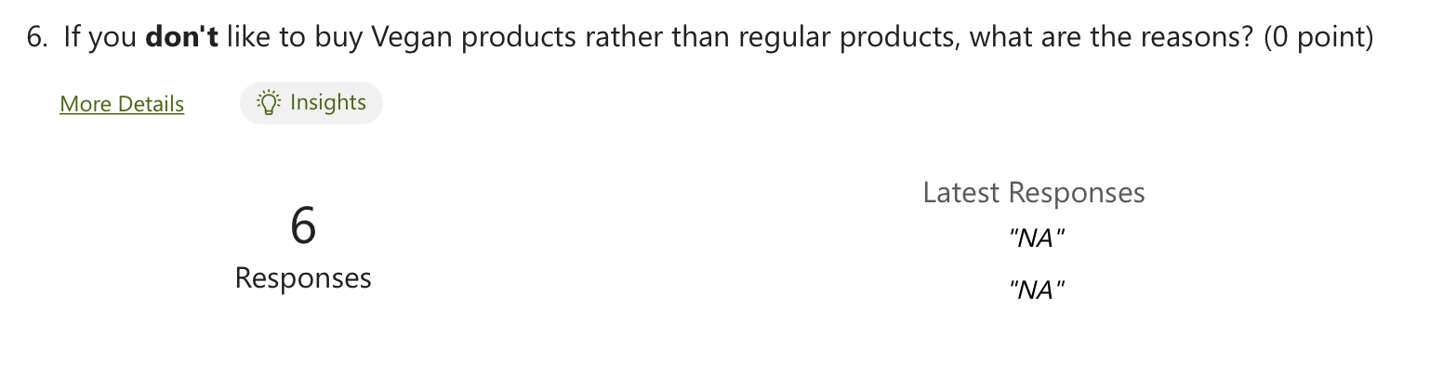
In this question we can see there was no response about not buying vegan products, which give a great optimism for growth.

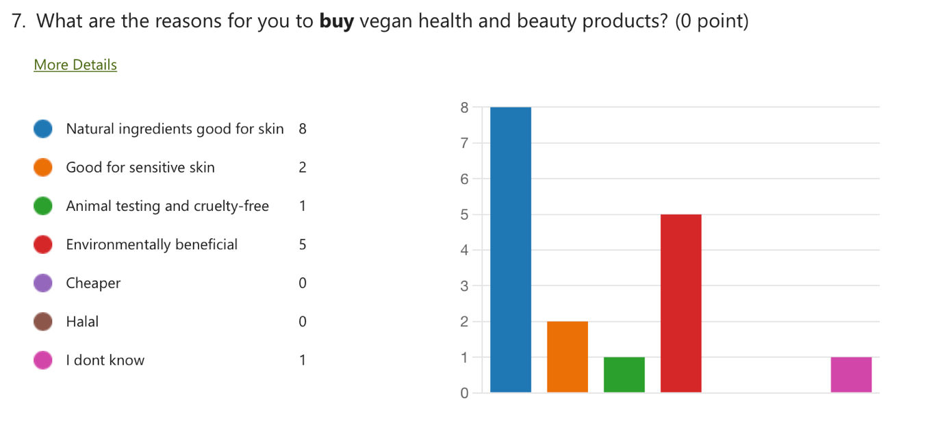
From this question we can see the main reason for people to buy vegan products are natural ingredients. This is good for skin. As there is no use of harmful chemical use and environment friendly is the biggest drive for people to use vegan products.

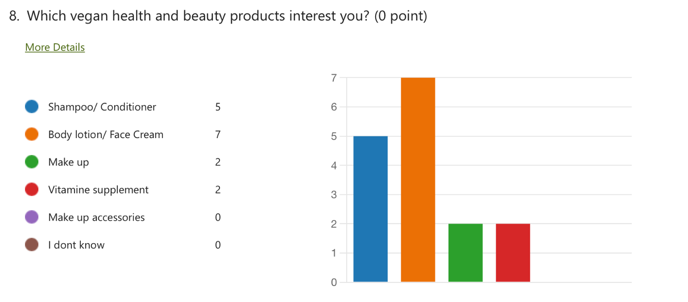
There are lot of different vegan health and beauty products are available but from bar chart we can understand that most popular items are body lotion and face cream. Hair products such as shampoo and conditioners are also popular.

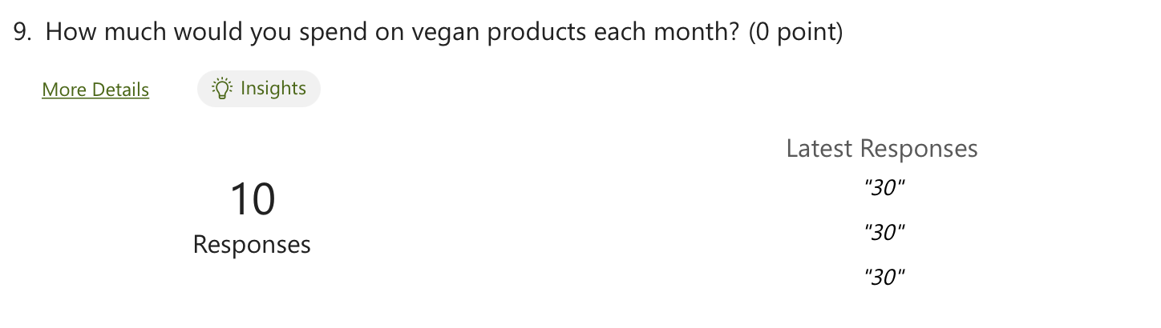
This question’s answer give us an idea of how much people are willing to spend on this kind of items.

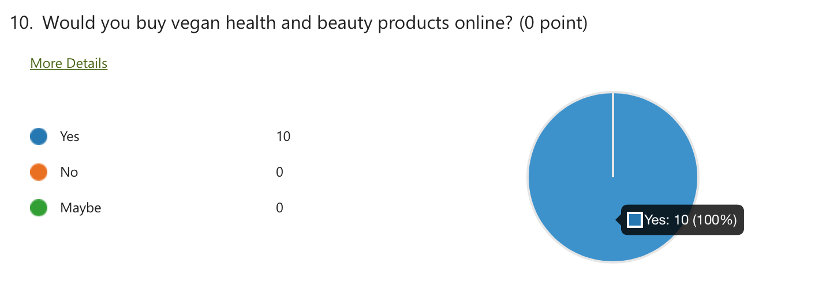
From above question we can see that all the people are interested to buy vegan products online.

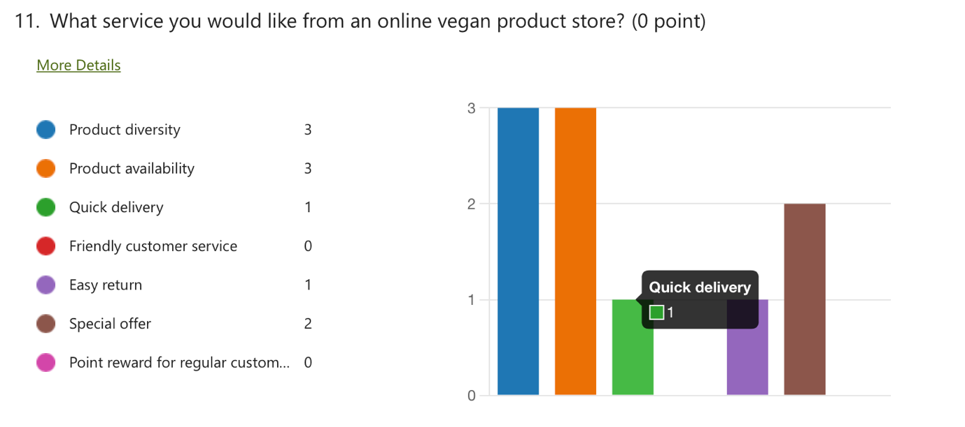
The question above gives us the indication of the services customer expect from us. The response bar chart shows that product diversity, availability and quick delivery is the key areas we need to focus.

Website Design

Web design is evolving rapidly, but there are some general trends we can learn from. The point here is that just because a web trend is the latest doesn't mean it's right (Research the latest web design trends, 2022, online).

So design has to be one the based on primary research outcome. Only this way webpage can corelate between products and target customers. Good design is finding relationships and balance between related elements (Beaird, Jason, et al., 2020).

Also Colour has the potential to elicit emotions or behaviours. Our visual and cognitive systems are adapted to recognize and process colour information contained in all visual stimuli encountered (Elliot and Maier, 2007; Kaya and Epps, 2004; Cyr D. and Head M. and Larios, H., 2010).

In summary our business is online market for vegan products. So it was most important to create a website to build the relationship between our products, service and their end users. We have used the research data to design and navigate the site to be effective. Below is the picture of the web page:

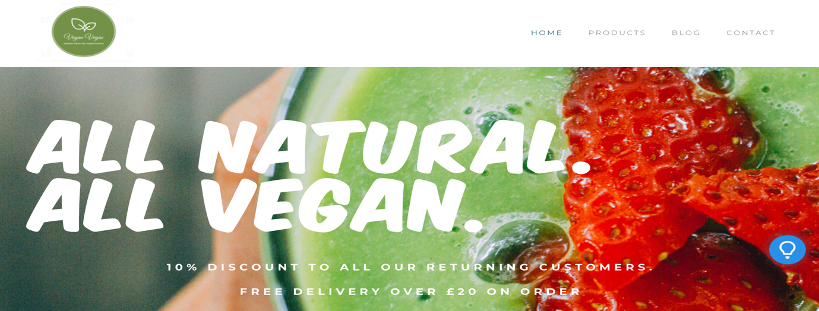

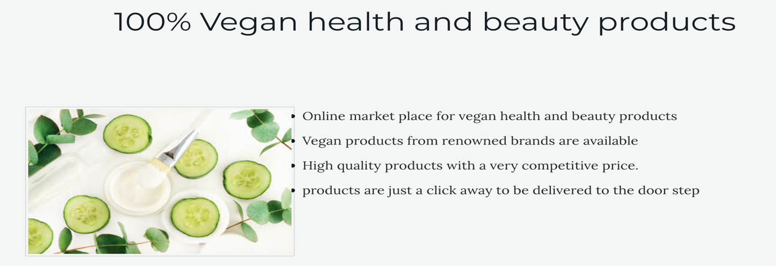

Fig: Home page
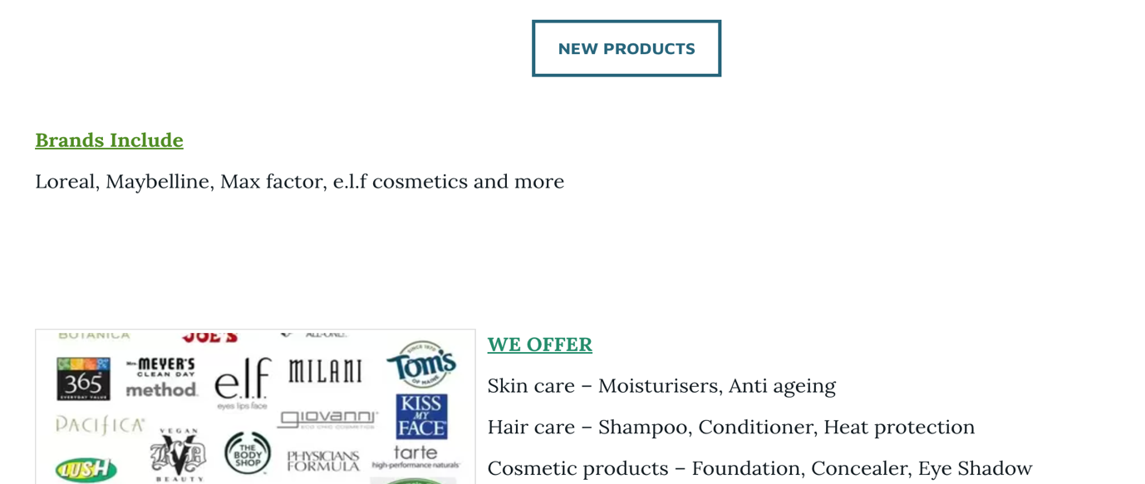

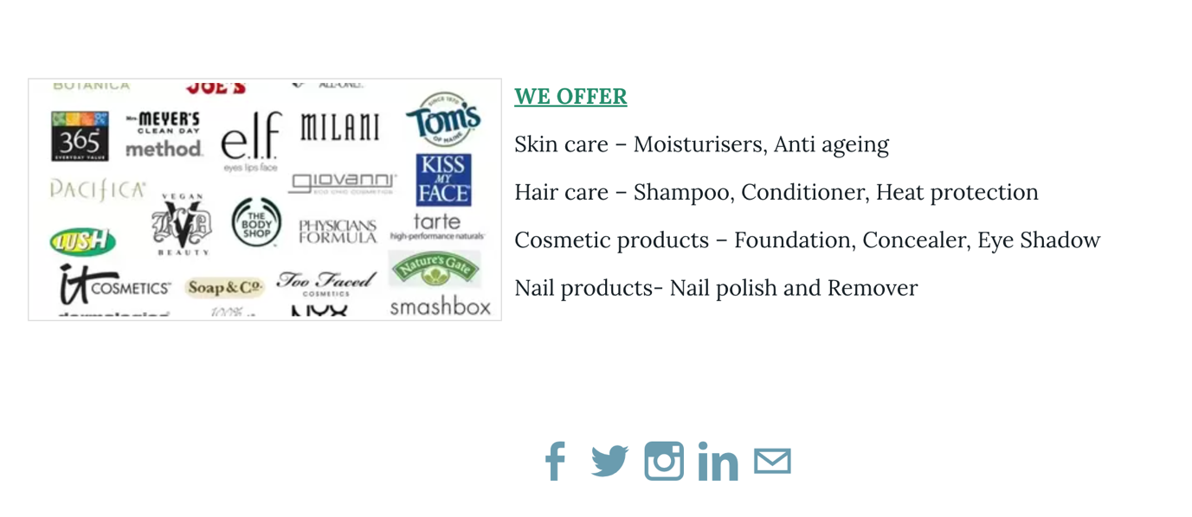

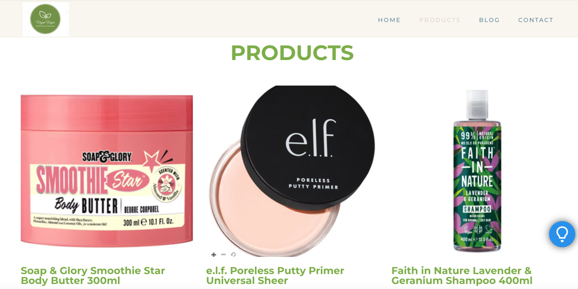
Fig: product page

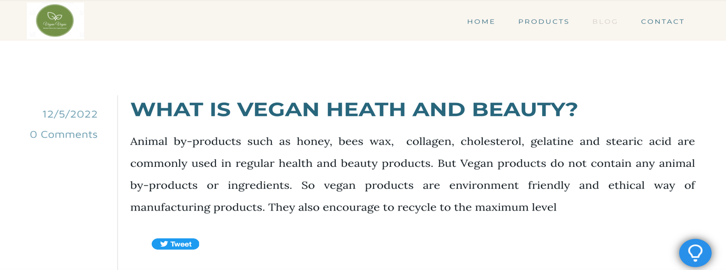

Fig: BLOG page



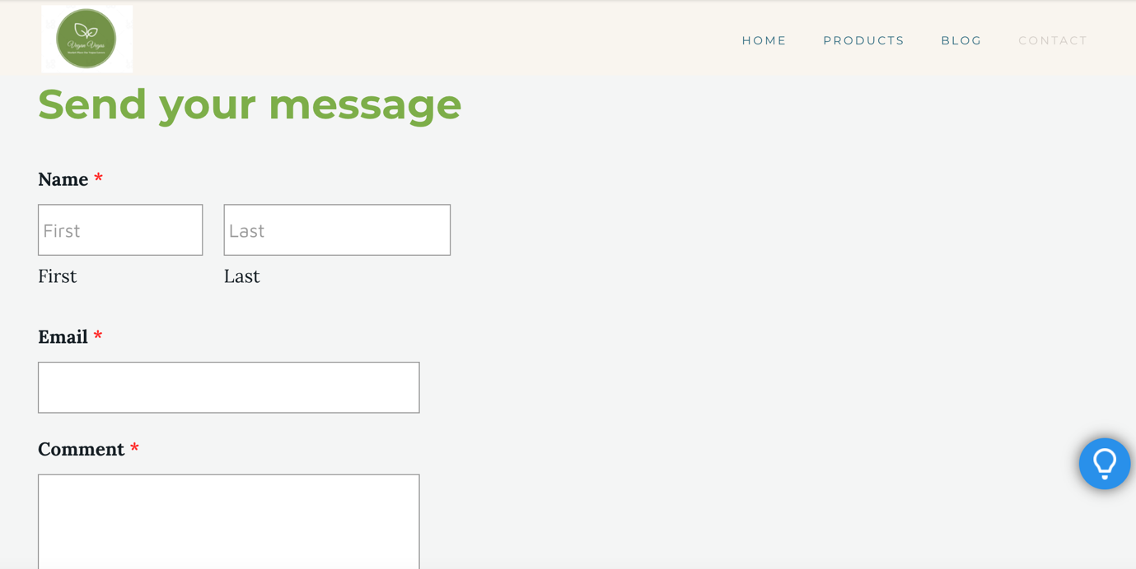

Fig: Contact Us page
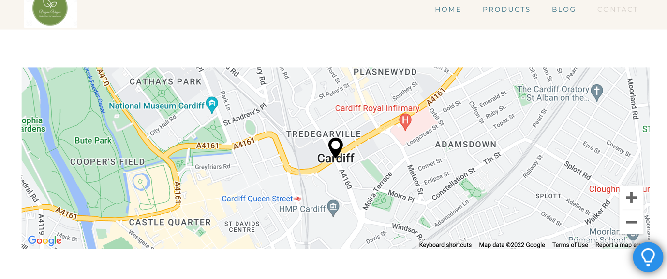
Fig: Contact Us Page

SEO and Its Importance

SEO- search engine optimisation is very important to make the business web page visible on the web site search engines such as google, yahoo and others. When developing the web page it is necessary to include right key words so that visitor can easily find the webpage while searching. This key words will help higher organic ranking of the site in search engine algorithm.

In digital marketing plans, keyword selection for search engine positioning is critical to customer acquisition and related investments are becoming a significant part of marketing budgets(Erdmann, A. & Arilla, R. & Ponzoa, J., 2022). Search engines such as Google and Yahoo have become the primary tools used to locate information on the internet.

Several user behaviour studies have shown that most users visit websites listed on the first page of results and the percentage of users visiting websites listed on the third and subsequent pages of results rapidly decreases (LUH, C., YANG, S. and HUANG, T.D., 2016).

From our primary research we have seen our major customers are between age 25 till 35. Men and women both can be our target customers but women are slightly more than men. Majority people already know about vegan health and beauty products, are research shows this is 80%. And they are willing to switch from regular product to vegan product because vegan items don’t use any harm full chemical and totally cruelty free on animal. Also environment friendliness and high recycling done by vegan manufacturer also retain people faith to use vegan products. Most people are interested to buy shampoo, conditioner, body lotion, face cream and other make up items. There is also some interest on vitamin supplement and make-up accessories. All the people participated in the research are happy to buy online and expects good variety of products, special offer and quick delivery.

Considering these we have selected these key words for our SEO, “vegan health and beauty products, vegan cosmetics, vegan shampoo, vegan conditioner, vegan make-up, vegan body lotion, vegan face cream, vegan vitamin supplement, environment friendly products, vegan health and beauty products special offer online, vegan health and beauty products home delivery, vegan health and beauty products quick delivery”.

Conclusion

Market research is the ultimate method to set up the strategy of new business. Proper primary research can guide us through the development progress of the business. There are lot of different method of market research but we have used the questionnaire method to understand the opportunity and risk factors in the market. By using this research we have developed our web page and implemented the response we have received from this research.

Reference

Anett Erdmann, Ramón Arilla, José M. Ponzoa, 2022. Search engine optimization: The long-term strategy of keyword choice, Journal of Business Research, Volume 144, Pages 650-662,

Beaird, Jason, et al. 2020. The Principles of Beautiful Web Design, Site Point Pty, Limited, ProQuest Ebook Central,

Cyr D. and Head M. and Larios, H., 2010, Colour appeal in website design within and across cultures: A multi-method evaluation, International Journal of Human-Computer Studies, Volume 68, Issues 1–2,
Elliot, A.J., Maier, M.A., 2007. Colour and psychological functioning. Current Directions in Psychological Science 16 (5), 250–254.
HASANI, T. and O'REILLY, N., 2021. Analyzing antecedents affecting the organizational performance of start-up businesses. Journal of Entrepreneurship in Emerging Economies, 13(1), pp. 107-130.
ISSN 0148-2963.

John Kirwan, 2009. Good Small Business Planning Guide : How to Make a Successful Business Journey. A&C Black Business Information and Development, London.
Kaya, N., Epps, H.H., 2004. Relationship between colour and emotion: a study of college students. College Student Journal 38 (3), 396–405.
LUH, C., YANG, S. and HUANG, T.D., 2016. Estimating Google's search engine ranking function from a search engine optimization perspective. Online Information Review, 40(2), pp. 239-255.

Research the latest web design trends, 2022, available at: https://www.websitebuilderexpert.com/designing-websites/ (accessed on 29th November 2022)

Saunders, Mark, et al., 2019. Research Methods for Business Students, Pearson Education.

