BSc Applied Computing Usability Engineering
Full Interface & Testing
ACCB6017
Student: Mariana Lupu (2313748)
Lecturer: Fahad Ahmed
Table of Contents
1.Introduction 2
2. Design Development and Full-Colour Prototype 2
2.1 Visual Design Approach 2
2.2 Differences from the Wireframes 3
2.3 Full-Colour Storyboard 5
2.4 Key Screens 6
2.5 Navigation Flow 8
3. Feedback on Final Prototypes 8
3.1 Feedback Collection Method 8
3.2 Positive Feedback 9
3.3 Negative Feedback / Issues Raised 9
4. Data for a Working Version 9
4.1 What Data Would Be Collected, and Why 9
4.2 How It Would Be Collected 10
4.3 Usage Data vs. Emotional Response Data 10
4.4 How This Data Would Shape the Next Version 10
5. Usability vs. User Experience 10
5.1 A Usability-Only Approach 10
5.2 Conflicts Between Usability and UX 11
5.3 How the Conflicts Were Resolved 11
6. Reflective Summary 11
7. Conclusion 12
References 13
Appendix A - Raw Feedback Data 14

1.Introduction
This report advances the design of UWTSD Campus Edition, a mobile adaptation of the cooperative board game Pandemic, by building directly on the research and wireframe storyboards created in the previous stage of this project. The four personas, user and experience requirements, and low-fidelity wireframes established earlier serve as the foundation for this stage, which transforms those wireframes into full-colour storyboards and expands on the design process [1].
This report focuses on four areas. First, the wireframes are converted into full-colour storyboards, with visual design decisions explained and justified in relation to the previous low-fidelity version. Second, the method for collecting feedback on these final prototypes is described. Third, the data that would be collected from a functional version of the app is discussed, as well as how it would be collected and used. Finally, the report examines the relationship between usability and user experience throughout the design process, citing concrete examples from the decisions made.

2. Design Development and Full-Colour Prototype

2.1 Visual Design Approach

The high-fidelity design employs a straightforward, medically inspired colour scheme to keep the game clear and thematically consistent. Green indicates a safe, treated, or positive state, such as confirmed actions and cured outbreaks. Red denotes danger and infection: outbreak markers and warning signs. A neutral dark background is used for structural elements such as navigation bars, allowing the green and red accents to stand out clearly [2].
The screens feature clear headings, large buttons, and simple icons to help players understand what they need to do. Text was kept as short as possible, especially after earlier feedback that too much information could make the interface difficult to scan [1]. Campus images and game-related graphics were used to make the design feel more connected to UWTSD without distracting from the main actions.
Overall, the visual design aims to keep the interface simple and accessible while also making the game engaging and appropriate for students.

2.2 Differences from the Wireframes

The original wireframes showed the basic structure of the game. From there, the design was developed step by step from low to medium and finally high fidelity [3]. More detail was added at each stage, while the main navigation and game flow remained the same.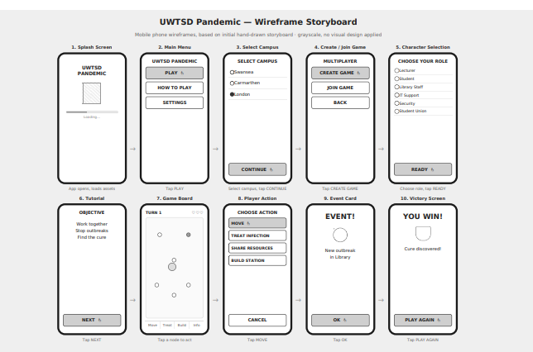
Figure 1. Low Fidelity
The original wireframes used only greyscale shapes and text labels to communicate structure and navigation. Status information, such as whether an area was safe or infected, was only available as written labels, requiring a player to carefully read the screen to understand what was going on. This version focuses solely on layout and flow, with no visual design applied.

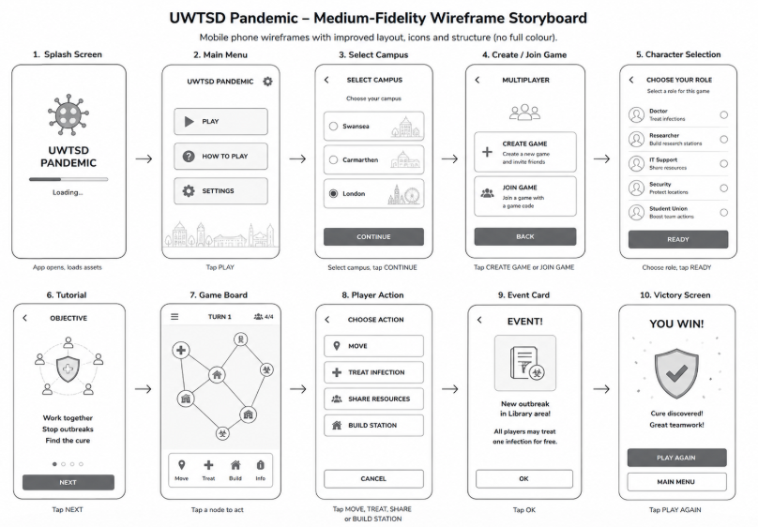
Figure 2. Medium Fidelity
At the medium-fidelity stage, the basic layout was developed further by adding clearer icons, improved spacing and more structured navigation. The screens were still visually simple, as the main purpose was to test whether the interface and game actions were easier to understand before applying the final colour scheme.
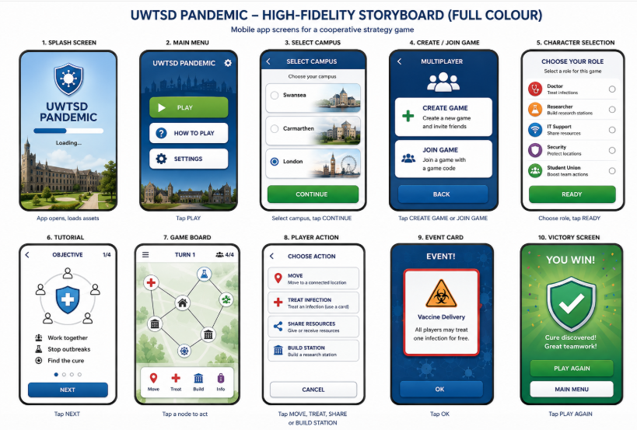
Figure 3. High Fidelity
The high-fidelity stage introduces the final colour scheme and gives the interface a more complete and realistic appearance. Primary buttons use stronger visual contrast, making the main actions easier to identify. The tap-hand icon from the wireframes was removed because it was no longer needed once the buttons became visually distinct. The bottom navigation bar was also redesigned with a highlighted active state, helping players see where they are in the game.

2.3 Full-Colour Storyboard

The final full-colour storyboard depicts how the player progresses through the game in a realistic use scenario. Unlike the previous wireframes, it depicts both the interface and the user's interaction with it, from starting the game and selecting a role to completing actions and achieving the desired outcome. This makes it easier to see how the individual screens work together to create a complete experience.
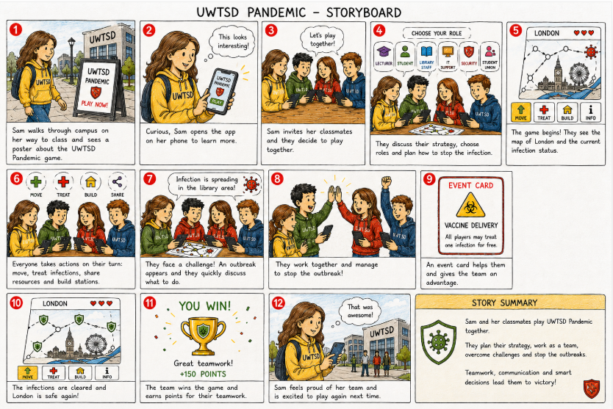
Figure 4. Full-colour storyboard

2.4 Key Screens
Three screens were crucial in the final design: Character Selection, Tutorial, and Game Board. Character Selection provides information about each role without crowding the main screen. The Tutorial provides guidance for new players, while the Skip Tutorial option allows experienced players to get started more quickly. The Game Board consolidates the main actions and game status into a single screen, using icons and clear visual states to help players understand what is going on.
These screens reflect some of the key needs identified in Assessment 1, including clearer information, fewer unnecessary steps, and an easy-to-scan interface.

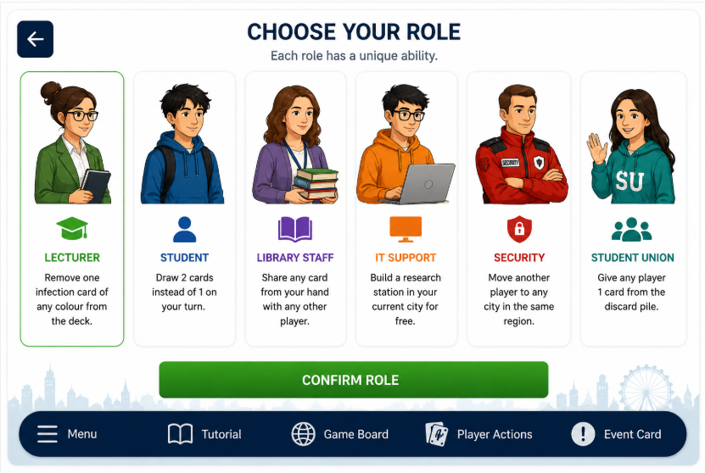
Figure 5. Character Selection
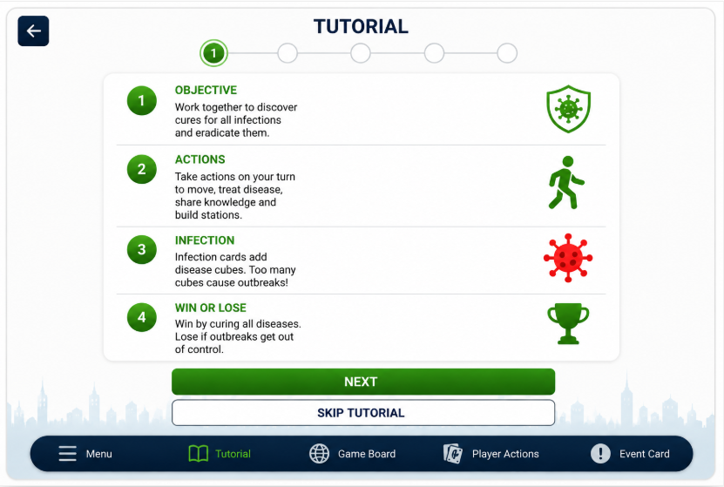
Figure 6. Tutorial

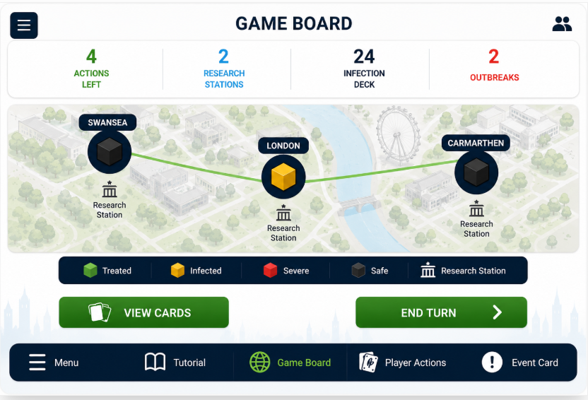
Figure 7. Game Board

2.5 Navigation Flow

The navigation flow was intended to keep the game simple and easy to understand. Before entering the game, players navigate through the main menu, campus, and role selection. During gameplay, the bottom navigation bar links to the Tutorial, Game Board, Player Actions, and Event Card screens.
The active section is highlighted so that players can easily identify where they are. A Skip Tutorial option also allows experienced players to skip unnecessary steps and get right into the game. This allows for flexible navigation for both new and returning players.

3. Feedback on Final Prototypes

3.1 Feedback Collection Method
Semi-structured interviews were used to collect feedback on the full-colour storyboards, just as they were for the wireframes in the previous stage. Most of the questions were adapted specifically for the new design, with a focus on colour, visual clarity, and overall look and feel, though a few core questions from Assessment 1 were retained to allow for direct comparison of how participants responded to the wireframes and the finished version. This method was chosen because it allows for direct observation of emotions and reactions via tone of voice and facial expressions, rather than just what a participant says. A questionnaire would provide useful answers, but it would not show hesitation, confusion or enthusiasm while participants were viewing the prototype. Each participant was shown the full-colour storyboards and asked to react to specific screens, followed by short usability and emotional response questions that followed the same general structure as the previous round of testing.

3.2 Positive Feedback

Overall, the response to the final prototype was positive. Participants found the high-fidelity design to be clearer and engaging than the earlier wireframes. The use of colour, icons, and highlighted buttons made it easier to identify key actions and game states. The navigation was also deemed simple, particularly because the active section was clearly highlighted. Features like the Skip Tutorial option, progress indicators, and cooperative elements were also well received. Participants felt that these changes made the game easier to understand while still maintaining the collaborative experience that was identified as important during the project's first stage.

3.3 Negative Feedback / Issues Raised

Despite the overall positive response, participants identified several areas for improvement. Some screens, particularly the Game Board, were considered slightly busy due to the simultaneous display of multiple pieces of information. Although short ability descriptions were already included, some participants felt that additional role information could help players make more informed decisions during Role Selection. The Skip Tutorial option improved the setup process, but experienced players may still find it too long. Accessibility was another factor to consider, as some smaller text and interface elements may be difficult to read on a mobile screen. These issues suggest that the next version should prioritise reducing information overload, improving role guidance, and ensuring consistent readability across all screens.

4. Data for a Working Version

4.1 What Data Would Be Collected, and Why
If UWTSD Campus Edition were developed and released as a functional app, two broad types of data would be collected. The first is usage data, which includes how frequently students play, how long each session lasts, which roles are chosen most frequently, where in the game flow players drop out, and how frequently each feature (chat, event cards, achievements) is used. This data would reveal whether the app is being used as intended and would highlight areas of the interface that cause confusion or disengagement, extending the usability evaluation begun with the four test users in this project [1]. The second type of data is emotional response data, which indicates whether players are satisfied, motivated, or frustrated. This cannot be inferred solely from clicks and indicates whether the app meets the experience requirements outlined in Assignment 1, not just functional ones.

4.2 How It Would Be Collected
Usage data would be collected automatically using in-app analytics that log actions such as session start/end times, screen transitions, and button taps, with no player input required. This is low effort for users and results in a large, consistent dataset over time.
Emotional response data cannot be collected automatically in the same way because feelings cannot be directly observed from behaviour. Direct interaction with users would be required, such as a short in-app rating after each session, occasional pop-up surveys, or optional feedback prompts after specific events (for example, after losing a game). Because repeated surveys can irritate users and decrease engagement, these prompts would be brief and infrequent.

4.3 Usage Data vs. Emotional Response Data
The main difference is directness. Usage data is passive and objective: it records what a user does without requiring their cooperation, and it can be collected in bulk with no additional burden on the player. Emotional response data is active and subjective: it records how a user felt and can only be obtained by asking them, resulting in smaller sample sizes and a higher risk of survey fatigue. Usage data answers the question "what is happening?" while emotional response data answers the question "why does it matter?" — both are required because high usage with low satisfaction would indicate a problem that usage data alone could not reveal.

4.4 How This Data Would Shape the Next Version
Usage data would reveal areas where players consistently struggle or disengage, such as if many players leave during Character Selection, necessitating a redesign of that screen. Emotional response data would confirm whether functional fixes improve how players feel, rather than how long they play. This would enable future versions of the app to be prioritised based on real evidence rather than assumptions, maintaining the user-centred approach taken throughout this project [1].

5. Usability vs. User Experience

5.1 A Usability-Only Approach
ISO 9241-210 defines usability as the effectiveness, efficiency, and satisfaction with which specific tasks can be completed [4]. If the storyboards had been designed solely from this perspective, several elements would have looked different. The Tutorial screen would most likely be removed or made mandatory but brief, as it adds steps before the user reaches the actual task (playing the game) that are not strictly required to operate the interface. Character Selection would display roles as a simple list with no supporting information, as selecting a role with the fewest taps is the most efficient path. Achievement badges and progress celebrations would also be reduced or removed because they do not help a user complete a task faster and introduce visual elements that are not functionally required.

5.2 Conflicts Between Usability and UX
User experience is more than just usability; it includes how a user feels while completing a task, not just how quickly or accurately they do it [5]. This resulted in three instances of direct conflict with a usability-only approach.
Tutorial versus confidence. Usability favours removing friction, but Ben and Jamie's interview responses revealed that first-time players value feeling guided, as none of the four interviewees had previously played a similar game. Removing the tutorial entirely would increase efficiency but also risk confusion and decreased confidence among new players.
Role selection: speed versus informed decision. A flat list of roles is the quickest usability solution, but peer evaluation feedback (Assignment 1, Section 7.1) revealed that users preferred short descriptions to help them select a role that matched their playing style. Adding this information improves the experience, but it increases reading time and screen complexity, which works against pure efficiency.
Rewards versus minimalism. Jamie and Alex explicitly requested achievement badges and visible progress, stating that these features kept them motivated to continue playing. A strict usability perspective would regard these as unnecessary decoration, as they do not assist a user in completing a task, only how they feel about completing it.

5.3 How the Conflicts Were Resolved
Each conflict was resolved by defaulting to the efficient usability solution and only adding the experience-focused element when it did not significantly increase the number of steps required. The Tutorial was kept, but a "Skip Tutorial" option was added, allowing returning or confident players (such as Sam) to completely bypass it while new players could still benefit from it. Short role descriptions were added directly to the Role Selection screen so that players could understand the main ability of each role before making a choice. The descriptions were kept brief to avoid adding unnecessary complexity or reading time. Achievement badges were placed only at natural checkpoints, such as the end of a round or game, rather than throughout core gameplay screens, to reduce visual load on the main game board while still providing the motivational feedback requested by the personas.
In each case, the resolution did not treat usability and user experience as competing goals, but rather used usability as the foundation and layered experience-focused elements on top, only where they did not jeopardise the efficiency identified in the interviews (see Section 4.1, Assignment 1).

6. Reflective Summary

Looking back on this stage of the project, the most important aspect was to keep real UWTSD students involved throughout, rather than guessing what a "typical" student would want. The four interviews from Assignment 1 provided a solid foundation for the personas, which paid off later. When Sam struggled with the wireframe setup sequence during testing, it wasn't a new issue; it had already been mentioned in her original interview. I just hadn't followed through on it the first time around. That was a valuable lesson: research is not something you do once and then put away. It needs to keep informing the design as it evolves.
The section on usability versus user experience (Section 5) probably influenced my thinking the most. I approached usability almost like a checklist, something to tick off. However, working through conflicts such as the Tutorial screen and the reward system taught me that usability and experience don't really compete for the same space. Usability established the floor, the unbreakable standard, and experience-focused touches earned their place only if they did not undermine it.
Peer feedback caught me off guard, in a positive way. I assumed accessibility had already been addressed, primarily because Ben's persona existed and covered it. Nevertheless, reviewers continued to bring it up. That was a valid and useful point: accessibility is not something you tick off for one persona and then forget about. It should be behind all screens, not just those designed with a specific user in mind.

7. Conclusion

This stage transformed the wireframes from Assignment 1 into full-colour storyboards, based on the same research and personas as before. Feedback on the finished prototypes came from the same interview approach as before, which I kept deliberately consistent so that I could compare how people reacted to colour and visual design, rather than just navigation and flow. Beyond the visuals, this report anticipated what a working version of the app would need to track, as well as the true difference between data collected quietly in the background and data obtained only by asking users how they feel. The discussion of usability versus user experience was the one aspect of this stage that stood out to me the most. The two are not diametrically opposed and competing for space; they simply need to be carefully considered, screen by screen and decision by decision. More importantly, this project demonstrated that design work is never truly "done" after a single round of testing. It constantly changes shape based on what real people say.

References

[1] | H. Sharp, J. Preece and Y. Rogers, Interaction Design: Beyond Human-Computer Interaction, Hoboken, NJ: John Wiley & Sons, 2023.
[2] | W. Swasty and A. R. Adriyanto, “Does color matter on web user interface design?,” CommIT, vol. 11, no. 1, pp. 17-24, 2017.
[3] | J. Rudd, K. Stern and S. Isensee, “Low vs. high-fidelity prototyping debate,” Interactions, vol. 3, no. 1, pp. 76-85, 1996.
[4] | International Organization for Standardization, “Ergonomics of Human-System Interaction — Part 210: Human-Centred Design for Interactive Systems,” ISO, Geneva, 2019.
[5] | D. A. Norman, The Design of Everyday Things: Revised and Expanded Edition, New York: Basic Books, 2013.

Appendix A - Raw Feedback Data

Questions
Q1. Compared with the earlier wireframe, how clear do you find the final design?
Q2. Do the colours, icons and buttons make it easy to understand what is happening in the game?
Q3. Is the Role Selection screen clear, and do you have enough information to choose between the six roles?
Q4. What do you think about the Tutorial and the option to skip it?
Q5. Is the Game Board easy to understand, or is there too much information on the screen?
Q6. Is it easy to understand where you are in the game and what you should do next?
Q7. Does the final design make the game feel cooperative and engaging?
Q8. Is the text, colour and other information easy to see and read on a mobile screen?
Q9. What do you like most about the final prototype?
Q10. What is the main thing you would improve?

Participant 1 – Jamie
Q1 The final version is much clearer than the wireframe. The colours make it easier to see what is important.
Q2 Yes. I particularly like the green confirmation states because I can quickly see when an action has been completed.
Q3 Yes, the roles are easy to find and understand.
Q4 I would probably use the tutorial the first time. I think having the option to skip it later is useful.
Q5 Mostly yes, but the Game Board feels a little busy at first because there is quite a lot of information on it.
Q6 Yes. The highlighted navigation makes it clear which part of the game I am using.
Q7 Yes. The progress, rewards and working together make it feel more like a team game.
Q8 Yes, most of the information is easy to read.
Q9 I like the colours and progress/reward elements because they make the game feel more engaging.
Q10 I would simplify the Game Board slightly so the most important information stands out more.

Participant 2 – Alex
Q1 It is easier to understand than the first version. The buttons and icons make the next action more obvious.
Q2 Yes. The different visual states help me understand what is happening without having to read everything.
Q3 The six roles are clear, but I would like a little more information about what each role can do before choosing one.
Q4 The tutorial is useful for the first game, and Skip Tutorial is useful once you know how to play.
Q5 I can understand the Game Board. The icons and status information help.
Q6 Yes. It is clear where I am and what options are available.
Q7 Yes. Sharing resources and completing the objective together makes the cooperative part clear.
Q8 Yes. I didn't have any major problems reading it.
Q9 I like the teamwork and resource-sharing parts most.
Q10 I would add short descriptions or more information about each role before confirming the selection.

Participant 3 – Sam
Q1 It looks much clearer and more complete than the original wireframe.
Q2 Yes. The main actions stand out and I don't need to read as much text to understand the screen.
Q3 Yes. The Role Selection screen is easy to follow.
Q4 Skip Tutorial is useful because I would not want to go through the tutorial every time I play.
Q5 Yes, I can understand it. The status information is easier to scan than before.
Q6 Yes, although I would still prefer to get into the actual game as quickly as possible.
Q7 Yes. Playing and making decisions with other people makes it more interesting.
Q8 Yes. The main information is clear and readable.
Q9 I like that the final design feels quicker and easier to use.
Q10 I would make the setup even faster for returning players, perhaps by remembering the previous campus or role selection.

Participant 4 – Ben

Q1 The final design is clearer because there are more visual clues than in the wireframe.
Q2 Yes. I like that icons and text are used with colour, so colour is not the only way to understand the information.
Q3 The roles are clear, although some additional information could be useful for someone playing for the first time.
Q4 The tutorial is useful because new players may need guidance. Having Skip Tutorial means it doesn't slow everyone down.
Q5 The main information is clear, but some smaller information could be difficult to read on a phone.
Q6 Yes. The highlighted section in the navigation helps.
Q7 Yes. The design makes it clear that players need to work together rather than play individually.
Q8 Most of it is readable, but I would make some of the smaller text larger.
Q9 I like the larger buttons and the combination of text, icons and colour.
Q10 I would improve the size of some smaller text and make sure the same accessibility approach is used on every screen.

