Accounting Fundamentals

Assignment-A1

By Anca Ghizela Hotca
(2021006/BABM Level4 T2G2/22.07.2021)

Tutor’s name: John Malagila

Table of ContentsIntroduction 3
Question 1 3
a) Preparation of profit & loss statement and statement of financial position for the year ended 31st December 2020 3
i. Profit and loss statement 3
ii. Statement of financial position 4
b) Reason to balance Statement of financial position 6
Question 2 6
a) Calculation of different ratios 6
1. Return on capital employed (ROCE) 6
2. Return on equity (ROE) 7
3. Earning per share 8
4. Net profit margin 9
5. Asset turnover 9
6. Stock holdings days 10
7. Debtors collection period 11
8. Current ratio 11
9. Gearing ratio 12
10. Interest cover ratio 13
b) Comment on the performance of Chocco Plc 13
Conclusion 14
References 15
Appendices 17

Introduction
This assignment is based on accounting fundamentals and is divided into two parts. The first part will prepare a statement of profit and loss of Kedison plc for the year ended 2020 to determine the profit or loss of the company. Further the report will show financial position of the company for the same period. In the second part of the assignment different ratios of Chocco plc will be calculated in order to determine the financial position, profitability and performance of the company. Lastly based on those ratios an overall comment on the company’s performance will be given.

Question 1

Preparation of profit & loss statement and statement of financial position for the year ended 31st December 2020

Profit and loss statement
Profit & loss statement is a financial tool used by every business organization that shows the expenses and revenue of the organization in an organized manner for a particular time period. It clearly shows the transformation of revenue into net profit after adjusting all the expenses occurred during the period (Daryanto, Muhlisin and Nugraha, 2020). Here expenses include all kind of costs incurred while running the particular business. In case of Kedison Plc several operational as well as others expenses can be seen. In 2020 the company has incurred administrative cost of £30000, cost of sales £171355, distribution cost of £2800 and directors’ remuneration of £5000. Also salesman commission of £3000 was due and unrecorded on the date of preparing profit & loss and financial position statement. Profit and loss statement gives an overview of the company’s capacity in generating profit throughout the year. If the bottom line gives positive figure then it is considered as profit or if it shows a negative figure then the firm has said to incurred loss (Husain and Sunardi, 2020).
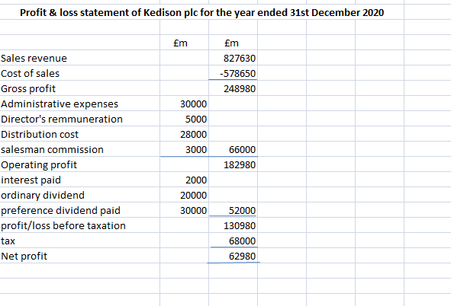
Figure 1 showing the statement of profit and loss of Kedison plc
(Source: excel)
Generally most of the business firm uses several steps to reach the bottom line of profit and loss statement. This method is known as multi step profit & loss statement. Here first gross profit is calculated by considering revenue and cost of sales of the business (Ives, 2020). In the above picture it can be seen that the Kedison plc’s revenue for the year 2020 was £826650 and cost of sales was £578650, which was deducted from sales revenue in order to reach gross profit of £248980. Purchase cost of raw materials and direct labor charges are the elements of cost of sales or cost of goods sold. Then from the acquired gross profit all other operational costs are to be deducted in order to find out the net profit of the period. Kedison plc’s total operating cost was £66000, which was deducted from gross profit to get operating profit or profit before interest and tax of £182980. After this dividend expenses of £20000 ordinary dividend and £30000 preference dividend along with interest payment of £2000 got deducted from operating profit to get net profit of £62980. Bottom line of statement of profit and loss for the year ended 2020 is showing a positive figure after adjusting all expenses. Therefore the Kedison plc has earned a profit of £62980 in the said period.

Statement of financial position
Statement of financial position commonly known as balance sheet statement shows the detailed pictures of assets, liabilities and equities of any business organization for a particular time period. Further liability side is consists of two parts equities and liabilities. Liabilities represent the companies’ obligation or indebtedness to third parties, whereas equities represent the portion of equity shareholders along with preference shares (Moschenskyy, 2017). In other words liabilities side shows the sources of funding the business. Alternatively asset side shows the application of those acquired funds.
Liabilities are further to be divided in current and non current liabilities to show in statement of financial position. Kedision Plc’s current liability is mainly consists of trade creditors of £171355. Also there is an outstanding salesman commission of £3000 in the year 2020. The company has 4% debenture of £100000 as its non- current liability. So, the company has external source of capital in the form of debenture. The financial position statement of Kedison plc is given below.
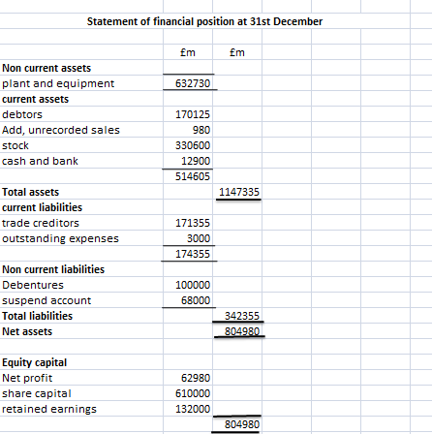
Figure 2 is showing the statement of financial position for the year ended 31st December 2020
(Source: excel)
Company’s financial position statement has clearly shown the distribution of funds in different assets. Kedison plc has plant and equipment of £632730 as its non- current liabilities. Further the current liabilities of the company are £330600 as stock, debtors of £170125 and balance at cash and bank of £12900. Further an unrecorded sale which was due on the date of preparing financial position of £980 was found. This amount was added with the debtors balance. Therefore total assets of the company on 31st December 2020 stand as £1147335 and a total liability was £342355 along with £804980 as share capital. After adjusting total liabilities and assets side a deficiency of £68000 has occurred in liabilities side, which is recorded as suspend account (Calotă, et al., 2020). Suspend account is created whenever any error happened while recording and accounting of transactions and data.

Reason to balance Statement of financial position
Statement of Financial position or balance sheet gives the overview of assets and liabilities of any business, as well as tells about the net worth of the business firm. Liabilities indicate the sources of fund, whereas asset side shows the application of those funds (Rebaccal, 2019). Suppose X a business owner takes bank loan of £45 million and segregate this fund in purchasing raw materials and a plant for the company. Here the amount of bank loan will go under the liabilities and the plant and raw materials or inventories will show as assets in the asset side of the balance sheet. If equities & liabilities don’t match with assets it will indicate that some error has happened while accounting, such as wrong entry into accounts, omission of data etc. So, if financial position shows more assets and less liability it will raise question where the fund does came from and similarly if liabilities side is more than assets side it will question where the raised fund being used. So, if accounting rules are strictly being followed with making any error, the financial position must balance (Daryanto, Muhlisin and Nugraha, 2020).

Question 2

Calculation of different ratios

Return on capital employed (ROCE)
Return on capital employed is an accounting tool used to measure the capacity of the company to make profit with each dollar of investment made. So, it is a kind of profitability indicators for any firm. To determine the return on capital employed earning before interest and tax is divided by capital employed. Capital employed is the excess of total assets over current liabilities. Higher return on capital employed is considered more acceptable by the business firms as it indicates higher efficiency (Husain and Sunardi, 2020).
ROCE= total assets/ current liabilities
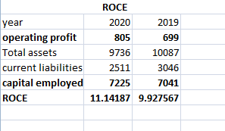
Figure 3 showing the calculation of ROCE
(Source: excel)
ROCE of Chocco plc for the year ended 2019 and 2020 was 10% and 11% respectively. The company has maintained a balance ROCE in both the year along with a little development in 2020. The proportion of increase in operating profit in the later year is more than the increase in capital employed, which has ultimately result in getting more return from capital investment.

Return on equity (ROE)
Return on equity is the tool to measure company’s performance in relation to the shareholder’s equity. It is necessary to figure out the company’s capability in generating income with the shareholder’s fund. Whether return on equity is acceptable or not by the company depends on the type and nature of the company. Net income of the period is divided with shareholders fund/ equity to find out the return on equity (Rahman, 2017).
ROE= (Net income/shareholders fund)*100
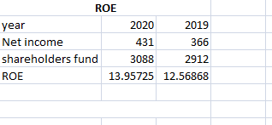
Figure 4 is showing the calculation of ROE
(Source: excel)
Return on equity of Chocco plc was 12.5% in 2019 and 14% in 2020. So, this increase on Return on equity indicates that the company is generating more profit without investing much of equity capital. This also signifies the efficiency of company’s management.

Earnings per share
Earnings per share is used as a profitability measurement of the firm against number of shares. By dividing earnings available for shareholders with number of shares outstanding can generate Earning per share (Reid and Myddelton, 2017). This indicator is widely used for the valuation of the firm and to compare companies of same size and type. This indicator is mostly used by the external parties like investors of the companies to decide the value of the company.
EPS= net profit/ number of outstanding shares
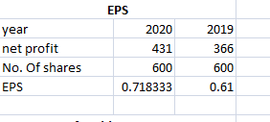
Figure 5 showing the calculation of Earning per share
Earnings per share of Chocco plc in 2019 was 0.61 and in 2020 was 0.71. So, the company generates almost £1 against each equity share. Further there is a slight increase in the EPS in 202. This again indicates that the company has increases its efficiency in generating profit either by reducing cost or increasing sales.

Net profit margin
Net profit margin is one of the profitability measurements of the firm. It uses the net profit to determine the ultimate profit earning capacity of the firm from sales revenue. By tracking the trend of net profit margin a company can decides whether current policies and strategies are giving fruitful results or not. This ratio determines the overall efficiency of the managerial decision (Agusta and Hati, 2018).
Net profit margin= (net profit/ sales)* 100
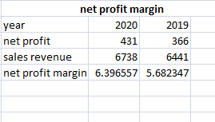
Figure 6 is showing the net profit margin
(Source: excel)
Net profit margin of Chocco plc has a increasing trend from year 2019 to 2020. In the previous year company’s net profit margin was 5.6% which was increased to 6.3% in the later year. So it indicates that the management of the company has more efficiently operated operational as well as other costs in 2020 along with the increase in sales.

Asset turnover
Asset turnover ratio indicates the number of times assets are turnover to generate each dollar of sales. Net assets are to be divided by average total assets of the period to calculate this ratio (Singh, 2017).
Asset turnover = net sales/ average asset

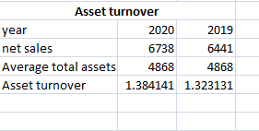
Figure 7 showing the calculation of assets turnover ratio
(Source: excel)
Asset turnover of Chocco plc for the year 2020 was 1.38 and 2019 was 1.32. The asset turnover ratio of the company is quite good in both the year. Also there is an increase in asset turnover in 2020 which represent that company’s capacity to generate sale with available assets is appreciable.

Stock holdings days
Stock holding days refer to the average number of days any business organizations hold their inventory or stock. This is to be calculated by diving total inventory by cost of goods sold and then multiplying the figure with 365 to determine the time in days form. Too lengthy stock holding period signals the either company’s inefficiency in stock management or fall in, market demand (Izzalqurny, Subroto and Ghofar, 2019).
Stock holding days = (Inventory/ cost of sales) *365
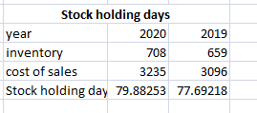
Figure 8 is showing the stock holding day calculation
(Source: excel)
Stock holding period of the company in 2019 was 78 days and in 2020 was 80 days, which is surely not sign of an efficient inventory management. The management needs to focus on their inventory management plan. The company either by lowering stock proportion or by increasing demand can improve stock holding.

Debtors collection period
Debtors collection period refers to the average time period taken by the customers of a company to clear due payments. The longer debtors’ collection period is not favorable by any company as it will tie up funds to debtors for long period, which in turn will also increase the credit risk (SUTHAR, 2018).
Debtors collection period= (trade receivables/ sales) *365
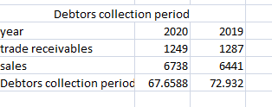
Figure 9 is showing the calculation of debtor’s collection period
(Source: excel)
The debtors’ collection period of Chocco plc is showing a lengthy collection gap in both the years. In 2019 company takes almost 73 days to collect its dues from debtors but in 2020 the time has slightly reduced to 68 days. The company has tried to reduce collection period 2020 but it still not sufficient to be acceptable. The management needs to imply effective strategy to reduce collection period to maximum of 1.5 months.

Current ratio
Current ratio is used to measure the short term solvency of the company. Whether a company can sustain with its current ratio or not depend on the nature of the company. Generally a higher current ratio is considered better than the lower. Management of current assets and liabilities is very important for ensuring the short term solvency of the business (Agusta and Hati, 2018).
Current ratio= current assets/ current liabilities
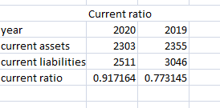
Figure 10 is showing the calculation of current ratio
(Source: excel)
Current ratio of Chocco plc in the year 2019 was 0.77 and in 2020 was 0.91. Current ratio of the company in the later year was comparatively higher than the previous year. The company’s current liabilities in 2020 has decreased significantly and comparatively more than decreased in current assets. Decrease in trade payables and in other creditors signifies the company’s efficiency in paying short term debts.

Gearing ratio
Gearing ratio is used to compare different form of shareholder’s equity with borrowed capital. Capital gearing ratio determines the shareholders risk against external capital(SUTHAR, 2018).
Capital gearing ratio= total debt/ shareholders equity
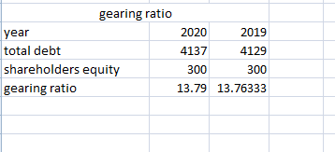
Figure 11 showing the gearing ratio
(Source: excel)
Capital gearing ratio of Cocco plc in 2020 was 13.79 and 2019 was 13.76, which is quite acceptable in both the years. It also indicates that the shareholders’ interests are safe in relation to external borrowings.

Interest cover ratio
Interest cover ratio is determined by dividing EBIT by interest expenses. Therefore this ratio indicates the capacity of company’s profit to cover external debt like interest expenses (Rahman, 2017).
Interest cover ratio= EBIT/ interest tax
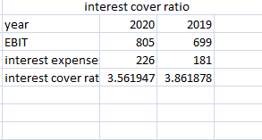
Figure 12 is showing the interest cover ratio
(Source: excel)
The company’s capacity to cover its interest expense with the profit was almost thrice in 2020 which was lower capacity compared to the company’s capacity in 2019. The company needs to maintain this ratio in the following year because any further fall in this ratio may put the company in difficulties.

Comment on the performance of Chocco Plc
Chocco plc has managed its performance quite well in both the year 2019 and 2020. It can be seen from the ratios like ROE, ROCE and Net profit margin that the profitability of the company is admirable. Moreover company’s profitability from all aspect is sufficient and has an increasing trend in 2020. From net profit ratio overall profitability of the company was determined, which has shown a sustainable ratio. Further the profitability measurement in compare with equity invests, capital invests and assets are all signaling healthy financial position of the company.
Further the performance measurement of the company is not showing effective managerial control almost in all aspect of company’s performance. Inefficiency can be shown both in stock management and in debtor’s collection. In one hand stock is being kept by the company for quite a long period and on the other company’s collection period is also taking quite long period to recover its dues.

Conclusion
The first part of the assignment has focused on Kedison plc’s financial position statement and on the statement of profit and loss. The statement has shown that the company has incurred profit in 2020 but a suspend account has been found in financial position statement. The management need to review all entries in order to find out the error created while recording data. The second part of this report has calculated several ratios of Cocco plc and based on those ratios financial strength and performance of the company has been discussed.

References
Agusta, R.F. and Hati, S.W., 2018. Calculation of Liquidity, Solvency and Profitability Ratio in Manufacturing Company. Journal of Applied Accounting and Taxation, 3(2), pp.110-116.
Calotă, T.O., Robu, S.A., Oncioiu, I. and Burlacu, G., 2020. The Informational Value of the Profit and Loss Account in Line With International Accounting Standards. In Management Accounting Standards for Sustainable Business Practices (pp. 80-91). IGI Global.
Daryanto, W.M., Muhlisin, I.A. and Nugraha, I.M., 2020. Financial Performance and Stock Performance Analysis at PT Aneka Tambang Tbk. Before and When The COVID-19 Pandemic in The First Half of 2020. South East Asia Journal of Contemporary Business, Economics and Law, 23(1).
Husain, T. and Sunardi, N., 2020. Firm's Value Prediction Based on Profitability Ratios and Dividend Policy. Finance & Economics Review, 2(2), pp.13-26.
Ives, M., 2020. Financial Statement Analysis. In Encyclopedia of Public Administration and Public Policy (pp. 1472-1478). Routledge.
Izzalqurny, T.R., Subroto, B. and Ghofar, A., 2019. Relationship between financial ratio and financial statement fraud risk moderated by auditor quality. International Journal of Research in Business and Social Science, 8(4), pp.34-43.
Moschenskyy, S.G., 2017. INTERNATIONAL RULES FOR LIABILITIES DISCLOSURE IN THE FINANCIAL POSITION STATEMENT (BALANCE SHEET). In Science and practice: innovative approach (pp. 190-194).
Rahman, A.A.A.A., 2017. The relationship between solvency ratios and profitability ratios: Analytical study in food industrial companies listed in Amman Bursa. International Journal of Economics and Financial Issues, 7(2), pp.86-93.
Rebaccal, A., 2019. A STUDY ON FINANCIAL STATEMENT ANALYSIS. Scholar: National School of Leadership, 8(1.5).
Reid, W. and Myddelton, D.R., 2017. Ratio calculation. In The Meaning of Company Accounts (pp. 34-34). Routledge.
Singh, S., 2017. Ratio analysis in manufacturing sector a study. International Journal of Innovative Research in Engineering and Management, ISSN, pp.2350-0557.
SUTHAR, K. (2018). Financial Ratio Analysis: A Theoretical Study. International Journal of Research in all Subjects in Multi Languages, Gujarat, India.
Van Mourik, C. and Katsuo Asami, Y., 2018. Articulation, profit or loss and OCI in the IASB conceptual framework: Different shades of clean (or dirty) surplus. Accounting in Europe, 15(2), pp.167-192.

Appendices



