

NAME: PLACIDO OWONO BOKESA
STUDENT ID NUMBER: 1605627
LECTURER’S NAME: YAJESH KUMAR

School of Business London Campus

Emergent Leadership Skills for the Workplace
BMSK6001

Contents
Introduction 3
McDonald Workplace culture 3
McDonalds Leadership role 4
Whitbread board Annual report 2017/2018 6
Whitbread CEO leadership Style. 7
Conclusion & Recommendations 7
Appendix 8
Appendix1 8
Appendix2 9
Appendix3 9
9
Appendix4 9
References 10

Introduction
In this essay, the author, through the search for information, find out what are the factors that produce employee high performance and engagement at McDonald's. First In the statement, the author describes McDonald's workplace culture and the tools and techniques used by the corporation for the employee's wellbeing. Herzberg's two-factor motivation theory uses to demonstrate that employees are happier and more engage if they feel highly motivated. Also, the author provides information about how McDonald creates a structure and how it creates development programs so that his employees have different approaches and can seek a career within the organization. Also, the author gives several examples of managers leadership profiles within the organization, what trait approach they do? Also, how they act with their key responsibilities of a leadership role with effectiveness? Another part of this essay, the author defines what leadership is and whether it affects the organization. The author also gives some examples of McDonald managers job performance, and some rules to follow to be a good leader. The report describes the benefits and problems of each leadership; bear in mind that the most important attribute of this second section is to try to intertwine the job description with some leadership. Additionally, here is how Whitbread annual report gathers all the activities in which the board is involved, the techniques that the board uses, and how it distributes the dividend with its shareholders. The last section describes the approach method and leadership style that Whitbread's CEO has with her employees. The trait approach theory is also well defined to know the characteristics of a leader and finally, the author, try to identify his strengths and limitations, uses a precise step-by-step effective method, the conclusion, recommendation, appendixes, and references close the essay on how good emergent leaders are made.

McDonald Workplace culture
MacDonald corporate management knows that the motivators factors to their team and managers allocated in numerous restaurants around the world have influences when creating a positive organizational high performance' commitment and effectiveness to provide employees an excellent work environment. McDonald corporate management culture is that everyone has the right to speak freely without having to worry or concerns about the application of their human and ethical rights. Macdonald corporate management uses an anonymous development tool channel called the 'Business Integrity' line that is open 24 hours a day to anyone. In terms of emphasizing individual and take calculated risks, McDonald management uses anonymous feedbacks in each branch that its employees make called 'your viewpoint' that helps to know and understand how their employees feel when they go to work and also offering employees strengthen progress towards organizational objectives and goals. The head offices and restaurants receive the feedbacks results to generate an action plan to enhance the job performance, goal-oriented, and the confident leadership responsibilities role need for each branch. (Mcdonalds,2017-2019). The author of the essay suggests that the Herzberg's two-factor motivation theory, which is a model which describes the factors that affect the personal feeling of satisfaction or dissatisfaction in any organization. It is very important for any McDonald manager or assistant manager knows this theory to be able to understand their responsibilities within the organization and employees job performance.

- Factors causing satisfaction: 'satisfiers' are intrinsic motivators who are related to the job itself, development, opportunity responsibility, recognition, and the need for achievement. These factors attempt to endeavour individuals needs of self-realization and self-actualization
- Factors causing dissatisfaction: 'Hygiene factors' are those related with job context, such things as salary, personal life, status working conditions, and company policies; it is a concept that neither motivates nor satisfies but because it identifies needs, its key responsibilities of the leadership role to eradicate dissatisfaction at the workplace and create right attitude towards real work. This Herzberg method emphasizes the positive value of the intrinsic motivator factor (Amstrong,2005).

It is part of MacDonald' core culture to motivate and recognize its employees concerning their job; the author through reflective research suggest that this theory is employed at McDonald's because if the workers are happy even in a low- skill position, the customers are too. It is also important to realize that hygiene and motivational factors help avoid problems for the manager or assistant manager and allow him to assess key responsibilities of the leadership role, empower the employee, improve the work environment, assign jobs and improve the employee work performance, giving them greater job satisfaction (Adair, zodml.org, 2004). The largest fast-food restaurant chain goes fast, either serving its fantastic meals to its customers or helping its employees build their future. Inside the business

organization structure, McDonald corporate management provides its employees from different background, flexible shifts, opportunity, equality, and development. The employees share the same approaches: optimism, customer satisfaction, and a fun workplace environment (Mcdonalds,2017-2019). A person with the naked eye would think that the managers at McDonald's almost always influence their employees by status and power since the average MacDonald's employee is juvenile or inexperienced profile. However, this is not the case, because, particularly during the busiest business time slots, Assistant managers were observed working at a speedy pace as fast as others. Additionally, it is true that most of the time, assistant managers are relatively relaxed and calm and sometimes were hard to identify them from other employees. The organization culture, in general shows that managers or assistant managers did not seem interested to put any vertical obstacle between themselves and their subordinates.
Furthermore, assistant managers and their key responsibilities of the leadership role want to see employee's wellbeing and emotions; something was not expected in this scene. The Corporate Values belief in employee 'training' makes McDonald corporate management offer training not only to its executives but to all its employees. This characteristic makes the organization reinforce and distribute its values in all directions. This culture, which is a pillar in corporate management, believes in people rather machines. To conclude the author, mention above McDonald training purposes also serves as key responsibility of the leadership role to make the employee feel valued and essential within the organization and to achieve a positive corporate image based on the employees' importance and growth. (Goldman, 2008).

McDonalds Leadership role
To learn what leadership style, the manager should take into consideration that the meaning and interpretation employees have in their mind is important, at least when the employee 'voluntarily' obey orders. McDonald manager should make a continuous effort to apply effective leadership styles allow him to make interpretations in and try to identify how their employee think? How they relate to the ideas and systems? Know very well his responsibilities in his leadership approach. Therefore, in the sociological meaning, leadership style is a way of understanding the social interpretation of all those concerned in the process in which, leaders, employees, leadership style, and actions are acts. This, of course, does not mean that leadership style influences or impact can change the culture that was already before (Alvesson, 2013). Thus 'motivation' creates voluntariness, and at McDonald's, they recognize that well, at first sight, the working environment and key responsibilities of the leadership role is presented calm, and tasks do not seem stressfully even in lunch and dinner rush hours, employees never seem anxious or stressed (Goldman, 2008). That is why McDonald's assistant managers or managers styles is not to manage his team through 'fear' but with the attribute and knowledge of the concept of emotional intelligence. When employees were in low-activity times, they usually clean their stations, chat with their colleagues, or get something to drink from the soda machine. Any probable work environment impact or change is a consequence of how a team read and give significance to various leadership styles the manager applies. It is essential to notice how the team interact with each other, to know how they interpret it? In terms of organizational culture if it has been reformed or transformed by some external agents to having social awareness in terms of empathy, how the understanding may go wrong when conducting a cultural analysis. The manager should be mindful to the aspirations that illuminating organizational culture and the importance of continuous self-development. Focusing on the levels of behaviours rather than the level of meaning, he can display confidence and self-assurance. However, leadership can be dangerous when a manager or assistant manager has employees does not think autonomously and only let their leader enchantments lead themselves. For different team works, leadership or one leadership style can be a negative thing because may be related with elitism, authoritarianism or be non-professional, these groups often believe that qualified people do not need a boss to be oriented and tell them how to do their job (Alvesson,

2013). The leadership style applied by the manager is important because it influences the team who are responsible. In some cases, leadership style can raise or reduce the levels of engagement. It is not enough to know one type of leadership style to be a good leader, but there may be time and place where to use different leadership style approach (Wang, 2015). The author indicates what type of leadership style the candidate of team leader should apply according to McDonald job description (app) that seek to fulfil responsibilities of his leadership function. The team leader principal duties are delegate and assign tasks. This key responsibility of the leadership role closely linked in 'decision making, communication, and be a good motivator person,' top three essential attributes to be a good team leader. It is the immediate effect of reflection, reporting, and achieving tasks, and it is required for the new team leader to be ready to assess and work hard until 'it injures.' It is about when? How? What? How and where? Leaders should act, more concrete, decision making is something direct to obtain a goal and the tasks done, but many times, there are obstacles to face through actions, this requires judgment and potential to assimilate risks. Besides, the team leader practice these principal duties of his leadership position are very important. The method contains six elements to make an effective decision, and they are the following ones (Adair, zodml.org, 2004):

- Establishing the purpose.
- Collecting enough data.
- Recognizing the available possibilities.
- Appraising those possibilities.
- Creating the decision.
- Examining its implementation.

In terms of which leadership style used, the team leader should apply the 'affiliative' leadership style, according (Guerri, 2019) identified the facts that leaders want the employee to be happy and harmonious. Leaders always seek to emphasize the relationships they keep with their employees through the tasks. This method uses emotional bonds to create loyalty and motivation in its employees.
The approach advantages establish a channel of communication between employee and leader, and this allows both parties to collaborate effectively. Leaders who approach these leadership styles use feedbacks often and are flexibles according to a conducted survey. However, without a clear and directives vision, the employee could become rude, and all their work loses value because it is not aligned with the organization objectives. Other outstanding requirements in the job description (app) is assisting with meal service; an excellent key responsibility of the leadership role for a team leader is to represent the organization to the team and vice versa; McDonald team is functional rather than individual and works autonomously while not all employees can be superstars. All that team should do is focus their attention on a specific area, if one employee falls or is unproductive in his post, it can be detrimental to the rest of the group because it is disadvantageous and costly delays. McDonald team is not self-reliance and requires constant direct orders.
The team leader should be aware of what leadership style fit to raise self-esteem at the same time identified who require it. The leadership style that best fits are 'democratic leadership style' because it is where the team works participate in the decisions, but the final word has the team leader. This democratic leadership style is characterized by the fact that the team leader within the group creates more motivation, participation, and creative skills. The tasks efficiency and the job quality are the direct team leader key responsibility of the leadership role. So, it is imperative to attempt for the leadership

style to motivate the team, not punish the team, reward good jobs performance in not too long periods (Guerri, 2019). The next key responsibility of the leadership role in the job description (app) for the team leader is to supervise the team and be able to manage a team, the team leader should build first a 'good team' and he can do so through the method of an effective lead management, which believes that good team are those whom: (1) have a clear vision of how to do the job,(2) have the ability or confidence to face new challenges,(3) believe and be identified within the organization, (4) stay together when things go though, (5) keep respect and trust with managers and adapt to potential changes in the environment. Leaders key responsibilities of the leadership role to build a good team, should provide functions such as planning, initiation, control, support, information, and evaluation (Adair, zodml.org, 2004). In terms of which leadership style use, the team leader should display the Edwin Friedman model explains better the 'visionary, and charismatic' leadership style is the best style to build a close bond with the team. Friedman's leadership style states that vision and commitment are what makes a man progress and leader success.
Edwin Friedman describes how the leader physical' presence', is important to create calmness, confidence, and attention among the team. For Friedman, presence is an important characteristic to be a good leader because it demonstrates the ability to take responsibility and respond emotionally mature. Friedman thinks that wherever the head goes, the body follows him next. If the leader connected to the team, the team would follow the leader's direction. This leadership style model widely used in team building, enhance the relationship between employees and managers, and communication improvement (Kavanagh, 2019). The outcome is a confident team that commits to aim the organizational objectives, and the team leader engages to his crew. Knowing how to manage innovation is a challenge for the responsibilities of his leadership role.
and especially for top managers. As a team leader, it is an innate quality to actively remind employees of their commitments so that they can think positively about new ideas. In term of Emotional intelligence, one McDonalds manager uses a trait denominated ‘selling approach’ with this emotional intelligence quality she demonstrates the high level of key responsibilities of leadership role she has with her employees. Beyond giving simple orders, she makes feedbacks and is open to alternative ideas that her team can suggest. The manager behaves like this because his team is in the last stage of its development, and she seems comfortable outside a predefined role (Goldman, 2008). Few emotional intelligence ‘treats’ itself alone cannot describe a single effective method in key responsibilities of the leadership role; however, it is considered a set of high skills that includes optimism, ‘integrity, honesty, self-confidence, and drive’ (Daft, 2006).
Women leadership styles, according to a survey carried out, generally have different characteristics than men. They show that as having more idealized influence, subordinates tend to follow more what they do. Women are more inspirational motivator which means that their subordinates see them as a symbol or element fitted to motivate them and fulfilling the objectives desired of the organization; individually they respond better, they focus their attention in the inexperienced employee so, through the learning lesson task and providing greater intellectual stimulation. Women leaders always question the established methods and challenge their employees to think in new ways. In usual, this emotional intelligence ‘traits approach’ practiced by women leaders, according to the survey, are more ‘prolific, satisfying, and help the employees to work harder in the workplace (Daft, 2006). In this case, the type of leadership style that women use most is coaching because they focus unconsciously on the employee to identify their strengths and weaknesses. Their primary mission is to help the employee development within the organization. The advantages of this leadership style are the

continuous open communication growth channels, and the good vibes employee values feel and the effort it needs to give the best of itself. The disadvantage of the leadership style is because it is a slow process that ignores the short-term failures for long term gains and recognizes the same low-performing employees and high-performing employees, providing high performers a reason not to keep up their high level of productivity.
Additionally, a leader or manager should not reflect a domineering personality over subordinates not to discern their guiding motivations. Thus, the leader should entrust the subordinates less experience because it is the only way they acquire the relevant experience, skills, and knowledge. Another emotional intelligence trait of a great leader is to transform their subordinates to help them meet their needs as individuals within a group. As a general principle, the more members contribute in decisions making, the more they feel motivated and aware in the life functional group, this is a potential opportunity to complete and empower their sharing decisions with the team (Adair, Effective Leadership Development, 2006).

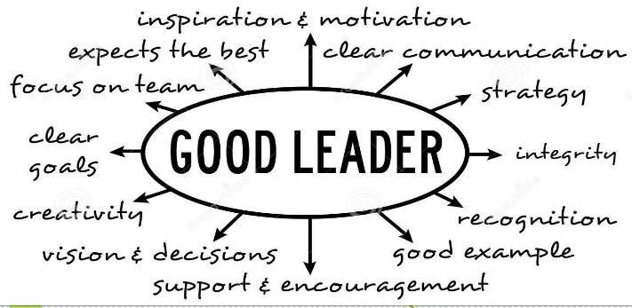 (Lacroix, 2019)

Whitbread board Annual report 2017/2018
The organization vision and mission statement are to grow and expand the business through the winning team that gets its customers back. The board should increase profitable growth through a system that is passionate and focuses on everyday efficiency, along with pride, focuses on helping the community by offering jobs and services for everyone. Whitbread has more than 50000+ employees divided between its two organizations. Costa and Premier Inn continue to invest and give a considerable part of their profits to the employees' development in their different levels. The surveys conducted technique is the proper development tool to identify employees' limitations and strengths. The board has shown that the high engagement level is something possible, and they want to ensure that all managers work to make Whitbread an even better workplace. The most board effort is the advancing development strategies applied, and through the two-way dialogue, feedback designates to listen to the employees actively keeps employees motivated and with monetary rewards. There are numerous ranges of methods to evaluate and monitor the organization financial activities. These methods include two statutory ways: total income and earnings before tax. Other existing systems are the (APMs) such as underlying earnings before tax, like for likes, and sales and return on capital are also evaluable and regular methods because they also assess how the organization business performance works internally.-see in- (app1).The dividend distribution policy within the organization is to increase broadly in line with the annual profit cycle. The share price has risen by 5.8% in one year, and shareholders are again announced to participate in a yearly reinvestment plan (Whitbread, 2018). The organization statement review is conducted by the board to assure that the economic unit and the outcomes are correctly reflected.

The Board responsibilities are to maintain the long-term organization accomplishments and keep it effectively controlled to evaluate any risk if it occurs. All board members are responsible for tactics, opportunity, and people. The chairman and the chief executive maintain the difference in functions and respective roles. Apart from the chairman and chief executive officer, there are four interdependent non-executive directors and three executives' directors. At Whitbread, they understand that it is indispensable for the board to include a different wide experience variety, backgrounds, and qualities to contribute to the organization challenge and mutual respect in all aspects and among all board members positively. The corporate governance is responsible for creating the necessary reports to display how the organization has compiled with code 2017/2018; these codes reflect that who new figures have signed with the organization and are the key framework where the organization interacts with stakeholders, investors, and employees. For Whitbread's values and culture to be paramount, corporate governance should work together with the management area to ensure the organization's strategies and display the board activities. The Director's report shows that the organization plan is to achieve the key performance indicators through discipline, and they follow three priority strategies that are: (1) Grow and innovate in the nucleus UK-based businesses, (2) Focus attention on the power they have to expand globally and (3) Build the ability to sustain long-term growth. All the information about the organization key performance can be found in detail (app2). The HR director's revision, Louis Smalley, says that they are very focused on employee retention and career development opportunities, so much so that offering opportunities for developing their career remains to be the core of the strategies they follow. The Auditors report analysis display that the important areas of analysis and the measures considered by the Audit Committee report Committee, concerning the accounts, were: Non-underlying items, Defined benefit pension, Intangible asset capitalization, Impairment, and Residual value and asset lives.

Whitbread CEO leadership Style.
The chief executive director Alison Brittain has the innate talent to encourage and motivate employees who work customer-facing so that they can work and provide excellent service to customers. Alison has a strong belief that customers are the heart of the business and is, therefore, well adhered to the Whitbread culture (Seymour, 2016). The trait theory of leadership attempts to focus on the characteristics and different personalities that are linked to the leader to or occur in different situations. This theory focuses more on the deals that the leader exhibits since the leader personality is something that he alone possesses, closely relates to the intelligence, confidence, integrity, and leader determination. The traits that the leader uses with his followers define if his leadership is operative; this theory emerged from early research to discover how a leader can perform effective leadership. The author, on this occasion, has identified that the executive chief director uses an approach that defined as the ability to encourage people. Any prominent leader apprehends how to stimulate and motivate others to do their best (Cherry, 2019). For leadership style the author describes Whitbread's CEO of using a democratic style, the characteristics of this type of style, is that the leader shares the decisions to be made with his followers, as in a democratic government the leader provides a structure and at the same time acts as a guide. The outcomes of this style of leadership make the followers participate in the decision-making process and feel more valued in that atmosphere (Brehse,2017).
The author to be self-aware and assess his strengths and limitations needs to identify what others also think about him. The author uses a tool called Johari window that covers (1) what author or others know about himself (2) what author reveal to others and what others know about he, without being him conscious. The first pane is called popular because it fills in information about what the author and others know about

himself. Over time the quadrants are wider or longer to teach what knowledge of growth and delivery has occurred over time. In the end, the author should compare this pane with overtime to see the changes that have taken place in the open pane (app3). The second step is to identify what kind of leadership approach the author uses. The author uses a questionnaire whose purpose is (1) to see what type of leadership the author view (2) to explore his different perceptions about the different aspects of leadership the questionnaire can be found in (app4). The result of the author's approach has been the trait emphasis, suggest that the author accentuate the performance of the leader and unique leaders faculty in the leadership process, in another words followers, tend to recognize or look to the leader for how tasks should be performed (Cherry, 2019). Because there are different situations to use different leadership styles, the author discovered that situational leadership focuses on the actions of followers rather than those the leader follows. That is why the leader has four options and to select the most coherent for each situation, which is (1) delegating (2) preserving (3) coaching (4) leading. In the case of the author, if he finds an employee who does not know how to do the task, he is required to use the fourth option directing, the leader who uses situational leadership adapts to any situation that may be encountered and may act differently with different employees (small business, 2019).

Conclusion & Recommendations
The three pillars of high-performance are ‘competence,’ which means that leaders can understand when to apply leadership styles for each situation in their leadership role responsibilities. It is very important to know the skills that a leader has because it could make his leadership style could impact or change organizational culture. Motivation in the workplace is a fundamental pillar because it creates engagement and well-being among leaders and employees. Leaders who recognize how to motivate their employees often use emotional intelligence even in adverse situations. The leader should be careful about adopting a different leadership style with his employees. The more motivated employees there is more high productivity, preserving motivation high effects allows creating team cohesiveness. The key for employees being considered as part of a well-structured organization with excellent training and development programs is the opportunity. Leaders should enable employees to be able to reach decisions, to develop, to communicate so that everyone seems heard to so that the leader through a range of questions can make an active choice if there is a difficulty. The style that the author would choose to lead is the charismatic leadership style because it is characteristic where the leader motivates and inspires employees. Charismatic leaders’ intentions rely on not change organization culture or transform a team but to focus on themselves and their ambitions. The disadvantage of this style of leadership is that be very focused on the self-ambitions the author may think that he never does anything wrong and that everything he does is right (mindtools, 2019).

Appendix

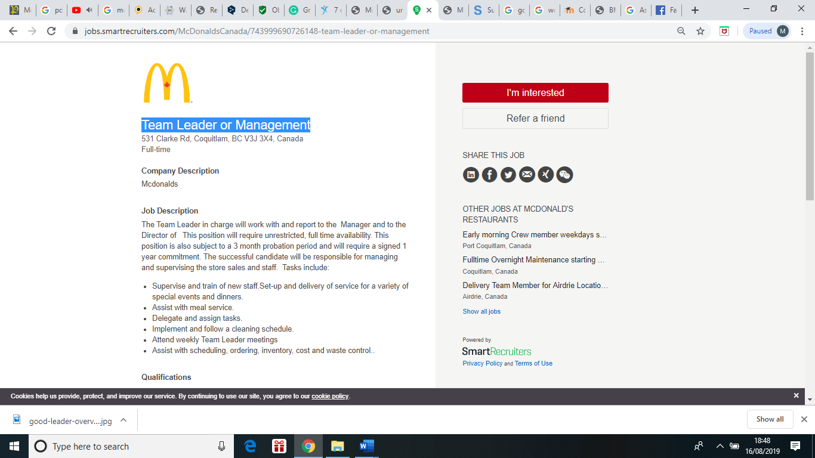 (Smartrecruiters, 2019) Job description

Appendix1
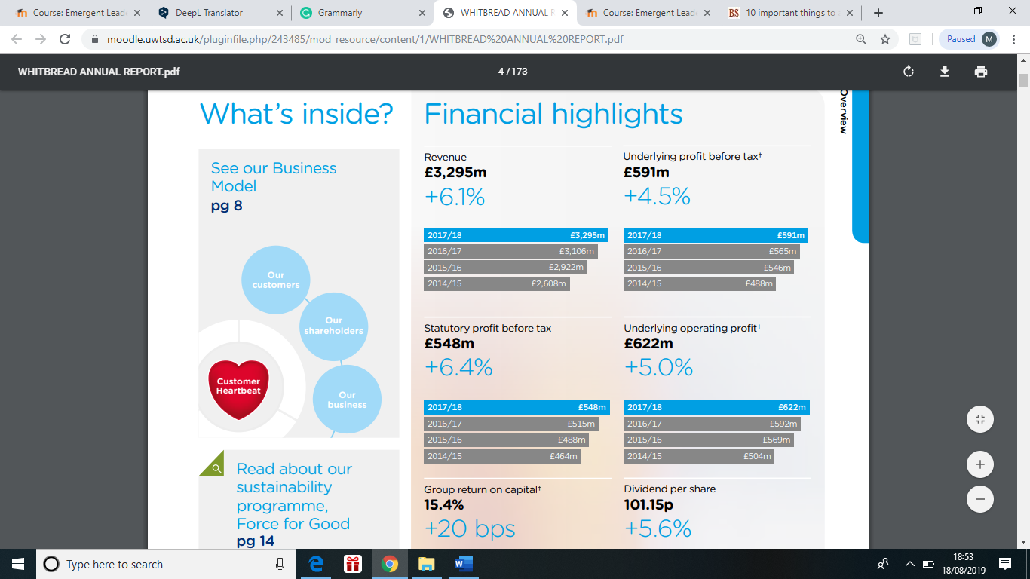 (Whitbread, 2018) APMS

Appendix2

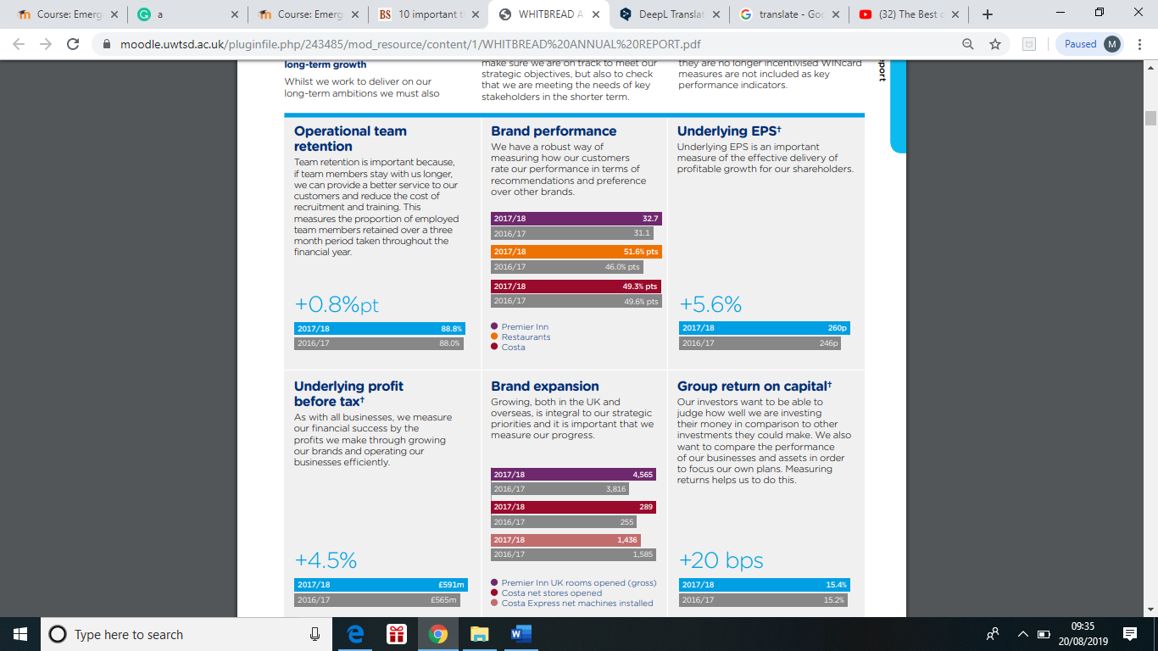 (Whitbread, 2018) KPI

Appendix3

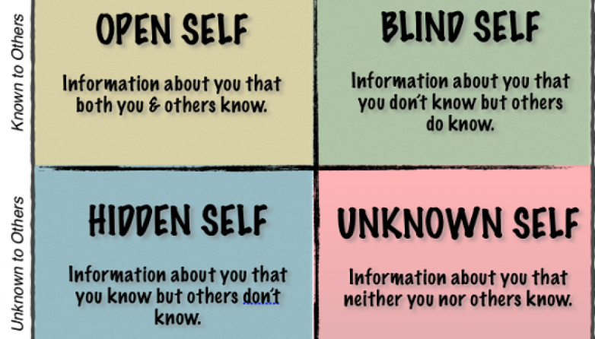 (successfulculture, 2019) Johari window

Appendix4
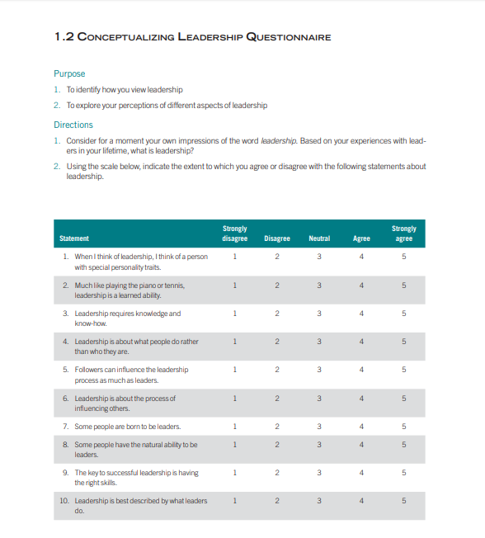 (gvsu, 2017) Questionnaire

References
Adair, J. (2004). zodml.org. Retrieved from zodml: https://zodml.org/sites/default/files/John_Adair_The_Handbook_of_Management_and_Leadership.pdf
Adair, J. (2006). Effective Leadership Development . London: Jaico Publishing House .
Alvesson, M. (2013). Understanding Organizational Culture. SAGE.
Amstrong, M. (2005). Developing effective people skills for better leadership and management. United states : Kogan page limited .
Brehse, T. (2017). ignitespot. Retrieved from ignitespot.com: http://blog.ignitespot.com/how-to-use-the-right-leadership-styles-to-motivate-your-team
Cherry, k. (2019). verywellmind. Retrieved from verywellmind.com: https://www.verywellmind.com/what-is-the-trait-theory-of-leadership-2795322
Daft, R. L. (2006). the leadership experience. Stamford: Cengage learning.
Goldman, E. (2008). Observation of Leadership & Organizational Behavior at McDonald's. ericgoldman.name.
Guerri, M. (2019). psicoactiva. Retrieved from psicoactiva.com: https://www.psicoactiva.com/blog/7-estilos-liderazgo-cuando-usarlos/
gvsu. (2017). gvsu. Retrieved from https://www.gvsu.edu: https://www.gvsu.edu/cms4/asset/2A5AE22B-956D-2248-D9B84E75755BA24E/session_two_conceptualizing_leadership_17.pdf
Kavanagh, E. (2019). Three Leadership Models:Kurt Lewin, Hershey and Blanchard, and Edwin Friedman . University Canada West Business School.
Lacroix, A. (2019). dreamstime.com. Retrieved from dreamstime: https://www.dreamstime.com/stock-illustration-good-leader-overview-skills-qualities-image47100420
Mcdonalds. (2017-2019). mcdonalds corporation. Retrieved from /www.mcdonalds.com: https://www.mcdonalds.com/gb/en-gb/help/faq/18357-what-is-mcdonalds-culture-like.html
mindtools. (2019). Leadership Styles. Retrieved from mindtools.com: https://www.mindtools.com/pages/article/newLDR_84.htm
Seymour, A. (2016). foodserviceequipmentjournal. Retrieved from foodserviceequipmentjournal.com: https://www.foodserviceequipmentjournal.com/alison-brittain-chief-executive-whitbread/
smallbusiness. (2019). smallbusiness. Retrieved from smallbusiness.chron.com: https://smallbusiness.chron.com/trait-vs-situational-approach-leadership-38796.html
Smartrecruiters. (2019). smartrecruiters. Retrieved from jobs.smartrecruiters.com: https://jobs.smartrecruiters.com/McDonaldsCanada/743999690726148-team-leader-or-management
successfulculture. (2019). successfulculture. Retrieved from successfulculture.com: https://www.successfulculture.com
Wang, D. (2015). THE RIGHT LEADERSHIP STYLES FOR HIGHER EMPLOYEE ENGAGEMENT. Retrieved from tinypulse.com: https://www.tinypulse.com/blog/dw-the-right-leadership-styles-for-higher-employee-engagement
Whitbread. (2018). Delivering on our strategy. Whitbread annual report, 173.

