Water Management plan
Block B - Student Accommodation
University of Wales Trinity Saint David
Lampeter
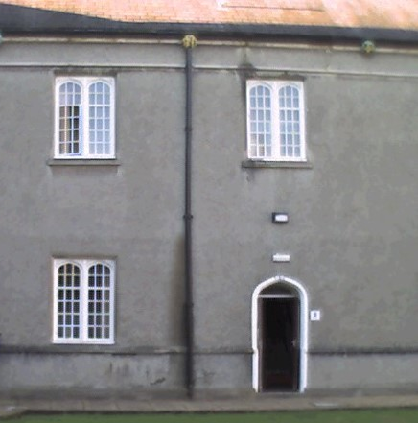

Author - Melanie Wright
University number - p144061
Date of report publication – 13th March 2019

Contents

- Introduction

- Case study

2.1 Building Description
2.2 New water management strategy
2.2.1 Proposed New Configuration
2.2.2 Proposed Floor Plans

2.3 Reducing Water Consumption

2.4 Greywater and Rainwater
2.4.1 Drawings of Water System
2.4.2 Greywater
2.4.3 Rainwater

- Expected Results

- References

- Appendices
5.1 The Water Efficiency Calculator
5.2 The Greywater Recycling Calculations
5.3 The Rainwater Recycling Calculations
5.4 Current Water Installations

- Introduction
The aim of this report is to produce solutions for a complete refurbishment of Block B of the student accommodation complex. Located in the University of Wales Trinity Saint David campus, Lampeter. Block B has been empty for about 3 years because of its poor condition and needs to be refurbished back into good quality student accommodation.

This report is part of a collaborative group of reports that will culminate in an overall report identifying a complete refurbishment of Block B. The designated category for this report is water management. Catherine Morgan-Jones the Project Officer from Estates Management at Lampeter is managing the renovation. It is currently in the planning stage. The building is Grade 2* Listed. It was constructed in 1822 and holds a high heritage value. The funding for the refurbishment is from private Chinese funders.

CADW (2019) is the Welsh Government’s historic environment service. It states that its primary concern is to protect and conserve Welsh heritage. CADW have to authorise any proposals for the works on the refurbishment. Therefore although CADW requires the block to be made fit for purpose it enforces stringent restrictions on what works can be carried out. It over rules all other regulations, for example the entrance door cannot be widened to provide disabled access because it would spoil the heritage aesthetics.
The roof space of Block B is home to a variety of different species such as swifts and bats. Works will has to be scheduled around the seasonal habitation/migration/hibernation of swifts and bats as both these species are protected. A licence will be required prior to work commencing and the refurbishment works will have to be completed within a limited timescale of between November and March.

2.0 Case Study

2.1 Building Description

A site visit to Block B was undertaken to complete a structural and measured survey. The building is solid stone, traditional construction with solid stone internal partition walls. The external walls are 600mm thick. Thermal imaging was carried out to try to determine any hot water leaks, but none were identified. This result is inconclusive as this test was not an accurate reflection of the hot water system due to the property being unoccupied and it is not known when the hot water was last utilised.

The building internally is very damp which is symptomatic of penetrating damp, rising damp and condensation, caused by the following issues:
- The walls had a cement render applied in the 1960’s which covers the breathable lime mortar. It has cracked and will be allowing a build-up of moisture behind it.
- The external ground level was raised in the 1960’s surpassing the internal floor level and any conceivable dpc level.
- Information was provided about the drainage system under the property, which is failing.
- The guttering is failing.
- The building has not been heated or aired for s substantial period of time.

B Block houses (see pictures of current facilities in Appendix 5.4):
- 7 bedrooms all with wash hand basins. Rooms B1, B2 and B3 are all on the ground floor. B5, B5A, B6 and B6A are all on the first floor.
- Bedroom B2 has the hot water immersion heater installed in a cupboard.
- A shared shower room on the first floor that houses a shower, w.c. and wash hand basin. There is only one shower room servicing 7 bedrooms.
- B4 is a shared kitchen on the ground floor. There is no washing machine in the property.

CADW will not allow the internal partitions surrounding the staircase to be moved so the internal layout cannot be significantly reconfigured. CADW believe that the bedrooms are not spacious enough to incorporate en-suites but they are requesting that the number of shower rooms be increased.

2.2 New water management strategy

The current legislation that needs to be adhered to is the Building Regulation Part G2 and Regulation 36: Water efficiency. This regulation sets out the maximum fittings consumption for the new installations that are required: Table 12.6 (Billington, et al. (2017).

Maximum fittings consumption:
110 litres per person per day
W.C. dual flush | 4 and 2.6 litres
Shower | 8 litres/minute
Hand wash basin taps | 5 litres/minute
Kitchen sink taps | 6 litres/minute
Washing machine | 8.17 litres/kg

The aim of this strategy is to reduce the water consumption of regulated water. The target for this will be calculated against the maximum required level of 110 litres per person per day. This strategy will also incorporate recycled rainwater and greywater which will be the primary source of water for the shower room wash hand basins, showers, w.c.’s and washing machine. If there is not sufficient recycled water available then the mains water will be utilised. Mains water will already be supplying the bedroom wash hand basins and the kitchen tap so it is still extremely important to used water saving components.

2.2.1 Proposed New Configuration

Bedroom 1 is going to be converted into two shower rooms and a laundry area with a washing machine and the hot water boiler. The boiler will get its water supply from rainwater. The rainwater will be stored in a header tank in the attic space. The remaining 6 bedrooms will still contain a wash hand basin but it will only have a cold water supply as the hot water is not potable. The first floor shower room will remain a shower room. All the new installations with have isolation valves to shut off the water and registers to enable blockage checks to be carried out.

The primary source of water for the following components is as follows (this information will be included in the Buildings Instructions Book):
Mains potable water
- 1 kitchen tap
- 6 wash hand basin taps in the bedrooms
Recycled rainwater
- 3 wash hand basin taps in the shower rooms
- 3 showers
Recycled greywater
- 3 w.c.’s
- 1 washing machine

2.2.2 Proposed Floor plans
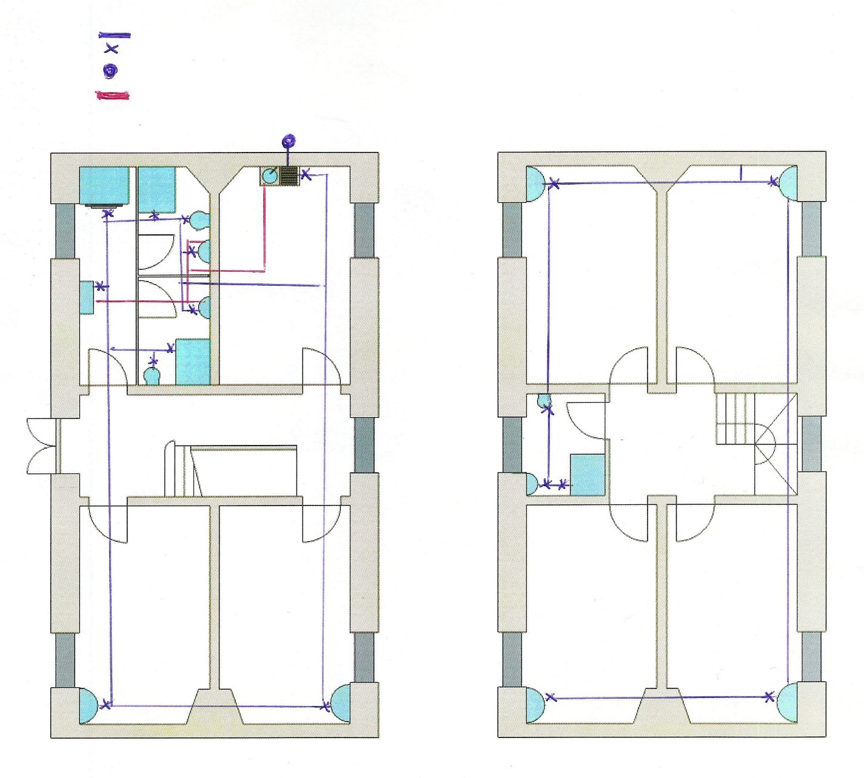
Cold water supply
Isolation valves
External stop tap
Hot water supply

2.3 Reducing water consumption

All the new water consumption figures below have been inserted into:
- Table A1 (see Appendix 5.1) The Water Efficiency Calculator
- Tables A4.1, A4.2, A4.3, A4.4 and A4.6 (see Appendix 5.2) The Greywater Calculations
- Tables A5.1 and A5.5 (see Appendix 5.3) The Rainwater Calculations
All these figures are either equivalent to or lower than the maximum fittings consumption for 110 litres per person per day.

Appliance | New Water Consumption | Specifications | Current Water Consumption | Supplier
Kitchen tap | 6 litres/minute | Mixer tap with aerator. Self-closing | 15 litres/minute  Save Water Save Money (2019) | Tap Store (2019)
Shower room wash hand basin taps | 4 litres/minute | Mixer taps with aerators. Self-closing | 15l/m see above | Tap Store (2019)
Bedroom hand wash basin taps | 4 litres/minute | Cold water taps with aerator. Self-closing | 15l/m see above | Tap Store (2019)
Showers | 6 litres/minute | 12.5 KW electric. Fitted with timers & flow regulators on head | 15 litres/minute Harwood & Associates (2019) | Ideal Standards (2019)
W.C.’s | 4 litres full flush  2.6 litres partial flush | High efficiency toilets (HET) with dual flush | 13 litres/flush Home Water Works (2017) | Ideal Bathrooms (2019)
Washing machine | 6 litres / kilogram | Bosch Active Water with automatic load size recognition. Unrivalled water efficiency | None but potentially 14 litres/kg How To Save Water (2019) | Which (2017)

- According to Home Water Works (2017), an average of 31% of potable water is used for flushing w.c.’s and only 4% is used as drinking water.
- Aerators are also known as flow regulators. They are attachments that fit to the tap spout to reduce the space that the water has to flow through. They act like sieve’s separating one flow of water into many streams which allows the water to be mixed with air which significantly reduces the amount of water dispensed. The water pressure remains the same although it will take twice as long to fill the sink or basin. All the aerator’s will need to be cleaned periodically to prevent a build-up of scum and limescale.
- Mixer taps allow you to regulate the temperature of the water you require very quickly thus saving on water consumption.
- Self-closing taps, means they will shut off after a certain amount of time. This can be set from 2 seconds to 3 minutes.
A flow-based water leak detection system will be installed, such as an AquaGuard (AquaLeak, 2019). It will be installed next to the stopcock and monitors the variations of the flow of water though the pipe, comparing the water consumed against the expected water usage. If the flow of water exceeds the expected usage an alarm will be triggered and a motorised value will automatically shut off the water supply.

2.4 Greywater and Rainwater

2.4.1 Drawings of Water System

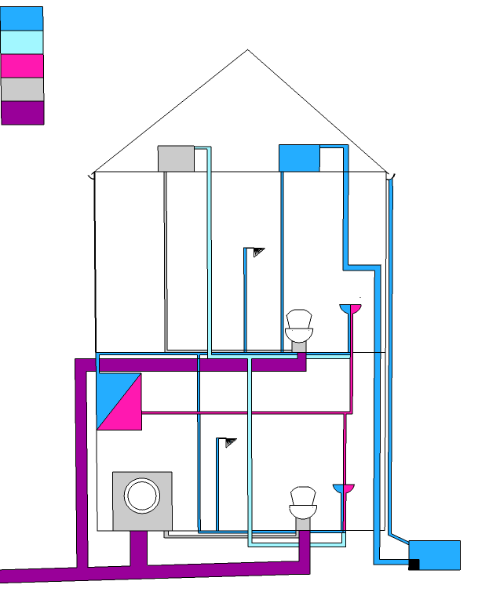
Rainwater supply
Greywater collection
Hot rainwater
Greywater distribution
Sewage

Inspection Chamber

2.4.2 Greywater

Although greywater cannot be used as drinking water or to supply the hot water boiler it can be used as the primary water supply for the 3 w.c.’s and the washing machine. It may contain traces of dirt, food, grease, hair, and certain household cleaning products. Homebuilding (2017) state that 60% of used water can be recycled into greywater. Greenage (2019) state that recycled water properly can save about 70 litres of potable water per person per day. A greywater system such as the Aquawiser GW 210 will be sourced (Aquaco 2019). It can deal with households of up to 6 people. The tank size is 210 litre volume which is ideal as the greywater available for Block B is 25.09 l/p/d (see Appendix 5.2) which equates to a maximum of 200.54 litres per day that needs to be stored. Greywater cannot be stored for more than 24 hours because any nutrients in it will start to break down causing a bad smell.

Water from the waste pipes of the 9 wash hand basins and 3 showers will be collected in a greywater stack. This connects to an underground greywater tank. At the entrance to the tank the water will go through a pre-filter which removes any hair and large particles. This debris and any excess water drains off through an overflow. The water then enters the tank and is treated with bromine disinfection. This disinfected water is then pumped to a header tank in the attic space. Prior to entering the header tank the water passes through an activated carbon filter which removes discolouration, particulates and excess bromine. This water is then ready for distribution to the w.c.’s and washing machine via gravity fed pipework. If there is not sufficient greywater available then a mechanical ball value in the header tap will automatically fill the tank with mains water. The filters and pumps will require regular maintenance to prevent breakdowns and blockages. The pump will consume energy to run it.

2.4.3 Rainwater

Anglian Water (2019) state that rainwater collected and stored correctly, with minimal treatment can save up to 50% of household water use. The British Standard BS8515:2009: Rainwater Harvesting Systems Code of Practice gives recommendations on the design, installation, testing and maintenance of rainwater harvesting systems. They state that rainwater is non-potable and not suitable for drinking. However this point is argued by many organisations including WTS (2019) who state it can be potable water if suitably cleaned and treated with chlorides. For Block B the recycled rainwater will be used as the primary source of water supplying the 3 shower room wash hand basins and the 3 showers.

Trawsgoed is the nearest weather station to Lampeter and according to the Met Office (2019) the average yearly rainfall for this area between the years of 1981-2010 was 1216.7mm per year (see map below). This figure will be included in Table 5.1 (see Appendix 5.3). The catchment area for the rainwater will be the roof of the building. Internally the property measures 5.68 metres x 12.17 metres, giving a total collection area of 69.13m2. This figure will be used in Table 5.1 (see Appendix 3).

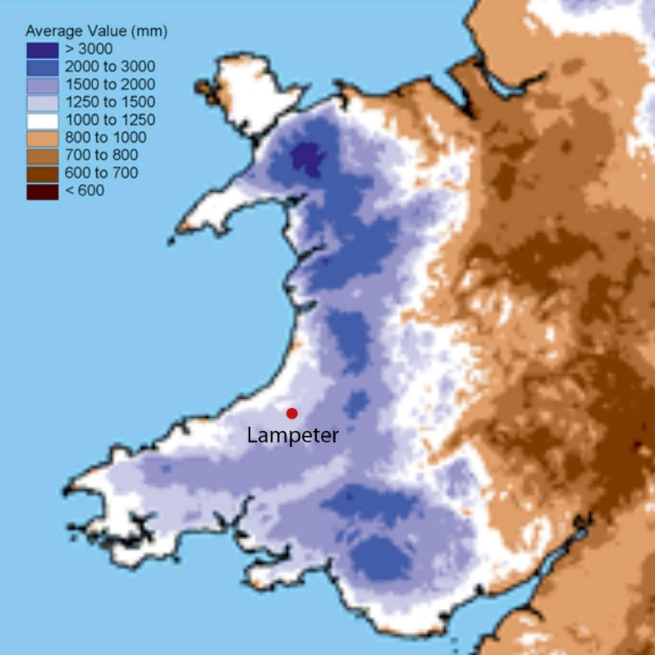

Map of Wales showing the average rainfall.
Adapted from Met Office (2019).

The rainwater will be collected and run through gutters to a tank underground. This tank allows the water to be stored at a constant temperature of 11ºC which removes the risk of legionella and prevents the water from freezing. Rain may pick up pollutants from the air and contaminants from birds, leaves etc, so before entering the tank the water passes through a particulate sand filter system which removes any debris larger than 5 microns in diameter. This filter is used alongside ultra violet light sterilisers which kill any dangerous microorganisms.

The water is then pumped to a header tank in the attic pace ready for distribution via gravity fed pipework. The tank has an overflow for an excess influx of rainwater and if the system runs low the mains water back-up pump will be activated. The water can only be stored for 7 days otherwise algae and other microbes will grow. The filter and gutters require regular cleaning and the pump needs to be maintained. As with the greywater system this will also use energy to run the pump.

The Owlshall (2019) Direct Rain Harvesting System has been sourced. This has a 1500 litre size tank volume which is ideal for Block B which can collect 34.55 l/p/d equating to 207.3 litres per day for 6 people. As it can be stored for 7 days this gives a total maximum water collection of 1451 litres. The header tank has a mains top-up feed with a built in leak detector and a 3-stage particle filter to protect pipe valves. This system a yield coefficient of 90%. This figure will be entered into Table A5.1 (see Appendix 5.3).

3.0 Expected Results

Reducing water consumption comparison table:

Component | Current level of in-situ component | Optional maximum required level for 110 litres l/p/d | Actual capacity of new component | Savings on maximum vs actual
Wash hand basin taps | 15 l/min | 5 l/min | 4 l/min | 1 l/min
Kitchen taps | 15 l/min | 6 l/min | 6 l/min | 0
Showers | 15 l/min | 8 l/min | 6 l/min | 2 l/min
W.C.’s | 13 litres/flush | Full flush 4 litres  Part flush 2.6 litres | 4 litres  2.6 litres | 0  0
Washing machine | None in-situ but potentially 14 l/kg | 8.17 l/kg | 6 l/kg | 2.17 l/kg

The wash hand basin taps, showers and washing machine installations are all significantly below the maximum consumption for 110 litre/person/day. The kitchen tap and w.c.’s are on target. These new installations equate to the total calculated consumption of 80.64 litres/person/day (see Appendix 5.1). A saving of 27% on the maximum 110 litres/person/day consumption. This figure is aided by having showers instead of baths installed into Block B.

The actual amount of potable water consumed comes in very low at 27.91 litres/person/day. This is because the total water consumption of 80.64 litres/person/day has a contribution from greywater of 25.09 litres/person/day and a contribution from rainwater of 34.55 litres/person/day. So the actual total potable water consumption of 29.91 litres/person/day is a 73% saving of the maximum potable water consumption of 110 litre/person/day. (Figures all available from Appendix 5.1). The saving from the new water consumption to the current water consumption is not comparable because specific specifications of the current installations are not available.

4.0 References

Aquaco (2019). Greywater Recycling. [online] Available at <https://www.aquaco.co.uk/grey-water-recycling/residential/> [Accessed 18 February 2019].

Aqualeak (2019). Flow-based water leak detection systems. [online] Available at <https://www.aqualeak.com/32/flow-based-water-leak-detection/> [Accessed 26 February 2019].

Anglian Water (2019). Rainwater Harvesting. [online] Available at <https://www.anglianwater.co.uk/environment/using-water-wisely/rainwater-harvesting.aspx> {accessed 18 February 2019].

Billington, M.J., Barnshaw, S.P., Bright, K.T., and Crooks, A. (2017). The Building Regulations Explained and Illustrated. 14th Edition. West Susses: Wiley Blackwell.

BRE Global Ltd (2014). BREEAM UK New Construction, Non-domestic Buildings (UK). Technical Manual. SD5076(5.0)

CADW (2019) Conservation Principles. [online] Available at <https://cadw.gov.wales/historicenvironment/conservation/conservationprinciples/?lang=en> Accessed 26 February 2019.

Green Age (2019). Recycling Greywater. [online] Available at https://www.thegreenage.co.uk/tech/greywater-recycling/ [Accessed 15 February 2018]

Harwood and Associates Ltd. (2019). Guidance on Flow Rates. [online] Available at <http://www.harwoodandassociates.co.uk/faqs/guidance-on-flow-rates-for-taps-showers-and-baths/> [Accessed 13 February 2019].

Homebuilding & Renovating (2017). How to Use Recycled Water for Your Home. [Online] Available at <https://www.homebuilding.co.uk/recycling-water/> Accessed 15th February 2019

Home Water Works (2017). Toilets. [online] Available at < https://www.home-water-works.org/indoor-use/toilets> [Accessed 13 February 2019.

How to Save Water (2019). Washing Machines. [online] Available at <http://www.how-to-save-water.co.uk/washing-machines/> [Accessed 13 February 2019].

Ideal Bathrooms (2019). Armitage Shanks. [online] Available at <https://www.idealbathrooms.com/products/toilets/cisterns/s364367-7787> [Accessed 13 February 2019].

Ideal Standards. (2019). Choosing a Shower for your Home. [online] Available at <https://www.ideal-standard.co.uk/inspiration/choosing-a-shower.html> [Accessed 13 february 2019].

Met Office (2019). Lampeter Climate. Trawsgoed (Nearest climate station to Lampeter). [online] Available at <https://www.metoffice.gov.uk/public/weather/climate/gcm07nrwu#?region=wales> [Accessed 12 February 2019].

Owlshall (2019). Underground Garden Rainwater Harvesting System. [online] Available at <https://www.owlshall.co.uk/rainwater-harvesting/complete-systems/garden/below-ground/> [Accessed 18 February 2019].

Save Water Save Money (2019). Tap Aerators – how do they work? [online] Available at <https://www.savewatersavemoney.co.uk/water-efficiency-tips-advice/view/120/tap-aerators---how-do-they-work.html> [Accessed 13 February 2019].

Tap Store (2019. Basin/Pillar tap flow. [online] Available at <https://tapstore.com/bristan-basin-pillar-tap-flow-limiters-6-litres-per-minute.html> [Accessed 13 February 2019.

Which (2017). Bosch washing machine ‘unrivalled’ for efficiency. [online] Available at <https://www.which.co.uk/news/2011/03/bosch-washing-machine-unrivalled-for-efficiency-248425/ - Which?> [Accessed 13 February 2019].

WTS (2019). Water Chlorination, Disinfection & Water Tank Cleaning. [online] Available at < https://watertreatmentservices.co.uk/water/water-chlorination-disinfection/> [Accessed 18 February 2019].

5.0 Appendices

5.1 The Water Efficiency Calculator
5.2 The Greywater recycling calculations
5.3 The Rainwater recycling calculations
5.4 Current water installations

Appendix 5.1
7.Table A1: The water efficiency calculator
Litres/person/day – l/p/d
Litres/minute – l/m
Litres – l
Litres/kilogram – l/kg

Installation type | Unit of measure |  | 1 - Capacity flow rate | 2 – Use factor | 3 – Fixed use (l/p/d) | 4 – l/p/d  1x2+3=4
W.C. (dual flush) | Full flush volume (l) Part flush volume (l) |  | 4l  2.6l | 1.46  2.96 | 0.00  0.00 | 5.84  7.70
Taps (not kitchen) | Flow rate (l/m) |  | 4l/m | 1.58 | 1.58 | 7.90
Shower only | Flow rate  (l/m) |  | 6l/m | 5.60 | 0.00 | 33.60
Kitchen taps | Flow rate (l/m) |  | 6l/m | 0.44 | 10.36 | 13.00
Washing machine | l/kg dry load |  | 6l/kg | 2.10 | 0.00 | 12.60
 |  | 5 – Total calculated use  (sum of column 4) |  |  |  | 80.64 l/p/d
 |  | 6 – Contribution from greywater (l/p/d)  From table 4.6 |  |  |  | 25.09
 |  | 7 – Contribution from rainwater (l/p/d)  From table 5.5 |  |  |  | 34.55
 |  | 8 – Normalisation factor |  |  |  | 0.91
 |  | 9 – Total water consumption  5 – 6 – 7 x 8 = 9 |  |  |  | 27.91
 |  | 10 – External water use |  |  |  | 0.00
 |  | 11 – Total water consumption  9 + 10 = 11 (l/p/d) |  |  |  | 27.91 l/p/d

Appendix 5.2
Greywater Calculations

Table A4.1: Greywater demand calculations – w.c.
To find the effective flush volume the following calculation for domestic buildings was required, one full flush for every two reduced flushes (BREEAM, 2014). Therefore this equates to (4 litres x 1) + (2.6 litres x 2) / 3 = 3.1 litres

a | b | c | d
Efficient flushing volume (l) | Number of fittings present | Quantity using greywater | Greywater demand (a x c)
3.1 litres | 3 | 3 | 9.3
e |  | f
Total fittings  (sum of b) | 3 | Total greywater demand (sum of d) | 9.3
Average greywater demand from w.c.’s  (= f / e x 4.42) |  |  |  | 13.70

Table A4.2: Greywater demand calculations – washing machine

a | b | c | d
Litres/kg | Number of fittings | Quantity using greywater | Greywater demand (a x c = d)
6 | 1 | 1 | 6
 | e |  | f
Total fittings (sum b) | 1 | Total greywater demand (sum d) | 6
Average greywater demand (= f / e x 2.1) |  |  | 12.60

Table A4.3: Greywater collection calculations – taps

a | b | c | d
Litres per minute | Number of fittings | Quantity supplying greywater | Greywater supply (a x c = d)
4 | 9 | 9 | 36
6 | 1 | 1 | 6
e |  | f
Total fittings (sum of b) | 10 | Total greywater supply (sum of d) | 42
Average greywater supply from taps (f / e x 1.58 + 1.58) |  |  | 8.22

Table A4.4 Greywater collection calculations - showers

a | b | c | d
Litres per minute | Number of fittings | Quantity supplying greywater | Greywater supply (a x c = d)
6 | 3 | 3 | 18
e |  | f
Total fittings (sum of b) | 3 | Total greywater supply (sum of d) | 18
Average greywater supply from showers (f / e x 5.60) |  |  | 33.60

Table A4.6: Greywater collection calculation

a | b | c | d | e
Taps and shower usage (l/p/d) | % of used water to be recycled | Greywater available for use (l/p/d)  = a x b / 100 | Greywater demand (l/p/d) | Greywater savings (l/p/d)
Taps  8.22 |  |  | Wash/machine 12.60
Showers 33.60 |  |  | W.C.’s  13.70
41.82 | 60% | 25.09 | 26.30 | 25.09

Appendix 5.3
Rainwater Calculations

Table A5.1: Rainwater collection calculation
a | Collection area m² | 69.13m²
b | Yield coefficient and hydraulic filter efficiency | 0.9
c | Rainwater (average mm/year) | 1216.7mm/year
d | Daily rainwater collection litres  (a x b x c / 365) | 207.4 litres
e | Number of occupants | 6
f | Daily rainwater per person litres (d / e) | 34.55 l/p/d

Table 5.5: Rainwater saving calculations
a | Rainwater collected (l/p/d) | 34.55
b | Rainwater demand (l/p/d)  From Table A1 | Taps 7.90  Showers 33.60
 |  | Total demand 41.50
c | Rainwater savings | 34.55

Appendix 5.4
Bedroom Wash Hand Basins - Pictures by M Wright (2019)

Room | Appliance | Specification | Water Consumption
B1 | Hot & cold tap | Not known | Not known
B2 | Hot & cold tap | Not known | Not known
B3 | Hot & cold tap | Not known | Not known
B5 | Hot & cold tap | Not known | Not known
B5A | Hot & cold tap | Not known | Not known
B6 | Hot & cold tap | Not known | Not known
B61 | Hot & cold tap | Not known | Not known

Other water installations - pictures by M Wright (2019)
All the pictures were by M Wright (2019)

Room | Appliance | Make/Specification | Water consumption
B4 - Kitchen | Mixer tap | Not known | Not known
Shower room | Electric shower | Triton Enrich | Not known
Shower room | Hot water heater for whb | Newlec | Not known
Shower room | W.C. | Shanks | Not known
B2 | Immersion heater | Not known | Not known

