Journey, Identity and Naturalisation: Who am I?
P139833
BA(Hons) Illustration
M6X01791
Word Count: 4,541

Dr. J. M. Lockheart

Table of Contents:

Introduction: 3
Chapter One: The Cogito Sum v. Tabula Rasa. 5
Chapter Two: Hume and Buddhism. 9
Chapter Three: Anatta. 12
Chapter Four: The Five Skandhas. 14
Conclusion: 19
Reference List 20


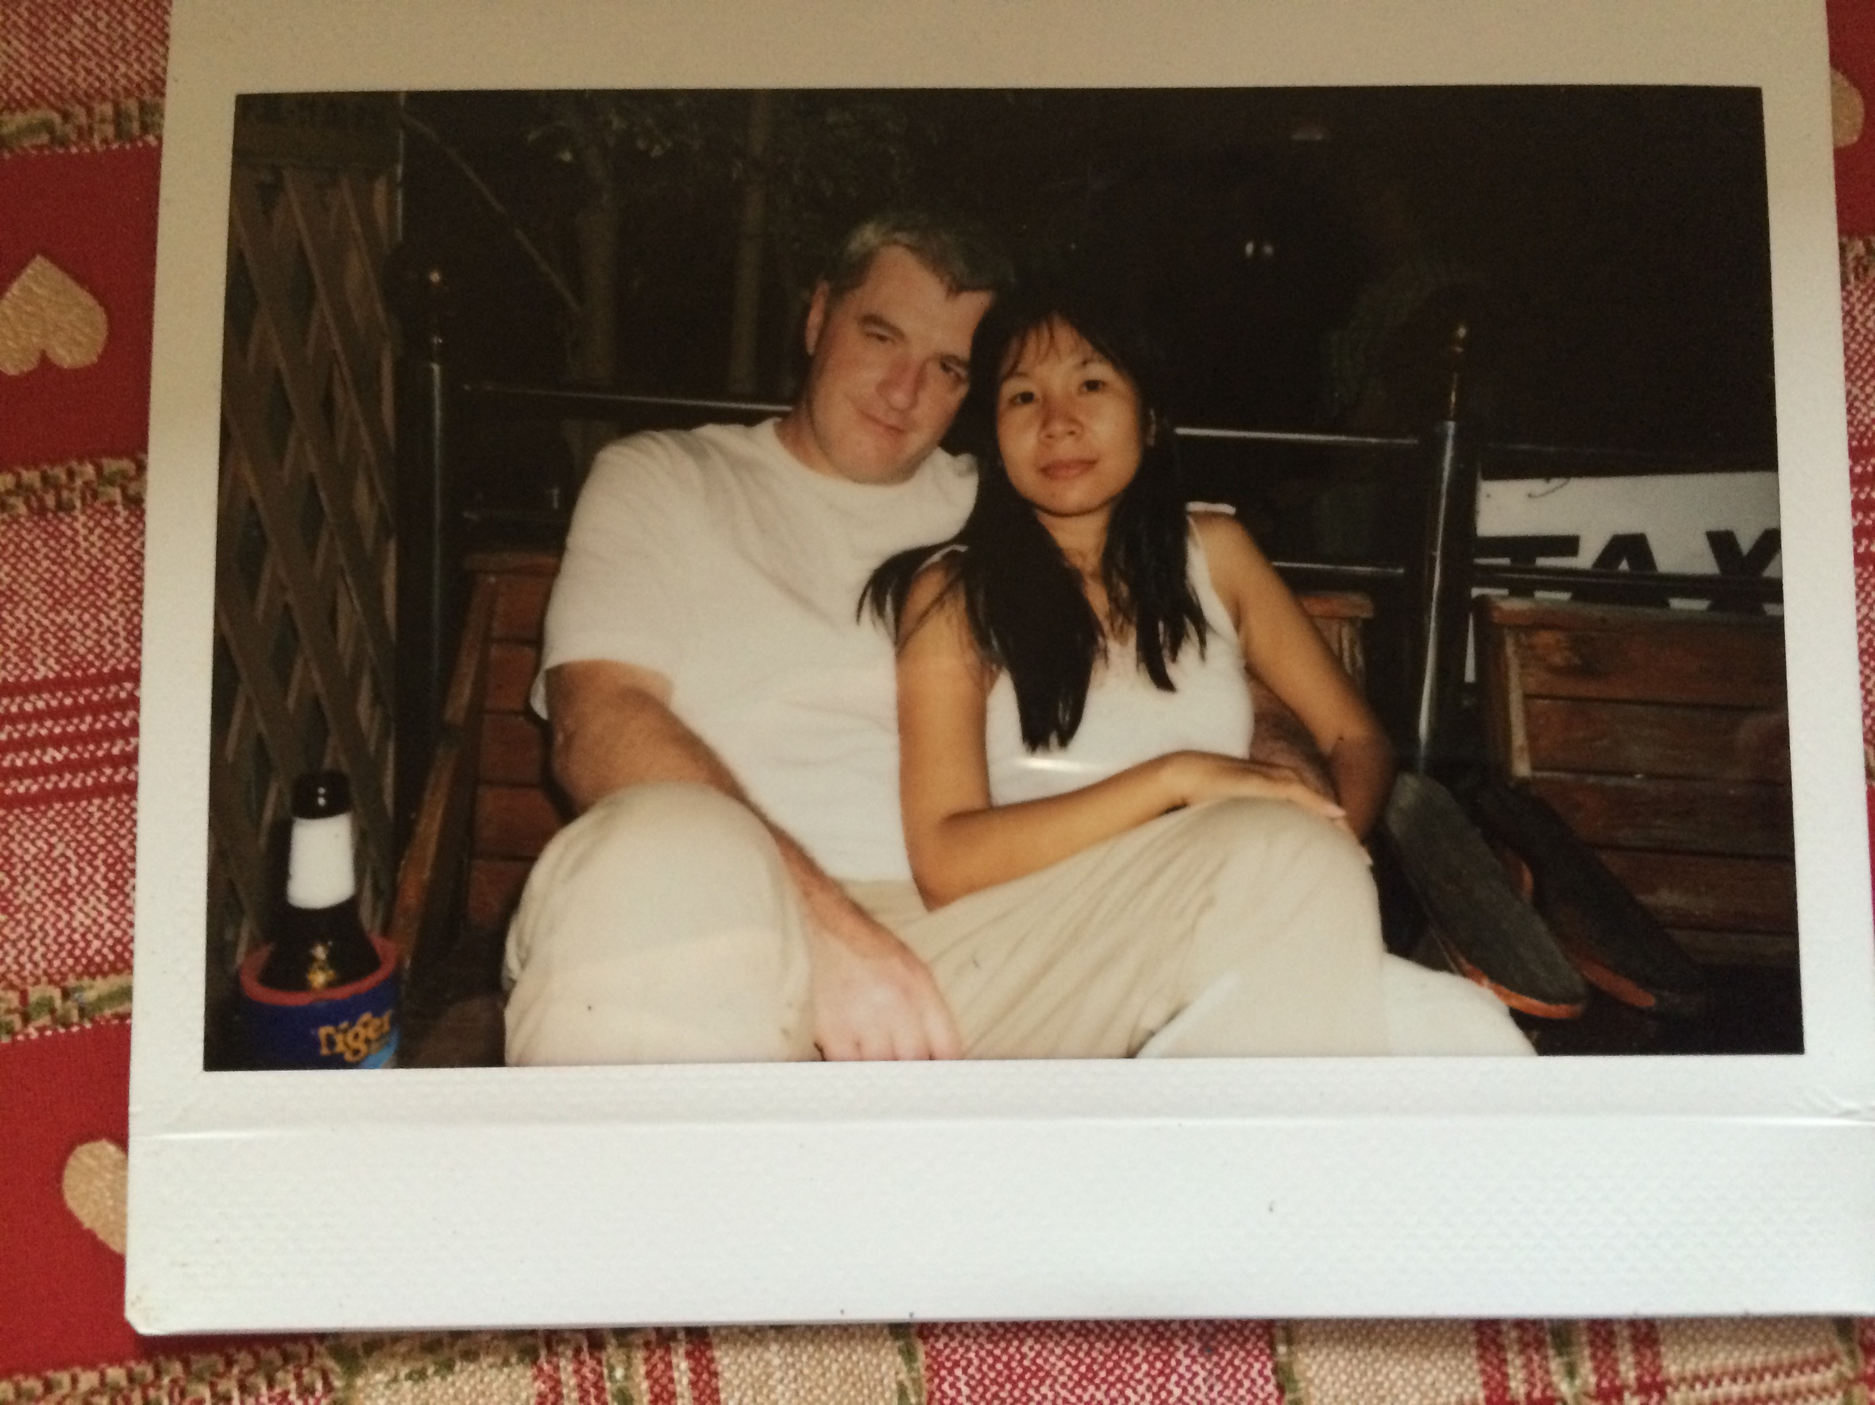
Introduction:

My name is Kimberley Anne Davies, I am a British citizen and I live in Swansea, South Wales. My name used to be Wachirintra Domthaisong and I lived in Kalasin province in the far North East of Thailand. By the time I was 11 years old, my parents had split-up and a new British father had entered my life. My mother and new-father, along with myself, then left Thailand for a new life in the United Kingdom.
In that journey, I left my life as a child in a quiet Issan village where I awoke each day to the sounds of cockerels and temple-bells, and arrived in the bustling metropolis that is Bangkok, possessed by the mysterious and frightening thought of an impending new life in a totally alien foreign culture. The 11 quiet hours spent in the cocoon like Boeing 747 were rudely shattered when I arrived in the bustling, strange and polluted airport that is Heathrow. I was no longer scared: I was fascinated!
My new home in Gowerton was covered in snow, which was perfect for my first ever Christmas. The holiday passed all too quickly, and I was soon placed into my local comprehensive school. I could not speak English, so I found it difficult to communicate with my school friends. I had so many questions, though no means of asking them.
When I became 17, I became a naturalised British citizen by default, as my mother by that time had become a British subject through the long-process of naturalisation. I also felt that it was clearly the right time to anglicise my name, as I was now capable in law of making my own life choices: Wachirintra Domthaisong had metamorphosed into Kimberley Anne Davies: I felt like a shape-shifter.
This transmigration journey of 6000 miles, spanning 10 years and vastly different cultures, is one that has taken me half-way around the world, and in doing so incorporated life in two vastly different cultures. However, it is important to note that my transmigration to the UK was not a one-way journey: I return every year to my old home in North-East Thailand, and I incorporate my life there into my life here, and vice versa.
By having a life in both countries, I conform to what is now accepted as a common trend in modern migration, that of international transmigration, which has been described in this way: The assumption that people will live their lives in one place, according to one set of national and cultural norms, in countries with impermeable national borders, no longer holds. (Levitt. Peggy, 2004) My migration journey has indeed become a two-way process: I exist in both places, and both cultures, though this has obviously created a sense of inquiry in regard to a question that constantly haunts me: who am “I”?
In order to discover the real “Me
” or who am ‘I’ it will initially be necessary to determine what convention actually defines as the ‘self’ and can it in fact be established to exist at all as an empirically proven, independent entity? A reasonable working definition of the ‘self’ from which to commence a journey of self-discovery, in an endeavour to answer those questions is this: “a person’s essential being that distinguishes them from others, especially considered as the object of introspection.” (The Oxford Living Dictionary).

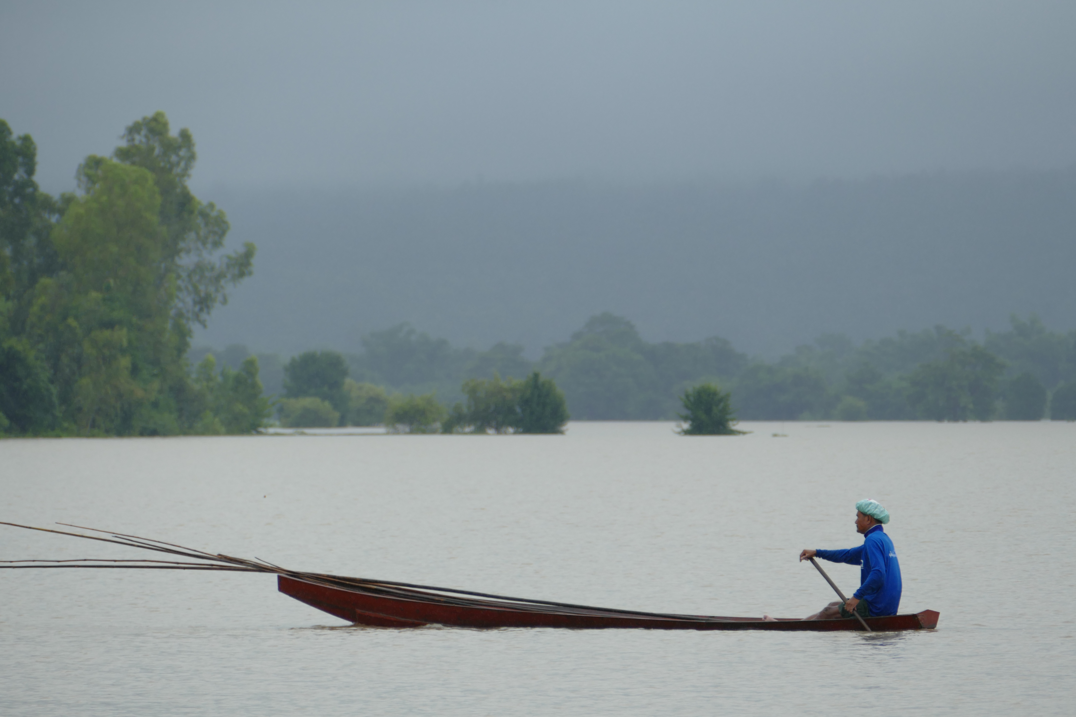
Chapter One: The Cogito Sum v. Tabula Rasa.

What then is my unique `essential being` that I may seek and find through such introspection? Perhaps we may find clues from the hypothesis of classical philosophers, from both the East and West, who have considered this very question throughout the ages. A good commencement point may be found in the works of Descartes from the early 17th century.
René Descartes, in a classical example of his succinct, rational, empiricist approach to philosophy, considered that he could not in fact claim to exist at all, unless he could subjectively witness the fact by means of his own senses. Therefore, he held in his famous axiom, originally written in French to reach a wider audience than through the canonical language: Latin; “Je pense, donc je sui” - “I’m thinking; therefore, I exist.” (Descartes. R, 1637).

Ultimately, he decided to remove the word “therefore” as he probably believed that its use was indicative of self-doubt on his part, and subsequently he stated confidently, and by that time in Latin: the language of the church; “Ego cogito, ergo sum:” “I think - I am.” (Descartes. R, 1644).
While this succinct cogito-sum: “I think = I am” is quite rightly attributed to Descartes, it should also be noted that Descartes himself, simply reiterated what was effectively the same hypothesis posited by Aristotle during the 3rd century BC, thus: “and if one who sees is conscious that he sees, one who hears that he hears, one who walks that he walks, and similarly for all the other human activities there is a faculty that is conscious of their exercise, so that whenever we perceive, we are conscious that we perceive, and whenever we think, we are conscious that we think, and to be conscious that we are perceiving or thinking is to be conscious that we exist.” (Aristotle. Nic. Eth. 1170a).
Indeed, John Locke the 18th century philosopher subsequently believed that the Descartes cogito, was far too simplistic a means of determining the attributes of a ‘self.’ Instead, he proposed that the ‘self’ is actually independent of any physical body (which Descartes had referred to in couched terms as simply a substance,) and was also independent of any fixed-soul, as held by the Cartesian theorists (again epitomised by sceptics such as Descartes,) in that humans do not incorporate souls that possess a consciousness which incorporates a divine understanding provided by god. To a sceptic such as Descartes, if he could not witness a fact as existing by means of his own five-senses, then lacking empirical proof, it could not stand as an hypothesis: faith played absolutely no part in that process!
The assertion that one’s consciousness resided in one’s soul was originally expounded in the 17th century by the priest and philosopher: Nicolas Malebranche who endeavoured to incorporate the works of a divine god into the consciousness/thought-process implied within the Descartes cogito sum.

It was suggested therefore, that the consciousness referred to by Descartes, resides in one’s soul, and that the ‘self’ based upon the ideas or concepts as posited by Descartes, were in the view of Malebranche: ideas and concepts that had been implanted directly by god into our very souls. (Schmaltz, T, 2003).
This would appear to be a diplomatic way by which the established church, in the form of a Christian philosopher and priest such as Malebranche, could by interpretation, ascribe the works of god into Descartes agnostic cogito sum, and by doing so sanitise accusations made following the release of his Discourse that Descartes was a heretic, agnostic, or even an atheist.
The philosopher John Locke proposed an entirely different, alternative explanation of the ‘self,’ by positing the concept of tabula rasa or as he phrased it: “let us suppose the mind to be, as we say, white paper, void of all characters.” (Locke. J, 1690). Locke’s hypothesis may be defined in this way: At birth, the mind of a child has no implanted ideas or rules for processing experiences whatsoever. Nature merely provides that child with a blank parchment. As the child matures, then via his senses, and his life experiences: that child will write his story indelibly upon his soul.
Thus, an individual creates the rules they live by (or lack thereof) by means of acquisition via their own senses, and in doing so create the permanent attributes of their persona and soul. Therefore, according to Locke, the concept of a blank parchment would be more appropriate than that of a blank slate as the former can never be wiped clean.
It has been academically noted (Trimble. Michael R, 2007) that these two contrasting views of the ‘self’ dominated the philosophical and intellectual perspectives of academics throughout the late 18th and early 19th centuries. Descartes cogito sum v. Locke’s tabula rasa. That in Descartes theory: as the mind is non-divisible, and the body divisible, then the mind is clearly distinct from the body and that allowed clerical rational philosophers (Malebranche: discussed above) to further hypothesise that the attributes of the mind must therefore be that of the soul, and by extension, placed there directly by god.
By contrast, Locke’s empiricist views held that each child is born with a mind that is completely blank, and that during its life, ideas and theories are acquired through experiences.
Locke’s empirical theories subsequently influenced later empiricist philosophers such as David Hume who questioned the very definition of a self, as a stable, unchanging, fixed entity. Hume held (some believe, and it is difficult to disagree, that by this stage Hume had clearly encountered Buddhist principles of the self: Gopnik. Alison, 2015) that if we endeavoured to find a fixed, immutable self, we would instead find a mercurial process of constant change or flux.
What such a self-investigation would reveal, is an actual snap-shot of the experience of self that we examined at that particular moment of self-analysis. I believe therefore that such Buddhist beliefs, would be better investigated in the context of the original Dhamma as provided directly by Buddha and not as interpreted by Hume.


Chapter Two: Hume and Buddhism.

David Hume was a child prodigy who enrolled in university aged 11, was an empiricist who believed that no hypothesis could be regarded as valid unless experienced personally through one’s own sensory perception. As a sceptic, he believed that any faith based philosophies of the self, founded upon religion, or the divine grant of morality, should be treated with a large degree of cynicism and doubt: If phenomena could not be empirically proven via the use of one’s own senses it would be regarded as simply faith-based conjecture.
Empiricists and sceptics, such as Descartes and Hume, believed that if a person could not establish that they had acquired specific knowledge of a subject through the direct use of their senses, then their opinion was to be considered as nothing more than purely subjective conjecture, or unsubstantiated opinion hence rendered incapable of being considered as objectively established facts.
Also, as advocates of scepticism, they further believed that one should begin the investigation, of any long established purely faith-based beliefs such as religion, or morality from an initial position of absolute doubt: For both Descartes and Hume, empirically proven facts had replaced faith-based beliefs.
It is very difficult to consider Hume’s thoughts upon the existence or otherwise of a self without realising how similar his viewpoint was to that of Shakyamuni Gautama, an Eastern philosopher from the 5th Century BC. Of course, Gautama upon achieving perfect self-enlightenment, under a Bodhi tree at Bihar in Northern India over 2,500 years ago, became what we now call the Buddha.
However, it is impossible to consider the hypothesis of either Hume or Buddha, in regard to the existence or otherwise of a ‘self,’ without noting remarkable similarities in their hypothesis, not least in that both noted the impossibility of being able to empirically establish the existence of any fixed `self` at all.
Let us consider Hume’s ground-breaking philosophical work: A Treatise of Human Nature (Hume. D, 1896), in which he stated: “For my part, when I enter most intimately into what I call myself, I always stumble on some particular perception or other, of heat or cold, light or shade, love or hatred, pain or pleasure. I never can catch myself at any time without a perception, and never can perceive anything but the perception… [that mankind] is nothing but a bundle or collection of different perceptions, which succeed each other with an inconceivable rapidity, and are in perpetual flux and movement.”
This discovery of no-self, made by intimately entering into what he calls “myself,” appears to impliedly refer to an introspective search for the existence of an `I` by means of a Buddhist meditative method called Vipassana or insight meditation. In failing to discover a fixed, enduring-entity capable of being called an `I` and instead finding a process of ever changing perceptions, he appears to confirm in other words, that the `I` is simply anatta which in the ancient Pali language is the term for the Buddhist concept of non-self.
A question therefore clearly arises: How could an early 18th Century Presbyterian scholar such as Hume, have encountered Buddhist theory, even if he had chosen not to give credit to what would have at that time been regarded as a pagan, idolatry, belief system?
I believe that this was far more than coincidental, and that as suggested by others: Hume had encountered the works of a Jesuit missionary who had spent many years in Tibet studying Buddhist philosophy.
That Jesuit missionary was Ippolito Desideri who had completed a book, which some regard as the most accurate and complete treatise on Buddhist philosophy before the 20th Century, just prior to Hume commencing work on his treatise: (Gopnik. Alison, 2015)
It is also pertinent to note, that had he accredited his belief in a non-self to Buddhist principles of anatta, it may well have been considered as constituting the criminal offence of blasphemy against the church: (Dominus Rex v. Woolston 1732 ER655.)

Chapter Three: Anatta.

What then is the Buddhist theory of non-self or anatta? The Pali word `atta` means self, and the word `an` means not: thus `atta` prefixed by `an` creates anatta which means non-self, which has been metaphorically described in this way: “No self is your true reality, we do not have any self to discover. We are just like an onion: if you go on peeling it, thinking that beyond this layer you will find something: you will just find another layer to peel off, and then yet another. If you carry on peeling, then finally nothing is left in your hands. That nothing or void is anatta. We are neither a body, a mind, a heart, not even ourselves. We are just a pure awareness beyond all kinds of cages. But don’t ask a question. Rather experience it, because it is not a question-and-answer thing. It is not something to be believed, it is something to be lived (and experienced.)” (Rajneesh. Osho, 1989).
I believe this metaphor to be accurate: that through the use of personal introspection, which is simply a metaphor for insight meditation, that we can determine that any `self` we may possess, is not a fixed unchanging-entity that can be labelled as a definitive “Me.”
Rather, it is more appropriate to think of ourselves as an constantly changing flux, as a continual process of change, which continuously morphs as we encounter, incorporate and then discard different experiences within our lifetimes.
That proposition may be self-evidenced in this way: Look at a photograph of yourself from your youth, or consider something you really believed in from that same era. Are you still that person? Are your views and beliefs the same as then, or have they changed?
Is it not correct to say, that you and I are simply shape-shifting processes undergoing constant change, forever evolving and morphing into something different, and someone else. I suggest that the snapshots from our past are simply freeze-frames, of a time-lapse movie, of a process recording our own personal evolution that spans our entire lifetime.
A prevalent, present-day interpretation of the self is therefore that it is simply an illusion, in that it subjectively appears as an object within our minds, though it does not also exist objectively in what we could call the outside world. The identities that we have created for each other, in order to distinguish ourselves from others, can only therefore ever be considered an illusion as the experience of self cannot exist independently of the experiencer. (Hood. Bruce, 2012).
Therefore, as the self cannot exist independently from my brain, then it cannot be said to be part of the reality of the outside world. Yet again, there is nothing new here, that does not echo what Hume had said some 300 years earlier, which in all probability (discussed above) he had himself copied from Buddhist principles of anatta or non-self as promulgated by Shakyamuni Gautama some 2,200 years prior to that. An appropriate phrase that describes all these empiricist, sceptical theories is that there is nothing new under the sun.


Chapter Four: The Five Skandhas.

It is therefore prudent to consider the actual source or fount of knowledge relating to non-self or anatta. Buddha said in the Tipitaka (Pali Canon) written in the original Pali language over 2,500 years ago : "Sabbe sankhara anatta iti yada pannaya passata – atha dukkha nibbindati esa visuddhiya maggo" which may be translated into English as: “ when one perceives with wisdom that all things are without a self then one leaves suffering. This is the path to purification.” (Dhammapada: verse 279).
This is the original theory of no-self which is the basis of anatta. Buddhists believe that what we take to be the ‘self,’ is instead five impermanent skandhas or bundles, which may be thought of as five interconnected changeable phenomena.
This bundle of skandhas that we call our ‘self’ is comprised of one physical and four mental elements. The physical phenomena, in the Pali language, is called rūpa and is our physical-form or body. The four mental phenomena may be thought of as our unique mental attributes which distinguish us from other sentient beings. They are feelings or vedanā, perception or saññā, mental formations or saṅkhāra, and consciousness or viññāṇa.
It is a fundamental Buddhist belief that all five skandhas are impermanent, empty, and insubstantial. Therefore, as there is nothing permanent capable of existing, then neither can there be a soul capable of being reborn: as there is no ‘self’ then neither can there be any associated ‘soul’ capable of rebirth. If Buddhism was thought of incorrectly as a religion (which it clearly is not as Buddhists neither worship Buddha as a deity or believe in a god for that matter) then it would clearly be distinct from Christianity, Judaism, Hinduism and Jainism all of whom believe in a ‘self’ and associated eternal soul.
In a modern sense, I like to think of Buddhas description of the skandhas as being like an operators guide to a machine, such as for example: a factory workshop-manual for use by any mechanic who needs to know how to investigate the esoteric machine he must now analyse and repair. This would appear to be a reasonable contemporary way of viewing working-definitions that were recorded 2,500 years ago in Pali, which is effectively a dead language, based upon Sanskrit, which is yet another dead language.
This contemporary approach seems sensible and has been adopted by others (O’Brien. Barbara, 2017) who explained it in this way: “ Everything we think of as ‘I’ is a function of the skandhas. Put another way, we might think of a person as a process of the skandhas…the component parts [of which] work together so seamlessly they create the impression of a single-self, or an ‘I.’ Yet the Buddha taught that there is no ‘self’ occupying the skandhas. Understanding the skandhas is helpful towards seeing the illusion of ‘self’.”
The first of the skandhas: rūpa is materialistic and forms our actual body. This physical element is the form by which most people would identify as being either ‘me’ or ‘you.’ Therefore, while rūpa serves as the physical life-support system for the four-mental elements of feelings, perceptions, mental-formations and consciousness: at a very superficial level of human interaction, it is also clearly far more than just that, noting that some people can be very superficial indeed.
Our physical form or rūpa , is also therefore our initial means of projecting who we are to the rest of mankind. Are we not all, at this very superficial level simply actors, and the person or persona is, as held by Carl Jung, simply the mask we wish to present to the worlds social-stage at large, in order to portray who we wish to be considered as ‘me’ while simultaneously disguising our true less palatable ‘selves’? (Jung. Carl, 1967). If this is so, it would appear to be a very good reason not to metaphorically speaking: judge a book by its cover.
The second skandha is feeling/sensation or vedanā: This is a mental-element and the means by which we file our likes, dislikes, and ambiguous feelings about all the phenomena we encounter throughout our lives. In a pure form, this categorisation process simply occurs by filing any phenomena into one of three groups: I like it, I do not care about it, I do not like it.
A mindful practitioner of Buddhism would ideally categorise all phenomena in the neutral central-category: ambivalence. However, most of us less skilful lay-people would not only file our preferences as like/dislike, but also extend these two categorisations where like extends to include love, and dislike extends to include hate.
The third skandha is perception or saññā. This skandha is the way by which we perceive all phenomena that we encounter, and the way by which we categorise such things through association.

Let us consider saññā by the example of encountering a phenomena that is similar to something previously encountered. As I enter a favourite sushi restaurant, a waitress passes by with a plate of my favourite California rolls. I have an image of those in my saññā or memory, and I remember that I enjoyed them very, very much. I know exactly what they are, and how I feel about them.
An alternative saññā process occurs when we encounter a phenomena for the very first time: I walk past a fruit stall in Thailand and see what looks like an English pear, though when I bite into it: the taste and texture is like dry cotton-wool: I am told that it is called a farang. That image is then stored in my memory or saññā, and I attach the sensation or vedanā; I do not like it.
In this way our memories are full of associated files, by which we can usually recognise a phenomena and immediately know, by means of association which way we feel about it. In modern life we have to filter information quickly, and make choices even faster, the saññā/vedanā process allows us to make those quick decisions. California Rolls or a farang? Thanks, I will take the sushi.
The third skandha is saṅkhāra or conceptual-proliferation. This is not just the mental process of thinking: it extends to the way that a simple thought or association can, in a very short space of time, proliferate into a hugely different mental fantasy. Think of the original trigger-thought as a train sitting at a station: if you are not mindfully watching your thinking-process then sometime later you realise that the train has left, is hundreds of miles from the station, and you have very little idea how it got there!
The saṅkhāra thought-proliferation process is also noteworthy in regard to two of its aspects. The first is the Buddhist concept of karma. I think of it in this way: all intentional actions (karmas) have consequences (vipaka). All intentional actions are preceded by thinking: the thought precedes the deed. Such thoughts occur during the conceptual-proliferation that is saṅkhāra.
The second is the interplay between feelings/perceptions/mental-proliferation or vedanā/saññā/saṅkhāra. The interplay may be thought of in this way: A perception and associated feeling occurs in the memory-bank of saññā. The image of an ice-cold watermelon on a hot summers day, which through experience I know that I like very much. I see the watermelon outside a grocers but I have no money. In saṅkhāra my thoughts proliferate, and thinking that it is unlikely that I will get caught, I grab the watermelon and run. Obviously, my thoughts did not proliferate enough, the melon is heavy, the grocer catches me, my karma/vipaka ripens and I spend a night in the police-station.
This is why as Buddhists we meditate upon the thinking-process within saṅkhāra. We are acutely aware that intentional acts are always preceded by the thoughts which result in the intention to act (or not act) followed either by the act itself, or a decision not to. By watching this thinking-process, you become aware of the microsecond between the intention to act, and the act itself. The Buddhist concept of mindfulness is found in that very moment, most people are unaware that it exists, and is the millisecond where a karmic event with consequences (vipaka) can be stopped, or allowed. Mind the gap!
The final skandha is viññāṇa which is sometimes referred to as consciousness, though is more correctly thought of as cogniscense or awareness. It works in this way: as Buddhists we are aware that we actually have six-senses, not the five which is the prevalent belief among non-Buddhists. The additional sixth-sense is the mind, which as just discussed in saṅkhāra is the mental-process we use in contemplation. Viññāṇa is the bare cognisance that some ‘thing’ has been encountered by one of the six-sense doors.
The viññāṇa process may be clarified by considering how the five skandhas operate as a process within two subjects. A toddler and an adult. The toddler hears a sound (viññāṇa or cognisance via hearing),
the sound is a car backfiring, though he is unaware of that as he does not understand the concept of either a car or backfiring in his rudimentary saññā or perception, neither in that case has he filed any associated feeling or vedanā, the child is not equipped for conceptual-proliferation in saṅkhāra. The child is simply startled and cries for its mother.
The adult hears a sound (viññāṇa or cognisance via hearing) – the sound is a car backfiring, and she is aware of that and understands the concept of both a car and backfiring in her saññā or perception, in that case, as the associated feeling in vedanā is ambivalence, the mental-proliferation available within saṅkhāra does not commence.

Conclusion:

Who then am ‘I’?
Ultimately, ’I’ am neither Kimberley Anne Davies the British subject or Wachirintra Domthaisong the Thai national. These are just conventions used by society to identify me and distinguish me from other sentient beings. They are simply labels, and the moment you label something, or someone, then you limit them.
‘I’ am a sentient being! ‘I’ am a Buddhist! ‘I’ am five skandhas, and as such ‘I’ am a process that will remain unfinished until my last breath! ‘I’ am a work in progress so watch this space!

Reference List

Damapada, verse 279, http://www.tipitaka.net/tipitaka/dhp/verseload.php?verse=277 5th Centuary BC.
Descartes. R, 1637, Discours de la méthode pour bien conduire sa raison, et chercher la vérité dans les sciences (Discourse on the Method of Rightly Conducting One’s Reason and of Seeking Truth in the Sciences), Part IV, Para 1.
Descartes. R, 1644, Principia philosophie (Principles of Philosophy), Part 1, Para 7.
Locke. J, 1690, An Essay Concerning Human Understanding. Book 2. Chapters 1 & 2. IIhttps://ebooks.adelaide.edu.au/l/locke/john/l81u/contents.html
Hume. D, & Selby-Bigge. L A, 1896, A treatise on human nature. Sect. VI. Of Personal Identity, Oxford. Clarendon Press.
Aristotle in 23 Volumes, Vol. 19, translated by H. Rackham. Cambridge, MA, Harvard University Press; London, William Heinemann Ltd. 1934.
http://data.perseus.org/citations/urn:cts:greekLit:tlg0086.tlg010.perseus-eng1:1170a
Jung. Carl Gustav, 31st March 1967, Two Essays on Analytical Psychology (Collected Works of C.G. Jung: Volume 7), Routledge, United Kingdom, Page.190.
Rajneesh. Osho, , July 1 1989, The Buddha: The Emptiness of the Heart, Osho International, Chapter 4.
Schmaltz, T, 2003, Malbranche’s Theory of the Soul – A Cartesian Interpretation, Oxford University Press, Page.192.
Peggy Levitt, October 1st 2004, Transnational Migrants: When "Home" Means More Than One Country, MPI: Migration Policy Institute. https://www.migrationpolicy.org/article/transnational-migrants-when-home-means-more-one-country
Trimble. Michael R, M.D, The Soul in the Brain: The Cerebral Basis of Language, Art, and belief. April 16th 2007, John Hopkins Press, Baltimore: Maryland, Page 28.
Hood. Bruce, September 2013, The Self Illusion: How the Social Brain Creates Identity, Oxford, Oxford University Press.
Gopnik. Alison, October 2015, How an 18th-Century Philosopher Helped Solve My Midlife Crisis: David Hume, the Buddha, and a search for the Eastern roots of the Western Enlightenment, The Atlantic: https://www.theatlantic.com/magazine/archive/2015/10/how-david-hume-helped-me-solve-my-midlife-crisis/403195/
O’Brien. Barbara, 29th July 2017, The Five Skandhas: An Introduction to the Aggregates, ThoughtCo: https://www.thoughtco.com/the-skandhas-450192
The Oxford Living Dictionary: https://en.oxforddictionaries.com/definition/self 2017

