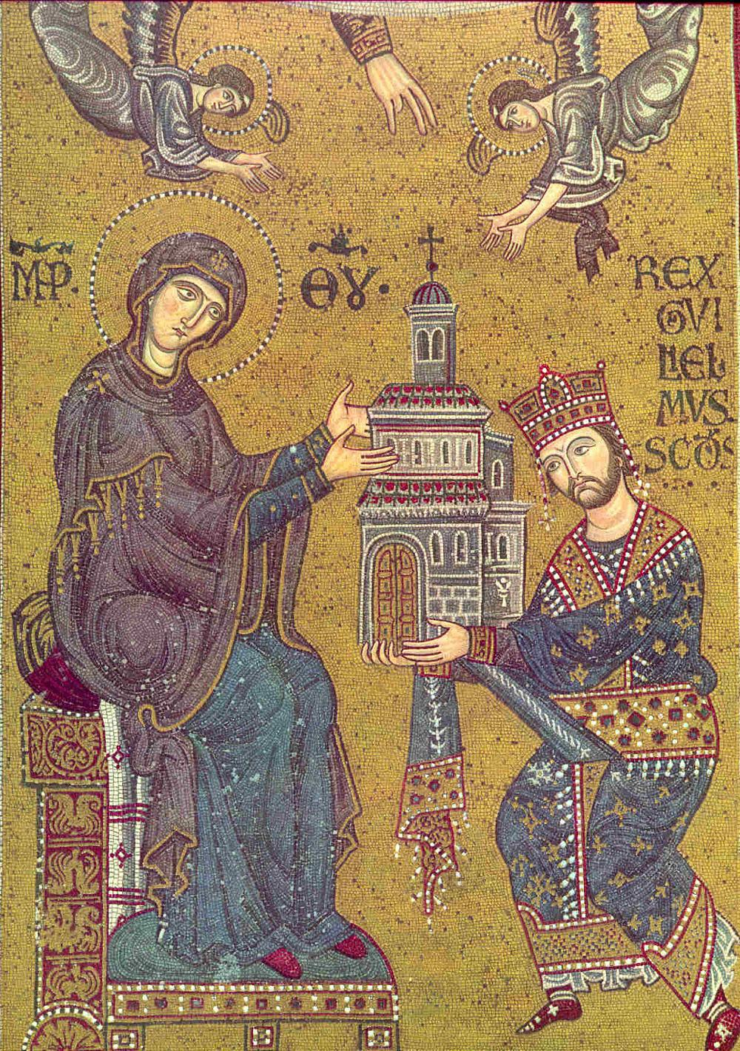
Montreale Cathedral mosaic, depicting William II and the Virgin Mary.

