Student name | Paraschiva Nunuca
Programme | Certificate of Higher Education Skills for the workplace
Module | Academic and Employability skills
Module code | BMSW4001 | 100%
Assignment title | TASK 2- Academic. Report-1000 words  ‘What is the most effective way to motivate staff?’
Lecturer name | Dr Besty Jose
Student number | 2029228

ACADEMIC REPORT - TASK 2

Executive Summary
Every organization needs motivated and well-trained staff to perform its functioning in a balanced way. This entire report talks about the motivation among the staff and what are the ways that can be utilized in an organization to motivate the employees to perform better. Various strategies are adopted by the organization to motivate the employees. Managers and team leaders play an important role in motivating employees. This helps them to achieve their tasks by creating a positive impact on other employees. This enables the motivation among the staff to learn and update their skills so that they can work to get a positive environment in the organization.

Table of Contents
Executive Summary 2
Introduction 4
Motivation 4
Ways to motivate staff 5
Setting up an attainable goal 5
Creation of employee incentive program 5
Give employees meaningful feedback 6
2
Provide an opportunity for career development 6
Conclusion 7
References…………………………………………………………………………………………….7

Introduction
This report will help in providing an understanding regarding the meaning of motivation and how motivation helps in changing the internal environment of business. Positive work culture in an organization helps them to increase productivity by helping its employees so that the positive attitude of employees becomes stable. Organizations use various strategies to motivate their employees by allowing them to participate in the business decision-making process and involve them in an employee engagement activity which helps them to increase productivity in an organization. The motivation factor does not end by giving their employees a monetary incentive instead it can be non-monetary as well.

Motivation
Motivation refers to the process which involves initiative, and guidance to create an environment of willingness that maintain their behavior toward the one who is goal-oriented and focused on the work. It helps the organization to increase productivity by engaging its employees in things that are not always related to work. Various organizations start their activity by giving them monetary rewards to create motivation among them so that they can always take participation in the decision-making process. This helps the employees to boost their morale while working in an organization which brings less absenteeism to an organization. (Olusadum,2018)
 Figure 1(Source: Virtunus Blog, 2022)

4

Ways to motivate staff
Managers and team leaders play an important role in motivating employees so that they can achieve their tasks by creating a positive impact on other employees instead of involving in irrelevant wasteful movements. (Akhmetshin, et al. 2018)
Following are the motivational strategies that organizations try to achieve goals
- Setting up an attainable goal
- Creation of employee incentive program
- Give employees meaningful feedback
- Provide an opportunity for career development

Setting up an attainable goal
Organizations should always set up goals that are SMART which means specific, measurable, actionable, relevant, and time-bound. These kinds of goals help them to be motivated towards the work without creating wasteful movement in an organization. By setting up non- attainable goals’ employees feel demotivated and frustrated which allows them to change their organization by wasting the resources of the current organization. While setting up of goal organization has to specifically mention the roles and responsibilities of each individual so that they focus on productivity. Goals which are not measurable are useless for the organization as well as for employees. This help the organization to motivate and direct employees toward achieving the goal which is set by the managers and team leader. A pre-set goal helps them to eliminate the unproductive time towards the productive one by focusing on the work-related activity. The goals which are not measurable are not beneficial for the organization as well as the employees. (Ameyaw,2021)

Creation of employee incentive program
To motivate employees in an organization, managers should also focus on creating an incentive program for their employees so that they feel motivated while working in the organization. The incentive plan should be fair to all levels of management. Most of the employees in an organization work to earn more and more to raise their standard of living. The incentive can be in the form of bonuses, paid-offs, gifts, vouchers, and trophies. The incentive allows them to perform their action according to their best. An employee incentive program helps the organization to bring motivation to the work by encouraging them through the addition of awards, recognition, incentives, and bonus. These factors help the organization motivate them toward working hard for the organization to achieve something extra from their salary. The incentive plan of the organization should be fair so that everyone can get the chance to earn through hard work. (Tien, 2020)
5
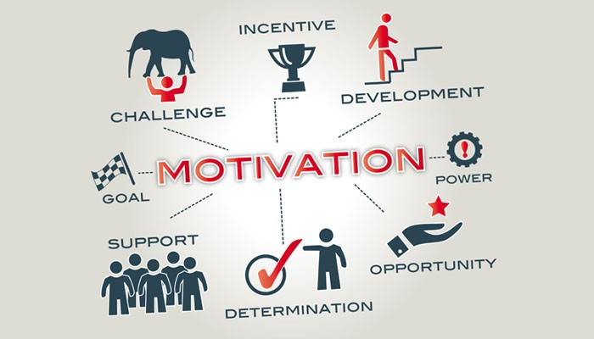 Figure 2(Source: Research Leap, 2022)

Give employees meaningful feedback
Appreciation plays an important role in the motivation of the employees. To motivate the staff, the organization and leader should give feedback to the employees. Feedback given should be real and meaningful. Feedback helps the employees to improve by learning skills. If feedback is given to employees, it will give them a feeling of value in the organization. Feedback gives them opportunities for growth and expansion in their professional life. Feedback can be positive or negative depending upon the performance of employees. If there are positive feedback leaders should give them appreciation in front of other employees so everyone feels motivated to appreciate their superior. If the feedback is negative then the leader or manager should take them inside and explain to them polity the reason behind lacking in performance and explain to them the ways through which they can improve themselves. This enables the motivation among the staff to learn and update their skills so that they can work to get positive feedback from their superiors. (Stock, 2019)

Provide an opportunity for career development
Employees who know their goals help them to work toward one direction without wasting time on irrelevant activities. Organizations should provide them with career opportunities by guiding them toward the right path. They can also offer them on-the-job training and various other certificates to enhance their skills. They can also provide various certificates and courses for their learning so that they feel motivated and up to date to be with the current needs of the organization. This gives an employee a feeling of belongingness in an organization which allows them to give their best. Managers also them their employees by providing them courses and certifications to achieve something fruitful and beneficial for their career. They should provide their employees with on-the-job training which helps them to shape their careers in the right direction. On-the-job training is a kind of training given to employees while working in an organization by working for their regular role as well. (NAHODA, 2020)

6

Conclusion
This report has helped in providing an understanding of motivation in a workplace required by the employees. The management accomplishes the ultimate goal of an organization by satisfying the needs of customers. It also helped in providing an understanding to know about the strategies an organization utilizes to motivate employees. Stability is directly related to the motivation of employees which can be achieved only by involving them in the decision-making process. They can also involve their employees in employee engagement
activities which helps in bringing a positive work environment to an organization by bringing them creativity and innovation to perform job smartly. These are strategies organizations use to bring smooth workflow to an organization.

References
About us, 2022. Definition of motivation | Dictionary.com. [online] www.dictionary.com. Available at: <https://www.dictionary.com/browse/motivation> [Accessed 9 July 2022].
Akhmetshin, E.M., Morozov, I., Pavlyuk, A.V., Yumashev, A., Yumasheva, N. and Gubarkov, S., 2018. Motivation of personnel in an innovative business climate.
Ameyaw, S., Asante, E., Kwakye Joseph, O.K. and Ronald, A.K., 2021. Motivation: A Catalyst of Library Staff Performance in Academic Libraries, Ghana. International Journal of Library and Information Science Studies, 7(2), pp.35-53.
NAHODA, N.P., 2020. Impacts of Career Development on Employees’ Performance: A Case of TRA-Headquarters (Doctoral dissertation, Mzumbe University).
Olusadum, N.J. and Anulika, N.J., 2018. Impact of motivation on employee performance: a study of alvanikoku federal college of eduaction. sigma, 1(1), pp.53-65.
Stock, R., Lynam, S. and Cachia, M., 2019. A quantitative study of the relationship between feedback orientation and students’ motivation to learn.
Tien, N.H., 2020. Staff motivation policy of foreign companies in Vietnam. International journal of financial management and economics, 3(1), pp.1-4.

7

