Thomas Cahill
2004206 Ba (Hons) Computer Animation
Emerging Trends: Hackathon 2024

Our group was formed on the 30th of January 2024, where I created a group chat on Discord [1], a messaging service that allows us to keep in contact with each other and share any ideas or files we come across. For the first few weeks we were unable to decide on a subject that was suitable for our combined skillsets. We initially started with the idea of making an infographic containing information on various resources for the homeless and impoverished, such as the locations of local shelters and foodbanks, which would be displayed on the electronic billboards around Swansea City. After some lengthy consideration, we decided to forgo this plan, as it would not be able to take advantage of our mostly creative skillsets.
In order to make the most of our individual skills, we came up with a new concept: a free Virtual Reality application, that uses the inbuilt hand/motion tracking from the Quest headsets [2] to encourage users to perform full body exercise in their own home, which was meant to help combat rising rates of obesity over the last few years [3]. After another lengthy discussion we were eventually able to decide how to allocate research topics leading up to our first progress presentation on February 20th, 2024, where my job was to carry out competitive analysis on existing products with similarities to our concept, along with how they work and were received by customers. Specifically, I researched the Vital Bracelet [4] and Pokémon Go [5], two services that use existing franchise characters in a “real life” setting. Specifically, The Vital Bracelet is a wrist worn Digivice [6] combined with a fitness tracker for one’s pulse and step count, which contributes to the development and evolution of a wide variety of characters [7]. Pokémon Go is an app for mobile devices, that uses a map of the user’s real time location, where the player is encouraged to explore their local area to collect, evolve and battle the franchise’s titular creatures.

After the presentation, it was noted that we should have had a thorough run-through before that day, as certain statements were not backed up by presentable evidence and brought a number of fair criticisms to light about said statement. After consulting with the team about feedback from our peers and lecturers, I acted as spokesperson in the following lecture and apologised for the statement on our group’s behalf and how we intend to rectify our group’s approach to the project. This new approach concerned our target market, which shifted from people with obesity, to a more general audience who want to exercise at home, which allowed us to design for a bigger market and avoid controversy arising from a lack of tact.
Our group’s ensuing communications over the next few weeks finally resulted in the assignment of design roles, since we wanted a visual presentation of what the game might look like from the user’s perspective. This included:
- User Interface: What will the buttons and menu layout look like? How will they be formatted in 3D space? Will the UI include a Heads-Up Display? Can it be toggled to reduce visual clutter?
- Exercise Guides: What workouts can be performed safely in the home wearing a headset? Will any of them require auxiliary equipment? Are they proven to be effective?
- Companion NPCs: How will they interact with the player? How can they encourage the user to stay healthy? How big will they be?
I was assigned to create the designs for the companions, since I had the most experience designing characters with appeal [8].

I planned to make about three or four concepts for different characters, that would interact with the user by presenting diagrams of exercises and fitness milestones to them, while also encouraging them during workout sessions. The User would be able to pick from a selection of these characters, then work towards completing exercises or meeting fitness goals, which would earn them points to use as currency to unlock additional characters. Each character ended up being an anthropomorphic version of something, whether living or inanimate.

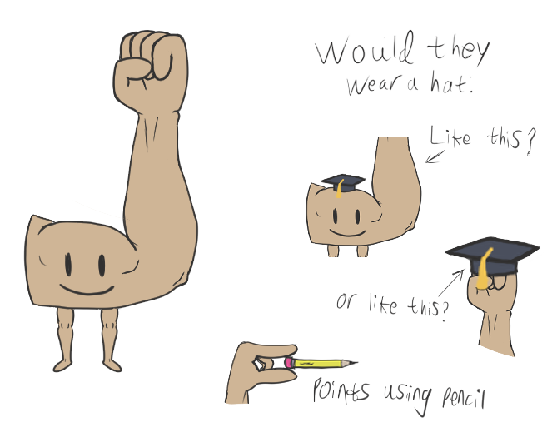
The first character I created was deliberately designed to be absurd in appearance, being a standalone muscular arm with a smiley face. This definitely stands out due to having a very distinct silhouette and shape. The face is meant to look minimalistic to contrast with the complexity of the musculature, along with the academic’s hat that sells the idea of an oxymoron. Each companion has their own set of a hat and pointer, which they would use when presenting graphics and data to the User.

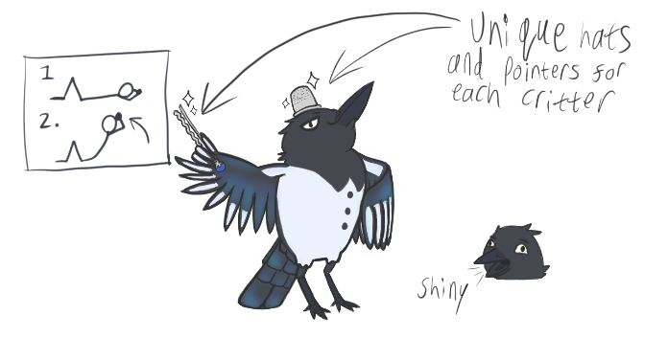
The second design was the bird, heavily based on a black-billed magpie [9]. I chose this species because birds from the Corvid family are intelligent and have distinctive plumage, which I took advantage of in my design process. I included some individual personality in this sketch, as the bird usually wears a somewhat smug expression and has a hairpin and thimble for his hat & pointer set, based off the myth that Magpies tend to collect shiny objects.
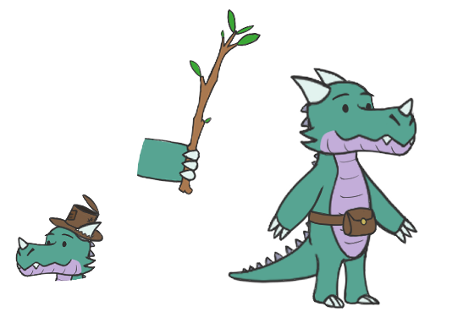
Next, was the little dragon, a cutesy reptilian biped. They were designed to be small and friendly in appearance, with a small pouch strapped across its belly. Traditionally, dragons are depicted as fierce creatures with angular features with their sharp claws, horns and teeth. By contrast, this design utilises softer curves and angles to take a smaller, more “cuddly” form, which can appeal to a wider audience. Additional details to add more character are its worn-out hat and pointer/stick, which it inexplicably stores in their pouch for a whimsical touch.
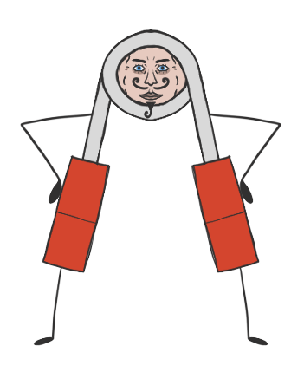

The final concept was this anthropomorphised grip strength trainer. The contrast of the spindly cartoon stick limbs with the detailed face reminiscent of a classic circus strongman [10], was designed to promote a feeling of the absurd. Whatever feeling a user gets while looking at it is impossible to predict. I myself don’t know how I feel when I look at this. Everyone I have shown this design to has had a different response.

Team ratings
As our presentations approached, we often found ourselves focusing on our own individual projects due to the workload. We arranged to have team meetings at least once every Monday, since it was the only available opportunity for some team members due to other commitments. Some of these meetings fell through due to outside circumstances, but we always had material ready to show for each progress presentation. Most of our meetings had full attendance, so we were almost always on the same page. Nevertheless, I must rate my team honestly:
Cian – 4/5
He was present in every meeting and presentation, always having something to contribute once we established our roles and researched/designed the exercise diagrams fit for our software.
Phoenix – 3.5/5
Missed some meetings, but always created his own slides for the presentations once he knew what was needed.
Alex – 3.5/5
He usually took some wrangling to aim his focus during most meetings, but completed his assigned UI design and research tasks on-time nonetheless.
Josh – 2.5/5
Proposed the initial project ideas and research, but not much else after that. He was prone to complaining about irrelevant topics during time-limited meetings, which would sidetrack some team members. He also did not contribute to the second presentation, then researched and created slides for the final presentation, only to not show up without any communication or apology afterwards, leaving us to divide his workload among ourselves on the day.

In conclusion, also considering our final presentation, most of the group performed well despite our respective circumstances and commitments. We were able to present a cohesive idea that we could communicate well to our audience despite our setbacks. As a group we shared ideas and research with each other and communicated often, which usually meant we were always on the same page. However, it was also clear that none of us were used to working in a group, as some aspects were lacking, for example we had no defined team leader to keep meetings on track and some of the team were more interested in their own individual accomplishments, which had a knock-on effect with the rest of the team.

References
[1] Discord. “Discord | your place to talk and hang out.” Discord | Your Place to Talk and Hang Out. [Online]. Available: https://discord.com/
[2] “Getting started with hand tracking on Meta Quest headsets.” Meta. [Online]. Available: https://www.meta.com/en-gb/help/quest/articles/headsets-and-accessories/controllers-and-hand-tracking/hand-tracking/
[3] House of Commons Library. “Obesity Statistics.” UK Parliment. [Online]. Available: https://commonslibrary.parliament.uk/research-briefings/sn03336/
[4] Bandai Namco, “NT82569 | Bandai | Vital Bracelet BE | Digimon Ghost Game | Digimon Ghost Game Set | Device”, Bandai. [Online]. Available: https://shop.bandai.co.uk/brand/bandai/vital-bracelet-be/collection/digimon/digimon-ghost-game/nt82569-bandai-vital-bracelet-be-digimon-ghost-game-digimon-ghost-game-set-device/.
[5] Pokémon, “Pokémon GO,” Pokémon, Jul. 14, 2016 [Online]. Available: https://www.pokemon.com/uk/app/pokemon-go
[6] Bandai Namco. “Digimon — Bandai Collector Shop UK.” Bandai Collector Shop UK. [Online]. Available: https://shop.bandai.co.uk/collection/digimon/
[7] Bandai Namco. “Digimon Vital Bracelet — Bandai Collector Shop UK.” Bandai Collector Shop UK. [Online]. Available: https://shop.bandai.co.uk/collection/digimon/digimon-vital-bracelet/
[8] M. Railton. “Mastering Character Design for Animation â Explanimate!” Explainer Videos Australia - Corporate Animation & Video Production. [Online]. Available: https://www.explanimate.com.au/play/the-art-of-designing-appealing-characters-for-your-animation
[9] Cornell University, “Black-billed Magpie,” Celebrate Urban Birds. [Online]. Available: https://celebrateurbanbirds.org/learn/birds/focal-species/black-billed-magpie/.
[10] J. Wood. “Pyotr Krylov - www.oldtimestrongman.com.” www.oldtimestrongman.com. [Online]. Available: https://www.oldtimestrongman.com/blog/2018/01/01/pyotr-krylov/

