
University of Wales Trinity Saint David

Topic: Individual presentation in favor of flexible working in relation to diversity and inclusion at work and analysing the role of Human Resources in promoting diversity and inclusion through flexible working in Tesco

Module Name: Managing People
Module Code: LCBB5004

Student Name: Pavlinka Todorova Veleva
Student Number: 2028165

Lecturer Name: Nishi Ramsurrun
Date:
Table of Contents:

About the company: 3
Moral and Business case in Tesco: 4
Flexible working arrangements in Tesco: 6
Equality and diversity in Tesco: 8
How Tesco’s HR department provide diversity: 9
Impact of flexible working arrangement in Tesco: 11
Recommendations for Tesco: 15
Conclusion: 16
References: 17

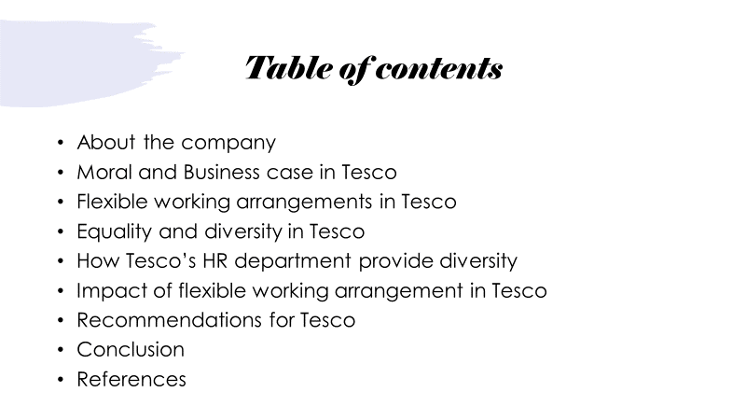

About the company:

The company is founded by Jack Cohen in 1919. In 1929 – The first TESCO store is opened in Burnt Oak, London; 1946 – Self service - Jack Cohen travelled to America and introduced to the people self-scanning machines.
It sells food, beverage, clothing, home appliances and financial services
It employs 354,000 people worldwide (Emma Bedford, 2022)
Operating 4,752 stores, situated in UK (In London – 306) (Emma Bedford, Tesco's number of stores worldwide from 2008 to 2022, 2022)

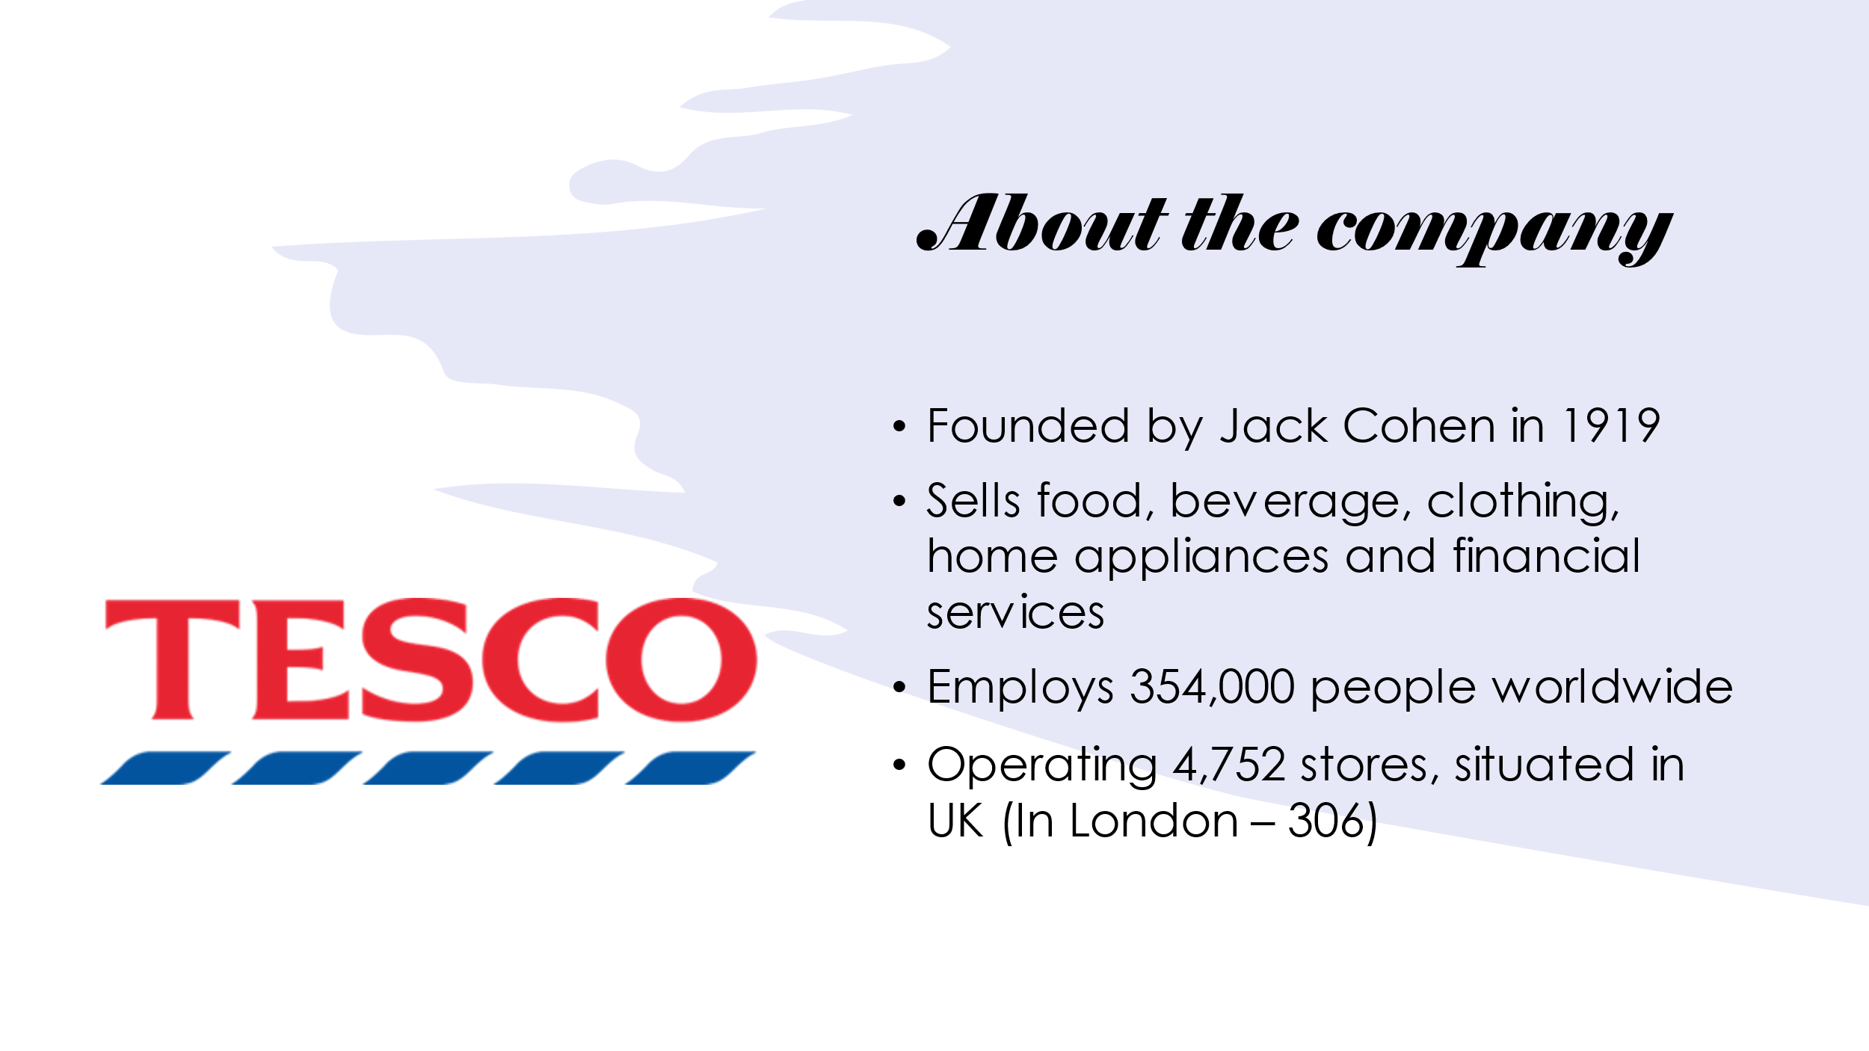

Moral and Business case in Tesco:

Moral case:
- Equality - everyone should be treated equal. All people have same rights, and everyone should be offered with the best opportunities in order to show their strengths. Because of the Equality Law (2010) nobody mustn’t be treated unfairly.
- Diversity – discrimination is not tolerated. It does not matter what is the ages, sex, race, where are the people coming from, or whether they have disability. All of them should be respected and understanded.
- Inclusion – everyone should be appreciated. People should see that they are important and valuable at work. If they know that they will contribute better for the work.
Business case:
- Diversity makes the company more productive and also yields better performance. The company (or mostly the individuals in it) can be led by diversity in a good way in order to positive outcomes. (Thomas, 2020)
- Advantages of using diversity:

- Innovation and creativity – as everyone have different experiences and knowledge can contribute positively to teamwork. Different focuses are leading to complex vision and variable thinking in the workplace. (O'Donovan, 2018)
- Increased flexibility – organizations which is using flexible arrangements are most likely to provide alternatives to redundancies in difficult times allowing them to retain the employees. (O'Donovan, 2018)
- Business growth – diversity yields the company to understand more about the marketplace that is in it. If the staff know that they are supported by their leader, their productivity will be increased, and they will use their own special skills, motivation, and contribution for the success. Inclusion also can lead the knowledge exchange. This will build a stronger collective path to the effectively making business operations. (O'Donovan, 2018)
- Job satisfaction – inclusion has got a result on the employees confident. This raises the potential for good performance. Once the link between the staff and the managers has done immediately the employees’ loyalty will be on higher level. (O'Donovan, 2018)
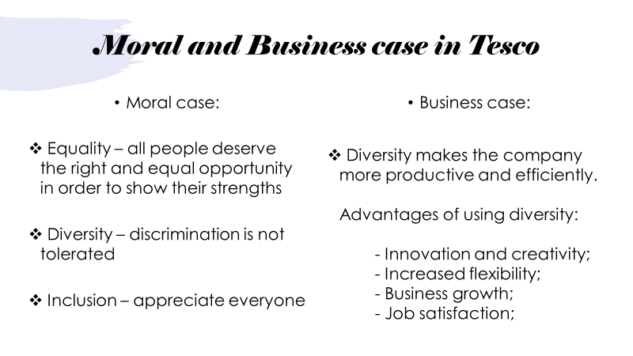

Flexible working arrangements in Tesco:

• Part-time working – it is suitable for staff with children, individuals with disabilities, and elderly people and it’s working for fewer hours per day or week, this can also be explained as out of a proportion of 38 hours weekly which represent 100%, someone can decide to work only 50%. The work is on shifts and mostly they can be flexible. (Colette Fagan, 2014)
• Job sharing – it is a type of work, where two people can share the same position and it is suitable for people who want to reduce their hours before retirement. The salary is divided by the two and it depends on how many hours each of them has been working. The task is divided in a way suitable for each of them in terms of their responsibilities. (Branine, 2004)
• Phased retirement – this is a flexible arrangement that allows you to take part of your pension while you are working (Hermansen, 2015)
• Lifestyle Break also referred as sabbatical or career break– you can have up to four weeks free from work to take care of yourself such as a holiday, getting an experience in a new field, or taking care of your children. After the rest, it is considered that you will be at times more productive than before.
• Blended working – this is a complex arrangement that allows people with different employees to work together using both remote working and in housework such as Tesco can ask someone to work 50% from home and 50% in store with a diverse workforce.
• Fixed shift pattern – the weekly schedule for the staff is fixed and cannot be changed. The main advantages of this form for working are that people can plan their trips, appointments, and fun activities.
• Staggered shift patterns – this was an essential approach in the coronavirus time in way to protect each other such as distancing and not working at the same time. It means that the company has got plan when everyone should start and finish work.

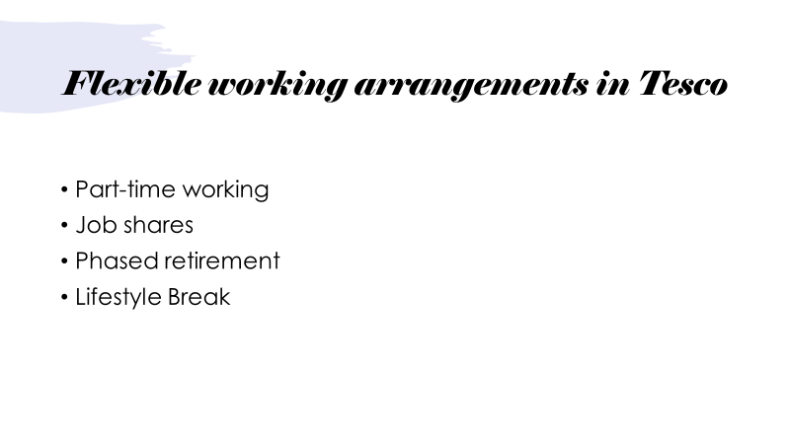
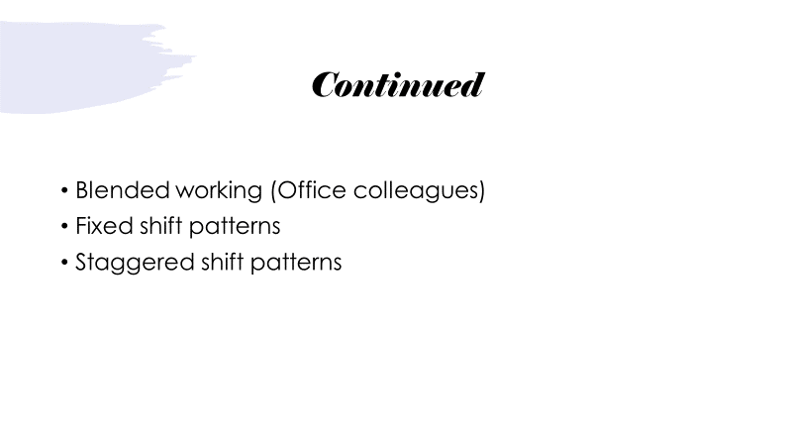

Equality and diversity in Tesco:

Tesco’s aims:
- making good working environment
- giving chance to all members of the staff
- supporting everyone’s strength in order to achieve better result
The employees must be felt like a part of our big network.
We appreciate everyone’s ethnicity, race age, gender, disability, orientation, and personality. Diversion and inclusion are staying at the middle of our organisation.

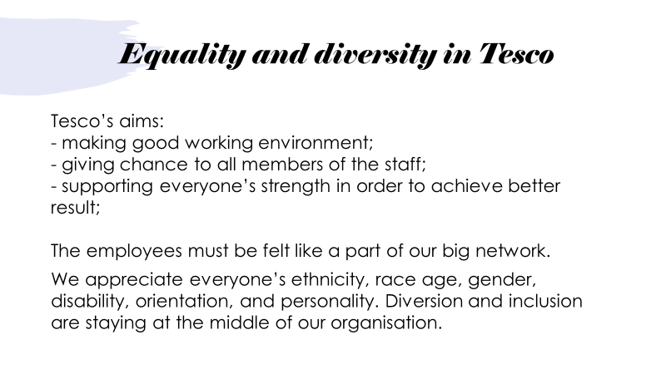

How Tesco’s HR department provide diversity:

At Tesco inclusion means everyone can work there, and everyone will be appreciated, understand, empowered, and respected. People are judged because of their personalities and skills. All the staff is given equal opportunities. Zero tolerance for harassment, bullying, or discrimination is the most common policy. Everyone is welcomed in Tesco to grow up in the career and the network. There are some groups of people who are not discriminated against in our company:
- Vulnerable people - The talent of these people is just wordless – they make small communities and put all of their skills, which formed great performance. We have relationships with different disability organizations such as Remploy, Shaw Trust, Whizz-Kidz, Business Disability Forum, and Valuable 500. With our “Disability Confident Employer” (Level 2) attracting people with the right programs.
- LGBTQ+ Tesco - is one of the biggest communities in Europe. Tesco supports LGBTQ+ because these our colleagues have to be as confident as all the other employees. We are a proud member of Stonewall Global Diversity Champions Programme and the Open for the Business coalition to support LGBTQ+ inclusion around the world. We are also signatories of the United Nations Standards of Conduct for Business on tackling discrimination against LGBTQ+ people.
- Race and ethnicity in Tesco – we are hold Top 10 Ethnicity Award. The aim of Tesco is to concentrate on education for everyone on race and ethnicity awareness of diversity, culture, and inclusion including how to have a great conversations guide, D&I glossary, and how to be an ally guide. “In 2019 we signed up to the Race at Work Charter and are working to implement its five calls to action to tackle barriers that ethnic minority people can face. These include appointing an executive-level champion for a race, board-level commitment to a zero-tolerance of harassment and taking action that supports ethnic minority career progression – all of which have been actioned.” (How we create an inclusive working environment, n.d.)
- Women at Tesco – women are leaders of diversity; they promote a culture of diverse and inclusive thinking. They are feeling more confident in an environment where they are appreciated more. It is important to us to support women’s health and mental well-being too. In 2020 we became a founding partner of the “every woman promise” with the Eve Appeal. Also, we have signed up for a PWC-led initiative called Tech She Can which aims to encourage women to consider careers in Technology.
- Retirement scheme – Tesco supports older people and their experiences. In the UK, we include people of all ages in our apprenticeship, A-Level, and graduate programs, giving them the opportunity to develop their careers.
- Young people – we have got good practice in recruitment, training and giving the best hour options to the children and young people. The most important with them is not to harm them and to promote welfare.

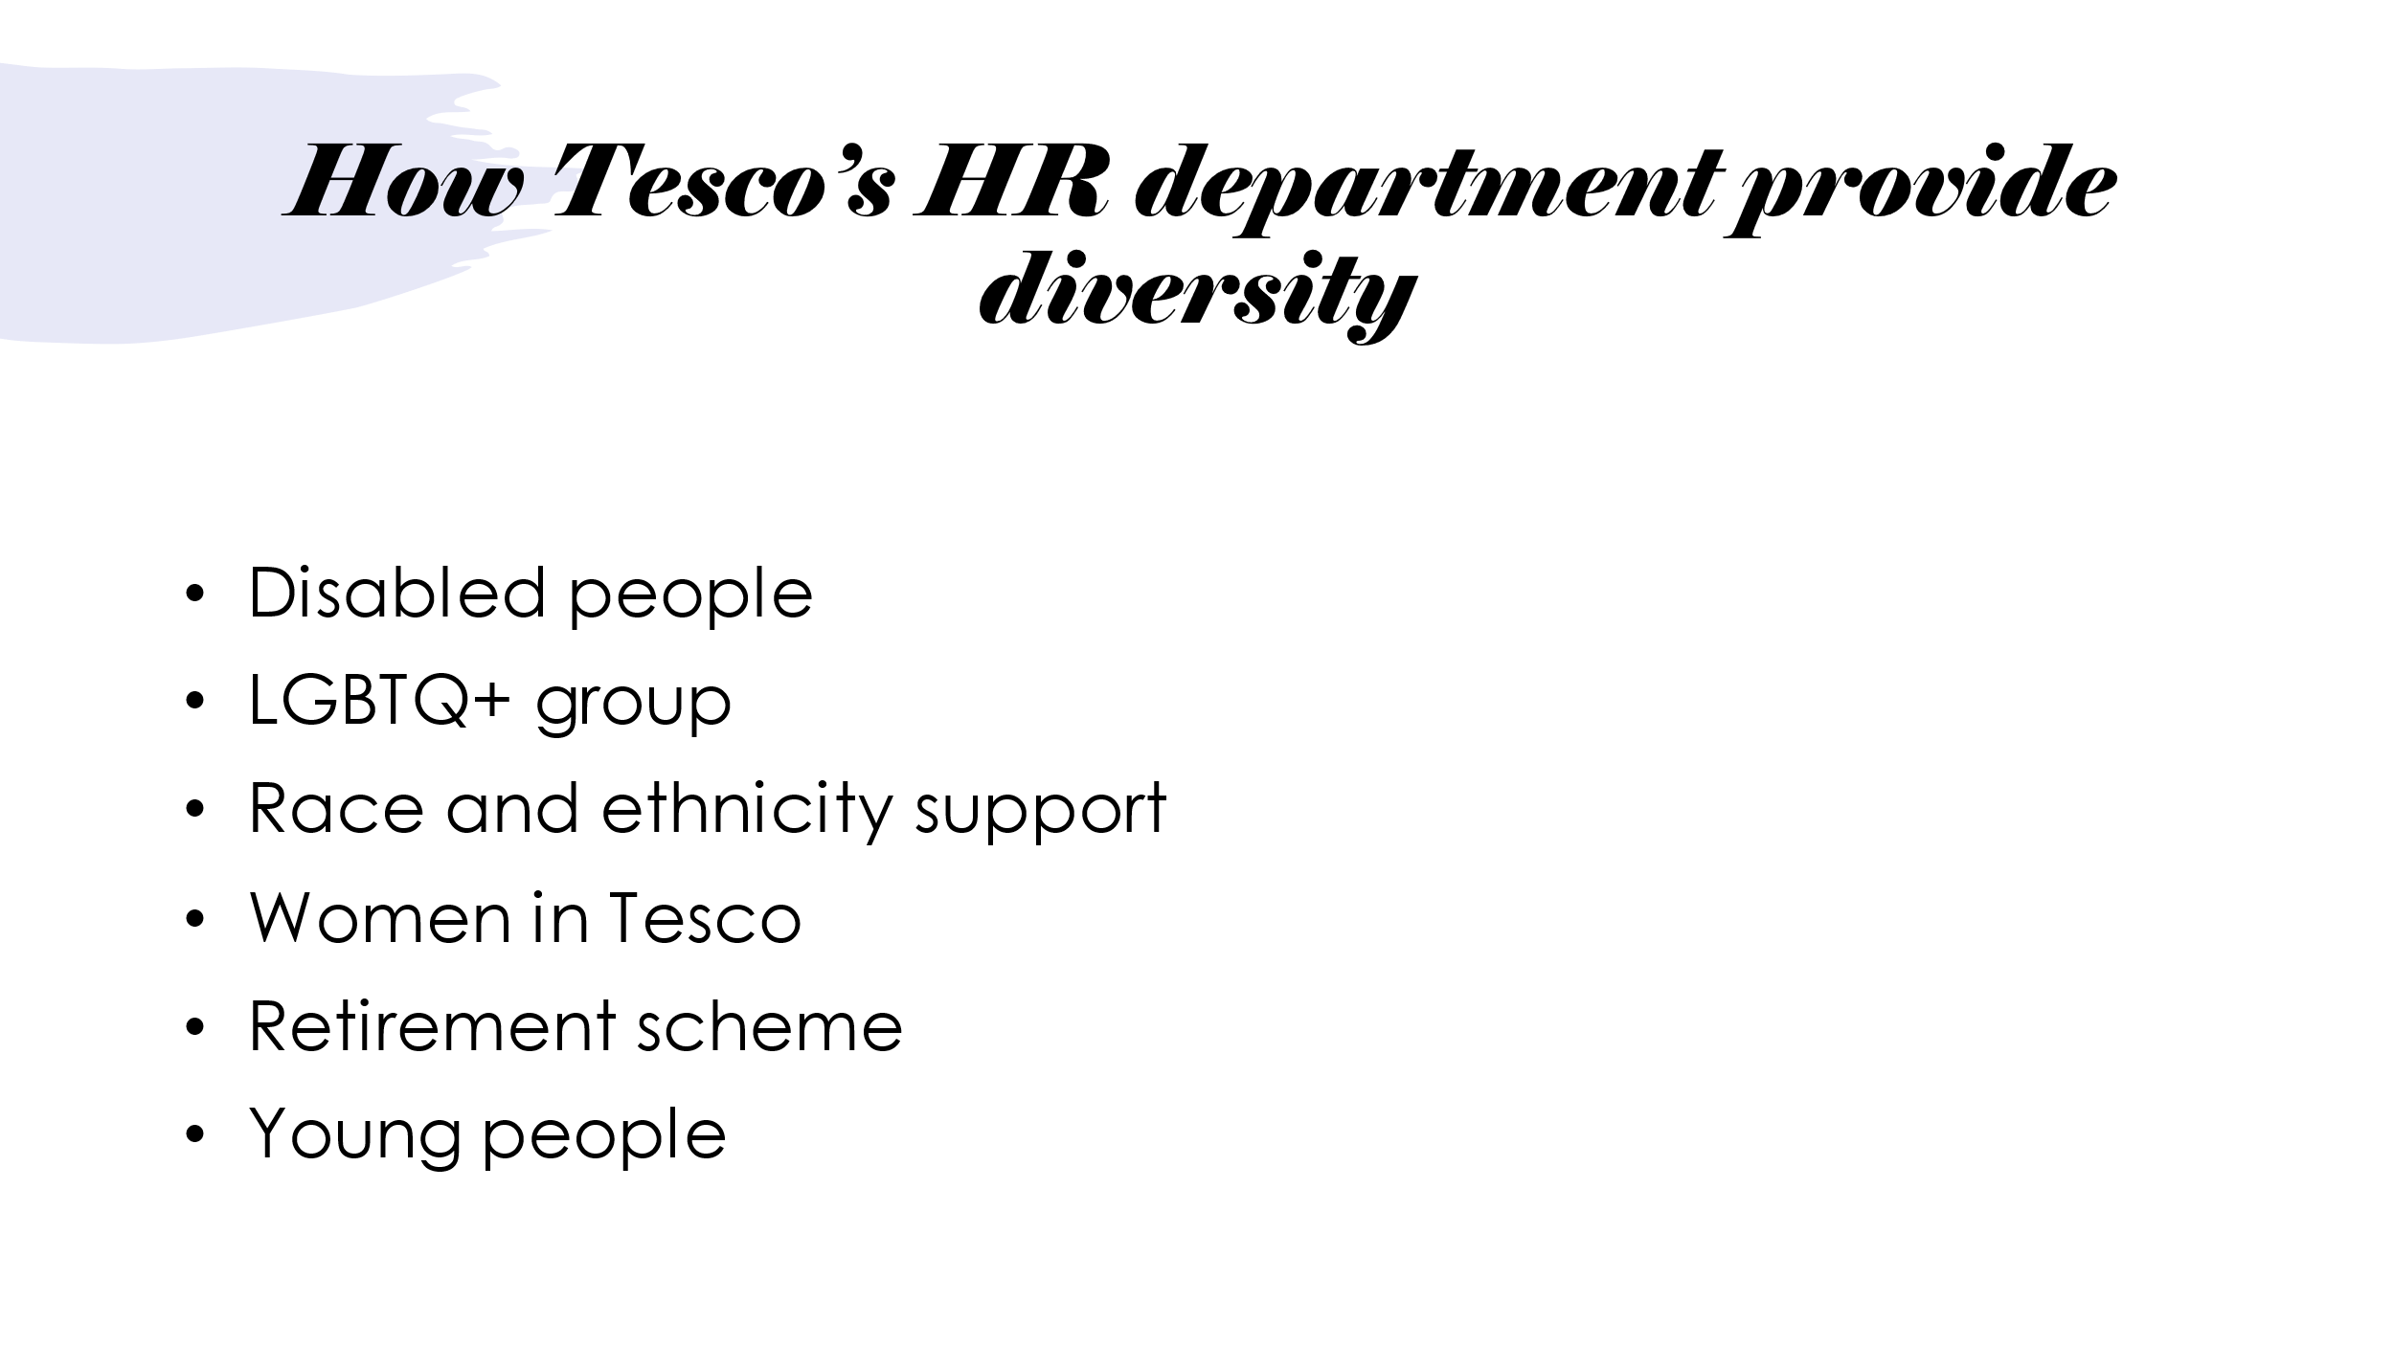

Impact of flexible working arrangement in Tesco:

Part-time working

Advantages:
- Great flexibility – the staff is able to fix their shifts depending on their needs such as childcare, maternity leave, or even because of another job.
- Help in busy periods – this advantage is mainly for Tesco. They can employ staff when required – during the pick periods throughout the year. Ex.: when the company needs more cashiers.
Disadvantages:
- Schedule meetings – a bit more difficult, because of everyone’s shifts, sometimes they can be covered and is going to be a problem if it does not have staff in the exact moment. (Janza, 2020)

Job shares

Advantages:
- The people make a better decision – problems could be solved easily and faster. More solutions could be offered, and the troubles could be defined before the time gone.
Disadvantages:
- Having a bad partner – one of the could be lazier or even not to contributive as the other is. The time for defining the problem could be expanded.
- Competition between both – both of them would like to suggest better ideas or suggestions, which Is not bad, but sometimes this could make a struggle through the work. (Reddy, n.d.)

Phased retirement

Advantages:
- Keep more time for the talented ones – when the employer cut the working hours of the staff who is satiated before retirement, they can work more years. They can offer a bit more of their experience with us and to contribute to our company.
Disadvantages:
- Reducing the pension – that is because usually the pension is based on the last years of working. And if you had worked less, your pension could be less. (Eisenberg, 2012)

Lifestyle break

Advantages:
- Relax yourself from the stressful environment – going on holiday or just relaxing at home will clear your thoughts and you can be more productive after the rest period.
- Learn new skills – taking a course can gain your knowledge in your area, which will contribute to your next steps further in the company.
Disadvantages:
- Less income – of course when you do not work you cannot take a salary, which will affect your income.
- Explaining gaps – this stage can be in your CV when you fill it. They should be explained in gaining purpose. (Levine, 2016)

Blended working

Advantages:
- Less cost and recruiting – because of the working at home, the company is not required to pay for rent. All the interviews can be lead online as well.
- Mixed solution – because of the perspectives the solution can be diverse. This will lead to more successful team and company at all.
Disadvantages:
- Higher hourly rate – cause by different freelancers, contractors and people who are sitting between the company and the staff.
- More difficult dealing with the staff – it has need of additional HR layer. (Group, 2021)

Fixed shift patterns

Advantages:
- Less working hours – the breaks through the day are include in the whole summary of the shift hours.
- Training process – the training hours are included in the shift, so the staff it dos not have to stay longer to gain new skills.
Disadvantages:
- Same daily routine – breakfast and lunch at work, leaving at the same time can upset the staff. Workers become disoriented because of it.
- Work imbalance – the night shift tells their words. The body is changing in order to be productive more at the night instead of the day. This can destroy your health, habits and personal life. (Reddy, What is Shift Work? Advantages and Disadvantages, n.d.)

Staggered shift patterns

Advantages:
- Reducing overcrowded offices – also saving the social distance for example in the time of Coronavirus it was absolutely helpful.
Disadvantages:
- Extra costs – paying for two teams instead of 2 for example is for sure cost more to the company.
- Problems with the new schedule – this type offers changeable shift from 9am-4pm, 4pm-9pm or other, and if the employee was affected by its change they should reorganize their plans and activities through the day. (Work, 2020)

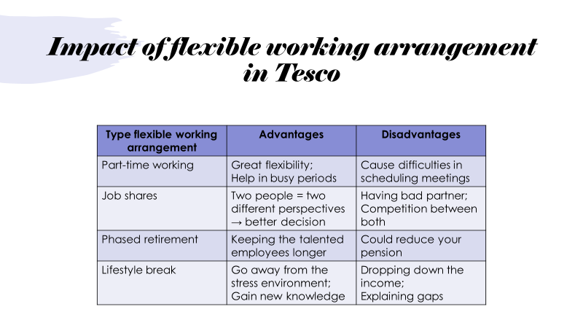
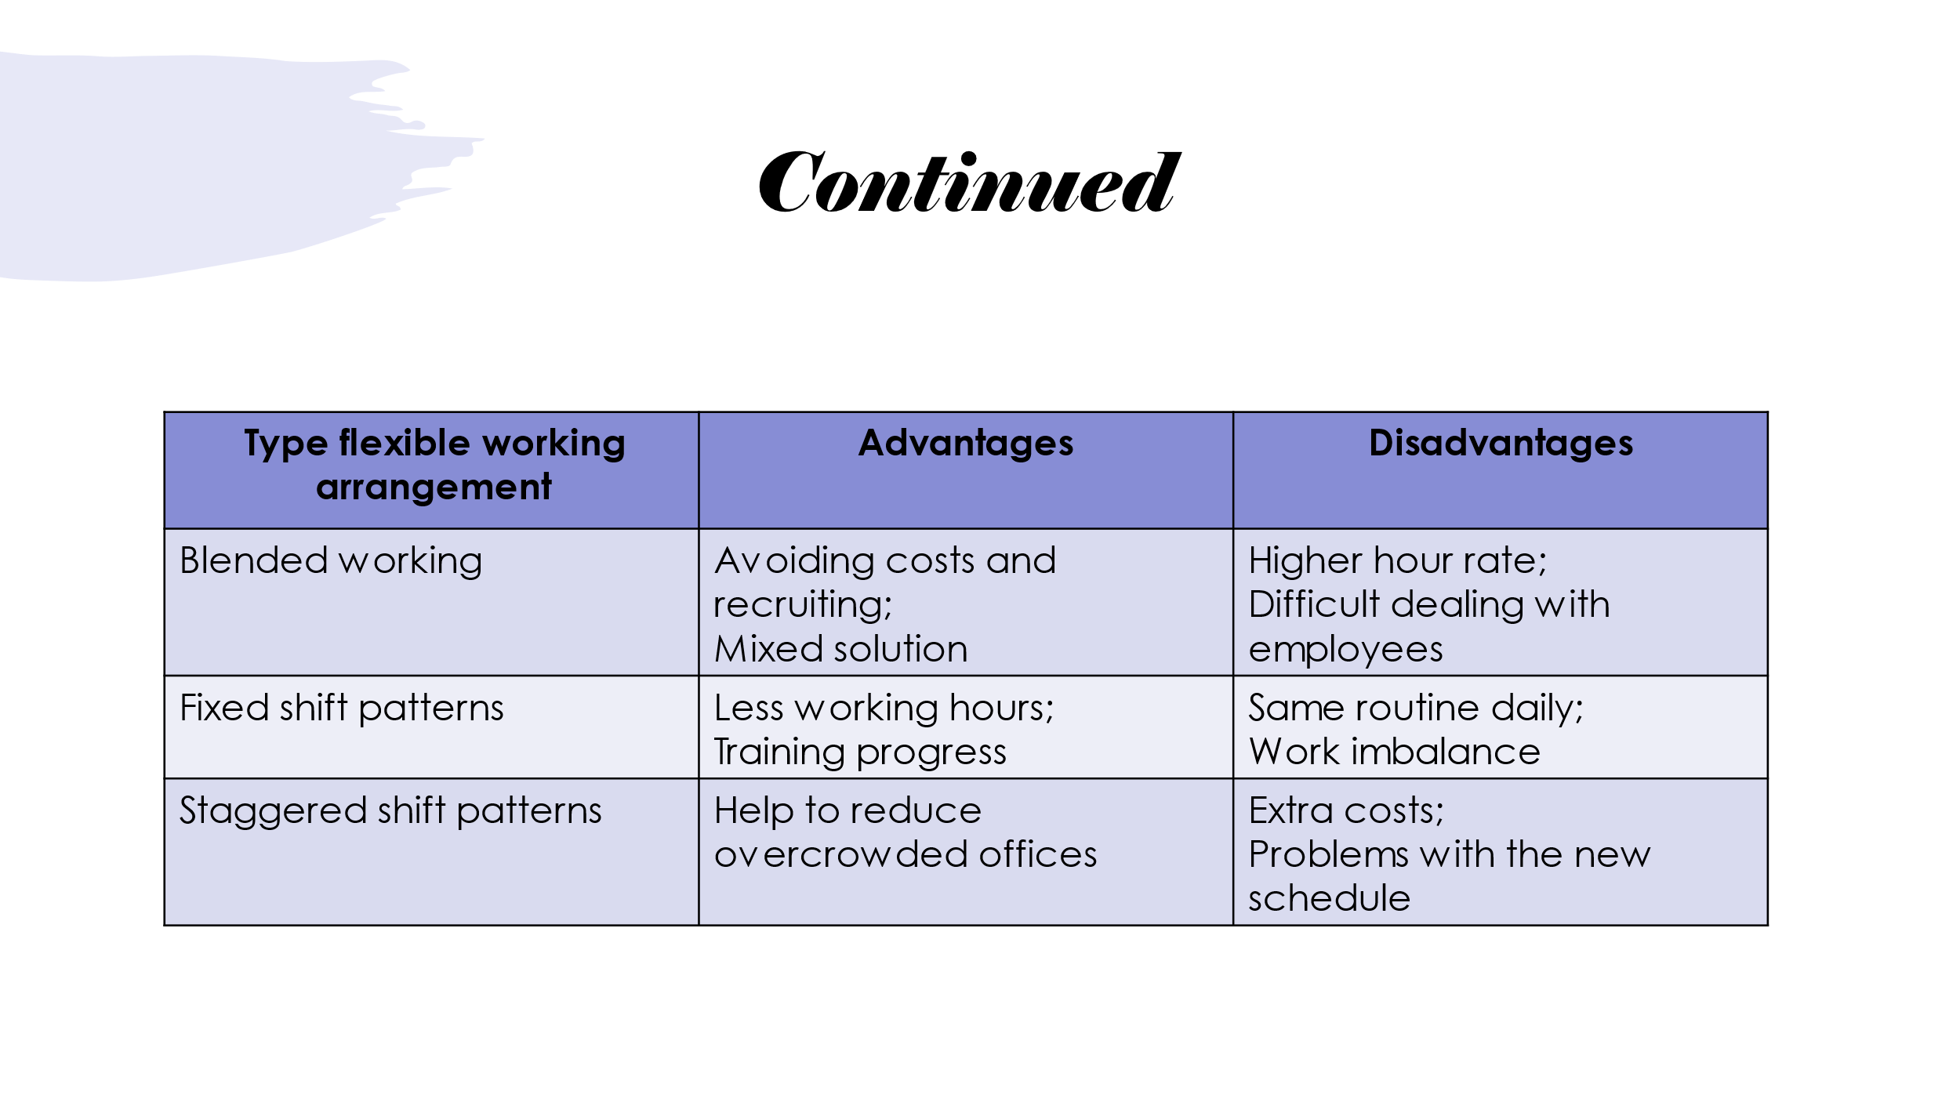

Recommendations for Tesco:

- Restock more frequently shop’s shelves – to satisfy customer’s needs it is important to have all the product in the right time/ right place
- Organize special events to promote new products/sections – degu stating centers around the shop.
- Replacing the plastic bag with paper bag – the future saving of the environment is important, and people take care of it.
- Offer people with special help – people with disabilities have to be provided with extra help.
- Give more importance to the people’s feedback – ask the people to leave their comments about the quality of the product, the service and offers for upcoming suggestions.

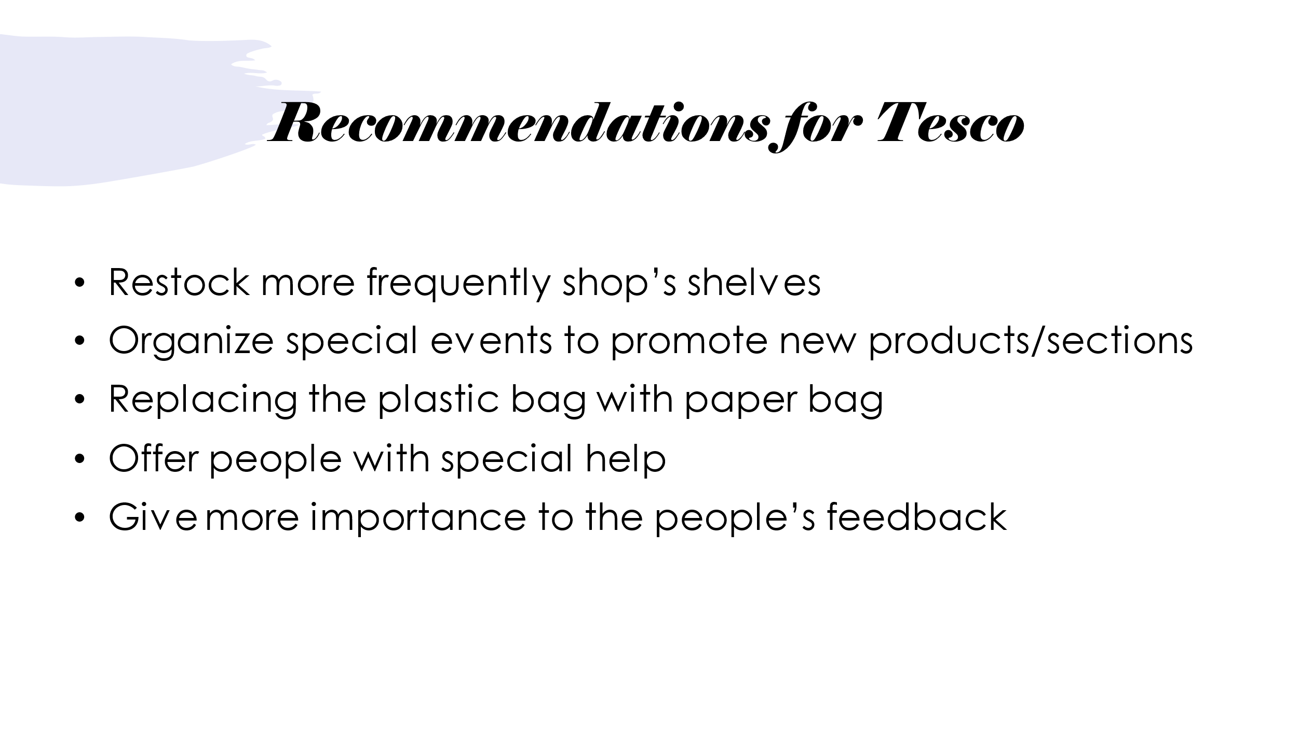

Conclusion:

At Tesco is considered that the staff should be treated fairly in terms of everyone’s needs such as a child growing, family events, or even self-care. Finding the best suitable way of working for the staff is one of the primary purposes of the company.
With all the forms of flexible arrangements which Tesco offer, this is possible if the person has more than 26 working weeks with us. They allow people to lead a well-balanced and healthy life. This impact on the company’s reputation – fast problem solving, effectively decision-making, and satisfied staff is the path to successfully managing Tesco.

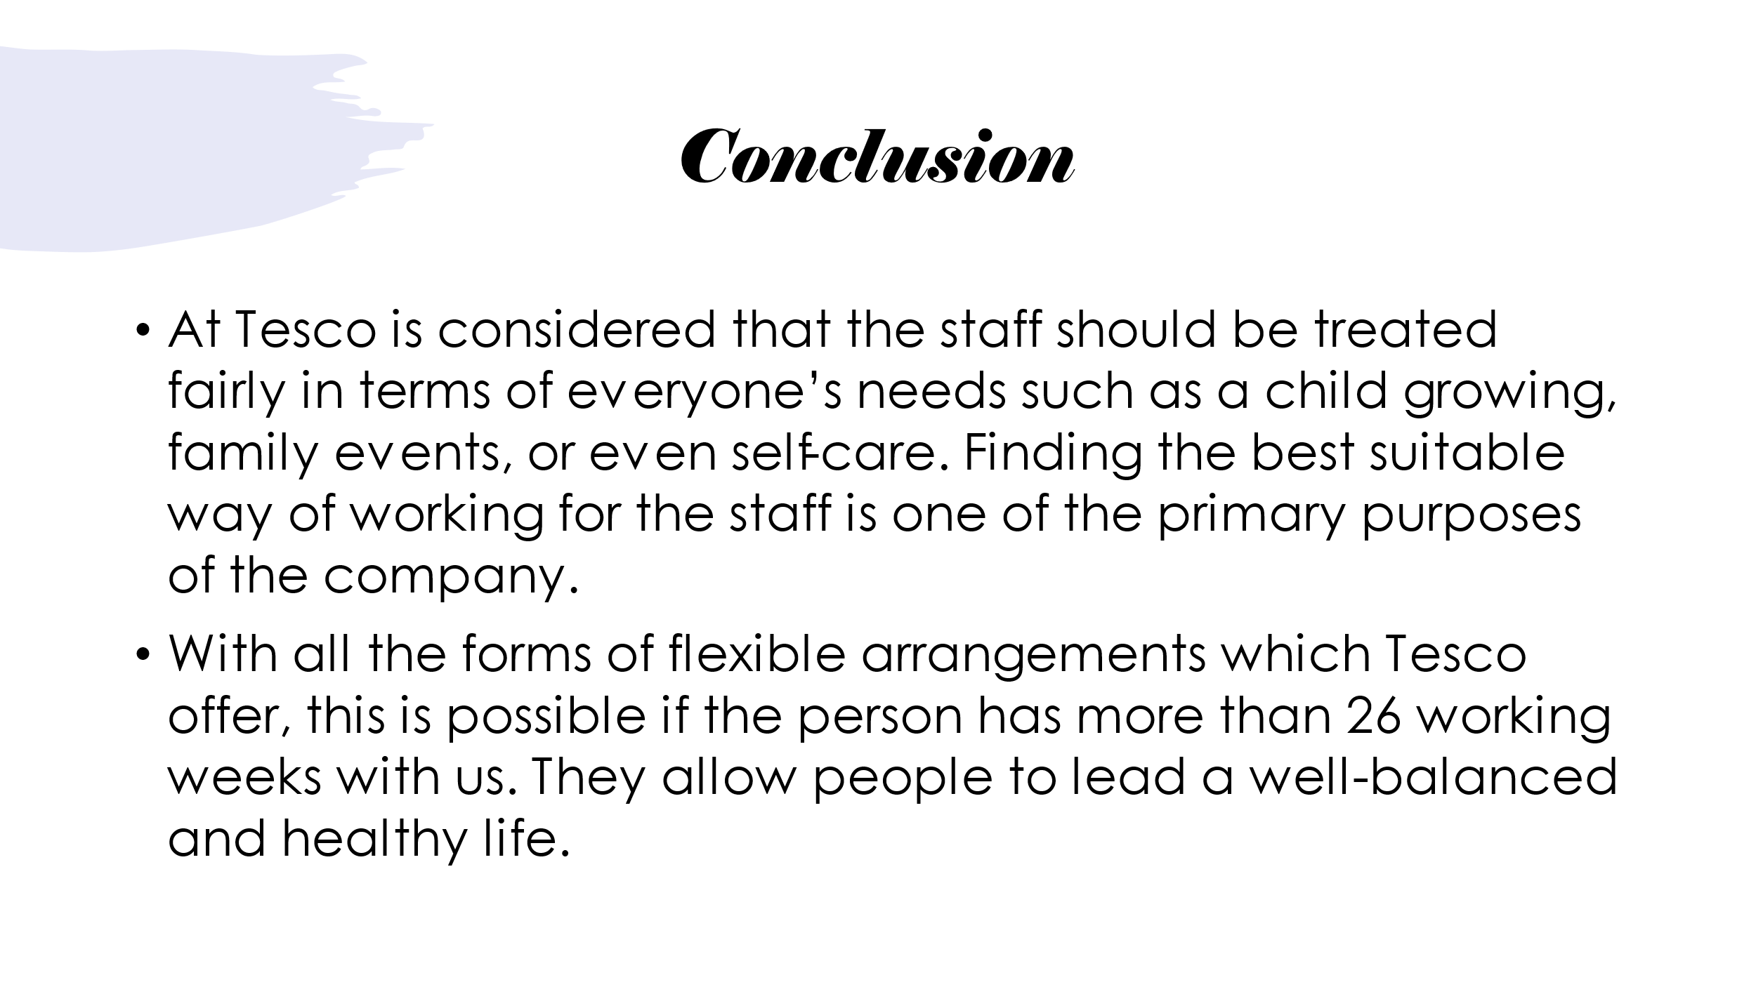

References:

Branine, M. (2004, March). Job sharing and equal opportunities under the new public management in local authorities. nternational Journal of Public Sector Management, pp. 136-152.
Colette Fagan, H. N. (2014). In search of good quality part-time employment. Geneva: TP/Design Unit, ILO.
Eisenberg, R. (2012, 04 13). Phased Retirement: What You Need to Know. Retrieved from Nextavenue: https://www.nextavenue.org/phased-retirement-what-you-need-know/
Emma Bedford. (2022, May 17). Average number of employees at Tesco worldwide in 2021 and 2022, by region. Retrieved from Statista: https://www.statista.com/statistics/490890/tesco-group-number-of-employees-worldwide/
Emma Bedford. (2022, May 17). Tesco's number of stores worldwide from 2008 to 2022. Retrieved from Statista: https://www.statista.com/statistics/238667/tesco-plc-number-of-outlets-worldwide/
Group, S. S. (2021, 08 11). PROS & CONS OF THE BLENDED WORKFORCE. Retrieved from Smart staffing group: https://www.smartstaffinggroup.com/2021/08/11/pros-cons-of-the-blended-workforce/
Hermansen, Å. (2015). Retaining older workers: The effect of phased retirement on delaying early retirement. NORDIC JOURNAL ofSOCIAL RESEARCH, 42-67.
How we create an inclusive working environment. (n.d.). Retrieved from https://www.tescoplc.com/sustainability/documents/policies/how-we-create-an-inclusive-working-environment/: https://www.tescoplc.com/sustainability/documents/policies/how-we-create-an-inclusive-working-environment/
Janza, N. (2020, 11 13). Part-time work: the Definition, Pitfalls, and Pluses. Retrieved from SPICA: https://www.spica.com/blog/part-time-work#advantages-and-disadvantages-of-part-time-work
Levine, N. (2016, 12 31). The pros and cons of taking a career break. Retrieved from Aatcomment: https://www.aatcomment.org.uk/career/the-pros-and-cons-of-taking-a-career-break/
O'Donovan, D. (2018). Diversity and Inclusion in the Workplace. In J. P. Carolina Machado, Organisational Behaviour and Human Resourse Management (pp. 73–108). Switzerland: Springer International Publishing A&G.
Reddy, C. (n.d.). What is Job Sharing? Its Advantages and Disadvantages. Retrieved from Wisestep: https://content.wisestep.com/top-advantages-disadvantages-job-sharing/
Reddy, C. (n.d.). What is Shift Work? Advantages and Disadvantages. Retrieved from wisestep: https://content.wisestep.com/top-advantages-and-disadvantages-of-working-in-shifts/
Thomas, R. J. (2020, November-December). Getting Serious About Diversity: Enough Already with the Business Case. Retrieved from Harward Business Review: https://hbr.org/2020/11/getting-serious-about-diversity-enough-already-with-the-business-case
Work, S. (2020, 10 20). Implementing Staggered Shifts: What You Need to Know. Retrieved from Safeter Home: https://safeter.work/implementing-staggered-shifts-what-you-need-to-know/



