Software Engineering Principles and Testing
Assignment
Harry Keinzley
2026
Contents
1. Introduction 1
1.1 Scenario Summary 1
1.2 Report Structure 1
2. Evaluation of the Design 1
2.1 The Design Process Followed 1
2.2 Wireframe of the Battleships Web Application 2
2.3 Strengths of the Approach 2
2.4 Weaknesses and Limitations 3
2.5 Reflection on Teamwork 3
3. User Stories and Story Map 3
3.1 Introduction to User Stories 3
3.2 Selected User Stories 4
3.3 Story Map 5
3.4 Discussion of the “Benefit” Clause 6
4. CRC Card Design 6
4.1 What Is a CRC Card? 6
4.2 Strengths and Weaknesses 7
4.3 The CRC Cards I Produced 7
4.4 Supporting Diagrams 8
4.5 Evaluation of the CRC Cards 9
5. Evaluation of Software Testing 10
5.1 Why Software Testing Matters 10
5.2 Black-Box vs White-Box Testing 10
5.3 Example Scenarios 11
5.3.1 Black-Box Example 11
5.3.2 White-Box Example 11
5.4 Testable Code 11
6. Application Tests and Unit Testing 12
6.1 Black-Box Tests 12
6.2 White-Box Tests 13
6.3 Unit Testing Principles 14
6.4 Applying Unit Testing to the White-Box Tests 15
7. Conclusion 16
8. References 16

1. Introduction
This report aims to evaluate the design and testing work that I produced for a web based version of Battleships, with 2 extra rules being added on top of the normal ruleset. The first of these rules is the drop-bomb which can be used once per game and destroys a whole ship in 1 move, and the second is the counter-manoeuvre which is also only usable once and lets a player move 1 of their ships by 1 square so that an incoming hit becomes a near miss instead.

1.1 Scenario Summary
The scenario that was being designed was a 2 player Battleships game where each player places 5 ships onto a 10×10 grid, these ships being the Carrier (size 5), Battleship (4), Cruiser (3), Submarine (3) and Destroyer (2). The ships can be placed horizontally, vertically or diagonally, however they cannot overlap or go outside the grid. Players then take turns calling coordinates and the other player reports back with hit, miss, destroy or near miss, with the first player to destroy all of the opponent’s ships winning the game.

1.2 Report Structure
This report is split into a number of sections in order to cover the design work and the testing work. Section 2 looks at the design process that I followed and also reflects on what was gained and lost by completing the work individually rather than as part of a team. Section 3 covers the user stories, the story map and the benefit clause. Section 4 then looks at the CRC cards and the supporting diagrams. Section 5 gives an overview of testing methods and section 6 applies them to the Battleships application using black-box, white-box and unit test examples. Section 7 then finishes the report.

2. Evaluation of the Design

2.1 The Design Process Followed
I worked through the problem in roughly the same order as the SDLC and requirements lectures, however it was not followed as a fully strict waterfall method because I kept going back when something needed changing. I first read the brief, then drew a rough UI on a whiteboard in order to make sure the main screen was clear, and after this I moved onto user stories, a story map, CRC cards and then the class and sequence diagrams. When a later stage showed that something had been missed, the earlier artifact was changed, with the clearest example being the CRC exercise which caused 2 of the user stories to be rewritten [1]. Figure 1 shows the overall process that I followed.
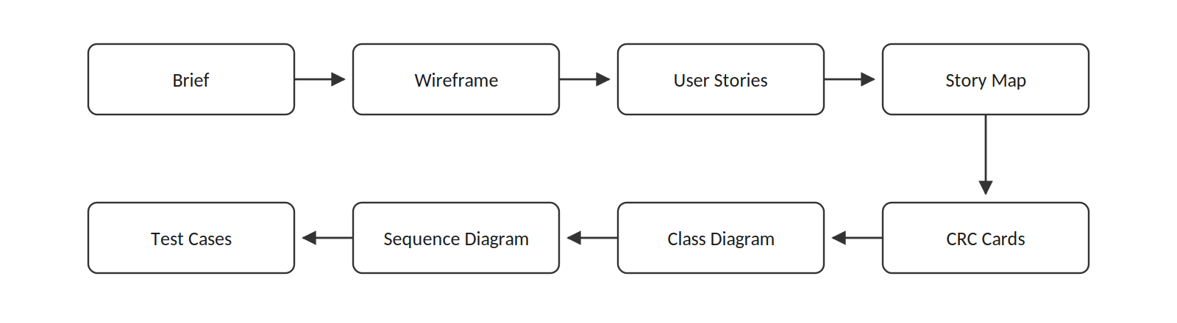
Figure 1: The design process that I followed

2.2 Wireframe of the Battleships Web Application
Figure 2 shows the main game screen that I designed. The player’s own fleet is placed on the left side and the opponent’s tracking grid is placed on the right, with the turn indicator in the middle so that it is clear whose go it is. Hits are shown using a red cross, misses use a white circle, destroys use a red “D” and near misses use a yellow arrow. The 2 special move buttons are then greyed out after they have been used so that the player knows they cannot use them again.
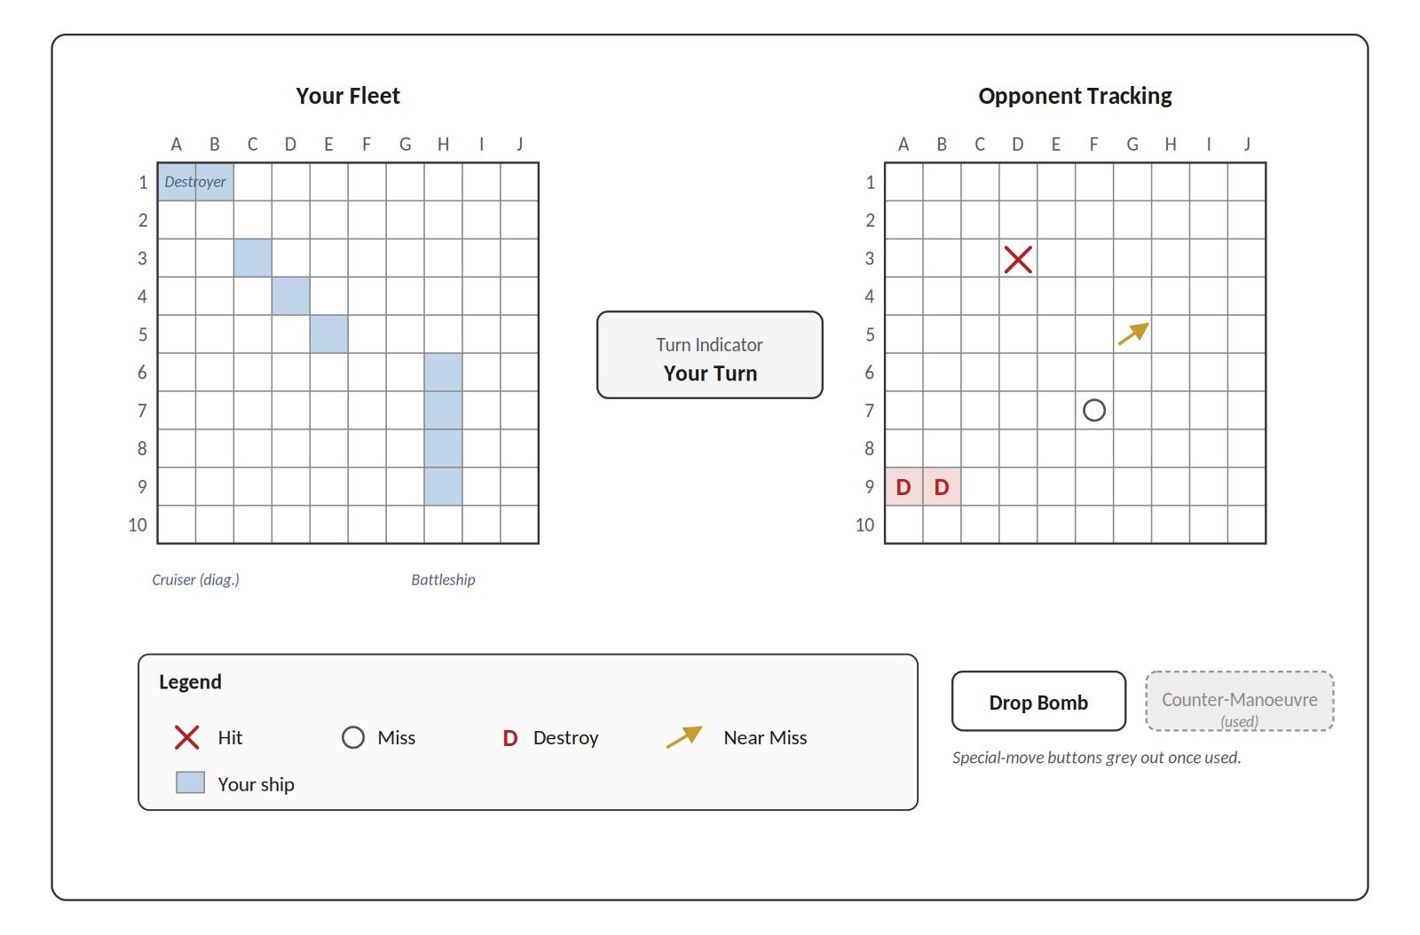
Figure 2: Wireframe of Battleships web application

2.3 Strengths of the Approach
The wireframe was probably the most useful resource that I produced because it gave every later stage something to refer back to. When I was deciding whether “destroy” needed its own visual state it was much quicker to just look at the picture and decide, rather than relying only on a written description [2]. The user stories were also useful because they kept the design focused on what the players actually needed to do, rather than going too early into choices such as frameworks or databases. The CRC cards also helped find missing collaborators, because when I role-played the classes it became clear that Ship had no proper connection to Board when reporting a hit.

2.4 Weaknesses and Limitations
This approach also had a range of weaknesses. The biggest issue was that the non-functional requirements were almost missing completely, meaning that there was nothing about response time, accessibility or what should happen if 1 of the players disconnects during the game. Pressman and Maxim state that these kinds of concerns should be included early in design [3], but in this case they were mostly skipped. Another issue was that the CRC responsibilities were not all written at the same level, with some sounding like whole paragraphs and others sounding like single methods. The 2 rule changes were also added on afterwards rather than being built in from the start, which made Player, Game and SpecialMove more tightly connected than they needed to be. A cleaner version would have been to make each special move its own object, such as through the command pattern.

2.5 Reflection on Teamwork
In this project I did not really work with a team, and instead completed the design and testing work on my own. This changed the meaning of the teamwork reflection, because there were no meetings, task allocations or disagreements to analyse in the normal sense. The main advantage of working individually was that the process was quicker and more consistent. I could move between the wireframe, stories, CRC cards and diagrams without waiting for other people, and the final artifacts all followed the same interpretation of the brief. This helped the work stay focused.
However, the lack of a team also created clear weaknesses. In a real group design activity, other people can challenge assumptions and notice parts of the problem that 1 person misses. For example, another student might have questioned the missing non-functional requirements earlier, or suggested a different way of handling the counter-manoeuvre rule. Because I was working alone, I had to create that challenge myself by checking each artifact against the brief and against the acceptance criteria. This was useful, but it was still not as strong as proper peer feedback because I was reviewing my own decisions.
To make up for the lack of teamwork, I tried to treat the design artifacts as separate viewpoints. The user stories forced me to think as the player, the CRC cards forced me to think as the programmer, and the test cases forced me to think as the tester. This gave the project some of the benefits of collaboration, but only in a limited way. If I completed the task again with a real team, I would want clearer roles, such as 1 person checking requirements, 1 person challenging the design and 1 person focusing on testing. That would make the design less dependent on a single viewpoint and would probably reveal gaps earlier.

3. User Stories and Story Map

3.1 Introduction to User Stories
A user story is a short statement used to describe something a user wants to do and the benefit they should get from doing it [2]. The usual format is “As a <role>, I want <action>, so that <benefit>”, and this is then followed by acceptance criteria which can be checked as pass or fail. Stories are kept short because they are not meant to be a full specification, they are more of a starting point for a conversation about what the system should do.
For a user story to be useful it should follow the INVEST criteria, meaning it should be Independent, Negotiable, Valuable, Estimable, Small and Testable.

3.2 Selected User Stories
The 5 stories below were chosen because they cover the main path through a Battleships game, starting with setting up the ships, then taking a turn, using the 2 special moves and finally winning the game. For the stories after US-01, only the acceptance criteria and priority are shown in order to save space.
Story ID | US-01
Title | Place ships before play
As a… | player
I want… | to position my 5 ships on my grid before the game starts
So that… | I can set up a fleet layout that I think will survive my opponent’s guesses
Acceptance criteria | • Exactly 5 ships of the correct sizes can be placed  • Ships may be placed horizontally, vertically or diagonally  • Ships cannot overlap or extend off the grid  • Play does not start until all 5 are placed
Priority | Must have
Table 1: US-01: Place ships before play.
Story ID | US-02: Take a turn
As a / I want / So that | As a player, I want to fire at a chosen square on my opponent’s grid, so that I can hunt down their ships and work towards a win.
Acceptance criteria | • I can fire only during my own turn  • I cannot fire at a square I have already fired at  • The result (hit, miss, destroy, near miss) is returned  • My tracking grid is marked automatically  • The turn passes once the shot is resolved
Priority | Must have
Table 2: US-02: Take a turn.
Story ID | US-03: Use the drop-bomb
As a / I want / So that | As a player, I want to use my drop-bomb once per game, so that I can finish off a ship in one move when I am confident that I have located one.
Acceptance criteria | • Usable once per game only  • Lands on a ship → whole ship destroyed, reported as “destroy”  • Lands on empty water → counts as a normal miss  • Button disabled after use
Priority | Must have
Table 3: US-03: Use the drop-bomb.
Story ID | US-04: Use the counter-manoeuvre
As a / I want / So that | As a player, I want to slide 1 of my ships by 1 square when I am fired at, so that I can dodge a shot and buy some time.
Acceptance criteria | • Usable once per game only  • Only when an incoming shot would hit one of my ships  • I choose the direction (any of 8)  • Cannot move a ship off-grid or into another ship  • Opponent is told “near miss” rather than “hit”
Priority | Should have
Table 4: US-04: Use the counter-manoeuvre.
Story ID | US-05: Win the game
As a / I want / So that | As a player, I want the game to declare me the winner once I have sunk every opposing ship, so that the game ends cleanly and I know that I have won.
Acceptance criteria | • Win checked at the end of every turn  • Win message shown to both players  • No further shots accepted after a win  • A “new game” option is offered
Priority | Must have
Table 5: US-05: Win the game.

3.3 Story Map
A story map is described by Patton as a 2 dimensional view of the product [4]. The user journey runs from left to right across the top, which is often called the backbone, and the user stories are then placed underneath it in slices based on priority. Figure 3 shows the map produced for my design. The backbone goes from Set Up, to Place Ships, Take Turn, Use Special Move and then End Game. The first slice is the must-have MVP and contains US-01, US-02 and US-05, while the second slice adds the 2 special moves US-03 and US-04 along with some smaller polish items.
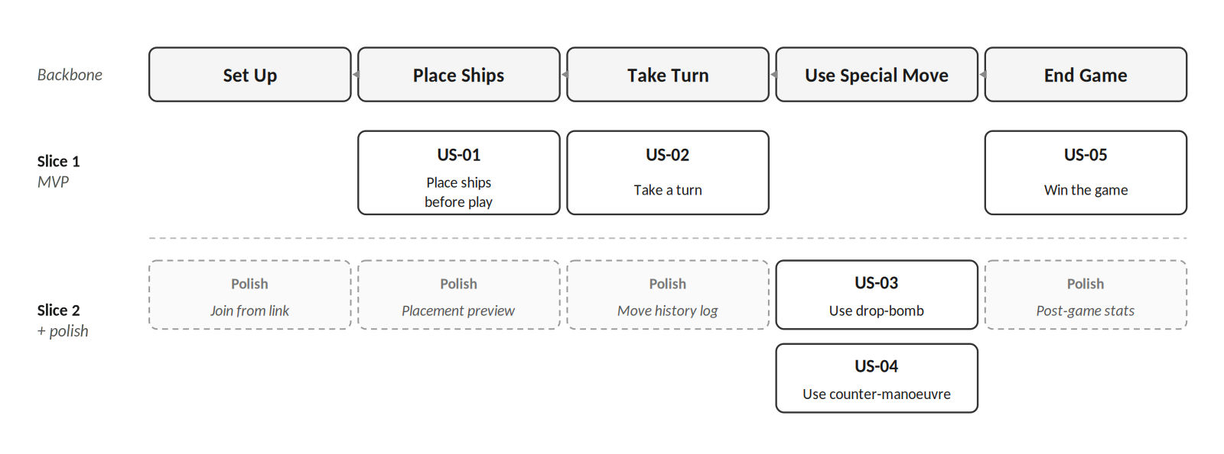
Figure 3: User story map for Battleships web application

3.4 Discussion of the “Benefit” Clause
Cohn argues that the “so that” part of a user story is often the part that gets skipped, even though it is useful because it explains why the feature matters [2]. 3 of my stories are useful to look at more closely.
US-03 (Drop-bomb). The benefit for this story was “finish off a ship when I am confident I have located one”, and this is not just about destroying a ship but is also about giving the player more certainty. A normal hit tells the player that a ship is there but does not tell them the whole shape, while the drop-bomb turns 1 correct guess into full information about that ship. Looking at the benefit in this way led to the acceptance criterion that the whole ship should be revealed on the tracker, not only the square that was selected.
US-04 (Counter-manoeuvre). The first version of the benefit was “to avoid a hit”, which made the feature sound like a simple dodge. When it was rewritten as “buy some time” it created the question of whether 1 extra turn is actually useful. I decided that the main value was psychological because the attacker then has to question whether their next hit is reliable. This is why the opponent is told “near miss” rather than nothing, because if there was no feedback then the feature would lose most of its point.
US-05 (Win). The benefit “the game ends cleanly and I know I have won” actually contains 2 parts. The game could show a win message but still allow more shots to be made, which would mean that only half of the benefit had been achieved. Splitting this benefit up led to the acceptance criterion that no further shots should be accepted after the game has been won.
The same pattern appeared across all 3 stories, because when the benefit was vague the acceptance criteria also became vague, while a clearer benefit made the criteria much easier to write [4].

4. CRC Card Design

4.1 What Is a CRC Card?
A CRC card records the class name, its responsibilities, meaning what it knows and what it does, and its collaborators, meaning the other classes that it needs. The technique was first introduced as a teaching tool [5], but it is still useful because it is quick and allows the designer to work through object responsibilities in a structured way. Each class is written onto 1 card and the designer can then act out a scenario by letting each card perform its responsibilities. Gaps show up when a card needs to do something but has no collaborator to send the work to, or when multiple cards all seem to claim the same responsibility.

4.2 Strengths and Weaknesses
CRC cards have multiple advantages that make them useful in early design. They are cheap because they only need a pen and some cards, and they also make it easy to explore responsibilities before writing code. Role-playing the cards can also show missing responsibilities quickly, as happened in my design work when it became clear that Ship needed to work with Board in order to report hits. The output also leads quite naturally into a class diagram later on.
There are also disadvantages to this method. CRC cards are informal, so 2 teams can create different cards for the same problem without either 1 being completely wrong. They also become harder to use when the number of classes gets larger, because too many cards makes it difficult to keep track of the design. Another issue is that responsibilities can be written at different levels, for example “manages the grid” is much broader than “returns the Square at (x, y)”, and mixing both of these on 1 card can hide gaps in the design.

4.3 The CRC Cards I Produced
In total I identified 8 classes. The 5 main classes are shown below, while ShotResult, Fleet and GameHistory are supporting value objects and were left out in order to save space.
Class: Game
Responsibilities  • Create a new game with 2 players  • Track whose turn it is  • Route shots from firing to target player  • Check for a win after every turn  • Declare winner and stop accepting shots | Collaborators  • Player  • Turn
Table 6: CRC card: Game.
Class: Player
Responsibilities  • Own a Board and fleet of Ships  • Record whether drop-bomb has been used  • Record whether counter-manoeuvre has been used  • Receive incoming shots on own Board  • Fire shots at opponent’s Board | Collaborators  • Board  • Ship  • DropBomb  • CounterManoeuvre
Table 7: CRC card: Player.
Class: Board
Responsibilities  • Hold the 10×10 collection of Squares  • Place a Ship (checking bounds and overlap)  • Record incoming shots on the correct Square  • Resolve a shot to hit / miss / destroy / near miss  • Report whether every Ship has been sunk | Collaborators  • Square  • Ship
Table 8: CRC card: Board.
Class: Ship
Responsibilities  • Know its size  • Know the Squares it occupies  • Register a hit on one of its Squares  • Report whether it has been sunk  • Shift by 1 Square for a counter-manoeuvre | Collaborators  • Square
Table 9: CRC card: Ship.
Class: DropBomb
Responsibilities  • Execute a bomb shot at a coordinate  • If coordinate belongs to a Ship, mark every Square of that Ship destroyed  • If coordinate is empty, behave as a normal miss  • Mark itself used after firing | Collaborators  • Board  • Ship  • Square
Table 10: CRC card: DropBomb.

4.4 Supporting Diagrams
Figure 4 shows the class diagram that was created from the CRC cards. Aggregation is used for Player-Board and Board-Ship because these objects can be described as whole-part relationships, while composition is used for Player-DropBomb and Player-CounterManoeuvre because the special moves do not exist outside the player that owns them. Figure 5 then shows the sequence diagram for 1 turn, where Player does not resolve the shot by itself and instead delegates to the opponent’s Board, which then asks the Ship to register the hit and report whether it has been sunk.
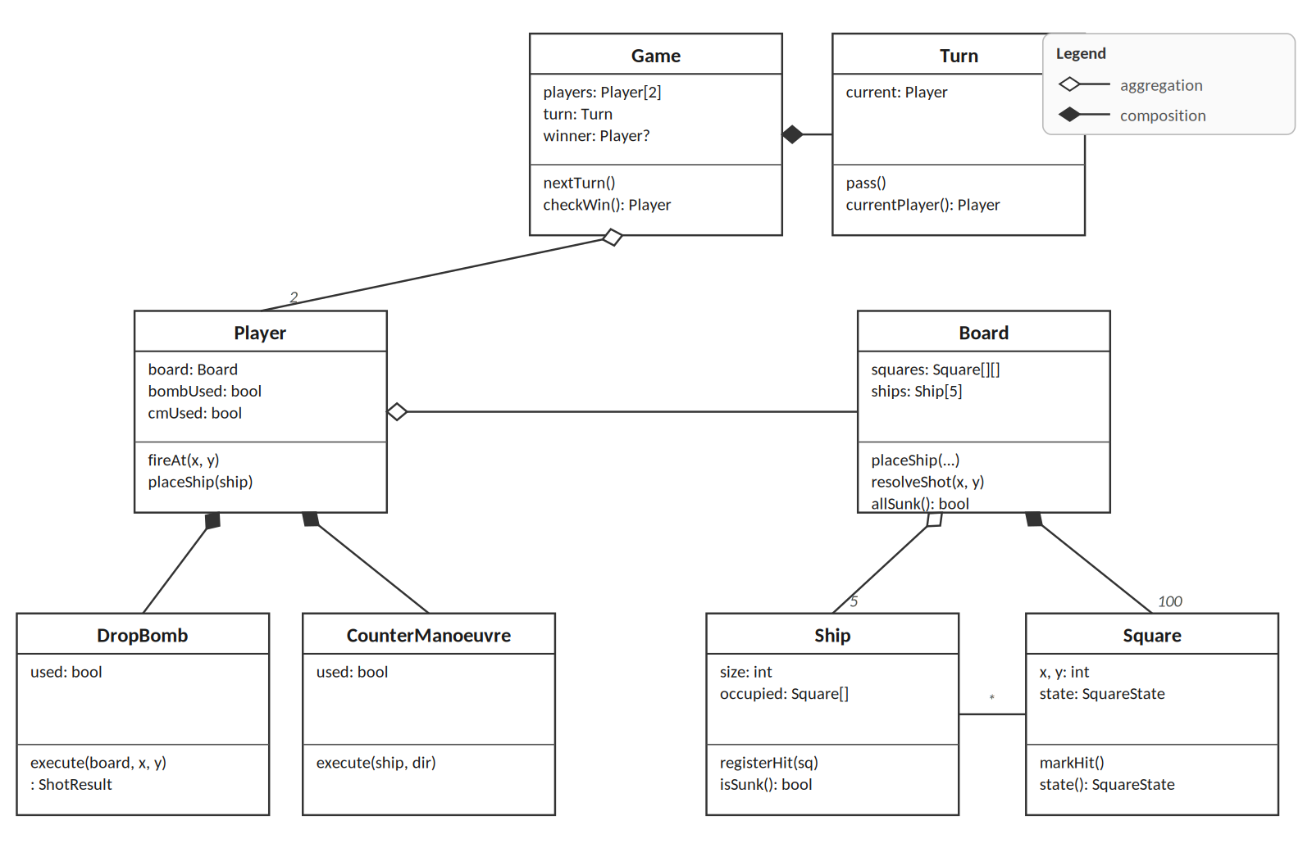
Figure 4: Class diagram for Battleships application
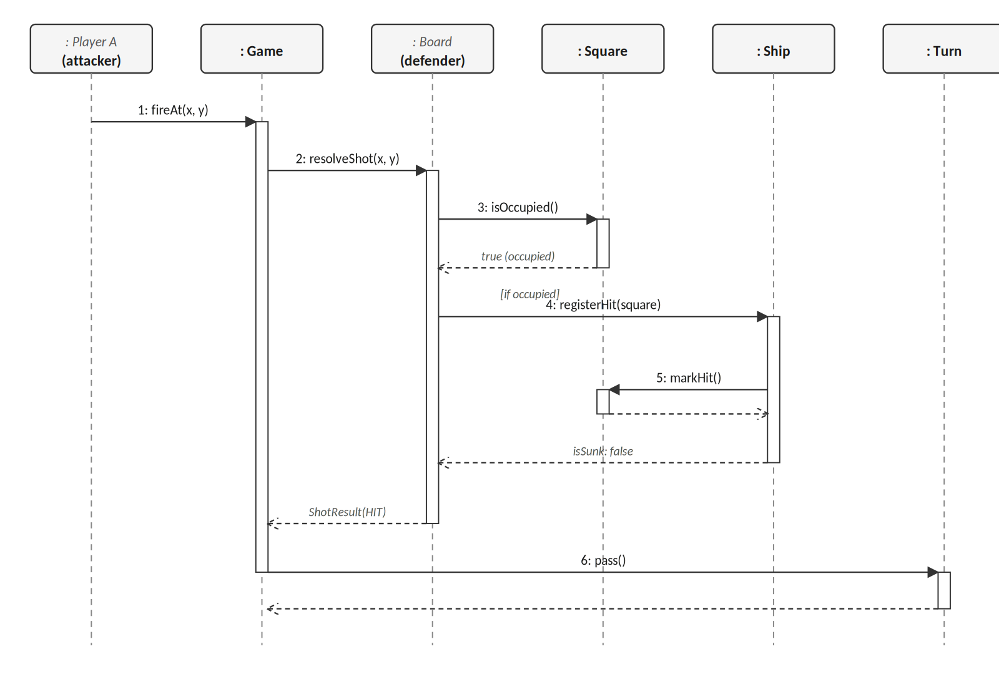
Figure 5: Sequence diagram for 1 turn

4.5 Evaluation of the CRC Cards
The brief asks whether the CRC cards are enough to support implementation and testing, and whether they match the acceptance criteria. The answer to both of these is partly, because they are useful but not complete.
In terms of implementation, the Game, Player, Board and Ship cards include the main collaborators that are needed and their responsibilities are clear enough to be turned into methods. Methods such as Board.placeShip(), Board.resolveShot() and Ship.isSunk() can be seen quite directly from the cards. The DropBomb card is weaker however, because it does not clearly say what should happen if the player tries to use it a second time, such as whether the UI blocks it or whether the class should throw an error, and this matters when tests are being written.
In terms of acceptance criteria, the link is weaker. US-01 says that ships can be placed diagonally, but this is only implied by the responsibility “places a Ship”. US-04 says that the counter-manoeuvre cannot push a ship off the grid, but this does not appear properly on any card because the CounterManoeuvre card was not finished. A useful improvement would be to add a column to each card showing which story ID each responsibility supports. Beck and Cunningham warn about this kind of problem in the original CRC paper [5], because CRC cards are meant to guide a conversation rather than act as a full contract.
The main improvements that should be made before coding are to add a full CounterManoeuvre card with validation responsibilities, rewrite the vague responsibilities so they are closer to method level, and label each responsibility with the user story that it supports.

5. Evaluation of Software Testing

5.1 Why Software Testing Matters
Testing is important because the cost of fixing a defect usually becomes higher the later it is found. Sommerville gives multipliers of between 10 and 100 between development and production [1]. Testing also makes it safer to change the code later, because a good set of tests can show whether behaviour has stayed the same after refactoring or adding new features. Without tests, every change becomes more risky because a hidden regression could be introduced without anyone noticing.
There is also a design benefit to testing. Code that is easy to test is usually better structured, because writing a test forces the developer to look at a class from the outside and this often leads to smaller classes, clearer methods and fewer hidden dependencies [6]. In this way testing does not only check the design, it can also improve it.

5.2 Black-Box vs White-Box Testing
Black-box and white-box testing are the main 2 testing approaches covered in this report, with the difference being how much the tester knows about the internal code. Table 11 gives a comparison between the 2.
Aspect | Black-Box | White-Box
Knowledge | Specification only | Internal code structure
Techniques | Equivalence partitioning, boundary-value analysis | Statement, branch, path coverage
Battleships example | Fire at empty square, expect “miss” | Assert Ship.isSunk() returns true only when all squares hit
Strength | Close to real user behaviour; tester-developer independent | Targets specific branches; exposes edge paths
Weakness | Cannot guarantee every branch exercised | Couples to internals; breaks on refactor
Table 11: Comparison of black-box and white-box testing.
In black-box testing, the tester treats the software as a closed box and checks whether the output matches the specification. This is useful for acceptance testing because it is close to how the user sees the system and it can keep working even if the internal code changes. In white-box testing, the tester can see the source code and aims at specific statements, branches or paths. Neither method is enough by itself, because black-box tests might miss rare branches while white-box tests might still pass even when the visible behaviour has changed, meaning that a strong test suite should use both.

5.3 Example Scenarios

5.3.1 Black-Box Example
One black-box example would be checking that firing at an empty square returns “miss”. The tester only needs to know the rule from the specification, with the input being a fire command at a coordinate that has no ship on it. The expected output is “miss”, a miss symbol being added to the tracking grid, and the turn then passing to the other player. The way the grid is stored internally does not matter for this test, so if the internal code changed the test should still remain valid.

5.3.2 White-Box Example
A white-box example would be testing that Ship.isSunk() only returns true when every Square belonging to the ship has been hit. The setup could be a Destroyer at (0,0) and (0,1), where the test registers a hit on (0,0), calls isSunk() and expects false, then registers a hit on (0,1), calls it again and expects true. This is white-box testing because it goes straight to the Ship class and avoids Board and Game. The disadvantage is that if the sunk logic was moved during a refactor, the test could break even if the user-visible behaviour was still the same.

5.4 Testable Code
Code is testable when a test can put it into a known state, run the part being tested and then check the result without needing the whole application to be running. Martin links this to the SOLID principles [7], because a class with 1 clear responsibility and dependencies that can be passed in is usually much easier to test than a large class with hidden dependencies. Signs of testable code include small classes, dependencies passed in rather than created inside the class, pure functions where possible, return values that can be checked, and low coupling between classes.
For Battleships this means that Ship should not know how the UI draws a near miss, because that is not its responsibility. Game should be given its Players through the constructor, and small helper functions such as isOnGrid(x, y) should return a clear result without changing hidden state. The benefit of this is cheaper change over time, because a codebase that needs a full manual run-through after every small edit becomes more expensive to work with as it grows [6].

6. Application Tests and Unit Testing

6.1 Black-Box Tests
The tests below use the 4 fields required by the brief. Together they cover normal successful cases (TC-01 and TC-04), invalid input (TC-02), a boundary case (TC-03), and the end of the game (TC-05).
TC-01: Place a ship within the grid
Pre-conditions | New game started; no ships placed
Inputs | Place a Destroyer (size 2) horizontally at (3, 3)
Expected outputs | Destroyer occupies (3, 3) and (4, 3); visual confirmation shown
Description | Simplest happy-path placement. Also confirms zero-based indexing.
Table 12: TC-01.
TC-02: Reject overlapping placement
Pre-conditions | A Destroyer is already placed at (3, 3) horizontally
Inputs | Attempt to place a Cruiser horizontally at (4, 3)
Expected outputs | Placement rejected; visible error; no second ship recorded
Description | Exercises the overlap rule against an easy case. This helps protect against off-by-one overlap errors that might show up in trickier placements later on.
Table 13: TC-02.
TC-03: Reject off-grid placement
Pre-conditions | New game started
Inputs | Place a Carrier horizontally at (7, 0)
Expected outputs | Placement rejected (would need squares 7–11 on a 10-wide grid)
Description | Boundary-value case against the longest ship. Catches off-by-one bounds errors.
Table 14: TC-03.
TC-04: Drop-bomb hits a ship
Pre-conditions | Drop-bomb unused; opponent has a Cruiser at (2,5), (3,5), (4,5)
Inputs | Fire drop-bomb at (3, 5)
Expected outputs | Result “destroy”; all 3 Cruiser squares marked destroyed; drop-bomb shown as used and disabled
Description | Central case for US-03. Confirms that the whole ship is destroyed and that the usage flag is updated. A pass here is strong end-to-end evidence that the destroy path works.
Table 15: TC-04.
TC-05: Win on final hit
Pre-conditions | Opponent has exactly 1 un-hit square
Inputs | Fire at the final un-hit square
Expected outputs | Hit and ship sunk; win message shown; no further shots accepted
Description | End-of-game path. Verifies both win detection and the stop-accepting-shots behaviour. This catches a common mistake where the game correctly declares a winner but leaves the input fields live.
Table 16: TC-05.

6.2 White-Box Tests
These tests focus on specific methods that came out of the CRC card design.
TC-W1: Ship.isSunk()
Pre-conditions | Destroyer occupying (0,0), (0,1)
Inputs | Hit (0,0), call isSunk(); then hit (0,1), call again
Expected outputs | false, then true
Description | Exercises both branches of the loop. A single assertion would miss a bug where any hit causes isSunk() to return true.
Table 17: TC-W1.
TC-W2: Board.placeShip() overlap
Pre-conditions | Destroyer placed at (3,3) horizontally
Inputs | placeShip(Cruiser, 4, 3, HORIZONTAL, 3)
Expected outputs | Returns false / throws overlap exception; Board unchanged
Description | Tests the overlap branch directly in the domain class, independent of UI.
Table 18: TC-W2.
TC-W3: DropBomb.execute()
Pre-conditions | Cruiser at (2,5), (3,5), (4,5); DropBomb unused
Inputs | execute(board, (3, 5))
Expected outputs | Every Cruiser Square in destroyed state; DropBomb.used = true
Description | Covers the “hit a ship” branch. A paired miss-branch test at (0,0) would give full branch coverage of the method.
Table 19: TC-W3.

6.3 Unit Testing Principles
A unit test checks a small and isolated part of the code automatically. It should not need a database, network connection or global state, it should run quickly, and it should pass or fail without a human having to interpret the result.
A common set of principles for unit tests is FIRST [6], which means Fast, Independent, Repeatable, Self-validating and Timely. Another common structure is Arrange, Act, Assert, where the test first creates the objects it needs, then runs 1 method, and then checks the result. Other useful rules are to keep each test focused on 1 behaviour, test what the code does rather than how it does it, use test doubles such as stubs, mocks and fakes when a dependency needs to be replaced [8], and name the test so that it describes the behaviour, for example ship_isSunk_returnsTrue_whenAllSquaresHit.

6.4 Applying Unit Testing to the White-Box Tests
TC-W1 can be rewritten as 2 JUnit tests, with 1 test for each branch of isSunk():
@Test
public void ship_isSunk_returnsFalse_whenSomeSquaresUnhit() {
Ship destroyer = new Ship(ShipType.DESTROYER,
List.of(new Square(0, 0), new Square(0, 1)));
destroyer.registerHit(new Square(0, 0));
assertFalse(destroyer.isSunk());
}

@Test
public void ship_isSunk_returnsTrue_whenAllSquaresHit() {
Ship destroyer = new Ship(ShipType.DESTROYER,
List.of(new Square(0, 0), new Square(0, 1)));
destroyer.registerHit(new Square(0, 0));
destroyer.registerHit(new Square(0, 1));
assertTrue(destroyer.isSunk());
}
Figure 6: TC-W1 as JUnit tests
Each test only checks 1 main behaviour, can be read as a specification of what is being tested, and would run very quickly. This means that it follows the FIRST principles fairly well. TC-W3 can then be written in a similar way:
@Test
public void dropBomb_execute_destroysEverySquareOfHitShip() {
Board board = new Board();
Ship cruiser = new Ship(ShipType.CRUISER,
List.of(new Square(2,5), new Square(3,5), new Square(4,5)));
board.placeShip(cruiser);
DropBomb bomb = new DropBomb();

ShotResult result = bomb.execute(board, new Square(3, 5));

assertEquals(ShotResult.DESTROY, result);
for (Square s : cruiser.occupiedSquares()) {
assertEquals(SquareState.DESTROYED, s.state());
}
assertTrue(bomb.isUsed());
}
Figure 7: TC-W3 as a JUnit test
This test follows Arrange, Act, Assert clearly. The Arrange part creates the Board, Ship and DropBomb, the Act part calls execute once, and the Assert part checks the 3 important outcomes of the contract. A matching test using execute(board, (0, 0)) on empty water would then cover the miss branch as well.

7. Conclusion
In conclusion the design exercise produced a workable set of artifacts and the iterative approach fitted a problem of this size. The strongest parts of the work were the wireframe, because it gave me a clear reference point, and the CRC role-playing, because it helped expose missing collaborators. The main weaknesses were the lack of non-functional requirements, the uneven level of detail on some of the cards, and the fact that the project did not benefit from real team discussion. User stories kept the design focused on player value, and looking carefully at the “so that” clauses changed the way the drop-bomb and counter-manoeuvre were specified, which supports Cohn’s point that the benefit clause is important [2]. In terms of testing, black-box tests linked behaviour back to the specification while white-box and unit tests checked the internal logic, meaning that the 2 methods worked alongside each other rather than replacing each other. If the exercise was repeated, I would include a paper play-test, clearer CRC responsibilities, non-functional requirements from the start and, where possible, peer review to replace the missing team feedback.

8. References
[1] I. Sommerville, Software Engineering, 10th ed. Harlow: Pearson, 2016.
[2] M. Cohn, User Stories Applied: For Agile Software Development. Boston: Addison-Wesley, 2004.
[3] R. S. Pressman and B. R. Maxim, Software Engineering: A Practitioner’s Approach, 9th ed. New York: McGraw-Hill, 2020.
[4] J. Patton, User Story Mapping: Discover the Whole Story, Build the Right Product. Sebastopol, CA: O’Reilly, 2014.
[5] K. Beck and W. Cunningham, “A laboratory for teaching object-oriented thinking,” in Proc. OOPSLA ’89, New Orleans, LA, USA, Oct. 1989, pp. 1–6.
[6] K. Beck, Test-Driven Development: By Example. Boston: Addison-Wesley, 2003.
[7] R. C. Martin, Clean Architecture: A Craftsman’s Guide to Software Structure and Design. Upper Saddle River, NJ: Prentice Hall, 2017.
[8] G. Meszaros, xUnit Test Patterns: Refactoring Test Code. Boston: Addison-Wesley, 2007.

