Corina Georgiana Cirstea
Student ID 2007930
LCBB4003

Dr Gregory Cowen

INTRODUCING THE MODERN WORKPLACE
Executive summary
Undertaken report is about understanding the modern workplace culture and performance manage. In this project, the leadership and management aspect of Primark has been done in order to understand their business functions and processes. Variable of effective management and leadership has been determined in this report. It has been found that, it is very much important to analyze the management and leadership approach to identify organizational performance. On the other hand, it is also important to understanding the factors which affect differences in individual behaviour on an employee. Better organizational culture helps to signify the positive working environment of an organization.
Table of Contents
1. Introduction 4
2. Analysis of relationship between structure, culture, people and organizational performance 4
3. The essential nature of managerial work 7
4. The behavioral approach to management 8
5. Conclusion 9
Reference List 11

1. Introduction
This report is all about the analysis of a modern workplace. In this case, a company called Primark has been chosen in order to evaluate their workplace culture and performance. It is one of the biggest retail organizations in the United Kingdom. This report will discuss the culture, people and performance of this organization. On the other hand, this report will also discuss the business management and leadership functionalities of this organization in order to identify the functions and process of this organization. In this report, the behavioural approach to the management will be discussed by understanding the factors that affect employee behaviour.

2. Analysis of relationship between structure, culture, people and organizational performance
Structure and people
Structure, culture, people and the performance of an organization are related to each other. All of these factors are important in order to manage a business successfully. As per the views of Oyemomi et al. (2019), the performance of an organization depends on its structure, business culture and people. It has been found that Primark follows a bureaucratic structure. As mentioned by Miao et al. (2018), the basic elements of a bureaucratic organization are it mainly emphasizes the regularity of process, system hierarchy and responsibility. It has been found that the organizational structure of Primark mainly focuses on the hierarchical structure to motivate every individual. On the other hand, the motivating factors are also changing considerably with the hierarchy.
The organizational structure of an organization shows the management process in order to manage every work. Therefore, the structure of an organization is very important for understanding the total management of an organization. Primark also follows a structure in order to achieve its business objectives and goals. The organizational structure helps to signify the process and functions of an organization to achieve some particular goal. Therefore, it is important to identify the proper structure to manage the whole process of an organization. The performance of an organization mainly depends on three specific areas and those are product marketing, financial performance and shareholder return. It can be said that, the functional aspect of an organization depends on the organizational structure. This organization has better management to underline every aspect of culture and performance to achieve the desired height. In this matter, the leadership and management activities of this organization play an important role in order to justify the process of implementation. The business practice of this organization shows the modern working culture with the help of organizational behaviour and management.
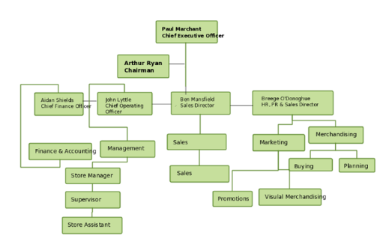
Figure 1: Organizational structure of Primark
(Source: Oyemomi et al. 2019)
This organization has different types of functions in order to manage the performance this organization. The HR department, controlling department, sales department, supply chain department, marketing department, all these are related to each other in order to increase the performance of this organization. It has been found that every function of this organization is interrelated and interdependent to each other. Therefore, it has a relationship with the people who are related to this organization. Every individual related to this organization is already placed in a hierarchy model to operate properly.
Culture and organizational performance
The culture of an organization defines the way to behave properly in the organization. As per the comment of Fitria et al. (2018), a culture of an organization shares values and beliefs and the process of reinforcement through various methods. This organization follows the hierarchy culture in order to operate its business successfully in the market. On this matter, organizational performance is also related. As mentioned by Nikpour (2017), organizational performance signifies the actual results of an organization which is normally measured by the expected output. The performance of an organization mainly depends on three specific areas and those are product marketing, financial performance and shareholder return. On this matter, it can be said that the culture of this organization is very much noticeable and it reflects over its performance.
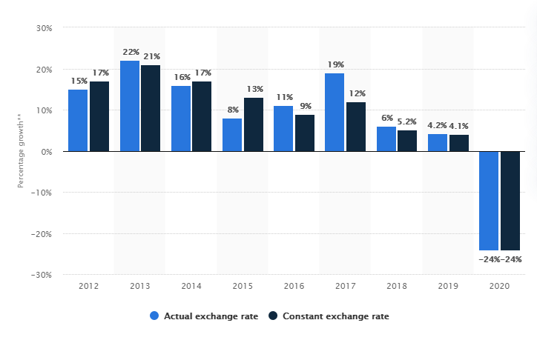
Figure 2: Primark sales growth
(Source: Statista.com 2020)
Primark is one of the major retail organizations in the market of the UK. The market demand of this organization is good which shows that the performance of this organization is continuous. In this matter, the culture of this organization also plays an important role to improve performance. This figure shows the sales growth of this organization from 2012 to 2020. The result of this figure shows that this organization improves their sales every year. This indicates that this organization has proper business culture in order to manage every aspect of a business. However, the sales have decreased in 2020 due to the COVID situation, this is one of the global problems therefore, and this organization also suffers from it. It can be said that the performance and culture of an organization are related to each other.

3. The essential nature of managerial work
The managerial work of an organization indicates the process of management. In this matter, the importance of leadership comes into action. The role of leadership is very important in order to manage any kind of work in an organization. As per the views of Alrowwad et al. (2017), leadership is the art of motivating other people to perform any kind of work better. It helps to achieve a common goal in a business setting. Effective leadership increases the performance of an organization. As mentioned by Sun et al. (2017), there are several types of performance theory and those are social cognitive theory, control theory and goal theory. All these theories are important in order to increase the performance of an organization. In this case, this organization uses the goal theory of performance to manage their essential works and to increase performance.
Goal theory of performance
Goal setting is important in order to increase the performance of an individual or organization. According to the vision of Isik et al. (2018), setting difficult goals help to increase the quality of performance of an organization or individual. In this case, Primark also uses this theory of performance in order to manage their business work comfortably and also increase the performance output. This organization also follows some basic property of this theory and those are clarity, challenge, feedback, commitment and work complexity. This organization has a clear vision about their goal in order to overcome the decent level of difficulty. In this process, leadership comes into play to motivate others in order to overcome any type of difficult situation.
Variables of effective management and leadership
Effective leadership is all about finishing every work and that finishing work boils down to the effect of effective management. As per the views of De et al. (2021), there are mainly three types of variables that can be found and those are money, time and resources. These three variables help to determine the effective management and leadership of this organization. All of these variables are important in order to manage any kind of business work. In this matter, it can be said that the managerial work of an organization needs the consideration of these three variables in order to optimize effective management and leadership. On the other hand, leadership is important in an organization and the role of a leader is to inspire, guide and influence other people. In some cases, the leader goes beyond the limit in order to guide other people.
Role of leadership
The role of leadership is very important for an organization in order to set a goal, initiating action, motivation and direction, a link between workers and management etc. The leader of this organization also follows this role to improve performance. It can be said that management and leadership are very much related to each other; they complement each other to achieve a business goal of an organization. As per the views of Bernerth et al. (2018), different management processes also help to increase the effect of leadership in an organization. The management of Primark implements different types of leadership strategies in order to improve their functions and processes of business. Therefore, it can be said that proper management and leadership strategies are important in terms of both functions and processes of an organization.

4. The behavioural approach to management
The behavioural approach to management mainly focuses on employee well being and human relationship. As mentioned by Ciccone et al. (2019), the behavioural approach of management highlights the human aspect. The behavioural approach to management discusses group processes and individual behaviour. On the other hand, it also acknowledges the importance of a behavioural approach in the workplace. The behavioural approach has two types and those are human relations approaches and behavioural science approaches. This organization follows both these approaches in order to achieve workplace harmony and efficiency.
The approach of Human relation
Human relation is important in a workplace environment in order to maintain workplace harmony. As per the comment of Zwick et al. (2021), the human relation approach allows the manager to connect with the subordinators. This organization also follows this behavioural approach and this organization recognizes its employee's needs. The management of this organization also looks upon the employee group as a positive force to use them productively. As mentioned by May et al. (2021), a manager must be competent with the relation of human skills and technical skills. Primark also recognizes their employee's ability and skill to incorporate with the business management managerial work. The application of a behavioural approach helps this organization to unite its workers properly. In this matter, it can be said that a behavioural approach to management is very important in order to consider the individual behaviour of an organization. On this matter, the culture of an organization is also important. It has been found that organizational culture shows the proper way to behave.
In this matter, this organization follows the theory of Functionalism in order to maintain a better culture in the working environment. As per the views of de et al. (2021), functionalism specifies an existing entity of a holistic character. It mainly consists of some specific elements and functions in order to achieve correlation. Therefore, this organization also implements this theory of organizational culture in order to maintain a good working environment and values between the employee and management. It has been found that the environment of the modern workplace always maintains a proper organizational culture in order to maintain business ethics and employee relations. This also incorporates the human relation approach to management. It can be said that a behavioural approach to management is a very important aspect of an organization in order to address the employee viewpoint of an organization.
The approach of behavioural science
The approach of behavioural science is an extension of the human relation approach. It helps to give value to the behaviour, attitude and performance of employees and groups of an organization. As per the views of Motl et al. (2018), this approach mainly focuses on the complexity of work in an organization. This approach helps to satisfy the employee's need to show their expertise and skills. In order to get better performance, motivation, communication, leadership and management, every process has been integrated into this approach. The performance of an organization mainly depends on three specific areas and those are product marketing, financial performance and shareholder return. On this matter, it can be said that the culture of this organization is very much noticeable and it reflects over its performance. The behavioural approach to management discusses group processes and individual behaviour.

5. Conclusion
Thus, it can be concluded that analysis of modern workplace culture is very important in order to understand the ideology behind a very successful business. Primark is a global organization that follows modern workplace functions and processes to achieve its business objects. In this report, organizational culture and behaviour have been discussed. On the other hand, a discussion has been made over the organizational structure and performance of this organization with respect to management and leadership. In this project, all the variables of effective management have been determined by this organization for better understanding. The behavioural approach to management also has been discussed in this project with the help of relative behavioural theory applied by the organization to maintain employee need and desire.

Reference List
Alrowwad, A.A., Obeidat, B.Y., Tarhini, A. and Aqqad, N., 2017. The impact of transformational leadership on organizational performance via the mediating role of corporate social responsibility: A structural equation modeling approach. International Business Research, 10(1), pp.199-221.
Bernerth, J.B., Cole, M.S., Taylor, E.C. and Walker, H.J., 2018. Control variables in leadership research: A qualitative and quantitative review. Journal of Management, 44(1), pp.131-160.
Ciccone, N.W., Patou, F. and Maier, A.M., 2019, July. Designing for better healthcare: A systemic approach utilising behavioural theory, technology and an understanding of healthcare delivery systems. In Proceedings of the Design Society: International Conference on Engineering Design (Vol. 1, No. 1, pp. 937-946). Cambridge University Press.
de Almeida Leite, E.M., Ribeiro, H.N.R., Alves, S.R., Kurowska-Pysz, J. and da Silva, A.F., 2021, February. BUSINESS LESSONS FROM AN EARLY ENTREPRENEUR: THE CASE OF DOÑA GRACIA NASI. In Economic and Social Development (Book of Proceedings), 65th International Scientific Conference on Economic and Social (p. 172).
De Clerck, T., Aelterman, N., Haerens, L. and Willem, A., 2021. Enhancing volunteers capacity in all‐volunteer nonprofit organizations: The role of volunteer leaders' reliance on effective management processes and (de) motivating leadership. Nonprofit Management and Leadership, 31(3), pp.481-503.
Fitria, H., 2018. The influence of organizational culture and trust through the teacher performance in the private secondary school in Palembang. International Journal of Scientific & Technology Research, 7(7), pp.82-86.
Isik, U., 2018. The Impact of Pre-Competition Estimated Results for Elite Archers on Performance According to Achievement Goal Theory. World Journal of Education, 8(4), pp.146-158.
May, D., Arancibia, S. and Manning, L., 2021. Understanding UK farmers’ Brexit voting decision: A behavioural approach. Journal of Rural Studies, 81, pp.281-293.
Miao, C., Humphrey, R.H. and Qian, S., 2018. A cross-cultural meta-analysis of how leader emotional intelligence influences subordinate task performance and organizational citizenship behaviour. Journal of World Business, 53(4), pp.463-474.
Motl, R.W., Pekmezi, D. and Wingo, B.C., 2018. Promotion of physical activity and exercise in multiple sclerosis: Importance of behavioural science and theory. Multiple Sclerosis Journal–Experimental, Translational and Clinical, 4(3), p.2055217318786745.
Nikpour, A., 2017. The impact of organizational culture on organizational performance: The mediating role of employee’s organizational commitment. International Journal of Organizational Leadership, 6, pp.65-72.
Oyemomi, O., Liu, S., Neaga, I., Chen, H. and Nakpodia, F., 2019. How cultural impact on knowledge sharing contributes to organizational performance: Using the fsQCA approach. Journal of Business Research, 94, pp.313-319.
Statista.com (2020).Sales growth of the retail division of Associated British Foods worldwide from financial year 2012 to 2020. Available at: https://www.statista.com/statistics/490941/uk-primark-sales-growth-worldwide/ [Accessed on: 06.04.2021]
Sun, R. and Henderson, A.C., 2017. Transformational leadership and organizational processes: Influencing public performance. Public Administration Review, 77(4), pp.554-565.
Zwick, H.S., 2021. Egyptian students’ disinterest in overseas academic mobility: A behavioural approach based on the capability-opportunity-motivation model. Journal of International Students, 11(2).

