Janine Dixon_1600982
To what extent was St Edmund a symbol of English national identity?

St Edmund was the Saxon king of East Anglia in the second half of the 9th century and England’s original patron saint. Killed by the Danes during their invasion of England in 869, he became a highly venerated saint throughout much of the early medieval period. He became the subject of many hagiographical texts which helped to promote his cult. The cult of St Edmund became increasingly popular and his shrine, located in Bury St Edmund’s, was a popular pilgrimage site until his shrine was destroyed during the English Reformation in 1539. To the present day, Edmund is still remembered within the town that bears his name which contains many reminders of his existence and importance. By examining a variety of sources relating to St Edmund, this essay explores the idea that Edmund embodied the idea of national identity, but to what extent. Focussing primarily on the period of the Danish invasion of England, but also looking at his legacy.
Almost nothing is known about St. Edmund’s life which many historians believe could be due to the destruction of contemporary evidence of his reign during the Danish invasion of East Anglia in the 9th century. The earliest surviving mention of St. Edmund appears in the Anglo-Saxon Chronicle. In the entry dated A.D. 870 it states, ‘And in the winter King Edmund fought with them; but the Danes gained the victory, and slew the king; whereupon they overran all that land, and destroyed all the monasteries to which they came.’ This description of Edmund’s death implies that he possibly died in battle which differs to Abbo of Fleury’s account that Edmund died a martyrs death,
When Ivar the impious pirate saw that the noble king would not forsake Christ, but with resolute faith called after Him, he ordered Edmund beheaded, and the heathens did so. While Edmund still called out to Christ, the heathen dragged the holy man to his death, and with one stroke struck off his head, and his soul journeyed happily to Christ.

It was a common ideal amongst the Anglo-Saxon people that it was a noble death for a king to die in battle for his people so it is possible that Edmund’s cult would have grown regardless of the hagiographical ideal of martyrdom bestowed on him but, perhaps, not as significantly. Abbo of Fleury wrote Passio Sancti Eadmundi while visiting Ramsey Abbey between 985 and 987 at the request of the monks of Ramsey. Abbo dedicates the Passio to Archbishop Dunstan who had a keen interest in royal saints’ cults. Aelfric of Eynsham, who wrote a Anglo-Saxon version of St Edmunds life, wrote that a young Oswald had overheard Edmund’s sword bearer relating the story of St Edmunds martyrdom to King Aethelstan. Considering that St Edmund’s cult was centred around the rival monastery of Bury, it is intriguing that Edmund was commemorated at Ramsey. Edmund was the king of East Anglia who Abbo describes as ‘wise and worthy… humble and virtuous…[who] guided his people always towards righteousness, and restrained the cruel, and lived happily in the true faith.’ These saintly qualities could explain why the monks of Ramsey considered Edmund worthy of veneration, not just within East Anglia. However, Edmund’s martyrdom was probably the most significant reason for this desire to memorialise the saint. Martyrs were considered as witnesses to the faith who went straight to heaven and acted as an intermediary between the people and Christ. What ever the motivations, it is evident that St Edmund was important, not just in the locality of Bury St Edmunds.
Over twenty years after the death of the king, the St Edmund memorial coinage came into circulation (fig.1). It is not certain who was responsible for circulating these coins, but one argument put forward by historians is that the coins were minted
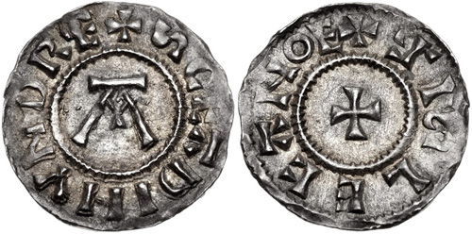
Fig. 1. St Edmund Memorial Coinage c.890s
by the new rulers of East Anglia, the Danes. Susan Ridyard argues that, ‘perhaps the Danish rulers, in acknowledging Edmund’s status as saint [in the St Edmunds coinage], sought to perform an act of expiation and political reconciliation.’ This is a plausible argument. After Guthrum’s death in 890, there may have been some division within East Anglia and using the revered former king Edmund could have been an attempt to unite the territories. However, Anna Chapman provides an alternative explanation. She argues that, perhaps, Alfred the Great was responsible for the circulation of the coinage. By using the story of St Edmund’s martyrdom at the hands of the Danes, this could enhance his claim to East Anglia and justify the replacement of the Danish leaders. She goes as far as to ask the question,
who requisitioned Edmund as a national saint and hero? We could do worse than look to the West Saxon dynasty , who with startling inventiveness, brought the notion of ‘English kind’ into being and used the martyred king as a symbol of all that it stood for.
This argument relies on whether Alfred the Great would have known the story of St Edmund’s martyrdom. This is possible if the story was part of the oral tradition before being written down by Abbo of Fleury which is plausible considering it is recorded that Archbishop Dunstan heard the story when he was young. However, it should be noted that there is a level of ambiguity surrounding the manner of Edmunds death in the Anglo-Saxon Chronicle, as mentioned previously. Regardless of the origins and the reasons for minting the St Edmund coins, it is clear by there existence that even twenty years after Edmund’s death, he was still celebrated as a king. The coins are inscribed with the word’s SCE EADMVNDE REX (0 Saint Edmund the King). By invoking St Edmund as a saint, rather than just a king, this implies that the coinage had a wider appeal than if it just addressed East Anglian nationalistic sentiment.
When considering St Edmund as a symbol of English national identity during the Danish invasion, it is useful to refer to Abbo of Fleury’s passio. Abbo describes that Edmund received a message from Ivar, the leader of the Danish invaders giving him an ultimatum: ‘become his vassal-king. If you want to stay alive.’ To which Edmund replied,
The poor people of this country are already shamefully afflicted, I would rather die fighting so that my people might continue to possess their native land…This I heartily wish and desire, that I may not be the only survivor after my beloved thanes are slain in their beds… I would rather die for my country if I need to.
This gives the impression that Edmund was already a figurehead for East Anglian independence. To explore this point further, it is useful to consider the first of St Edmund’s post humous miracles. In the Golden Legend, Jacobus de Voragine explains that after Edmund is beheaded the Danes took his head and hid it in the woods so that Edmund would be denied a proper Christian burial. He writes,
But by the purveyance of Almighty God there came a wolf which diligently kept the holy head from devouring of beasts and fouls. And after, when the Danes were departed, the Christian men found the body, but they could not find the head, wherefore they sought it in the wood. And as one of them spake to another: Where art thou? …the head answered and said: Here! Here! Here! And anon then all they came thither and saw it and also a great wolf sitting and embracing the head between his forelegs. (see fig.2)
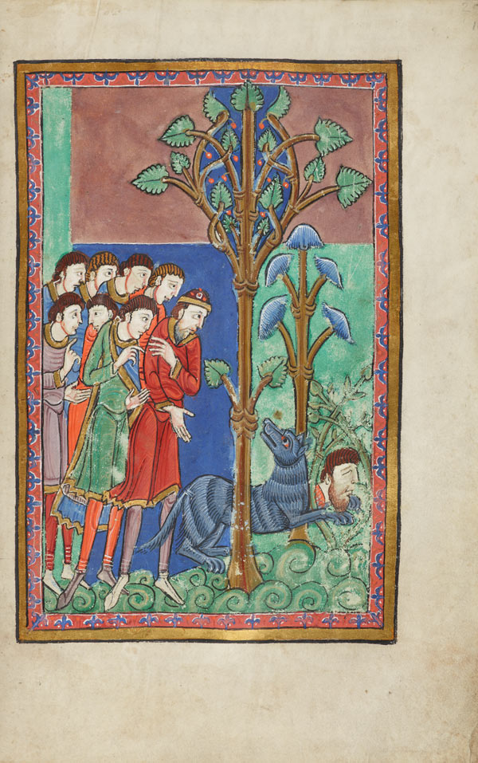

Fig.2. Wolf guarding Edmunds head. Pierpont Morgan Library. MS M.736.
The wolf is significant here. In Old English and Old Norse poetry, the wolf is part of the ‘Beasts of Battle’ motif which was often used as a metaphor for death on the battlefield. The Beasts of Battle consist of three animals: the wolf, the raven and the eagle who accompanied warriors into battle to feast on the bodies of the slain. Although, this is a poetic trope that is shared between the Anglo-Saxons and the Vikings cultural heritage, the wolf is often used as a metaphor for the Vikings. For example, In the poem, ‘Battle of Maldon’, the Vikings are described as wælwulfas (slaughter-wolves). This metaphor is used to demonise the Vikings. Abbo of Fleury also uses the wolf metaphor when describing the Vikings invasion of East Anglia in his passio. Therefore, having a wolf guarding St Edmunds head is very significant and it illustrates Edmunds sanctity. Timothy Jordan states that, ‘the wolf’s pacification certainly symbolises the hope that the saint will subdue evil, be it in the form of the Devil or the Danes.’ In Jordan’s article he discusses the history of redaction in the vita of St Edmund focussing primarily on Abbo of Fleury’s passio and Ælfric of Eynsham’s Life of St. Edmund. These two sources are closely related with Ælfric using Abbo as a source for his work. Written at the time when AEthelred was paying tributes to the Danes instead of taking a stand against then, Jordan argues that Ælfric’s reason for his redactions of Abbo’s passio was to provide the Anglo-Saxon people with hope. He states,
Ælfric needed to make Edmund more than a figure of holiness; he needed him to embody the values of the comitatus code that AEthelred failed to display. In this way St Edmund became an example of a positive leader… to remind Ælfric’s Anglo Saxon audience not to lose hope in a time of invasion and extended political turmoil.
The comitatus code was extremely important in Anglo-saxon culture. It sets standards for the actions of the lord and thane who have possibly one of the closest bonds in a protector/protectee relationship. Thus, it is significant when discussing Edmund’s relationship to national identity to consider that Edmund was still celebrated as embodying the values of the comitatus code.

Through the primary sources that relate the post- humous miracles of St Edmund, it appears that the authors of these works considered Edmund to be a protector of the Anglo-Saxon people and their way of life, even in death. A good example of explore involves St Edmund taking a more aggressive role as protector against King Sweyn of Denmark. Hermann documented this miracle in his De Miraculis Sancti Eadmundi. He explains how the lands and people of East Anglia were left vulnerable after King Ethelred fled to Normandy. Sweyn took advantage of this and began to tax the East Anglian people. The peasants of Bury are said to have visited the saint’s shrine to ask for his help in this matter. Simon Yarrow documents that according to Hermann,
St Edmund visited Sweyn in his sleep and warned him, ‘Cease, cease to exact tribute which they have never under any king given. It was not taken or paid in the time of any of them after me, and if you do not remove this oppression from them, you shall soon know that you displease God and me on behalf of the people.’
Despite Edmund’s warning, Sweyn continued and consequently met a sudden death. Hermann’s legend visualises his death as if by a spear directed by Edmund as depicted in fig.3.
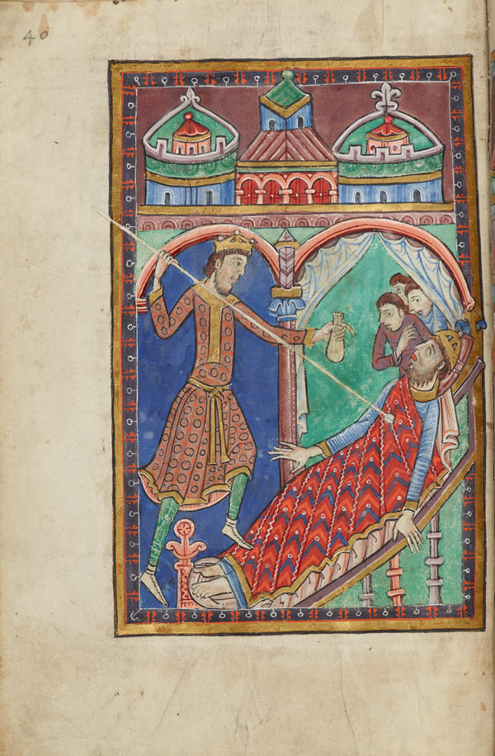

Fig.3 King Sweyn’s death scene. Pierpont Morgan Library. MS M.736.
This image appears in the Miscellany on the life of St. Edmund; written and illuminated in the Abbey of Bury St. Edmunds, ca. 1130. It depicts King Edmund thrusting a spear into the chest of King Sweyn. Edmund is holding a money bag to symbolise that Sweyn is dying because of the money he took from the East Anglian people which Edmund deemed as an act of oppression, according to Hermann’s legend. This miracle story serves to depict Edmund as a defender of the Anglo-Saxon people and provides hope to those familiar with it.
St Edmund’s cult centres around Bedricsworth (modern day Bury St Edmund’s) where Edmunds remains were moved to in 902. King Athelstan founded a religious community there to care for Edmund’s shrine and in 1020, King Cnut built an abbey to house his shrine. The cult of St Edmund became very popular and his shrine was an extremely popular pilgrimage sight. Thus, becoming one of the richest monastery’s in England at the time of the Doomsday survey. For centuries, St Edmund’s shrine was patronised by the kings of England. Ellen Castelow explains that,
Such was the influence of St Edmund that on St Edmund’s Day in 1214 rebel English barons held a secret meeting here before going to confront King John with the Charter of Liberties, the forerunner to Magna Carta which he signed a year later. This event is reflected in the motto of Bury St Edmunds: ‘Shrine of a King, Cradle of the Law’.
The original patron saint of England, Edmund was replaced by St George in 1348 when Edward III declared him England’s patron saint. However, Edmund’s influence had began to decline after King Richard I adopted St George as is personal patron and protector of the army in 1199 after being victorious in battle after visiting St Georges tomb in Lydda. In recent times, there have been two attempts to get St. Edmund reinstated as England’s patron saint by the English public. In 2006, a petition was rejected by the government and in 2013, Bury St Edmunds based brewery, Greene King launched another campaign. Although unsuccessful, it shows that St Edmund is still remember especially within Bury St Edmund’s and there are still people who identify with him.
During the Danish invasions of England, St Edmund was used as an example of Anglo-Saxon identity and as a figure of hope to the people of East Anglia. Primarily, a figurehead for East Anglian independence, he was adopted by future English kings and became a symbol of national identity and provided inspiration during times of invasion and turmoil.

Bibliography
Primary Sources
Abbo of Fleury's ‘Life of St. Edmund’, King of East Anglia before 870, here comes from the Anglo-Saxon version as it appears in Sweet's Anglo-Saxon Primer, 9th edn. (Oxford University Press: Oxford, 1961), pp. 81-87, trans. Kenneth Cutler 1998, found at https://sourcebooks.fordham.edu/source/870abbo-edmund.asp
Anglo-Saxon Chronicle, Translation by Rev. James Ingram (London, 1823) found at http://mcllibrary.org/Anglo/
A. Hotstetter (trans.), The Battle of Maldon, found at https://anglosaxonpoetry.camden.rutgers.edu/battle-of-maldon/
The Golden Legend or Lives of the Saints. Compiled by Jacobus de Voragine, Archbishop of Genoa, 1275. First Edition Published 1470. Englished by William Caxton, First Edition 1483, Edited by F.S. Ellis, Temple Classics, 1900 (Reprinted 1922, 1931.) found at https://sourcebooks.fordham.edu/basis/goldenlegend/GoldenLegend-Volume6.asp
Miscellany on the life of St. Edmund, (England, Bury St Edmunds ca. 1130) Purchased by J. P. Morgan, Jr., 1927.

Secondary Sources
Castelow. E., St Edmund, Original Patron Saint of England found online at https://www.historic-uk.com/HistoryUK/HistoryofEngland/Edmund-original-Patron-Saint-of-England/
Chapman. A., King Alfred and the Cult of St Edmund, History Today, Jul 2003; 53, 7, ProQuest Research Library.
Jordan. T, ‘Holiness and Hopefulness: The Monastic and Lay Audiences of Abbo of Fleury's Passio Sancti Eadmundi and Ælfric of Eynsham's Life of St. Edmund, King and Martyr.’ Enarratio 19 (2015): 1-29. PDF file.
Ridyard. S., The Royal Saints of Anglo-Saxon England: A Study of West Saxon and East Anglian Cults ( Cambridge, 1988).
Yarrow. S., Saints and their Communities: Miracle Stories in twelfth Century England (Oxford Scholarship Online, 2010)

Websites
https://opendomesday.org/name/bury-st-edmunds-abbey-of/
https://www.eadt.co.uk/news/bury-st-edmunds-campaign-to-reinstate-st-edmund-as-patron-saint-of-england-1-2220915

Anglo-Saxon Chronicle, Translation by Rev. James Ingram (London, 1823) found at http://mcllibrary.org/Anglo/
ibid
Abbo of Fleury's ‘Life of St. Edmund’, King of East Anglia before 870, here comes from the Anglo-Saxon version as it appears in Sweet's Anglo-Saxon Primer, 9th edn. (Oxford University Press: Oxford, 1961), pp. 81-87, trans. Kenneth Cutler 1998, found at https://sourcebooks.fordham.edu/source/870abbo-edmund.asp
ibid
ibid
S. Ridyard, The Royal Saints of Anglo-Saxon England: A Study of West Saxon and East Anglian Cults ( Cambridge, 1988)
A. Chapman, King Alfred and the Cult of St Edmund, History Today, Jul 2003; 53, 7, ProQuest Research Library, p.43.
Abbo of Fleury's ‘Life of St. Edmund’, King of East Anglia before 870, here comes from the Anglo-Saxon version as it appears in Sweet's Anglo-Saxon Primer, 9th edn. (Oxford University Press: Oxford, 1961), pp. 81-87, trans. Kenneth Cutler 1998, found at https://sourcebooks.fordham.edu/source/870abbo-edmund.asp
ibid
The Golden Legend or Lives of the Saints. Compiled by Jacobus de Voragine, Archbishop of Genoa, 1275. First Edition Published 1470. Englished by William Caxton, First Edition 1483, Edited by F.S. Ellis, Temple Classics, 1900 (Reprinted 1922, 1931.) found at https://sourcebooks.fordham.edu/basis/goldenlegend/GoldenLegend-Volume6.asp
ibid
A. Hotstetter (trans.), The Battle of Maldon, found at https://anglosaxonpoetry.camden.rutgers.edu/battle-of-maldon/
T. Jordan, ‘Holiness and Hopefulness: The Monastic and Lay Audiences of Abbo of Fleury's Passio Sancti Eadmundi and Ælfric of Eynsham's Life of St. Edmund, King and Martyr.’ Enarratio 19 (2015): 1-29. PDF file.
ibid
S. Yarrow, Saints and their Communities: Miracle Stories in twelfth Century England (Oxford Scholarship Online, 2010) pp.36-37.
Miscellany on the life of St. Edmund, (England, Bury St Edmunds ca. 1130) Purchased by J. P. Morgan, Jr., 1927.
https://opendomesday.org/name/bury-st-edmunds-abbey-of/
E. Castelow, St Edmund, Original Patron Saint of England found online at https://www.historic-uk.com/HistoryUK/HistoryofEngland/Edmund-original-Patron-Saint-of-England/
https://www.eadt.co.uk/news/bury-st-edmunds-campaign-to-reinstate-st-edmund-as-patron-saint-of-england-1-2220915

