Component 2:

How a school develops one aspect of its SDP: a report that critically reflects on the actions, impact, and evidence base.

Targets from the previous assignment

 | Targed/target | Yr hyn yr wyf wedi'i wneud yn yr aseiniad hwn  What I have done in this assignment...
Targed/Target 1 | To further enhance your work, consider paraphrasing some of the direct quotes into your own words. This will not only showcase your understanding but also add a personal touch to your analysis. | I have made sure that I have paraphrased the direct quotes.
Targed/Target 2 | There were missed opportunities to expand your thinking/arguments occasionally. For example, in your templates, what have you learnt about how to use authentic context? any literature discussing the benefits/limitations of particular approaches (e.g. key readings from the module; professional standards)? | I have made sure that I read more and gain knowledge for this assignment and do not miss any opportunities to expand my thinking and argument.
Targed/Target 3 | There were some minor inaccuracies in your use of in-text citations and the reference list. Please consult the latest Harvard Referencing handbook to ensure consistent accurate referencing. | I have used the Harvard Referencing Handbook to ensure accurate referencing.

Introduction

The purpose of this report is to critically evaluate how a school develops one aspect of its School Development Plan (SDP). It is important to consider the British Educational Research Association (BERA) guidance for School X to remain confidential and anonymous (BERA, 2018). The report will discuss the School X’s SDP. The school is in Wales, with 473 mixed-gender pupils from nursery to year six (My Local School, 2023). According to Estyn (2023) 36.3% of pupils have additional learning needs (ALN), which is twice the national average. Also, 4.8% of the pupils have been identified with English as an additional language; however, none speak Welsh at home as their first language (Estyn, 2023). Within the school, 7% of pupils are entitled to free school meals which fewer than the national average (Estyn, 2023). Following the Estyn Inspection School X has been provided with five different priorities to work towards (Estyn, 2023). One priority identified was implementing a whole-school approach to emotional and mental well-being. In this report, the primary focus is on critically evaluating the strategies employed by School X in its SDP to address the identified priority. The key aspect under consideration is the impact of these strategies, particularly in relation to providing access to various provisions that contribute to the overall well-being of the pupils within the school’s community. The report aims to provide a comprehensive analysis of the effectiveness of School X's initiatives in promoting and sustaining a high level of well-being as the whole school approach.

Literature review
A thorough analysis of a wide range of literature and research reveals many definitions of an SDP. According to the Welsh Government (2014) the school’s strategic plan for improvement is known as an SDP. It outlines the steps and actions schools must take to enhance learner’s performance. Ylimaki & Brunderman (2022) agree with the Welsh Government (2014) stating that the SDP is an ongoing process that schools follow to improve pupils’ learning and performance. By critically researching and evaluating what the SDP means, it appears to be a process of improving learner outcomes by reflecting and acting. The SDP should be a dynamic document that provides the school with the ‘roadmap’ to follow and improve the priorities that have been identified (Education, 2023). However, for the school improvement to be meaningful and relevant, the staff must know what ‘success’ looks like and how to work toward the priorities that they have identified (Welsh Government, 2022).
Moreover, having critically researched a wide range of literature on self-evaluation. Self-evaluation is how schools reflect and examine their progress, development, and practice to determine what has improved and still needs improvement (Education Scotland, 2016). Education Scotland (2016) is in line with the Welsh Government (2014), stating that schools reflect on their practice and progress based on improvement planning. The process of improvement planning and self-evaluation is essential in supporting schools to make improvements, and progress and promote professional learning and learner outcomes (Welsh Government, 2014). Ainsworth (2010) also states that self-evaluation is crucial and must be carried out daily; it must be effective and identify its strengths and weaknesses. Therefore, self-evaluation must be effective, and an individual must act as without this, self-evaluation is a waste of time (MacBeath, 2006). Overall, by school staff self-evaluating and implementing appropriate support for learners, there will be a greater chance that they will succeed and develop in their education (OECD, 2014). Both the SDP and self-evaluation process appeared to be vitally important for schools to make improvements on their ethos and develop children’s learning, health, and well-being further.

Furthermore, Section 21(5) of the Education Act 2002 states that it is the responsibility of governing bodies in Wales to promote the well-being of all learners in school (Legislation, 2021, p. 1). This ties in with section 25(2) of the Children Act 2004, which states that in Wales the well-being of the learners at school is related to the Curriculum for Wales statements of What Matters Code (Legislation, 2021). Therefore, Evans the Chief Inspector of Estyn, stated that the well-being of the pupils and staff in Wales is “at the heart of our work” (Welsh Government, 2022, p. 3). However, it is important to note that Covid-19 significantly affected the well-being of children and young people. The impact of COVID-19 is “likely to remain with us for some time. This will require additional effort from all of us to support and improve the emotional well-being of the individual” (Welsh Government, 2021, p. 3). It is crucial to state that it was after the Covid-19 outbreak that the Welsh Government (2021) put a great emphasis on prioritising a whole-school emotional and well-being framework. The framework aims to support children, young people as well as staff’s well-being (Welsh Government, 2021). The emphasis is also placed on the different ways that parents, staff, and learners work together to address and recognise poor well-being “when it arises and to ensure effective support for schools and the learner when a learner experiences more severe distress” (Welsh Government, 2021, p. 5). The Welsh Government's (2021) research is in line with the Department of Health (2014, p. 19) which indicates that “wellbeing is important to health and health is important to wellbeing”.
One of the most relevant Acts that would be considered when evaluating the SDP will be the Well-being of Future Generations (Wales) Act 2015. The Act highlights the importance of improving the social, economic, environmental as well as cultural well-being in Wales (Welsh Government, 2015). The Act emphasises the seven well-being goals, including “a resilient Wales and healthier Wales” (Welsh Government, 2015, p. 1). The school SDP is in line with the 2015 Act, as it is developing a whole-school approach to emotional and mental well-being, promoting the school environment, including learners, staff, and stakeholders, to be healthier and more resilient, leading to a healthier Wales (Welsh Government, 2015). Another important document that will be considered is “Our national mission: High standards and inspirations for all” (Welsh Government, 2023). According to the Welsh Government (2023) its national mission is to improve the learner's and staff's well-being within the school environment and making sure their learners and staff’s health is at the heart of good practice. The Welsh Government (2023) has made a significant effort to work toward the learner’s well-being by offering free school meals for the most primary school-age children.

Developing an action point
The Welsh Government (2021) noted that it is through self-evaluation that schools can identify their improvement priorities. After their Estyn inspection, School X’s priority is: “well-being – to implement a whole-school approach to emotional and mental well-being” (School X, 2022-2023, p. 9). It is important to point out that for school improvement to be successful the Welsh Government highlighted four different stages of a school development planning cycle (see Figure 1) that schools must follow to improve their priorities (Welsh Government, 2014). The cycle starts from September to July; the aim is to evaluate and identify the priorities the school need to develop, in the summer term, normally, self-evaluation is carried out to identify the priorities for the next academic year (Welsh Government, 2014). Therefore, School X undertakes annual self-evaluation to make improvements to its SDP.

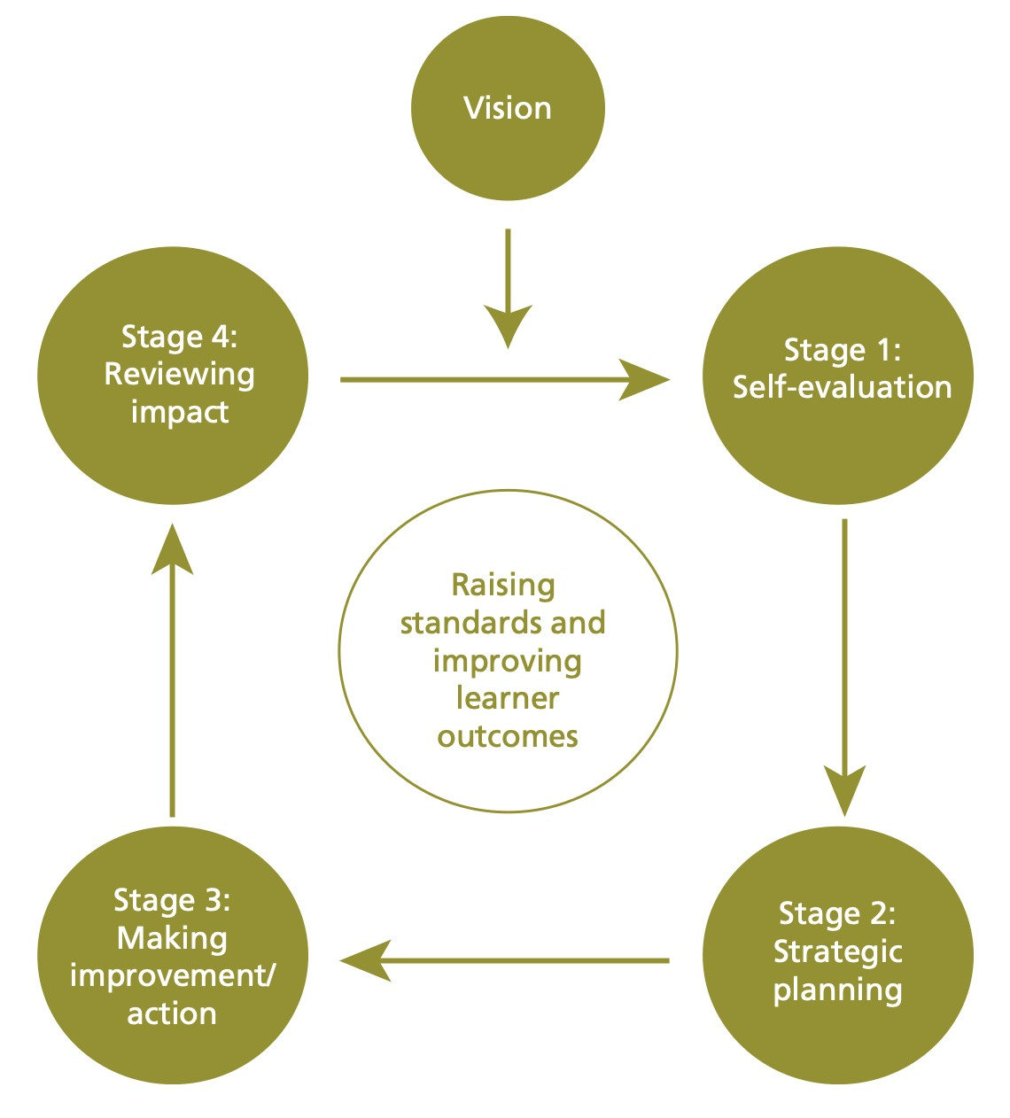
Figure 1: School development planning cycle

(Welsh Government, 2014, p. 7)

Self-evaluation
Self-evaluation is the first stage of the school development planning cycle; during the process of self-evaluation, schools reflect, evaluate their goals, and consider success criteria and the actions that need to be implemented for improvement within the school context (Inspectorate, 2012). Self-evaluation is vital for schools in identifying their priorities which allows them to evaluate their strengths, weaknesses, and areas for improvement (Welsh Government, 2022). In School X this stage was carried out due to well-being being one of the priorities from the national mission as well as a recommendation as one of the areas for development by Estyn inspectors (Welsh Government, 2022). For School X to be more effective in their progress of self-evaluation they need to analyse their data and evidence effectively (Estyn, 2020). They also suggested that self-evaluation should include all stakeholders and involve surveys (Estyn, 2020).

Strategic planning
Strategic planning is the second stage of the cycle, where partners and stakeholders in the school have an explicit plan outlining their commitment to achieving the SDP targets. Moreover, for the school to be successful, they work toward the priorities that have been identified by developing an action plan as well as using different strategies. It can be argued that it is essential to have good and ongoing communication with all the stakeholders including parents, school staff, governors, school councils, and school communities (Welsh Government, 2014). Guzman (2022) emphasises the importance of involving all stakeholders in outlining the school's SDP commitment and changes. Therefore, it is crucial to involve the stakeholders as this allows the schools to develop a successful plan and underline any issues which lead to meeting the stakeholder’s requirements. Furthermore, to ensure this stage, School X develops plans of action, different strategies, and focused interventions based on evaluating staff and parents by completing questionnaires/surveys to learn more about individual’s well-being. This led staff and parents to act and put different interventions in place to support pupils in progressing their well-being. Some interventions that learners can access include regulation stations, emotional coaching, and restorative practice (School X, 2022-2023). All of the discussed strategies are ‘soft data’ that measure the state of the learners' and staff’s well-being based on the interventions that are carried out in school as well as the questionnaires and surveys by both parents and staff (Adolfsso & Hakansson, 2021). Involving parents in improving learners’ well-being is valued by School X as “parents know their child best” (Scottish Government, 2022, p. 1). This demonstrates how School X incorporates the community partnership into their ethos and places a high priority on parents' role in children's wellbeing (Welsh Government, 2022).

Making improvements/actions
The third stage of the planning cycle is making improvements/actions identified in every SDP, and schools must implement them in their practice. For the SDP to be implemented successfully and efficiently, the Welsh Government (2014) argues that it is critical that all staff members understand their roles, responsibilities, and level of commitment at this point. School X team meets up once a week and reflects on the progress of children and other staff well-being, as Estyn's inspection always highlights the importance of the well-being of staff and learners (Welsh Government, 2022). The Welsh Government (2022, p. 20) asserted that “well-being is critical as a platform for high-quality learning” therefore well-being underpins pupils' achievement, which in turn supports the whole school improvement. School X also make sure that they are making progress and improvement by providing support from external agencies on training to teach different strategies in improving learners, parents and staff’s well-being and mental health. After reviewing the impact of acting and monitoring the progress of the learners to raise standards and improve well-being School X adjusted their planning to meet all individual’s needs.

Reviewing impact
The last stage of the school development cycle is reviewing impact. The Welsh Government (2014) noted that the SDP must be treated as living documents officially evaluated and revised at least once a year and routinely monitored during the development cycle. It is significant that schools listen and consider the learner’s and staff’s points of view regarding actions being followed and their effects. During the discussion with the Deputy Head of School X, it was noted that every half-term a review takes place, and the written findings from every class teacher regarding children’s well-being are collected and evaluated to identify the progress they have made in developing their priorities. After reviewing, the school team work collaboratively to make changes in their strategies, planning and improving strategies. To make effective change schools need to use both evidence and data analysis effectively to then adjust their strategies (Kaufman et al., 2006 cited in Scott & McNeish, 2013).

Reflection and evaluation
School x has implemented its whole-school approach to emotional and mental well-being provision by providing staff, learners as well as parents opportunities to access Emotional Coaching, Mindfulness, check-in system, Child and Adolescent Mental Health Services (CAMHS), Emotional Literacy Support Assistants (ELSA) workshops as well as therapy dogs. It is important to mention that some of the interventions that School X undertake will be considered. Moreover, it is important to note that Gibbs's Reflective Cycle (1988) will be considered in this part of the assignment to reflect on SDP (Chiplin & Stavric, 2017, p. 3).
One of the most effective interventions that School X undertake in supporting the learners and staff regarding their well-being is the use of therapy dogs. Research by Islam, et al. (2017) has noted that therapy dogs are used in supporting children and staff’s well-being and that the dog’s calmness and friendly nature have had significant benefits for their overall well-being. Research by Baird, et al. (2023) highlights that therapy dogs comfort and support learners with their well-being. Researchers have also reported improvement in the learner’s mood, reduction in anxiety and stress, and support them with self-regulation, learning engagement and improvement in learners’ academic performance as well as attendance (Baird, et al., 2023; Islam, et al., 2017). However, it is vital to point out that there are also limitations in using therapy dogs with every individual, one of the reasons could be due to cultural backgrounds, some individuals might be allergic or have a fear of dogs (Spruin, et al., 2020). One potential solution to address this issue might involve educating children about dogs and that therapy dogs have a friendly nature before bringing the dog to the school environment.
Furthermore, School X also has implemented its well-being support by using the regulation station and a check-in system. In School X every class has a check-in system where the class teacher check-in with its learners every morning. However, some learners do not like to share how are they feeling in front of everyone, therefore, in School X especially for older children, they can use the regulation station area and feelings cards to show the class teacher how they are feeling and based on that the teacher checks-in with that learner(s) individually. This supports the learners to self-regulate and understand their emotions (Grimmer & Greens, 2022). Research by Chaves & Taylor (2020) indicates that it is important that learners understand their feelings/emotions to be able to learn, be happier, relax, calm, attend, and complete the work.
Mindfulness provision is another intervention that was introduced by CAMHS in School X to support learners and staff's well-being. The provision has supported both staff and learners to recognise and manage their emotions, the different ways to interact with others and how to manage their emotions when they are either upset, excited or happy (Beach, 2020). Moreover, by teaching the learners simple activities of mindfulness including: ‘breathing hands and hug and hop’ (Christelis, 2021) and allowing the learners time to undertake these physical self-help activities helps them with their well-being. Research by Weare (2015 cited in Mainstone-Cotton, 2017) stated that if poor well-being is recognised and treated at an early age, the children will develop better well-being and “there is much more hope for the future of our children” (Mainstone-Cotton, 2017, p. 12). It can be concluded here that incorporating mindfulness into school environments can significantly contribute to the well-being of both children and staff by equipping them with valuable tools for reducing stress, regulating emotions, and fostering positive relationships (Carrion & Rettger, 2019).

Conclusion
In conclusion, School X has effectively aligned with Welsh Government policies and national priorities, aiming to achieve their priorities within their SDP. In addressing the priority of a whole-school approach to emotional and mental well-being, the school has implemented an efficient planning system to facilitate effective enhancements. Furthermore, School X has centred on the well-being of both pupils and staff in their SDP and its effectiveness in supporting their learners as well as staff. The school views the SDP as a living document that has been developed in collaboration with all staff members, community partnerships, and stakeholders. This report has provided valuable insight into understanding the SDP and the school planning cycle, which is crucial for my future professional development as a primary teacher engaging in self-evaluation and SDP planning and activities.
2694 words without heading and references.

References
Adolfsso, C.-H. & Hakansson, J. (2021) ‘Data Analysis for School Improvement within Coupled Local School Systems: Which Data and with What Purposes?’, Department of Education and Teachers, pp. 1-14.
Ainsworth, P. (2010) A practical guide: Developing a self-evaluating school. London: Continuum International Publishing.
Baird, R., Berger, E. & Grové, C. (2023) 'Therapy dogs and school wellbeing', A qualitative study. Journal of Veterinary Behavior, Volume 68, pp. 15-23.
Beach, S. R. (2020) Mindfulness for Children: Simple activities for parents and children to create greater focus, resilience, and joy. London: CICO Books.
BERA (2018) Ethical Guidelines for Educational Research. Available at: https://www.bera.ac.uk/publication/ethical-guidelines-for-educational-research-2018-online (Accessed: 5 February 2024).
Carrion, V. G. & Rettger, J. eds. (2019) Applied Mindfulness: Approaches in Mental Health for children and adolescents. America: American Psychiatric Association Publishing.
Chaves, J. E. & Taylor, A. (2020)The "Why" Behind Classroom Behaviors, PreK-5: Integrative Strategies for Learning, Regulation, and Relationships. s.l.:SAGE Publications Inc.
Chiplin, J. & Stavric, V. (2017) Models of reflection. Available at: https://pnz.org.nz/Attachment?Action=Download&Attachment_id=770 (Accessed: 28 March 2024).
Christelis, P. (2021) Take a Moment: 50 Mindfulness activities for kids. s.l.:Hachette Children's Group.
Department of Health (2014) Wellbeing Why it matters to health policy: Health is the top thing people say matters to their wellbeing. Available at: https://assets.publishing.service.gov.uk/media/5a7ba1d6ed915d4147621a24/Narrative__January_2014_.pdf (Accessed: 5 February 2024).
Education (2023) RAISING ASPIRATIONS, SUPPORTING LEARNING AND EMPOWERING IMPROVEMENT DIRECTORATE. Available at: https://www.education-ni.gov.uk/sites/default/files/publications/education/Guidance%20on%20School%20Development%20Planning%20for%202023-24.PDF (Accessed: 7 February 2024).
Education Scotland (2016) How good is our early learning and childcare?.
Available at: https://education.gov.scot/media/qryie4yx/hgioelc020316revised.pdf (Accessed: 19 February 2024).
Estyn (2023) A report on Sketty Primary School. Available at: https://www.estyn.gov.wales/system/files/202307/Inspection%20report%20Sketty%20Primary%20School%202023_0.pdf (Accessed: 5 February 2024).
Estyn (2020) Including all staff in the self-evaluation process. Available at: https://www.estyn.gov.wales/effective-practice/including-all-staff-self-evaluation-process (Accessed: 12 March 2024).
Grimmer, T. & Greens, W. (2022) Nurturing Self-Regulation in Early Childhood: Adopting an Ethos and Approach. s.l.:Taylor & Francis Ltd.
Guzman, J. C. (2022) 'STAKEHOLDERS’ PARTICIPATION IN SCHOOL IMPROVEMENT PLAN AND SCHOOLPERFORMANCE OF SECONDARY SCHOOLS', International Journal of Arts, Sciences and Education, 3(51-66).
Inspectorate (2012) School Self-Evaluation Guidelines for Primary Schools: Inspectorate Guidelines for Schools. Available at: https://pdst.ie/sites/default/files/sse_guidelines_primary.pdf (Accessed: 23 February 2024).
Islam, S., Spruin, E. & Fernandez, A. (2017) 'The Benefits of Therapy Dogs on Student Wellbeing within a UK University', Psychology and Behavioural Sciences International Journal, 7(1), pp. 1-4.
Legislation (2021) Education Act 2002. Available at: https://www.legislation.gov.uk/ukpga/2002/32/section/21#:~:text=21%20General%20responsibility%20for%20conduct%20of%20school&text=(1)Subject%20to%20any%20other,of%20the%20school%27s%20governing%20body (Accessed: 5 February 2024).
MacBeath, J. (2006) School Inspection and Self-Evaluation: Working with the new relationship. Oxon: Routledge.
Mainstone-Cotton, S. (2017) Promoting Young Children's Emotional Health and Wellbeing: A Practical Guide for Professionals and Parents. London: Jessica Kingsley Publishers.
My Local School (2023) My Local School: Sharing Information about Local Schools. Available at: https://mylocalschool.gov.wales/School/6702054 (Accessed: 5 February 2024).
OECD (2014) Improving Schools in Wales: An OECD Perspective. Available at: https://www.oecd.org/education/Improving-schools-in-Wales.pdf (Accessed: 19 February 2024).
School X (2022-2023) Sketty Primary School Development Plan Current Targets 2022 - 2023. Available at: https://primarysite-prod-sorted.s3.amazonaws.com/sketty-primary-school/UploadedDocument/ee0e4740-2dc6-4fd2-978a-b64a86909434/sdp-2022-2023.pdf (Accessed: 21 February 2024).
Scottish Government (2022). Working Together: Supporting positive communication between education professionals and parents and carers of children with additional support needs. Available at: https://education.gov.scot/media/ks4aqt5m/module-4.pdf (Accessed: 25 February 2024).
Scott, S. & McNeish, D. (2013) School leadership evidence review: using research evidence to support school improvement. Available at: https://www.bristol.ac.uk/media library/sites/cubec/migrated/documents/evidencereview3.pdf (Accessed: 25 February 2024).
Spruin, L., Dempste, T., Islam, S. & Raybould, I. (2020) 'The effects of a therapy dog vs mindfulness vs a Student Advisor on student anxiety and well-being', Journal of Further and Higher Education, pp. 1-31.
Welsh Government (2014). School Development Plans. Available at: https://www.gov.wales/sites/default/files/publications/2018-03/school-development-plans.pdf (Accessed: 6 February 2024).
Welsh Government (2015). Well-being of Future Generations (Wales) Act 2015: the essentials: Guidance on our law to improve social, economic, environmental and cultural well-being. Available at: https://www.gov.wales/sites/default/files/pdf-versions/2023/7/2/1688462036/well-being-future-generations-act-essentials.pdf (Accessed: 6 February 2024).
Welsh Government (2022).School improvement guidance: framework for evaluation, improvement and accountability. Available at: https://hwb.gov.wales/evaluation-improvement-and-accountability/school-improvement-guidance-framework-for-evaluation-improvement-and-accountability (Accessed 24 February 2024).
Welsh Government (2022). What we plan to do in response to Estyn’s report on how maintained primary, secondary, all-age and special schools are developing effective approaches to assessment that improve teaching and learning. Available at: https://www.gov.wales/effective-approaches-assessment-improve-teaching-and-learning-html (Accessed: 7 February 2024).
Welsh Government (2023). Our national mission: High standards and aspirations for all. Available at: https://www.gov.wales/sites/default/files/publications/2023-03/our-national-mission-high-standards-and-aspirations-for-all_0.pdf (Accessed: 24 February 2024).
Welsh Government (2021). Framework on embedding a whole-school approach to emotional and mental well-being. Available at: https://www.gov.wales/sites/default/files/publications/2021-03/framework-on-embedding-a-whole-school-approach-to-emotional-and-mental-well-being.pdf (Accessed: 5 February 2024).
Welsh Government (2022). New framework for school improvement to focus on learner progression. Available at: https://www.gov.wales/new-framework-school-improvement-focus-learner-progression (Accessed: 5 February 2024).
Ylimaki, R. M. & Brunderman, L. A. eds. (2022) School Development Approaches Over Time: Strengths, Limitations, and the Need for a New Approach. In: Evidence-Based School Development in Changing Demographic Contexts. s.l.:Open Access, pp. 3-21.

