Models of communication and communication skills

Report
Written by: Dzheylyan Basrieva 2023967

Module: BMSW 4002
Lector: Ejiro Esohwode

Table of Contents
Introduction 3
Communication and its importance 3
Models of communication 3
1. Shannon-Weaver model 3
2. Schramm communication model 6
3. Berlo`s communication model 7
Communication skills 8
Conclusion 11
REFERENCES 11
Appendix 1 12
APPENDIX 2 12

Introduction

In this report we will look around the communication skills and how we are using communication as a part of our lives. We will introduce most communication theories like Shannon- Weaver theory, Berlo`s theory, Schramm theory of communication. In this report we will look at types of communications and how the communication is affects our work and workplace.

Communication and its importance

Communication is the process of transmitting information from one person to another. The purpose of communication is to understand the information. No matter what a person wants to say to someone, they must understand it clearly, otherwise the purpose of the communication will be misunderstand.
In an organisation communication facilitates the flow of information and understanding between different people and departments through different media using all the channels and networks. Communication thus helps understand people better removing misunderstanding and creating clarity of thoughts and expression.
Compelling communication is imperative for proficient administration and to make strides in mechanical relations. In the present day world, the development of media transmission, data innovation, and the developing competition and complexity in generation have expanded the significance of communication in associations huge and little independent of their sort and kind. A corporate officer must be able to communicate successfully with his bosses, colleagues in other offices, and subordinates. This will make him perform well and empower him to deliver his hundred percent to the association.

Models of communication

Shannon-Weaver model

The Shannon and Weaver model is the most popular communication model and is widely accepted worldwide.
Let's look at the following example first to understand the model better.
Peter is the vice president of marketing in a well-known multinational company. He currently manages Mike, and Mike oversees managing a small team. Peter hopes Mike will prepare a comprehensive report on marketing strategies that can be used to achieve organizational goals. He also hopes to study the contestants' activities in detail at the end of the day. While talking, the company worker interrupted him to order. Finally, when Mike got the complete information, he delegated the responsibility to his team members. He deliberately conveyed what Peter really wanted his team to prepare. At the end of the day, the team prepared the report and handed it to Peter, but then they corrected very few mistakes.
Now let us understand this example in more detail.
Who is Peter?
Peter is someone who wants to prepare a detailed report for better organizational results. He is the source of this idea. It was Peter's brain that came up with the idea of preparing a marketing strategy for the organization. Therefore, Peter is the source of the information.
If Peter just keeps this idea in mind and doesn't share it with his team, the organization will never benefit from it. It is very important for a person to share their thoughts and information with others to maximize the use of the information. Do you think if he just stored it in his brain, Mike and his team would know what Peter was thinking? Obviously not. Peter had to translate his thoughts into words and speak the information through his mouth. Here, the mouth acts as a transmitter, which helps to transfer information from the brain to the mouth after carefully converting thoughts into language. Peter talked about some reports he wanted to get from his team. Peter's words or voice were a signal to Mike about what he should do. No signal or no content, how does Mike know what he should do? Review this example again. The conversation was interrupted by an employee who came to order lunch. In the same way, the signal will be interrupted by various noise and interference as it propagates from the emitter and finally reaches the receiver. The sound of horns on crowded streets, the bustle of the markets, the crying of babies and the screaming of people are all kinds of noises, which are combined with signals or, in other words, information. Eventually, Mike ignored all the hard work said, compiled all of Peter's information and downloaded it to his team to prepare the report.
The Shannon and Weaver model simply states that news comes from people who have thoughts or information. The sender is also called an information source or information source. The information is then transmitted from the brain to the mouth and sent out as a signal, and then reaches the receiver after working hand in hand with various noises and other disturbances. The recipient then delivers the message to its destination or other people's minds.

Information source (thought/message)
↓
Transmitter (brain-to-mouth) [with noise and interference with external obstacles]
↓
Signal
↓
Recipient (receiving signal)
↓
Finally received message
Let us Let's review the previous example again. The team prepared the report, but later corrected some errors. This is the vulnerability of the Shannon Weaver model. The information on how to get to the destination can sometimes be distorted because different people interpret the information in different ways. For Mike, the marketing strategy can be a branding strategy, but for the team, the marketing strategy can be a simple sales technique to increase production. Therefore, even a simple message can have different meanings after it finally reaches its destination.
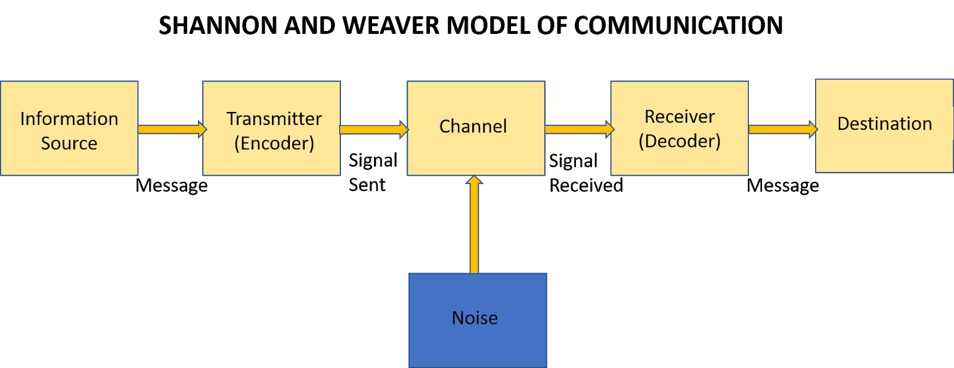(Sis Michelle 2018)

Schramm communication model

In 1954, Wilbur Schramm published a circular communication model based on the model in Charles Egerton Osgood in’s book "The Process and Impact of Mass Communication" (The Process and Effects of Mass Communication).
Schramm's communication model has the following elements:

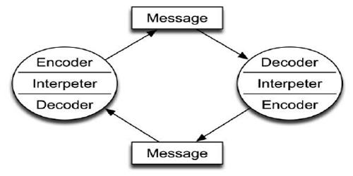 QS Study

When sender is sending the message, the source must be clear and must be able to show why it is important that the recipient read it. The message is the communication that is passed from the sender to the receiver. When receiver starts to be transmitting the information based on the main message from the sender that action is called feedback.

Example
Schramm`s communication model is practically more useful then the Shannon-Weaver model. This model can be considered as a combination of classic elements as well as modern elements like feedback. It has more practical application than other communication models.

Berlo`s communication model

Another communication model is created by David Berlo in 1960. This communication model follows Shannan-Weaver communication model the four basic components are source, message, channel and receiver. For first time Berlo uses `effect` component for the five channels of the model. Every channel has five components which can affect negative or positive on the communication. (Uma Narula 2006)
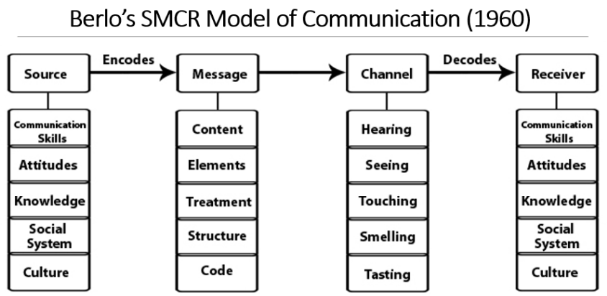(Course hero, Inc. 2021)
Sender is the source who sends and encodes the message or information that source can affect by components these components are applicable for the receiver as well.
Message is the information which is sender sends to the receiver. Message can be audio, speech, text, video or other media. This channel of the communication can be affected by:
Channel is the platform where the message is sent from this platform can be affected by:
Mass communication always involves technical tools, such as phones, the Internet and television.
Receiver is the person who receives the message and decoded the message.
To have more effective communication Berlo includes that affects components must be same between sender and receiver.

Example

In conclusion Berlo`s communication model is same as Shannon-Weaver communication model linear model there is no feedback and if the sender and receiver not sharing same platform the communication can be not effective.

Communication skills

In the last 10 years, verbal and non-verbal communication has increasingly occurred in the digital environment. In this online environment, traditional media, such as newspapers and magazines, have been struggling to keep their readership. However, in May 2015, Facebook launched Instant Articles, a feature that allows publishers to host their news and content directly on Facebook, giving traditional media a new foothold in the digital world (Rezab,2015). In addition to printing news articles, publishers can also post pictures and other non-verbal communications to one of the largest websites in the world. The growing popularity of the Internet has caused the media landscape to change completely from physical to digital; Facebook News Feet and Twitter Timeline are now the two largest discovery channels for consumers to find and consume verbal and non-verbal communication. (Quintanilla, K.M. and Wahl, S.T. 2017)

- Verbal communication
Oral communication is the use of words to share information with others. Therefore, it can include oral and written communication. However, many people use this term only to describe oral communication. The linguistic elements of communication have to do with the words you choose and how they are heard and interpreted.
Examples of written communication: letters, text messages, emails.
• Letters are short messages that are sent to recipients who are generally outside the organization (Bovee and Till, 2020). They are printed on letterhead and use a page or two to represent a business or organization.
• The frequency of texting and email may be higher today, and effective business correspondence remains a common form of written communication. It can be used to introduce you to potential employers, advertise products or services, and even convey feelings and emotions.
Examples of oral communication: face-to-face conversations, speeches, broadcasts.
• Face-to-face communication is the ability to see the difference between each other or multiple parties in a conversation. It allows for better exchange of information, because both the speaker and the listener can see and interpret body language and facial expressions. Face-to-face communication does not have to be in the same physical space; these benefits can also be achieved through video conference calls or more informal video chats.

• Radio -The main purpose of radio is to transmit information from one place to another through intermediate media (ie, air, space, non-conductive materials) without wires. In addition to transmitting sound and television signals, radio is also used to transmit data in encoded form
- Nonverbal communication
Nonverbal communication is the use of body language to convey information, including eye contact, facial expressions, and gestures. For example, smiling when you meet someone indicates friendliness, acceptance, and openness. Everyone has been using nonverbal communication, whether they know it or not.
There are several types of non-verbal communication you should be aware of, including:
• Body language is the way someone positions their body based on the situation, environment, and feelings.
Example: If someone is feeling angry or nervous, they can cross their arms.
• Exercise: The way you move your arms and legs, such as walking fast or slow, standing, sitting, or fidgeting, can convey different messages to viewers.
Example: Sit quietly in a meeting and focus on expressing respect and concern.
• Facial expressions: the use of eyebrows, mouth, eyes and facial muscles to convey emotions or information is very effective.
Example: When someone is surprised, they may raise their eyebrows and open their eyes.
• Eye contact: Using visual content strategically is an extremely effective way to convey your attention and interest.
Example: Looking away, looking at the ground, or looking at a mobile phone may indicate disinterest or disrespect.

- Listening
Listening is the ability to accurately receive and interpret information in the communication process. Listening is the key to all effective communication. Without the ability to listen effectively, information can easily be misunderstood. As a result, communication is interrupted, and the sender of the message can easily become frustrated or annoyed.

- Active listening
It can be easy to become focused on planning your response rather than listening to the other person when having a conversation. However, to be a truly effective verbal communicator, you must also be a good listener. It is a few ways to practice and improve active listening:
- Focus on the speaker and what they are saying. Wait to formulate your reply until after they have finished talking.
- Maintain an open mind. It's imperative that you truly hear their message before making snap judgments based on prejudices or stereotypes.
- Avoid concentrating on certain aspects of the speaker's message exclusively. Instead, attempt to understand their overall message as well as their primary points.
- Keep distractions at a minimum. If necessary, suggest moving to a quieter area or turn your phone on silent.

- Empathic listening
Empathic listening is a structured listening and questioning technique that allows you to develop and enhance relationships with a stronger understanding of what is being conveyed, both intellectually and emotionally. As such, it takes active listening techniques to a new level.
- Building working relationships
- Helping you act considerately
- Increasing productivity
- Problem solving

Conclusion

Communication is the most important. In order to live a fuller and happier life, it is important to share your thoughts and feelings. The more we communicate, the less pain we suffer and the better we feel about everything around us. However, it is more necessary to learn the art of effective communication to get the main points correctly. Communication is not just language, but a mixture of tone and body language. You can effectively use your tone and body language to convey your message. It is generally recommended to make eye contact whenever possible, rather than other forms of indirect communication. Not only will you send the wrong message this time, but a single sentence will also cost you money or hurt businessmen. So, in the business style, communication is sometimes very important. Not only does the business style when you talk to people will undermine your morals.

REFERENCES

Andy Cheng (2020) The importance of effective communication in the workplace https://www.ringcentral.com/us/en/blog/the-importance-of-effective-communication-in-the-workplace/
Berlo David K.(1960) The Process of Communication (New York: Holt, Rinehart, and Winston, Inc. 1960).Google Scholar
Bovee and Thill (2013) Excellence in business communication ed. 10th. Published by Boston: Pearson,
Erik Hollnagel, David D. Woods (2005) Joint Cognitive Systems: Foundations of Cognitive Systems Engineering
Hitesh Bhasin (2021) Schramm’s Model of Communication | Elements, Advantages & Limitations.
Indeed, Editorial Team (2021) Empathic Listening: Definition, Examples and Tips
Indeed Editorial Team (2021) Nonverbal communication skills: definition and examples
Schram, W. E. (1954) The process and effects of mass communication.
Sis Michelle (2018) “Communication blog by Sis Michelle” https://michellemathiasfsp.blogspot.com/search/label/Shannon%20and%20Weaver%E2%80%99s%20Model%20of%20Communication
Skills you Need (2020) An introduction to communication skills. Published by Skills you Need Ltd. https://www.skillsyouneed.com/docs/communication-skills-PV.pdf
QS Study (2021) Business studies. Introduction to Business.
Uma Narula (2006) Communication models published by Atlantic Publisher & Distributors(P) Ltd.

Appendix 1
An editor made call to one of the reporter about a meeting happening for important news coverage at 5pm but during his call, noise appeared (transmission error) and reporter received ‘we have a meeting about the important news coverage’ (‘’at 5pm’’ goes missing due to phone network disruption or noise).

Sender: Editor
Encoder: Telephone network company
Channel: Mobile network
Noise: Missing time due to disruption
Decoder: Mobile phone
Receiver: Reporter Here again reporter asked (feedback) – at what time?
Due to transmission error or noise, reporter can’t able to understand Editor’s messages. The noise affected the communication flow between them.

This model was first made to improve technical communication, It was made to maximise telephone capacity with minimum noise and later it’s widely applied in the field of Communication

APPENDIX 2
COMMUNICATION: A CASE STUDY adapted from The University of Iowa Food Safety Project

Case Study 1 – Barry and Communication Barriers: Effective Communication as a Motivator
As you read their case, think about how you might help communicate with the employee to remedy the conflict. Answer the critical thinking questions at the end of the case.
Barry is a 27-year old who is the manager of a restaurant. He is responsible for supervising and managing all employees in the kitchen. Employees working there range from 16 years old to 55 years old. In addition, the employees come from diverse cultural and ethnic backgrounds. For many, English is not their primary language.
Barry is qualified food safety officer who tries his best to keep up with food safety issues in the kitchen, but he admits it’s not easy. Employees receive “on the job training” about food safety basics (for example, appropriate hygiene and handwashing, time/temperature, and cleaning and sanitizing). But with high turnover of employees, training is often hurried, and some new employees are put right into the job without training if it is a busy day. Eventually, most employees get food safety training of a kind. The owners of the restaurant are supportive of Barry in his food safety efforts because they know if the Health and Safety Inspector found standards to be poor, their restaurant could go out of business. Still, the owners note there are additional costs for training and making sure food is handled safely.
One day Barry rushes to get into work on time. He had been working on his car until 2 a.m. and realized that he didn’t have a clean uniform. However, he managed to find one that was not very dirty. As he dressed, he realized that he needed a haircut and a good hand scrubbing, especially after working on his car.
When he rushed into the kitchen, he noticed several trays of uncooked meat on the work tops. They appeared to have been sitting at room temperature for some time. Barry is frustrated and doesn’t know what to do. He felt like he was beating his head against a brick wall in trying to get his employees to practise food safety.
Barry has made many efforts to get them to learn how to handle food safely. He has put large signs all over the kitchen: KEEP HOT FOOD HOT AND COLD FOOD COLD and WASH YOUR HANDS OFTEN. All employees are given a thermometer when they start so that they can assess the temperature of food. Hand sinks, soap, and paper towels are available for employees so that they are encouraged to wash their hands frequently.

1. Communication challenges abound at any workplace. Barry has some common challenges in his
operation.
a. Language barriers: not all employees speak English as their first language making verbal
communication a challenge at times.
b. Generational (age) barriers: having employees in various age categories can pose a
unique set of challenges. While the younger generation is used to texting and using
shortened messaging, their vocabulary may not be consistent with that of older
employees. Work values and attitudes may also affect communication between
younger and older employees.
c. Cultural and ethnic barriers: Cultural differences in food safety practices may be a
challenge for Barry to overcome.
d. Non verbal challenges: Barry’s body language (appearance) is telling others he does not
care about personal appearance and cleanliness.

2. Barry might consider the following solutions to the identified challenges and barriers:
a. Language barriers: Several potential solutions might be addressed here including
posting signs in employees’ primary language. Putting signage with visuals, not just
words. Barry might learn some simple words in the employees’ primary language to
help show interest in the employees.
b. Generational (age) barriers: Currently there are 4 generations in the workforce and
each potentially has a different preferred method of communication. While the younger
generation might prefer to receive text messages as their preferred way of
communication, older employees may not find this method of communication
acceptable. Consider your employee’s preferences and be willing to communicate a
message in a few different ways.
c. Cultural and ethnic barriers: Barry may need to identify cultural beliefs and work to
understand the ethnic barriers related to food safety. For instance, two employees
come from the same country and they have made comments that controlling
temperature in their country is not a priority; food can be at room temperature for long
periods of time and nothing ever happened.
d. Non verbal challenges: Barry’s appearance is a nonverbal cue to employees. Barry’s
appearance is important as he is a role-model to the employees. His actions and
behaviors should be consistent with what he is expecting of them. For example, because
he is expecting the employees to follow proper handwashing procedure, he should also
use proper handwashing procedures.

