

DATABASE IMPROVEMENT PROPOSAL
This report has been written as an assignment to Database Management System course, Lecturer Joy Botu, at T.S.D. University, London Campus

Projected for: Dreamt House Estate Agency
Author: Biancamaria Di Napoli

05/05/2020

Table of Contents
INTRODUCTION 3
TRIGGER 3
DATABASE IMPROVEMENT 4
TRANSACTION AND CONCURRENCY 9
CONCLUSION 11
REFERENCE 12
APPENDIX 13

INTRODUCTION

In this report, in quality of Database administrator, I will consider some improvements needed in our Database Management System, to increase its management capacity. This requirement results fundamental based on the business growth of the estate agency, in fact, the increase of the demand requires an efficient response addressed to close monitoring of all the activities carried out by the sales department.
This monitoring activity also appears to be a sensitive area, because of the suspicion of fraudulent activity carried out by some employees in the company.
In this report, an exhaustive explanation will be provided to support the triggers as an action to implement to identify these fraudulent activities and those responsible. Furthermore, in Database Management System environment, the topic of Transaction and Concurrency will be analysed to have a better understanding of the system.

TRIGGER

Triggers are SQL Server objects and they also are a kind of particular procedure that is automatically activated after a certain event. Triggers are used for several purposes in the design of a database, and mainly:

- to maintain referential integrity between the tables
- to maintain the data integrity inside the table
- to monitor all the fields of a table
- to create auditing tables for records that are inserted, updated or deleted

The triggers can be initiated to produce a proactive or reactive action accordingly to the result wanted. The proactive triggers intervene avoiding the execution of the firing statement, thus preventing the modification of the database structure schema and they are called INSTEAD OF triggers. On the other way, triggers with reactive action act after the firing statement action, keeping a copy of the modification made to the database, and they are called AFTER triggers. In the improvement solution of the database currently in use, the AFTER trigger is taken into consideration, because of the need to have a record of all the transactions, to be able, in the end, to trace back to those who carry them out.
There are several types of triggers:
- Data Manipulation Language (DML): this kind of triggers are fired from INSERT, UPDATE and DELETE SQL statements and therefore their action on elements in the database tables.
- Data Definition Language (DDL): this kind of triggers are fired from CREATE, ALTER, and DROP SQL statements and therefore their activities involve the database table.
- Logon: this kind of trigger is in response to a logon event following a user session establishment.

DATABASE IMPROVEMENT

The database improvement has been designed based on the fraudulent activities suspected. The first activity to monitor is the creation, deletion and alteration of tables created with the purpose to hide sales data from the Estate Agency Management Team. The operation involved regards all the database integrity so the trigger used to monitor the activity is a Data Definition Language. Being this transaction an after trigger, it allows recording the fraudulent activities and for this reason, it is fundamental to create an audit table to store the record and select the information to track. The table created is named PRGDatabaseAudit and it has been projected to store the following information:
- Database Name
- Table Name
- Event Type
- Login Name
- SQL Command
- Audit Date & Time
At this point it makes sense create a DDL AFTER trigger to collect this information when the CREATE, DROP, ALTER table SQL statement is performed.
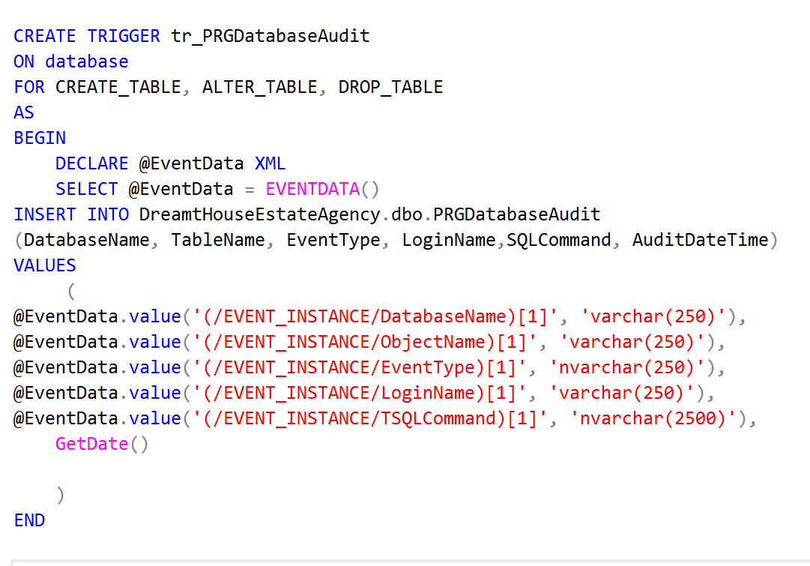
Figure 1. DDL Trigger. Source (Author)

To retrieve the information to store in the PRGDatabaseAudit table, EVENTDATA() function has been used and as output give us data in XML (Extensible Markup Language).
After a few testing sessions the Output of the Audit table is the following:

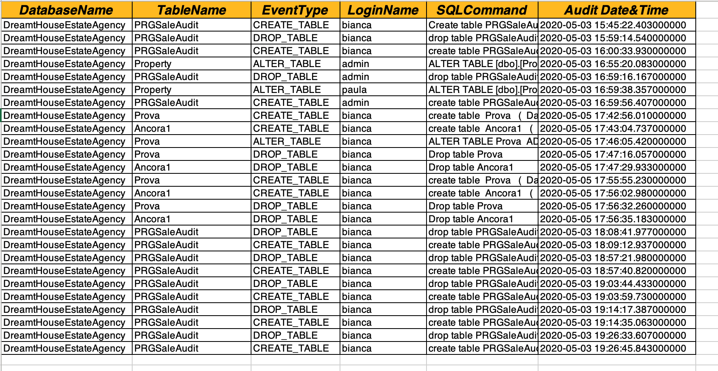
Figure 2. PRGDatabaseAudit table exported in Excel. Source (Author)
This table contains all the information related to creation, deletion and alteration of tables, it also contains the login name of the user who operated the SQL statement and date and time of the transaction.

The second suspicious fraudulent activity to monitor is the deletion of records from the Sales table after that the sale occurs. To implement an action on a table to record all the deletion, update and creation transaction it is good practise to use the Data Manipulation Language trigger. Also for this trigger, a table to store all the information requested as Property ID, SQL command, the user responsible and date and time of the transaction, has been created and its name is PRGSaleAudit. In DML trigger the information collected is stored in first place in virtual tables (inserted and/or deleted) so the data need to be retrieved from there. Therefore three different triggers have been created, one for each SQL commands.

The first DML trigger that we are going to consider is related to INSERT command.

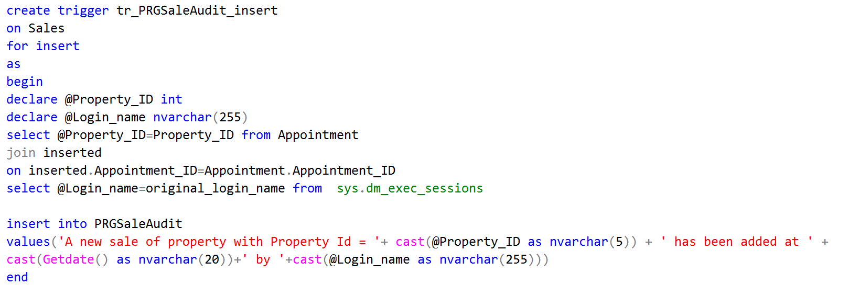
Figure 3.tr_PRGSaleAudit_insert. Source (Author)
In designing this trigger it has been considered to retrieve the Property ID from the Appointment table and this has involved joining inserted table (virtual table) with Appointment table. To record the login name of the user, the sys.dm_exec_sessions file has been used. In fact, this file collects all the user login for each session.

The second DML trigger created is related to DELETE command and its structure is similar to the previous explained with the only difference that the data is temporally stored deleted virtual table.

The last DML trigger is related to the UPDATE command and it has a more complex structure. To fully understand the process it is necessary to consider the mechanism involved in the update transaction: when a record is updated part or all the data is modified so the new data is temporally stored in the inserted virtual table and the old data into deleted ones. Also to produce a final audit string to record the total transaction the new data must be compared with the old ones and if there is any difference, both values must be recorded. The following picture is illustrating the first part of the trigger structure. The complete structure is illustrated in the Appendix.

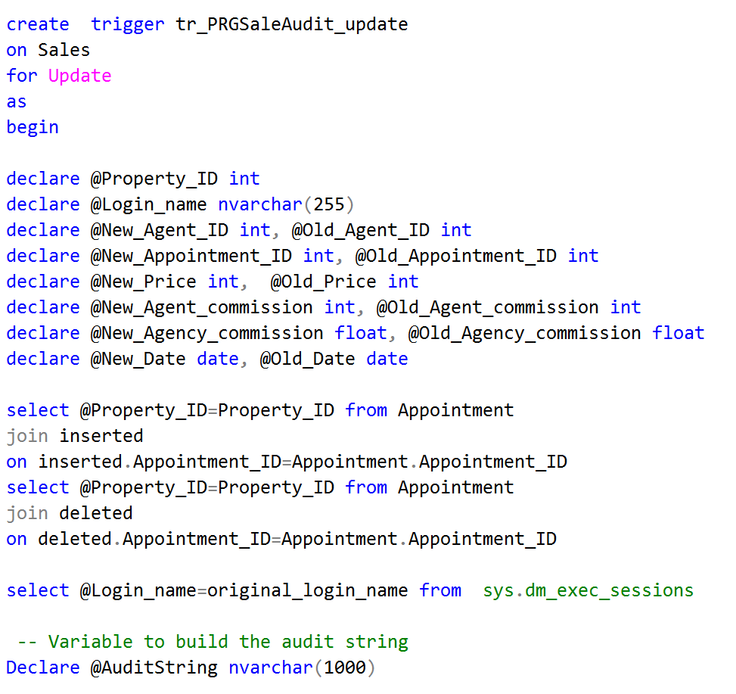
Figure 4. tr_PRGSaleAudit_update, part 1. Source (Author)
In this trigger more variables are declared to evaluate all the sensitive updating fields.

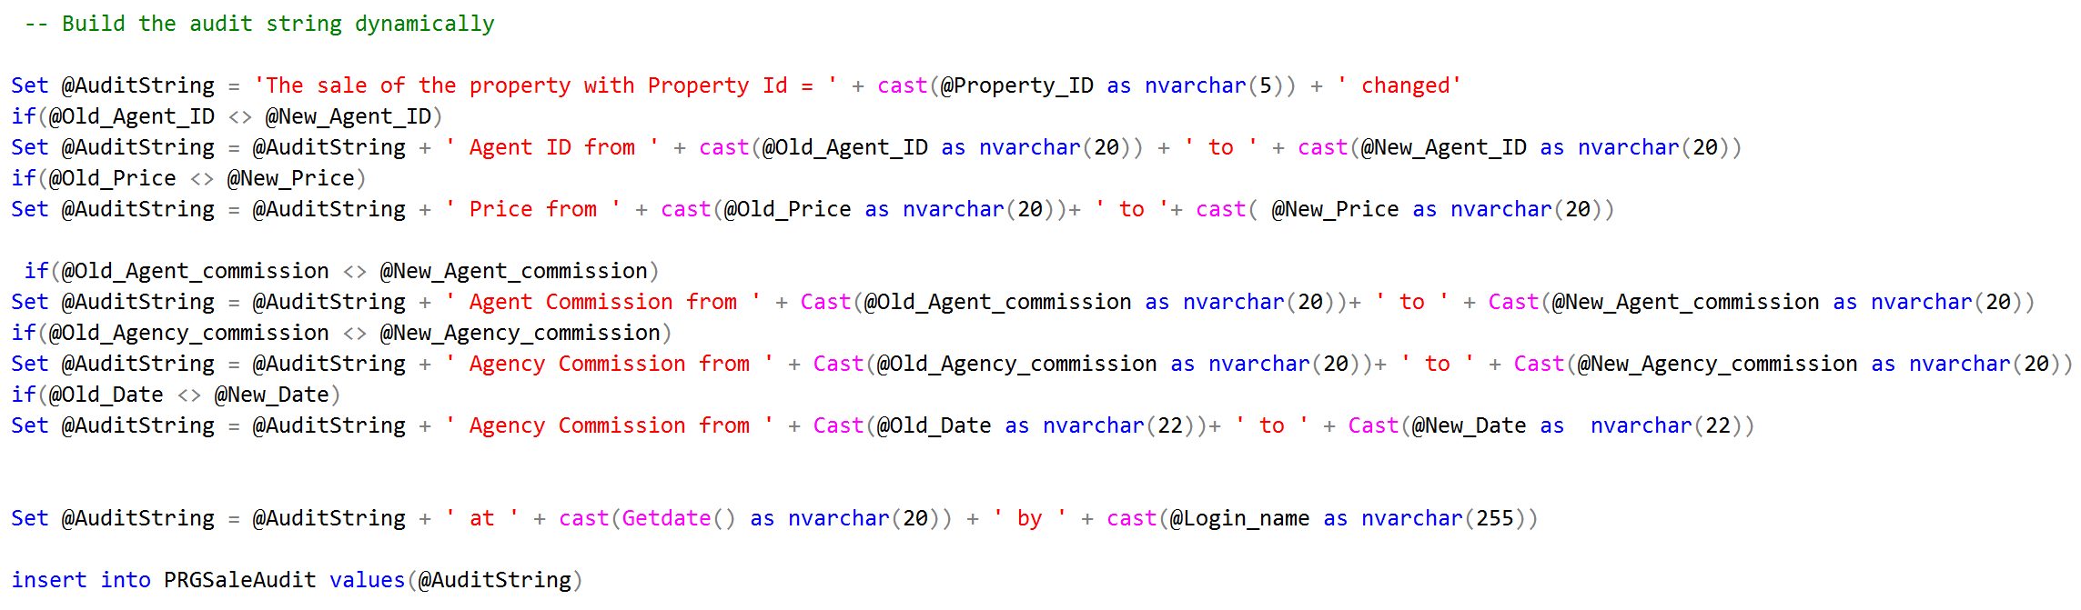
Figure 5.tr_PRGSaleAudit_update, final part . Source (Author)
In this figure is shown the way to build the final audit sting dynamically comparing the new value with the old to verify any possible update.

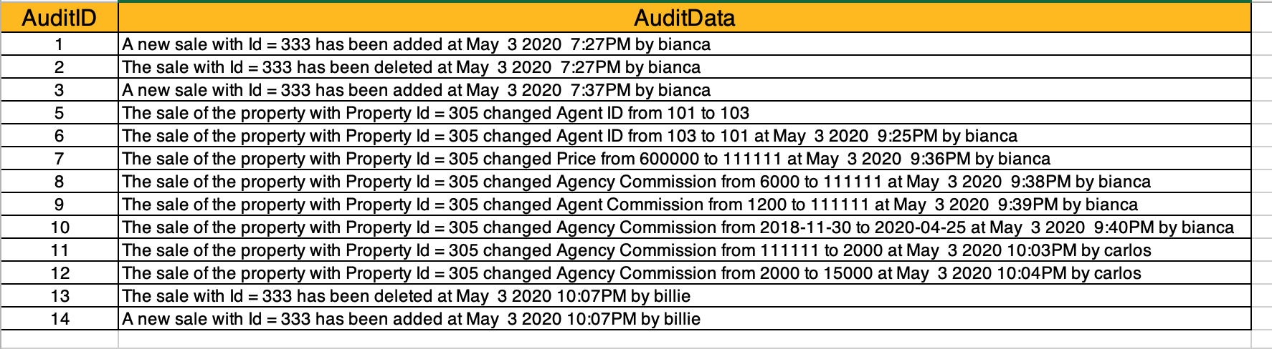
Figure 6.PRGSaleAudit table exported in Excel. Source (Author)
After a few tests performed on the database this is the final result, after the synergistic action of all the DML triggers. There are all the information to monitor any activity on the Sales table records and also for the UPDATE SQL command there is a full record of the old data and new data.

The database implementation is simply based on developing two types of triggers, the DDL trigger to monitor the database integrity and the DML triggers to observe the integrity of the record in the Sale table. The information retrieved from the triggers makes it possible to identify who makes the changes and when, providing an additional tool for any disciplinary measures.

TRANSACTION AND CONCURRENCY

In this section, some topics will be examined to better understand how a Database Management System works. We can start defining a Transaction as a piece of SQL code that when executed successfully produce modification on the database data.
Transactions must respect logical properties known as ACID transaction property. ACID is an acronym for:
- Atomicity: it means that the transaction is indivisible and its execution must be effective or null.
- Consistency: it means that when a transaction begins, a database must be in a consistent state. When the transaction ends the database will have to be in another consistent state. To achieve this consistency, integrity constraints must not be violated.
- Isolation: it requires that each transaction must be performed in isolation and it must be independent from other transactions. The failure of a transaction must not interfere with other running transactions.
- Durability: it means that once the transaction is committed, the changes made will no longer be lost.

The concurrency, on the other hand, is the ability of multiple processes to take place simultaneously to make changes in the database. Concurrency can also be defined, in a nutshell, as the ability of multiple users to simultaneously perform transactions on the database. The concurrency is subject to a mechanism control regarding the interlaced execution of more than one transaction. This mechanism intervenes to avoid the onset of the error that could compromise the data integrity in the database, in fact, the three most common anomalies that can occur are:
- Dirty Read: it occurs when a transaction updates a record and fails. But the update of it in the buffer is used by another transaction before the original record is modified or restored to its last value.

First Transaction | Second Transaction
Read the record A
Write the update of A
The update is temporally stored in the buffer | Read the record A stored in the buffer(DIRTY READ)
 | Write the update of A
 | Commit the transaction
Failure of transaction

Analysing the table it is possible to visualise what happens in this anomaly: the second transaction start when the first is still in execution and so not committed yet; when the second transaction commits the update of record A, this value is wrong because in the meanwhile the first transaction failed so the value initially read by the second transaction now it does not exist anymore.

- Unrepeatable Read: it occurs when two or more read operations of the same transaction read different values from the same record.
First Transaction | Second Transaction
Read the record A
 | Read the record A
Write the update of A
 | Read the record A (UNREPEATABLE READ)

In this table, there is a visual representation of unrepeatable read, where the second transaction in two following reading of the same record has as output two different value.

- Lost Update: it occurs when the data update made by one transaction is lost because it is overwritten by the update made by another transaction performed simultaneously.

First Transaction | Second Transaction
Read the record A
Write the update of A
The update is temporally stored in the buffer | Write the update of A
 | Commit the transaction
Commit the transaction

This table clearly shows the process of losing data update, because while the first transaction is executing the second update the record and commit the transaction whereby when the first transaction is committed the value stored is the same of the second transaction, this means that the update of the first transaction is lost.

To avoid these anomalies occurrence, SQL Server has mechanisms that imposes and releases locks. Locks ensure that inconsistent data is not read in multiple transactions, so when a transaction starts SQL server locks the objects involved for the transaction and then release them after the transaction has been executed.
The granularity of the locks, the detail level of this operation, allows blocking the database, the tables or even just a field inside a table and this ensures to carry out targeted operations. There are different types of locks, but we will focus on considering Two-Phase locking usually used to guarantee serializability. Serializability is a transaction property that ensures that the result of simultaneous transaction it is the same that would have been achieved by executing the transactions individually.
In Two-Phase locking two phases are identified:
- a growing phase where the transaction obtains all the necessary locks;
-a shrinking phase where the transaction begins to release the locks without being able to have others.
Two-Phase locking can happen with two different locking types:
- Exclusive lock: that completely locks the object requested from the transaction;
- Shared lock: that makes available the object requested from the transaction for reading mode only.

In the following table is shown the Two-Phase Exclusive locking to prevent the Dirty Read anomaly

First Transaction | Second Transaction
EXCLUSIVE LOCK A
Read the record A | WAIT FOR UNLOCK A
Write the update of A | EXCLUSIVE LOCK A
The update is temporally stored in the buffer | Read the record A stored in the buffer(DIRTY READ PREVENTED)
 | Write the update of A
 | Commit the transaction
Failure of transaction | UNLOCK A
UNLOCK A

In this case when the first transaction starts a lock gets, in this phase the second transaction before to start must wait till the lock for the first transaction is released and so when the first transaction completes its execution. Now the second transaction gets a lock and can retrieve the real value for the record A because the first transaction is completed. In this way, Dirty Read has been prevented.

CONCLUSION

Database Management System is an extremely flexible software that allows to be implemented and improved according to needs and based on work flows. In this report we have seen that through the use of triggers it has been possible to improve the monitoring system related to some operations. Furthermore, the understanding of some mechanisms that operate in Database Management System certainly helped to further appreciate its characteristics and performance.

REFERENCE

Babu, R., 2019. Trigger in SQL Server. [Online]
Available at: https://www.sqlshack.com/triggers-in-sql-server/
[Accessed 03 05 2020].
Bolton, C. et al., 2020. SQL Server Concurrency–Dirty Reads. [Online]
Available at: https://logicalread.com/sql-server-concurrency-dirty-reads-w01/#.XrkdYRNKhQJ
[Accessed 03 05 2020].
Elias, J., 2018. Concurrency problems – theory and experimentation in SQL Server. [Online]
Available at: https://www.sqlshack.com/concurrency-problems-theory-and-experimentation-in-sql-server/
[Accessed 03 05 2020].
Peschka, J., 2011. https://www.brentozar.com/archive/2011/06/sql-server-locking/. [Online]
Available at: https://www.brentozar.com/archive/2011/06/sql-server-locking/
[Accessed 05 05 2020].
Upton, B., 2014. What is a transaction?. [Online]
Available at: https://www.mssqltips.com/sqlservertutorial/3304/what-is-a-transaction/
[Accessed 03 05 2020].
Yaseen, A., 2019. SQL Server Transaction Overview. [Online]
Available at: https://www.sqlshack.com/sql-server-transaction-overview/
[Accessed 03 05 2020].

APPENDIX

--(f) Create a Trigger that responds to Update commands on Sales.

create trigger tr_PRGSaleAudit_update
on Sales
for Update
as
begin

declare @Property_ID int
declare @Login_name nvarchar(255)
declare @New_Agent_ID int, @Old_Agent_ID int
declare @New_Appointment_ID int, @Old_Appointment_ID int
declare @New_Price int, @Old_Price int
declare @New_Agent_commission int, @Old_Agent_commission int
declare @New_Agency_commission float, @Old_Agency_commission float
declare @New_Date date, @Old_Date date

select @Property_ID=Property_ID from Appointment
join inserted
on inserted.Appointment_ID=Appointment.Appointment_ID
select @Property_ID=Property_ID from Appointment
join deleted
on deleted.Appointment_ID=Appointment.Appointment_ID

select @Login_name=original_login_name from sys.dm_exec_sessions

-- Variable to build the audit string_
Declare @AuditString nvarchar(1000)_
_
-- Load the updated records into temporary table_
Select *_into #TempTable_
from inserted_
_
-- Loop thru the records in temp table_
While(Exists(Select Appointment_ID from #TempTable))_
Begin_

--Initialize the audit string to empty string_
Set @AuditString = ''

-- Select first row data from temp table_
Select Top 1 @New_Agent_ID = Agent_ID , @New_Appointment_ID = Appointment_ID , _
@New_Price = Price, @New_Agent_commission = Agent_commission,_
@New_Agency_commission= Agency_commission, @New_Date = Date
from #TempTable_
_
-- Select the corresponding row from deleted table_
Select @Old_Agent_ID = Agent_ID , _
@Old_Price = Price, @Old_Agent_commission = Agent_commission,_
@Old_Agency_commission= Agency_commission, @Old_Date = Date
from deleted where Appointment_ID = @New_Appointment_ID

-- Build the audit string dynamically
_
Set @AuditString = 'The sale of the property with Property Id = ' + cast(@Property_ID as nvarchar(5)) + ' changed'_
if(@Old_Agent_ID <> @New_Agent_ID)_
Set @AuditString = @AuditString + ' Agent ID from ' + cast(@Old_Agent_ID as nvarchar(20)) + ' to ' + cast(@New_Agent_ID as nvarchar(20))_ _
if(@Old_Price <> @New_Price)_
Set @AuditString = @AuditString + ' Price from ' + cast(@Old_Price as nvarchar(20))+ ' to '+ cast( @New_Price_as nvarchar(20))

if(@Old_Agent_commission <> @New_Agent_commission)_
Set @AuditString = @AuditString + ' Agent Commission from ' + Cast(@Old_Agent_commission as nvarchar(20))+ ' to ' + Cast(@New_Agent_commission as nvarchar(20))_ _
if(@Old_Agency_commission <> @New_Agency_commission)_
Set @AuditString = @AuditString + ' Agency Commission from ' + Cast(@Old_Agency_commission as nvarchar(20))+ ' to ' + Cast(@New_Agency_commission as nvarchar(20))_ _
if(@Old_Date <> @New_Date)_
Set @AuditString = @AuditString + ' Agency Commission from ' + Cast(@Old_Date as nvarchar(22))+ ' to ' + Cast(@New_Date as nvarchar(22))_ _

Set @AuditString = @AuditString + ' at ' + cast(Getdate() as nvarchar(20)) + ' by ' + cast(@Login_name as nvarchar(255))

insert into PRGSaleAudit values(@AuditString)_

-- Delete the row from temp table, so we can move to the next row_
Delete from #TempTable where Appointment_ID = @New_Appointment_ID
End_
End

