Assessment 2 – Field Journal:
Lecture 1 – Introduction - 13th January:
In this lecture, we were given a brief introduction to this module, this included information about when lectures would be, where they would be and when the fieldtrip would be. This was useful as it allowed us to understand how this module would work, and how it would be set out. I also found this session interesting, as we were able to see the differences between the history module and the archaeology module. We also went over how the module would be assessed. This session was useful, however it would have been better and more useful if it had been conducted by a lecturer who was part of the module, as instead we had a different lecturer who wasn’t clear on everything that we needed to know.
Lecture 2 – Sources - 14th January:
In this lecture, we looked at sources, what they are, how we use them and the different places that you can find them, for example: The National Archives and The British Library. We also discussed how we research history by using sources. For this lecture we focused on pre-modern sources, for example we looked at the types of sources that exist from the medieval period and their purposes and uses. We also talked about archives and what is kept in them and how this is decided. I found this lecture to be useful as sources are a key tool for historians and understanding where to find them and how to use them is very important.
Lecture 3 – Sources and Historiography - 16th January:
In this lecture, we continued looking at sources as well as discussing historiography. We learnt about different methods and approaches to History. For example, we looked at the conceptualisation of the relationship between ‘memory’ and ‘history’ as well as tracking historiography and we looked at forms of critical reflection against the erosion of the influence of memory within its communal setting. We also discussed ‘Ephemera’; which can be defined as: scraps of paper often, personal sources, for example: receipts, tickets, autograph books, this was interesting to me as I had not previously heard this word. Overall, this lecture was useful as it developed my understanding of the subject that I am studying, it also encouraged me to consider the way I approach interpretating sources.
Lecture 4 – 17th January:
In this lecture, we looked at theories of history and models of historiography. For example, we learnt that history can be considered to be a term that combines the ontological (being) with the epistemological (how we know things), and that it can be used to refer to both the past and our representations of the past. This is important as we only have access to the past through the representations of it. We also looked at the key question ‘Is a ‘nation’ the place or the people in it?’ and discussed it within the group. We also looked at the concept of a ‘Nation State’ and the ‘World Systems Theory’. I found this lecture useful as it allowed me to further understand the concepts behind the subject that I am studying.
Lecture 5 – 20th January:
During this lecture, we focused on the important skills required for writing essays, as well as focusing on improving our first assignment. For example, we studied the correct way to reference sources and the importance of doing this in a correct manner in order to avoid accusations of plagiarism. We also were taught methods to allow us to search for sources that we could use to support our essay, and where to find these sources for example: the library, the library website and the National Archive website. This lecture was useful for this module as well as my degree overall, as it taught me important skills required for writing essays, and this is very important.
Lecture 6 – Cross-Faculty Forum – 21st January:
During the cross-faculty forum, we listened to lecturers discuss the ‘Production of Meaning’ from their different subject perspectives. During the Architecture talk, we learnt about buildings and the purpose of their outside design and the meaning of this. During the Ancient Egypt talk, the meaning of modern Egypt looking back and reflecting on Ancient Egypt was discussed. During the Archaeology talk, there was a focus on not only the meanings of Archaeological finds, but also the meaning of what else is there, that is typically not regarded as important. Although I do not study Architecture, Ancient Egypt or Archaeology, I enjoyed learning about these different subjects and found it beneficial to expanding my general knowledge and my knowledge about other humanities subjects. I found this cross-faculty forum useful, as it was interesting to hear from lecturers of different subjects, in order to further develop my understanding of history and how it interacts with other humanities subjects. I also found it useful as it was interesting to talk to students who study other subjects and hear their thoughts on the forum and compare them to mine. It was also interesting to discover the different ways that ‘production of meaning’ can be defined based on personal interpretation for each lecturer present. This has enhanced my knowledge of ‘Doing History’, as it has allowed me to further understand the links between history and other subjects, as well as understanding different approaches to understanding history. Overall, I think that this was useful to my development throughout my degree. However, I did find that this conference was not aimed at history students, so could have been more useful if there had been a talk by a history lecturer.
Lecture 7 – Roderic Bowen Library and Archives – 23rd January:
During this lecture, we visited the Roderic Bowen Library and Archives. I found this incredibly useful and extremely interesting. While we were there, we were shown the Archives, and we discussed the importance of keeping documents in order to place them in Archives as well as the necessity of keeping them in the appropriate conditions in order to ensure that they do not get damaged. We then were able to look at historical sources from the library and the archive. For example, we looked at medieval manuscripts, such as a book about believed sea creatures, as well as documents relating to the history of the University, for example Tutor books. I found this useful as it is important to understand how and why we keep archives and the importance of this. I also found it interesting to look at these manuscripts. It was also good to further understand this importance of using archives for studying, this was further emphasised to us by our lecturer as well as by the library and archive staff. I am very grateful for this experience.
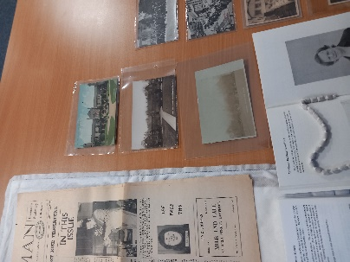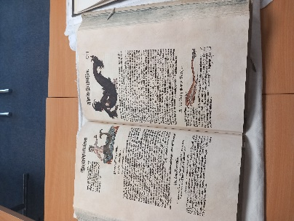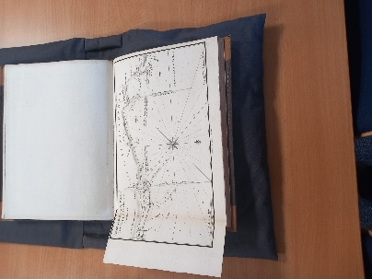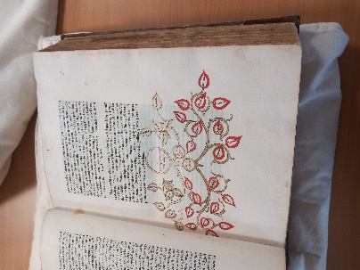
Photos taken by me (Megan Dabell) on 23/1/25
Lecture 8 – Referencing and Formatting Guidance – 24th January:
In this lecture, we were taught how to correctly reference sources using the MHRA referencing guide, as well as how to format our assignments. We learnt the importance of using the correct referencing style for the subject. This was incredibly helpful, as it allowed me to develop my understanding and ensure that I reference correctly, as well as hopefully helping me to improve any future assignments. This was useful to me as this is a very important skill for all assignments, therefore this will be useful to me throughout my degree. This lecture was also helpful as we were also given guidance on the structure of assignment two, this allowed me to ensure that I was doing the correct thing.
Lecture 9 – Fieldtrip Preparation – 27th January:
In this lecture, we discussed the upcoming fieldtrip and what the day was going to look like, this was useful as it allowed me to be more prepared. We also discussed the questions that we could ask while at the places in order to develop our understanding. For example, we looked at questions such as: What types of historical materials are held?, Can you find any information on past or current projects?, How do they use the collection/archive material? , How do they contribute towards our knowledge and understanding of Wales’s past?. I found this session useful, as it allowed me to further understand how the trip was going to run, as well as allow me to understand what I needed to take with me.
Lecture 10 – Fieldtrip – 28th January:
In this lecture, we went on a field trip to Aberystwyth. This would have been incredibly useful however unfortunately I was unable to partake in this trip due being ill. On this trip, I would have been able to visit the National Library, while there I would have been able to view the archives and many other important documents. I was informed by those who were able to go on this trip that it was very interesting and useful. This library is a centre of research into culture and heritage of Wales and the Celtic Nations. After the National library, the trip continued on to the ‘Royal Commission on the Ancient and Historical Monuments of Wales’. The Royal Commission has ‘a leading national role in developing and promoting understanding of the archaeological, built and maritime heritage of Wales, as the originator, curator and supplier of authoritative information for individual, corporate and governmental decision makers, researchers, and the general public’. This would have been useful as I would have been able to use the material there in order to expand my knowledge and develop my understanding. After this, the group then went to the Ceredigion County Museum, this would have been very useful and would have developed my understanding of the history of Ceredigion. The museum is ‘home to both permanent and temporary displays that explore Ceredigion’s heritage, culture and art’. I was informed by those who went on the trip that they found out lots of new information while here. Overall, this trip would have been incredibly useful to me and allowed me to further develop my understanding of history as well as exploring archives and viewing other important artefacts that are key to the history of Wales, therefore it is a shame that I was unable to go.
Lecture 11 – Historiography and ‘In defence of History’ – 30th January:
In this lecture, we discussed historiography and different views of it. For example, we looked at the Constructivist view of history as well as the Objective view. We also discussed how history can be viewed as the ‘act of writing’. Furthermore, we looked at how history could be viewed something that happens in the interactions between humans and what they think has happened, as well as the view that history is what happens in life, come into being when people think about what has happened in the past. We then were told about history in China, and the importance of periodisation. Overall, I found this lecture very interesting, and it was useful to developing my understanding of the discipline I am studying.
Lecture 12 – Course Overview - 31st January:
In this lecture, we discussed the module as a whole, including which parts we found useful and which parts we didn’t. We also discussed what could have been improved. This was useful as it allowed me to express my opinion on this module, as well as hear others’ opinions. This also allowed me to further establish what I have gained from this module.
Module Overview:
Overall, I found this module very interesting and very useful to developing my understanding of history and how you research it.

Bibliography:
‘Home - Amgueddfa Ceredigion Museum’, Home - Amgueddfa Ceredigion Museum, n.d. <https://ceredigionmuseum.wales/> [accessed 29 January 2025]
n.d. <https://rcahmw.gov.uk/about-us/> [accessed 29 January 2025]

n.d. <https://rcahmw.gov.uk/about-us/> [accessed 29 January 2025]
‘Home - Amgueddfa Ceredigion Museum’, Home - Amgueddfa Ceredigion Museum, n.d. <https://ceredigionmuseum.wales/> [accessed 29 January 2025]

