3D Modelling Diary
Name: Sêren Williams
Student ID: 2501567
Module Name: Academic and Professional Development
Lecturer: Jenni Steen
Date: 16/11/2025

Table of Contents
1 | Introduction 2
2 | Module Lessons 3
2.1 | Learning the Basics of Maya 3
2.2 | Tools to Create a “Dumpster” 4
2.3 | Combine, Bride and N-gons 5
2.4 | Using Soft Select 6
3 | Developing the 3D Models 7
3.1 | Dumpster 7
3.2 | Lamppost 8
3.3 | Soda Can 9
3.4 | Cup and Saucer 10
4 | Conclusion 11
5 | References 11

1 | Introduction
A production diary is a detailed record of a creative project’s development which includes documenting initial ideas, planning and executing. In my “Introduction to 3D modelling” class, where I must learn a new software, use special modelling tool and produce multiple 3D models for evaluation, I will use this diary to log my skill development. This diary will consist an overview of my lessons and what I learnt, how I will be applying these skills to my models and a reflection of my progress so far. I’m learning and developing my skills by using Autodesk Maya [1]. I have only used Blender [2] in the past. For my assessment, I must create 5 different models through using Maya. Tools I’ll be using will be Maya, to create the models I need for my assessment. I will be using an internet browsing service like google for accessing all educational tools given to me from the University. I will be using Maya forums to help with expanding my skill set using Maya and using YouTube videos if needed. My aim from developing this production diary is to expand my knowledge and skill set of using Maya and 3D modelling skills, broadening my knowledge on academia and learning how to correctly write professionally and to finally hand in my assignments to continue my studies.

2 | Module Lessons

2.1 | Learning the Basics of Maya
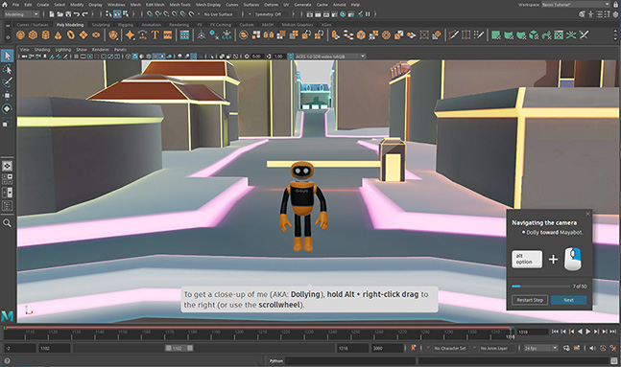
In this lesson, I learned the basics of Autodesk Maya. Our lecturer introduced us to a tutorial video that is inside of the software library shown in fig.1 that allows you to interact with the tools and features that are available in Maya. Once this tutorial was over, our lecturer explained how to extrude and bevel objects. This lesson helped with developing the fundamental skills of using Maya and how I can apply these new skills to help create my 3D models. This helped with my workflow as it helps with speeding up slow processes by the computer doing things automatically rather than doing things manually, such as the extrude and bevel tools.
Figure 1 - Maya Modelling tutorial used for learning the basics [4]

2.2 | Tools to Create a “Dumpster”
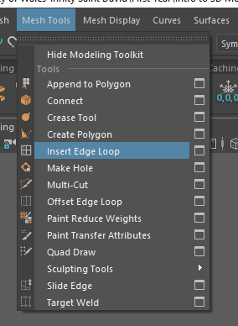
In this lesson, I learned new tools like using the edge tool, mirroring and snap to point. We started with a cube. We used tools such as extrude and bevelling to create a general shape of a dumpster. A problem occurred where the face was slanted when you pulled it down, when it needed to lay flat.
Figure 2 Screenshot of Edge Loop Tool in Maya [6]
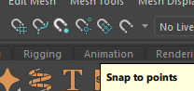
I fixed this by selecting the face and pulled it down which then made the face lay flat. We used a new tool called edge loop tool as shown in fig.3, which allows you to insert extra sides and vertices to an object and using the snap to point tool which is shown in fig.2 allows the number of edges loops you want to be inserted equally rather than freehand.

Figure 3 Screenshot of Snap to Points in Maya

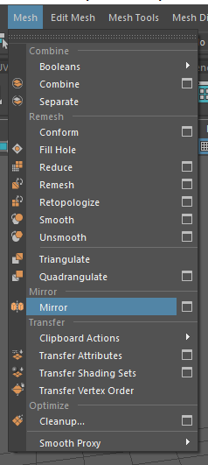
Then using the mirror tool allows you copy a side of the object you’ve manipulated and replicate it on the other side itself without you needing to repeat what you already did all over again. By reducing human error, the new tools made the process of creating the dumpster simpler and more effective. While the mirror tool effectively duplicated the detailed work I created using the edge loop tool.

Figure 4 Screenshot of the Mirror tool in Maya

2.3 | Combine, Bride and N-gons
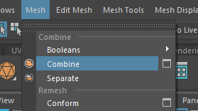
In this lesson we learnt how to combine objects, bridging and what N-gons are. To combine objects, you select the objects you want to combine, go to the mesh window and click combine as shown in fig. 5.

Figure 5 Screenshot of the Combine tool in Maya [7]

Combining the objects allows you to then bridge 2 objects.
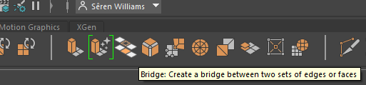

Figure 6 Screenshot of the Bridge tool in Maya [7]
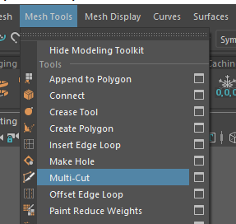
Finally in this lesson, we learned briefly about N-gons. An N-gon has 5 or more vertices/sides. They are an issue when texturing the model in a separate software such as Adobe Substance 3D Painter [3] as it messes with the texturing and patterns of what your trying to texture. Therefore, using a new tool called Multi-Cut tool shown in fig 7 which allows you to insert vertices and sides freely to divide N-gon faces into smaller faces. This ensures that the textures on my 3D models are more smoother and fluid.

Figure 7 Screenshot of the Multi-Cut tool in Maya [5]

2.4 | Using Soft Select
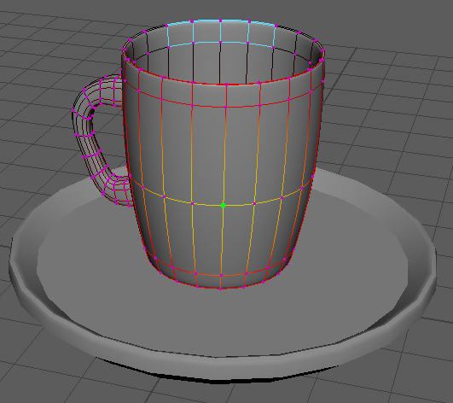
The soft select tool [4] will give a gradual transition from where the vertices is pulled back to the object it came from. This tool is helpful when making round and bulbous objects like a teacup which is one of the models I must create for my assignment, as it allows you to blow up the bottom slightly like a balloon to give that bulbous effect.
Figure 8 Screenshot of the soft select tool being used

3 | Developing the 3D Models
During the development of the models, I used the tools written about above and my understanding of 3D modelling to produce 4 models. I haven’t been able to complete the 5th model as within my time frame, I would have to complete it after Christmas. I also recorded the process of myself producing these models for my 3D modelling assessment due in January which made tracking my progress easier.

3.1 | Dumpster
To have practice with the new tools I was introduced to, I started by getting reference images off google and inserting them into a separate document. I started by inserting a cube and using tools like extrusion, bevelling, edge loop and mirroring to create the model. I again came across the slanted face issue again but that was a simple fix as I had already overcome this challenge in class. Fig.9 shows this below. A skill I got to understand with this model was topology and how the edge loop tool helped with this. Because I understood the topology of a simple dumpster, I was able to create detail from a cube by inserting new faces using the tool to manipulate the cube further.

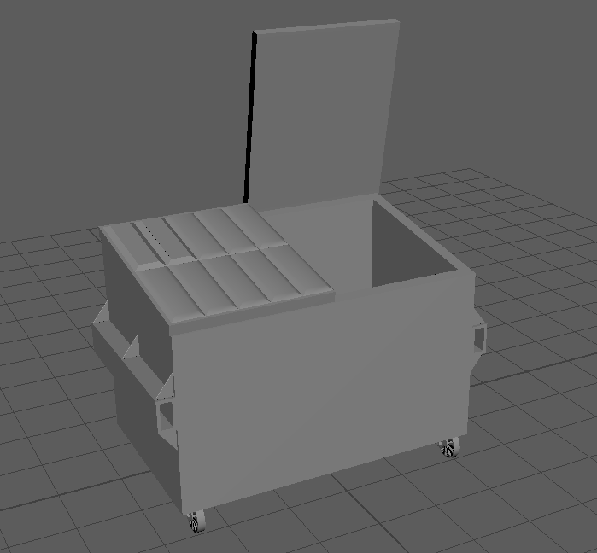
Figure 9 Screenshot of Dumpster Model Created in Maya

3.2 | Lamppost
The objective for this model was to have practice with cylindrical modelling and proportions to create a Lamppost. I wanted to test myself by including more detail in this model. With this render, it mainly consists of 4 cylinders and a single cube. I created the detailing on the poles by extruding, bevelling and creating edge loops to create sections for each detail. I decided to do a bar rather than a curly motif in the corner of the model like most Victorian styled lampposts do as within my time frame I had, it better to do the bar. In this model, I practiced my time management skills by prioritising my time over detail by adapting my design that I initially was going for. See fig.10 below for final model. If I could improve 1 thing, it would be using the mirroring tool to create the horizontal bar points equal rather than doing both myself.

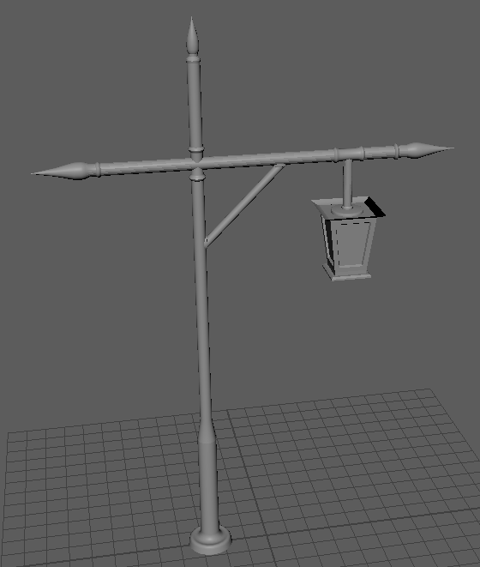
Figure 10 Screenshot of Lamppost Model created in Maya

3.3 | Soda Can
With this model, I wanted to practice smooth curves and edge loops. The development of this model consisted of a cylinder, and extruding and bevelling the top and bottom to create a can shape and creating a deep curve on the underside of the can using edge loops. A challenge in this model was the fact that I was unable to finish it as I ran out of time. I was unable to finish the pull tab at the top that soda cans have, fig. 11. Although this is an unfinished model, I have a better understanding of using the bevelling and extruding tools. I have also learnt that my time management failed here as I was unable to complete it by this assignment’s due date.

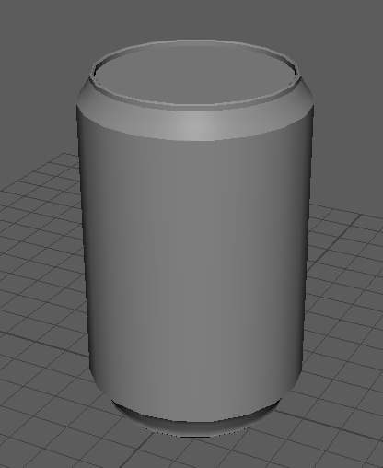

Figure 11 Screenshot of Soda Can model created in Maya

3.4 | Cup and Saucer
The objective of this model was to practice modelling organic shapes and the cups handle. The model consists of 4 different shapes, being 2 cylinders and 2 cubes. In this model, I made use of the soft select tool and bridging tool. I used the soft select tool to help with the bulbous shape of the cup and the bridging tool to create the handle by using 2 cubes to create it, final model in fig. 12. Overall, I believe that using the soft select tool helped with the organic shaping of the cup and practicing my use of tools.
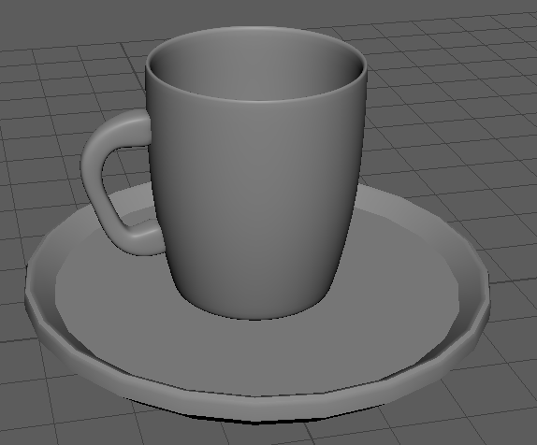

Figure 12 Screenshot of Cup and Saucer Model created in Maya

4 | Conclusion
Throughout this semester, I have gained a better understanding of Maya’s features, particularly useful tools like edge manipulation, mirroring, snapping and controlled extrusion. I became better at solving problems such as fixing the slanted face, time management and prioritisation which helped build my confidence. These abilities helped me work more effectively, helped me maintain clean topology and avoided errors early in the process, all of which will be beneficial for future models. This simplifies the modelling process and lessens the need for significant adjustments in the future. My time management skills have developed during this first semester. I have learnt how to divide my activities into manageable increments rather than hurrying though shapes without preparation. Understanding topology made modelling easier as it made modelling simpler by thinking of an object as its most basic shape. In general, I am getting more methodical and structured in my modelling approach and I will use these skills that I have learnt and will use them in future projects to come.

5 | References

[1] | AutoDesk Inc., “Autodesk,” Autodesk Inc., February 1988. [Online]. Available: https://www.autodesk.com/uk/products/maya/overview. [Accessed 08 12 2025].
[2] | Blender Foundation, “Blender,” Blender Foundation, 1995. [Online]. Available: https://www.blender.org/. [Accessed 08 12 2025].
[3] | Adobe, “Adobe 3D Substance Painter,” Adobe, [Online]. Available: https://www.adobe.com/uk/products/substance3d/apps/painter.html. [Accessed 08 12 2025].
[4] | Autodesk Inc., “Interactive Learning in Maya,” Autodesk Inc., [Online]. Available: https://help.autodesk.com/view/MAYAUL/2024/ENU/?guid=GUID-87A146F7-99B4-4EF9-BE49-4A22F436C44A. [Accessed 08 12 2025].
[5] | M. Toolbelt, “The Maya Toolbelt - Cut Faces Tool in Maya 2016,” Maya Toolbelt, 21 July 2015. [Online]. Available: https://youtu.be/dOo4_MH2tvQ?si=2cz3rQrqlMX9OcF9. [Accessed 27 November 2025].
[6] | F. Rahman, “how to add edges in MAYA,” 14 July 2020. [Online]. Available: https://www.youtube.com/watch?v=hObFhSIiB_Y. [Accessed 27 November 2025].

