Project Initiation Document
Assignment – ACDA5004

Lauren Davies
1805950
Contents
Abstract 2
Objectives – what the project is about 2
Scope 2
Constraints 3
Timescale 3
Budget 3
Authority 3
Project Organisation Chart 3
Team Members & Roles within Project 4
Joshua 4
Kaylie 4
Elliot 4
Connor 4
Lauren 5
Nic 5
Equipment 5
Finance 5
References 5
References 5

Abstract

The project which has been put forward by the team is a Medical Bracelet. This product will be a band that will contain a microchip which contains the medical information along with a GPS, which will be able to locate the user if they are in trouble. A possible feature that may be incorporated upon further development is the bracelet being able to be scanned by paramedics upon their arrival, allowing them to see all medical history and if there is any particular medication that they may also need or have had on that day to prevent any clashing of effects from medicine.

Objectives
The outcomes of the project are as followed:
- To provide those with disabilities and their families the comfort of knowing that their loved one is safe
- Grants Emergency Services with swift and easy access to needed medical information
- The band design being a medical band, but not pointing out that the wearer has any medical issues.

Scope
As a group we are a Community Interest Company (GOV, ND), so our product would be producing the medical bracelets for NHS, meaning any profit involved would be put towards production.

Constraints

Timescale
Due to having a limited amount of time the work will have to be evenly distributed in order to meet the deadline. This means that if a member of the group were to be absent, it will affect the flow of work as the missing member will also have to be informed of what they have missed during their time off along with completing the work that they have missed.

Budget
When creating the product as a team, the consideration of the set budget has to be apparent at all times when thinking about the individual pieces of the bracelet such as the strap and the microchip as these can sometimes be expensive depending on the material used, in order to ensure the completion of the overall design/production of the project that has been set.

Authority
It was decided by the team that the Project Manager would be Kaylie, who would oversee everyone’s work and check in with group members to ensure that everyone is keeping to the deadlines and is progressing with their work. The Project Sponsor for the team is Joshua, as the original idea/concept for the bracelet was thought up by him.

Project Organisation Chart

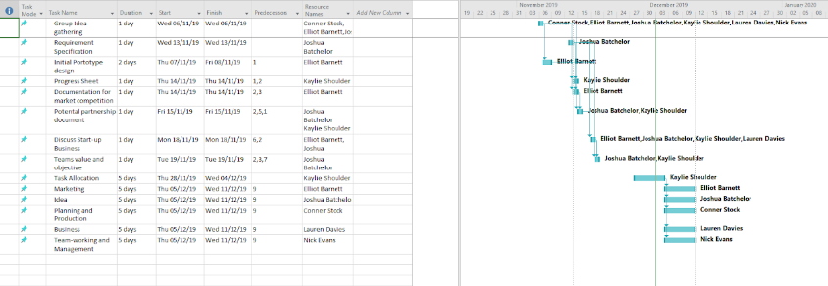
(Helpers, 2019)
The gantt chart allowed the Project Manager (Kaylie) ad Project Sponsor (Joshua), to see who had been completing work each day to keep track of all progress provided by the team. As shown in the chart, there were members that later joined the group.
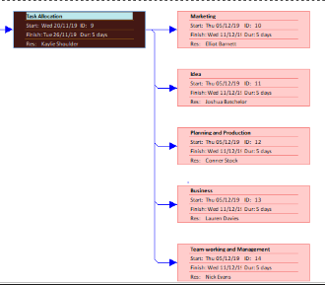
(Progress, 2019)
This is showing that once the team leader (Kaylie), had created a task that needed to be assigned to all departments to be completed, which ensured that the group was producing work within the time allocated.

Team Members & Roles within Project
The group consists of 6 members:

Joshua
Their role in the group is Ideas and Project Sponsor. This member had created the idea/concept of the medical bracelet and had explained what the product should consist of.

Kaylie
This member had the role of Project Manager. They ensure that each individual is attending the meetings to check on each department and see the progress that is being contributed towards the product.

Elliot
The department of Marketing was appointed to this member. This department researches into the advertising of the product and seeing what other businesses have to offer and if they share any similarities to the product in design.

Connor
Planning and production was assigned to this member. This department makes sure that the team members are able to reach their targets and that the team are able to use resources that are within the projects budget to prevent any issues.

Lauren
For this member Business & Graphical design had been designed. This department was to deal with the Legal aspects needed for the company, such as the Legal Classification along with its Mission Statement. Along with the Legal aspects, Graphical design meant progressing and producing designs (prototypes) for the medical bracelet, such as providing the Project Manager/Sponsor with designs of the clasps, microchip and bracelet.

Nic
This member was assigned the role of Team working & Management. This department dealt with keeping track of all progress and issues within the team. This role works closely with the Project Manager, as they both ensure that all members attend and are completing the work set by the manager via Team Progress Sheets.

Equipment
The equipment needed for this product is as followed:
- People experienced in design/programming
- Silicone/Rubber/Fabric
- Additional Padding/protection for microchip
- Metal clasps

Finance
This is something which is still in discussion by the team currently due to the resources needed for the project.

References

References
GOV. (ND). Setting up a social enterprise. Retrieved from GOV.UK: https://www.gov.uk/set-up-a-social-enterprise
Helpers, H. (2019). Team Progress - Gantt chart. Kaylie, Joshua, Lauren, Elliot, Nic, Conor.
Progress, H. (2019). Team Progress.

