Habibur Rahman
Student No: 1809410
Module Title: BMSK4003 – Digital Skills and Research Methods
Assignment Title: Write a report of 2,000 words which evaluates the effectiveness of the use of modern technologies within the workplace and explore social media as a tool for marketing, information gathering and communication within the work-place, creating their own professional online presence to illustrate and evidence this research.
Module Lecturer’s Name: Joy Botu
The use of modern technologies in the workplace has made it easier for companies and organizations to complete their tasks and also helped in bridging gaps between the employees and the management team. In this report, the various ways in which emails, smart phones and tablets have acted both as a boon and curse for the workplace will be analysed. The different providers of emails, its efficiency and employability are being judged in this project report. Information about social networking sites like Facebook, Twitter, LinkedIn and their role within workplaces will also be explored.
Web-based email accounts are generally free email accounts that are put into operation from a website. E-mails can be compared to postal letters, with the only difference of it having 2 parts to it, a header and a subject. While the header contains name of the recipient (to whom the mail is addressed to) and the subject includes the whole body of the message. There are many web-mail services available such as, MSN Hotmail (which has been replaced by Outlook), Gmail, and Yahoo. It is even possible to send pictures, videos, sounds and files as part of attach-ments. Mobile phones were initially used for calls and text, but with the advent of technology and the regular releases of smart phones and tablets, users are able to enjoy access to internet, use of multiple apps and also play games and watch videos from one medium.
The introduction of email in the 90’s completely revolutionized the whole work environment. The main benefit of the introduction of email is that it has enhanced the workplace communication to a whole new level. It has led to transmission of information from one person to another more viable and quick. Increased communication as a result means that the employees and the organization can be more productive.
Secondly, the use of email have drastically reduced the use of paper in workplaces, which not only makes it more environment friendly but also means work is less likely to get lost or misplaced. Emails have made it easy for companies to store electronic files rather than have stacks of paper files at their office desks. It also reduces the expenditures of the companies to a great extent, as the cost of paper production generally exceeds the cost of establishing internet connectivity in offices. Emails also allow employees and employers to send work related documents anywhere in the world within seconds and receive quick response. The usages of emails, smart phones and tablets in workplace are very much similar as it is through these gadgets that we connect to internet and thus to emails. The smart phones and tablets, like emails gives boost to productivity of the company. Modern technologies also helps people to take better notes during meetings at offices as now they are able to type up all their information or even record the meeting on a phone or tablet which they can use later for reference. Many employers and employees are able to have access to a large number of work related apps like Quire and Slack. Communicating in the workplace and completing tasks and events becomes much easier with the help of smart phones and tablets.
We live in an era where digital media is everywhere and as it makes running a business or an organization easier, many people tend to buy the latest programs and applications for their company. The use of emails, smart phones and tablets has made it more practical for employees to modify online data and information and mail it to the appropriate recipient. Also, companies that use graphs, tables and charts for work purpose or even success analysis, they are able to use online programs such as MS Excel, SPSS etc which makes creating data quicker and more reliable. It has provided many employees with flexibility as if their employer agrees then they can choose to work from home and send over any important files via email. The email service has given us more control as we can directly send the structured work to the concerned recipient at any time we like. This very much eases the whole work load and increases the productivity of the company. Smartphone and tablets are all about communication which has given us a chance to get over the postal letter sending era. These smart phones have given us features like text messages, group chats, emails and even team managing apps like Drop Box, which makes the carrying out of work easily and does not bind the employees to co work only when they see each other at the office. Thus enabling the work to be carried out from anywhere in the world. Smart-phone and tablet apps such as, Skype or WhatsApp Video call allows employers and employees to have meetings with other company executives across the globe (Koppel et al, 2015). Individuals can directly come in contact with their clients in other parts of the world through video calls for a better understanding of their problems and situations. This would surely increase the efficiency of that particular organization.
Two of the largest email providers in the world market today are Google (Gmail) and Microsoft (Outlook). In the matter of connectivity which is a vital factor in workplace, Gmail appears to be faster in recovering and setting up email and folders for clients on any operating system. Gmail and Outlook, both offer 15 GB of storage. It is much easier to search for a particular email in Gmail than in Outlook. Thus, for many, Gmail seems to be more appealing for everyday workings at offices.
E-mails, smart phones and tablets help a lot in increasing employability at workplaces. Employees are now able to benefit from working from home, where they are able to complete tasks at home when necessary. This alternative allows them to complete their work at home with ease and thus increases employability of an organization (Ali-Hassan et al, 2015). Emails and work related apps can be used outside of work and outside of office hours means employees are not forced to stay at the office to complete any remaining work. They can access work from anywhere around the globe and mail it to the recipient once complete. This takes off the burden from the employees and increases their work level. The various apps within these smart phones and tablets aid the employees in their work (Gee et al, 2017). The Calendar app is useful for employers and employees as they are able to set reminders and use it as a means to organize their schedules. It allows workers to set reminders for important tasks, meetings and deadlines, etc. Thus, ensures work goals are met and all tasks/duties completed to a high standard within a set time.
Social Media as a tool for Marketing
With the arrival of social media it has brought a whole lot of arena within it. Social media sites like Facebook, Twitter and LinkedIn can very much be used to seek out jobs. These sites could be used as platforms to portray one’s social and professional skills to filter out the best suitable jobs for them. Although LinkedIn is a place where people go to find a job, it portrays itself as the social site for finding employment (Kritzler et al, 2015). However, if we look closely, Facebook is still the social networking site which many people use to interact, talk and share parts of their lives. Meeting new people also paves way for new opportunities and chances. Using social media means one is able to network with a larger audience and this may help an individual get a new job. During this form of network one may encounter with individuals with a high position or job role in a company. Thus, personnel relationships could lead to growth of professional opportunities (Massenberg et al, 2015).
On the other hand, individuals visit sites such as LinkedIn only when they need to find new jobs, update their profile and so on. People do not visit these sites everyday and nor do they interact much using LinkedIn. Twitter as compared to Facebook and LinkedIn is a much unfiltered medium for finding jobs. One has to portray their creative ideas through their posts, follow key leaders of companies sharing things that are similar to their interest of job. In short, it is an indirect tool of job searching (Tudu and Pathak, 2015). However, when comparing Facebook and LinkedIn, both can be used to find out about new job opportunities. But as people are more familiar and comfortable using Facebook compared to LinkedIn, it surely does have an upper hand (Panahi et al, 2016). Facebook is multi-purpose and so you are able to interact with old and new friends and also find out about employment opportunities via word of mouth (Brougham and Haar, 2018).
Social media apps like Instagram, Facebook and Twitter are increasingly becoming a part workplace culture. These social media outlets are being used in various departments of work; be it branding, advertising or even finding an ideal candidate for a job role (Dheepa and Annapoorani, 2015). Many retail companies often use social media to inform customers of sales and promotions or of any upcoming events.
Advantages
- It is through these sites that candidates for a particular designation at office are generally recruited. Recruiters use these sites to connect with candidates fit for job profiles.
- These sites help the organization or the company to gain recognition from a large audience (Lee et al, 2015).
- New customers and clients could be found by the company through these social sites.
- Most importantly, these sites help in the branding and advertising of the product or service of the concerned company. For example, a newly opened restaurant could create a page for on Facebook to advertise what it has to offer to its customers and any current promotions available. This would advertise the restaurant and would also make its brand value clear (Stodart, 2016).
- Encourages productivity of the company or business
- Helps the company to assess their performance by observing the number of likes, followers and comments (engagement).

Disadvantages
- These sites act as a hindrance for employees to focus on work. People are caught surfing Facebook for long hours, which is against work ethics.
- Reputation is an important thing for companies. Thus, people that are unable to connect with the audience or lack social media handling experience could cost them company its reputation.
- It is easy to get involved in scandals and words/posts may be taken out of context which would negatively affect the business.
- Excessive use of these sites by employees can lower the productivity and efficiency of company which may incur loss for the company.
A reliance on the internet and social media means there is higher risk of misappropriation of confidential information of work by hackers (Ladkin and Buhalis, 2016). Thus, cyber security is a great need for both personnel and private information. One must avoid sharing too much personal details at such sites and should be aware of how one’s information is being used by different sites; building strong passwords so that the risk of hacking is minimized (Oldham and Da Silva, 2015). On a professional level, company’s social networking policies should be kept well maintained. The computers and laptops of companies should have good security protection to be able to detect any scam or virus. One must avoid sharing their location on unknown or third party sites. It is vital to adopt safety measures for both personal and work while exploring the internet (Maceli and Burke, 2016).
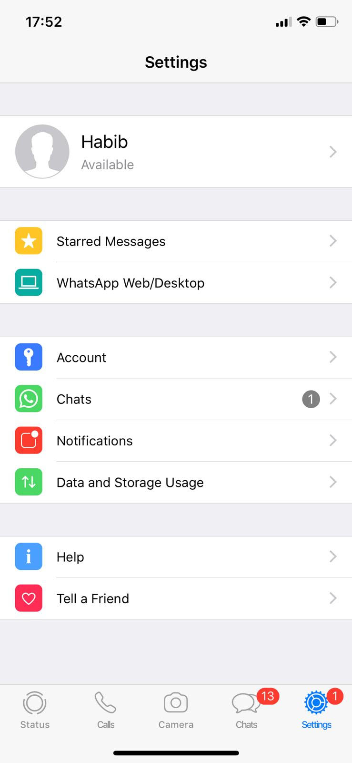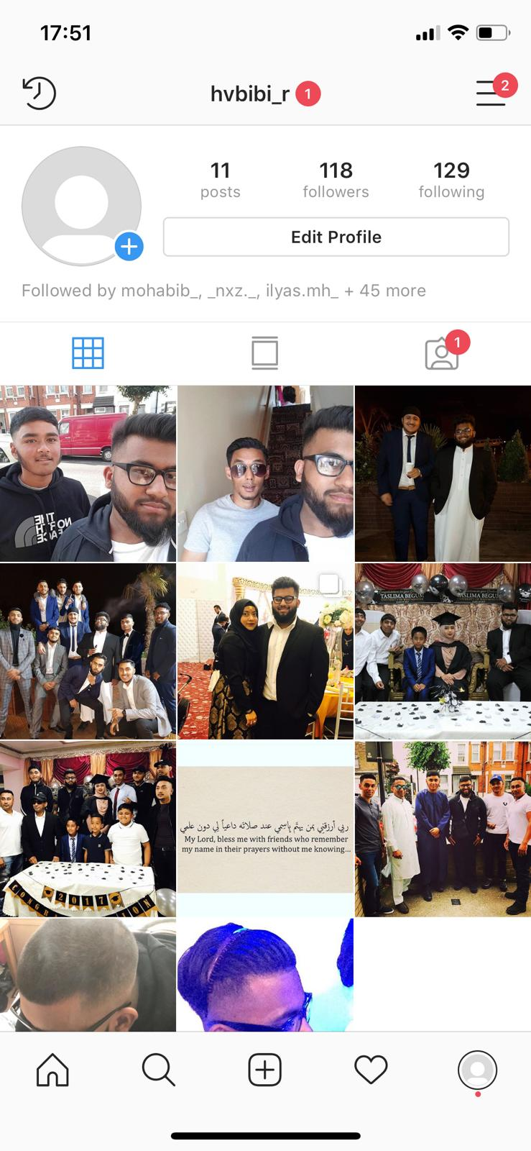
Social Media Profile
To conclude, with the technological advancement, emails, smart phones and tablets have become a vital part of workplaces. They have made work load, communication easier and work can be completed to a high standard without being physically present in the office. Urgent files and documentation can be circulated to other members of the team via email attachments.
Social networking sites like Facebook, Twitter and LinkedIn have acted as a great production booster at work. Although, it also increases the risk of data breach, companies can work to prevent this by ensuring security software is updated and all computers and programs are password-protected.

Reference List
Ali-Hassan, H., Nevo, D. and Wade, M., 2015. Linking dimensions of social media use to job performance: The role of social capital. The Journal of Strategic Information Systems, 24(2), pp.65-89.
Brougham, D. and Haar, J., 2018. Smart Technology, Artificial Intelligence, Robotics, and Algorithms (STARA): Employees’ perceptions of our future workplace. Journal of Management & Organization, 24(2), pp.239-257.
Cao, X., Guo, X., Vogel, D. and Zhang, X., 2016. Exploring the influence of social media on employee work performance. Internet Research, 26(2), pp.529-545.
Dheepa, K. and Annapoorani, G., 2015. Knowledge discovery on extracted outlook pst files and emails. In Green Engineering and Technologies (IC-GET), 2015 Online International Conference on (pp. 1-5). IEEE.
Gee, L.K., Jones, J. and Burke, M., 2017. Social Networks and labor markets: How strong ties relate to job finding on Facebook’s social network. Journal of Labor Economics, 35(2), pp.485-518.
Koppel, R., Smith, S.W., Blythe, J. and Kothari, V., 2015. Workarounds to computer access in healthcare organizations: you want my password or a dead patient?. In ITCH (pp. 215-220).
Kritzler, M., Bäckman, M., Tenfält, A. and Michahelles, F., 2015, November. Wearable technology as a solution for workplace safety. In Proceedings of the 14th International Conference on Mobile and Ubiquitous Multimedia (pp. 213-217). ACM.
Ladkin, A. and Buhalis, D., 2016. Online and social media recruitment: Hospitality employer and prospective employee considerations. International Journal of Contemporary Hospitality Management, 28(2), pp.327-345.
Lee, J., Choi, M. and Lee, H., 2015. Factors affecting smart learning adoption in workplaces: comparing large enterprises and SMEs. Information Technology and Management, 16(4), pp.291-302.
Maceli, M. and Burke, J.J., 2016. Technology skills in the workplace: Information professionals' current use and future aspirations. Information Technology and Libraries (Online), 35(4), p.35.
Massenberg, A.C., Spurk, D. and Kauffeld, S., 2015. Social support at the workplace, motivation to transfer and training transfer: a multilevel indirect effects model. International Journal of Training and Development, 19(3), pp.161-178.
Oldham, G.R. and Da Silva, N., 2015. The impact of digital technology on the generation and implementation of creative ideas in the workplace. Computers in Human Behavior, 42, pp.5-11.
Panahi, S., Watson, J. and Partridge, H., 2016. Social media and physicians: exploring the benefits and challenges. Health informatics journal, 22(2), pp.99-112.
Stodart, K., 2016. Smartphones at work. Kai Tiaki: Nursing New Zealand, 22(5), p.26.
Tudu, P.N. and Pathak, P., 2015. Social network sites: Can they enhance employee productivity in an organization?. The International Journal of Management Science and Information Technology (IJMSIT), (17), pp.23-35.

