01/12/2023
Kaleb Bartholomew (2305793)
University of Wales Trinity Saint David
Construction Materials:
The Burj Khalifa
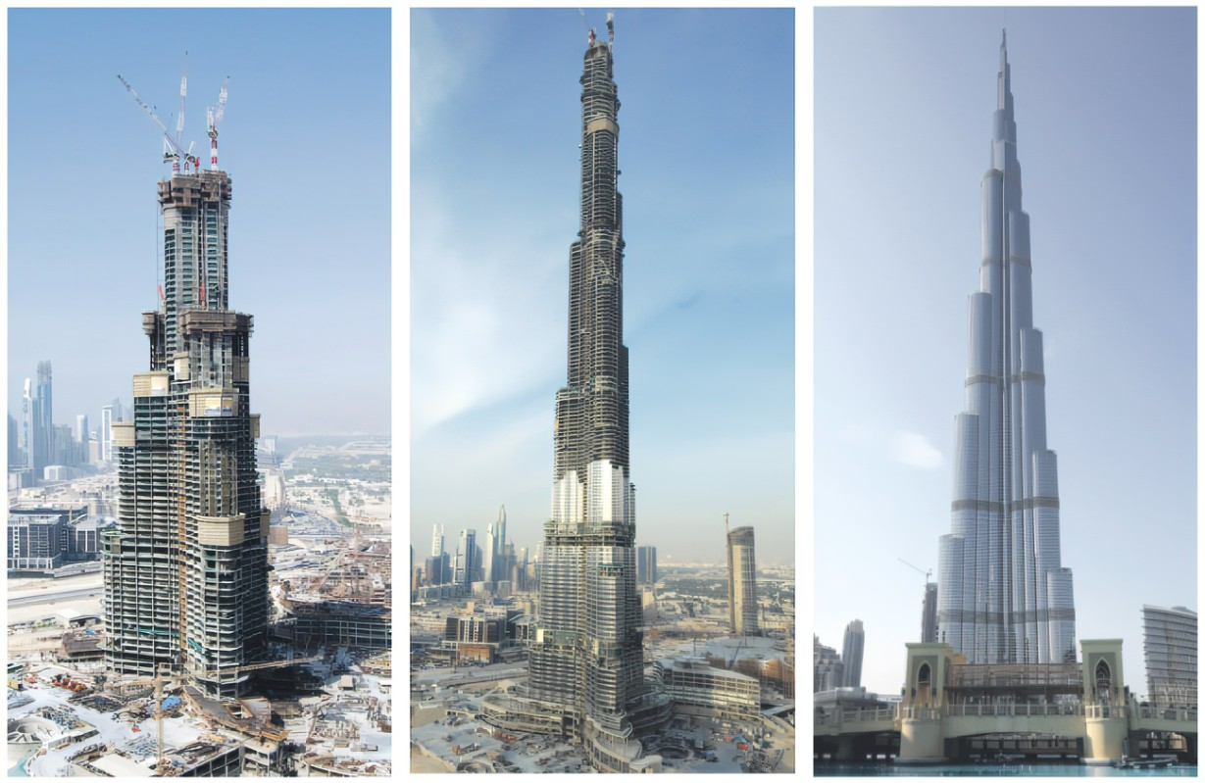
Contents
Behind the beauty of The Burj Khalifa 2
Adaptability 4
The Ever-Reliable Concrete 5
Concrete VS Steel 6
References 7

Behind the beauty of The Burj Khalifa
The Burj Khalifa which is the world’s tallest building took 6 years for its construction and was introduced on 4th January 2010. It is 828m tall and is an entirely reinforced concrete tower structure. The tower comprises 280,000 m² area. This area is utilized for 700 residential apartments located from 45 to 108 floors. The remaining spaces go up to the 160th floor which is occupied by the corporate officers. The total project cost is estimated to be US$20billion. The tower construction itself costs $4.2billion. The structural elements utilized, and their total amount is stated below:
- Concrete Used = 250,000 cubic metres
- Curtain Walls = 83,600 square metres of glass and 27,900 square metres of metal
- Steel Rebars Used = 39,000 tones
- Man-Hours = 22million man-hours

The basic structure is a central hexagon core with three wings, which is clustered around it, as shown in figure 1. While moving up along the tower, one wing at each tier is set back. This makes decreasing cross section when moving up. The structure consists of 26 terraces.
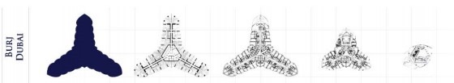
Figure 1.
The Burj Khalifa employs a ‘Y’ shaped floor plan which gives a full view of the Persian Gulf and provides a higher performance. The wind forces acting on the structure is reduced due to the help provided by its shape and upward setbacks. Wind tunnel tests were carried out thus helping to set a fixed shape for the tower. The structural system employed for Burj Khalifa can be called as the Buttressed Core System, which is a system constructed with the use of high-performance concrete wall. Figure 1 shows how each wing buttresses the other through a hexagonal central core. The central core has a higher resistance towards the torsional resistance. The structure is more designed for wind force and related effects. There are corridor walls that extend from the central core to the end of the wing, hammer walls are us to thicken the end of these walls. These walls resist the wind shears and moments by acting like the web and the flanges of the beams. The mechanical floors and the perimeter columns are connected by means of outrigger walls. Which helps to resists higher wind loads laterally. The outrigger depth is three storey heights. There is periodic encounter of outrigger system through the height of the tower.
The high-performance concrete used in Burj Khalifa guarantee low permeability and higher durability. The C80 and C60 cube strength concrete is used incorporating fly ash, Portland cement, and the local aggregates. A young’s modulus of 43800N/mm² is said to be granted by the C80 concrete. The largest concrete pumps in the world were used to pump concrete to a height up to 600 m at a single stage. Two numbers of this type of pump were used. As the temperature of the location (Dubai) is very high, there were chance of cracks due to shrinkage. So, the concrete pouring process was carried out at night at a cooler temperature and Ice was added to the concrete mix to facilitate the desired temperature. To withstand the excessive pressure caused due to the building weight, special concrete mixes were employed. Every batch was tested before placing.
The superstructure of Burj Khalifa is supported over a large reinforced concrete raft which is in turn supported by bored reinforced concrete piles. The raft has a thickness of 3.7m and was constructed in four separate pours. The grade of the concrete raft is C50 which was self-consolidating concrete, 12,500 meters cube is the concrete volume used. With a capacity of 3000 tons each, 194 piles were used with each of them having a diameter of 1.5 metres and a length of 43 metres. The tremie method was used to place the piles which used a concrete grade of C60 SCC concrete. This utilized polymer slurry to carry out the process. To reduce the detrimental effects of chemicals, cathodic protection was provided under the raft.
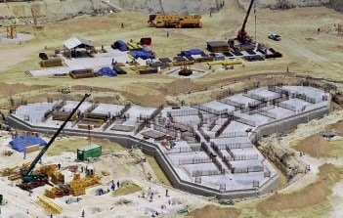
Figure 2.
For The Burj Khalifa the choice of materials was critical in achieving sustainability goals. It was constructed using eco-friendly materials, including high strength concrete, which reduces the amount of material required and minimizes the building’s carbon footprint. Additionally, the building features recycled and locally sourced materials, further reducing environmental impacts. The building’s façade incorporates a high-performance glass curtain wall with low emissivity coatings, providing excellent insulation and reducing heat gain, this façade also features photovoltaic cells that harness solar energy to generate electricity. The extensive use of high-performance glass helps to minimize heat transfer and reduce the need for artificial cooling during hot weather. The glass allows ample natural daylight to penetrate the interior spaces, reducing the reliance on artificial lighting during the day. Additionally, an advanced energy management system regulates the use of lighting and HVAC systems to ensure optimal energy efficiency.
As water scarcity is a pressing concern in the arid region of Dubai, Burj Khalifa has implemented water conservation strategies. The building has a sophisticated water recycling system that treats and reuses wastewater for irrigation and non-potable purposes. To further minimize water consumption, the Burj Khalifa incorporates water efficient plumbing fixtures and fittings where Low flow faucets, toilets, and showers help to reduce water wastage, additionally, greywater generated from sinks and showers, undergoes treatment and is reused for various purposes without compromising user experience. The building’s irrigation system utilizes smart technologies, such as moisture sensors and weather-based controllers, to optimize water usage for landscaping. Rainwater is collected from the building’s roof and stored in reservoirs for later use in irrigation and other non-potable applications. The tower employs desalination techniques to convert seawater into fresh water, reducing the strain on the city’s freshwater resources.
Effective waste management is a crucial aspect of sustainable design. The Burj Khalifa implements on site waste sorting and recycling facilities to minimize the amount of waste sent to landfills. Recycling initiatives target materials such as paper, plastic, glass and metal, diverting them from traditional waste streams. Efficient construction methods and careful material planning helped minimize excess materials and construction waste. Additionally, the building management team continues to implement waste reduction measures during the operational phase. Dubai’s urban environment is susceptible to the heat island effect, where built up areas retain heat and experience higher temperatures than surrounding natural areas. The Burj Khalifa employs various strategies, such as reflective and light-coloured materials, green spaces, and water features, to mitigate this effect and create a more comfortable microclimate around the building.
The Burj Khalifa’s location in the heart of Dubai’s bustling downtown area was a conscious decision to promote sustainable transportation options. The building is well connected to an efficient public transportation network, encouraging occupants and visitors to use buses, metro, and other forms of sustainable transit. Moreover, the building’s design prioritizes walkability, making it pedestrian friendly and reducing the need for private vehicular transportation.

Adaptability
High strength concrete/ high performance concrete was used in the construction of the building which guarantees low permeability and high durability. The reinforced concrete piles as well as the concrete raft used in the start of the project helped set a stable and strong foundation for this massive skyscraper. The high durability of the concrete used was shown as the project was carried out and the concrete worked hand in hand with the splendid design of the building making for a masterpiece of construction.
The arid climate of Dubai made it so that measures had to be taken to ensure the concrete does not begin to crack because of the heat. So, the use of ice in the concrete mixture was a revolutionary idea that worked towards solving this problem. The massive height of the tower made it so that winds became a daunting factor in the building’s construction. However, high performance concrete along with the design used to combat this climatic challenge shows the building taking a ‘Y’ shape and using upward setbacks throughout its construction to offset the wind factor therein solving this immense issue.

The Ever-Reliable Concrete
Concrete is a composite construction material, composed of cement, coarse aggregate, fine aggregate, water and chemical additives. Structural concrete is the type used in this construction project as it has good load bearing, low permeability and high density.
Cement is a binder, sets and hardens independently, and can bind other materials together. Cement used in construction is characterised as hydraulic or non-hydraulic. In order to make cement a large primary crusher which impacts or compresses the limestone rock is used. Depending on the size of the feed stone required and the kiln in which it will feed into, the same stone can go through a second and even tertiary crusher to reduce its mass even further. The stone is then screened into a wide range of different sizes from 125mm kiln stone all the way down to dust. Some of the stone at this point is washed to remove any clay particles that may remain. Golf Ball’ size pieces of Limestone pass through a rotating kiln. The kiln is angled and rotates slowly, pushing aggregate from one end to another and gradually heating it to almost 2000 degrees. Carbon Dioxide gas is burnt off. Limestone decomposes to Calcium Oxide then reacts with additives (silica, alumina, iron) to form calcium aluminates, silicates and alumino-ferrites. Dry state mix of these is called ‘clinker’. Red hot clinker is discharged into coolers and then stockpiled. This is then ground to the required fineness to form cement, with the addition of gypsum (Calcium Sulphate) usually 4-7% by weight, which controls the setting time. The cement used in this project is hydraulic cement as it used fly ash and Portland cement.
Aggregates are inert granular materials such as sand, gravel, or crushed stone that, along with water and Portland cement, are an essential ingredient in concrete. As aggregates account for 70 to 80% of the total volume of concrete, the selection of suitable material is important as it can affect its performance. Fitness for purpose lies not only in strength of the end product, but also in materials choice and the approach to quality.
There are different types of admixtures which are used to provide certain properties. Admixtures or additives such as pozzolans or superplasticizers are included in the mixture to improve the physical properties of the wet mix or the finished material.
Various types of concrete are manufactured these days for construction of buildings and structures. These have special properties and features which improve quality of construction as per requirement.
Concrete is the most abundant manufactured material on earth and provides the foundations of modern life. However, making concrete comes with a high environmental cost. The cement industry alone produces more carbon dioxide than the entire aviation industry. The environmental impact of concrete includes:
- landscape degradation,
- dust and noise pollution,
- visual impact on areas of natural beauty,
- proximity to population centres,
- loss of agricultural land,
- and use of potable water to wash aggregates,
- dust suppression,
- and in the manufacturing process.
In addition to its environmental impact, concrete can also have social impacts, such as:
- The construction of concrete buildings can lead to the displacement of local communities.
- And also, the destruction of cultural heritage sites.

Concrete VS Steel

Concrete is easily moldable and can be manufactured to the desired strength using low-cost materials. Reinforced concrete provides the most durable building system. It can be reinforced with steel bars to further increase its strength, also it has a very low labour and maintenance cost. Concrete is fire and water resistant.
Steel Is stiff and fixed in shape. It is suitable for mass production because it is quick to install, easy to transport and easy to recycle and no formwork is required.
Concrete is more suitable for complex designs where the shape may be irregular where as steel is used for more straightforward designs.

References

Concrete | Definition, Composition, Uses, Types, & Facts | Britannica

Structural Details of Burj Khalifa - Concrete Grade and Foundations - The Constructor

The Environmental Impacts of Concrete (greenspec.co.uk)

