Course: Community engagement (LCBB4002)
Lecturer: Zahra Mohammadnazari
Institution: University of Wales Trinity Saint David
Student: Georgeta Denisa Orosanu
Date: 25.11.2022

Table of Contents
Introduction 2
Reflection 2
Purpose of this Reflective Practise 2
Discussion on how reflection is beneficial for Personal and Community Development skills 3
The theories that can be used for Self-Development 4
Conclusion 7
References 8

Introduction
The purpose of this task is to assess a student’s ability to reflect on the practises of personal and community development by analysing the interpersonal skills required for community development and self-development. Individual and community development is dependent on self-management, interpersonal and communication skills. There are some skills which are required to make a person a better person and help a community to develop their personality. These are the skills which can help a community to perform better in professional and personal life. On the other hand, it is important to identify personal strengths and weaknesses to identify which skills should I work on to make a brighter prospect. By highlighting the strengths and weaknesses, one person can understand which skill he or she needs to work on in the future to get better results for the community as well as personal development.
This report sheds light on the purpose of this reflection and what objectives are going to be covered under the reflection. The benefit of applying a reflective perspective for personal and community development skills is also given along with important theories.

Reflection

Purpose of this Reflective Practise
What;
The main purpose of this reflection is to highlight how personal opinion can influence a person or a community’s growth and success. I am a student and want to become a financial analyst at a multi-national IT company like Accenture, Wipro, Aegis or Genpact. As I do not have any previous experience of job in this field, it is getting tough for me to crack a job.
So what:
The community which is known as fresher is a struggling community and it is hard for them to understand what their strengths and weaknesses are as they did not have any past working experiences (Miceli et al. 2021). Therefore this report aims to discuss the journey of struggle in order to become a successful businessman in the future.
Now What:
I think to become a successful person in the corporate field, patience is required and more than hard work, smart work can be beneficial because sometimes hard work does not make sense, whereas people achieve their objected desire through smart work (Bednar and Welch, 2020). Smart work does not mean to increase the quality of work, but smart work means to complete work more smartly by addressing all of the requirements of the task. By practising continuously, I can learn all the important aspects of becoming a better version of myself. For example, I have to increase my knowledge of hardware and software if I want to achieve my desired position. The purpose of this reflection is to find out how I can become successful to achieve the position of a financial analyst by improving my personal skills. Improving my personal skills will not only develop my performance, but it will also improve the performance of the community which is aiming to become a successful person in life.

Discussion on how reflection is beneficial for Personal and Community Development skills
What:
I think it is quite challenging but interesting to improve my self-management, interpersonal and communication skills because earlier I did not focus on my self-development skill, but now I have understood that it is very important to become a person who knows the critical aspects of the business to go through among any dimension of it. In order to proceed with this aim, I think reflection is the best way to identify which skills are required to improve my personal and professional aspects. As per my understanding, I found myself very less talkative as I am an introvert. Therefore, I think the biggest limitation of my personality is my lack of communication skills which I can face severe problems in the future. This is one of the most self-development skills that helps to avoid misunderstanding during work (Wahyuni et al. 2018). Another skill that is required for my personality and community development is time management skill by which I can increase my multi-tasking ability it is also an important self-management skill to develop a smooth career in business.
So What;
I found these skills very important in terms of business management because time is the first aspect that drives a business smoothly and communication skill gives you the ability to express your thoughts and opinions to others by clearing your objectives. Except for these skills, there are many more interpersonal and self-management skills on which I have to work more. I have to work harder on stress management, self-motivation, adaptability, decision-making, presentation and self-discipline maintenance. The reason for choosing these skills to manage my personal development is I am a very nervous person and always hesitate before taking any decision. I have to increase my level of motivation because the more I will become depressed, the more it will become difficult for me to fight my weakness. Motivation is required to fight anxiety and stress and increase confidence levels as well (Buil et al. 2019). I have to become more confident while taking any important decision because once a decision is taken, it cannot be withdrawn and the consequences can be fatal which is enough to damage a business completely.
Now what;
After realising my weak points, I must work hard on those points to improve my personal and professional skills in the future. In terms of improving my motivation level, I must be confident while taking any decision and before that, I have to analyse the importance of the situation. For example, if Accenture is going through severe loss and I am cutting off employees rapidly being the CEO of the organisation, it does not make sense because many people are capable of handling the job pressure and are performing well. In this situation, sacking those employees is a bad decision which should be avoided. However, it is important to find out the performance of the employees over the last few months to observe who is performing well and who is performing at average or low. After analysing their performance, the management should act against those employees who are not performing well.
Decision-making is an important skill of a person through which he or she can assess the root cause of a problem and gives a solution to resolve the problem for the betterment (Aydiner et al. 2019). Most importantly, I must get rid of my stress and anxiety which always drags me behind to take any action confidently. I cannot become a successful financial analyst in the future if I will not improve my ICT as well as my presentation skill. First of all, I have to complete the finance courses and excel management to gain better knowledge and after that, I have to continue practising financial tasks continuously so the skill can get more improved and refined. These actions should be taken to improve my personal development along with the community development and from my perspective, it is better that I have analysed my weak points very well so I can take better actions on those points. However, I have some strong points which I can improve if I get proper assistance which are- critical thinking skills and people management skills, but I require strong guidance for improving those skills in the future.

The theories that can be used for Self-Development
The theories that are used to improve my personal development are mentioned below:
- McClelland's Three Needs Theory
- Mead's stages of development
McClelland's Three Needs Theory:
This is the theory of motivation which inspires a person to get motivated and perform better. As per this theory, a person has to focus on three parameters to get motivated by which one can perform well and always stay focused.
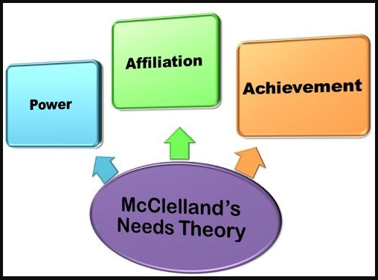
Figure 1: McClelland's Three Needs Theory
(Source: Self-Developed)
The first parameter is the need for power which can enhance the leadership capability inside a person. Whenever the desire of controlling everyone and everything is dominating a person’s personality, the person becomes overconfident to achieve the desired position, but when these desires are lo, that person does not try to achieve success and growth in the future (Rybnicek et al. 2019). Therefore, this should be balanced because a leader must be polite and humble and not dominating.
The second parameter is the need for affiliation which makes a person loyal to the authority and responsible also but remaining aloof and maintaining social distance is not recommended for personal development because it can create a negative impression of yourself to the authority (Rybnicek et al. 2019). Another parameter is the need for achievement which ensures how much a person is desperate for winning. For example, if a person is very desperate to win a deal at any cost then it means, the person is extremely desperate. On the other hand, if a person does not want to win because of failure that means the person is not confident enough and avoids taking responsibility for work. The proper balance of these three parameters makes a person a successful and clever businessman indeed.
Mead's stages of development:
This is the theory which shows the journey of personal development from childhood to adulthood. There are mainly three stages of self-development in this theory in which a person goes through a continuous development process after which the person becomes able to recognise the generalised person (Fath et al. 2020). The first stage is the Imitation stage which is observed between 1.5 years to 2 years of children who try to imitate the verbal and physical behaviour of significant others without any proper understanding. This is the initial stage of any person's growth which leads towards further progress. The second stage is the play stage which is observed in children between 3-4 years old. This is the stage in which a child used to develop a creative world around him or her and tries to be happy in that world.
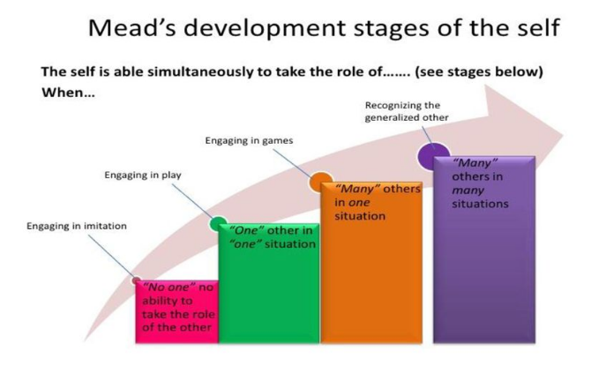
Figure 2: Mead’s Self-Development Stages
(Source: Self-Created)
The first two stages are the most sensitive stages of a person’s personal development in which a child is trying to learn about the world and its tactics to live slowly by creating their power of understanding and adaptability (Fath et al. 2020). The third stage is the game stage which is observed among children who are over 4 or five years. In this stage, a child adapts the capability of playing with their mind and tries slowly to anticipate actions. After this stage, a child becomes capable of acquiring knowledge about the lesson of life and gains experiences from real life. The last stage is known as the Recognition stage in which the child becomes a different person and recognises the strengths and weaknesses of the character slowly.
These are the theories that can help a person or a community with personal development. These theories show how a person can get motivated and through motivation, they can increase their working ability. On the other hand, another theory shows a journey of personal growth and development from childhood after which a person becomes a different one by gaining real-life experiences and becoming able to handle real-life challenges as well.

Conclusion
After analysing the entire report, I find that every person can have some strengths and weaknesses which should be developed if the person will get proper guidance and training. In terms of community development, one person has to be very expressive and straightforward by which he or she can express his or her thoughts clearly to the other communities. Moreover, the person has to be confident enough to take any decisions in life whether it is business or personal life so he or she can become a successful person beating all the obstacles. In order to proceed with this aim, some self-development and motivational theories are suggested to improve a person's personal as well as professional growth. A person who is belonging to a certain community represents the entire community because by improving one person's professional and personal skills, the entire community can be benefited. "McClelland's Three Needs Theory and Mead's development” theory have been taken for guiding a person for the future benefit.

References
Aydiner, A.S., Tatoglu, E., Bayraktar, E. and Zaim, S., 2019. Information system capabilities and firm performance: Opening the black box through decision-making performance and business-process performance. International Journal of Information Management, 47, pp.168-182.
Bednar, P.M. and Welch, C., 2020. Socio-technical perspectives on smart working: Creating meaningful and sustainable systems. Information Systems Frontiers, 22(2), pp.281-298.
Buil, I., Catalán, S. and Martínez, E., 2019. Encouraging intrinsic motivation in management training: The use of business simulation games. The International Journal of Management Education, 17(2), pp.162-171.
Fath, V., Kockmann, N., Otto, J. and Röder, T., 2020. Self-optimising processes and real-time-optimisation of organic syntheses in a microreactor system using Nelder–Mead and design of experiments. Reaction Chemistry & Engineering, 5(7), pp.1281-1299.
Miceli, A., Hagen, B., Riccardi, M.P., Sotti, F. and Settembre-Blundo, D., 2021. Thriving, not just surviving in changing times: How sustainability, agility and digitalization intertwine with organizational resilience. Sustainability, 13(4), p.2052.
Rybnicek, R., Bergner, S. and Gutschelhofer, A., 2019. How individual needs influence motivation effects: a neuroscientific study on McClelland’s need theory. Review of Managerial Science, 13(2), pp.443-482.
Wahyuni, L.M., Masih, I.K. and Rejeki, I.M., 2018. Communication skill attributes needed for vocational education enter the workplace. In Journal of Physics: Conference Series (Vol. 953, No. 1, p. 012111). IOP Publishing.

