+

academic and employability skills
BMSW4001


Omolara Lawal-akintola (1906883)
Lecturer - Lloyd Beharry

Contents
INTRODUCTION 2
SKILLS 2
HARD SKILLS 3
SOFT SKILLS 3
EMPLOYABILITY SKILLS 4
COMMUNICATION 4
TEAMWORK 5
TIME MANAGEMENT 6
S.W.O.T. ANALYSIS 7
JOHARI WINDOW 9
ACADEMIC SKILLS 11
PROFESSIONAL DEVELOPMENT PLAN 12
CONCLUSION 14
References 15
Appendix 16

INTRODUCTION
This structured academic report seeks to evaluate my employability and academic skills. It is a self assessment report, taking into consideration all the present modules being taken, Academic and Employability Skills, Digital and Research Methods, Effective Team Working and Communication and Professional Career Development. Evaluating my Hard and Soft or Transferable skills, will enable me to make an objective assessment of my Employability skills. Transferring the theories learnt so far to one’s present workplace or what I plan to be after the completion of the Higher Education Certificate course, identifying my strengths and noting where improvements are needed. Will my Employability skills fit into the future’s highly digitalized workplace or not?
Presently, we exist in a digitalized working environment which is characterized by constant change. Thus, employers are also moving with the time, they now seek to employ graduates that have the relevant employability skills, to give them a competitive edge within the industry in which they exist.

SKILLS

According to the Chambers Dictionary (2011) a skill is having the aptitudes and competences appropriate for a particular job. That is having expert knowledge. Therefore a skill can be defined as the ability to perform an activity or job functions efficiently and effectively.

HARD SKILLS

Hard skills are taught and can be measured or are easy to quantify. Hard skills are normally a specific set of abilities directly related to the job role that use them (Doyle, 2019). This is because without these specific abilities such jobs cannot be performed, for example a Medical Practitioner or a Pharmacist.

SOFT SKILLS

Soft skills can be identified as the distinguishing qualities of a person that helps in their work behavior, influencing others and in their professional understanding. It is the necessary interpersonal skills, that can be applied to all jobs and the way an individual connects to, participates with and influences other people (Cottrel, 2010). According to Cottrell (2011) the three most demanded soft skills are communication skills, team-working and leadership. There are also time management, problem solving, decision making, interpersonal skills, work ethics, flexibility, to mention a few (Maund, Schriek, & Tinkler, 2017). The soft skills evolve progressively from a persons’ practical experience through the performance of a person’s job and personal daily life, the skills are not restricted to the person’s occupation but can be used in any job description (Lowden, Hall, Ellot, & Lewin, 2011). Soft skills or Transferable skills are abilities that are needed in all types of jobs, they are often difficult to measure, but enables the smooth running of the workplace (Cottrel, 2010).

EMPLOYABILITY SKILLS
Employability skills are the successful group of personal qualities, efforts and understanding that will enable individuals to be gainfully employed and make them successful in their chosen jobs that will be advantageous to themselves, the company, and the society at large (Lowden, Hall, Ellot, & Lewin, 2011). Employability skills refers to the combination of both academic and transferable skills needed to obtain and maintain a job, to succeed within an organizational setting, ultimately adding significant value to self and the organizational long-term objectives (Singh, 2008).

COMMUNICATION

There are some transferable skills that overlap into both academic and the work environment, such as Communication skills. Communication is making information known by speaking, writing or using any other channel. Oxford Dictionary (2nd Edition). It is needed to understand what is being taught, how to write and read information, as well as express what has been or is being communicated both in the academic and workplace. Such as writing, using formal language in academic reports, note taking, gathering information for research purposes via the internet and library resources, all these require effective communication skills in the academic setting, while in the workplace writing of emails, the use of digital media, writing of standard business letters, interpersonal interactions with people require effective communication, which in turn enables a smooth flow of communication.

TEAMWORK

A team is a number of persons who influence each other and work together efficiently and effectively to achieve a common goal. (Daft & Noe, 2001). According to (Maund, Schriek, & Tinkler, 2017) a term is a group of persons who are closely connected, firmly established and rely on one another to achieve specific objectives. Team work is used in both the academic setting as well as in the workplace. Individuals will collectively work together performing their job functions to improve the quality of the service that is being provided, working together towards the same goal (Trought, 2017). In our Digital skills and Research Methods Module we were grouped into teams to do a group presentation. We had to collaborate, collate and coordinate with each other, to ensure that the final presentation had a coherent flow of ideas. Furthermore, as a Care Worker I work in collaboration with my colleagues, Manager, the Administrative Office, Representatives of the Service User, and other professionals as a team to provide the best quality support and care service.

TIME MANAGEMENT

Time Management is an essential factor in a person’s life. Time management is the way a person organizes ones time among the various activities one needs to do, it could be within a day, week, month, or over a long period of time. For instance being punctual as a student or worker is essential, whilst arranging one’s activities as a student or a worker within the required time and meeting deadlines shows time discipline. A person has to organize one’s priorities appropriately, ensuring that the most important activity is attended to first and the next,
subsequently follows. In both academic and the workplace meeting deadlines is essential, as it reflects efficiency and effectiveness in ones performance in assignments or projects. Procrastination causes a lot of stress. In the Care setting time management is essential because we are dealing with vulnerable individuals, who need prompt attention, when providing a service of support and care.

S.W.O.T. ANALYSIS
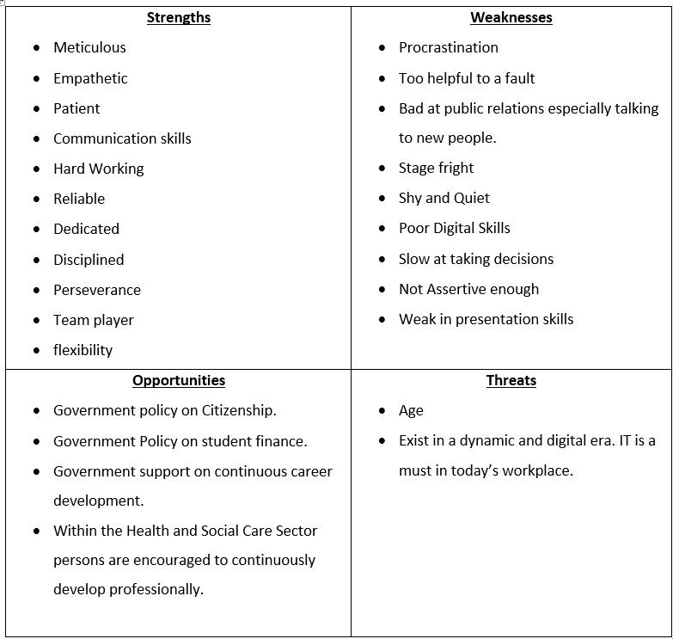
(by Author)
Going through my Professional S.W.O.T. Analysis I think I will be able to use some of my strengths and opportunities to improve some of my weaknesses and my threats, to be able to reduce the effect on my career to the barest minimum. For instance, the opportunities I have are the UK government policies, being able to come back to the university and transitioning my Career to being a Care Worker are great opportunities for me. Government support on student financing, has enabled me to continue my professional career development.
I will harness my strengthens of being an effective communicator, hard worker, dedicated, reliable and persevering, to improve my weaknesses of procrastination, slow at making decisions, poor digital skills and poor presentation skills. I feel all these weaknesses can be improved upon via the various modules being taught at the university, which have various transferrable skills included in their outline. Thus, this will improve my weaknesses and reduce the effect of my threats to the barest minimum.
On completion of the Certificate in Higher Education Skills for the Workplace (Heath and Social Care) I will be able to use my interpersonal skills confidently at the workplace. As a care worker, my focus will be to improve my interpersonal skills because in my career, interpersonal skills are important to provide the best quality care.

JOHARI WINDOW

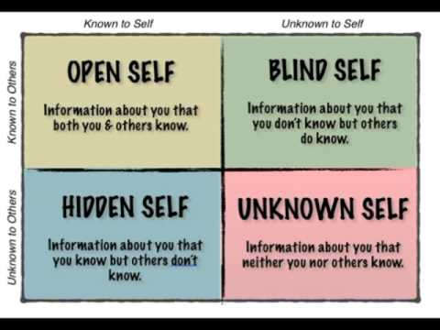
(Google, 2019) 1.2
Johari Window is an academic tool or communication model that helps effective interpersonal communication by the conscious knowledge of one’s own characteristics and comprehension, if executed appropriately it will not only alert managers of the significance of soft skills but will also establish original ideas and enhance collective learning (Saxena, 2015). The Johari Window propagates the
disclosure and constructive feedback of information. It is one’s own knowledge as well as others, about feelings, experience, views, attitudes, skills, intensions, motivation and so on. This is how a person is aware of these attributes, discloses information and receives and gives feedback (Saxena, 2015). As shown in the diagram 1.2 the model is divided into 4 quadrants/areas.
The open area is the focus in the quadrant, the more the disclosure of information in the hidden area by oneself and the more the feedback from the blind area from others, enables the open area to widen both horizontally and vertically. This process identifies areas of usefulness as well as areas of improvement by either oneself or as a team, which enables individuals to be more efficient and effective. This academic model, Johari Window will be useful to me in the care setting, since my immediate goal is to become a Lead Adult Care Worker which will require the supervision of a team. It will enable me to enhance disclosure and deliver constructive feedback of information. This will establish a conducive work environment, where there is a regular flow of information about oneself, team members, the organization and the service users.

ACADEMIC SKILLS

Academic skills or study abilities are also important, they aid employability skills. Study approaches boost our ability to retain and recall information that has been learnt, this could be by experience gained or taught directly. When writing an academic paper like this, literature extracted has to be summarized and paraphrased, while the person has to avoid plagiarism. A person has to give in-text citations, that is referencing or acknowledging the Author of the literature cited. According to the Cambridge Advance Learners Dictionary (4th Edition) Summarizing is to convey the most significant facts or ideas about something or someone in a short and concise manner. It is making a long piece of literature short, but also being comprehensive or detailed. A person must ensure that sentences or phrases reflect an identical meaning of the author’s literature. The author’s literature can be paraphrased by changing the author’s words and rewriting in ones’ own words. This can be done by using Synonyms, changing the word class, or changing the word order that is shuffling the same words. Plagiarism is the use of another person’s idea or part of their work and pretends that it is your own (Cambridge Dictionary, 2013). That is exploiting someone else literature and not acknowledging the person, by behaving as though it is your own piece of work. Summarizing and paraphrasing is essential in both the academic and workplace settings, such as the care setting. To be able to handle vulnerable individuals you must be able to communicate effectively and one of the ways to do this is through active listening which requires summarizing and paraphrasing.

PROFESSIONAL DEVELOPMENT PLAN
According to (Morgan, 2017)) there are two types of Development Plans, these are the Personal and Professional Plans. The Personal Development Plan seeks to improve personal abilities that are of marginal importance to the workplace, while a Professional Development Plan is a detailed proposal that aims to achieve or improve one’s’ abilities that are essential to the workplace. It gives a detailed step by step procedure of what a person wants to improve or achieve, that is ones short and long term goals.
At present I am a Care Worker, and my short-term goal is to become a Lead Adult Care Worker in the next one year, while my long-term goal is to become a qualified Nurse within the next five years.
I have taken the opportunity to come back to the University to acquire a Certificate in Higher Education Skills for the Workplace (Health and Social Care). This will enable me to acquire new and improve my academic and transferable skills that are relevant to the Health and Social Care sector and acquire managerial abilities to elevate my present position. I have observed that I am weak in my Presentation skills, IT skills, Interpersonal relationship skills and Time Management, while my colleagues and course mates observed that I must be more assertive, confident and be less of an introvert.
To improve my digital skills, I have arranged foundation lessons in Word and Excel, so that by the end of my one year course I will be able to work with these programs confidently. For the presentation and interpersonal relations skills, I will put more effort in learning the content of the presentation to be more confident and practice my presenting in the presence of my class mates. The interpersonal relations, I will try to join a professional body as a student member, which will allow me to interact with members in the same related field.
The resources to achieve my short-term goal are in place, the government has supported by providing the student finance, which has allowed me to enroll in the University, while the institution provides student support and the various modules offered that will enable me to acquire relevant academic and employability skills to become a Lead Adult Care Worker within the next one year. While the latter will be a stepping stone towards becoming a qualified Nurse within the next Five years.

CONCLUSION
A graduate requires both academic/hard and employability skills to function effectively and efficiently in the workplace. As a care worker I require both skills to function successfully in the Health and Social Care sector. In the Health sector, soft skills are very important since it is a person-centered, thus as a Care worker, improving my interpersonal skills is my focus. Enrolling in the University to study has given me the opportunity to improve my academic and employability skills. I belief that all the modules to be offered during the course will improve and develop new skills that will make me confident and readily available to become a Lead Adult Care Worker, which will also be a stepping stone to enable me to continuously develop myself to become a qualified Nurse in the next 5 years.

References
Cottrel, S. (2010). Skills for Success, Personal Development and Employability (2nd ed.). New York: Macmillan Publishers Ltd.
Daft, R. L., & Noe, R. A. (2001). Teams and Teamworks. In Organisational Behavior (p. 270). Orlando: Harcourt College Publishers.
Doyle, A. (2019). The Balance Careers . Retrieved December 8th, 2019, from https://www.thebalancecareers.com/hard-skills-vs-soft-skills-2063780
Google. (2019). Google . Retrieved December 23, 2019, from https://i.ytimg.com/vi/MJiw6HMKIwg/hqdefault.jpg
Lowden, K., Hall, S., Ellot, D., & Lewin, J. (2011). Employers' perceptions of the Employability Skills of New Graduates. London: Edge Foundation.
Maund, A., Schriek, M., & Tinkler, P. K. (2017). Introduction to Teams. In B. A. Griffiths, & E. B. Dunham, Certificate in higher Education: Skills for the Workplace Student Yearbook (pp. 5-27). London: SAGE Publications Inc.
Mclntosh, C. (2013). Cambridge Advance Learners Dictionary (4th ed.). UK: Cambridge.
Morgan, P. (2017). Personal Development and Learning. In The Business Student's Guide To Study And Employability (pp. 27-28). London: SAGE PUBLICATIONS lTD.
Saxena, P. (2015). Johari Window: An Effective Model For Improving Interpersonal Communication and Managerial Effectiveness. S I T Journal of Management, v(2), 134 - 146.
Singh, G. S. (2008). Malaysian Employability Skills. UNITAR, 4, 16 -18.
Stevenson, A. (2010). Oxford Dictionary (3rd ed.). Oxford: Oxford University Press.
The Chambers Dictionary. (2011). London: Chambers Harrap Ltd.
Trought, F. (2017). Brilliant Employability Skills (2nd ed.). Great Britain: Pearson Education.

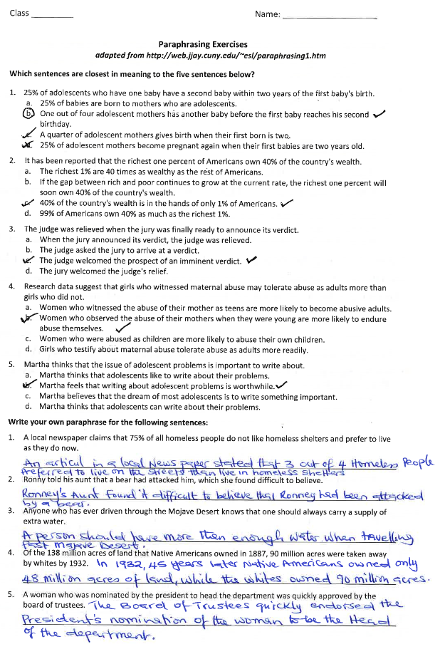
Appendix



