Assessment 1 – Organisational Structure & Culture

Introducing the modern workplace
LCBB4003

Table of Contents
1.0 Introduction 3
2.0. How organisational Structure and cultures can influence the organisational performances 3
3.0 Based on the behavioural approach, how different factors can influence individual behaviour at workplace 7
4.0 Conclusion 9
References List 10

Introduction
Organizational structure and culture are the two dimensions that are considered as important and groundline for the organizations (Meng and Berger, 2019). Organizational structure is the layout that determines the positions in the organizations along with clarity in the job roles. Organizational culture is considered as the work environment in which the employees do perform and behave accordingly with the motivation and other factors as the stimuli. The report will aim to make a discussion on the way the structure and the culture do play a catastrophic role in determining the organizational performance. In the report, another section will highlight the behavioural approach followed by the organization. It will extend to present an in-depth analysis of the way the factors can influence individual behaviour in the workplace. In the report, the main point of discussion will be the organizational factors that can affect the employees and influence their performance with good knowledge of their job roles.

2.0. How organisational Structure and cultures can influence the organisational performances
In the opinion of Dubey et al. (2017), organizational structure and culture are interlinked with organizational performance. It is being discovered that in the 21st century with the presence of digitalization, sustainability has been an important context where the employees are kept as the priority and all possible opportunities are given to them so that they can perform well. Organizational culture is considered as the behaviour that certainly influences the way people react and behaves in an organization that can be both negative and positive. Organizational structure on the way has been considered as the key path to determine the different job roles and the positions in the organization. It is being researched from different scholarly sources and empirical studies that employees having a clear knowledge on the roles to be performed to get the idea of which tasks to be performed and accordingly follow the objectives hence the productivity becomes in line with the organizational goals. On the contrary, Umrani et al. (2018) have made a discussion in the study that organizational culture does shape the behaviours of the employees and builds up an environment where people are willing to perform. With the leaders being friendly and using emotional intelligence to know the problems of the employees, people do feel that they are active members of the organization and thus the willingness generates among them. The organizational structure builds a clear knowledge on the employees to work systematically and ensure that they are meeting the organizational motives and objectives.
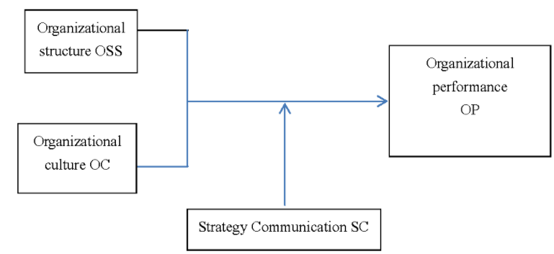
Figure 1: Organizational structure and culture relationship
(Source: Created by the learner)
Considering one of the aspects of the Power Culture, it is stated that employees do refrain from performing since the power sometimes acts in a negative way that deviates the mentality of the people working. Similarly, if the power is centralized but the opinions of the employees are taken, they feel associated with the organizational decisions and inbuild a positive culture. The organizational structure in the opinion of Shahzad et al. (2017), enables the managers, the leaders and the employees as part of the organizational process to foster the attention on human resource needs, financial resources and also to oversee that customer satisfaction goal is achieved. Some of the multinational organizations like Apple Inc or IBM with their organizational structure and positive work culture have created a robust performance that has set true examples of the corporate world. In the research conducted by Felipe et al. (2017), it is pointed that organizational culture does increase the agility of the institution and oversee that quality performance is delivered.
Organizational Structure
Through the framing of the organizational structure in the opinion of Abubakar et al. (2019), an organizational structure with its clear picture helps the management to have informed decision-making and set forth targets for each department to perform on it. Through the framing of the organizational structure in the opinion of Abubakar et al. (2019), an organizational structure with its clear picture helps the management to have informed decision-making and set forth targets for each department to perform on it. The structure within an organization is always framed with the presence of the vision and mission. Considering the example of Tesco Plc as one of the case study organizations in the UK, it has been performing over the year with an organizational structure of hierarchical structure with the different positions segregating the job roles. Due to the large size of the business, it is being often observed that there are chaos and conflicts hence with the structure, the layers can prevent confusion and focus on the customer’s needs.
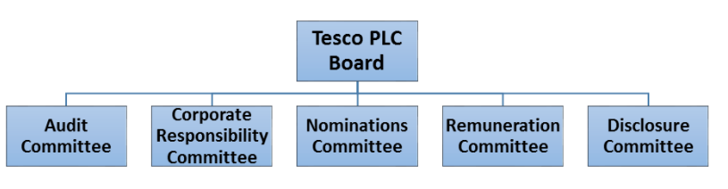
Figure 2: Tesco Organizational structure with the governing bodies
(Source: Created by the learner)
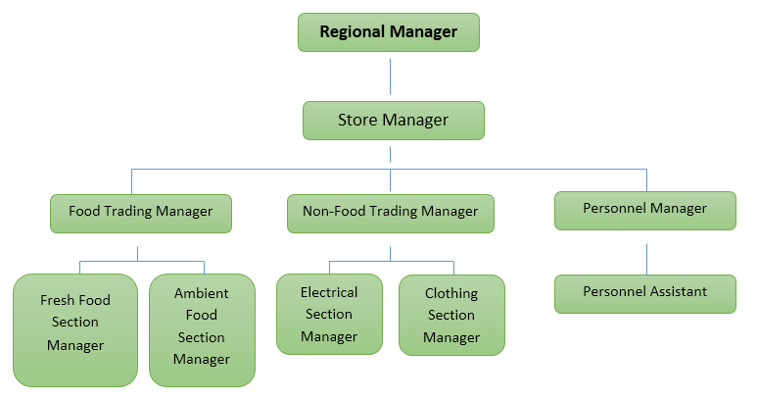
Figure 3: Organizational structure in the store level
(Source: Created by the learner)
Thus, from the figures, it can be evaluated that the organizational structure does have been formed to support the needs of the customers and take care of the employees at the store levels and the main organization. Tesco Plc as one of the largest retailers in the UK has focused on delayering of the management levels so that unity can be maintained and chaos can be avoided. With internal chaos, an organization can never focus on external needs and remain entangled with the chaos and conflicts. With the structure, the performance gets systematic and enables the employees and the management to work together following the channel. Tesco Plc thus had framed an appropriate structure for the outlook focusing on employees, management and customers at the same time.
Organizational Culture
In the opinion of Dubey et al. (2019), organizational culture has highlighted the fact that flexibility is the core need. It is being analysed that with the culture, the mindset and behaviours of the employees are determined. With digitalization as the core need of the contemporary business environment, the culture should be developed in a way that it can foster greater attention on the IT needs. Similarly, in Tesco, there has been an organizational culture of Collaborative culture where employees are being recognized and performances are being credited. Tesco Plc has identified the diverse demands of the customers and this has set forth an example for other organizations (Alam, and Raut-Roy, 2019). With the organizational culture, it has been evidenced that Tesco focuses on leading the change. Therefore, Tesco Plc has built an environment where employees can lay down their issues or even discuss them with the senior management.
Right from giving opportunities for the improvement of the employees to being motivated and having a work-life balance, Tesco has shown the significance of culture and its relation with performance (statista, 2021). The values in the organization are central to the business operations but do not encourage of treatment of employees as slaves that have got the key attention. In odd situations, flexibility is provided to the employees to work from home. Thus, from the research on the organization, Tesco Plc has shown the way culture do have a positive mindset in the employees with the management having smooth governance. Currently, with the strength of 360,000 colleagues, Tesco has truly shown a positive culture that has positively influenced the attitude of the people to deliver a better experience for the shoppers. Psychologically with frustration or conflicts in the mind, employees cannot behave normally with the customers (Warrick, 2017). Tesco mainly has the culture embedded in the below-mentioned points such as
Work with the spirit of a team
Listen, support and appreciate
Have knowledge sharing scope
Trust and respect for everyone

Figure 4: Tesco’s Culture
(Source: Alam, and Raut-Roy, 2019)

Based on the behavioural approach, how different factors can influence individual behaviour at workplace
Different factors influence the behaviours of an individual in the workplace such as the following:
Physical setting: the physical setting indicates the resources being made available to the employees or workflow. With increased workflow, often there are de-motivation among the employees and it is being overseen as a negative factor. Thus, the workflow is always balanced with several paid leaves and compensations to make the environment look flexible.

Organizational Culture: By application of Herzberg Two Factor theory, it is being propounded that two factors motivate the employees as Motivation factors and Hygiene factors (Kotni and Karumuri, 2018). In the motivational factor, the appreciation given by the leaders or the perks and benefits received from the performance in monetary form does influence the behaviour of an individual. On the contrary with the Hygiene factor, it is pointed at the compensation, the health and safety policies along diversity and inclusion practices. The organizational culture becomes organized and healthy with such factors into consideration (Eliyana and Sridadi, 2020). As pointed by Fonseca et al. (2019), it is being highlighted that with the decisions on the different ways to satisfy the employees and give them the space to be heard, the employees do have positive behaviour.
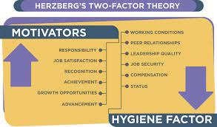
Figure 5: Herzberg Two Factor theory
(Source: Kotni and Karumuri, 2018)
Technology: With technology, the training programs organized by the organization is being highlighted. With different technological programs and training, employees do get interested to be active members of the organization and participate in activities.
Social factors: The characteristics of an individual do influence the behaviours and reactions of other people. Human resource management does for this reason as evidenced from many credible studies have been shown to start with effective recruitment by seeing the background of the individual like having any criminal background or not or have been alleged by any other company or not with experience. In the opinion of Osborne and Hammoud (2017), employees are influenced by the attitudes of other employees that can either lead to a positive or negative outcome. Through the actions of an individual, the behaviour and the performance is shaped or receives a reflection of it.
Thus, from a discussion of all of the factors, it is being determined that all factors do influence the behaviours of the employees. The behaviours from a behavioural approach are depended on some of the external factors that can be managed by the organization. It has been found that organizational culture also has a significant impact on it.

4.0 Conclusion
From the report, a conclusion can be drawn that the culture and structure of the organization are interrelated with the case study of Tesco Plc. Over the years, Tesco has shown the culture of giving importance to the people since they are the main hand behind the production. It is being evidenced that with structure, the decision-making process becomes crucial and effective that gives the reasons for the organizations to develop a structure and bring a change in the culture if needed. In the report, the main focus has also been on the behavioural approach that can influence the way an individual does behave. It can be concluded that organizations either small medium or large size do need to have a proper structure and culture for shaping the organizational performance. Thus, from the elaboration on the performance of Tesco, the organizational performance and its interlinked factors are highlighted that has let the company incurred and earn a good position.

References List
Abubakar, A.M., Elrehail, H., Alatailat, M.A. and Elçi, A., 2019. Knowledge management, decision-making style and organizational performance. Journal of Innovation & Knowledge, 4(2), pp.104-114.
Alam, S. and Raut-Roy, U., 2019. Evaluating the Effectiveness of Reward Strategy at Tesco: Evidence from Selected Stores in the UK. Indian Journal of Industrial Relations, 55(1).
Dubey, R., Gunasekaran, A., Childe, S.J., Papadopoulos, T., Hazen, B., Giannakis, M. and Roubaud, D., 2017. Examining the effect of external pressures and organizational culture on shaping performance measurement systems (PMS) for sustainability benchmarking: Some empirical findings. International Journal of Production Economics, 193, pp.63-76.
Dubey, R., Gunasekaran, A., Childe, S.J., Roubaud, D., Wamba, S.F., Giannakis, M. and Foropon, C., 2019. Big data analytics and organizational culture as complements to swift trust and collaborative performance in the humanitarian supply chain. International Journal of Production Economics, 210, pp.120-136.
Eliyana, A. and Sridadi, A., 2020. Workplace spirituality and job satisfaction toward job performance: The mediation role of workplace deviant behaviour and workplace passion. Management Science Letters, 10(11), pp.2507-2520.
Felipe, C.M., Roldán, J.L. and Leal-Rodríguez, A.L., 2017. Impact of organizational culture values on organizational agility. Sustainability, 9(12), p.2354.
Fonseca, X., Lukosch, S. and Brazier, F., 2019. Social cohesion revisited: a new definition and how to characterize it. Innovation: The European Journal of Social Science Research, 32(2), pp.231-253.
Kotni, V.D.P. and Karumuri, V., 2018. Application of Herzberg two-factor theory model for motivating retail salesforce. IUP Journal of Organizational Behavior, 17(1), pp.24-42.
Meng, J. and Berger, B.K., 2019. The impact of organizational culture and leadership performance on PR professionals’ job satisfaction: Testing the joint mediating effects of engagement and trust. Public Relations Review, 45(1), pp.64-75.
Osborne, S. and Hammoud, M.S., 2017. Effective employee engagement in the workplace. International Journal of Applied Management and Technology, 16(1), p.4.
Shahzad, F., Xiu, G. and Shahbaz, M., 2017. Organizational culture and innovation performance in Pakistan's software industry. Technology in Society, 51, pp.66-73.
statista.com 2021. Topic: Tesco PLC [Online]. Available at: https://www.statista.com/topics/3807/tesco-plc/[Accessed 4 September 2021].
Umrani, W.A., Kura, K.M. and Ahmed, U., 2018. Corporate entrepreneurship and business performance: The moderating role of organizational culture in selected banks in Pakistan. PSU Research Review.
Warrick, D.D., 2017. What leaders need to know about organizational culture. Business Horizons, 60(3), pp.395-404.

