Student ID : 2331050
Student Name : Unnati Vara
Programme : MSc Public Health and Social Care in Practice
Module : Population Health and Digital Health Promotion
Module code : LCHS7007
Supervisor Name : Dr Ping Wu

Table of Contents
- Task 1: Blog 2 entries 2
1.1 Blog 1 2
1.2 References 6
1.3 Blog 2 8
1.4 References 11
2. Task 2 : Poster 12

Task 1: Blog 2 entries

1.1 Blog 1
Artificial intelligence ushered in a new era in addressing mental health problem
Mental health: an alarming public health concerns
In recent times, millions of people around the world have been facing mental health concerns. It affects around 450 million people across the world, making up 12% of various diseases (Persaud, et al., 2018). Some of the prominent instances of mental health disorder include bipolar disorder, depression, and schizophrenia and concern disorders. As per the statistics provided by the World Health Organisation, there is an increase of 26% and 28% hike in anxiety and major depressive disorders in a year. People who are exposed to poverty, disability, inequality are more susceptible to mental disorder (Schofield et al., 2019). One of the major challenges of dealing with this health concern is delayed diagnosis and stigma among the people.

(Source: The Guardian, 2024)

- Role of AI in health promotion and addressing mental health concerns
The application of artificial intelligence (AI) in mental health promotion is many-sided, starting from application and website development to deliver round-the-clock mental health support to the exploration of mental health disorder (Oladimeji et al., 2023). Besides, machine learning has also proved its efficacy to deal with personalised therapeutic needs and tracking realistic data via wearable devices. AI-powered interventions bear the capability of going beyond the domain of clinical areas to wellness incorporations, thereby offering various recommendations regarding mental exercises. Besides, AI has revalorised the mental health disorder diagnostic, ranging from early detection to improved treatment outcome.
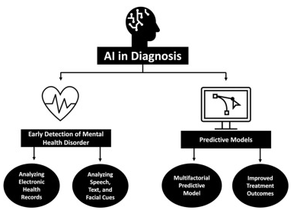
(Source: Olawade et al., 2024)
Artificial intelligence has extraordinary capabilities in terms of decoding the complicated mental health patterns and associations (Olawade et al., 2024). It is also evident that AI integration has reshaped the landscape of mental healthcare while facilitating widespread access to early intervention and tailored treatment. Besides, the 20th century witnessed the emergence of computer-driven cognitive behavioural therapy (CBT) (Blackwell and Heidenreich, 2021). With the integration of AI, mental healthcare has become data-driven, accessible and highly effective.
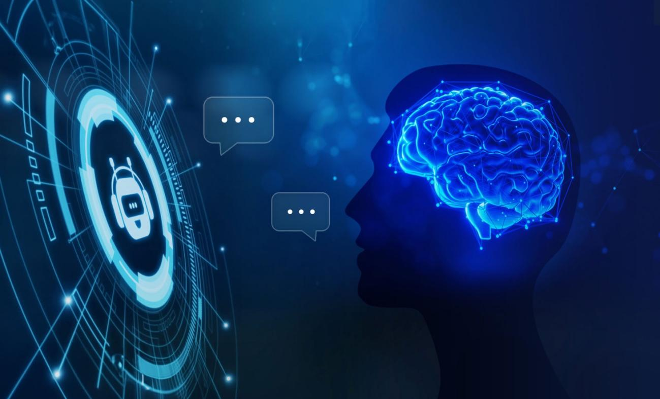
(Source: Trends Research, 2024)
- AI in mental health: merits and demerits:
Advantages:
A major advantage of AI in mental health promotion is that it can facilitate early detection by harnessing predictive models (Olawade et al., 2024). Moreover, it bears the capability of micro-expressions and minute changes in facial expressions that are effective during video consultations via mobile apps.
Disadvantages:
However, some of the major challenges in integrating AI in mental health promotion entail biases, privacy and security concerns (Timmons et al., 2023). Further, lack of guidelines can also spark ethical issues.

What is the solution?
Effective and clear guidelines and codes regarding safety and ethics can go a long way for AI tools to fulfil the expected standards. A strong collaboration between organisations and governments can also ascertain effective use of AI to promote mental health.

1.2 References
- Blackwell, S.E. and Heidenreich, T., (2021). Cognitive behavior therapy at the crossroads. International Journal of Cognitive Therapy, 14(1), pp.1-22.
- Chaudhari, K.S., Dhapkas, M.P. and Kumar, A., (2024). Mental disorders–a serious global concern that needs to address. Int J Pharm Qual Assur, 15(02), pp.973-978.
- Oladimeji, K.E., Nyatela, A., Gumede, S., Dwarka, D. and Lalla-Edward, S.T., 2023. Impact of artificial intelligence (AI) on psychological and mental health promotion: an opinion piece. New Voices in Psychology, 13, pp.12-pages.
- Olawade, D.B., Wada, O.Z., Odetayo, A., David-Olawade, A.C., Asaolu, F. and Eberhardt, J., (2024). Enhancing mental health with Artificial Intelligence: Current trends and future prospects. Journal of medicine, surgery, and public health, p.100099.
- Persaud, A., Day, G., Gupta, S., Ventriglio, A., Ruiz, R., Chumakov, E., Desai, G., Castaldelli-Maia, J., Torales, J., Juan Tolentino, E. and Bhui, K., 2018. Geopolitical factors and mental health I. International journal of social psychiatry, 64(8), pp.778-785.
- Schofield, D., Cunich, M., Shrestha, R., Tanton, R., Veerman, L., Kelly, S. and Passey, M., 2019. Indirect costs of depression and other mental and behavioural disorders for Australia from 2015 to 2030. BJPsych open, 5(3), p.e40.
- The Guardian. 2024. Mental Health Issue among the Young People. Available at: https://www.theguardian.com/commentisfree/2024/mar/04/the-guardian-view-on-young-peoples-mental-health-this-decline-must-be-reversed (Accessed 24th March 2025).
- Timmons, A.C., Duong, J.B., Simo Fiallo, N., Lee, T., Vo, H.P.Q., Ahle, M.W., Comer, J.S., Brewer, L.C., Frazier, S.L. and Chaspari, T., 2023. A call to action on assessing and mitigating bias in artificial intelligence applications for mental health. Perspectives on Psychological Science, 18(5), pp.1062-1096.
- Trends Research. 2024. Smart Therapy Solutions. Available at: https://trendsresearch.org/insight/smart-therapy-solutions-the-rise-of-ai-in-mental-health-care/ (Accessed 24th March 2025).
- WHO. 2024. Fact-sheets. Available at: https://www.who.int/news-room/fact-sheets/detail/mental-disorders (Accessed: 18th March 2025).

1.3 Blog 2
EmotiveAI technology can pave the way for mental health promotion intervention
Addressing a public health concern and why is it a concern?
The prevalence of mental health disorder has remained a serious concern all over the globe. Data published by the World Health Organisation reveals that one out of six people aged from 10 to 19 years encounters mental disorder (WHO, 2024). It is a serious concern because it affects social wellbeing by creating challenges like trauma, extreme poverty and unfavourable social circumstances (Gayapersad et al., 2023).

(Source: CNBC, 2023)
- Designed Digital Technology: EmotiveAI--an advanced AI-guided app for detection and therapy
A cutting-edge digital technology to deal with the growing mental health concerns is EmotiveAI. It is predominantly an unmanned AI-powered app that is convenient to use. It can be run in background and can detect any behavioural or facial expression related changes and signals the user about mental health concerns. It possesses the screening and reporting facility so that one can become aware of present state of mental health. Moreover, based on the severity of the problem, it can deliver tips to overcome mental health issues. Moreover, it can also provide an individual required address of the mental healthcare centres depending on client locations.
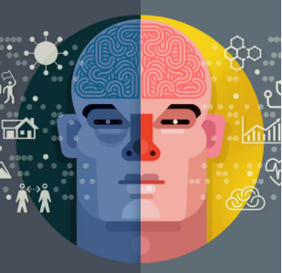
(Source: Deliotte, 2021)
- How EmotiveAI will be used in mental health promotion and addressing public health concerns
EmotiveAI is capable to suggest daily mental exercises and relaxation tips after tracking the behavioural patterns and activities of the client. Moreover, one of the major shortcomings of the mental health therapy is that it necessitates physical visit to a professional (Galea, Merchant and Lurie, 2020). However, AI-driven emotion reading technology can facilitate not only early detection but also arrange virtual therapies. This advanced AI-powered application is also capable to create tailored experience for the users so that they feel more support during virtual therapy sessions. It is also advantageous to break stigma of many people who feel reluctant to seek assistance. The AI-powered app is also capable to make the relatives of the users aware if any extreme or sudden behavioural changes are observed.

(NASSCOM, 2024)
- Impact of the designed technology in health promotion
Advantages:
The EmotiveAI technology can be utilised to detect emotional issues like sadness, anger, stress and anxiety. After learning emotional changes, the app will suggest pertinent techniques for calming mind. Further, the app will facilitate multimodal interaction like text-based conversations, voice recognition, and video for effective communication.
Disadvantages:
Some of the salient challenges associated with the utilisation of the technology entail privacy concerns, biases and dearth of human empathy.
Ways to address shortfalls
Regular monitoring and formulation of transparent polices can be effective in terms of addressing the challenges. A robust security system is also essential for safeguarding patient data and develops trust.

1.4 References
- CNBC. 2023. Mental Health Issue Could be Next Pandemic. Available at: https://www.cnbctv18.com/healthcare/world-mental-health-day-2023-heres-why-mental-health-issue-could-be-the-next-pandemic-especially-for-gen-z-18000061.htm (Accessed: 18th March 2025).
- Deliotte. 2021. Future Behavioural Health. Available at: https://www2.deloitte.com/us/en/insights/industry/health-care/future-of-behavioral-health.html (Accessed: 18th March 2025).
- Galea, S., Merchant, R.M. and Lurie, N., 2020. The mental health consequences of COVID-19 and physical distancing: the need for prevention and early intervention. JAMA internal medicine, 180(6), pp.817-818.
- Gautam, S., Jain, A., Chaudhary, J., Gautam, M., Gaur, M. and Grover, S., (2024). Concept of mental health and mental well-being, it's determinants and coping strategies. Indian journal of psychiatry, 66(Suppl 2), pp.S231-S244.
- Gayapersad, A., Embleton, L., Shah, P., Kiptui, R., Ayuku, D. and Braitstein, P., 2023. Using a sociological conceptualization of stigma to explore the social processes of stigma and discrimination of children in street situations in western Kenya. Child abuse & neglect, 139, p.104803.
- NASSCOM. 2024. AI and Mental Health. Available at: https://community.nasscom.in/communities/healthtech-and-life-sciences/ai-and-mental-health-innovations-diagnosis-and-treatment (Accessed: 18th March 2025).
- WHO. (2024). Fact Sheets. Available at: https://www.who.int/news-room/fact-sheets/detail/adolescent-mental-health (Accessed: 18th March 2025).

Task2 : Poster

