L5000-DATA HANDLING & BUSINESS INTELLIGENCE: DATA ANALYSIS & VISUALISATION

Executive Summary
The report has explained the data analysis and visualisation during working with bulk data sets. In the following concern, advantages to use SPSS software and excel sheets have been outlined. It’s been observed that SPSS is a comparatively challenging tool than Excel. Nonetheless, for using both tools, the user requires skilled talents. Furthermore, in Excel, multiple features such as pivot tables, IF and others, were followed by simplistic data processing. Additionally, in SPSS, users are benefited with the implementation of functions such as mean regression, median for data interpretation and analysis.

Table of Contents
Introduction 4
Part 1: 4
a. Determine the decline in sales or profits over the years 4
b. Evaluate the use of Excel for pre-processing the data, analysing the data and visualising the data 5
c. Demonstrate how you can do this practice with the use of at least two Excel functions such as IF, LOOKUP, PIVOT TABLES 6
Part 2: 9
2.1: How many students like the vanilla flavour of ice cream? 9
2.2: How many students are Male and Female? 10
2.3: What are the Mean and Median of participants who likes chocolate and strawberry flavoured ice cream? 10
2.4: Using the dataset Ice-creams provided in conjunction with SPSS, give a specific example of clustering (ex. K-Means). Show your workings with screenshots and clearly explain your results. 11
2.5: Explain the most common data mining and text mining methods that can be used in business with real-world examples. 13
2.6: Discuss the advantages and disadvantages of using SPSS and Excel using relevant practical examples and present your discussions in table 15
Conclusion 16
References 18

Introduction
Data analysis and visualisation is concerned with the systematic procedure of data representation with the help of graphical structure. Data analysis serves as a fundamental work entailing both skills associated with analysis and calculating (Freeman et al. 2020). Calculating isn’t all, which data analysts require analysing and interpreting the data too. Subsequent to the completion of the analysis, via the data visualisation aspects, the data is updated, supported and created by analysts out of the database. Data analytics is the key procedure to analyse data sets for leading decisions based on the information possessed, increasingly via advanced systems and software. The report shall involve a coherent discussion of the using SPSS excel for data visualisation as well as visualisation.

Part 1:

a. Determine the decline in sales or profits over the years
Referring to the order date of the entire year 2009, from January to December, it has been analysed that the maximum no. of months in the respective year tend to have faced substantial financial losses in the superstore, where the condition has been fluctuated from low, high, medium, critical to not specified. The losses have extended from 400 to over 14000. On the contrary in certain months in 2009 the profits have also extended to around 8000. On 10th March, the loss amount was worth 14140.7. However, on 5th February, 2009, the profit amount was 8734.88. Thus, it could be analysed that as the superstore sales information has highlighted maximum losses and minimum profits, the year has been a loss-making one for the business. On the other hand, the no. losses in all months of the year 2010 have been even more; however, the number of losses has been lower. The maximum number of losses faced in individual months has been around 1000 to 2000. However, the number of profits in some months during 2010 has extended to around 10000. Thus, it could be analysed that losses-amount are being minimised in the year, which reflects improvement in superstore sales.
The same condition is being observed in the year 2011 too, where the maximum number of profits have exceeded to 13340 and the losses; amount have restricted to over 2000, which has been an even better situation for the business concerning the superstore sales in terms of profits as compared to the past year. In the year 2012, the operational sales at the superstore were initiated from the first day of January. Thus, it has been analysed that the number of profits has been extended to around 12000; however, the no. of losses has been in multiple months. On the other hand, the profits have been much lower on a monthly basis in the year 2012. Such condition with minimum level of profits and maximum losses is supposed to take place due to higher incurrence of the costs considering the substantial nos. of order id.

b. Evaluate the use of Excel for pre-processing the data, analysing the data and visualising the data
For commercial causes, enterprises tend to commonly use spreadsheets as well as Ms Excel for analysis of large-scale data. On a primary extent of the excel sheet, key data points are included in every single data cell. Such respective data is likely to indulge exports of the raw data, units, data related to sales, which are left for being sold as well as others. The data is systematically exported to the spreadsheet for easy and better interpretation along with reviews in a place by users. Henderson and Salado, (2021) opined that the key benefit of the excel spreadsheet is that it demonstrates data in the readable proforma for getting a detailed idea of analytical actions undertaken. Furthermore, in consideration with more complicated data sets, excel supports users in customising the relevant fields along with necessary functions so that data analysis and computations become simpler and more precise. Additionally, data segmentation is possible at excel without utilising any further external software.
So as to conduct the data processing, the excel spreadsheet is considered as beneficial in diverse ways. Following are certain key advantages, which are produced by few specific and logical functions built into the excel spreadsheet. Amongst it, the initial one is the IF function, stressed on the verification and identification of condition thereby ensuring the output delivery accordingly (Bishop et al. 2021). There have been 2 key conditions applicable such as false and true. As an instance, there is the data where, available articles are offered amidst ten years (2010-20). Thus, the condition is articles being before the year 2015 shall be regarded as invalid as vice versa whereas those after 2015 year, shall be considered valid. However, in such cases, IF conditioning is implemented for identifying the validity of articles. Additionally, IFERROR is the other function, which is useful in dealing with errors or mistakes in data analysis. Hofer et al. (2021) contended that in Ms Excel spreadsheet, during working with the data analysis, users usually tend to endure common errors, which are #DIV/0!, #VALUE! or #N/A. As an example, division of 1 by zero shall lead users to observe the output at #DIV/0!. On the contrary, the user did that deliberately also in the case, she or he is supposed to utilise IFERROR function for automatically undertaking any formula thereby fostering delivery of an outcome, like -1000. On the other hand, the LEFT function is supportive in returning ‘n’ characters out of the data set. As an example, if someone desires for the extraction of the initial 3 characters from the left, the formula is going to be =LEFT ("Excel",3). In addition, the FIND function is available for helping users in controlling the beginning point. Moreover, ISNUMBER is the key function, which is developed for ensuring that input returns TRUE, in case it’s a number or it shall be FALSE. There are certain other functions, which have developed the hassle-free nature and accuracy at the excel sheet.

c. Demonstrate how you can do this practice with the use of at least two Excel functions such as IF, LOOKUP, PIVOT TABLES
The Excel functions selected for the discussion are PIVOT TABLES and IF.
ESTIMATED BUDGET | ACTUAL BUDGET | STATUS
$800.00 | $921.58 | Over Budget
$375.00 | $324.98 | Within Budget
$150.00 | $128.43 | Within Budget
$150.00 | $174.38 | Over Budget
Table 1: IF function
(Source: Self-created)
IF function: Zhou, (2020) stated that the IF function in the Excel Spreadsheet is regarded as one of the most productive characteristics to pre-process and structure data in a methodological manner. In such a manner, the user could have a coherent contrast amidst the standard outcome and the existing value. The outcome yielded from IF function, comprises binary results, often considered as false or true. As an outcome, IF feature supports mathematic-based decision-making across the spreadsheet. It assists the user in testing a provided condition for checking its accuracy. Utilising the formula, a set of instructions and without understanding it, one could not run the function. There is a flow of key steps for consideration while running the feature. As per the table mentioned above, an understandable data sorting has been utilising the IF function. The table comprises 2 kinds of data such as actual and estimated budget. Thus, it is necessary to figure out relevant budget status i.e., either within or over budget. The IF function’s formula is IF(B2>A2,"Over Budget", "Within Budget"). If B2 i.e., actual budget is lower than A2 i.e. estimated budget, the status shall be within the budget. However, the initial condition was IF B2 (Actual Budget) is more than A2 i.e., estimated Budget; thus, shall be over budget.
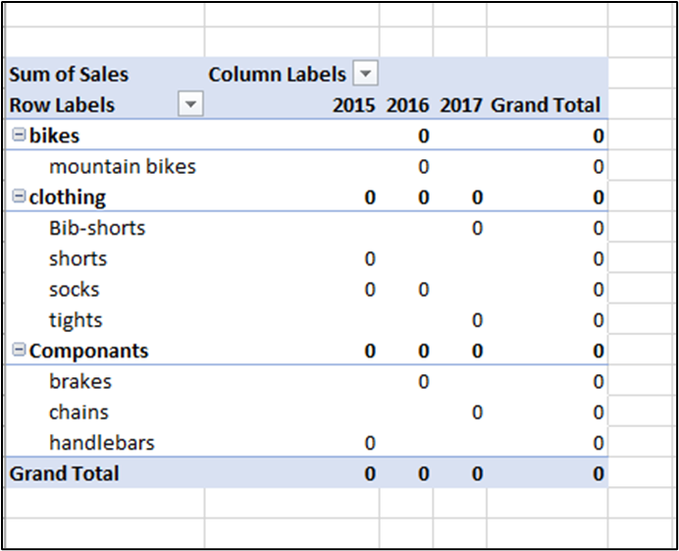
Figure 1: PIVOT table
(Source: Self-created)
PIVOT TABLES: The pivot table is regarded as the statistics technique, which tends to summarise and restructure selected rows as well as columns selected in the spreadsheet or the database table for obtaining the desired report. The tool doesn’t actually modify the spreadsheet itself. However, it simply turns or ‘pivots’ the data for viewing it from diverse perspectives. It is helpful in the interpretation of a specified kind of trends and patterns indulged in the data. It is commonly used to pass information thereby rapidly responding to business queries. Becker and Gould, (2019) opined that it might be inappropriate to note that Pivot tables shall demonstrate graphs or charts. As the name reflects, the table is sufficient for visual story-telling. It comprises data fields, pages, rows and columns. Such tables reflect user-friendliness and could yield instant data developing ease in the data analysis process. Thus, users could simply summarise the data by segmenting them in the spreadsheet. Via excel spreadsheets, accurate reports could be generated. Following are key stages for doing pivot tables. Initially, the table is formulated with diverse data entry- rating, sales, product, category and year. Tsou, (2019) contended that data must be put to appropriate columns and rows. The instruction shall include selection of data cells and insertion of pivot data tables. There shall be an alternative for suggested Pivot tables where existing or new worksheet is selected. The requirement for dragging targeted segments for getting the ultimate pivot table.

Part 2:

2.1: How many students like the vanilla flavour of ice cream?
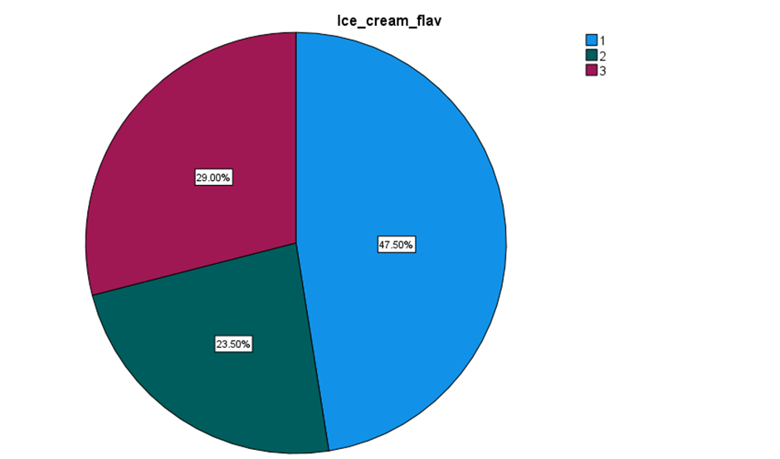
Figure 2: No. of students liking the vanilla ice cream flavour
(Source: Self-created)
Referring to the SPSS analysis, observation has been made that students’ proportion preferring strawberry ice cream (47.50%) are more than those preferring chocolate (23.50%) and vanilla (29%). Therefore, it has been identified that preference for strawberry flavour amongst students has been the most where least no. of students have likings for chocolate.

2.2: How many students are Male and Female?
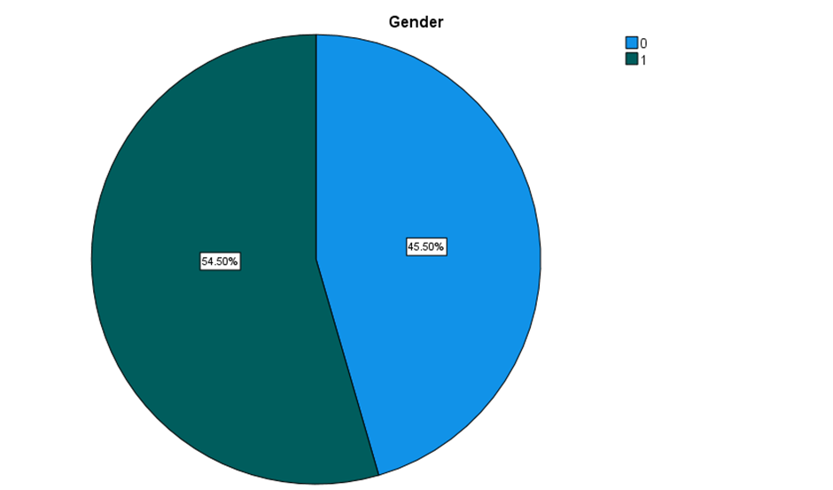
Figure 3: Students’ gender
(Source: Self-created)
In affirmation of the graphical representation made above, interpretation has been made based on the Ice Cream data set, where around 45.50% of participants are male; however, 54.5% respondents are female. Thus, the analysis shall be undertaken critically, based on the female perspective. Moreover, it has been interpreted that female have more ice cream than males.

2.3: What are the Mean and Median of participants who likes chocolate and strawberry flavoured ice cream?
Total respondents | 105
Mean | 0.580952 | Half of the people like strawberry ice cream and chocolate.
Median | 1 | All females are liking strawberry ice-cream and chocolate
Table 2: Participants’ Mean and Median, liking strawberry and chocolate flavour ice cream
(Source: Self-created)

2.4: Using the dataset Ice-creams provided in conjunction with SPSS, give a specific example of clustering (ex. K-Means). Show your workings with screenshots and clearly explain your results.
Centers of Initial Cluster
 | Cluster
 | 1 | 2
Gender | 0 | 1

Iteration Historyª
Iteration | Change in Cluster Centers
Iteration | 1 | 2
1 | .000 | .000
a. Convergence achieved for the relevance of small change or no changes in cluster centres. Coordinate change in the maximum absolute rate for any center is .000. The count of current iteration is evaluated as 1. The min. distance is conferred as 1.000 between the initial centeres.

Final Cluster Centers
 | Cluster
 | 1 | 2
Gender | 0 | 1

Number of Cases in each Cluster
Cluster | 1 | 91.000
Cluster | 2 | 109.000
Valid |  | 200.000
Missing |  | .000

Table 3: Clustering for Ice cream data sets
Source: (Self-created)

2.5: Explain the most common data mining and text mining methods that can be used in business with real-world examples.
Several relevant data mining methods that are used by the organisations are-
1. Data classification theorem of Bayes: Bayes Theorem is applicable for classifying the information with a prediction of the probability statistics. Bayes Classification theory is effective for the process of decision-making through prior probability and posterior probability. According to Berrar (2018), Bayes Theorem is the fundamental theory to infer statistics and the models of ‘advanced machine learning’. Bayesian Statistics is helpful in providing mathematically rigorous but still concise information. With the process of this theory, one and only one of the results from various possible outcomes is derived. A data analyst can evaluate the probability of data set A on the basis of B set that is denoted by P(A|B). Evaluating the data from P(A|B), the data analyst can ascertain the information about P(B|A).
Bayes theorem can be conferred by a real-life example of the rainfall probability when the cloudy condition occurs.
P(Rain | Cloud), this value tells that the rain could be happened today
For 60% cases, most cloudy weather gives the result of rainfall,
Hence, the rainfall’s probability is “P (Cloud | Rain) = P(E|H)” where Evidence is denoted as “E” and E is compared as cloudiness
75% of the total days in a rainy month remain cloudy and hence, the probability of P(cloud) is 75%.
In 15 out of 30days rainfall occurs, that means the probability of rainfall is P(Rain) which is = 15 divided by 30 = 50% or 0.5. Hence, the final calculation of the rainfall probability is evaluated in the following.
“P(Rain | Cloud) = (P(Cloud | Rain) * P(Rain)) / (P(Cloud))”
= “(0.6 * 0.5) / (0.75)”
= 0.4 or in percentage it is 40%.
2. Decision tree analysis: It is referred to as the analysis method that visually outlines the costs, potential outcomes and the consequences of ‘a complex decision’. It plays as an effective tool to make decisions by quantifying and analysing some sort of information. According to Hamoud et al. (2018), data mining can be effectively performed by the algorithms of decision trees. In the opinion of the authors, J148 tree algorithm was stated as the best algorithm rather than the performance of RepTree and Random Tree algorithm.
Besides of data-mining methods, relevant text-mining methods used by the organisations have been illustrated below:
a. Clustering and classification: It is also a mutual method for the pattern identification of the machine learning programme. Only difference between the two processes is that the classification only uses the classes that are predefined whereas the clustering identifies the similarities of the objects. Clustering is used by the organisations to create a map of customer journey and apply customer segmentation whereas supervised learning is underlined in the classification process. According to Chamroukhi and Nguyen (2019), complexity in data analysis is the central topic due to the improvement in the prevalence of high-dimensional data. The knowledge can be discerned by the clustering techniques whereas the future data can be predicted by classification techniques.
b. Retrieval and information extraction (IE): It is the mutual method to arrange the overall information concisely. IE is the task taken by the text-miner to extract the structured information automatically with the help of variant software like Fivetran, Ephesoft and Hevo Data. The meaning of Retrieval is to get back and IR is approved by the text-miner to find relevant material from unstructured text for further analysis of the information. As opined by Waltl et al. (2018), information extraction can be categorised into the two phases that are machine-learning based and knowledge-based. Total 5 areas are covered for the analysis of information extraction that are ‘creation and induction of rules’, ‘evaluation and testing of rules’, ‘frameworks for the ruling in the management and application of large document corpora’ and ‘domain specific languages.
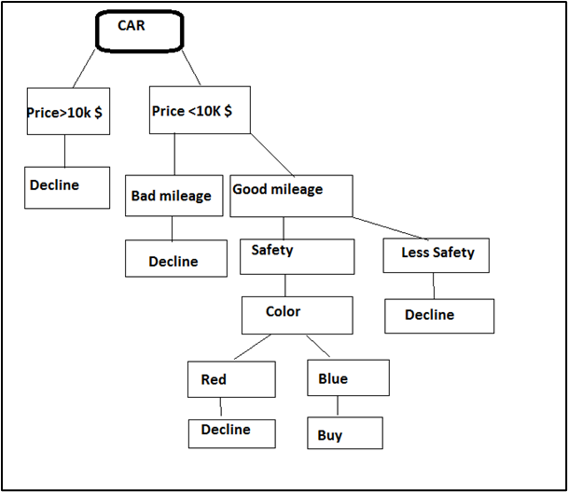
Figure 4: Decision tree analysis
(Source: Self-developed)

2.6: Discuss the advantages and disadvantages of using SPSS and Excel using relevant practical examples and present your discussions in table
SPSS: SPSS is conferred as the software consisting of statistical packages that are used for statistical data analysis in depth for gathering quantitative data.
ADVANTAGES | DISADVANTAGES
- Using the facilities of data transformation data format can be transformed into the progression methods. | - The cost of purchasing SPSS software is a bit high compared to other software like Microsoft Excel.
- SPSS is useful for analysing both qualitative and quantitative data. | 2. The prime limitation of SPSS is that it is not capable of analysing very large data sets. The data analyst in that case uses SAS instead of SPSS.
- Since for the dynamic characteristics, SPSS has the greater efficiency while calculating graphs and tables. | 3. Much proper skill and training is required to handle the simultaneous features of SPSS.
- According to Mishra et al. (2019), SPSS is described as a faster analytical tool for containing text analysis, modeller programming and statistical programming.
Table 4: Advantages and Disadvantages of SPSS software
(Source: Inspired by Okagbue et al., 2021)
Excel: Microsoft Excel is a well-known statistical tool that helps the users in inputting several information and presenting the findings through several tables and charts.
ADVANTAGES | DISADVANTAGES
- In-built formulas in Excel help the user to calculate the large amount of information precisely and accurately. | - MS Excel has the lack of information about who edited the spreadsheet last.
- Free templates consist of the taskbar of Excel that helps in representing the evaluated data in a concise way. | 2. The absence of Quick autofill gives the beginners in handling the data analysis.
- The organisation can print the financial report through MS Excel. | 3. The beginners have to learn about every function that consists of MS Excel.
- Document of MS Excel can be protected through password. | 4. Error calculation in Excel sheet is another limitation as the outcome can also be misplaced.
Table 5: Advantages and Disadvantages of MS Excel
(Source: Inspired by Demir et al., 2018)

Conclusion
Affirming to the aforementioned discussion, it has been concluded that data analysis supports in organising and structuring data gathered. However, data visualisation assists in putting data into the graphical order via diagrams and charts. It is undertaken for magnetising readers’ interest and becomes simple for explanation and interpretation of data via pictures. SPSS and Ms Excel are some of key analytical tools, utilised for years by analysts. SPSS is a relatively high-end data analysis software, which supports in organising substantial chunk information sets and analysing them. However, in Excel part 1 sheet, there has been a key analysis for the decline in the sales over years. However, while undertaking the report’s part 2, the overall procedure of data sorting, analysing median and mean thereby clustering was undertaken. As a result, accomplishing the assessment produces a key insight of successful data analysis along with visualisation.

References
Becker, L.T. and Gould, E.M., 2019. Microsoft power BI: extending excel to manipulate, analyze, and visualize diverse data. Serials Review, 45(3), pp.184-188.
Berrar, D., 2018. Bayes’ theorem and naive Bayes classifier. Encyclopedia of Bioinformatics and Computational Biology: ABC of Bioinformatics, 403.
Bishop, C., Lake, J., Loturco, I., Papadopoulos, K., Turner, A. and Read, P., 2021. Interlimb asymmetries: The need for an individual approach to data analysis. The Journal of Strength & Conditioning Research, 35(3), pp.695-701.
Chamroukhi, F. and Nguyen, H.D., 2019. Model‐based clustering and classification of functional data. Wiley Interdisciplinary Reviews: Data Mining and Knowledge Discovery, 9(4), p.e1298.
Demir, S., Duman, S., Manav Demir, N., Karadeniz, A. and Lubura, E., 2018. An MS excel add‐in for teaching hydraulics of pipe flow in engineering curricula. Computer Applications in Engineering Education, 26(3), pp.449-459.
Freeman, T.C., Horsewell, S., Patir, A., Harling-Lee, J., Regan, T., Shih, B.B., Prendergast, J., Hume, D.A. and Angus, T., 2020. Graphia: A platform for the graph-based visualisation and analysis of complex data. bioRxiv.
Hamoud, A., Hashim, A.S. and Awadh, W.A., 2018. Predicting student performance in higher education institutions using decision tree analysis. International Journal of Interactive Multimedia and Artificial Intelligence, 5, pp.26-31.
Henderson, K. and Salado, A., 2021. Value and benefits of model‐based systems engineering (MBSE): Evidence from the literature. Systems Engineering, 24(1), pp.51-66.
Hofer, B., Jannach, D., Koch, P., Schekotihin, K. and Wotawa, F., 2021. Product metrics for spreadsheets—A systematic review. Journal of Systems and Software, 175, p.110910.
Mishra, P., Pandey, C.M., Singh, U., Gupta, A., Sahu, C. and Keshri, A., 2019. Descriptive statistics and normality tests for statistical data. Annals of cardiac anaesthesia, 22(1), p.67.
Okagbue, H.I., Oguntunde, P.E., Obasi, E.C. and Akhmetshin, E.M., 2021. Trends and usage pattern of SPSS and Minitab Software in Scientific research. In Journal of Physics: Conference Series (Vol. 1734, No. 1, p. 012017). IOP Publishing.
Tsou, M.C., 2019. Big data analysis of port state control ship detention database. Journal of Marine Engineering & Technology, 18(3), pp.113-121.
Waltl, B., Bonczek, G. and Matthes, F., 2018. Rule-based information extraction: Advantages, limitations, and perspectives. Jusletter IT (02 2018), pp.1-2.
Zhou, H., 2020. Excel and Data Mining. In Learn Data Mining Through Excel (pp. 1-19). Apress, Berkeley, CA.

