
APPENDIX GA36b

LEVEL 5 ASSESSMENT SPECIFICATION

Student name: | MAX AARON | Student ID number: | 2014490
Programme: | Built Environment Programmes – Level 5. BSc (Hons) Construction Management; BSc (Hons) Civil Engineering and HND pathways.
Module: | Project Planning
Module code: | ACBA5001 | Contribution to Overall Module Assessment (%): | 60%
Lecturer: | Rhodri Thomas | Internal Verifier: | Dr Deborah Hughes
Assignment Title: | Programmes | Word count (or equivalent): | 2000 or equivalent
Submission deadline: | Week Commencing 4/4/23 | Return date of provisional marks & written feedback: | 25/4/23

A Report Discussing a Site Specific Time, Cost, and Resources Evaluation, and Producing a Gantt Chart and Programme for the Scope of Works with Relevant Method Statements

Written for Rhodri Thomas

Written by Max Aaron

Table of Contents
Introduction 1
Work Breakdown Structure 1
Gantt Chart 2
METHOD STATEMENT 4
Kerbs & Edgings 4
Earthworks 9
Surfacing Works 10
Report – Time, Cost, Resources 12
Time 12
Resources 12
Cost 12
Conclusion 14
References 14

Introduction
This document provides three critical method statements, a gantt chart programme, a detailed work breakdown structure, and site-specific report for time, cost and resources; towards completing highway access for a housing estate in SA1 based on the information that a section 278 agreement has been signed and work will commence on the 6th March 2023.

Work Breakdown Structure
Below is a snapshot of the entirety of the project showing the work breakdown in a detailed structure for all major activities. The projects start date is Monday the 6th March 2023. The scheme is projected to run for a duration of 76 working days (15 weeks and 1 day) and to finish on the 19th of June 2023. I have broken down the work that is required into the following stages; Site Set Up, Pre-Construction, Earthworks Phase 1, Kerbs and Edgings, Earthworks Phase 2, Surfacing Works, and Site Clearance. The work breakdown structure shows predecessors and successors for each individual task, however certain tasks at each stage do have the possibility of starting in different orders depending on lead times of deliveries, weather conditions, and other external factors. Once the site set up has been completed, in the second week of the project trial holes and slip trenches to identify locations of possible buried services will take place. After a suitable number of trial holes are hand dug and services identified, Earthworks Phase 1 can begin. This consists of all excavation work prior to constructing the access road. All plant, materials, and resources are detailed in the snapshot for all the major activities and a further breakdown for this will be discussed later. Once the final task of Earthworks Phase 1 is completed (which can only begin once all other tasks are completed) Kerbs and Edgings can be laid. Earthworks Phase 2 then commences with the final tasks before surfacing works, as gully ironwork and raising formation levels with subbase ready for tar and paving are dependant on the kerb levels. The last stage is all Surfacing Works which includes tar, concrete setts and paving before the last week of Site Clearance.

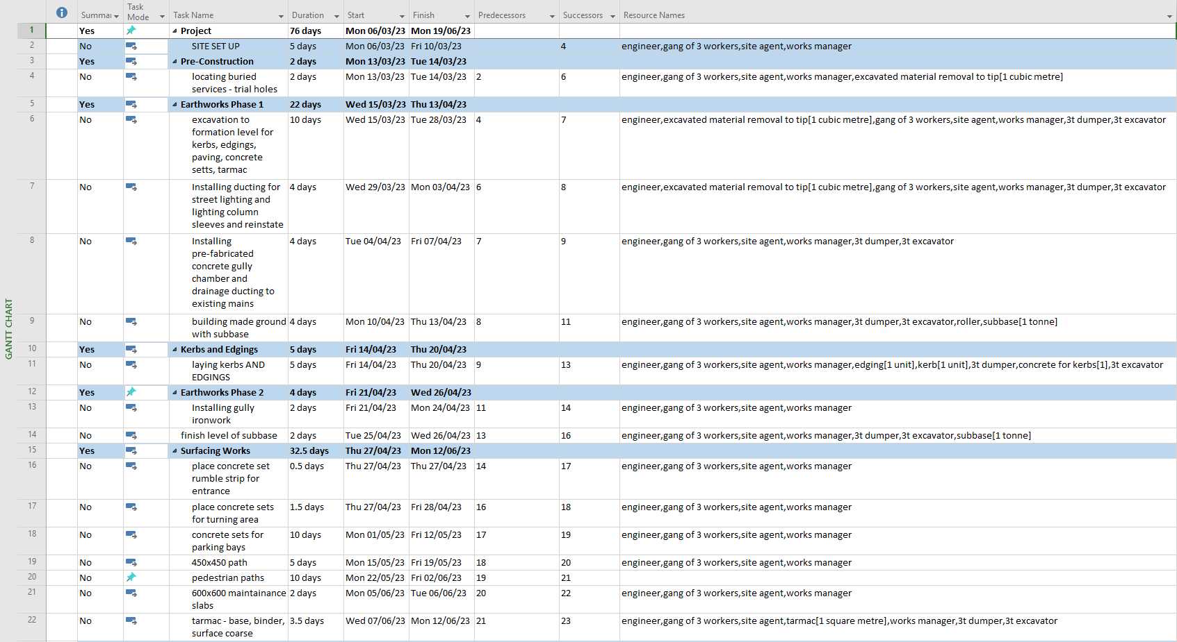
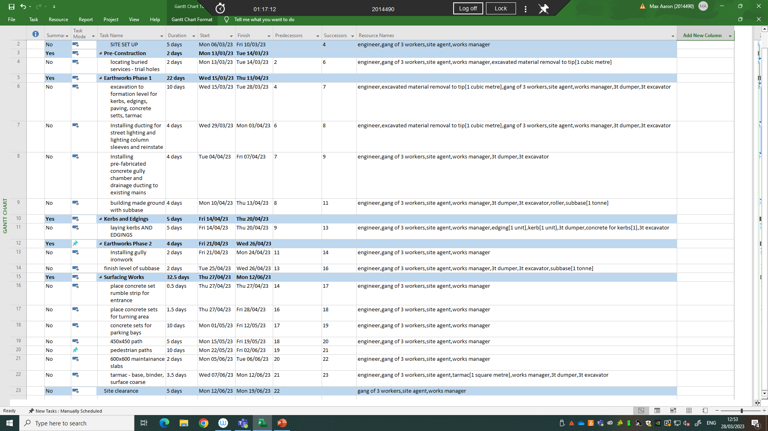

Gantt Chart
Below is the Gantt Chart created from the work breakdown structure for the project.
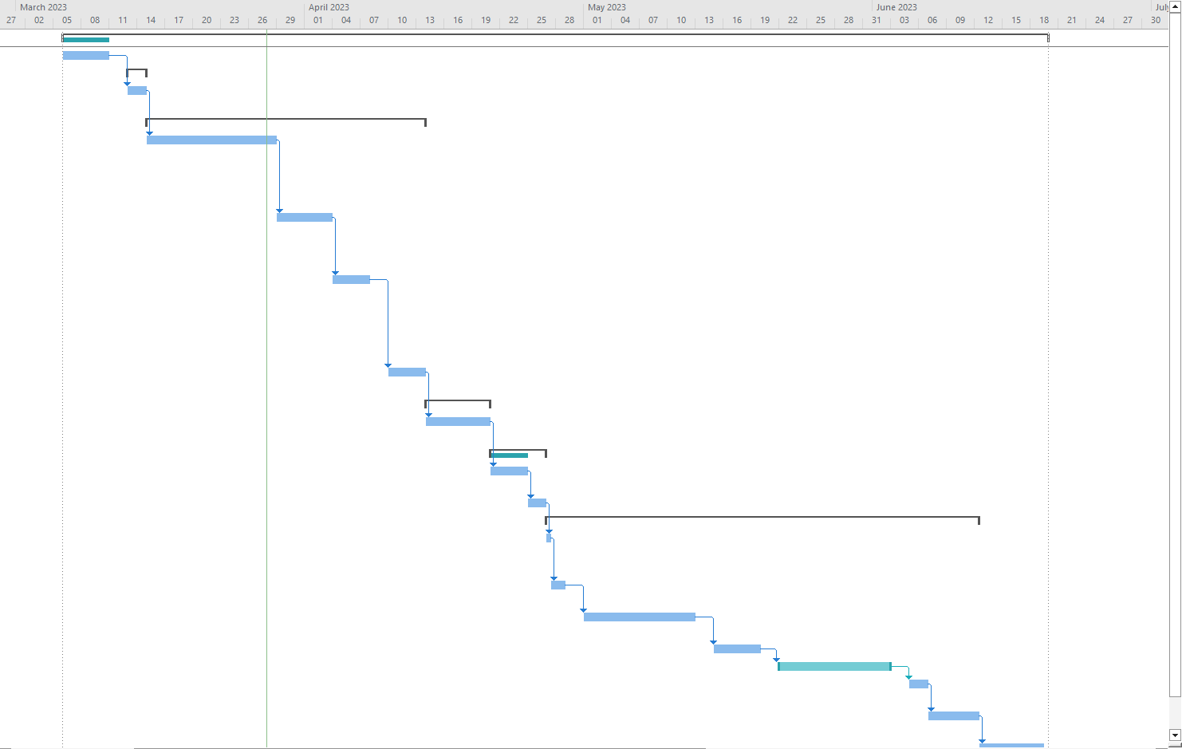

MAX AARON (CONTRACTORS) LIMITED

PLOTS D8 & E1, SA1 Swansea Waterfront

METHOD STATEMENT Rev 0

Kerbs & Edgings
1.0 - Introduction

The purpose of this method statement is to explain the general procedures for the work involved in the preparation for and the installation of Pre-Cast Concrete Kerbs and Edgings

  - – Location

All kerb and edgings work is associated with the PLOTS D8 & E1, SA1 Swansea Waterfront scheme, with the site compound located at Langdon Road.

  - – Programme

The element of works detailed in this Method Statement will be carried out in line with the construction programme submitted.

  - – Constraints

Constraints are;
- Daily Briefings
- Permit to dig in place before any excavation works.
- Existing service locations.
- Suitable Traffic Management and Pedestrian Management in place.
- Lift plans in place to minimize manual handling.

  - – Permits

The following permits must be in place before the work commences: n/a

2.0 Method/Procedure.

Procedure
- The site compound to be segregated by means of heras fencing, and working areas segregated by means of heras fencing or pedestrian barriers
- The transport of materials and plant must be organised to minimise impact on live traffic. Tracked machinery will be delivered to the works area via trailer. Materials will generally be delivered by site pick up. Bulk materials such as wet concrete or asphalt will be delivered by their specific vehicles.
- TM / Pedestrian Management is in place & maintained if required.
- Roadsaw cut to existing surfacing if required. Road saw with water to be used if in Tarmac or Concrete.
- Permit to dig to be issued prior to commencing any excavation works, known services to be marked on site. Hand dug trial holes may be required to positively locate existing services. NO mechanical excavation within 500mm of known services.
- Engineer to be mindful of services when driving kerb pins. Alternative methods may be required if high number of services are known to be present. I.e. Base plates on pins, Deck pins, non-conductive GRP Pins etc.
- Formation to be prepared and compacted prior to placing sub base.
- Sub base to be placed by excavator bucket in layers and compacted with roller or whacker plate to correct levels.
- Banksman to control plant / vehicle movements.

Kerb-laying procedure:
- Kerbs are delivered to location on pickup van, offloaded by excavator or forklift using straps, and stacked out ready to be laid.
- Concrete shall be run out from the delivery wagon, in order to bed the kerbs.
- The concrete bed placed to the required level, high enough to later tamp the kerb in place.
- The Kerbs will be placed using a mechanical lifter attached to an excavator.
- Manual lifting of Kerbs is prohibited.
- Each kerb shall be tapped into the freshly placed concrete and over a suitable length checked for line and level.
- Once correctly placed, each length shall be backed separately with fresh concrete.

Edging kerbs:
- Edgings are delivered to location on pickup van, offloaded by excavator or forklift using straps, and stacked out ready to be laid.
- Concrete shall be run out from the delivery wagon, to bed the edgings in place.
- The concrete bed placed to the required level, high enough to later tamp the edging in place.
- The edgings shall be placed either by mechanical means or placed by hand.
- Each edging shall be tapped into the freshly placed concrete and over a suitable length checked for line and level.

3.0 Equipment

Plant associated with this activity;
- 1 x 3t excavator
- 1 x 6t dumper
- 1 x 80 roller
- CAT 4+ cable avoidance tool
- Traffic Management
- Signage and barriers
- Hand tools
- Compaction equipment
- Hi-ab delivery vehicles

4.0 COSHH

Refer to main COSHH assessment file in site office for daily use materials

5.0 Specific requirements for Risk Assessments – main hazards
- Excavations
- Working area
- Services
- Working at depth
- Use of hand held small tools
- Transportation of materials
- Compaction of fill
- Concrete

6.0 PPE Requirements

The PPE that must be for this activity are as per the site induction listed below
- Hard hat.
- Safety footwear with metatarsal protection
- High visibility clothing. (incl. trousers and long sleeves)
- Safety Glasses
- Gloves

MAX AARON (CONTRACTORS) LIMITED

PLOTS D8 & E1, SA1 Swansea Waterfront

METHOD STATEMENT Rev 0

Earthworks

All of the following are consistent with the Kerbs and Edgings Method Statement;
- Introduction
- Programme
- Constraints
- Permits
- Equipment
- COSHH
- PPE

Method/Procedure
- Set profiles and/or batter rails along area of cut, where necessary.
- It is envisaged to construct the footpath cycleway in manageable sections and not excavate the entire length all at once.
- This will help protect formation levels of the construction remain intact.
- Topsoil strip and store in agreed stockpile areas adjacent to the works for re-use or transport off site if not needed.
- Areas of acceptable material shall be kept separately from any deemed unacceptable.
- Weathering layers shall remain in place to protect the formation, until immediately prior to the geotextile and sub-base placement and drainage construction (see separate method statement).
- Materials to be cut and deposited as efficiently as possible, making sure that the material is protected from the elements.
- Imported fill will be selected in line with the contract requirements.
- Deposited materials to be placed and compacted in suitable layers as per SHW 600 requirements.
- Any material deemed unsuitable will be kept in a separate location for processing or disposal as required.
- The as laid subbase material must be kept free from debris and tracking over the as laid material can only be done so with clean tracked or wheeled vehicles

MAX AARON (CONTRACTORS) LIMITED

PLOTS D8 & E1, SA1 Swansea Waterfront

METHOD STATEMENT Rev 0

Surfacing Works

All of the following are consistent with the Kerbs and Edgings Method Statement;
- Introduction
- Programme
- Constraints
- COSHH
- PPE

Delivery and placing

- Bituminous pavement courses shall be laid using the materials described in the appendix of the contract specification.
- Hot bituminous materials shall be delivered in clean insulated vehicles and remain covered while in transit or awaiting tipping.
- A nominated banksman wearing Orange Hi-Vis will direct the delivery vehicle
- The material shall be spread, levelled and tamped by a self-propelled paving machine fitted with an averaging beam.
- As soon as possible after delivery the material will be supplied to the paver and laid without delay.
- The rate of delivery shall be regulated to ensure continuity of laying.
- The rate of travel of the paver shall be maintained to ensure the material is laid to keep an even, uniform flow across the beam to avoid segregation and dragging of the material.
- The layer thickness shall be in accordance with the recommendations of BS4987 Part 2 as appropriate or normally the full layer thickness (except asphalt sand carpet – BS594).
- Hand laying/raking for adjustment of level shall only be permitted around gullies / manholes, for regulating if required and areas where the paver cannot operate.
- All tie-ins shall be in accordance with the typical details.
- All joints shall be offset by at least 300mm from the parallel joint of the previous layer, with the surface course joint being under the any proposed white line if possible.

Compaction

Compaction shall commence as soon as the laid materials can bear the weight of the roller without undue displacement or cause cracking of the surface and be complete before the material temperature falls below the minimum rolling temperatures. The compaction shall be carried out using an 80 roller or comparable roller.

Principal equipment.

- Delivery Lorries
- Self propelled paver
- 80 roller
- 3t excavator
- 3 tonne
- Wacker Plate
- Disc cutter

Report – Time, Cost, Resources

Time
I have used references and my experience of working in the construction industry for the last 3 years to derive calculated and accurate time scales, resources needed, and costs. I have chosen to use one gang of three workers consisting of an excavator operator, dumper driver, and banksman/groundworker to complete the work. The reason for this is due to small working area and access route into the building site and also considering the other operations going on at the same time such as the building of the housing, however another gang can be introduced if the project falls behind the programme schedule.

In my experience it takes around 1 week for a gang to excavate the formation, and build back up with subbase for a 40 metre section at 5 metres wide using an 8t excavator. Therefore, I would say it is achievable for this project for the ground to be reduced to formation level in a 2 week time frame using a 3t excavator and 3t dumper. I have chosen smaller plant due to the small working areas, lots of moving plant and workers on the ground on the building site, and more versatility in the various tasks.

For laying kerbs and edgings, I have used my experience currently working as an engineer on the Brocastle Active Travel Project in Bridgend, for calculating time against laying and backing them. We are able to achieve 200m of kerbs or edgings laid in 1 day. Therefore, I have allocated a week for this project due to the difficulty of laying radius and further detailing of kerbs and edgings to the various paths around the plots.

Surfacing works can vary dependant on the chosen tarmac and how it is to be laid. Another factor is the tightness of the access road and what size chipper and roller can utilised. From my experience I have allowed for a 3.5 days time frame which allows for 2 and a half days of laying the base and binder, and then a full day of surface coarse.

Resources
Below is a resource sheet I have produced for three major activities of which I produced method statements for.


Cost
I have based hourly rates of the gang, engineer, works manger, and site agent off indeed, linkedin, and my own knowledge and experience (Indeed, 2023).

An average cost for excavation and disposal would be typically £28 per square metre, subbase at £23 per square metre, and tarmac at £60 per square metre (Checkatrade, 2022).
Further research gave wide range of costs for tarmac dependant on type of material being used, if it was for private or commercial use, and more. Based on a road thickness of 450mm and using GSB type 1, one source indicates that the cost for laying tarmac of 20mm base which is 60mm thick and 10mm surface course which is 35mm thick, it would cost between £105-£130 per square metre (Checkatrade, 2022).

Another source averages tarmac between £45 and £60 per square metre (Houghton, 2022). Another source showed the average price of asphalt per square metre (m2)in the UK is between £50 – £80 depending on the layer thickness of the surface area (Hanson, 2023).

Therefore, I went for an average of £50/m^2 for tarmac.

Although above one source gave me £28/m^2 of excavated material I chose an inclusive price of excavated material by machine disposal off site at £155 per cubic metre (Construction Rates, 2023).

Furthermore, an estimate of type 1 subbase at £60 approximately per tonne was used (North West Aggregates, 2023).

The price of concrete would approximately be £100 per cubic metre, varying on the strength of concrete between C7.5P up to C25P and depending on the specification (Job Prices, 2023).

For kerbs and edgings I used a local supplier to the South West Wales region and approximated HB2 kerbs being £14/unit using Marshalls British Standard Half Battered Concrete Kerb 125mm x 255mm x 915mm - Pack of 16 £226.24 ex VAT (Travis Perkins, 2023).

Similarly for flat top path edgings EF 50mm x 150mm x 915mm 576 is £6.73 exc VAT per edging (Travis Perkins, 2023).
And Bs Eaton EF Flat Top Path Edge 50 x 150 x 915mm is £3.86 exc VAT per edging (Travis Perkins, 2023). So edgings were averaged at approximately £5 per edging.

For plant hire per week I have approximated the 3t excavator at £325 (Tool Hire Centre, 2023), the 3t dumper at £200 (Tool Hire Centre, 2023), and the 80cm Tandem Roller at £120 (Tool Hire Centre, 2023).

Below is a cost breakdown for the projects run-time which includes the hourly rate of the gang, engineer, supervisor and managers, and plant hire. It also includes 1 unit of measurement for each material that is used per task however an estimate for total quantity of the materials required isn’t achievable at this stage without a specification, drawings, or setting out data.


Conclusion
This report has detailed the work required in conjunction with the resources needed to complete the access road for the SA1 housing development in a sufficient and accurate time frame, where more workforce can be implemented if shorter project duration is necessary.

References
Checkatrade, 2022. Road Construction Cost Guide. [Online]
Available at: https://www.checkatrade.com/blog/cost-guides/road-construction-cost/
Checkatrade, 2022. Tarmac Driveway Cost Guidelines. [Online]
Available at: https://www.checkatrade.com/blog/cost-guides/tarmac-driveway-cost/
Construction Rates, 2023. BULK EXCAVATION AND FILLING RATES PER M2 M3 M. [Online]
Available at: http://www.constructionrates.co.uk/Rate_Gen/Bulk.Excavation@constructionrates.co.uk.html
Hanson, 2023. Asphalt Calculator. [Online]
Available at: https://www.hanson.co.uk/en/tools/asphalt-calculator
Houghton, Z., 2022. Tar Driveway Cost - UK Prices for 2022. [Online]
Available at: https://loftera.co.uk/blog/tar-driveway-cost/
Indeed, 2023. Construction Jobs in Wales. [Online]
Available at: https://uk.indeed.com/jobs?q=construction&l=wales&vjk=68eadeee37cb03b2
Job Prices, 2023. Concrete Prices. [Online]
Available at: https://job-prices.co.uk/concrete-prices/
North West Aggregates, 2023. Building Aggregates. [Online]
Available at: https://www.northwestaggregates.com/mot-type-1-sub-base-hardcore-bulk-bag-145-p.asp
Tool Hire Centre, 2023. Dumpers. [Online]
Available at: https://www.toolhirecentre.co.uk/dumpers
Tool Hire Centre, 2023. Excavators. [Online]
Available at: https://www.toolhirecentre.co.uk/excavators
Tool Hire Centre, 2023. Rollers. [Online]
Available at: https://www.toolhirecentre.co.uk/rollers
Travis Perkins, 2023. Bs Eaton EF Flat Top Path Edge 50 x 150 x 915mm. [Online]
Available at: https://www.travisperkins.co.uk/bs-eaton-ef-flat-top-path-edge-50-x-150-x-915mm/p/849180
Travis Perkins, 2023. Marshalls British Standard Half Battered Concrete Kerb 125mm x 255mm x 915mm - Pack of 16. [Online]
Available at: https://www.travisperkins.co.uk/kerbs/marshalls-british-standard-half-battered-concrete-kerb-125mm-x-255mm-x-915mm-pack-of-16/p/753046
Travis Perkins, 2023. Travis Perkins Concrete Flat Top Path Edging EF 50mm x 150mm x 915mm 576. [Online]
Available at: https://www.travisperkins.co.uk/edgings-copings-and-caps/travis-perkins-concrete-flat-top-path-edging-ef-50mm-x-150mm-x-915mm-576/p/805282

Student FEEDBACK FORM

Generic Assessment Criteria | Marks available | Marks  awarded
1. Engagement with Literature Skills  . | 10
2. Knowledge and Understanding Skills | 30
3. Cognitive and Intellectual Skills | 20
4. Practical Application Skills | 30
5. Transferable Skills for Life and Professional Practice | 10

Assessment Mark (Assessment marks are subject to ratification at the Exam Board. These comments and marks are to give feedback on module work and are for guidance only until they are confirmed. ) | Late Submission Penalties (tick if appropriate) |  | %
 | Up to 1 week late (40% Max) |  | %
 | Over 1 week late (0%) |  | %

