

Student name: Karen Cabey

Student ID: 2508282

Module name: Introduction to Health and Social Care
Module code: LCHS-4003
Lecturer name DR. Jolly Nwankwo
COMMUNITY ANTENATAL & MIDWIFERY SERVICES

Student Name, Course Name, Email Details Go Here

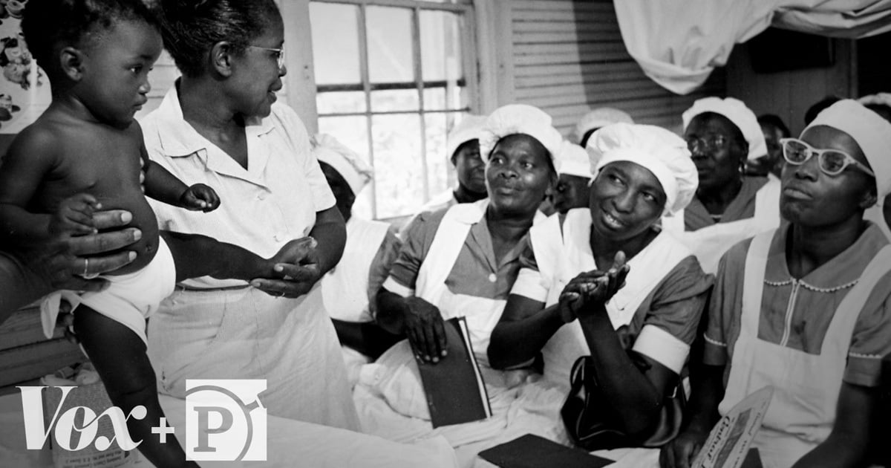
IMPORTANT DATES
(NHS,2026)
- 1902 Midwives Act introduced in the UK

- 1905 Central Midwives Board established

- 1948 NHS created, maternity services expanded to include regulations

- 1950’s to 2026 A Degree level of education required for UK midwives and an increase focus on women centred care

WHERE WE BEGAN (RCM,2002)
Midwifery is one of the world’s oldest professions. Midwives have supported women during pregnancy, childbirth and postnatal period for many years. Evidence of midwives date back to ancient civilizations such as Ancient Greece, Rome and Egypt.
In this time childbirth was assisted by women whose knowledge stemmed from experience which was derived from watching and learning hands on from the women who were doing it at that time. Most births took place at home and the women who assisted were very highly respected.

a
(NHS,2026)

Community antenatal and midwifery services play a vital role in supporting women and families. However, there are challenges which are still faced to date. It is important to remember that a strong workforce is essential for safe, high-quality care. Addressing inequalities is key to achieving safer and fairer services for all women who needs the service. For this reason, the NHS has devised a three-year plan for improving maternity and neonatal services which would reduce inequalities in maternity care and improve postnatal support. This would ensure equitable access remain an important priority. Particularly for woman from ethnic minority and socially disadvantaged groups. Continued investment in community midwifery and continuity-of -care models is essential to improve safety, patient experience and health outcomes. (Rayment, 2020)

Inequalities in Access, Experience and
Outcomes (WHO, 2019): (Rayment, 2020)
TECHNOLOGICAL ADVANCEMENTS
(WHO, 2023); (NHS. 2025)
The introduction of technology has improved the care given within the community.

- Electronic patient records which is accessible wherever it may be needed to be accessed

- Digital appointments and online information, resources and increase access to care materials.

- Mobile Health Applications which can include, foetal movement monitors and the NHS app which has links to other maternity specific apps such as badger notes (NHS, 2026; Kettering general hospital foundation trust, 2025).

- Postnatal digital support and monitoring can improve maternal and newborn wellbeing (world health organization, 2022)

- Telehealth and virtual appointments are also offered which offers healthcare advise from home, which means less travel time.
Improved access for women living in rural areas.

- Modern laboratory testing services available which can identify various blood disorders such as HIV infection, gestational diabetes, blood group incompatibilities and genetic disorders.


Key Issue | Explanation
Variation by ethnicity and socioeconomic status | Women’s experiences and outcomes differ significantly depending on ethnicity, income level and social disadvantage.
Inconsistent access to essential care | Many women face gaps in continuity of care, limited mental-health support and inadequate postnatal services.
Practical barriers to accessing services | Digital exclusion, lack of transport and childcare responsibilities make attending appointments difficult.
Influence of cultural and religious factors | Cultural practices and religious beliefs shape how women seek help, engage with services and perceive mental health.

WORKFORCE PRESSURES
- High demand for services but insufficient midwives
- High workloads can lead to increased stress levels which could cause staff burnout.
- The reliance on agency staff can affect consistency in the care provided
- Increasing vacancies and difficulty recruiting in rural and deprived areas

Community Mental Health Services: Origins, Developments and Impact on Quality of Life in the UK
Community mental health services in the United Kingdom have undergone a profound transformation over the past two centuries, shaped by evolving social attitudes, legislative reforms and advances in psychiatric treatment. Their origins lie in the 19th and early 20th centuries, when individuals experiencing mental health difficulties were placed in large institutional asylums. Although these institutions were initially intended to provide care and protection, they quickly became overcrowded, underfunded and associated with poor living conditions and social isolation (The King’s Fund, 2023). By the mid-20th century, growing awareness of patients’ rights and the development of new psychiatric medications prompted a shift away from long-term institutionalisation. This shift was reinforced by the Mental Health Act 1959, which encouraged treatment within the community and laid the foundation for modern community-based care.
The movement gained further momentum during the 1980s and 1990s with the introduction of the “care in the community” policy, which aimed to support individuals with mental health needs outside hospital settings (NHS, 2026). This policy marked a major turning point, promoting deinstitutionalisation and the development of local services designed to help individuals live independently. Today, community mental health services form a cornerstone of the UK’s health and social care system. Their primary aim is to provide assessment, treatment, rehabilitation and ongoing support for individuals experiencing mental health difficulties, while promoting recovery, autonomy and social inclusion (World Health Organization, 2022).
Modern community mental health services operate through multidisciplinary teams comprising psychologists, mental health nurses, psychiatrists, occupational therapists, social workers and peer support specialists. These teams work collaboratively to deliver person-centred care tailored to the needs of everyone. Recent government reports emphasise the importance of accessible, high-quality and responsive community-based care, noting that demand for mental health support is higher than ever (GOV.UK, 2026). The Health and Social Care Committee highlights ongoing inequalities, variable quality of care and long waiting times, stressing the need for integrated, equitable and lived-experience-led services (UK Parliament, 2025).

Current NHS data illustrates the scale of demand and pressure on services. As of May 2026, 2.36 million people had an open referral with NHS-funded secondary mental health services, including 1.65 million adults and 527,972 children and young people (NHS Digital, 2026). In the same month, 476,278 new referrals were received, and 24,176 people were subject to the Mental Health Act, including 16,619 detained in hospital (NHS Digital, 2026). These figures demonstrate both rising need and the strain placed on community services, contributing to delays in assessment and treatment. Such delays can lead to deterioration in mental health, increased risk of crisis and, in some cases, avoidable hospitalisation.
Despite substantial progress, community mental health services continue to face challenges. Workforce shortages, funding constraints and persistent inequalities—particularly in deprived areas—limit the ability of services to meet rising demand. Government reports acknowledge entrenched inequalities and call for improved integration across NHS, local authorities and voluntary sectors to strengthen community-based care (GOV.UK, 2026; UK Parliament, 2025).
Conclusion
Overall, community mental health services have significantly improved the quality of life for individuals experiencing mental health difficulties by promoting recovery, independence and social inclusion. Their evolution from institutional care to person-centred community support represents a major advancement in mental health provision. However, rising demand, workforce pressures and persistent inequalities highlight the need for sustained investment, improved access pathways and stronger integration across services. Addressing these challenges is essential to ensure that all individuals receive timely, effective and equitable mental-health support.

REFERENCES

Centre for Mental Health (2025) The Big Mental Health Report. Centre for Mental Health.

GOV.UK (2026) Mental health and wellbeing: Government action and priorities. Available at: https://www.gov.uk/ (Accessed: 17 July 2026).

Kendall, T. et al. (2011) “Quality, bias and service user experience in healthcare: 10 years of mental health guidelines at the UK National Collaborating Centre for Mental Health,” International review of psychiatry (Abingdon, England), 23(4), pp. 342–351. Available at: https://doi.org/10.3109/09540261.2011.607432. (accessed 16/07/2026)

NHS Digital (2026) Mental Health Services Monthly Statistics, Performance May 2026. NHS England.

NHS (2026) Care in the Community: Historical Overview. NHS England.

Rayment, J. et al. (2019) “Barriers to women’s access to alongside midwifery units in England,” Midwifery, 77, pp. 78–85. Available at: https://doi.org/10.1016/j.midw.2019.06.010. (Accessed on 5/07/2026)

Royal College of Midwives. (2002). RCM midwives: the official journal of the Royal College of Midwives. McMillan-Scott. (Accessed 02/07/2026)

The King’s Fund (2023) The history of mental health care in the UK. The King’s Fund.

Young, J. (1950). Maternity and the National Health Service. British Medical Journal, 1(4650), 392–396. https://doi.org/10.1136/bmj.1.4650.392 (Accessed 02/07/2026))

UK Parliament (2025) Health and Social Care Committee: Mental Health Services Report. House of Commons.

World Health Organization (2022) Community Mental Health Services: Promoting Person-Centred Care. WHO.

