~Assignment One Conference Research Paper~

~Contemporary Themes in Hotel and Hospitality: AI-Human Collaboration and the Future of Work in Guest Service Operations~

The Module Title: Contemporary Themes in the Hotel and Hospitality Sector BMIH6001
Student Name: Ada Roman
Student ID: 2207421
Module Tutor: Dr Ernest Balutie Wavei
Submission date: 26/05/2025
Worcount: 2750

Basic Acknowledgement format of AI tool use
I acknowledge the use of Grammarly (https://www.grammarly.com/) on 16 May 2025 to check my work using the prompt(s):
1. Please check the following text for readability, grammar and syntax. I confirm that I have not presented any AI-generated text as my own work. I confirm I have copies of my drafts, notes, and other resources I used before, and after the use of AI tools which I may be asked to provide in evidence.

Abstract:
The study examines how artificial intelligence and human collaboration change how hotels and hospitality businesses operate today. Based on a literature review and PEST analysis show that AI-enabled guest service operations are key to a hotel's strategy, not just a possible improvement.AI in the hospitality industry , which was worth $90 million in 2023., is anticipated to experience a 60% annual growth rate and reach $8 billion by 2033, indicating a robust industry commitment to collaborative technologies.
The main findings show that successful implementations are achieved by prioritising improving people rather than simply replacing them. When hotels use collaborative frameworks, they can lower operating costs by 70% and improve digital services by 60%. Still, the PEST analysis points out major difficulties such as meeting regulations, dealing with cultural issues, and integrating technology.
The recommendations highlight a step-by-step rollout, support for all workers and guidelines for ongoing AI governance. The study shows that changing gradually rather than suddenly gives hotels the best chance to compete and maintain important parts of their hospitality service. Those leading in industry should put more emphasis on improving people’s skills than on replacing them through the use of AI.

Introduction
The study examines "The Future of Work: Artificial Intelligence and Human Collaboration in Hotels and Hospitality" as a key theme transforming hotels and hospitality businesses' operations. The theme includes using AI for guest service, teaming up AI and humans in hospitality roles, and changing the workforce. The use of artificial intelligence in hospitality was worth $90 million in 2023 and is expected to grow at 60% every year, reaching $8 billion by 2033 (Schwarz, 2024).
Post-Pandemic Transformation Context
The pandemic led to a faster digital shift, so "AI has become essential for hotels to handle the changes in the market" (Schwarz, 2024). Worker shortages are common, so technology is being used to help.
Strategic Implementation Benefits
The latest implementations show important improvements in how things are done:
- Optimising Costs: Hotels say they have cut their incoming call volume by 70% and improved digital check-ins by 60%.
- Improving Income: 74% of guests are willing to pay more for AI-enhanced experiences (Zheldak, 2024).
Industry Adoption Prevalence
Because AI is being widely adopted, with 60% of hotels and 70% of travel agencies planning its use, the industry is evolving, so it needs careful academic attention (Team, 2024).

Literature Review
The literature review examines the application of AI in guest service operations and the collaboration between humans and machines in contemporary hotels.. This area is important because it links artificial intelligence to the experiences of guests and the workforce. According to Huang and Rust (2022), AI initially assists HI and takes over its function, but AI and HI work best when collaborating. After COVID-19, AI has become more important for hotels, as studies show it helps them adjust to the latest market conditions.

Current State of AI Implementation in Guest Services
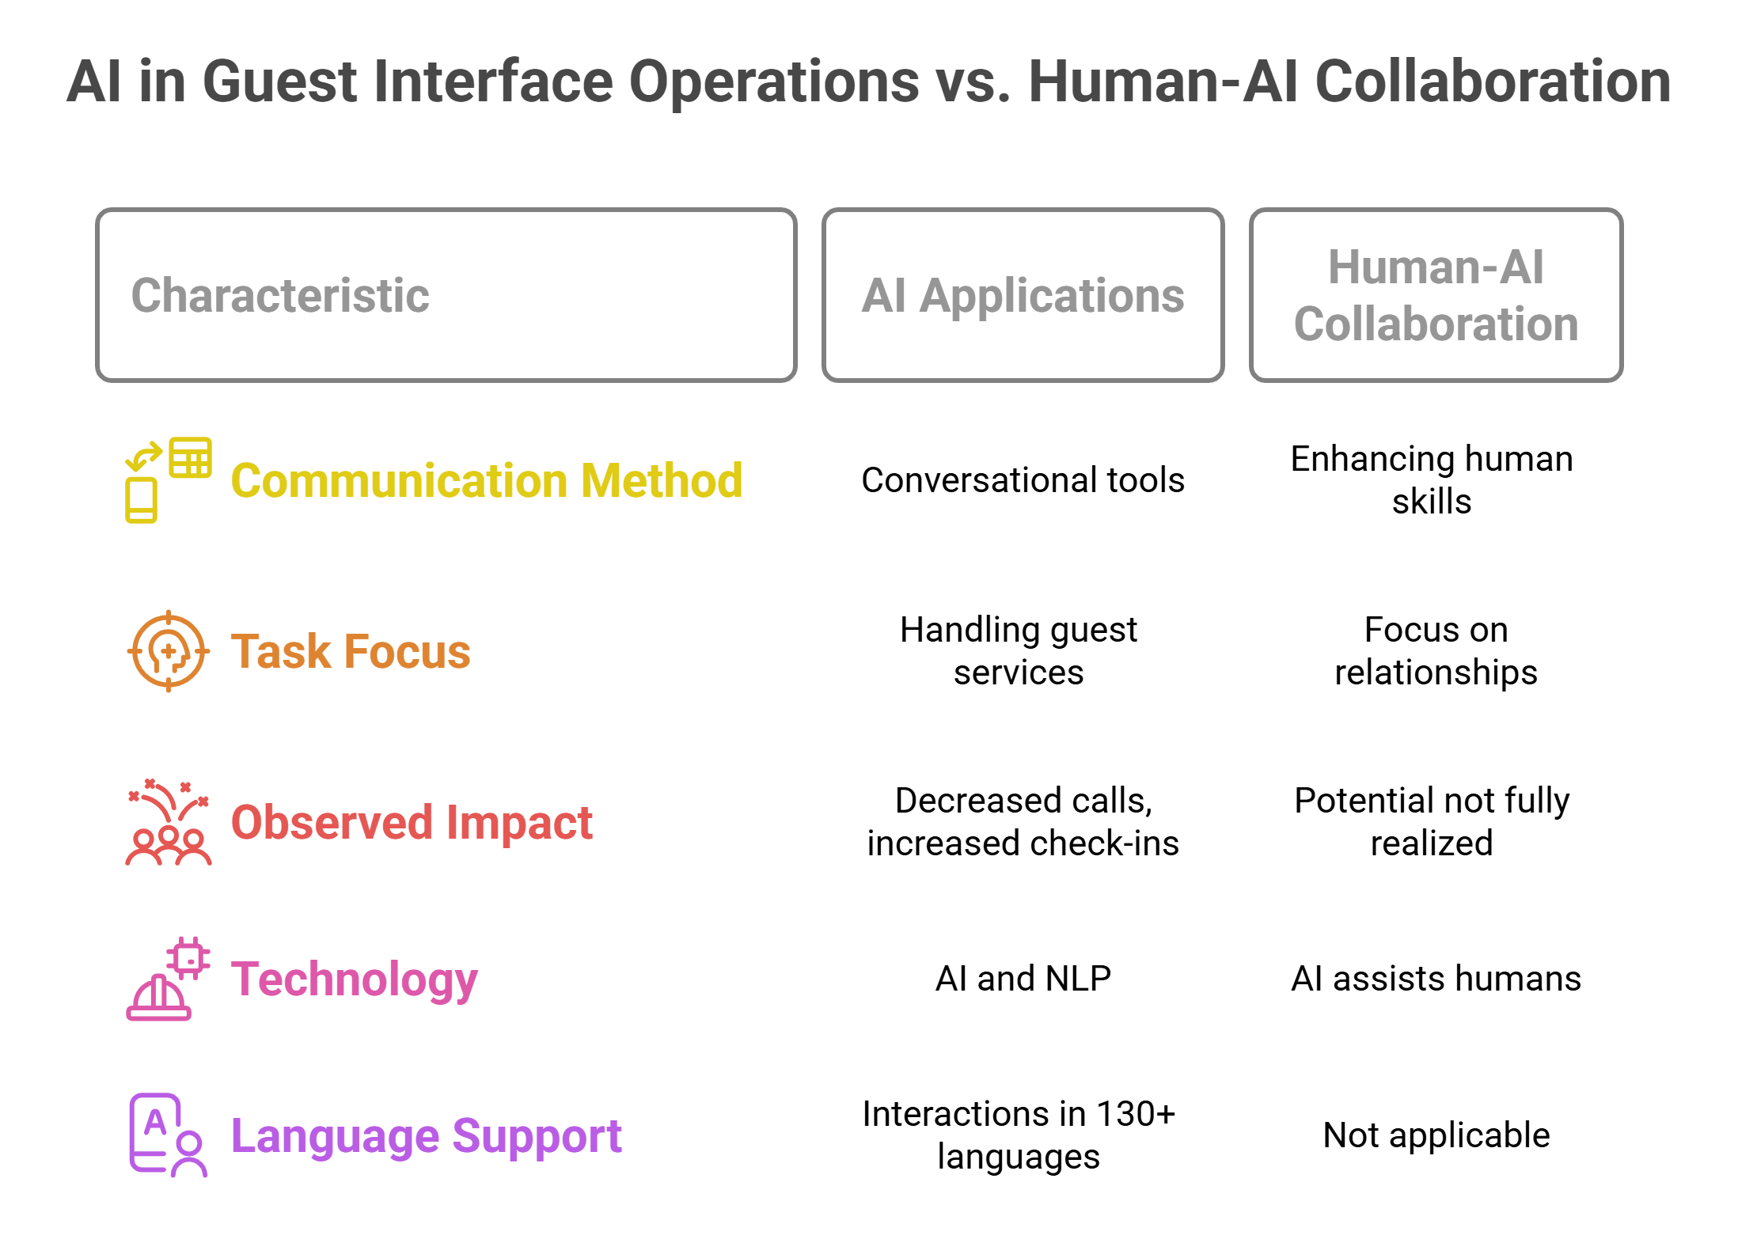
Figure 1: Al in Guest Interface Operations vs. Human-Al Collaboration.
AI Applications in Guest Interface Operations
Currently, hotels are using AI-based technology to communicate directly with guests, mainly through conversational tools. Today's AI chatbots in hotels operate like virtual assistants, handling various guest services through conversations and using AI and NLP to respond to guests immediately (Sam and Jasim, 2023). Industry data recently shows that hotels using these systems have seen a 70% decrease in calls and a 60% increase in digital check-ins (Schwarz, 2024).
Today's systems are much more advanced than earlier ones that followed rules. According to Pan and Fu (2024), having AI analyse intent and sentiment is very important in today's applications. Many leading industry solutions now have automatic interactions in over 130 languages, proving these frameworks can be used everywhere.
Human-AI Collaborative Models
According to Smids, Nyholm and Berkers (2020), robots are more likely to work with humans than to replace them. Today's approaches stress working together by using AI to enhance experiences and provide a setting where AI helps humans improve their skills (Pan and Fu, 2024). This approach is visible in practice, where Pericleous, Liasidou and Dyankov (2025) mention that AI can handle simple questions so human staff can focus on forming valuable relationships with customers.
However, setting up collaborative frameworks can be very challenging for organisations. According to Khlusevich, Inversini and Schegg (2024), AI has great potential for the hospitality industry, but its use in practice is far from where it could be.

Impact on Workforce and Operational Dynamics
Employee Adaptation and Role Evolution
Pericleous, Liasidou and Dyankov (2025) state that AI integration changes people's actions rather than replacing them. New studies suggest that hotel staff can also think creatively to help guests. They might shift their duties to improve how guests interact, design personalised experiences, join forces with different departments and handle their areas more independently (HFTP, 2024). This change is part of a broader shift, as Puorto (2025) explains, known as "Human-as-Luxury", in which human creativity and empathy are considered valuable assets.
Organisational Implementation Challenges
The literature points out major challenges that organisations face when trying to work together with AI. Khlusevich, Inversini, and Schegg (2024) explain that success in implementation depends on managers or owners being willing to put in the extra effort needed for the benefits to appear in the medium and long term. Integrating systems is still a challenge, and the quality of how they interact with current property management systems is a key factor in implementation.
These findings greatly affect human resource management. Fenwick, Molnár, and Frangos (2024) point out that AI is influencing the way HRM professionals work in organisations. AI is changing how many HR functions and tasks are carried out in organisations, making them more efficient.

Guest Experience and Service Quality Implications
Benefits of AI-Human Collaborative Service Models
Today's Research points out several important benefits of using AI and humans in service delivery. According to Kotka (2024), AI assistants can provide information quickly through all digital channels, guide customers during booking and reach out to them, while human staff handle emotions and difficult situations. According to Schwarz (2024), automation helps front desk workers concentrate on handling more challenging guest matters and building personal relationships.
Critical Challenges and Implementation Limitations
Even though AI-human cooperation holds many benefits, the literature points out several major obstacles. Blanche Gracia, Casalo, and Flavián (2022) note that some problems with AI include providers misusing information, AI replacing jobs, increasing social inequality and lacking emotion and empathy. Wang (2024) also points out that "cultural resistance appears when employees are used to old service practices and ethical problems arise when handling customer data."

Synthesis and Research Gaps
While AI and human teams working in guest services could greatly improve how things are done and how guests feel, putting this into practice is not always easy. Few studies currently follow up on collaborative effectiveness. There is not enough research comparing how guests perceive AI-assisted and human-only services and not enough ways to measure the success of models combining humans and AI.

Method
This section describes how to analyse secondary data using desk-based research, academic literature, industry information and the PEST framework.

Research Design and Approach
This study uses a single method and a systematic literature review to analyse AI-human collaborative systems in hotels. It takes a desk-based approach, supported by Kim et al. (2024), who studied AI from the viewpoint of hospitality employees by analysing existing data to understand how AI is being used and its consequences.

Data Collection Procedures
Academic Literature Sources
Publications from 2010 to 2024 in Current Issues in Tourism, the International Journal of Hospitality Management, and similar hospitality research journals form the main data foundation. As Khlusevich, Inversini, and Schegg (2024) showed, we searched databases for studies that provided actual examples of AI and humans teaming up in the hotel sector. The data selection criteria asked for examples of guest service applications and the related outcomes.
Industry Intelligence Integration
Pan and Fu (2024) suggest that industry reports from technology consultancies, hospitality associations, and market research firms should be added to academic sources to thoroughly cover hospitality technology research.

Analytical Framework and Tools
Using the PEST analysis framework, we study the political, economic, social and technological factors that impact AI use in hospitality, following the frameworks described by Wang (2024). Content analysis is used to organise findings by assessing implementation success factors and how employees cooperate, following the practices of modern hospitality research (Blanche Gracia, Casalo and Flavián, 2022).

Theme Impact Analysis: PEST Analysis of AI-Human Collaboration in Hotel Operations

Political Factors

Regulatory Framework and Data Privacy Implications
AI is being used more in the hospitality industry, but data protection rules are making it harder for companies to obey them. AI technology relies on a lot of data, and much of that data contains private and financial details about guests (Wang, 2024). Generally speaking, the level of government action on AI in hotels has differed globally. For example, the European Union's GDPR has encouraged hotels to implement strong data protection measures.
Marriott and Accor have built professional teams focused on data privacy and dedicated resources to achieve compliance (Manglani, 2024). Even so, the disparity in regulations adds complications for hotel groups operating globally.
While laws intended to protect consumers have had the side effect of keeping small properties out due to financial constraints, large chains have ultimately benefitted from this gap.
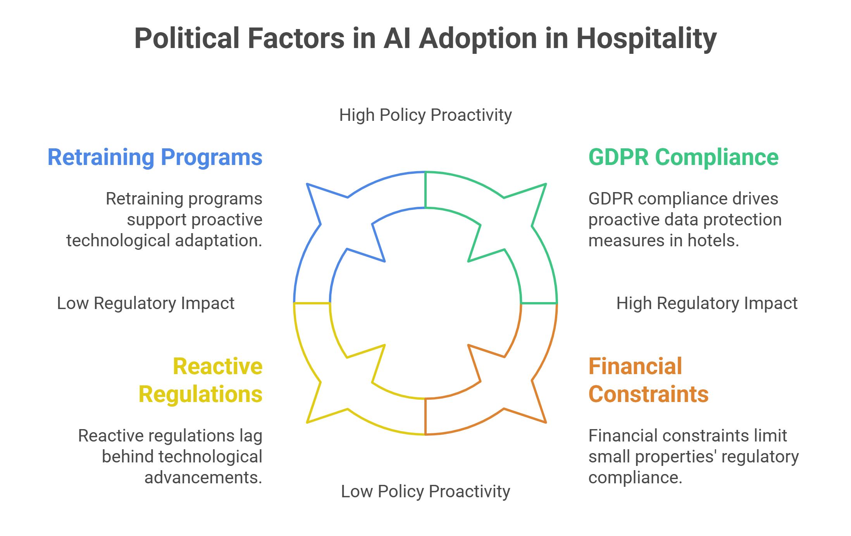
Figure 2: Political Factors in AI Adoption in Hospitality.

Employment Policy and Labour Displacement Concerns
The political rhetoric surrounding job displacement caused by AI has also altered policy discussions, as "hospitality is one of the leading industries susceptible to job displacement by automation" (Wang, 2024). Government employment policy tends to lean more towards retraining and technological leapfrogging support.
- Strengths: Policy frameworks that promote active planning and responsible AI deployment.
- Challenges: Many regulatory responses have been reactive rather than strategic, and they lag behind the increasingly fast pace of technology, which creates instability for industry investment.

Economic Factors

Market Growth and Investment Dynamics
AI is showing great potential to grow the economy within the hospitality industry. . The strong growth suggests that companies are becoming confident in cooperating with AI.
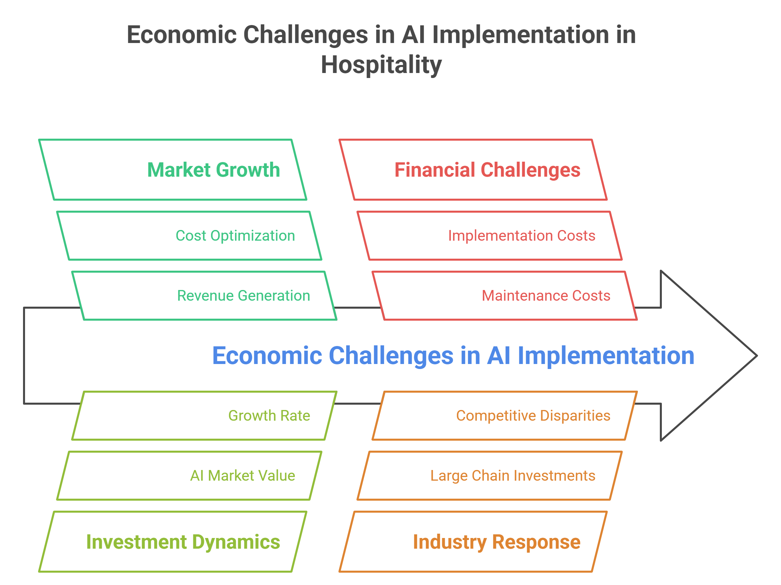
Figure 3: Economic Challenges in AI Implementation in Hospitality.
- Revenue Generation and Cost Optimisation: Today's big data analytics practices are highly profitable and cost-efficient. Many hotels are seeing up to a 70% drop in calls and a 60% increase in digital check-in rates, which helps them save money on operations. 30% of the respondents said they believe spending on hotel technology offers the most significant return on investment (Acropolium, 2025).
- Industry Response: Top chains are investing much more in AI now. Thanks to AI, Accor can find out what guests want and need, allowing them to serve customers with custom experiences and charge higher prices (Jelassi and Martínez-López, 2020).

Financial Challenges and Implementation Costs
While many expect large profits, working within the industry is beset by large economic obstacles. Setting up AI technology is expensive, which presents a big challenge for mid-market properties (Kejriwal, 2022). Implementation costs include technical tools, employee instruction, and maintenance.
As large chains save money on AI costs by doing things in bulk, smaller properties struggle to compete, which might lead to fewer unique competitors in the industry.

Social Factors

Employee Acceptance and Workforce Transformation
There are complex social dynamics around AI adoption, characterised by patterns of acceptance and resistance. AI in hotel housekeeping chores "is coming at a great time – when labour is hard to find". In a post-pandemic labour shortage landscape, "AI can automate the repetitive tasks, leaving much of the work to be done by the current staff members" (HFTP, 2024). This setting has made employees more receptive to cooperating with AI.
- Workforce Evolution: Many might wind up with a new kind of work instead of losing their current jobs. Line staff at hotels have the chance to offer creative entertainment. Their job roles will change to improve guest experiences, make personalisation a priority and team up with other departments (Maraj Rahman Sofi et al., 2024).
- Industry Response: Leading hotel chains have invested much in learning change management. Most training uses teaching people new skills instead of just preserving jobs from being attacked by AI.

Guest Acceptance and Cultural Integration
Consumer social attitudes towards AI reflect complex desires. A study indicates that 74% of visitors will pay 1-5% extra for enhanced technology, while almost 40% will pay 11-15% to take advantage of technology, significantly improving their stay (Acropolium, 2025).
- Cultural Resistance: Despite all the steps taken, cultural resistance still lingers. Even in culturally responsive societies such as New Zealand, "integration with the country's deeply embedded cultural values requires a considered approach" (Wang, 2024) and the necessity for a culturally adaptive AI strategy.
- Critical Assessment: Strengths involve increasing consumers' willingness to pay a premium for AI-driven services. Constraints involve cultural resistance in markets where traditional forms of hospitality are valued and the possibility of guests feeling alienated when AI systems are not emotive.

Technological Factors

Infrastructure Requirements and Integration Challenges
Technological deployment harbours deep complexity beyond the initial setup. Integration quality with current property management systems (PMS) is a key determinant of success. Compatibility problems with legacy systems pose considerable implementation challenges to most properties (HFTP, 2024).
Modern systems exhibit advanced functionality. Voice-controlled devices hold potential, with some 40% of hotel leaders seeing these as the most likely innovative technologies for 2024.
System Reliability and Performance Limitations
Challenges in technology involve system performance variability and dependability. The breakdowns of the robots in Henn na Hotel Tokyo Ginza exemplify implementation failures. The hotel "had to hold off and reassess its robot usage amid a mix of negative and positive reviews coming both from guests and staff" (Söderberg Granström, Pronk, and Criscione-Naylor, 2023).
Major technology vendors have been prioritising incremental implementation strategies over blanket automation. This incremental strategy provides an avenue for system refinement and staff adaptation while maintaining quality standards (Director, 2025)

Synthesis: Strategic Implications and Future Outlook
PEST analysis shows that AI and humans interact in the hospitality industry against mixed opportunities and obstacles. While it is fairly easy to continue pushing new technologies due to incentives and capabilities, companies must handle political obstacles and society's opinions carefully. Well-developed strategies that highlight using people alongside machines, not in place of them, give the most impressive results in gaining satisfaction, better performance, and staff engagement.

Conclusion

Key Findings
This research finds that AI-powered guest service is an important trend in hospitality today. Integrating people and technology in a fair way was found to boost guest satisfaction while saving hotels 70% of their operation expenses, as demonstrated in the literature (Schwarz, 2024).

Strategic Implications
According to PEST analysis, although the economy benefits from AI, additional care is needed due to challenges involving regulation, society and technology expected to affect AI use until 2033 (Acropolium, 2025). Well-managed hotels work to improve their existing workforce instead of trying to build a new one.

Future Outlook
Today, it is clear that partnering open environments empower hotels to use AI tools without giving up on hospitality. The goal of a sustainable industry is to unite technology with people, strengthening, not reducing, the number of employees.

Recommendations
The section offers hotel industry leaders advice on phased strategies, workforce priorities, technology use and detailed governance.

Strategic Implementation Framework
Hotels should use AI step by step rather than try to automate every process simultaneously. The Henn na Hotel Tokyo Ginza case showed that using robots too fast could disrupt operations when both advantageous and adverse feedback was received (Bost, 2024). Those in the industry should focus on making employees better rather than replacing them, working together to keep hospitality's human side while using AI for regular tasks that can be automated.

Workforce Development and Technology Integration
Comprehensive staff retraining programmes are critical for success. The authors suggest that hotels give their workers the training needed to use AI so they can handle more important customer interactions and provide unique experiences (Muzyka and Solovei, 2025). Introducing AI into repetitive parts of the business, like guest communication and pricing, is a better way to begin integration than to do it all at once.

Performance Optimisation and Governance
AI should be used to help achieve both sustainability and better efficiency. After Accor demonstrated that AI in energy management could help save 20% of energy, other hotels should focus on making their operations more environmentally friendly (Muzyka and Solovei, 2025). Many hotels benefit from AI-based data analysis to guide their decisions, as "most hotels already use or want to use AI and data analytics to personalise their offers" (Schwarz, 2024).
In addition, hotels need to implement solid AI governance practices that address privacy concerns, reliable systems, and ethics to ensure that their AI deployment is sustainable and that guests are still confident in it.

References
Acropolium.com. (2025). Top Hospitality Technology Trends in 2025 | Acropolium. [online] Available at: https://acropolium.com/blog/top-hospitality-technology-trends [Accessed 10 May 2025].
Bost, A. (2024). 2024 Hospitality Trends: AI & Robotics Revolution. [online] United Robotics Group. Available at: https://unitedrobotics.group/en/blog/article/top-trends-in-hospitality-for-2024. [Accessed 15 May 2025].
Director, (2025). AI in hospitality: enhancing hotel guest experiences. [online] Ey.com. Available at:https://www.ey.com/en_us/insights/hospitality/ai-in-hospitality-enhancing-hotel-guest-experiences. [Accessed 12 May 2025].
Fenwick, A., Molnár, G. and Frangos, P. (2024). Revisiting the role of HR in the age of AI: bringing humans and machines closer together in the workplace. Frontiers in Artificial Intelligence, 6(1272823). doi:https://doi.org/10.3389/frai.2023.1272823.
Gracia, B., Casalo, L.V. and Flavián, C. (2022). Frontline Robots in Tourism and Hospitality: Service Enhancement or Cost Reduction? [online] Ssrn.com. Available at: https://papers.ssrn.com/sol3/papers.cfm?abstract_id=4128172. [Accessed 10 May 2025].
Gidumal, J.B., Secin, E.W., O’Connor, P. and Buhalis, D. (2023). Artificial Intelligence’s Impact on Hospitality and Tourism marketing: Exploring Key Themes and Addressing Challenges. Current Issues in Tourism, [online] 27(14), pp.1–18. Available at: https://www.tandfonline.com/doi/full/10.1080/13683500.2023.2229480.
HFTP. (2024). AI in Hospitality: Predictions and impact in 2024 and beyond. [online] Available at: https://www.hftp.org/news/4120111/ai-in-hospitality-predictions-and-impact-in-2024-and-beyond. [Accessed 26 May 2025].
Huang, M.-H. and Rust, R.T. (2022). A Framework for Collaborative Artificial Intelligence in Marketing. Journal of Retailing, [online] 98(2), pp.209–223. Available at: https://ideas.repec.org/a/eee/jouret/v98y2022i2p209-223.html.
Jelassi, T. and Martínez-López, F.J. (2020). AccorHotels’ Digital Transformation: A Strategic Response to Hospitality Disruptor Airbnb. Classroom Companion: Business, pp.665–689. doi:https://doi.org/10.1007/978-3-030-48950-2_25.
Kejriwal, M. (2022). AI in Practice and Implementation: Issues and Costs. Artificial Intelligence for Industries of the Future, [online] pp.25–45. doi: https://doi.org/10.1007/978-3-031-19039-1_2.
Khlusevich, A., Alessandro Inversini and Schegg, R. (2024). Artificial Intelligence and Hospitality: A Challenging Relationship. Springer proceedings in business and economics, pp.247–258. doi:https://doi.org/10.1007/978-3-031-58839-6_27.
Kim, H., Kam, K., Shin, S. and Li, J. (2024). Artificial Intelligence in Hospitality and Tourism: Insights From Industry Practices, Research Literature, and Expert Opinions. Journal of Hospitality & Tourism Research, [online] 49(2). doi:https://doi.org/10.1177/10963480241229235.
Manglani, M. (2024). Compromised Systems, Compromised Data: A Technical Analysis of the Marriott Data Breach. International Journal of Science and Research (IJSR), [online] 13(4), pp.176–180. doi:https://doi.org/10.21275/sr24402124923.
Maraj Rahman Sofi, Bashir, I., Alshiha, A., Emad Alnasser and Sultan Alkhozaim (2024). Creating Exceptional Guest experiences: the Role of Engagement and Relationship Building in Hospitality. Journal of Hospitality and Tourism Insights, 8(3). doi:https://doi.org/10.1108/jhti-04-2024-0318.
Muzyka, B. (2025). AI in the Hotel Industry: Top Benefits & App Examples | TechMagic. [online] Blog | TechMagic . Available at: https://www.techmagic.co/blog/ai-in-hotel.
Pan, T. and Fu, R.J.C. (2024). Navigating the AI horizon in hospitality: a novel classification and future research agenda. International Hospitality Review. doi:https://doi.org/10.1108/ihr-01-2024-0003.
Pericleous, K., Liasidou, S. and Dyankov, T. (2025). AI and hotel employees’ coexistence: a helpful tool or a threat to job loss? Worldwide Hospitality and Tourism Themes, 17(1).
Puorto, S. (2025). Humans-as-Luxury: The Future of Hospitality in an AI-Driven Age. [online] Hospitality Net. Available at: https://www.hospitalitynet.org/opinion/4126522.html [Accessed 13 May 2025].
Sam, I. and K. Mohamed Jasim (2023). Diving into the technology: a systematic literature review on strategic use of chatbots in hospitality service encounters. Management Review Quarterly.
Schwarz, L. (2024). AI in Hospitality: Advantages & Use Cases. [online] Oracle NetSuite. Available at: https://www.netsuite.com/portal/resource/articles/business-strategy/ai-hospitality.shtml.
Smids, J., Nyholm, S. and Berkers, H. (2020). Robots in the Workplace: a Threat to—or Opportunity for—Meaningful Work? Philosophy & Technology, [online] 33(33), pp.503–522. doi:https://doi.org/10.1007/s13347-019-00377-4.
Söderberg Granström, D., Pronk, A. and Criscione-Naylor, N. (2023). Robotic Services in the Hotel Industry: An Examination of Henn Na Hotels. International Journal of Gaming Hospitality and Tourism, [online] 3(1). Available at: https://stockton.edu/light/documents/ijght_vol.3no.1/robotic_services_henn_na_hotels-6.7.23.pdf.
Team, B.M. (2024). How Ai Is Changing the Hotel Industry in 2024 - BookVisit. [online] BookVisit. Available at: https://bookvisit.com/2024/04/16/how-ai-is-changing-the-hotel-industry-in-2024 [Accessed 26 May 2025].
Wang, P.Q. (2024). Personalizing guest experience with generative AI in the hotel industry: there’s more to it than meets a Kiwi’s eye. Current Issues in Tourism, 28(4), pp.1–18.
Zheldak, P. (2024). Top Hospitality Technology Trends in 2023 | Acropolium. [online] acropolium.com. Available at: https://acropolium.com/blog/top-hospitality-technology-trends/.

