

UNIVERSITY OF WALES TRINITY SAINT DAVID
Y Drindod Dewi Sant
Prifysgol Cymru
Lecturer: Taonga Kaonga Sobere-Snithers

Student ID: 2538968

Student Name: Varun Chary Tarani
A Strategic Report on the Marketing Environment

Marketing Environment Analysis
Assessment Component 1: Individual Report

Module: Marketing Management (LCMB7024)
Master of Business Administration

Table of Contents
Task 1: Marketing Environment Analysis 3
The Natural Environment Actor 3
The Political and Legal Environment Actor 4
Interplay Between the Two Actors and Strategic Implications 5
Task 2: Strategic Growth and Competitive Positioning 7
Application of the Ansoff Matrix 7
Recommended Growth Strategies for Low-Carbon Transition and Competitive Advantage 8
Task 3: Critical Reflection on AI Usage 9
Tool Disclosure 9
Critical Evaluation of AI Output 10
Contribution Analysis 10
Ethical and Professional Reflection 11
References 12

Task 1: Marketing Environment Analysis

The Natural Environment Actor
The Natural Environment actor poses major physical and Transition risks to BHP. Physical risks refer to the growing number and intensity of extreme weather like cyclones, flooding and heatwaves within the Pilbara as well as chronic water stress in the Atacama Desert where BHP carries out most of its large copper activities (BHP, 2025e). These risks have the potential of disrupting production, destroying infrastructure and having impacts on the safety of workforce. Research shows that the risk of physical climate is already affecting the value of assets and operational planning in mining (Albanese et al., 2024; Ben-Salha et al., 2025).
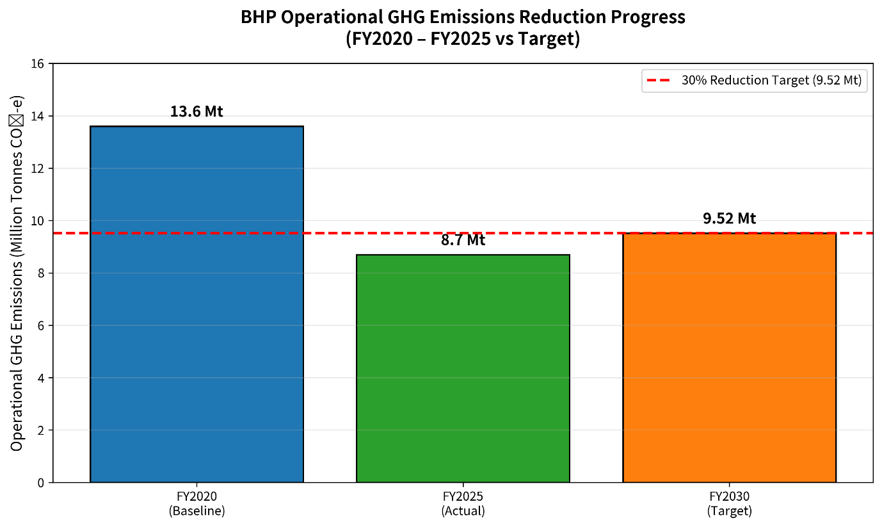
Figure 1 BHP Operational GHG Emissions Reduction Progress (FY2020 – FY2025 vs FY2030 Target)
Source: Adapted from BHP (2025f)
One of the main problems that lead to transition risks is the necessity to decarbonise the mining processes that are energy intensive. The significant source of Scope 1 emissions is diesel use in haul trucks and mobile equipment. The operation emissions of FY2025 recorded by BHP are 8.7 Mt CO2-e (adjusted), which is 36 percent lower than the FY2020 level, aided by power purchase agreements through renewable source (BHP, 2025f). But decarbonisation that is more profound will need massive displacing of diesel with battery-electric or hydrogen technologies, which have encountered delays in commercial maturity (BHP, 2025d). This limitation of water makes even the processing capacities limited, as well as the costs of desalination and reprocessing plants. These dynamics generate both the sense of urgency of technological change and the possibility to improve the operational resilience by taking proactive adaptation steps (Adedoja et al., 2025; Antonini et al., 2025).

The Political and Legal Environment Actor
The Political and Legal Environment is another critical external actor influencing BHP’s low-carbon transition. The world is seeing diminutively strict climate policies and environmental guidelines instituted as governments endeavour to enforce national and international decarbonisation measures. Being a multinational mining firm, BHP has operations in a variety of jurisdictions and has to adhere to various regulatory requirements which affect the investment decisions, practices and priorities of operation.
The Safeguard Mechanism in Australia is a key instrument to the emission reduction of the industries. The policy sets decreasing emission levels of large plants and imposes on organisations that surpass these rates to decrease emissions by selling carbon credits as an offset of surpassing emissions (Department of Climate Change, Energy, the Environment and Water, 2026). This framework will provide direct financial motivation to BHP to invest in emission-cutting technologies and renewable energy ventures. Adherence to the mechanism is thus not merely a legal necessity but also a significant element of the operational efficiency and cost management.
The regulatory pressures are also witnessed in Chile where environmental permitting issues, water allocation regulations and sustainability standards have increasingly been strict. Such policies add complexity to the operation and may even increase the turnaround time on project approvals. Nevertheless, they also urge businesses to have more sustainable practices and enhance environmental performance. The move by BHP to invest in desalination facilities and climate adjustment measures is an indicator of how the company is striving to uphold the changing environmental standards and still ensure its operations run uninterrupted (BHP, 2025e).
The BHP is another international climate policy that has an indirect impact in terms of market pressures. Carbon Border Adjustment Mechanism (CBAM) and European Union Emissions Trading System (EU ETS) is intended to promote decarbonisation by adding costs related to carbon to imported products with high levels of embedded carbon. Whereas the production of steel is not directly provided by BHP, most of the customers are in steelmaking industries that will be impacted by these policies. The need to address this with low-carbon iron ore and raw materials which can be used to produce cleaner steel is consequently growing (Johnson et al., 2025). It has been found that CBAM will hasten the decarbonisation process of the global steel industry by establishing economic incentives on the use of lower-carbon production processes (Zhao et al., 2023).
Another political and legal pressure is investor expectations and disclosure requirements related to climate. Stakeholders are placing more and more demands on mining companies to give transparent information about climate risks, performance based on emissions and transition strategies. BHP responds to these expectations by way of its Climate Transition Action Plan and annual sustainability disclosures (BHP, 2024; BHP, 2025a). However, there is still a lot of scrutiny. The pace of some of the decarbonisation efforts has been illuminated in recent media coverage, generating some internal concerns as to the timeframes of implementation as well as the organisational dedication (The Guardian, 2026). This questioning shows that being within the law is not a productive answer but companies have to be credible and trusted by the investors, the customers and the society at large.
All in all, Political and Legal Environment has both threats and opportunities to BHP. Though regulations can raise the costs of compliance and the complexity of operations, they also fuel innovation, drive investment in sustainable technologies and drive product demand to lower carbon products.

Interplay Between the Two Actors and Strategic Implications
The Natural Environment and Political and Legal Environment are directly related to each other and they jointly influence the strategic decision-making of BHP. Physical risks that are related to climate make operations more vulnerable, whereas regulatory systems convert the environmental threats into business financial and strategic issues. With the escalating rate of climate change, and governments enacting tougher environmental regulations and policies to reduce emissions, organisations are under increased pressure to decarbonise faster.
Studies indicate that the risks associated with physical and transition climate are becoming integral in financial and investment decisions (Bua et al., 2024). As a result, the environmental challenges are no longer perceived to be merely an operation issue, but instead also have an impact on competitiveness, profitability, and long-term value generation. In case with BHP, emphasis on renewable energy, emissions minimization technologies and climate adaptation measures can serve as a solution to both environmental risks and regulatory constraints.
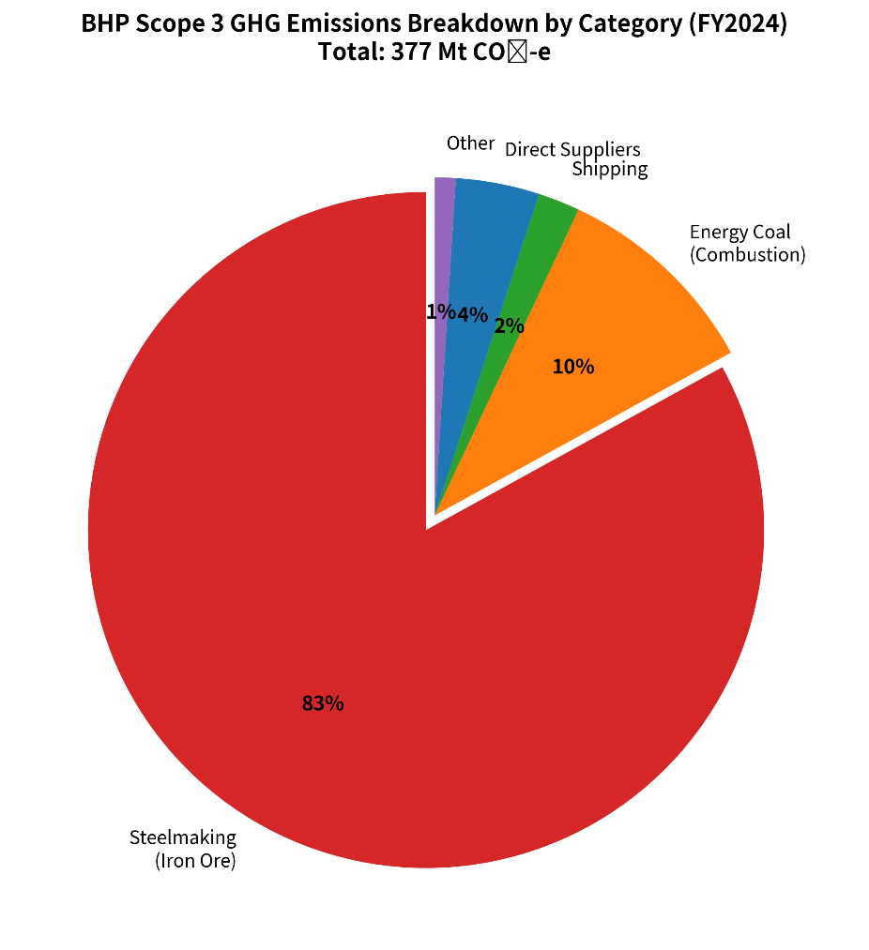
Figure 2 BHP Scope 3 GHG Emissions Breakdown by Category (FY2024)
Source: Adapted from BHP (2025b)
The relationship between these two players brings about differentiation opportunities in the strategic sense. Companies that can show believable action on climate and excellent environmental effectiveness will have better chances of drawing investors, meeting the requirements of regulatory forces and gaining them relationships with consumers who find lower-carbon supply chains. Nevertheless, the inability to attain mentioned climate targets could lead to reputational losses, a loss of stakeholder confidence and heightened regulatory oversight. Thus, BHP should keep considering climate adaptation, reduction of emissions as well as stakeholder engagement as part of the wider corporate strategy to sustain its competitiveness in an ever more sustainability-aware market.

Task 2: Strategic Growth and Competitive Positioning

Application of the Ansoff Matrix
Ansoff Matrix is an effective strategy planning instrument that determines the areas of growth depending on the current and new productions and the market (Kotler and Armstrong, 2023). The framework consists of four strategic choices, which include Market Penetration, Market Development, Product Development and Diversification. In the case of BHP, it needs to find ways of growing the business that will help in fulfilling commercial goals as well as achieving long-term decarbonisation goals.
The Market penetration is concerned with promoting existing products in the existing markets. Though the risk involved in this strategy is low, the potential it can contribute to the sustainability goals of BHP is also low. The growing sales of conventional products with high carbon content with a low environmental impact might be inconsistent with the customer expectations and regulatory trends that prefer low-carbon products. Therefore, the Market Penetration is also not regarded as the best primary strategy.
Market Development entails introducing products in the new markets or among the new customers. The tactic has a moderate future potential of BHP in the fields of developing relations with industries that assist in the creation of renewable energy technologies, the production of batteries and electrification processes. Nevertheless, the competitive advantage can be shallow unless products can be distinguished by using low-carbon features and certified sustainability labels.
Strategic fit Product Development is the best. This strategy entails the development of new products or developing the existing products in a better way. In the case of BHP, the Product Development can be directed to the provision of high quality, reduced carbon level iron ore and copper products that will support decarbonised industrial products. These products are in line with the rising customer expectations of sustainable raw material and complement the new green steel value chains as a result of international climate policies (Johnson et al., 2025).
Diversification is the case of venturing into new markets using new products. There are future opportunities that might be offered by diversification, but it is high risk with high capital requirements, technological uncertainty and possible diversion away BHP core competencies. Thus, diversification cannot be accepted as the initial growth strategy in the context.
Table: Ansoff Matrix – Strategic Options for BHP’s Low-Carbon Transition
Strategic Option | Description | Suitability for BHP | Risk Level | Potential Return | Recommendation
Market Penetration | Increase sales of existing products in current markets | Low – conflicts with decarbonisation goals | Low | Low–Moderate | Not recommended as primary
Market Development | Enter new segments with existing products | Moderate – opportunity in green-premium segments | Moderate | Moderate–High | Supporting strategy
Product Development | Develop new low-carbon differentiated products | High – addresses regulatory, customer and transition pressures | Moderate | High | Primary strategy
Diversification | Enter new industries with new products | Low – high capital and strategic stretch | High | Uncertain | Not recommended at present

Source: Adapted from Kotler and Armstrong (2023)

Recommended Growth Strategies for Low-Carbon Transition and Competitive Advantage
BHP must implement Product Development as the key growth strategy which should be backed by selective Market Development activities. The Product Development directly responds to the environmental and regulatory imperatives realized in Task 1 but also allows the firm to enhance competitive positioning in the existing markets.
It should be a plan to speed in the development and commercialisation of the low-carbon mineral products backed with tested, verified emissions data. High grade iron ore resource has the potential to contribute significantly to the hydrogen-direct reduced iron production and other low carbon steelmaking technologies that are emerging around the globe (Johnson et al., 2025). Moreover, the ongoing investment in new renewable energy sources, electrification and embarkation and reduction technology can lead to more product differentiation and customer confidence.
Product Development should be complemented with Market Development, which focuses on addressing customers and industries with priorities on sustainability. Possible markets are renewable energy infrastructure, battery manufacturing, transportation vehicles with electric engines and low-carbon steel manufacturing production. Such industries can only grow sharply as governments work towards net-zero goals and there is a growing demand of critical minerals (Adedoja et al., 2025).
Product Development combined with targeted Market Development can help BHP to turn challenges of decarbonisation into competitive opportunities. The plan will allow the company to enhance the relationships with its stakeholders, tap into new green-premium markets and confirm the position as a top provider of transition-critical resources as well as help achieve long-term sustainability goals.

Task 3: Critical Reflection on AI Usage

Tool Disclosure
The preparation of this report involved artificial intelligence (AI) tools limited and controlled. ChatGPT (OpenAI) was applied to facilitate initial research and to enhance the level of grammatical accuracy, the structure of sentences and their overall readability. In the research phase, AI helped to find the appropriate academic literature, find potential sources and summarise the major themes associated with climate change, sustainable mining and decarbonisation strategies. The AI application was useful to streamline the literature search process and to find the necessary above-academic and industry information.
Moreover, grammatical mistakes were detected with the help of AI-based proofreading tools that helped to clarify sentences and to write academic papers better. These tools were not applied until after the content of the report was developed and were only applied to enhance the language. The critical analysis of the report, arguments, recommendations and conclusion have not been created using AI.

Critical Evaluation of AI Output
Even though AI was helpful in the research and proofreading stages, all the results needed extensive validation before including them into the report. Experimental data proposed by AI was compared with reference to the original scholarly articles, corporation reports and official publications adopted in the reference list. This checking procedure was required as the answers provided by AI sometimes included some false facts, outdated data or missing interpretation.
Some examples were found that AI summaries did not provide essential context information or simplified complicated problems in the context of climate risks and mining sustainability. When this occurred, the inception sources were reread to assure that the interpretations were a reasonable representation of the arguments of the authors. Moreover, statistical information, data on the company performance, and climate-related targets were cross-checked with actual data provided by BHP. This was done to make sure that only valid and true information was to be incorporated in the final report.

Contribution Analysis
The author still had the responsibility of the intellectual contribution to this report. AI aided in finding applicable literature and grammatical correction, but the choice of the sources, evidence evaluation, and marketing theory application and recommendations were done on their own.
By analysing the Natural Environment and Political and Legal Environment actors and evaluating their strategic implications as well as the use of the Ansoff Matrix were using the interpretation of the literature and organisational evidence by the author. On the same note, the conclusions and recommendations on the low-carbon transition of BHP have been created via autonomous critical thought, and not AI-created materials.
Thus, AI was more of a research support and proofreading system, whereas all critical analysis and synthesis, as well as strategic decision-making, was left to the author.

Ethical and Professional Reflection
Ethical and professional factors have great importance in the context of Martinizing AI in academic work. Although AI can enhance efficiency and facilitate retrieval of information, overdependence on AI can minimize critical work with source content and augment the chances that inaccuracies incurred make it into academic work. Transparency, verification and accountability, therefore, are part of responsible use.
The applications of AI in this report were applied as an auxiliary tool instead of replacing independent research and critical thought. Any information that was retrieved with the help of AI was checked on reliable academic and organisational sources to be included. This method facilitates academic honesty as it makes sure that the final piece of work is the reflection of the personal knowledge and assessment of the topic.
Professionally, AI has been finding applications in marketing and business settings to aid in research, communication and decision-making. Nonetheless, specialists should be held accountable to critique the results of AI, and all decisions should be made on credible grounds. This experiment using AI in this evaluation emphasized the necessity to strike a balance between technological support and human practices, critical thinking and ethical accountability.

References
Adedoja, O.S., Sadiku, E.R. and Hamam, Y. (2025) ‘Multicriteria decision-making for sustainable mining: Evaluating the transition to net-zero-carbon energy systems’, Sustainability, 17(10), p. 4566. Available at: https://doi.org/10.3390/su17104566 (Accessed: 23 June 2026).
Albanese, M., Caporale, G.M., Colella, I. and Spagnolo, N. (2024) ‘The effects of physical and transition climate risk on stock markets: Some multi-country evidence’, International Economics, 181, p. 100571. Available at: https://doi.org/10.1016/j.inteco.2024.100571 (Accessed: 23 June 2026).
Antonini, S., Grisolia, G. and Blengini, G.A. (2025) ‘Three open questions on net zero in the mining and metals industries’, Mineral Economics. Available at: https://doi.org/10.1007/s13563-025-00554-2 (Accessed: 23 June 2026).
Ben-Salha, O., Zmami, M., Waked, S.S., Raggad, B., Najjar, F. and Alenazi, Y.M. (2025) ‘Assessing the impacts of transition and physical climate risks on industrial metal markets: Evidence from the novel multivariate quantile-on-quantile regression’, Atmosphere, 16(2), p. 233. Available at: https://doi.org/10.3390/atmos16020233 (Accessed: 23 June 2026).
BHP (2024) Climate Transition Action Plan 2024. Melbourne: BHP Group Limited. Available at: https://www.bhp.com/-/media/documents/investors/annual-reports/2024/240827_bhpclimatetransitionactionplan2024.pdf (Accessed: 23 June 2026).
BHP (2025a) Annual Report 2025. Melbourne: BHP Group Limited. Available at: https://www.bhp.com/investor-hub/reports-and-presentations/annual-report (Accessed: 23 June 2026).
BHP (2025b) ‘Operating and Financial Review 9.8 – Climate change’, in Annual Report 2025. Melbourne: BHP Group Limited. Available at: https://www.bhp.com/-/media/documents/investors/annual-reports/2025/250819_bhpannualreport2025.pdf (Accessed: 23 June 2026).
BHP (2025c) Climate change. Available at: https://www.bhp.com/sustainability/climate-change (Accessed: 23 June 2026).
BHP (2025d) Operational GHG emissions (Scopes 1 and 2 emissions from our operated assets). Available at: https://www.bhp.com/sustainability/climate-change/operational-ghg-emissions (Accessed: 23 June 2026).
BHP (2025e) Physical climate-related risk and adaptation. Available at: https://www.bhp.com/sustainability/climate-change/physical-climate-related-risk-and-adaptation (Accessed: 23 June 2026).
BHP (2025f) FY2025 Full Year Results Announcement. Available at: https://www.bhp.com/news/media-centre (Accessed: 23 June 2026).
Bua, G., Kapp, D., Ramella, F. and Rognone, L. (2024) ‘Transition versus physical climate risk pricing in European financial markets: A text-based approach’, The European Journal of Finance, pp. 1–35. Available at: https://doi.org/10.1080/1351847X.2024.2355103 (Accessed: 23 June 2026).
Department of Climate Change, Energy, the Environment and Water (2026) Safeguard Mechanism. Available at: https://www.dcceew.gov.au/climate-change/emissions-reporting/national-greenhouse-energy-reporting-scheme/safeguard-mechanism (Accessed: 23 June 2026).
Harpprecht, C., Sacchi, R., Naegler, T., van Sluisveld, M., Daioglou, V., Tukker, A. and Steubing, B. (2025) ‘Future environmental impacts of global iron and steel production’, Energy & Environmental Science. Available at: https://doi.org/10.1039/D5EE01356A (Accessed: 23 June 2026).
Johnson, C., Åhman, M., Nilsson, L.J. and Li, Z. (2025) ‘Emerging green steel markets surrounding the EU emissions trading system and carbon border adjustment mechanism’, Nature Communications, 16(1). Available at: https://doi.org/10.1038/s41467-025-64440-9 (Accessed: 23 June 2026).
Kotler, P. and Armstrong, G. (2023) Principles of Marketing. 19th edn. Harlow: Pearson Education Limited.
The Guardian (2026) ‘Revealed: the internal BHP memo that slammed the brakes on the world’s biggest miner’s climate push’, The Guardian, 25 May. Available at: https://www.theguardian.com/world/ng-interactive/2026/may/25/bhp-files-internal-memo-revealed (Accessed: 23 June 2026).
Zhao, L.-T., Chen, Z.-Y., Duan, Y.-X. and Qiu, R.-X. (2023) ‘How will CBAM affect the decarbonisation of the steel industry in China? A system dynamics approach’, International Journal of Production Research, pp. 1–22. Available at: https://doi.org/10.1080/00207543.2023.2285397 (Accessed: 23 June 2026).
OpenAI (2025) ChatGPT (GPT-4o model). Available at: https://chat.openai.com (Accessed: 23 June 2026).

