Community Engagement
Table of Contents
1. Introduction 3
1.1. Burglary: A common crime in the UK 4
1.2. Community Engagement and Crime Prevention 5
2. About the Campaign: Safety in Neighborhood - Burglary 2020 6
2.1. Community Engagement Policy 6
2.2. Principles and Standards that depict community engagement. 7
2.3. Benefits of Stakeholder’s Participation 8
2.4. Engaging Stakeholders through the use of Social Media. 8
2.5. Campaign’s Call-To-Action 9
2.6. Promoting Diversity and Inclusion 12
2.7. The need for a forward-looking approach 13
3. Conclusion 14
3.1. Recommendations 14
4. References 16

1. Introduction
Reports suggest that there has been an increasing crime rate in the communities of the UK, specifically in the areas of England and Wales. There has been an increase in crime rate from 79.52 per 1000 in the year 2020 to a 1.18% increase in the year 2021-2022. Whereas Wales was considered to be one of the countries with the highest crime rate which involves 75.16 crimes per 1,000 people in the recent year (crimerate.co.uk, 2022).
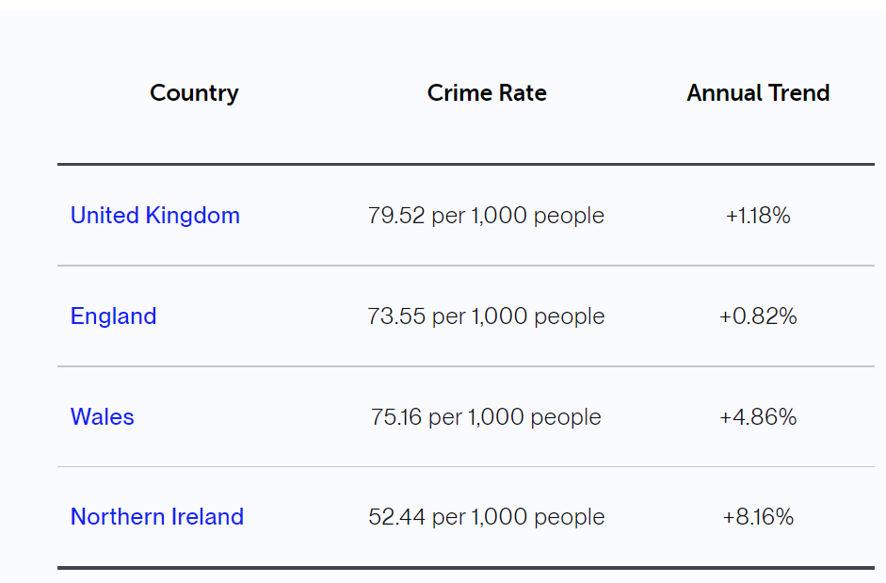
Figure 01: Crime rates reported in the year 2021-2022
(Source: crimerate.co.uk, 2022)
Furthermore, crime statistics suggest that the types of crime that are being dominated in the countries of Wales and England involve Anti-social behavior being at the top with the highest rate of crime count, followed by bicycle theft, Burglary, and even drugs (Laycock and Tilley, 2018).
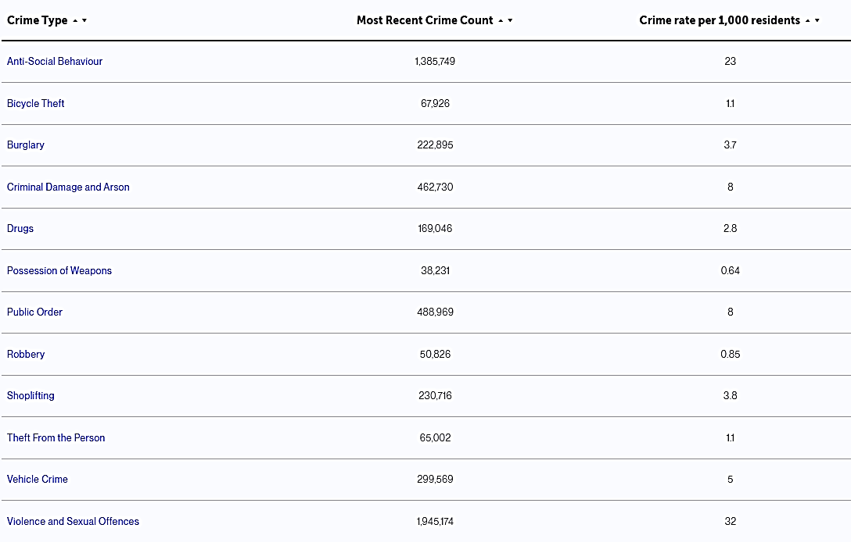
Figure 02: Crime Type Statistics In the UK
(Source: crimerate.co.uk, 2022)

1.1. Burglary: A common crime in the UK
Post the global pandemic, there has been a rising number of Burglary cases in the country, especially in the areas of Wales and England. By the year 2021, reports suggest that there were around 267,000 burglaries, with one taking place every 106 seconds. On average, each day around 817 houses are being burgled which as a consequence has led to severe emotional distress and other economical and financial damage (Hunter et al., 2021).
Burglary is being committed when a person enters a building as a trespasser and attempts to steal something from the household. Such entries are often unauthorized and non-connected to the target building.
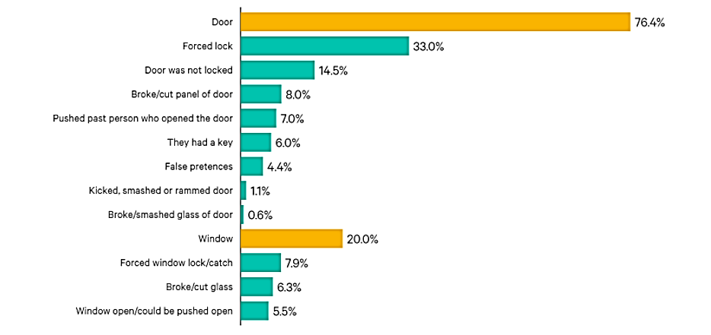
Figure 03: How do burglars gain entry?
Source: nmblefins.co.uk, 2022
With the addressing of increased crime rates, the police have been attempting to improve the situation by identifying the key disparities that widen the existing gap between crime and policing. These disparities have led the police to identify the need of:
- Re-establishing trust between the communities and police service
- Preventing harm rates and ensuring that young people do not enter the criminal justice system.

1.2. Community Engagement and Crime Prevention
The police and government authorities of the UK emphasize community engagement as one of the core factors to promote efficiency and reduce risk amongst the people in the community. Community engagement is defined as a tool to help identify some of the political, economical, environmental, technological, and even legal factors that are responsible to make the communities and individuals vulnerable in the society. It is being depicted that being able to understand these, can decrease the level of threat and harm that the society may possess (Mawby, 2019).

2. About the Campaign: Safety in Neighborhood - Burglary 2020
With the end of lockdown post the covid-19 period, it was expected that there would be a rise in the rates of burglary in the neighboring communities. Based on this idea, the government had developed a campaign to prevent it from happening. The campaign was set with the partnership to the home office and would help offer its members as well as non-members from preventing burglary by seeking effective practical tools.
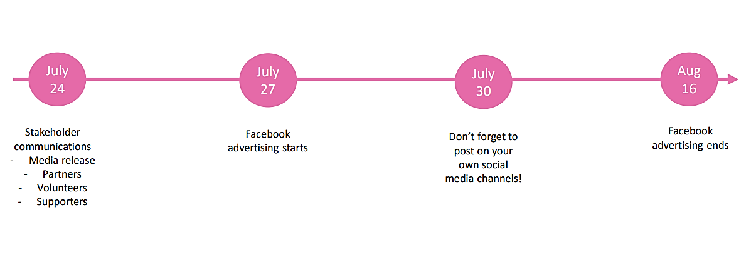
Figure 04: Campaign activities set on a timeline
Source: (www.ourwatch.org.uk, 2022)
The main idea of the set campaign was community engagement, and knowing one’s community and people in the neighborhood can help look out for unusual behaviors and immediately take action. This will help prevent burglaries from taking place. The campaign’s target audience was non-members as well as, specifically the younger audience of around the ages of 20-50 years in the areas of England and Wales. The campaign would offer its audience information on several tools and measures that could be taken to grow safety measures inside the house. As a result, it was predicted that it would lead to a decrease in the risk of burglary to around 49%

2.1. Community Engagement Policy
There have been emerging policies such as the West Yorkshire’s Policy where its police ensure to comply with the Authorised Professional Practise (APP) to improve the community engagement factor towards reduction and prevention of crime rates in the neighboring countries. The policy embassies on the importance of community engagement as the core factor towards effective policing and to make the communities feel safer (west Yorkshire.police.uk, 2022). The policy would adopt community engagement as a tool to create a better understanding of the policing strategy amongst the neighborhood members. This will help the communities to develop a sense of safety amongst each other and might result in strategically tackling the crime associated behavior. The policy is of value in tackling crime as it is applied to not only the community members but also the police officers, the volunteers, and even the staff that is involved in better management of crime (Slatcher, 2018).

2.2. Principles and Standards that depict community engagement.
The campaign held in the year 2020, named “Safety in Neighborhood- Burglary 2020” was run by a keen set of principles and standards that acted as a driving factor towards aligning its strategy accordingly. Community engagement is a factor that is being seriously considered by the West Yorkshire Police and developing early intervention strategies to solve an existing problems in the community (Pennington, 2021).
Protect the Vulnerable
To seek an understanding of the needs as well as vulnerabilities of the communities and develop a link between several intervention strategies that would be most helpful to the target population. Moreover, to seek an approach of victim-centered to seek an understanding of the experience that the victims are facing, followed by identification of their needs.
Reduce Crime
To be able to reduce crime by working with third sectors. It may also involve the identification of areas that require community engagement and creating a two-way dialogue between them and the local authorities.
Attack Criminality
To develop a room where two pathways between community service providers and the police to create engagement plans and inputs to focus on any available threat, harm, and potential risks that may take place in the community.
Provide Reassurance
To ensure that there is a sense of visibility and that the communities find the authorities approachable. The high-risk communities would be looked after by the authorities and can be made more inclusive and proactive in their decision-making process.

Provide Value for Money
The authorities will be able to seek resources and expertise that exists amongst the communities to build a communication channel amongst the vulnerable people in the surrounding. It will also seek funding so that the partners can develop a joint engagement with the community groups.

2.3. Benefits of Stakeholder’s Participation
The respective program involved keen participation of the stakeholders which depicted their involvement in the decision-making process of the program that was held (Fagan et al., 2018).
- It ensured that the plans and objectives of the project were a reflection of the needs of the communities
- Helped develop an environment of trust amongst the communities.
- The project was made accountable to the stakeholders.
- Transparency amongst the project goals and actions to be taken was maintained.
- Had managed to become a strategy that allowed us to win the project and seek a sense of commitment amongst the members and participants involved in the project.

2.4. Engaging Stakeholders through the use of Social Media.

The Program “Safety in Neighborhood- Burglary 2020” had managed to keep the stakeholders engaged through the means of social media, as it has become one of the greatest sources to keep the communities connected and to establish channels of connection that would bring in greater benefits. The campaign had its associations, support stand partners, and even the coordinators who would manage to promote the program using – Social media videos, posts, and suggested content. The campaign had allowed the activity to be run on a given timeline of 27th July (Monday) to 16th August (Sunday), which was proven to be a rewarding experience for all.

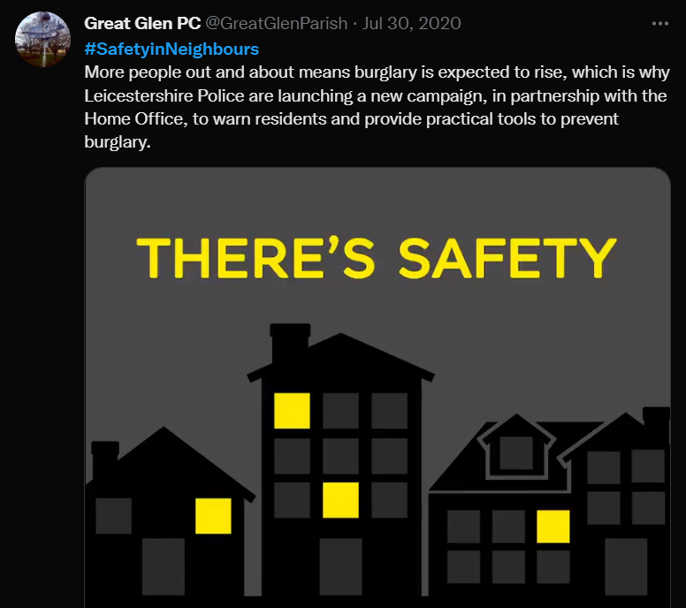
Figure 05: Engaging stakeholders through social media (Twitter).
Source: (Twitter.com, 2022)

2.5. Campaign’s Call-To-Action
The first kind of call-to-action allowed the neighbors to look out for each other and ensure that the burglary is being presented in this manner.
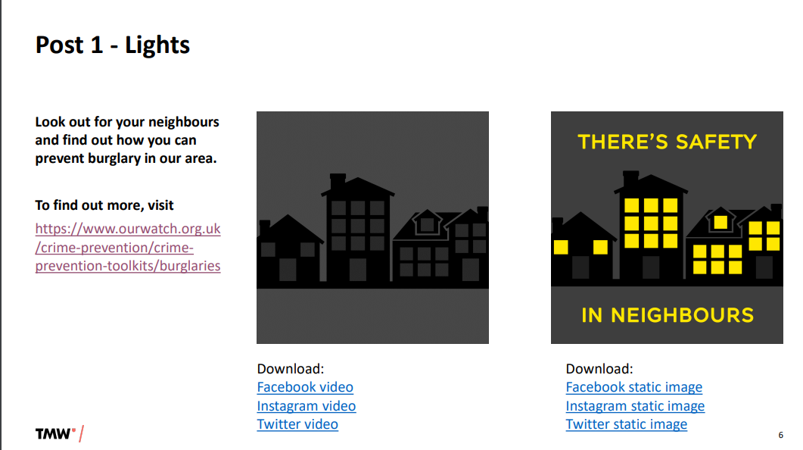
Figure 06: Program Call-to-action
Source: (ourwatch.org.uk, 2022)
The second call-to-action encouraged more people to watch the area helping in the reduction of risk being burgled.
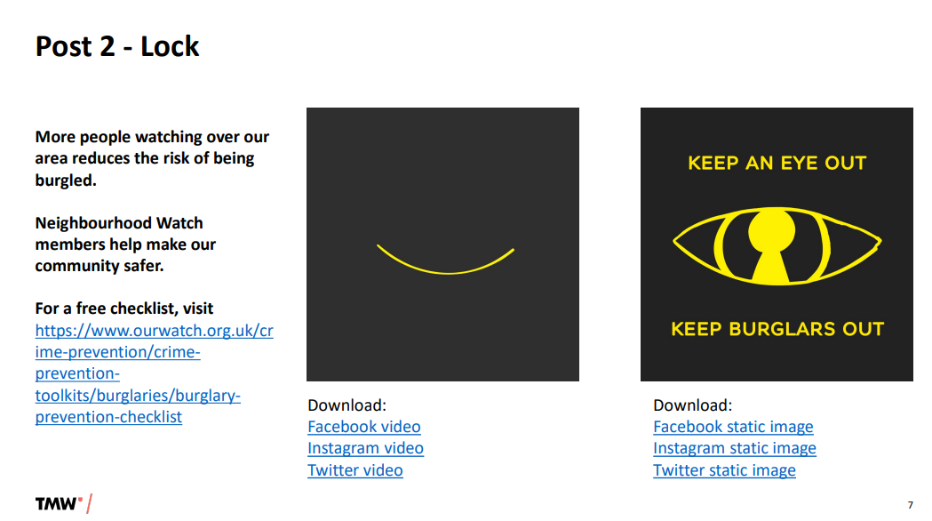
Figure 07: Program Call-to-action
Source: (ourwatch.org.uk, 2022)

The third call to action encouraged the members to spot unusual activity in the community by updating them on what was going on in the area.
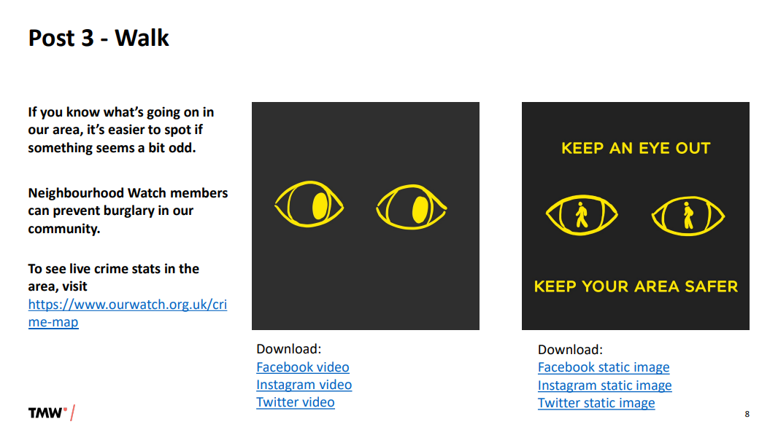
Figure 08: Program Call-to-action
Source: (ourwatch.org.uk, 2022)
Other call-to-actions involved:
- Burglary prevention checklist
- Watch live crime stats in the area
- Join the neighborhood watch movement.
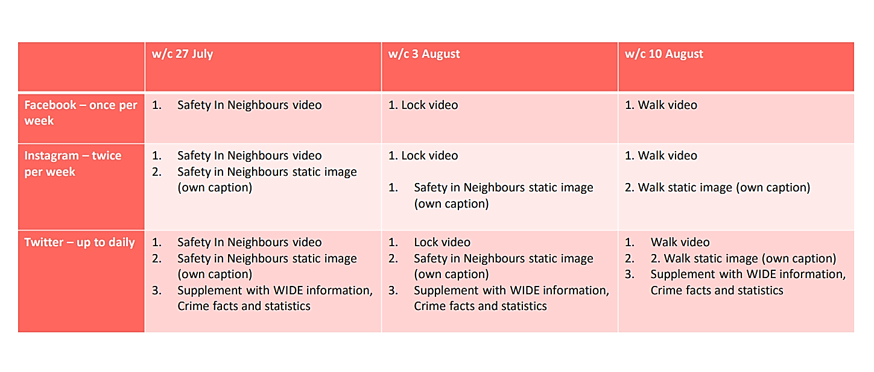
Figure 09: Posting-Frequency as recommended by the Campaign
Source: (ourwatch.org.uk, 2022)

Moreover, the campaign had set up its frequency of posting on social media which was highly specific to dates- 27th July, 3rd August, and 10th August. Facebook would be engaged once per week. While Instagram would be engaged twice per week and Twitter to be engaged daily. Moreover, the content to be posted was also made aware to the members in the local areas. Such as for Facebook, on the 3rd of August, the content that would be posted might be a locked video. Whereas on Instagram, it would be a locked video with a static image of safety in neighbors and people can add their caption to the same.

2.6. Promoting Diversity and Inclusion
The program aimed to promote diversity and inclusion by having its staff, volunteers, and even the officers to be able to adopt inclusion strategies and seek community engagement. This would result in improved confidence amongst the community members and promote good relationships. The core objective of the program that has been adopted was to bring in a set of diversity and inclusivity amongst the workforce, as it would act as a reflection of the communities amongst which the program would be held. To be able to create a sense of safety and confidence amongst communities, especially when having able to tackle the crime-related issues or incidents in the environment (Gulma et al., 2019).

2.7. The need for a forward-looking approach
Community engagement is a large concept in itself and considers a wide range of activities that involves several processes having their end terms. The term engagement would not bring its utmost value if perceived from a top-down approach. Rather by perceiving it using the forward-looking approach, it creates space for the co-production of a community, with its capacity building.
The forward-looking approach allows for the development of the specific network in the communities and improves the understanding of the interaction pattern that the members hold. In this manner, the officers and authorities can hold an approach that is unique to the different needs of the community members and adopt approaches that would be flexible enough to attend to these.
This will help towards the creative thinking process and an effective decision-making model that can allow the government to incorporate the voice of those individuals who have not gotten a chance to contribute.

3. Conclusion
An event similar to “Safety in Neighborhood- Burglary 2020” can be coordinated shortly to reduce the risk of crime and burglary in the communities that are already at a rising risk such as Welsh and England. Community engagement is a process that regardless of the circumstances, must bring about a sense of safety amongst the public. It must allow to increase confidence and trust amongst the community members, and be able to apply a wide range of early interventions for effective problem-solving mechanisms and decision making for a greater sense of wellbeing amongst the community members.

3.1. Recommendations
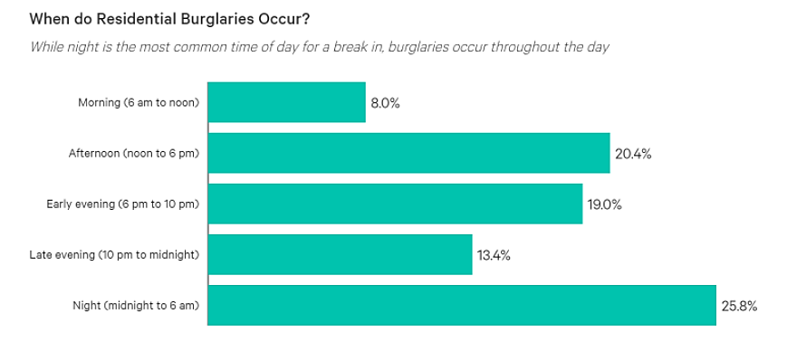
Figure 10: Awareness of the specific times when burglaries happen.
Source: nmblefins.co.uk, 2022
The authorities and stakeholders can improve community engagement by allowing means of greater community inclusion practices where the individual community members can share their thoughts and personal opinions without any hesitation. The development of communication channels would be a good start. Furthermore, developing means for the community members to be able to connect daily would be beneficial. Spreading awareness such as specific interventions like installing automatic door locking systems and surveillance cameras would be a rational way towards effective decision making.
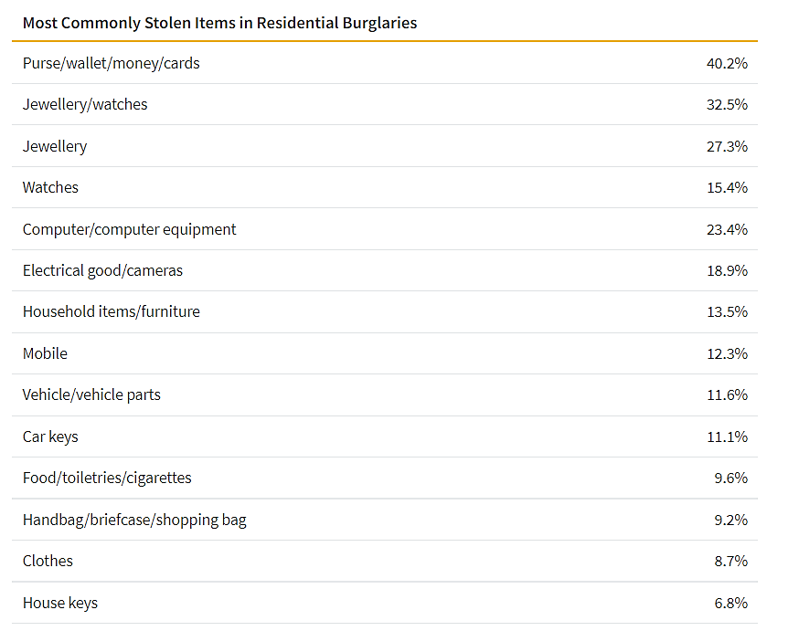
Figure 11: Awareness of common items in Burglaries.
Source: nimblefins.co.uk, 2022

The campaigns can also make people aware of the specific timings when the burglars are prone to attempt the crime and the specific things that they are likely to pick as helpful ways to make people engage in community-associated activities and prevent the crime from taking place.

4. References
Crimerate.co.uk, 2022 [online] Available at: <www.crimerate.co.uk> [Accessed 06 May 2022]
Fagan, A.A., Hawkins, J.D. and Catalano, R.F., 2018. Communities that care: Building community engagement and capacity to prevent youth behavior problems. Oxford University Press, USA. https://books.google.co.in/books?hl=en&lr=&id=0s50DwAAQBAJ&oi=fnd&pg=PP1&dq=Stakeholder%E2%80%99s+Participation+in+community+engagement+to+prevent+crime&ots=4Vx0QU7F_i&sig=2Gf1yauQbdVCyt1RMk-ieSMkys8
Gulma, U.L., Evans, A., Heppenstall, A. and Malleson, N., 2019. Diversity and burglary: Do community differences matter?. Transactions in GIS, 23(2), pp.181-202. https://onlinelibrary.wiley.com/doi/abs/10.1111/tgis.12511
Hunter, J., Ward, B., Tseloni, A. and Pease, K., 2021. Where should police forces target their residential burglary reduction efforts? Using official victimisation data to predict burglary incidences at the neighbourhood level. Crime Science, 10(1), pp.1-11. https://link.springer.com/article/10.1186/s40163-021-00144-x
Laycock, G. and Tilley, N., 2018. A short history of the England and Wales national burglary security initiatives. In Reducing burglary (pp. 21-44). Springer, Cham. https://link.springer.com/chapter/10.1007/978-3-319-99942-5_2
Mawby, R.I., Burglary and the Ideal Victim. https://osf.io/preprints/socarxiv/un2cq/download
Nimblefins.co.uk, 2022 [online] Available at: <https://www.nimblefins.co.uk/home-insurance/burglary-statistics#trends> [Accessed 06 May 2022]
Ourwatch.org.uk, 2022 [online] Available at: <www.outwatch.org.uk> [Accessed 06 May 2022]
Pennington, A., 2021. Colonising Communities? Community Engagement, Democracy, and the Articulation of Power in the Governance of Multi-Academy Trusts in England (Doctoral dissertation, York St John University). http://ray.yorksj.ac.uk/id/eprint/6278/
SLATCHER, S., 2018. The geographies of encounter in community-based social action projects in West Yorkshire (Doctoral dissertation, Durham University). http://etheses.dur.ac.uk/12658/
Westyorkshire.police.uk, 2022 [online] Available at: <https://www.westyorkshire.police.uk/sites/default/files/2019-09/community_engagement.pdf> [Accessed 06 May 2022]

