
University of Wales Trinity Saint David
School of Engineering

Engineering Design - ACMA4008

Georgia Cox
ID 2510065
January 2026

Word count: 1914

Abstract

Manual handling of removable lids on anodising tanks presents a significant health and safety risk within automotive manufacturing environments. This design project addresses an identified workplace hazard in accordance with the Manual Handling Operations Regulations 1992 and the Health and Safety at Work etc. Act 1974, which require risks associated with hazardous manual handling to be eliminated or reduced so far as is reasonably practicable. Three alternative lid concepts were developed and evaluated against criteria including operator safety, chemical compatibility with a sulphuric acid anodising process, manufacturability, cost, and regulatory compliance. Following comparative assessment, The selected solution, a two-piece polypropylene lid with integrated handles and locating features, provides a simple engineered approach that reduces individual lift mass by over 90%, enabling safe single-person operation and improving ergonomics during removal and replacement. Polypropylene’s excellent chemical resistance and recyclability also support long-term durability and environmental sustainability. The final design offers a low-cost, robust, and scalable improvement to operator safety within industrial anodising environments.

Contents
Table of Figures 4
Introduction and interpretation of the client brief 5
Context and Problem Overview 5
Objectives of the Design Solution 5
Scope of the Project 5
Key Legislation Considerations 6
3.1 Health and Safety Regulations 6
3.1.1 Health and Safety at Work etc. Act 1974 6
3.1.2 Manual Handling Operations Regulations (1992) 6
3.1.3 Provision and Use of Work Equipment Regulations (PUWER) 1998 6
3.2 The Control of Substances Hazardous to Health Regulations 2002 6
3.2.2 Material Compatibility and Durability 7
Specification 7
Time plan for producing the product. 8
Relevant research 8
Material 8
Mechanisms 12
Annotated sketches of multiple design concepts 13
Design 1 13
Design 2 14
Design 3 15
16
CAD model of the final design 16
Fully dimensioned technical drawings (BS8888), with material choices and tolerances 19
Material Choice 21
Tolerances 21
Manufacturing processes for each component 22
Polypropylene lid with handles 22
A full justification for design choices 23
Conclusion 24
Bibliography 25

Table of Figures

Figure 1. GPa of Grade 316 stainless steel. 9
Figure 2. Mechanical properties of Grade 316 stainless steel. 9
Figure 3 (Health and Safety Executive , 2020) 10
Figure 4. Properties of 316 stainless steel (Unt et al., 2010) 10
Figure 5. Properties of plastics (Guidigo, 2017) 11
Figure 6. Automated anionization tank lid (JBC Limited, 2013) 12
Figure 7 Gas strut mechanism (B&Q, 2024) 12
Figure 8. Plastic anionization tank lid (Sergei Broeska, 2022) 12
Figure 9. Comparison of PP & PE (Eryilmaz, 2020) 21
Figure 10 Self produced- information from (de Naoum, 2020). 22
Figure 11. Injection Molding (Lumafield, 2024). 22
Figure 12. Thermoforming (de Naoum, 2020) 23

Introduction and interpretation of the client brief

Context and Problem Overview
Anodization improves the corrosion resistance and aesthetic appeal of aluminium components used in OEM automotive manufacturing. Parts are lowered into a 30% sulfuric acid-filled stainless-steel tank that has been heated to 25°C. When the tank is not in use, a detachable stainless-steel lid that is 5 mm thick covers it for safety and health reasons. The current lid design is difficult to align properly and requires a two-person lift, which has led to staff complaints and a significant risk of manual handling. Due to the multiple tanks being used at different company locations, the issue presents both an operational inefficiency and a safety risk.

Objectives of the Design Solution
The objective is to create a solution that will allow a single person to safely operate the current tank cover while eliminating the identified health and safety risks. During regular operation, the design must maintain overhead clearance for anodized components and continue to effectively protect the tank. In addition to being durable and appropriate for the corrosive anodizing environment, the solution should be affordable, feasible to produce, and implement in several production facilities.

Scope of the Project
- Design a safe and practical solution for covering the anodization tank that can be operated by a single person.
- The existing tank dimensions and material must remain unchanged, although modifications to the tank are permitted where necessary.
- The tank lid will be redesigned to increase safety and usability while maintaining compatibility with current procedures, enabling a smooth transition into ongoing operations and enough room for parts to be lowered into the tank.

Key Legislation Considerations

3.1 Health and Safety Regulations
To guarantee that operator risks are reduced or eliminated as much as is reasonably possible, the tank lid must comply with all applicable health and safety regulations.

3.1.1 Health and Safety at Work etc. Act 1974

The Health and Safety at Work etc. Act 1974 states, “It shall be the duty of every employer to ensure, so far as is reasonably practicable, the health, safety and welfare at work of all his employees” (UK Government, 2014). This legislation supports the need for the lid to be safe to operate, minimise risk during normal use and eliminate foreseeable hazards associated with lifting, positioning, and exposure to hazardous substances.

3.1.2 Manual Handling Operations Regulations (1992)

The Manual Handling Operations Regulations require employers to avoid hazardous manual handling activities where reasonably practicable and to reduce the risk of injury where such handling cannot be eliminated. The redesigned lid must reduce the risk of musculoskeletal injuries, allow safe operation by a single person, and eliminate dangerous manual handling whenever possible (UK Government, 2023).

3.1.3 Provision and Use of Work Equipment Regulations (PUWER) 1998

Work equipment must be suitable for its intended use, safe to operate, and properly maintained, according to PUWER. These regulations state that the tank lid and any associated mechanisms must be stable, easy to operate, and risk-free (Health and Safety Executive, 2024).

3.2 The Control of Substances Hazardous to Health Regulations 2002

According to COSHH, the employer must evaluate the risks connected to dangerous materials like sulfuric acid and putting in place the necessary safety procedures, training, and control measures. As a designer my role is to reduce these risks through engineering controls (UK Government, 2015).

3.2.2 Material Compatibility and Durability
The materials chosen for the lid must be resistant to sulfuric acid corrosion and compatible with the chemically harsh environment. Through testing and validation, the design must guarantee that material deterioration does not jeopardize structural integrity, safety or service life.

Specification

Time plan for producing the product.

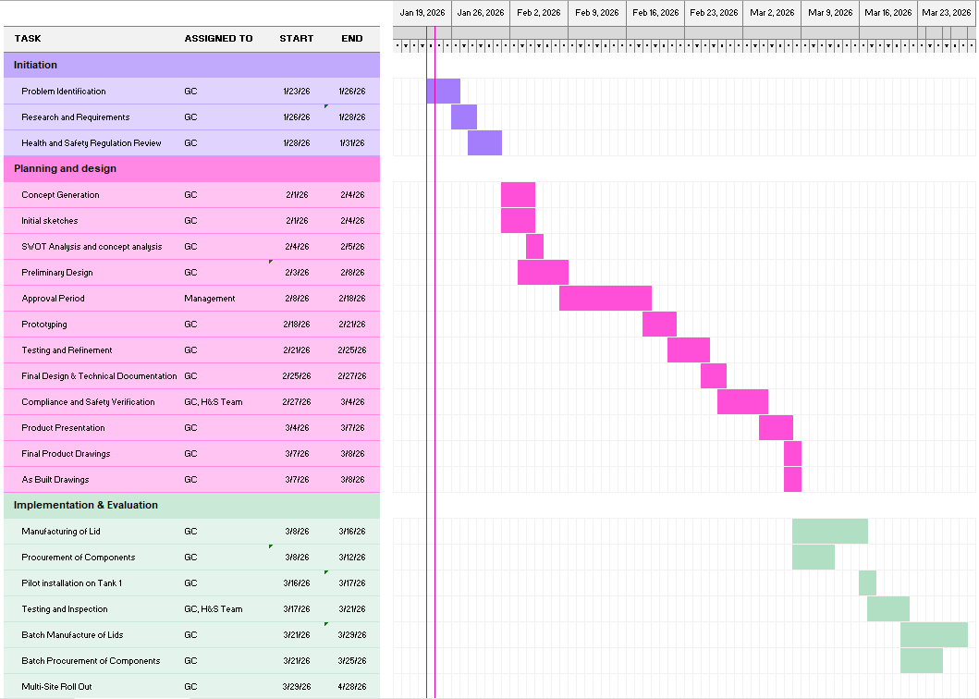

Relevant research

Material
According to industry practices documented by Arvind Anticor, anodising tanks are commonly manufactured from polypropylene, high-density polyethylene, and fibre-reinforced plastics. Each present chemical resistance, thermal stability, and mechanical strength. Polypropylene in particular is noted for its excellent resistance to aggressive acids used in anodising, and for maintaining shape and rigidity (Patel, 2025).
The stiffness needed to preserve the stability of big tank lids under self-weight and hinge loading is provided by Grade 316 stainless steel, which has a high elastic modulus of roughly 190–200 GPa, as seen in Figure 1. This is complemented by moderate yield and tensile strength with high ductility, as shown in Figure 2. This makes the material suitable for anodization tank lids and hinge components because it can withstand repeated opening cycles and local stress concentrations without brittle failure.
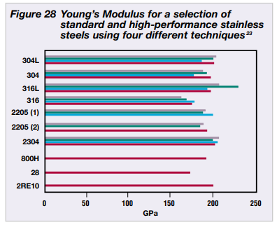
Figure 1. GPa of Grade 316 stainless steel.
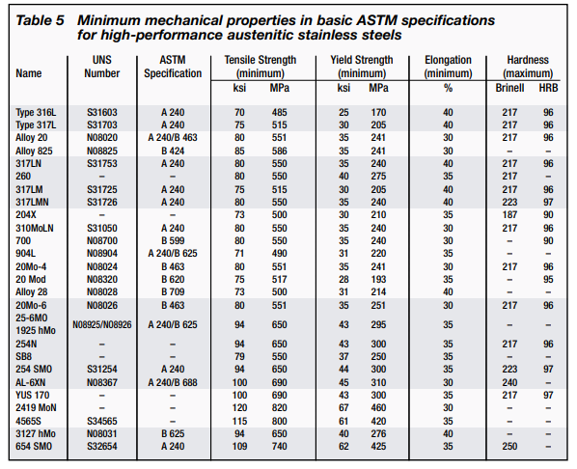
Figure 2. Mechanical properties of Grade 316 stainless steel.

Manual handling guidance recommends maximum lifting weights from knuckles height of 25 kg for men and 16 kg for women (Health and Safety Executive , 2020).
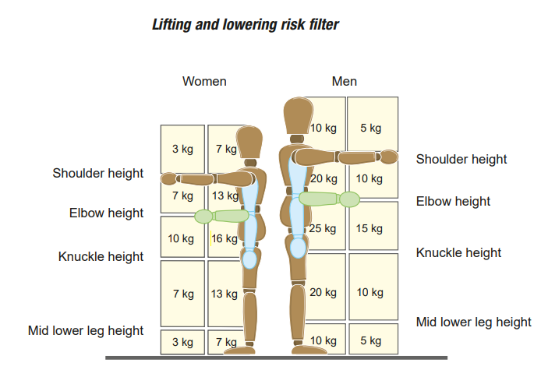
Figure 3 (Health and Safety Executive , 2020)

The existing stainless steel lid, based on a density of approximately 8000 kg/m³ (Unt et al., 2010), has an estimated mass of 72 kg, which significantly exceeds these limits.
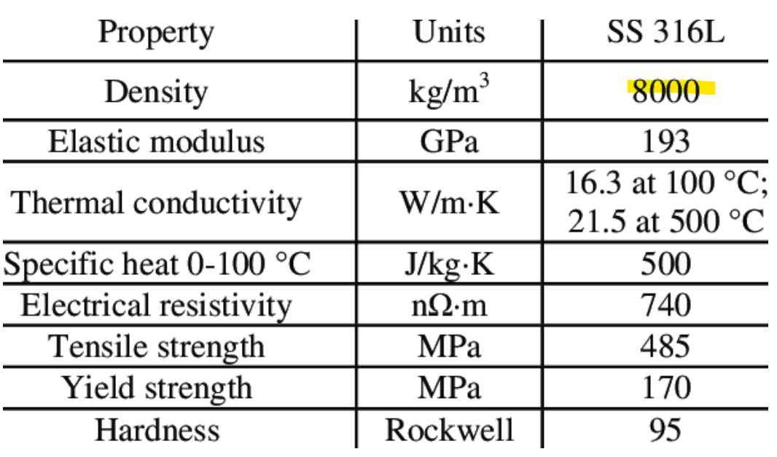
Figure 4. Properties of 316 stainless steel (Unt et al., 2010)

Replacing the lid with polypropylene, with a density of approximately 900 kg/m³ (Guidigo, 2017), would reduce the lid mass by approximately 89% to around 8 kg, bringing it within recommended lifting guidelines and enabling safe single-person operation.
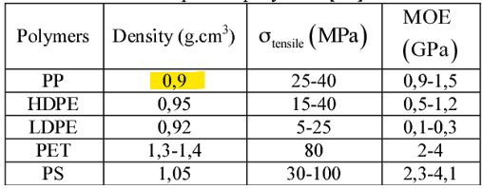
Figure 5. Properties of plastics (Guidigo, 2017)
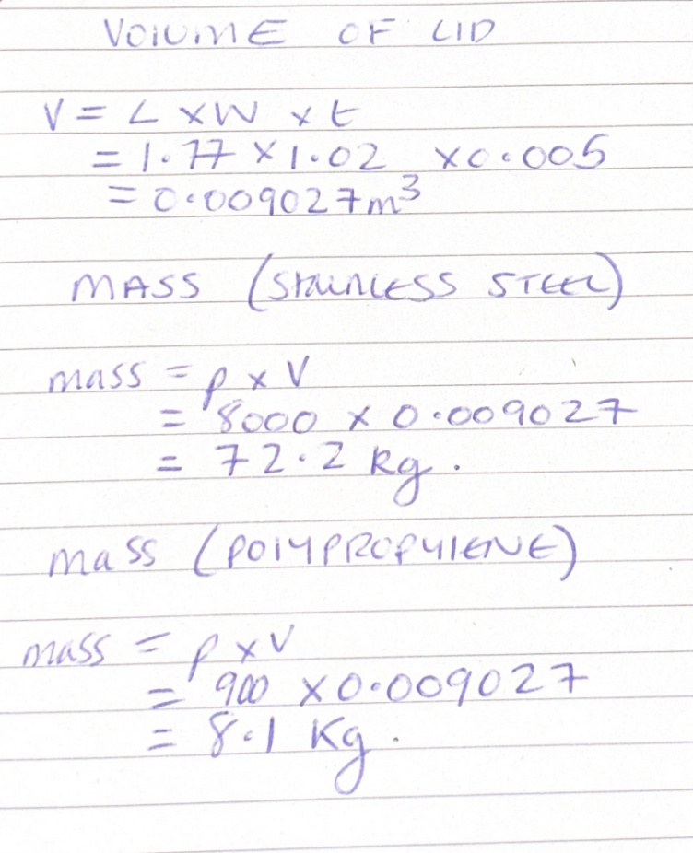

Mechanisms
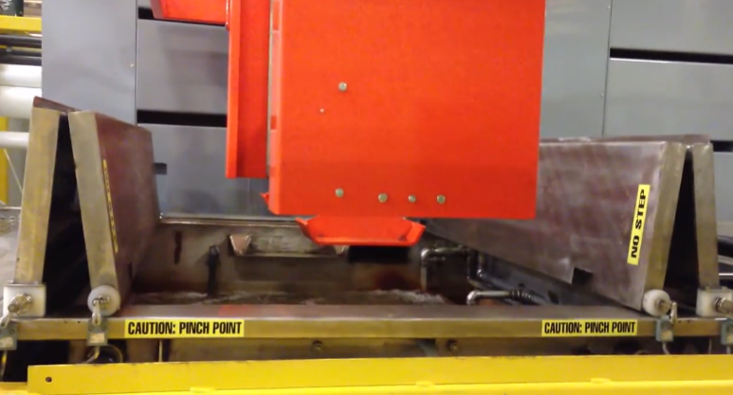
A range of tank lid mechanisms are used across industry, many of which are fully automated, however these systems are costly to implement. I have gathered initial design inspiration was from common lid and opening mechanisms observed on everyday household items, which demonstrate simple, reliable, and low-cost solutions that could be adapted for this application.

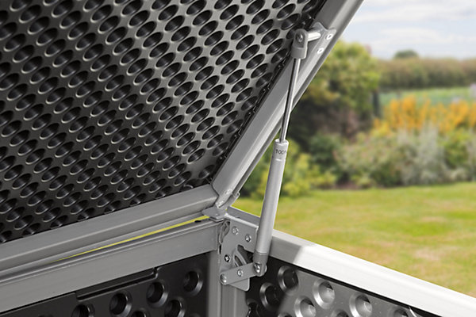
Figure 6. Automated anionization tank lid (JBC Limited, 2013)

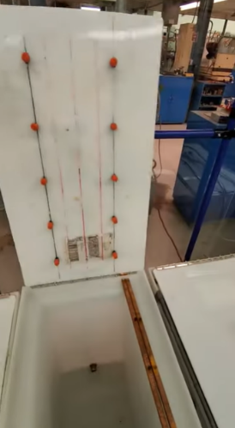
Figure 7 Gas strut mechanism (B&Q, 2024)

Figure 8. Plastic anionization tank lid (Sergei Broeska, 2022)

Annotated sketches of multiple design concepts

Design 1
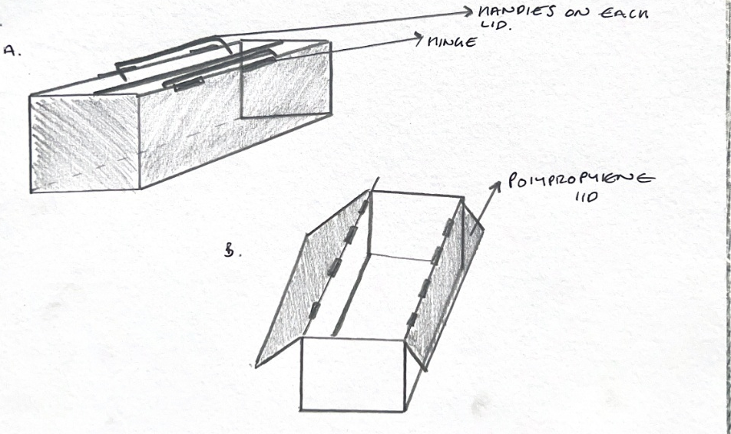

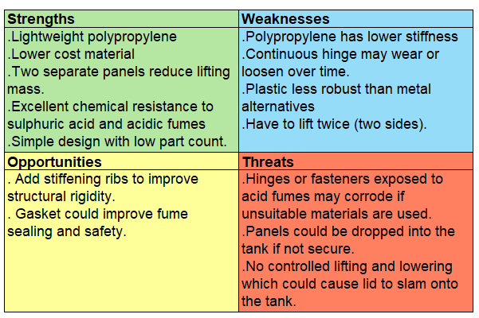
This design consists of a two-piece lid manufactured from polypropylene, connected by a continuous hinge and incorporating integrated handles for manual operation. Each panel can be lifted independently, effectively halving the lifting mass and enabling safe single-person use without mechanical assistance.

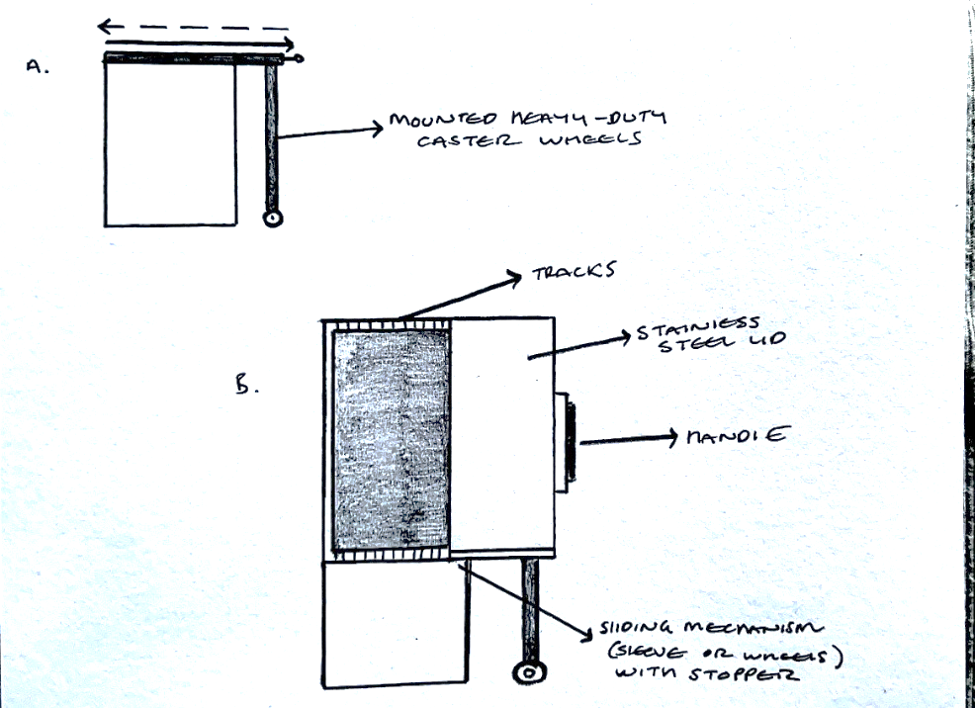
Design 2

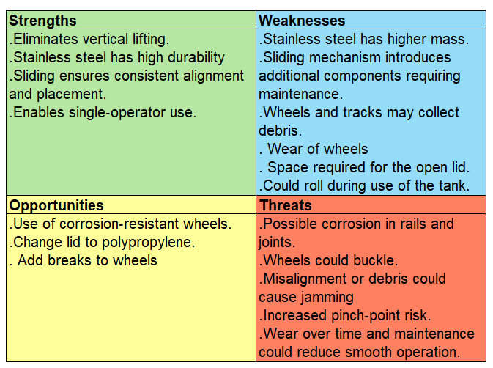
This design uses a Grade 316 stainless steel sleeve lid mounted on wheels, allowing it to slide horizontally, eliminating the need for vertical lifting and enabling single-operator use. The holes slot into stoppers on the end of the box to ensure the lid doesn’t slide too far.

Design 3
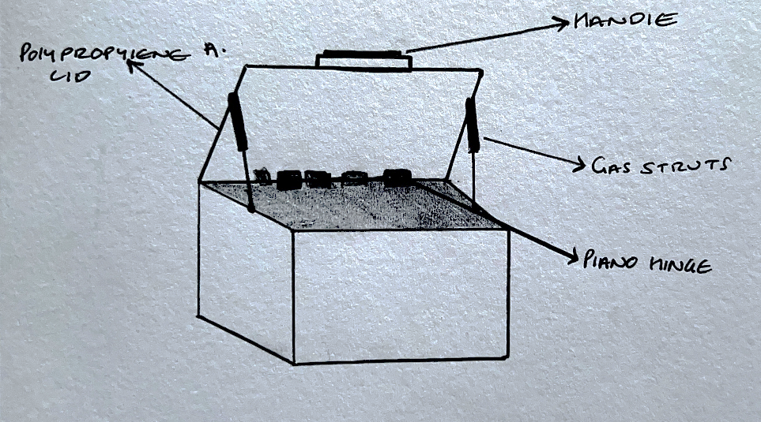

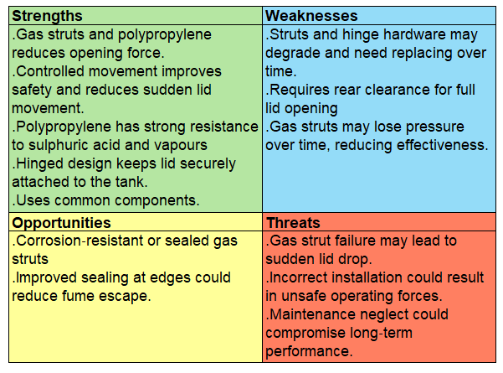
This design features a hinged polypropylene lid with gas-strut assistance which is attached via a full-length piano hinge mounted along the rear long edge of the tank. The gas struts act as a counterbalance, reducing the force required to open the lid and controlling its movement throughout the operating range.

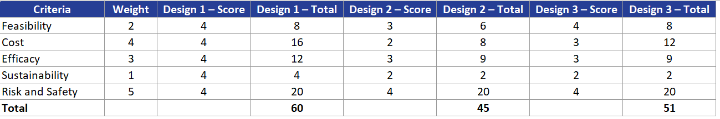

CAD model of the final design
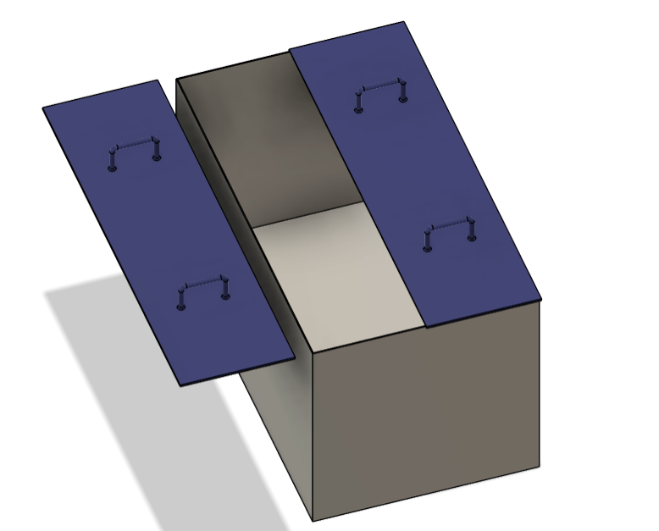
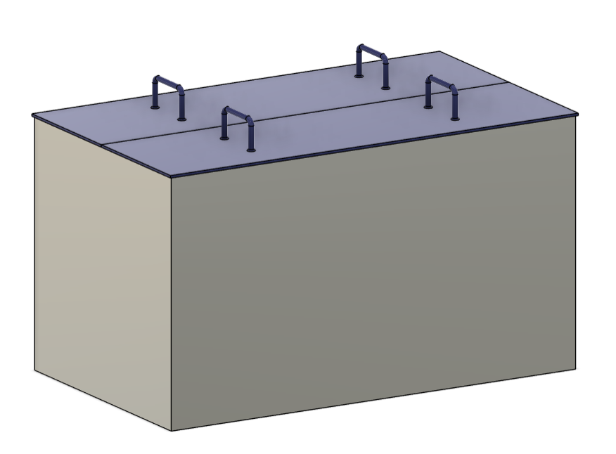
I selected Design 1 because it achieved the highest overall score and offered the most cost-effective and efficient solution. Following the SWOT evaluation, I introduced improvements: instead of using a piano hinge, which introduces risks, requires periodic maintenance or replacement, and creates challenges when attaching metal hardware to 5 mm polypropylene, I incorporate two handles on each side which allows the lids to be lifted off easily, while the integrated lips ensure accurate alignment when repositioned.
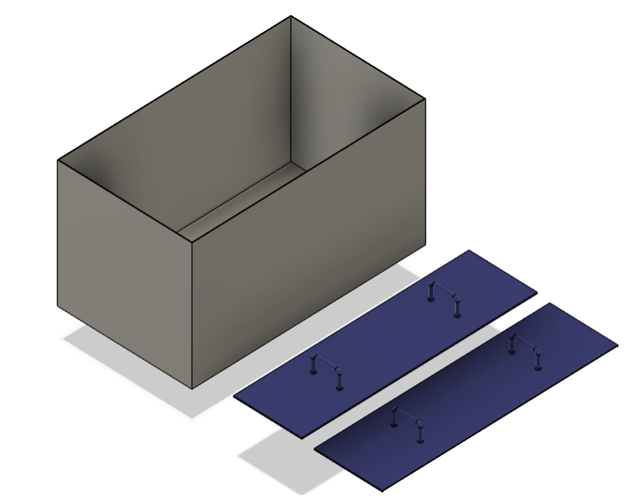
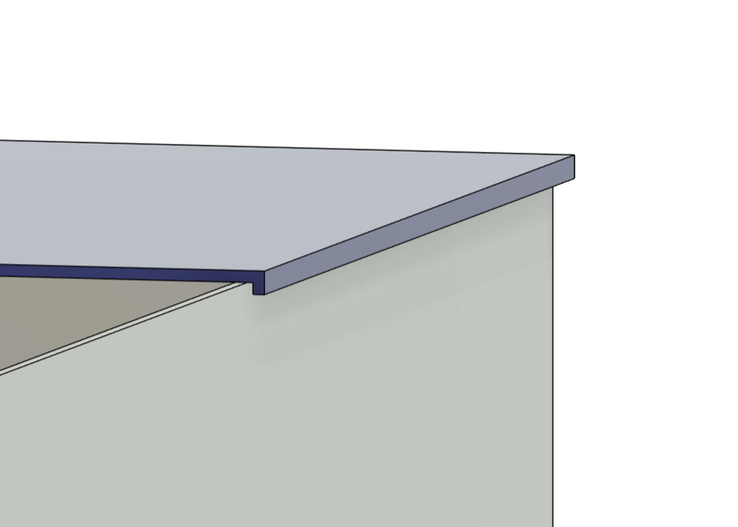
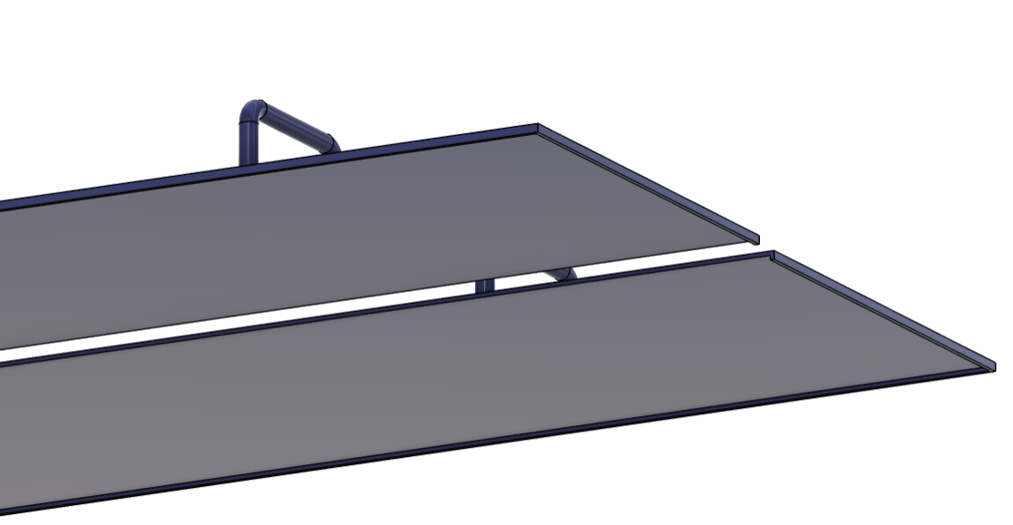
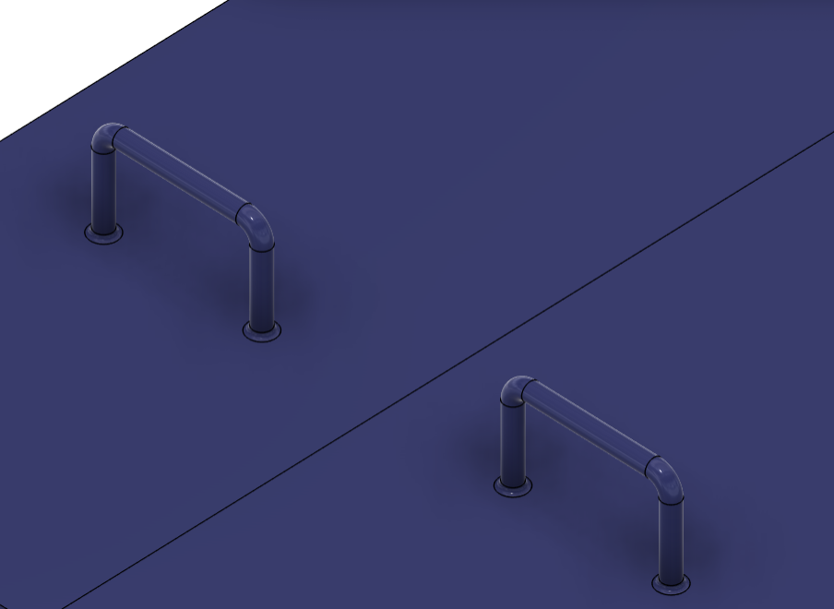

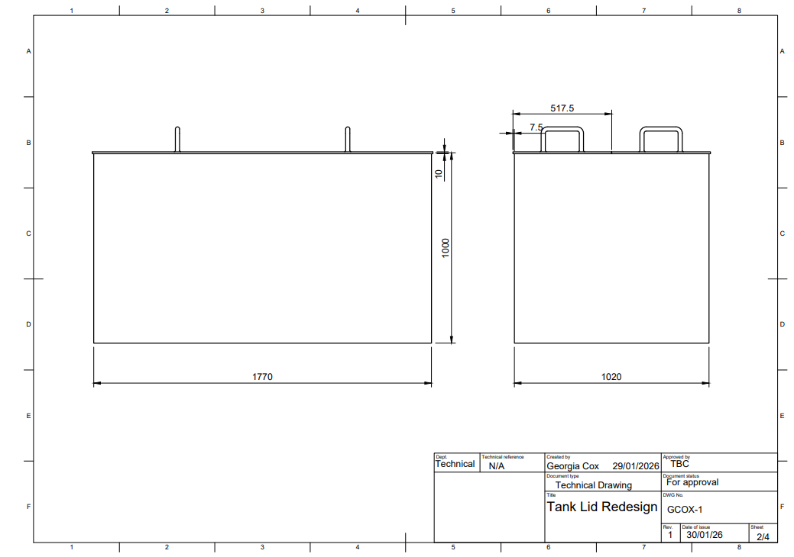
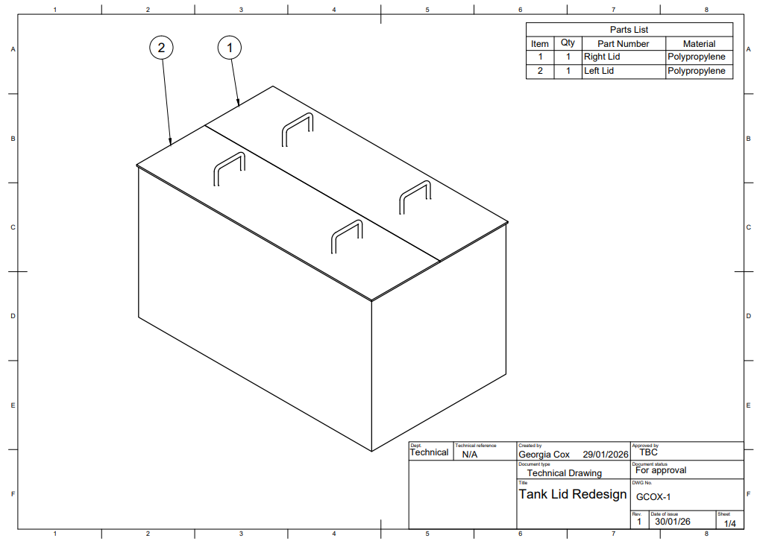
Fully dimensioned technical drawings (BS8888), with material choices and tolerances
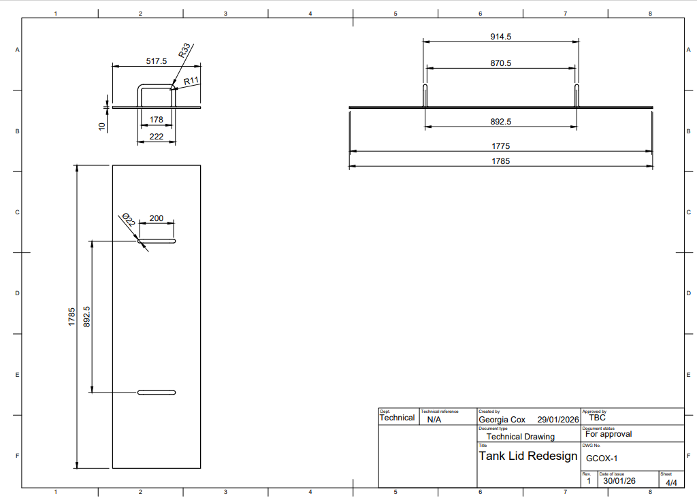
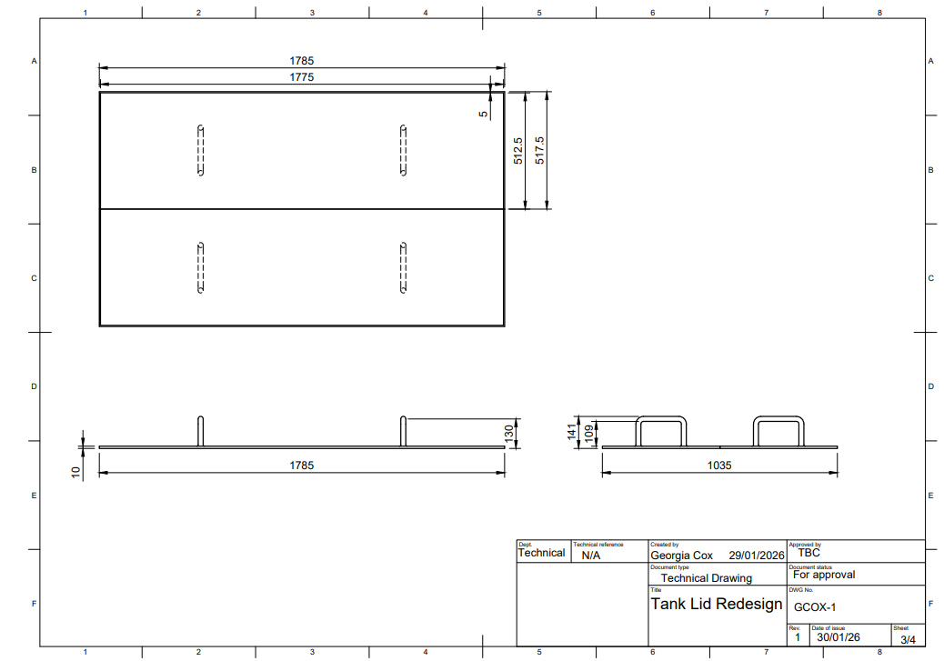

Material Choice
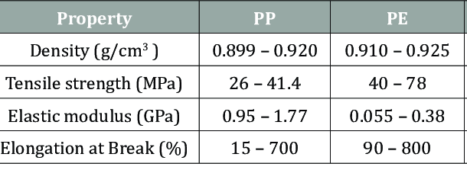
I changed the material from metal to chemical resistant plastic to significantly reduce weight. The table shows that polypropylene is lighter and stiffer than polyethylene, making it better for a large removable lid that needs to maintain shape when lifted. Polyethylene is more flexible and would sag or deform, whereas polypropylene provides the rigidity and dimensional stability needed.
Figure 9. Comparison of PP & PE (Eryilmaz, 2020)

Tolerances
A general manufacturing tolerance of ±0.5 mm will be applied across the overall lid geometry to ensure suitable fit on the tank, while the formed locating lips will use a tighter ±0.1 mm tolerance to maintain consistent alignment and stable seating when the lids are placed on or removed.

Manufacturing processes for each component

Polypropylene lid with handles

Both injection moulding and thermoforming methods for manufacturing the lid however, the functional requirements of the lids make injection moulding the superior choice. The lids require integrated handles, locating lips, and consistent stiffness so they can be repeatedly lifted and repositioned without distortion. Two mould cavities (or a dual-cavity mould) would be used, rather than producing a single large moulded panel and cutting it in half, which would compromise accuracy and introduce warping.
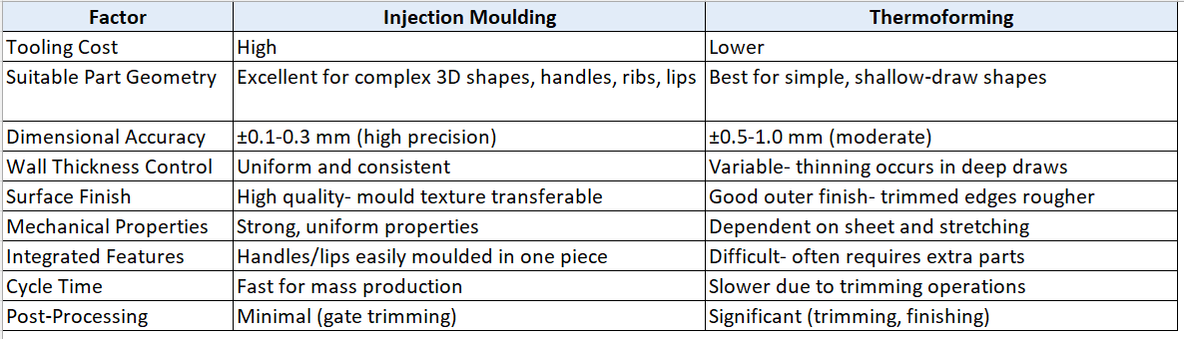
Figure 10 Self produced- information from (de Naoum, 2020).
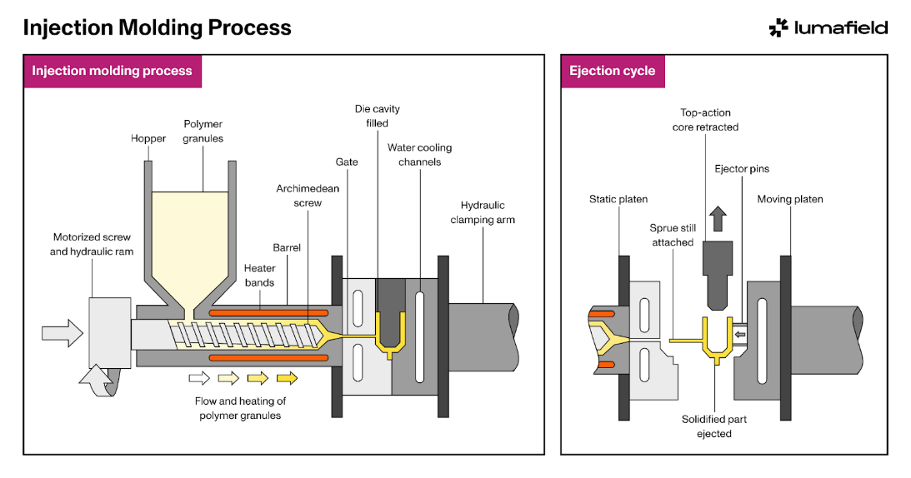
Figure 11. Injection Molding (Lumafield, 2024).

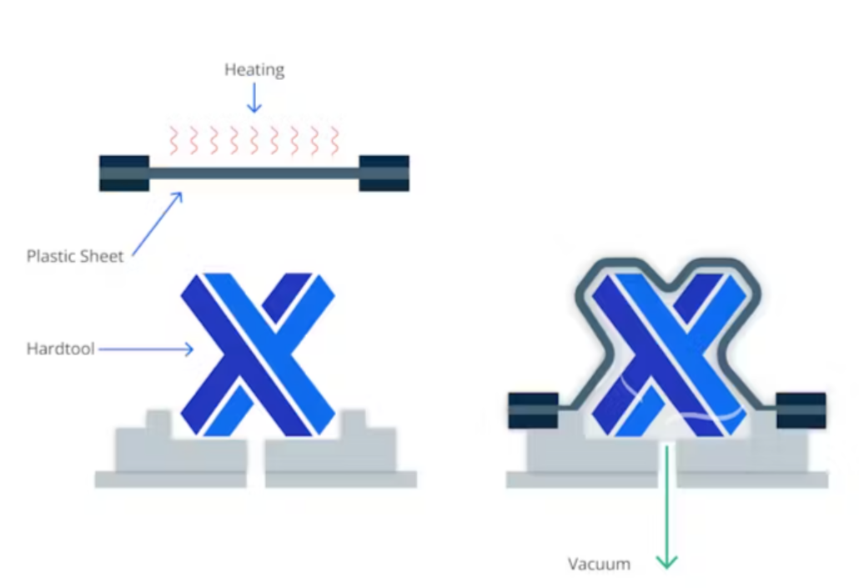
Figure 12. Thermoforming (de Naoum, 2020)

A full justification for design choices

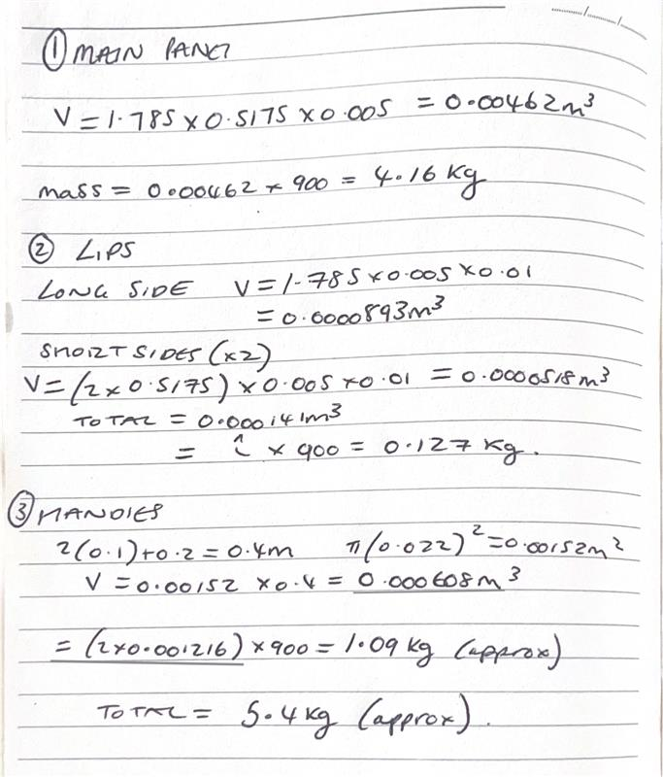
I identified the two-piece polypropylene lid as the most effective solution. The original lid had an approximate mass of 72.2 kg, presenting a manual handling hazard and necessitating two-person operation. Through material substitution and geometric redesign, the proposed solution reduces the effective lift mass to 5.4 kg per lid, representing an approximate 92.5 % reduction in lifting weight. This reduction directly addresses the safety issue by reducing the load well within accepted single-person manual handling limits, thereby substantially reducing the risk of musculoskeletal injury.
Polypropylene was chosen due to its strong resistance to sulphuric acid, low density, and proven performance in anodising environments. Its recyclability also offers a sustainability advantages. Dividing the lid into two narrow sections along the tank’s length further improves ergonomics by reducing the individual lift weight, enabling operators to keep the load close to the body, and limiting the need to reach across the tank. This arrangement also reduces the exposure of workers to acidic fumes or splashes during removal and replacement.
Each lid incorporates two fixed handles, oriented to promote balanced two-handed lifting and neutral wrist and shoulder postures. This handle arrangement improves control during handling and placement, reducing the likelihood of dropped components or sudden movements. Integrated locating lips on each lid ensure accurate alignment with the tank rim, preventing movement once installed and improving positional repeatability without introducing additional mechanical complexity that would increase maintenance, replacement requirements, or installation effort.
The design aligns with the hierarchy of risk control by reducing manual handling risk through inherent mass reduction, rather than relying on administrative controls or operator technique, while avoiding the introduction of additional mechanical systems that could create new hazards such as trapping points, uncontrolled movement or maintenance-related failures. Based on a raw polypropylene unit cost of 6,754 CNY per tonne (excluding processing and logistics), the combined material requirement for both lids results in an estimated material cost of roughly USD 10, supporting the feasibility of wider implementation across similar tanks.

Conclusion
While full automation or mechanical lifting systems could further reduce operator involvement, such solutions would introduce unnecessary cost, increased system complexity, additional maintenance requirements, and reduced scalability across multiple tanks.
The selected two-piece polypropylene lid design eliminates the primary hazard by significantly reducing lid mass, enabling safe single-person operation and removing the need for two-person lifting in accordance with the Manual Handling Operations Regulations 1992. The absence of complex mechanical components avoids the introduction of secondary hazards such as trapping points or uncontrolled movement, supporting safe and predictable use in line with PUWER 1998.
Material selection ensures excellent chemical resistance to sulphuric acid, supporting compliance with COSHH Regulations 2002, while the use of recyclable polypropylene aligns with the principles of the Environmental Protection Act 1990 by reducing material waste and improving end-of-life recyclability.
Overall, the final design represents a robust, compliant, sustainable, and cost-effective engineering solution that improves operator safety and is well suited for scalable implementation within an industrial anodising environment.

Bibliography
B&Q (2024). Garden Store Direct 830L/220 Gallon MASSIVE Capacity Outdoor Garden Storage Box. [online] B&Q. Available at: https://www.diy.com/departments/garden-store-direct-830l-220-gallon-massive-capacity-outdoor-garden-storage-box/5061035565310_BQ.prd?&&&&gclsrc=aw.ds&gad_source=1&gad_campaignid=21001176640&gclid=EAIaIQobChMIyaH0kYOgkgMV1qNQBh2SqSM1EAQYEiABEgK8YPD_BwE [Accessed 22 Jan. 2026].
de Naoum, K. (2020). Injection Molding vs. Thermoforming: Differences and Comparisons. [online] www.xometry.com. Available at: https://www.xometry.com/resources/injection-molding/injection-molding-vs-thermoforming/.
Eryilmaz, O. (2020). Investigation of the Water-Based Ink Hold onto the Thermoplastic Composites Reinforced with Sisal Fibers. Journal of Textile Science and Fashion Technology.
Guidigo, J. (2017). Polyethylene Low and High Density-Polyethylene Terephthalate and Polypropylene Blend as Matrices for Wood Flour. International Journal of Science and Research (IJSR), 6(1), pp.1069–1074. doi:https://doi.org/10.21275/art20164296.
Health and Safety Executive (2024). Provision and Use of Work Equipment Regulations 1998 (PUWER) - overview - HSE. [online] Hse.gov.uk. Available at: https://www.hse.gov.uk/work-equipment-machinery/puwer-overview.htm.
Health and Safety Executive (2020). Health and Safety Executive Manual Handling at Work a Brief Guide. [online] Available at: https://www.hse.gov.uk/pubns/INDG143.pdf.
Lumafield (2024). Manufacturing Process: Injection Molding. [online] Lumafield.com. Available at: https://www.lumafield.com/article/manufacturing-process-injection-molding.
Patel, H. (2025). Anodizing Tank for Metal Surface Treatment. [online] arvindanticor. Available at: https://arvindanticor.com/anodizing-tank-metal-surface-treatment/ [Accessed 18 Jan. 2026].
Sergei Broeska (2022). Caswell Anodize Process - Rinse Tank Setup. [online] YouTube. Available at: https://www.youtube.com/watch?v=QcHWEbSFwrw [Accessed 18 Jan. 2026].
Trading Economics (n.d.). Polypropylene - 2022 Data - 2013-2021 Historical - 2023 Forecast - Price - Quote. [online] tradingeconomics.com. Available at: https://tradingeconomics.com/commodity/polypropylene.
UK Government (2014). Health and Safety at Work etc. Act 1974. [online] Legislation.gov.uk. Available at: https://www.legislation.gov.uk/ukpga/1974/37/section/2.
UK Government (2015). The Control of Substances Hazardous to Health Regulations 2002. [online] Legislation.gov.uk. Available at: https://www.legislation.gov.uk/uksi/2002/2677/regulation/3.
UK Government (2023). The Manual Handling Operations Regulations 1992. [online] Legislation.gov.uk. Available at: https://www.legislation.gov.uk/uksi/1992/2793/regulation/4.
Unt, A., Piili, H., Hirvimäki, M., Manninen, M. and Salminen, A. (2010). Laser scribing of stainless steel with and without work media. International Congress on Applications of Lasers & Electro-Optics. doi:https://doi.org/10.2351/1.5061932.

