BMIH6005
Organisational Consultancy

Student: Razvan Fanachi (2110542)
Lecturer: Jaliya de Silva
Table of Contents
Executive Summary 3
Introduction 6
Analysis 8
Identification of Issues 8
PESTEL Analysis 12
SWOT Analysis 15
TOWS Analysis 17
Recommendations and Change Management 19
Premier Inn's Change Management Strategy 23
Measuring Success of the Recommended Strategies 25
Benefits Associated with the Recommendations 27
Cost Associated with the Recommendations 29
Action Plan 30
Conclusion 32
References 34

Executive Summary
Rapid technological advancements and changing customer demands have characterised the hotel industry's dynamic in the digital era. The renowned and well-known Premier Inn Dubai Al Jaddaf Hotel is facing difficulties that are signs of the changing environment. Although the hotel is in a prime location and has always provided dependable service to its clients, it has been confronted with the pressing challenge of staying up to date with the rapidly evolving digital landscape. The core of the issue is not just the technology setup, but also how it interacts with the contemporary customer experience. The more knowledgeable tourists of today make greater use of Internet resources for planning, booking, and even post-trip reviews. From booking a stay to checking out of a hotel, they expect a smooth digital experience. In this regard, Premier Inn has many challenges such as improving its online presence to draw in more visitors and integrating new technologies to improve its customers' in-room experiences.
The thorough investigation and industry benchmarking produced several useful insights that clarified the hotel's existing situation. When compared to modern digital standards, the Premier Inn Dubai Al Jaddaf Hotel's digital footprint seems to be inadequate. A recent survey of Booking.com found that 74% of leisure travellers and 57% of business travellers primarily rely on Internet search results when selecting a hotel. When compared to the hotel's present online presence, this statistic shows a substantial disparity and the possibility of losing this large traveller demographic. When delving further into the digital experience, the effectiveness of the online booking procedure is critical. A significant change in traveller booking behaviour was noted by a 2021 Statista research, which showed that 82% of travellers strongly preferred making hotel reservations online and attributed their decision to convenience. Although this trend is representative of the industry as a whole, this analysis of Premier Inn Dubai Al Jaddaf Hotel's current online booking procedure indicates that it may not be taking full advantage of this trend. Artificial Intelligence has completely changed the hotel industry's customer service landscape. Immediate, effective, and 24-hour question response has become standard, mostly because of chatbots with artificial intelligence capabilities. A summary of this is provided by the Zipdo 2023 survey, which highlights the fact that the integration of AI will yield 41.1% of CAGR by 2025. Ultimately, the in-room experience now includes technology, adding to its previous focus on comfort and elegance. Travellers nowadays, particularly those in younger age groups, want smart rooms with Internet of Things gadgets so they may customise their trip. In this technologically advanced day, the hotel may be seen as outdated if certain facilities are lacking.
The findings made throughout the investigation shed light on several urgent issues and promising directions for Premier Inn Dubai Al Jaddaf Hotel. The visitor experience is the lifeblood of the hospitality sector, and in the modern world, it is inextricably linked to technology. The apparent fall in digital presence raises more questions than simply marketing issues; it indicates lost potential income and a broader mismatch with the expectations of modern travellers. When it comes to online reservations, today's visitor looks for efficiency, transparency, and ease. Potential visitors may be turned off by any inconvenience, whether it comes from an antiquated interface, many booking stages, or unstated charges. In a market where competition is so intense, even little obstacles have the power to make a guest choose another hotel. Based on data from Statista, this is not a small percentage of travellers, rather it is the vast majority. There is no denying AI's importance in improving customer service. Quick response times to inquiries, on-demand support, and round-the-clock accessibility are now standard practices in the business and are no longer considered extra services.
The hotel needs to work with a top digital firm that specialises in the hospitality industry to update the website and make sure it is user-friendly, visually appealing, and responsive to mobile devices. By using SEO tactics, the hotel will increase its online exposure and take up a greater portion of the Internet search market. Furthermore, it is essential to simplify and expedite the online reservation procedure. This entails guaranteeing price transparency, reducing the number of steps needed to complete a booking, and facilitating user-friendly navigation across the system on various devices. Furthermore, using chatbots powered by AI has the potential to completely transform the way hotels provide customer care. By working with dependable systems like IBM Watson or Azure Bot Service, the hotel can instantly answer visitors' questions, improving their pre-stay experience and creating a good impression that lasts. It is also essential that the hotel makes the necessary investments in smart room amenities. Premier Inn can greatly enhance the in-stay experience by enabling customers to customise their room settings, including lighting and temperature, via the use of sophisticated IoT devices. This will enable the hotel to fulfil the demands of modern travellers and keep up with industry leaders.
Evolution and adaptability are not only vital for development in the ever-changing hospitality business but also for survival. At this crucial moment, the Premier Inn Dubai Al Jaddaf Hotel, with its rich history and dedication to client pleasure, is the right choice. The hotel can close the gaps it now has, strengthen its position in the industry, and usher in a new age of improved guest experiences and operational excellence by adopting the recommendations. As a consultancy firm, our goal as advisors has been to provide a concise, doable road map for overcoming the current obstacles. With these tactics, we are certain that Premier Inn will prosper and keep raising the bar for hospitality and visitor experience. We are eager to follow the hotel's transformational journey and are unwavering in our resolve to assist with any further projects.

Introduction
The hospitality sector has seen a significant transformation recently due to the COVID-19 pandemic. The definition of an exceptional hotel experience has been redefined by rapid technological progress and evolving customer demands. In light of this, the Premier Inn Dubai Al Jaddaf Hotel stands out as a legendary structure attempting to make its way through this changing environment. Premier Inn has around 900 hotels all around the world and only 7 hotels in Dubai. The total room count of the hotel is 83,576 and Premier Inn Dubai Al Jaddaf has 120 rooms in that location (Statista, 2023). The hotel is situated in Jaddaf Waterfront and tourist can take the Dubai Metro, which is conveniently located 500 metres from the hotel and will take them in minutes to Festival City, WAFI Mall, and the Dubai International Financial Centre. It is an excellent starting point for discovering Dubai's sights and sounds. Because of its advantageous position, which puts major transit hubs and some of Dubai's most well-known attractions only a short drive away, it has long been a top option for both leisure and business tourists.
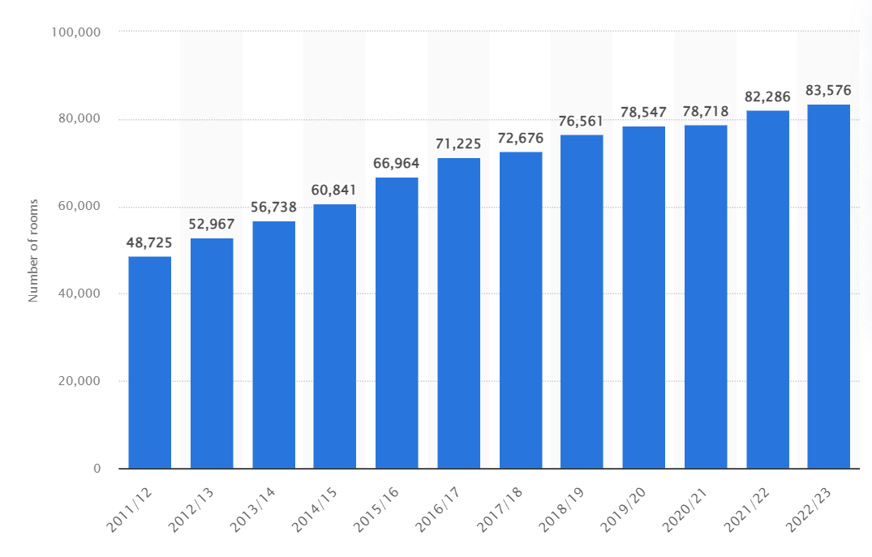
Figure 1: Total Number of Rooms of Premier Inn from 2012 to 2023, Source: (Statista, 2023).
But even established brands like Premier Inn Dubai Al Jaddaf Hotel need to regularly review their offerings and approaches in a market that is digitising quickly. It is becoming more and more necessary to improve internet presence, expedite booking procedures, and incorporate cutting-edge technology. This requirement is especially important in light of recent data showing how much internet media influences travel and accommodation choices.
Pathfinder Consultancy steps in in this situation. Our consultancy firm has specialised in hospitality and travel since 2016. Our experienced industry professionals can optimise operations and digitally change enterprises. Over the years, we have helped many hotels and resorts thrive in the contemporary world and adapt to its needs. We serve small boutique hotels and huge hotel companies, demonstrating our agility and dedication to excellence. Pathfinder is a change agent as well as a solution provider.
This study aims to assess the Premier Inn Dubai Al Jaddaf Hotel's issues and provide solutions. Our consultancy firm will utilise many proven analytical frameworks to achieve this. We shall also use solid techniques and enough empirical evidence to support our results and recommendations. This study uses PESTEL to analyse macro-environmental factors affecting the hotel. This study analyses macroenvironmental factors and focuses on opportunities and risks to provide a holistic picture of the environment. Additionally, the SWOT analysis will shed light on the external and internal variables affecting the Premier Inn Dubai Al Jaddaf Hotel. By comparing its innate strengths with the larger market dynamics, we will identify areas that need focus and those that can be used to achieve long-term success. Moreover, the TOWS analysis will concentrate on converting our conclusions into workable tactics, expanding upon the SWOT framework. To identify how the hotel can build on its advantages, mitigate its disadvantages, grab opportunities, and avoid dangers, it offers a matrix-based method. This study will be built around these three frameworks. This study wants to provide a plan that not only solves current difficulties but also prepares the Premier Inn Dubai Al Jaddaf Hotel for long-term success by systematically deconstructing the possibilities and challenges the hotel faces. This paper aims to be more than a work of analysis. It represents the dedication of Pathfinder Consultancy to excellence and collaborative progress. We anticipate a transforming journey to dive further into our findings and suggestions, guiding Premier Inn Dubai Al Jaddaf Hotel into an age of renewed prosperity and unmatched guest experiences.

Analysis

Identification of Issues
Enhancement of Digital Presence
A solid online presence is essential for every company in the modern day, but it's particularly important for businesses in the hospitality sector. A survey by Booking.com (2021), revealed that 57% of business travellers and 74% of leisure travellers made their hotel choice based on online search results. Even with its first-rate facilities and guest services, the Premier Inn Dubai Al Jaddaf Hotel seems to be lacking in this regard. A weakened online presence may be caused by several factors, such as an out-of-date website, irregular online content, little to no social media activity, and absence from major travel and hotel booking websites (Eaglen, 2020).

Figure 2: Choosing Hotels Based on Online Searches, Source: (Google, 2021).

Streamlining Online Booking Processes
Travellers in the present age need a flawless internet booking experience. According to Spendesk (2022), 82% of travellers said that the simplicity of Internet booking made them preferable when making hotel reservations. A large portion of prospective visitors may get resentful of the Premier Inn Dubai Al Jaddaf Hotel if their online reservation procedure is difficult or confusing. This might result in fewer reservations and, ultimately, lower income. Possible reasons include an old booking system, incompatibility with mobile devices, an excessive number of steps needed to complete a booking, or unstated fees that aren't disclosed to clients until the very end of the booking process (Baloglu et al., 2022).
Incorporation of AI-powered Chatbots
Instant customer service is expected in the modern digital era, not simply wanted. According to Zipdo (2023), the hotel and tourism business will have a CAGR of 41.1% by 2025. Chatbots with AI capabilities may be able to provide hotels with real-time support. The absence of might result in the Premier Inn Dubai Al Jaddaf Hotel losing out on possibilities for in-the-moment interaction, which could ultimately lower client satisfaction and loyalty (Gasimov and Aliyeva, 2020). The hotel may not have dabbled with AI because of a lack of technical expertise, worries about the necessary financial outlay, or incorrect assumptions about the difficulty of putting such systems into place.
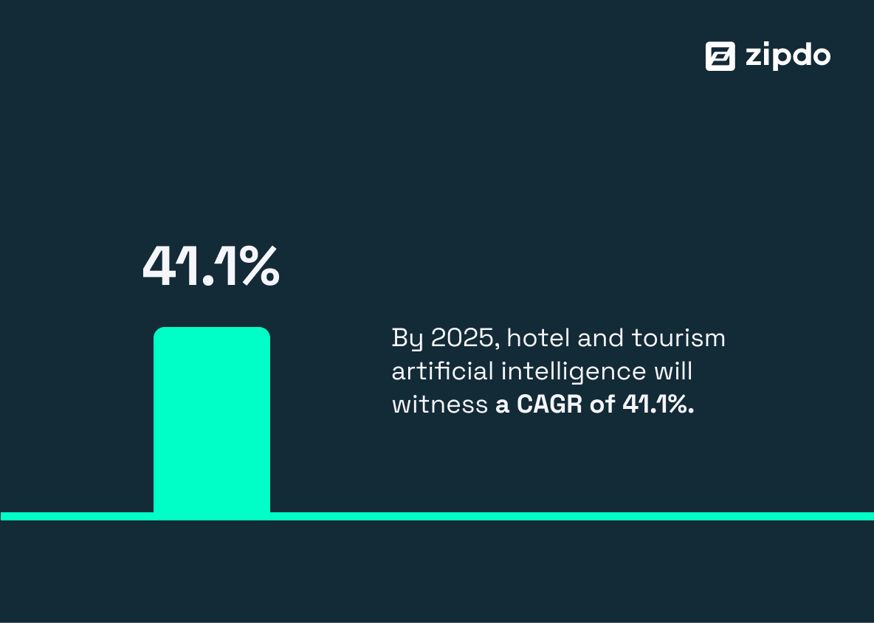
Figure 3: Expected CAGR of Hotel and Tourism, Source: (Zipdo, 2023).
Integration of Smart Room Controls
High-end hotels are quickly adopting smart room controls as standard equipment (Baigarin, 2019). They provide visitors with an unmatched degree of comfort and ease. The lack of these contemporary amenities might make the Premier Inn Dubai Al Jaddaf Hotel seem "outdated," which could reduce its attractiveness to tech-savvy tourists and those used to such comforts (Baigarin, 2019). The hesitation to include smart room controls may be due to implementation costs, a lack of knowledge about the possible return on investment, or difficulties in providing employees with the necessary training to operate and maintain these systems (Gasimov and Aliyeva, 2020).
Impact on Reputation
A hotel's reputation is directly impacted by its digital presence, effective online booking procedures, and integration of cutting-edge technology in the modern, digitally-driven world. According to Statista (2023), about 68% of travellers used online booking for travel and tourism in 2022. If Premier Inn Dubai Al Jaddaf doesn't deal with these problems, it might be seen as out of date and prospective customers would choose other hotels with more advanced digital services (Oliveira and Kakabadse, 2022). A bad reputation may spread quickly, with social media and internet platforms magnifying any unfavourable impression, making it more difficult to draw in new customers.
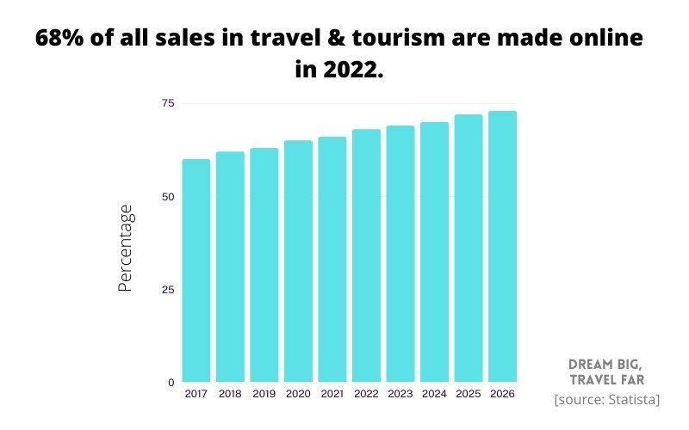
Figure 4: Sales in Travel and Tourism Made Online, Source: (Statista, 2023).
Impact on Income
There are clear financial ramifications. According to Ledsham (2022), 80% of hotel owners believe that online presence increases their bookings and revenue. Furthermore, cutting-edge technology like AI chatbots may raise hotel rates while lowering operating expenses by eliminating the need for round-the-clock human participation. In addition to fewer reservations for rooms, the absence of these innovations results in higher operating expenses and missed potential for premium pricing (Cheeseman, 2019).
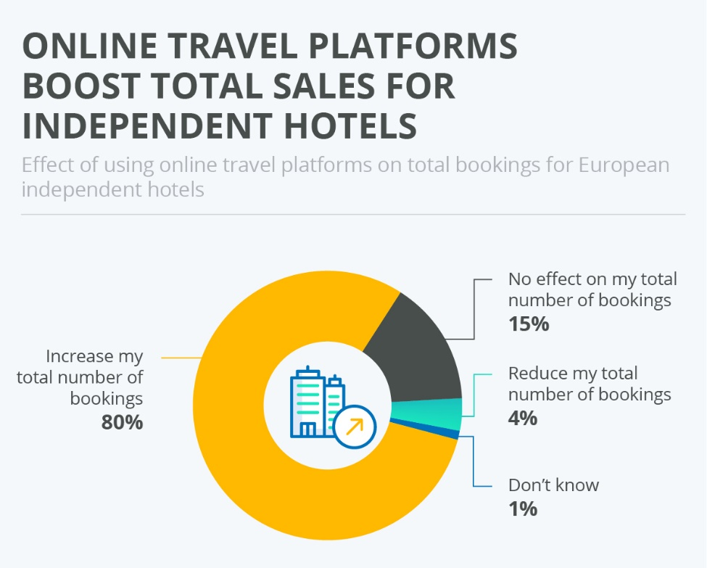
Figure 5: Online Platforms Boosting Sales of Hotels, Source: (Ledsham, 2022).
Scope of Issue Resolution
Premier Inn Dubai Al Jaddaf may see revolutionary change if the noted issues are resolved. First off, a strong online presence may increase the hotel's exposure and draw in more visitors from across the world (Nhamo and Chikodzi, 2021). By making the booking process more efficient, the hotel can better serve the demands of today's travellers and increase its market share. Using AI-powered chatbots increases visitor satisfaction and may result in recurring business, while smart room controls appeal to a technologically aware client that keeps the hotel at the top of the list (Nhamo and Chikodzi, 2021). When taken as a whole, these resolutions help the hotel stand out in the cutthroat industry and open the door to long-term, sustainable development.

PESTEL Analysis

Figure 6: PESTEL Analysis, Source: Author.
Political
The hotel business is heavily reliant on the political stability of the Dubai, particularly in the aftermath of the pandemic. Policies that encourage the use of technology in conjunction with the government's dedication to boosting tourism may have a significant impact. For example, the Dubai’s digital strategies made incentives for companies integrating digital solutions a priority (Korzay and Chon, 2022). On the other hand, unpredictability, such as shifting visa policies, may affect the number of foreign visitors and hotel reservations.
Economic
According to Statista (2023), the COVID-19 epidemic and other economic downturns caused a huge decrease in the tourism sector of Dubai but now the total number of international visitors reached 14.36 million (GMI, 2023). Due to this notable drop, hotels are being forced to provide better digital experiences to draw in a smaller clientele and engage in pricing competition.
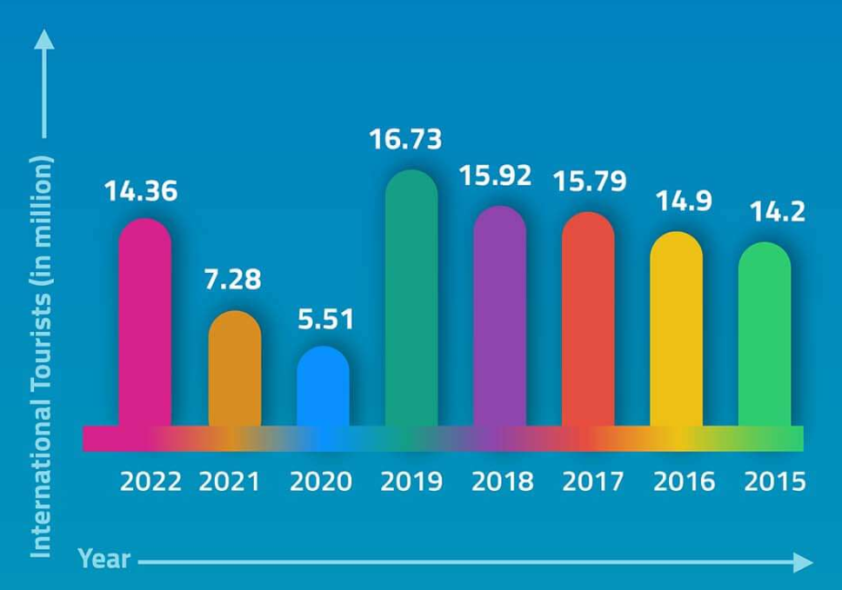
Figure 7: Number of International Visitors in Dubai, Source: (GMI, 2023).
Sociocultural
It's critical to adapt to guests' shifting tastes, who are more interested in tech-enhanced experiences. According to Wang (2021), 68% of European travellers give priority to hotels that provide digital facilities, such as in-room experiences and booking options, which reflects shifting cultural values in the hospitality sector.
Technological
Rapid advances in technology, such as 5G, IoT, and AI, have changed what guests expect (Bican and Brem, 2020). Hotels that are slow to adopt technology risk becoming outdated. Spendesk (2022) predicted that the hotel industry's AI-related business value might reach $100 billion by 2025.

Environmental
Environmental sustainability is now required rather than an option. According to Mordor Intelligence (2019), 70% of business travellers think about a hotel's environmental practices before making a reservation. Green technology integration into room controls may serve as a dual benefit, improving visitor satisfaction and exhibiting environmental responsibility.
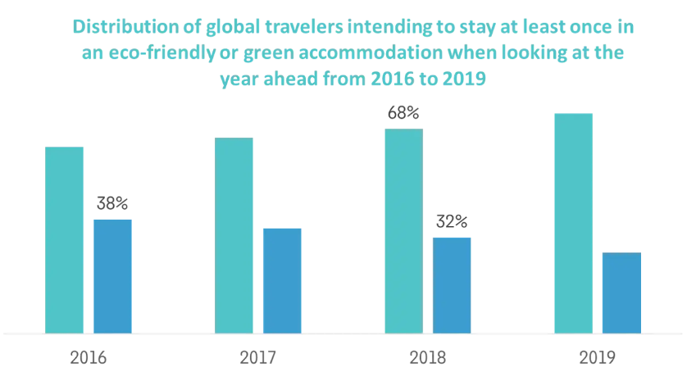
Figure 8: People Thinking about Sustainable Travel, Source: (Mordor Intelligence, 2019).
Legal
According to the European Data Protection Board, GDPR-related penalties in the hospitality sector reached around 114 million GBP by the end of 2021 (Natorina, 2021). This highlights the significance of regulatory compliance in digital operations, particularly when managing visitor data online.

SWOT Analysis
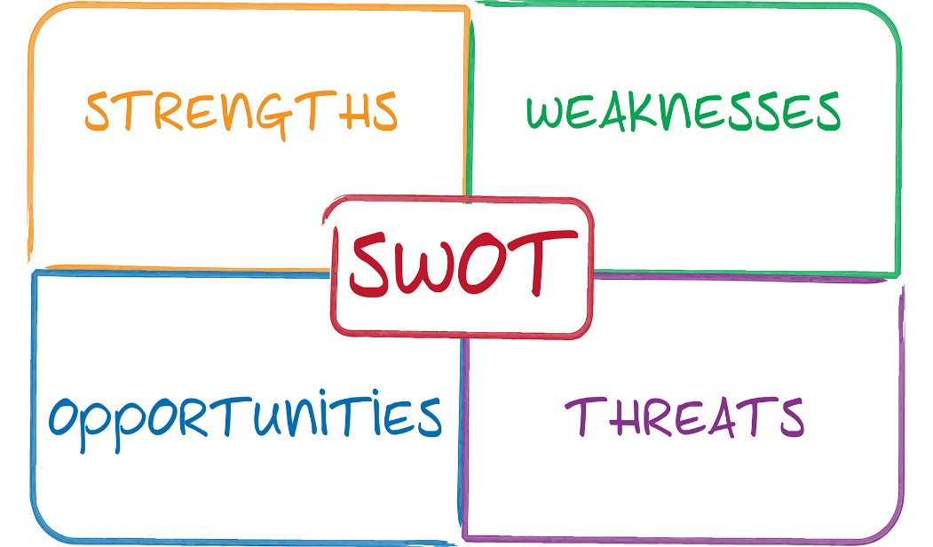
Figure 9: SWOT Analysis, Source: Author.
Strengths
Known for its reliability and excellence, Premier Inn is a mainstay in the Dubai. Jameson’s (2021) analysis showed that it was one of the most popular hotel brands among the general population. The Tolworth location combines the ease of city access with the tranquillity of suburbia, expertly tucked away close to important transit hubs and tourist destinations Jameson (2021). Additionally, Premier Inn has carved out a unique niche for itself by combining price and quality in a way that appeals to a broad range of consumers looking for value.
Weaknesses
Even with a strong brand basis, Premier Inn Dubai Al Jaddaf still needs improvement in a few areas. There are noticeable delays in online dynamism, booking smoothness, and tech integration, making the digital sphere the main area of worry. Although the brand's posture is great for travellers on a tight budget, it doesn't appeal to those looking for luxurious experiences. Furthermore, although Premier Inn's past popularity with domestic travellers is a strength, it also raises the possibility of a vulnerability due to its over-reliance on one particular market niche (Paskova, 2021).

Opportunities
Premier Inn Dubai Al Jaddaf has enormous opportunities due to the dynamic hotel business environment. The world of technology, which is exploding with innovations like IoT and AI, offers opportunities for revolutionary visitor experiences (Heng, 2020). Additionally, there is a growing worldwide awareness of sustainability. According to TripAdvisor (2022), nowadays, most travellers choose to book environmentally friendly accommodations. Moreover, Premier Inn might broaden its appeal by developing marketing tactics that appeal to visitors from throughout the world, given Dubai's worldwide popularity.
Threats
The hotel business in Dubai is very competitive, with an extensive number of luxury and low-cost businesses fighting for the business of visitors. Exogenous shocks could disrupt the balance of the hotel industry and need quick responses, whether they be political changes like Russia Ukraine War or worldwide pandemics (Gonzalo, 2021). Furthermore, the rapid advancement of technology brings with it a double-edged sword: whereas it offers avenues for improvement, it also necessitates ongoing adaptation to prevent today's ideas from becoming obsolete tomorrow (Shvetsov, 2021).

TOWS Analysis
A strategic planning technique called a Threats, Opportunities, Weaknesses, and Strengths analysis is used to assess a company's risks. Finding strategic choices that may build on a company's opportunities and strengths while defending against its weaknesses and threats is the aim of a TOWS study.
Matrix | Internal Strengths (S) | Internal Weaknesses (W)
External Opportunities (O) | SO Strategies | WO Strategies
External Opportunities (O) | 1. Tech-driven Enhancements: Leverage the brand's strong reputation and strategic location to integrate AI and smart technologies, providing a unique selling point for attracting a wider demographic (Teare, 2021). | 1. Digital Revamp: Utilize the emerging opportunities in the digital realm to address the hotel's online presence, booking process, and tech integration, positioning Premier Inn as a contemporary choice (Teare, 2021).
External Opportunities (O) | 2. Sustainability Drive: Build upon the brand's existing reputation to integrate and heavily promote eco-friendly practices, tapping into the growing trend of environmental consciousness among travelers (Montealegre and Iyengar, 2021). | 2. Diversified Marketing: To combat over-dependence on domestic markets, exploit global tourism trends by crafting marketing campaigns that resonate with international travellers, leveraging Dubai's global appeal.
External Threats (T) | ST Strategies | WT Strategies
External Threats (T) | 1. Reputation Defense: Utilise Premier Inn's strong brand value to mitigate potential reputational risks arising from intense competition. Implement robust online reputation management practices to handle negative feedback proactively (Mordor Intelligence, 2019). | 1. Agile Innovation: Given the rapid technological changes, adopt an agile approach to digital strategy. By addressing existing weaknesses in tech integration, the hotel can stay ahead of competitors and quickly adapt to industry changes.
External Threats (T) | 2. Strategic Alliances: Counter external disruptions (like Russia Ukraine War or health crises) by forming strategic partnerships or alliances, such as collaborating with local tourist attractions or travel agencies, further leveraging Premier Inn's strategic location. | 2. Regulatory Compliance: To counteract potential legal pitfalls, especially concerning GDPR, invest in robust data protection and cybersecurity measures. This not only addresses the weakness in digital operations but also counters threats from potential fines or legal actions (Montealegre and Iyengar, 2021).
Table 2: TOWS Analysis of Premier Inn, Source: Author.

Recommendations and Change Management
Here are the recommendations to solve the issues of the hotel:

Figure 10: Recommended Strategies, Source: Author.
Website Revamp
The hotel should work with a web development company that has experience in the hospitality industry so that important elements unique to hotel websites may be included. A small set of people should see a prototype before the updated website is made public. Their immediate feedback may provide priceless information about the usability and efficacy of the site's design. Prioritising a responsive design will guarantee the website's flawless operation across a range of platforms, including desktops and mobiles (Dickens, 2020). By integrating a dynamic Content Management System (CMS), hotel employees can update information regularly, maintaining the website's relevancy and authenticity. Furthermore, it is impossible to undervalue the significance of organic traffic, which is why the redesign of the website should be built around techniques like keyword integration, meta-tag optimisation, and the development of high-quality backlinks (Harrington and Akehurst, 2020).

Integration of AI
Premier Inn should start by shortlisting systems that are particularly dependable and flexible in AI integration; IBM Watson, DataRobot, and Azure Bot Service are two possible leaders in this regard. Once selected, the system should become well-versed in Premier Inn Dubai Al Jaddaf's details, thus turning it into a virtual concierge equipped with responses to frequently asked questions from guests. Iterative feedback, in which the correctness of the model's replies is frequently assessed, would help this AI model to be continuously improved. To make sure that the system's development stays in line with user expectations, visitors should be allowed to provide feedback on their chatbot experience after the contact (Grooss and Presser, 2022).
Booking Process Streamlining
To guide future refinement stages, a thorough audit of the present booking system might highlight existing pain spots. The development of an easy-to-use, welcoming booking experience for guests may be ensured by using the insights obtained from this investigation to guide cooperation with a software supplier. Prioritising simplicity, quickness, and clarity will help to minimise any possible areas of friction for users (Mshvidobadze, 2022). The system has to be optimised for mobile interactions given the increase in mobile reservations. This will guarantee a seamless experience from room selection to payment confirmation. Once a reservation is confirmed, customers can receive an automatic email containing specifics about their reservation, a personalised greeting, or an exclusive offer, adding a personal touch and improving their pre-stay experience.
Smart Room Upgrades
The Premier Inn Dubai Al Jaddaf has to think about incorporating Internet of Things (IoT) technology into its rooms to keep up with the changing needs of contemporary travellers. A thorough evaluation of the existing in-room technology is the first step in this transition. Smooth integration may be ensured by collaborating with a tech company that specialises in hotel smart systems (Gardini and Schuckert, 2021). Using a tablet that is supplied in the room or a specialised mobile app, visitors may be able to manage features like lighting, temperature, and entertainment via the use of a smart system. Staff training sessions are essential for troubleshooting small difficulties and assisting visitors who are not acquainted with these kinds of technology. Feedback channels should also be set up to continually learn about the preferences of visitors and adjust the smart room experience appropriately.
Data Protection Measures
Premier Inn Dubai Al Jaddaf should give data security priority, particularly for online transactions and guest data storage, because data breaches may seriously damage brand reputations in this day and age. To find weaknesses, a thorough assessment of the current cybersecurity infrastructure would be the first step. Once vulnerabilities are found, strengthen digital defences by working with cybersecurity companies. The fundamentals include using secure sockets layer (SSL) certificates, implementing end-to-end encryption for online transactions, and applying frequent security updates (Gardini and Schuckert, 2021). Employees should also get basic cybersecurity training so they can recognise possible risks like phishing attempts. The hotel's preparedness for cyberattacks may be evaluated via regular exercises or role-plays. Ensuring adherence to laws such as the General Data Protection Regulation (GDPR), which sets stringent data protection guidelines, is equally crucial.
Continuous Staff Training
Perfect service is the lifeblood of the hotel sector, and it comes directly from having well-trained employees. To preserve Premier Inn Dubai Al Jaddaf's prestigious image, it is essential to institutionalise ongoing employee training. The hotel should conduct a study of the training requirements to determine the areas in which employees need more training or expertise. After that, the hotel should create a training schedule for the whole year that includes both technical and soft skills, learning how to use new software or systems and guest interactions. Moreover, it should work together on specialised modules with organisations or specialists offering hospitality training. After training, holding frequent feedback sessions may help drive adjustments and reveal how successful each module was. Additionally, Premier Inn should think about developing a mentoring programme in which more experienced employees assist less experienced ones to guarantee knowledge transfer and uniform service standards. Regular evaluations may determine where these training programmes need to be improved and determine how successful they are (Davies, 2021).

Marketing Campaigns for Technology Integration
By showcasing its technological integration and creative marketing implementation strategies in focused marketing campaigns, Premier Inn Dubai Al Jaddaf can make a big difference in the cutthroat hospitality industry. By using a multifaceted digital marketing strategy, the hotel ought to launch a campaign named "Stay Smart with Premier Inn." The simplicity, comfort, and futuristic experience that the newly integrated smart room features provide will be highlighted in this campaign via the use of appealing imagery and tales. Virtual tours showcasing how these technologies enhance the visitor experience may be provided to guests through video material on social media sites like as YouTube and Instagram. Influencer collaborations, in which tech aficionados and travel bloggers evaluate and advertise the hotel's technological facilities, may increase reach even further (Corallo and Passiante, 2021). In addition, the campaign ought to highlight the hotel's innovative marketing methods, quietly conveying to visitors that Premier Inn is a forward-thinking establishment when it comes to both business and guest experiences. Potential visitors might be reassured and intrigued by behind-the-scenes information that shows how AI chatbots are improving customer service or how data-driven decision-making tailors offerings. Campaign reach may be further increased by targeting tech-savvy tourists and business people with strategic sponsored promotions on Google, Facebook, and Instagram. When combined with email marketing campaigns sent to current customers, this integrated campaign may convey Premier Inn Dubai Al Jaddaf's dedication to innovation and providing an exceptional guest experience.

Premier Inn's Change Management Strategy
The effective execution of the recommended modifications for Premier Inn Dubai Al Jaddaf depends on change management. Considering the scope of the changes, particularly regarding employee training, data security, and technological integration, it is essential to guarantee a seamless transition with little pushback from stakeholders. Kurt Lewin's Change Management Model can act as a main guide for this path of transformation.
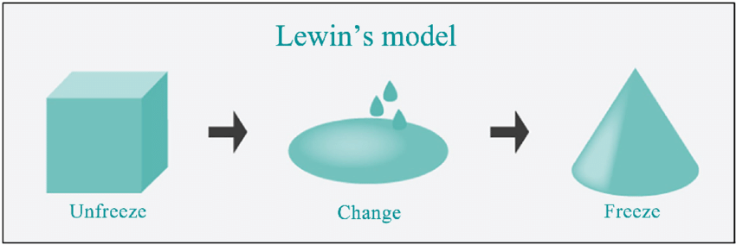
Figure 11: Kurt Lewin’s Change Management Model, Source: (Marinkovic, 2021).
Unfreeze
The foundation of Lewin's concept is preparing Premier Inn Dubai Al Jaddaf for the next changes. Right now, creating an atmosphere that is open to change and increasing awareness are the main priorities. Staff members will be educated about the impending technology developments and will understand the benefits and justification for these changes if comprehensive seminars are arranged. Establishing open lines of communication is essential at this stage (Downward, 2019). By promoting employee enquiries or concerns, management may anticipate and address any opposition early on. Furthermore, feedback forums or regular company meetings where employees may share their early thoughts on the changes would be quite helpful. Proactive actions like these in the 'Unfreeze' phase set the basis for a more seamless transition in later stages.
Change
The hotel is entering the 'Change' phase, and real implementation together with strong support systems is what matters. It will be crucial to provide personnel with thorough training modules that are specifically designed for the planned technological integrations, giving them the skills they need to operate the improved systems. It makes sense to carry out trial runs before a full-scale launch, given the size of certain changes, such as website redesigns or AI-based platforms. This method reduces disturbances and allows for in-the-moment adjustments based on prompt feedback (Marinkovic, 2021). Establishing mentoring programmes would also be very beneficial. Through the designation of mentors or change advocates across departments, employees have a resource for advice and are never left behind throughout this path of transformation.
Refreeze
'Refreeze,' the last phase, is about making sure the recently implemented improvements are ingrained into the hotel's daily operations by providing reinforcement (Downward, 2019). Evaluating the effectiveness of the implemented suggestions will be made easier by holding frequent review meetings where performance indicators are compared to predetermined standards. Staff members might be inspired by celebrating accomplishments, such as finishing training successfully or reaching a certain threshold for favourable visitor comments on the new features. In addition to raising spirits, praising and honouring people who have shown exceptional flexibility and skill throughout the transition phase fosters a feeling of pride and accountability (Tarrant, 2018). Last but not least, creating thorough policies and standard operating procedures that mirror the integrated modifications guarantees that all employees follow a uniform, clearly defined method of operation.

Measuring Success of the Recommended Strategies
For Premier Inn Dubai Al Jaddaf to implement the suggested techniques successfully, regular evaluations and the development of specific steps for measuring effect are required. The evaluation of impacts and success rates may be done in the following ways:
Metrics | Strategies | Details
Quantitative Metrics | Website Traffic and Engagement | After the website revamp, tracking metrics such as unique visitors, bounce rate, average session duration, and page views will provide insights into user engagement and the effectiveness of the new design.
Quantitative Metrics | AI Interaction Metrics | For AI chatbots, monitoring the number of interactions, successful query resolutions, and redirections to human agents can be telling of its efficiency (Montealegre and Iyengar, 2021).
Quantitative Metrics | Booking Conversion Rate | The streamlined booking process's efficacy can be gauged by comparing the conversion rates pre and post-implementation.
Quantitative Metrics | Smart Room Feedback | Post-stay surveys can have specific sections dedicated to guests' experiences with the smart room features, with metrics like usage frequency and satisfaction rates.
Qualitative Metrics | Guest Reviews and Feedback | Analysing reviews on platforms like TripAdvisor, Google, and the hotel's feedback system will offer insights into guest satisfaction levels regarding the new implementations (Tarrant, 2018).
Qualitative Metrics | Employee Feedback | Staff interactions with the new systems are crucial (Roper, 2020). Periodic focus group discussions or anonymous feedback platforms can help understand their comfort levels with the changes and any challenges faced.

Benefits Associated with the Recommendations
At Premier Inn Dubai Al Jaddaf, putting the suggested tactics into practice is expected to provide several advantages that will not only streamline operations but also greatly improve the visitor experience.
Operational Efficiency
Faster, error-free procedures can result from the booking system's simplification and AI integration. Staff can focus on more value-driven duties as a result of automated answers and seamless booking, which lower operational overheads and labour expenses (Jameson and Hamylton, 2017).
Improved Visitor Experience
Due to smart room amenities, visitors will have a customised, cosy stay. Each visitor will have a customised experience thanks to features like integrated entertainment systems, temperature control, and movable lighting that appeal to a variety of tastes.
Enhanced Online Presence
The hotel's online presence is increased via a modern booking system and a redesigned website (Gardini and Schuckert, 2021). Increased reservations could result from a strong digital presence, which can be enhanced by an intuitive user interface and AI-powered customer service.
Strong Data Security
Enhanced safeguards for visitor data will increase confidence. In the current digital era, when worries about breaches of personal data are common, guaranteeing data security and integrity could be a big selling point.
Ongoing Staff Development
Staff members are given access to the most recent industry information and best practices via ongoing training. A well-trained workforce is essential to providing unparalleled service, which encourages repeat business and excellent word-of-mouth referrals (Marinkovic, 2021).

Enhanced Reputation of Brand
As a forward-thinking hotel, Premier Inn Dubai Al Jaddaf embraces technology and data security. Updating itself bolsters its reputation as a creative and customer-focused establishment. Positive evaluations and comments result in increased brand awareness (Hoque, 2019).
Increased return on investment (ROI)
Bringing in customers who appreciate security and contemporary facilities balances out the initial expenditures in tech and training. Increased bookings, recurring business, and varied revenue are all a result of streamlined operations and AI insights, which also improve marketing efficacy and guarantee a significant return on investment (Dickens, 2020).
Adaptive Readiness for Future Developments
Premier Inn Dubai Al Jaddaf becomes ready for future technological developments by proactively incorporating present tactics. This ensures the hotel's sustained attractiveness in a dynamic hospitality market by keeping it current and establishing it as a trailblazer in the industry (Marinkovic, 2021).

Cost Associated with the Recommendations
Here's a table of estimated costs associated with the recommendations for Premier Inn Dubai Al Jaddaf:
Recommended Action | Estimated Cost
Website Revamp (incl. design, development, testing) | £15,000
AI Platform License (Annual Subscription) | £8,000
Booking System Software Upgrade | £10,000
IoT Devices for Smart Room Upgrades | £20,000
Data Protection Infrastructure | £12,000
Continuous Staff Training (Annual Programs) | £20,000
Marketing Campaigns (Ads, Content, Collaborations) | £25,000
Cybersecurity Drills and Simulations | £5,000
Mentorship Program Development | £4,000
Feedback Platforms & Tools | £3,000
Staff Rewards and Recognition Programs | £8,000
Post-implementation Review Sessions | £2,500
Data Analytics Tools for Performance Monitoring | £6,500
Post-stay Survey Development & Distribution | £2,000
Change Management Workshops and Consultation | £7,000
TOTAL | £158,000
Table 3: Cost Associated with Recommendations, Source: Author.

Action Plan
NO. | Problem | Solution | Desired Outcome | Time Scale | Completion Date | Planned Budget
1 | Ineffective website design & user experience | Website Revamp | Enhanced user engagement & increased online bookings | 3 months | 10/01/2024 | £15,000
2 | Lack of AI-driven customer support | AI Platform License | Improved customer support & response times | 2 months | 10/12/2023 | £8,000
3 | Outdated booking system | Booking System Upgrade | Streamlined booking process & reduced errors | 3 months | 10/01/2024 | £10,000
4 | Conventional room controls | IoT Devices for Smart Room Upgrades | Personalized guest room experience & increased guest satisfaction | 6 months | 10/04/2024 | £20,000
5 | Vulnerable data protection | Strengthened Data Infrastructure | Ensured guest data security & compliance with regulations | 4 months | 10/02/2024 | £12,000
6 | Staff unfamiliarity with new systems | Continuous Training Programs | Proficient staff leading to seamless service delivery | Ongoing | Ongoing | £20,000
7 | Potential cybersecurity threats | Cybersecurity Drills & Simulations | Staff readiness against cyber threats & improved system resilience | Bi-annually | 10/04/2024 & 10/10/2024 | £5,000
8 | No streamlined platform for feedback | Feedback Platforms & Tools | Constructive feedback collection & better service improvements | 2 months | 10/12/2023 | £3,000
9 | Monitoring post-implementation phase | Post-implementation Review Sessions | Feedback-driven refinements & ensured the success of implementations | After each implementation | Varies with each action | £2,500
10 | Staff resistance to changes | Change Management Workshops | Smooth transitions & reduced change resistance | 2 months | 10/12/2023 | £7,000
Table 4: Problems Associated with Recommendation and Action Plan, Source: Author.

Conclusion
After a thorough analysis of the Premier Inn Dubai Al Jaddaf Hotel, this report has identified several critical junctures that are essential to the hotel's growth and survival in the cutthroat hospitality market. The hotel's technology integration, digital presence, and adaptability are more important than ever in a world that is gradually becoming more digital. These factors directly affect its finances in addition to affecting its reputation. This research clearly shows that, while the Premier Inn Dubai Al Jaddaf Hotel has several natural advantages, such as its location and brand recognition, there are a few areas that need to be addressed right now. This study emphasises how crucial a strong online presence is for boosting exposure and generating reservations. Regretfully, the hotel's present digital arrangement underutilizes the potential of the brand. Furthermore, to match modern standards, the digital experience for prospective customers, from seeing hotel amenities to making a reservation, needs to be significantly updated (Marinkovic, 2021). Furthermore, technology is a fundamental component of contemporary hospitality rather than just an add-on. There's a opportunity for the hotel to greatly improve the visitor experience through these technology integrations. When implemented properly, these elements may appeal to a tech-savvy clientele and greatly increase the hotel's attractiveness. This becomes even more important in light of the increasing rivalry in the Dubai hotel market, where brands are constantly changing to provide customers with unique experiences.
The PESTEL study sheds light on the many external variables influencing Premier Inn Dubai Al Jaddaf Hotel from a strategic standpoint. The hotel has to handle several elements with skill, including the political landscape after the pandemic, evolving client tastes, quick technical improvements, and a renewed emphasis on environmental sustainability. The hotel's internal and external dynamics are further clarified by the SWOT and TOWS analyses, which also provide workable solutions for overcoming weaknesses, taking advantage of opportunities, and averting threats. The projected £158,000 worth of investments that are suggested in this study provide a significant financial return. These improvements not only have the potential to boost income and direct reservations, but they also present the hotel as a progressive player in the hospitality industry. Maintaining repeat business and fostering brand loyalty are two major benefits of this approach (Jameson, 2021). But putting these ideas into practice needs very careful planning. The proposed action plan outlines a methodical road map, including deadlines, projected costs, and expected results for every project. Even if these tactics are extensive, they need ongoing assessment and improvement to be current and useful in a changing market.
To the Prestigious Premier Inn Dubai Al Jaddaf Hotel management
We want to thank you from the bottom of our hearts for entrusting us with this assignment. Even if we're being blunt, our opinions are motivated by a sincere love for seeing Premier Inn grow and succeed even more in the hospitality sector. We firmly believe that Premier Inn Dubai Al Jaddaf Hotel will establish new benchmarks for outstanding client experiences in addition to solidifying its position in the market by implementing the recommendations we've made. We're committed to helping the hotel through this transition, and we look forward to working with it again in the future.

References
Baigarin, T. (2019). Approaches to changes in business model by applying digital technologies. Central Asian Economic Review, 45(2), pp.161–169. doi https://doi.org/10.52821/2224-5561-2021-2-161-169.
Baloglu, S., Erdem, M., Brewer, P. and Mayer, K. (2022). Advances and trends in hospitality and tourism. International Journal of Contemporary Hospitality Management, 22(7). doi https://doi.org/10.1108/ijchm.2010.04122gaa.001.
Bennett, S. (2023). Travel Management Statistics 2023 - Everything You Need to Know. [online] WebinarCare. Available at: https://webinarcare.com/best-travel-management-software/travel-management-statistics/ [Accessed 11 Oct. 2023].
Bican, P.M. and Brem, A. (2020). Digital Business Model, Digital Transformation, Digital Entrepreneurship: Is There A Sustainable ‘Digital’?. Sustainability, 12(13), p.5239. doi:https://doi.org/10.3390/su12135239.
Booking.com (2021). Booking.com’s 2021 Sustainable Travel Report Affirms Potential Watershed Moment for Industry and Consumers. [online] Booking.com’s 2021 Sustainable Travel Report Affirms Potential Watershed Moment for Industry and Consumers. Available at: https://globalnews.booking.com/bookingcoms-2021-sustainable-travel-report-affirms-potential-watershed-moment-for-industry-and-consumers/.
Bowen, H. (2019). Cultural tourism: the partnership between tourism and cultural heritage management. Tourism Management, 25(3), pp.412–414. doi:https://doi.org/10.1016/s0261-5177(03)00138-9.
Brotherton, B. (2019). Critical success factors in DUBAI corporate hotels. The Service Industries Journal, 24(3), pp.19–42. doi https://doi.org/10.1080/0264206042000247740.
Cecil, A. and Wang, S. (2019). Exploring resident awareness of cultural tourism and its impact on quality of life. European Journal of Tourism Research, 1(1), pp.39–52. doi:https://doi.org/10.54055/ejtr.v1i1.8.
Cheeseman, H.R. (2019). Contemporary business and e-commerce law: legal, global, digital, and ethical environment. Upper Saddle River, N.J.: Pearson/Prentice Hall.
Corallo, A. and Passiante, G. (2021). The digital business ecosystem. Cheltenham, DUBAI; Northampton, MA: Edward Elgar Pub.
Data Privacy Manager (2020). 5 biggest GDPR fines so far [2020]. [online] Data Privacy Manager. Available at: https://dataprivacymanager.net/5-biggest-gdpr-fines-so-far-2020/.
Davies, B. (2021). The Structure, Conduct, and Performance paradigm is applied to the DUBAI hotel industry. Tourism Economics, 2(2), pp.151–158. doi:https://doi.org/10.1177/135481669600200204.
Dickens, M. (2020). Productivity Performance in DUBAI Hotels. Tourism and Hospitality Research, 1(2), pp.187–190. doi:https://doi.org/10.1177/146735849900100209.
Downward, P. (2019). The applicability of industrial organization theory to the services sector: initial tests from the DUBAI hotel industry. Applied Economics Letters, 3(11), pp.733–735. doi:https://doi.org/10.1080/135048596355772.
Dubko, N.A. (2020). Regional Digital Business Platform. Digital Transformation, 36(3), pp.58–70. doi https://doi.org/10.38086/2522-9613-2020-3-58-70.
Duffield, B.S. (2021). Tourism: the measurement of economic and social impact. Tourism Management, 3(4), pp.248–255. doi:https://doi.org/10.1016/0261-5177(82)90046-2.
Eaglen, A. (2020). An Analysis of Culture as a Tourism Commodity. Tourism Culture & Communication, 9(3), pp.151–163. doi https://doi.org/10.3727/109830409x12596186103879.
Gardini, M.A. and Schuckert, M. (2021). The Routledge Companion to International Hospitality Management. Milton: Taylor & Francis Group.
Gasimov, V. and Aliyeva, S. (2020). Basic components of the digital business: cryptocurrency, blockchain, cloud technologies and the Internet of things. International Journal of 3D Printing Technologies and Digital Industry, 4(2), pp.97–105. doi https://doi.org/10.46519/ij3dptdi.734633.
GMI (2023). Dubai Tourism Statistics 2018 | Most Visited Dubai Tourist Places. [online] Official GMI Blog. Available at: https://www.globalmediainsight.com/blog/dubai-tourism-statistics/.
Gonzalo, F. (2021). How Travelers Use Online Sources for Travel Decision-Making. [online] Frederic Gonzalo. Available at: https://fredericgonzalo.com/en/how-travelers-use-online-sources-for-travel-decision-making/.
Grooss, O.F. and Presser, M. (2022). Surround yourself with your betters: Recommendations for adopting Industry 4.0 technologies in SMEs. Digital Business, 32(6), p.100046. doi:https://doi.org/10.1016/j.digbus.2022.100046.
Hanafizadeh, P. and Kim, S. (2020). Digital Business: A new forum for discussion and debate on digital business model and digital transformation. Digital Business, 1(1), p.100006. doi:https://doi.org/10.1016/j.digbus.2021.100006.
Harrington, D. and Akehurst, G. (2020). Service quality and business performance in the Dubai hotel industry. International Journal of Hospitality Management, 15(3), pp.283–298. doi:https://doi.org/10.1016/s0278-4319(96)00021-7.
Heng, T.M. (2020). Economic impact of tourism. Annals of Tourism Research, [online] 17(2), pp.246–269. doi:https://doi.org/10.1016/0160-7383(90)90086-7.
Hoque, K. (2019). New approaches to HRM in the Dubai hotel industry. Human Resource Management Journal, 9(2), pp.64–76. doi:https://doi.org/10.1111/j.1748-8583.1999.tb00197.x.
Jameson, S.M. (2021). HRM in Dubai hotels: a focus on commitment. Employee Relations, 22(4), pp.403–422. doi:https://doi.org/10.1108/01425450010340380.
Jameson, S.M. and Hamylton, K. (2017). The CRE’s Investigation into the Dubai Hotel Industry. International Journal of Contemporary Hospitality Management, 4(2). doi:https://doi.org/10.1108/09596119210010448.
Jones, S. (2021). The international hospitality business. International Journal of Hospitality Management, 16(4), pp.423–425. doi:https://doi.org/10.1016/s0278-4319(97)00026-1.
Khudolei, V. (2020). The Concatenated Phases of Digital Business Management in Digital Transformation. Marketing and Digital Technologies, 4(2), pp.44–52. doi:https://doi.org/10.15276/mdt.4.2.2020.4.
Kisusi, R.L. and Masele, J.J. (2018). Efficacy of public awareness strategies for promoting existing cultural heritage. Journal of Heritage Tourism, 14(2), pp.117–137. doi:https://doi.org/10.1080/1743873x.2018.1491980.
Korzay, M. and Chon, J. (2022). Impact of Information Technology on Cultural Tourism. Annals of Tourism Research, 29(1), pp.264–266. doi:https://doi.org/10.1016/s0160-7383(01)00021-4.
LaFlamme, A.G. (2019). The impact of tourism. Annals of Tourism Research, 6(2), pp.137–148. doi:https://doi.org/10.1016/0160-7383(79)90144-0.
Ledsham, C. (2022). Infographic: Online travel platforms boost total sales for independent hotels. [online] Statista Daily Data. Available at: https://www.statista.com/chart/28369/online-travel-platforms-boost-total-sales-for-independents/ [Accessed 11 Oct. 2023].
Levine, L. (2019). Digital Trust and Cooperation. Journal of Business Ethics, 25(7). doi:https://doi.org/10.1007/s10551-019-04201-z.
Marinkovic, L. (2021). Issues of Croatian Touristic Identity in Modern Touristic Trends. Journal of Tourism Research & Hospitality, 05(01). doi:https://doi.org/10.4172/2324-8807.s2-001.
Miller (2019). CTH - Understanding the Global Hospitality Industry. BPP Learning Media.
Mkono, M. (2020). Cultural Awareness and the Global Hospitality Business. Tourism Analysis, 15(2), pp.273–278. doi https://doi.org/10.3727/108354210x12724863553686.
Montealegre, R. and Iyengar, K. (2021). Managing digital business platforms: A continued exercise in balancing renewal and refinement. Business Horizons, 28(9). doi:https://doi.org/10.1016/j.bushor.2020.09.003.
Mordor Intelligence (2019). Online Accommodation Booking Market | 2020-2027 | Industry Report | Covid Insights. [online] www.mordorintelligence.com. Available at: https://www.mordorintelligence.com/industry-reports/global-online-accommodation-booking-market.
Mshvidobadze, T. (2022). THE EFFECTIVENESS OF DIGITAL TECHNOLOGIES AND ECONOMIC GROWTH. Globalization and Business, 24(12), pp.111–114. doi:https://doi.org/10.35945/gb.2022.13.016.
Natorina, A. (2021). Digital Business Strategies in the Post-Pandemic Era. Marketing and Digital Technologies, 5(4), pp.49–61. doi:https://doi.org/10.15276/mdt.5.4.2021.4.
Nhamo, G. and Chikodzi, D. (2021). Counting the cost of COVID-19 on the global tourism industry. Cham: Springer.
Oliveira, F. and Kakabadse, N. (2022). Board engagement with digital technologies: A resource dependence framework. Journal of Business Research, 139(38), pp.804–818. doi:https://doi.org/10.1016/j.jbusres.2021.10.010.
Ordóñez, P., Tennyson, R.D. and Zhao, J. (2019). Global Hospitality and Tourism Management Technologies. London: Hachette UK.
Paskova, A.A. (2021). Digital transformation of retail business: trends and technologies. New Technologies, 16(6), pp.123–131. doi https://doi.org/10.47370/2072-0920-2020-16-6-123-131.
Roper, A. (2020). Vertical disintegration in the corporate hotel industry: the end of business as usual. Abingdon, Oxon; New York, NY: Routledge.
Rysina, V.N. (2020). Digitalization of the economy and digital technologies. Management and Business Administration, 36(1), pp.116–127. doi https://doi.org/10.33983/2075-1826-2021-1-116-127.
Shen, H. (2017). Social Network and Job Satisfaction of Workers in Hotel Industry. Journal of Hotel & Business Management, 5(1). doi:https://doi.org/10.4172/2169-0286.1000120.
Shvetsov, A. (2021). Improving business efficiency: The contribution of the latest digital technologies. Management and Business Administration, 15(4), pp.69–81. doi https://doi.org/10.33983/2075-1826-2021-4-69-81.
Smirnov, V. (2020). The Business Ecosystem in the Economy Based on Digital Technologies. SSRN Electronic Journal, 47(15). doi:https://doi.org/10.2139/ssrn.3726409.
Smith, S. (2018). Hotel Industry Research Progresses. Cornell Hotel and Restaurant Administration Quarterly, 6(4), pp.40–40. doi:https://doi.org/10.1177/001088046600600406.
Spendesk (2022). 60+ fascinating business travel statistics for 2022. [online] Spendesk. Available at: https://www.spendesk.com/en-eu/blog/business-travel-statistics/ [Accessed 11 Oct. 2023].
Statista (2023a). Inbound visits to the Dubai 2005-2023 | Statista. [online] Statista. Available at: https://www.statista.com/statistics/287133/annual-number-of-overseas-visits-to-the-dubai/.
Statista (2023b). Premier Inn hotel rooms 2012-2023 Statistic. [online] Statista. Available at: https://www.statista.com/statistics/739855/whitbread-premier-inn-hotels/.
Tan, Y. (2017). Hotel-Specific, Industry-Specific and Macroeconomic Determinants of Profitability in Hotel Industry: Structure-Conduct-Performance or Efficient-Structure Hypothesis? SSRN Electronic Journal, 34(8). doi:https://doi.org/10.2139/ssrn.2943487.
Tarrant, C. (2018). Dubai hotel industry — market restructuring and the need to respond to customer demands. Tourism Management, 10(3), pp.187–191. doi:https://doi.org/10.1016/0261-5177(89)90068-x.
Teare, R. (2021). International Trends and Challenges in Tourism and Hospitality Business. International Journal of Contemporary Hospitality Management, 19(2), pp.178–178. doi:https://doi.org/10.1108/09596110710729283.
Wang, H. (2021). Development Practice Of Digital Business Environment. S.L.: Springer Verlag, Singapor.
Wilson, S. (2022). The social and economic impact of tourism on Pacific communities. Annals of Tourism Research, 5(2), p.291. doi:https://doi.org/10.1016/0160-7383(78)90277-3.
Wood, R.C. (2020). HRM in the Dubai hotel industry: a comment and response. Human Resource Management Journal, 10(4), pp.88–93. doi:https://doi.org/10.1111/j.1748-8583.2000.tb00008.x.
Zipdo (2023). Essential Technology In Hotel Industry Statistics in 2023 • ZipDo. [online] Zipdo.com. Available at: https://zipdo.co/statistics/technology-in-hotel-industry/ [Accessed 11 Oct. 2023].

