

LEVEL 7 ASSIGNMENT SPECIFICATION

Student name: | SIAW MO WAI | Student number: | 1710336
Programme: | DBA
Module: | Quantitative Research Methods | Module Level: | 7
Module code: | SBPD7010 | Contribution to Overall  Module Assessment (%): | 50%
Lecturer: | Dr Andrew Chan | Internal Verifier:
Assignment Title: | Project Report & Reflection | Assignment No : | 1 of 1
Hand Out Date: | 3 February 2018 | Submission deadline: | 8 April 2018
Referencing: | In the main body of your submission you must give credit to authors on whose research your work is based. Append to your submission a reference list that indicates the books, articles, etc. that you have read or quoted in order to complete this assignment (e.g. for books: surname of author and initials, year of publication, title of book, edition, publisher: place of publication).
Disclosure: | Please include the following statement on the title page of the submitted assignment, followed by your name:  I declare that this assignment is all my own work and that I have acknowledged all materials used from the published or unpublished works of other people. All references have been duly cited.
Student’s Signature: | (Only where hard copies required) | Date: | 8/4/2018
Turnitin: Lecturer to tick to indicate if an electronic version of the assignment must be submitted to Turnitin. Note: the Turnitin version is the primary submission and acts as a receipt for the student. All students MUST submit their assessments by the specified deadline. Late submission will result in a late penalty mark, as follows:  Up to one week late, maximum mark of 50% for first attempts and 0% for resubmissions. No work will be accepted more than one week after the submission deadline | YES

CONTENT

Page(s)

Background 3

Motivation 3

Hypotheses 4

Literature Review 4 – 8

Methodology 8 – 10

Results 11 – 15

Discussions and Conclusions 15 – 16

Limitations 16

References 17 – 18

Appendix 1 – Questionnaire 19 – 21

Appendix 2 – Correlation results 22

Additional information

Word count:

Component 1: Project Report (40%) 3,786 words

Background
Online shopping is one of the famous business model nowadays. According to Invespcro (2017), UK has the highest online retail sales as percentage of total retail sales (15.6%), followed by China (13.8%), Norway (11.5%), Finland (10.8%) and South Korea (10.5%) and US comes in 8th at (8.3%). According to Course Hero (2017), the most reliable online shops are Amazon, Target, Walmart, eBay, Trip Advisor, ToysR US and Kohl’s. Most of them are the famous brand name. According to the statistics of Nieslen Global Survey of E-Commerce 2014, the most important drivers to cause people for online shopping are three major reasons. They are faster delivery, safer ways to pay and lower cost. At the same time, the three major concerns that hinder the online shopping are security of online payments, cost of delivery and concern about not receiving items they bought. Among all concerns, the online shoppers do not trust giving the credit card information online. The online shoppers also do not like the large amount of shopping cost. Some of them also think that the websites of some online shops are very similar. It will cause confusion to them and also affect the creditworthiness of those reputable companies. The confidence of the people towards online shopping will weaken as the security may be the most controversial issue.

Motivation
According to the survey of A.T. Kearney’s 2013 Global Retail E-Commerce index, Hong Kong is fourteenth under the good infrastructure of online shopping ranking. In the ranking, the first position is US. So this research is tried to investigate customers’ number of purchase towards online shopping in Hong Kong. The stated aim is to see the impact of security issue towards the online shopping. It is because one of our subsidiaries is performed the trading business. Our products are quite diversify and serve for different customers. For low value products, they are the stationery, such as paper, pencil, pen and etc. For higher value products, it should be some electronic components for the manufacturers. Currently, we also like to promote the online business and then increase the sales. So we want to in-depth assess the business opportunities of electronic commerce. Through the study, it can provide some suggestion about the online business concerns to our management.

Hypothesis
Null Hypothesis:
The customers’ number of purchase will not affect by the security of the online shopping platform.

Alternative Hypothesis:
The customers’ number of purchase will affect by the security of the online shopping platform.

Literature Review
Al-Debei et al (2015) states online shopping behavior of the customers in Jordan will affect by the creditworthiness of the vendors’ website. So the quality of the website should be the key factor to affect the choice of the customers.

Akroush and A1-Debei (2015) states the roles of relative advantage, perceived website reputation, perceived website image, and trust in shaping consumers’ attitudes toward online shopping in emerging markets like Jordan. In Hong Kong, many companies want to explore China market and it can use these indicators to assist them to build the website, such as the company can form joint venture with the reputable China companies.

Bezes (2016) states the customers must much concern the financial risk of the online shops in France. Under the purchasing decision, the customers will compare how much will save compare between the online shop and physical stores. In the discount is not so much and it is a valuable goods. The customers will prefer to the physical stores than the online shops as they need to bear higher risk, such as logistics risk (i.e. missing of goods during delivery) or the financial risk.

Chou et al (2014) states different genders of customers will also affect the online shopping model. For female customers, they may not more concern about the security compare with the website appearance. In other words, the female customers is more prefer the good website design. According to the study, female customers are often purchased goods from the online clothing stores. It is because online stores will prefer the clothing business as the products are lower value and the female customers are less concern on the security issue through the credit card payments. So it should be specific characteristics of gender difference towards online shopping.

Dai et al (2014) states the customers are more concern the perceived privacy risk. Most of them afraid the leak of information and they afraid the loss of personal information ad cause them the financial loss during the online business transaction.

Elbeltagi and Agag (2016) states the customers should concern the trust commitment of the online retailers. In fact, the ethical issue should be very importance for online business. In some situations, the retailers may sell the information to third parties without the consent of the customers. So it is an ethical issue and affect the repurchase decision of the customers.

Gurung and Raja (2016) states the company should put more investment on the development of the online shopping website. So it can release the privacy and security concerns, risk perception and trust beliefs of the customers.

Hamid (2012) states the eleven factors which affect the electronic commerce service quality. The eleven factors are appearance, security, ease to use, efficiency, information, support, reliability, incentive, communication, structure & layout and linkage. Among all factors, the security, reliability and linkage should be the most important factors. Under the highly competitive business environment, the online shops should recognize the importance of “word-of-mouth” from the customers. In other words, the importance of the referral of existing customers should be extremely important. On the one hand, the existing customers will introduce new customers. On the other hand, they can cause more value through the repurchase of the customers. One important issue of online shop is the reputation building. The reputation building should be based on the feelings and the wordings of the customers. In other words, the personal comment of the customers are very important towards the success of the online shops.

Hsu et al (2014) quotes four principal trust factors towards the online business. It should really affect the successful rate of the online business. The four factors are trust in the web site, trust in the vendor, trust in the auction’s initiator and trust in the group members. For the auction’s initiator, it is the negotiation the price between the vendor and the customers. In other words, the customers may not trust or even difficult to assess whether their purchasing price is the lowest one or not. For group members, it is the comment of other customers through the online perform. It cannot deny that some comment may be fault or just artificial made by the vendors.

Hu et al (2015) investigates the complaint behavior of the online shoppers. They emphasis the creditability and trustworthiness of the online retailers are very important. According to the study, the online shopper will often concern the refund policy of the online shoppers as the customers will not see the products physically. So they will concern the refund policy when the products cannot meet their expectation or the quality cannot meet the standard. The refund policy will affect the trustworthiness of the online shoppers.

Kim et al (2013) states the good quality of website can release the perceived risk and enhance the customer satisfactions. The study is based on the psychological effect of the customers towards the online shops. In fact, the well-developed website can really enhance the reputation of the vendors. According to the result, it emphasis the important of interaction between the vendors and the customers. A well designed website should provide a “one-stop” solution to the customers and then consider how to settle the emotions behavior of the customers when they face the problems, such as poorer quality products and need the refund from the vendors.

Lu et al (2013) states the importance of the relationship management between online retailers and the customers. The study is performed the survey in Taiwan. From this study, it can show the relationship management or Guanix is very important to doing business in traditional Chinese market. It is because online business lack of face-to-face interaction between the buyers and the retailers. So it is very important to build the trust relationship. They will only know the retailers through the advertising. In fact, it is lack of concrete evidence to support the confidence of the customers. So the critical success factor of online business should be design a reputable platform to the customers. For the critical component of creditworthiness website should be highest security.

Metilda and Malathi (2016) states the importance of trust building. The trust building should base on the shopping experience of the customers. For the repurchase decision of the customers, it is also based on the shopping experience. From the study, it suggests that the online perform should provide an excellent and impressive shopping experience to the customers. So it can encourage the customers to buy the products again.

Motwani et al (2013) investigates the online shopping between of US and Indian customers. Apart from the product quality, the customers will more concern the security of the website. To solve this problem, one solution is to provide sufficient information and trust worth website for the online shoppers. Under the information aged, the good information disclosure can help to release the nervous of the customers. It can also build the long term relationship between the online shops and the customers. According to the result, the failure of most online shops are that they cannot build a sustainable relationship with the customers and then they cannot attract the new customers. It is because the online shoppers need to obtain the referral by the existing customers. So the trust relationship should be the critical success factors of the online shops.

Omar et al (2011) states Chinese customers are not only focus on the security payment of online shopping. The company needs to consider the quality of the products. Chinese customers will put more emphasis on the product quality when they purchase the goods from online shop. It will direct affect their repurchase consideration by the quality of products.

Sakarya and Soyer (2013) study the culture difference between two different cultures background customers. They investigate British and Turkey customers. According to the result, Turkey customers should prefer cash on delivery and direct money transfer even they accept the credit card payment method is the convenient method. Turkey should more security concern and prudent towards the online payment method. For British customers, they are more prefer the credit card transfer method. So it can show that different cultures will also affect the acceptance of the online shopping payment method.

Thakur and Srivastava (2015) state the customers will put more risk concern towards the security on the online payment. Generally speaking, most companies will only use common technologies to secure the online payment but they do not put investment on the perceived risk assessment and release the risk concern of the customers. Periodically, some security problems are often happened and it can show in the newspapers. In this case, it will damage the image and creditworthiness of the online shops. It will affect the survival opportunity of the shops. In the worst situation, the existing customers will stop purchase from this website. The potential customers will not consider the make the first purchase from the shop. The study suggests the online shops should any measurement to release the perceived risk, such as put more investment on the security matters, such as the information leakage from the website or even the online payment. In fact, the information infrastructure cannot ignore when doing the online business. It is the critical success factors of the online shops, especially the competitive is very keen in the online market.
Vos et al (2014) states the importance of risk reduction strategies. Under the electronic commerce, the concept of trust is extremely important for doing online business. Otherwise, they will develop the emotions of uncertainty and also discourage the buying from the online shops. The study suggests the online shop should provide a secure environment to reduce such type of perceived risk.

Yen (2014) states perceived risk (such as financial risk) will not significantly affect the customer loyalty. Perceived risk will not affect the purchasing intention of the customers. The most significant factor should be the switching cost. For the switching cost, it mainly relates to the brand name and reputation. So the study suggests the company should lower the perceived and higher the switching cost. In other words, the customers will not concern whether they purchase the goods from website or physical store. They may more concern the brand value.

Methodology
This study will use the quantitative research method and qualitative research method. The stated aim is to prove any relationship between the online shopping behavior and the security risk of the online website. For the online shopping behavior, it will mainly investigate the number of time of the customers to repeat purchase from the online platform of the vendors. So it can provide information about whether the customers trust such method or not.

For dependent variable, it should be the online shopping characteristics and it will use the number of time of online shopping of the target samples. For independent variables, they should be the gender, age, income level and certain types of security risk. It should expect that different degree of correlation between dependent variable end independent variables. In the past literature, it is already know that different gender and aged group will be different attitudes towards online shopping. It will not solely due to the security to deter the customers to buy the goods from online shopping platform. So it is expected to find out any statistically significant relationship between the dependent variable and independent variables. In other words, it needs to prove whether support or reject the null hypothesis. For null hypothesis, it is no relationship between the dependent variable and independent variables. If it rejects the null hypothesis, it means there is statistically significant relationship between the dependent variable and independent variables. Even it can prove the statistically significant relationship between dependent variable and independent variables. It needs to identify which independent variables should be the statistically significant relationship with the dependent variable. In independent variables, it is not related to the security of online platform, such as gender, aged, income level and appearance of website. So it needs to identify whether the number of the purchase of the customers really related to the security of the online shopping platform. In other words, it should investigate from the significant value from SPSS and then identify whether the statistically significant relationship exist between number of purchase and the security of the online platform.

A questionnaire will deliver to the target samples randomly in order to collect information from the participants. The detailed questionnaire can refer to the appendix 1. There will be fifteen questions in the questionnaire. The cover area will include the following items:
- Gender
- Aged
- Income level
- Number of time of online shopping within certain period of time
- Value of goods
- Various types of security risk

The expected sample size is around 20 people.

For the online survey questions, they will use the Likert scale to measure the target samples’ number of purchase by using different online shopping platform. Rating explanations:
5 – Very Agree 4 – Agree 3 – Neutral 2 – Disagree 1 – Very Disagree

For example, a sample question is as following:

The website is safe to pay money and perform a financial transaction on retailer’s website.
5 4 3 2 1

From this survey, there is totally sixteen questions will examine from the target samples. After collect the data from the questionnaire, it will perform the statistical analysis. It will use SPSS to perform the regression analysis and also find out any correlation between the dependent variable and independent variables. The stated aim is to obtain the overall pictures of the factors which will affect the customers’ purchase from online shopping platform.

Afterwards, it will use the research journal to interpret the statistical results.

Results
After collecting the data, there is twenty questionnaire. From the Cronbach's Alpha result as following:
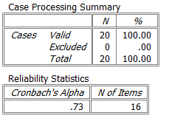
The value of Cronbach’s Alpha is 0.73 and it is acceptable reliability value. So the relationship between the dependent variable and independent variables can be further examine.

For the descriptive statistics, we can obtain the following result:
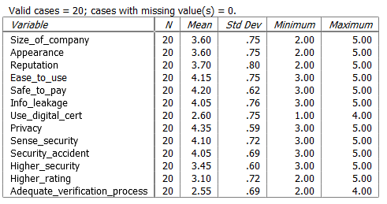
From the value of mean, it shows that most of the target samples are must concern about the protection of the privacy. It is highest value of rating in this survey. Apart from privacy matter, the target samples also concern the safe to pay and sense of security of the online shopping platform. In other words, the customers will concern about the overall security of the online shopping platform. From the above table, it also shows that the value about digital certificate and the verification process is not so higher. It may due to the target samples do not much knowledge of digital certificate and the verification process of online shopping platform.

For the regression analysis, it can obtain the following result:
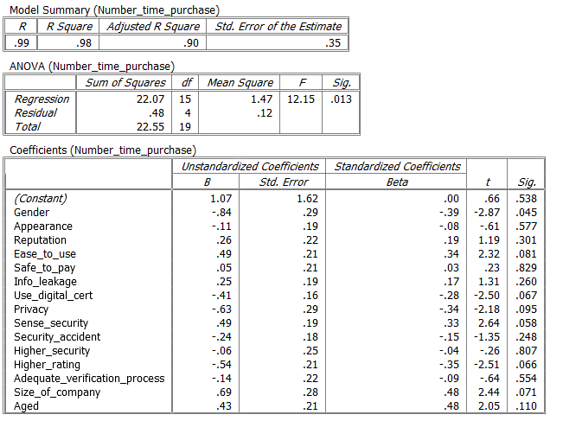
From the above table, Adjusted R square can cover 98% of the variation of the dependent variable (i.e. number of purchase) can explain by the independent variables under the linear regression analysis. Under ANOVA test, it can show the significant value of 0.013 and it is statistically significant as p < 0.05. The model is good enough in predicting the outcome variable. In other words, there is statistically significant relationship between the dependent value and the independent variables. From the table, the time of purchase is much affect by the gender of the customers. It is because the significant value between time of purchase and gender is 0.045 and the significant value is small than p<0.05. So the statistically significant relationship is existed. For other independent variables, the value is not so statistically significant compare with the gender difference. So it can show that the online buying habit may depend on the gender.

From the two sample T-test, we obtain the following result:
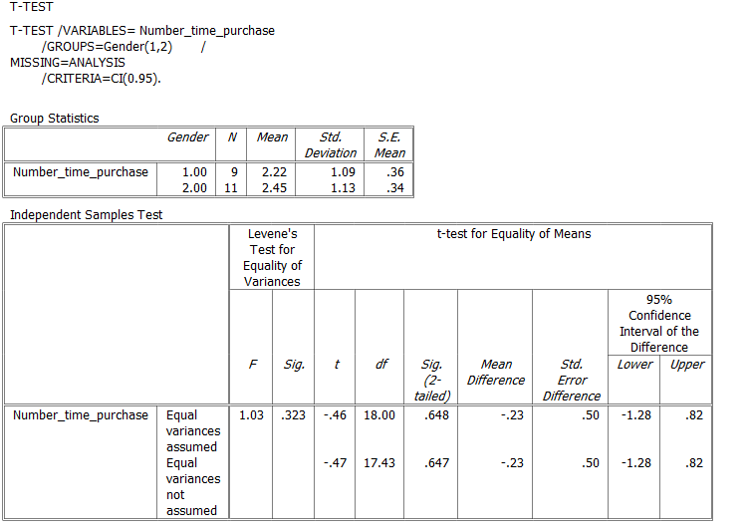
First, it needs to investigate the descriptive statistics for the two groups. In the survey, Gender 1 is Male and Gender 2 is female. It can show that the number of time of purchase of female is higher than male. So female will purchase more goods from online platform. It shows that the Levene’s Test for equality of variances and it is not significant as p>0.05. The two variances are not significantly difference. If it is not significant, the two variances are not significantly different, that is, the two variances are approximately equal. So the variance is not so significant between the two genders even the number of time of purchase shows a statistically significant with the gender. From the value, it is 0.648 and there is no significant difference between the two groups of gender. It can conclude that the number of time of purchase is statistically significant with the gender. But the variance is so much between the two genders.

From the correlation coefficients, it can refer to appendix 2. From appendix 2, it shows the number of time of purchase is higher correlated with aged group as show in the following diagram (extract from appendix 2):

 | Number_time_purchase
 | Pearson Correlation | Sig. (2-tailed) | N
Gender | 0.11 | 0.648 | 20
Aged | 0.89 | 0 | 20
Number_time_purchase | 1 |  | 20
Size_of_company | 0.56 | 0.01 | 20
Appearance | -0.33 | 0.151 | 20
Reputation | 0.61 | 0.004 | 20
Ease_to_use | 0.19 | 0.419 | 20
Safe_to_pay | 0.44 | 0.053 | 20
Info_leakage | 0.55 | 0.012 | 20
Use_digital_cert | 0.12 | 0.628 | 20
Privacy | 0.05 | 0.85 | 20
Sense_security | 0.15 | 0.515 | 20
Security_accident | -0.02 | 0.918 | 20
Higher_security | 0.15 | 0.534 | 20
Higher_rating | -0.11 | 0.631 | 20
Adequate_verification_process | 0.36 | 0.116 | 20

For correlated coefficient, it needs to consider the following interpretation:
Pearson coefficient Meaning
------------------------------------------------------------------------
0.70 or higher Very strong association
0.50 to 0.69 Substantial association
0.30 to 0.49 Moderate association
0.10 to 0.29 Low association
0.01 to 0.09 Negligible association

From the table of Pearson’s coefficient, it shows that the number of time of purchase is no very strong association with any independent variables. For substantial association, the number of time of purchase is such relationship with different aged group, sized of company, reputation and the issue of information leakage. For moderate association, the number of time of purchase is such relationship with safe to pay and adequate verification process. For low association, the number of time of purchase is such relationship with ease to use, privacy and sense of security.

Discussions and Conclusions
From the statistical results, it shows that the customers’ attitude towards the security of online shopping platform not so significant from the statistical analysis. The result is the female is higher intention to purchase goods from the online shopping platform. From the significant value, the statistically significant relationship between the gender and the number of time of purchase but there is no statistically significant relationship between the security factors and the number of time of purchase. So null hypothesis is supported and alternative hypothesis is rejected as there is no relationship between the security factors and the number of time of purchase. For the company, it should pay more time on the survey on the needs of different genders of customers and explore the market. From correlation coefficient, it can show the substantial association between number of time of purchase with the aged group and the information leakage and the reputation of the online shopping platform. From the survey result, it can show the younger aged group should more favour to use the online shopping platform. Most of the customers are concern the size of the company and also the reputation. In other words, the long established companies can obtain more trust from the customers and also enhance the penetration of the online shopping platform. So the company can consider to form cooperation and joint venture with some reputable companies to promote the online shopping platform.

Limitations
Under this survey, it only investigates the customers towards the security of online shopping platform. In future study, it can perform the analysis from different categories of products. The customers’ attitude may be quite different towards different value of goods. For the low value of goods, the customers may not so concern the security of the online shopping platform as they will lose too much money even they discover any fault on the online shopping platform. For the high value of goods, the customers may require higher security. It needs to recognize different needs between male and female customers. Furthermore, the sample size is also very small. It should get more targets from the market. So it can enhance the reliability of the survey.

References
Al-Debei, M.M., Akroush, M.N. and Ashouri, M.I. (2015), Consumer attitude towards online shopping The effects of trust, perceived benefits, and perceived web quality, Internet Research, Vol. 25 (5), pp. 707 – 733.

Akroush, M.N. and Al-Debei, M.M. (2015), An integrated model of factors affecting consumer attitude towards online shopping, Business Process Management Journal, Vol. 23 (6), pp. 1353 – 1376.

Bezes, C. (2016), Comparing online and in-store risks in multichannel shopping, International Journal of Retail & Distribution Management, Vol. 44(3), pp. 284 – 300.

Chou, S., Chen, C.W. and Lin, J.Y. (2015), Female online shoppers: Examining the mediating roles of e-satisfaction and e-trust on e-loyalty development, Internet Research, Vol. 25 (4), pp. 542 – 561.

Dai, B., Forsythe, S. and Kwon, W.S. (2014), The impact of online shopping experience on risk perception online purchase intentions: Does product category matter? Journal of Electronic Commerce Research, Vol. 15 (1), pp. 13 – 24.

Elbeltagi, I. and Agag, G. (2016), e-Retailing ethics and its impact on customer satisfaction and repurchase intention: A cultural and commitment-trust theory perspective, Internet Research, Vol. 26 (1), pp. 288 – 310.

Gurung, A. and Raja, M.K. (2016), Online privacy and security concerns of consumers, Information & Computer Security, Vol. 24 (4), pp. 348 – 371.

Hsu, M.H., Chuang, L.W. and Hsu, C.S. (2014), Understanding online shopping intention: the roles of four types of trust and their antecedents, Internet Research, Vol. 24 (3), pp. 332 – 352.

Hu, M., Rabinovich, E. and Hou, H. (2015), Customers complaints in online shopping: The role of signal credibility, Journal of Electronic Commerce Research, Vol. 16 (2), pp. 95 – 108.

Kim, J. and Lennon, S.J. (2013), Effects of reputation and website quality on online consumers’ emotion, perceived risk and purchase intention: Based on the stimulus-organism-response model, Journal of Research in Interactive Marketing, Vol. 7 (1), pp. 33 – 56.

Lu, L.C., Chang, H.H. and Yu, S.T. (2013), Online shoppers’ perceptions of e-retailers’ ethics, cultural orientation, and loyalty: An explanatory study in Taiwan, Internet Research, Vol. 23 (1), pp. 47 – 68.

Metilda, R.M. and Malathi, M. (2016), Reflections on The Dimensions of Trust of Online Consumers: A Review, Journal of Contemporary Research in Management, Vol. 11 (1), pp. 51 – 62.

Motwani, B., Haryani, S. and Matharu, S. (2013), A Comparative Study Between USA and India on factors affecting online shopping, International Journal on Customer Relations, Vo. 1 (2), pp. 1 – 7.

Omar, M., Bathgate, I. and Nwankwo, S. (2011), Internet marketing and customer satisfaction in emerging markets: the case of Chinese online shoppers, Competitiveness Review: An International Business Journal, Vol. 21 (2), pp. 224 – 237.

Sakarya, S. and Soyer, N. (2013), Cultural differences in online shopping behavior: Turkey and the United Kingdom, International Journal of Electronic Commerce Studies, Vol. 4 (2), pp. 213 – 238.

Thakur, R. and Srivastava, M. (2015), A study on the impact of consumer risk perception and innovativeness on online shopping in India, International Journal of Retail & Distribution Management, Vol. 43 (2), pp. 148 – 166.

Vos, A., Marinagi, C., Trivellas, P., Eberhagen, N., Giannakopoulos, G. and Skourlas, C. (2014), Electronic service quality in online shopping and risk reduction strategies, Journal of Systems and Information Technology, Vol. 16 (3), pp. 170 – 186.

Yen, Y.S. (2015), Managing perceived risk for customer retention in e-commerce The role of switching costs, Information & Computer Security, Vol. 23 (2), pp. 145 – 160.

Appendix 1 – Questionnaire
Questionnaires on online shoppers towards the security risk of the online retailers’ website.
Question 1:
What is your gender?
- Male
- Female

Question 2:
What is your aged group?

- Aged 15 – 20
- Aged 20 – 29
- Aged 30 – 39
- Aged 40 – 49
- Aged 50 – 59
- Aged over 60

Question 3:
Number of time of online purchase within one month:

- More than ten times
- Less than ten times but more than five times
- Less than five times
- Less than one time
- No

From Question 4 – 16, they are based on the following scale measurement.

Rating explanations:
5 – Very Agree 4 – Agree 3 – Neutral 2 – Disagree 1 – Very Disagree

Question 4:
The retailer’s website of large company should be more credible.

5 4 3 2 1

Question 5:
The appearance of this retailer’s website can provide confidence to me.

5 4 3 2 1

Question 6:
The retailer’s website is well-known and reputable.

5 4 3 2 1

Question 7:
The website is easily to identify and distinguish from other similar retailer’s website.

5 4 3 2 1

Question 8:
The website is safe to pay money and perform a financial transaction on retailer’s website.

5 4 3 2 1

Question 9:
The online catalogue of the retailer will protect my financial-related information from being leaked.

5 4 3 2 1

Question 10:
The catalogue retailer’s website is secured given that it uses digital certificates.

5 4 3 2 1

Question 11:
By using the online catalogue of the retailers, I can shop in privacy of home.

5 4 3 2 1

Question 12:
Apart from the convenience, buying from this retailer’s website can give me a sense security.

5 4 3 2 1

Question 13:
From this retailer’s website, I can know that there is not so many security related accident from the public news.

5 4 3 2 1

Question 14:
The security of the retailers’ website is higher than other retailers.

5 4 3 2 1

Question 15:
The retailer’s website can obtain higher rating in security rating by independent rating agency.

5 4 3 2 1

Question 16:
The retailer’s website can provide adequate security verification process.

5 4 3 2 1
Appendix 2 – Correlation results

