Q1. As part of her actions to improve systems and procedures at Nexxobyte, Aisha has established monthly on-site Management Team meetings to be attended by her, Kit, you and the three Team Leaders. She would like you to make a short presentation at the first meeting ‘appraising what it means to be a people professional, and some of the ways you can contribute at Nexxobyte.’ Provide a written response covering the points you would include in this presentation (AC 1.1).

People professionals play a key role in shaping positive working environments through fair, consistent and effective people management. Guided by frameworks such as the CIPD profession map (figure 1), they add strategic and ethical value while balancing organisational objectives with employee well-being and fair treatment (CIPD, 2026). Achieving this balance requires careful professional judgement and is critical to maintaining employee engagement and supporting organisational performance.

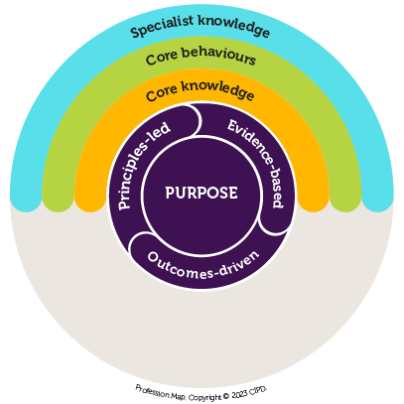

Figure 1

Applying these principles as HR/L&D Advisor at Nexxobyte will allow me to make a tangible contribution to addressing current organisational challenges. Nexxobyte has grown rapidly without formal structures resulting in inconsistent procedures, limited HR processes and team leaders with varying management experience. This highlights the importance of a people professional in creating accountability and structure.

One key area of contribution is improving systems and ensuring consistency. Implementing structured and standardised HR policies and procedures will bring clarity, promote fairness and support consistent decision-making (Armstrong, 2020). Embedding learning and development opportunities will further support growth and retention whilst reinforcing Nexxobyte’s commitment to ethical people management. These activities will help me shape organisational culture by encouraging behaviours which foster inclusion, respect and well-being (CIPD, 2026b). By applying these practices consistently and considering employee perceptions, I can help create a strategic climate that drives workplace safety, inclusivity and organisational performance (Schneider, Ehrhart and Macey, 2013). This highlights the importance of good people practice as a strategic function to support morale, retention and the mitigation of legal risks (Armstrong, 2020).

Another significant area of contribution is strengthening managerial capability. At Nexxobyte, team leaders were promoted without formal management training leading to poor leadership practices and inconsistent experiences across teams. By understanding managers’ learning styles and development needs, I can provide targeted training and coaching that builds confidence, strengthens leadership and promotes consistent decision-making (Gallos, 2006). Providing guidance on performance management and handling employee concerns will further enhance leadership capability. This not only improves day-to-day management but also reduces risks such as grievances, disengagement, turnover and poor performance (Malek, Kline and DiPietro, 2018; Armstrong, 2020).

Finally, my role will support employees and foster a positive workplace culture. Encouraging open communication and feedback will ensure concerns are addressed promptly whilst promoting inclusion, respect and well-being (Armstrong, 2020). Embedding clear, consistent people practices and developing the team leaders will ensure leadership practices align with well-being and organisational goals. This is essential in building trust and engagement in a growing organisation like Nexxobyte. As a result, this approach will enhance motivation, improve retention, reduce complaints and contribute to long-term organisational performance (CIPD, 2026b).

Overall, my role as a people professional will be strategic and operational focussing on improving systems, developing managers and fostering a positive workplace culture (CIPD, 2026; Armstrong, 2020). This demonstrates that effective people practice is both supportive and a driver of organisational success. Aligning these activities with the CIPD Profession Map ensures employee needs and organisational objectives are met ethically and professionally.

Q2. You are excited by your new role and whilst you can see that there is a lot to do, you feel ready for the challenge. Discuss two of your personal or ethical values that you believe will help you in your new role, and how consistently applying these will inform your people practice work at Nexxobyte. (AC 1.2)

Personal and ethical values are central to effective behaviour and decision-making in people practice. In my role as HR/L&D Advisor, it is essential that I act consistently and ethically to support both employees and the organisation, particularly in a rapidly evolving environment like Nexxobyte which has an informal structure and existing challenges. Integrity and inclusivity are two values that will guide my work and behaviours, ensuring my decisions are fair, professional and aligned to the ethical standards of the CIPD profession map (CIPD, 2026). The ‘Balance of Behaviour’ model (Figure 2) illustrates how my personal values and beliefs shape my professional conduct and ability to role model behaviours within Nexxobyte (Beevers et al., 2021). Applying these values consistently will also help foster a positive and supportive workplace culture whilst upholding the principles of the people professional (Beevers et al., 2021; CIPD, 2026c).

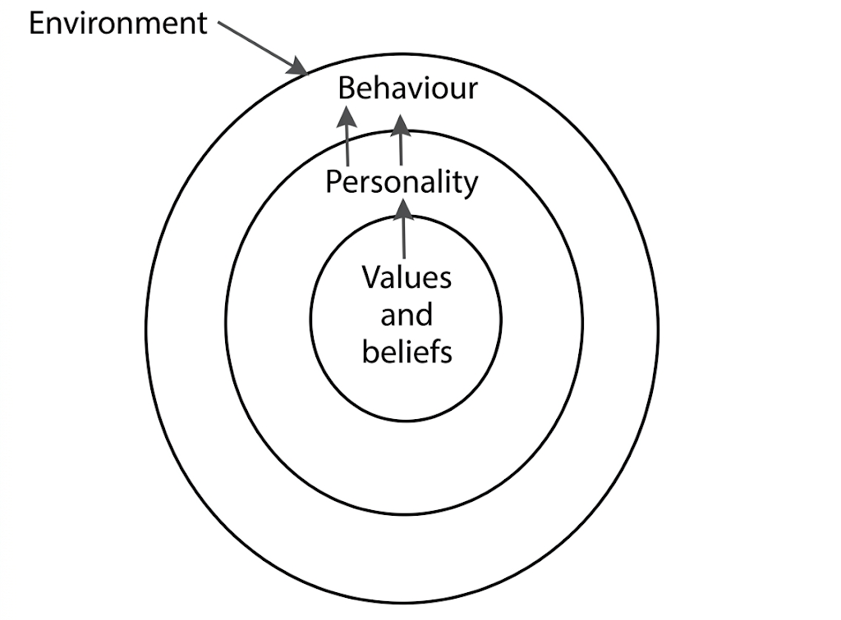
Figure 2
(Beevers et al., 2021)

Integrity is increasingly recognised as the ‘new currency’ for organisations, reflecting the importance of honesty, transparency and ethical decision-making in building trust, buy-in and long-term success (Hlupic, 2022). In people practice, integrity involves acting ethically in every decision, balancing the needs of employees and the organisation whilst avoiding bias or conflicts of interest. In my role as HR/L&D Advisor, I would apply integrity by safeguarding confidential information, managing sensitive situations with discretion and modelling ethical behaviour at all times (Beevers et al., 2021). At Nexxobyte, where growth has resulted in inconsistent leadership and employee concerns, consistently working with integrity will rebuild credibility and trust, ensure fair and consistent application of policies and uphold ethical standards across recruitment, training, performance management and conflict resolution (Bratton and Gold, 2000; CIPD, 2026b). Integrity will also give me the professional courage required to challenge inconsistent or poor practice. Demonstrating integrity in this way will support employee well-being, strengthen trust between employees and leadership and provide a foundation for long-term organisational effectiveness.

Inclusivity is another core value guiding my work, ensuring all employees are treated fairly, have equal access to opportunities and feel valued. This aligns with deontological ethics which emphasises a moral duty, fairness and respect for individuals without being influenced by short-term business pressures (Clark, 2015). Applying these principles at Nexxobyte will support consistent recruitment, training and performance processes whilst safeguarding employees and building trust in people practices. Holt (2020) notes that deontology can be rigid and may slow decision-making if applied inflexibly therefore I would ensure fairness is balanced with practical judgement. I would also embed inclusivity by ensuring employees have the opportunity to share feedback and ideas e.g. through surveys, feedback loops, reviews. Overall, inclusivity will enhance engagement, morale and well-being whilst supporting a fair, professional workplace.

Q3. Aisha has emphasised that she wants you to be a ‘a firm voice for people practice at Nexxobyte’. This means communicating with the management team in an informed, clear and confident way to convince them of the need for change and new ways of working. Consider why it is important to communicate in this way and two potential consequences (one for you and one for Nexxobyte) if you are unable to do so. (AC 1.3)

Being a firm voice for people practice means communicating in an informed, clear and confident way to influence managers and support employees. As HR/L&D Advisor at Nexxobyte, this communication style enables me to ensure ethical, effective and consistent people practice across the organisation.

I need to ensure the communication I share is credible, evidence-based and factually accurate. This involves providing information grounded in employment legislation, organisational policies and HR best practice so managers can rely on my guidance to make informed, fair and compliant decisions (CIPD, 2025). For example, when advising on formal processes such as performance management I must explain procedures and potential impacts clearly to prevent inconsistent or unfair decisions (CIPD, 2025b). I will also verify information against multiple sources and use organisational data to support my recommendations, ensuring decisions are evidence-based rather than opinion-driven (Taylor and Woodhams, 2022; Elder and Nikodem, 2023). This approach reduces legal risk and gives employees confidence that decisions are governed by best practice rather than informal rules.

Clear communication is also important. I will structure guidance logically, use plain language and provide practical steps so managers understand not only what they need to do but why. For example, when cascading a new policy I will provide written guidance, hold a briefing session and address questions to avoid ambiguity and ensure consistent application across teams. If communication is initially unclear, I am prepared to clarify repeatedly until understanding is achieved.

Confident communication will help establish my credibility with managers, improving buy-in and trust (Taylor and Woodhams, 2022). I will achieve this by supporting guidance and recommendations with evidence and organisational context, building positive relationships and advising assertively to ensure policies are applied effectively. Confidence will increase my ability to influence decisions, to advocate for good people practices and adapt my communication style to suit different situations for maximum impact.

If I fail to communicate in an informed, clear and confident way, my credibility as a people professional may be undermined, reducing my ability to influence managers and implement effective people practices (CIPD, 2026). Managers may ignore or question my advice and I could be perceived in an administrative rather than strategic capacity, limiting my impact and influence (Armstrong, 2022). For Nexxobyte, ineffective communication could lead to ambiguity, inconsistent application of policies and incorrect interpretation of the guidance. This increases legal and compliance risk, employee dissatisfaction, grievances and turnover (Taylor and Woodhams, 2022). Ultimately, poor communication could undermine performance, retention, organisational culture and Nexxoybyte’s long-term growth.

Q4. During a conversation with the two administration staff, you learn more about some of the problems there have been at Nexxobyte. Some of these involved unethical behaviour (one manager regularly approving attendance at expensive training events and conferences for his ‘favourite’ team members, whilst consistently refusing similar requests from others) and even some illegal activity (a former employee using Nexxobyte work time and equipment to operate his own separate business). Explain how, if you had been at Nexxobyte and aware of these two situations when they existed, you would have approached and raised them (AC 1.4)

In my role at Nexxobyte, I have a duty to uphold ethical standards, demonstrate professional integrity and challenge behaviour that is inappropriate or unlawful (CIPD, 2024b). Concerns must be addressed promptly and in line with employment law and organisational policies to promote fair and consistent outcomes (CIPD 2026). Had I been aware of both situations, I would have acted immediately and professionally, following procedures and guidance to maintain ethical and legal standards.

The first scenario, where the manager shows favouritism in approving training requests, would have represented unethical and unfair behaviour that could have undermined perceptions of justice and damaged trust, morale and engagement (Colquitt et al., 2022). I would have gathered evidence including attendance records, approvals, declined requests and witness statements where relevant. I would have spoken privately with affected employees to understand their experiences. Once the facts were established, I would have met with the manager professionally to raise concerns and encourage openness. If the behaviour had persisted, I would have escalated to Kit or Aisha to ensure they were appropriately informed (CIPD, 2026b; ACAS, 2026).

Alongside this, I would have implemented a fair and transparent training process. This would include revising request forms, maintaining a central training log and using 121s or training needs analysis to align opportunities with employee needs. I would have guided managers on scheduling and communicating training fairly. Regular feedback and review would have supported ongoing fairness and transparency whilst improving motivation, well-being and performance (Malek, Kline and DiPietro, 2018; CIPD, 2025b).

The second scenario, where an employee used Nexxobyte time and resources for personal business, would have been unethical and could have constituted a breach of contract, gross misconduct or even illegal activity depending on company policies, contract terms and statutory obligations. I would have investigated by reviewing activity logs, assessing work outputs and collecting statements from any anyone who reported or witnessed the behaviour. I would have reviewed the employee’s contract, policies and handbooks to determine whether rules or legal requirements had been breached. Even without explicit policies, this behaviour would likely have constituted a breakdown of trust or loss of integrity as employees are expected to fulfil contracted duties.

I would have informed Kit and Aisha of my proposal and commenced a formal investigation in line with the ACAS Code of Practice and allowing the employee to respond (ACAS, 2026). If evidence had warranted, I would have progressed to disciplinary proceedings, ensuring impartial oversight and compiling supporting documentation (Lewis and Sargeant, 2024). Depending on findings, dismissal could have been appropriate. Post-incident, I would have updated policies, implemented monitoring measures and reinforced ethical standards across the organisation (CIPD, 2025b).

Q5. You are pleased that your presentation at the manager’s meeting (see Q1) was well received. However, one manager has since commented in the Manager Chat group, “We don’t really need to change anything - the company is doing well financially and anyway people work much harder when they are not protected by a load of feel-good policies and procedures.” You want to respond to this comment in a professional and informative way which may help to change these views. With reference to research or theory, argue the human and business benefits of people feeling included, valued, and fairly treated at work. (AC 2.1)

As a people professional, I recognise that strong financial performance may lead some to question the need for additional policies which are sometimes viewed as feel-good measures. However, in my response I would argue that research consistently shows that employees who feel included, valued and fairly treated at work are more engaged, motivated and productive bringing measurable benefits for both individuals and organisations like Nexxobyte (Kahn, 1990; Hesketh and Cooper, 2019; Schaufeli, 2023; Mullins and McLean, 2019).

Focusing on the human benefits, employees who feel included and fairly treated experience higher engagement, motivation and psychological safety (Schaufeli, 2023; Wietrak and Gifford, 2024). This is because they feel respected and confident to contribute safely and openly which positives supports their well-being. Inclusive practices such as equal access to opportunities, involvement in decision-making and recognition of individual differences and perspectives foster trust and a sense of belonging by enabling employee voice and reinforcing that contributions are valued (Mor Barak, 2022; Ogu, 2024). Adams (1963, cited in Davlembayeva and Alamanos, 2022) argues that when employees perceive fairness between their efforts and rewards, it not only motivates them but also strengthens relationships and enhances performance. This challenges the manager’s belief that minimal policies drive greater effort, as equity theory suggests that when protections for fair treatment are removed, employees instinctively reduce their efforts to restore a sense of balance.

Fair treatment and investment in development helps reduce burnout and stress by ensuring employees feel supported and capable in their roles. This leads to higher job satisfaction and retention as employees are more likely to stay in an organisation when they feel fairly treated and able to grow (Mor Barak, 2022; Roberson, 2019). At Nexxobyte, addressing inconsistent policies and unequal access to training would improve morale and show that inclusive practices are not merely feel-good but essential to supporting wellbeing and performance (Mullins and McLean, 2019).

From a business perspective, inclusive and fair practices also drive long-term organisational performance and sustainability. When employees feel valued their motivation and commitment levels increase leading to improved performance and productivity (Gallup, 2023; Hesketh and Cooper, 2019). Research also suggests that inclusive workplaces promote diversity whilst allowing for a diverse range of perspectives leading to improved problem-solving, connectivity and innovation (Sabharwal, 2014). This contradicts the notion that minimal policies boost effort, highlighting that fair and well-defined practices promote stronger performance.

Additionally, inclusive practices support retention and attract new talent by strengthening the relationship between the organisation and its employee.This reduces the costs associated with absenteeism and turnover while enhancing organisational reputation, as employees are more likely to speak positively about their employer (Mor Barak, 2022). For Nexxobyte, implementing clear and consistent people practices would reduce complaints, improve engagement and create a more stable and productive workforce, ultimately supporting long-term financial success (CIPD, 2026; Armstrong, 2020).

Q6. Following several of the complaints about unfair practice in relation to staff training, Aisha has asked you to devise a fair Staff Learning & Development Policy, which will include all staff members and will set out factors such as: allowable paid time for development activities, individual training budgets, type of learning activities that can be included, etc. Discuss the steps you will take
- to make your design of the initiative fair and inclusive
- to check, after three months of implementation, that the initiative is as inclusive as you have intended.
An inclusive learning and development policy will ensure all employees have access to opportunities that support both career progression and Nexxobyte’s performance (Armstrong, 2020; CIPD, 2023). To be effective, the policy must be carefully designed and monitored to promote fairness, inclusivity and engagement whilst considering the organisation’s context.
To design an inclusive policy, I would begin by consulting employees through surveys and focus groups to understand their perceptions, preferences, learning needs and potential barriers/blockers. All staff would be included, with participants grouped to encourage open discussion and managers and employees consulted separately to create safe spaces for honest feedback. I would introduce a structured learning needs analysis, upskilling managers to conduct this with their teams, considering organisational, departmental and individual levels to capture comprehensive learning requirements (CIPD, 2025d). Triangulating data across multiple sources such as performance metrics, focus groups and discussions with managers and stakeholders would ensure qualitative and quantitative insights inform the policy (Taylor and Woodhams, 2022).
The policy would be designed in line with the Equality Act 2010, considering protected characteristics and applying equally across all roles to prevent issues such as favouritism (Government Equalities Office, 2013). Transparent criteria, agreed Kit and Aisha, would cover training budgets, allowable paid learning time, acceptable types of activities, communication and procedures if employees leave (CIPD, 2025e; Armstrong, 2020). A mix of learning activities including online, in-person, self-directed, formal and informal would provide flexibility to meet diverse employee needs (Spiro, 2024). Roles and responsibilities would be clearly defined noting managers and HR would need to approve, monitor and support participation whilst employees would be required to engage with learning and apply it in their work. The policy would be launched effectively, with briefings, documentation and a feedback mechanism to answer questions and clarify expectations.
After three months, I would review participation metrics, training logs and feedback from employees and managers (Armstrong, 2020). Follow-up focus groups would explore whether opportunities are fair, accessible and beneficial. Data analysis and triangulation would identify gaps or areas for improvement, including participation by team, role and protected characteristics (Taylor and Woodhams, 2022). I would also assess how learning has been applied and consider ways to measure return on investment. I would use these findings to inform adjustments to ensure fairness, engagement and effectiveness with a schedule for ongoing review and open communication to maintain inclusivity and continuous improvement (CIPD, 2025f).
Q7. Using a combination of your own reflections and feedback from at least one other person, review your own behaviour against the six Associate-level standards for ‘Working inclusively’ in the CIPD Profession Map. Summarise your conclusions from this activity, along with a brief explanation of who you involved and how their feedback informed your review. (AC 2.3)

I conducted a self-reflection (see appendix 2) against the six CIPD ‘working inclusively’ standards and gathered 360° feedback from three colleagues using a survey (CIPD, 2026c):

- John Price (Head of Operations) – peer
- Ryan Steer (Aftersales Manager) – direct report
- Staci Miller (HR Officer) – direct report

They were selected due to their close working relationship with me, providing a mix of peer and direct report perspectives which strengthened validity. Colleagues scored my behaviours using a 1–5 scale (1 = Rarely, 5 = Always) with qualitative comments to support (see appendix 1).
Feedback confirmed my strengths across inclusivity, building relationships and psychological safety. Colleagues believe I take time to understand individuals, communicate openly and supportively and foster trusting environments. Conflict resolution and valuing diversity were also recognised as I actively listen to different views, encourage participation and address issues proactively. Whilst I regularly share knowledge and support development, I sometimes find delegation challenging. Colleagues also highlighted that improved delegation would encourage collaborative problem-solving and make my expertise more accessible across teams.
Overall, feedback aligned with my self-reflection whilst validating my inclusive behaviours and highlighting development areas. Using multiple perspectives provided insight into the impact of my behaviours and reinforced the importance of maintaining inclusive practices.

Q8. Research and identify two ways the people practitioner role (generalist or any specialist) is evolving. Summarise these two developments and the implications they have for your ongoing professional development. (AC 3.1)

As Head of People, my role is evolving due to technological advances, changing employee expectations and strategic demands.

The first development is digital transformation and people analytics reflecting a shift from transactional processes to data-informed, evidence-based practice (CIPD, 2020; CIPD, 2025c). Digital tools increasingly support workforce planning, recruitment, learning and performance management whilst automation and AI enhance efficiency and scalability (Kirchherr et al., 2025; Reyes, Mallon and Sanford, 2025). This reduces administrative work enabling greater strategic focus, for example, through dashboards tracking metrics, engagement and performance to inform decisions and mitigate issues. This requires strengthening my IT and data literacy, analytical competency and ethical awareness to ensure fair, unbiased decisions (Majumder, Salman and Dey, 2026). Development may involve self-directed, in-house or external training, with focus on applying these skills to improve organisational performance.

A second development is the increasing focus on employee well-being and hybrid/flexible working, reflecting evolving employee expectations and people-centred practices (CIPD, 2021; Cave, 2023). Recent data indicates most employers (91%) offer flexible working with 74% offering hybrid arrangements (McCartney, 2025). Hybrid working can improve work-life balance but may create well-being risks such as isolation or stress requiring proactive HR management (Vartiainen and Vanharanta, 2024). This requires developing knowledge in hybrid team management, well-being, employee experience and coaching managers to support initiatives such as retention, engagement, culture and performance.

Both developments highlight the need to combine technological proficiency with people-centred leadership to make strategic, ethical and evidence-based decisions to enhance employee experience and organisational impact.

Q9. With reference to your reflections and feedback at Q7, and your research at Q8, assess your current strengths, weaknesses and development areas in relation to people practice. (AC 3.2)

My key strength is my ability to understand individuals and adapt my communication style to meet different needs. This was consistently evidenced in colleague feedback and supports well-being, employee experience and a people-centred approach (Appendix 1). I am viewed as a trusted ‘go-to’ person, building strong relationships that support collaboration, retention and culture. Through active listening and a coaching approach, I create psychological safety and manage conflict effectively. I maintain an open-door, non-blame approach that supports well-being and performance. These strengths align with the increasing focus on employee experience and inclusive practices identified in question 8.

A key weakness is my tendency to take a hands-on approach, limiting delegation and knowledge sharing. This can lead to managers over-relying on HR, increased workload and reduced capacity for strategic priorities. A key development area is to empower and upskill managers to take ownership of people responsibilities, shifting my role towards guidance rather than intervention. This will improve capability, collaboration and scalability enabling focus on strategic people activities including well-being, workforce planning and organisational development.

I also need to continue developing my IT and data literacy alongside ethical awareness in response to digital transformation and AI. Whilst confident using technology, enhancing these skills will strengthen my ability to analyse and apply data effectively and ethically. Overall, I have strong people-centred leadership skills but need to further develop strategic, digital and capability-building skills to meet the evolving demands of people practice.

Q10. Following on from your self-assessments, identify two development activities you will undertake (or commence) in the next six months. Provide a brief explanation of the activities you have selected along with your reasons for choosing them. (AC 3.3)

Based on my self-assessment and research into evolving people practice, I have identified two development activities to undertake over the next six months.

Firstly, I plan to undertake a formal CIPD course in people analytics to strengthen my IT, data literacy and evidence-based skills (figure 3). This addresses my development need for enhanced analytical capability in response to digital transformation and AI adoption. I would begin with a 60-90 minute bitesize module to gain basic knowledge, progressing to the People Analytics certificate aligned with my management role (CIPD, 2026d).

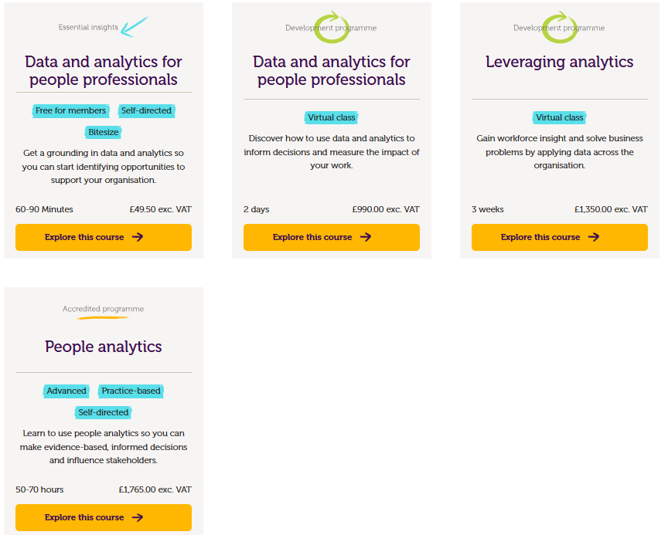

Figure 3 (CIPD, 2026d)

Internal sign-off would be sought via a business case outlining strategic benefits and expected return on investment. Learning would be applied directly to organisational HR data and shared with my HR team to support knowledge transfer. Expected outcomes include improved confidence in interpreting analytics, integrating data into strategic decisions and ensuring ethical use of digital tools.

Secondly, I will undertake informal learning focused on coaching and delegation to upskill and empower managers. This addresses my development need to enhance knowledge sharing and managerial capability. This will involve reading and listening to books and podcasts (figure 4) whilst applying findings to work scenarios by actively coaching managers to take ownership of people-related matters.

The activity suits my learning style combining flexible learning with practical application. Progress will be evaluated through feedback and self-reflection. Expected outcomes include increased manager autonomy, improved employee experience and reduced reliance on HR allowing focus on strategic priorities.

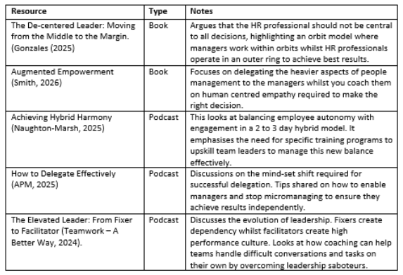

Figure 4

Q11. Shifting your focus to development activities you have already undertaken within the last two years, reflect on the two activities (formal or informal) that you consider had the greatest impact on your behaviour and performance.

Activity 1
Date | February 2026
CPD Activity | I advised on a request from a Director to transition from employee to contractor status.
CIPD Profession Map Links | Employee relations, ethical practice, professional courage and evidence-based practice
Purpose | To help assess the legal, financial and organisational implications of the proposed change. To then provide informed and balanced advice to support decision-making
What I learned | The activity was predominantly driven by initial self-learning as this was a new area for myself and the business and one which we lacked knowledge and expertise. I began by developing my understanding of employment status including the risks associated with IR35, misclassification and the importance of considering factors such as control, substitution, mutuality of obligations, change management and integration into the business. I reviewed guidance on the .gov website and watched a series of pre-recorded webinars on their website e.g. off-payroll working rules, contracted out services and statements of work. I briefly consulted with Morgan La Roche to confirm my understanding was correct. I also utilised the Check Employment Status for Tax (CEST) tool. I developed a formal proposal and presentation for Directors which provided evidence-based insights to support compliant and informed decision-making. Personally, I gained greater understanding on employment status and managing changes such as this. I gained awareness of the potential legal, financial and reputational risks as well as ensuring business decisions are compliant and ethically sound as opposed to being commercially driven. I also developed confidence in handling more senior, challenging cases outside of my knowledge area.
How this changed my behaviour | Although only a short time has passed, I feel this has affected by behaviour by:  - Shifting my experience from being primarily operational to more risk-focused and advisory at a more senior level.  - Allowing me to take a more structured approach to assessing legal and compliance risks.  - Encouraging me to explore self-learning and validating this via external support when required.  - Feeling more confident in challenging senior stakeholders when needed.  - Ensuring decisions are supported by evidence and aligned with legal requirements and best practice.  - Encouraging me to think about long-term implications rather than short-term solutions. For example, I am now leading the change management process focused on minimising organisational disruption whilst positioning the move as a positive opportunity.
Impact on performance | I believe this has increased confidence in my role and credibility as a trusted senior team member in an advisory capacity. It has also helped reduce risk and ensured more informed decision-making. It has helped mitigate legal and financial liability that could have resulted from misclassification. By using multiple sources of information and tools I was able to validate findings and use an evidence-based approach. It has improved my confidence in handling complex changes, influencing and challenging stakeholders. Additionally I feel this has enhanced alignment between HR practice and legal compliance. I am also readily equipped to support similar scenarios.
Reflection | Although initially daunting, this was a valuable development experience that has strengthened my confidence and knowledge. It has highlighted the importance of maintaining professional integrity and not being afraid to challenge in the right way, even at senior level. Going forward I would like to continue developing my knowledge of employment status regulation ad to manage similar situations with greater confidence and depth of knowledge.
Activity 2
Date | October 2025
CPD Activity | Attended a webinar on menopause in the workplace, strengthened knowledge and updated internal policy
CIPD Profession Map Links | Well-being, working inclusively, culture and behaviour, ethical practice
Purpose | Following an increase in open communication and support requests from employees experiencing menopause. I wanted to increase my awareness and understanding its impact in the workplace. My aim was to assess whether our current policies and practices were inclusive, supportive and legally compliant and to identify areas for improvement.
What I learned | I attended a series of webinars starting with “The Hidden Cost of Ignoring Women’s Health at Work’ lead by Adecco in mid-October. This explored menopause alongside wider aspects of women’s health such as fertility and mental wellbeing. This developed my understanding of the biological and psychological impacts of menopause and how these can affect attendance, performance and retention. I also strengthened my knowledge of legal considerations under the Equality Act, including potential risks relating to disability, age and sex discrimination. A key insight was that effective support does not necessarily require financial investment but a shift in awareness, communication and policy application. I identified practical adjustments such as flexible breaks, temperature control and the importance of normalising health-related conversations. To build on this, I reviewed guidance from ACAS, NHS and other reputable sources to ensure my approach was informed and evidence-based.
How this changed my behaviour | The led to a more proactive and inclusive approach in my role. I have:  - Increased my confidence in initiating and supporting conversations around menopause.  - Taken a more flexible and individualised approach to attendance and wellbeing management  - Reviewed and updated internal policies, including menopause guidance within handbooks and the intranet  - Actively considered how existing processes (e.g. absence triggers) may unintentionally disadvantage employees  - I am now more confident in advising managers and ensuring support is applied consistently and empathetically.
Impact on performance | This has improved the quality of support provided to employees experiencing menopause. It has increased awareness and confidence across my HR team and managers through guidance and knowledge sharing. I have helped promote psychological safety by increasing awareness and created a more open, supportive work environment. I have also strengthened inclusive practice in the organisation.
Reflection | This exercise broadened my understanding of inclusion particularly in relation to women’s health at work. It has highlighted how important it is to take a proactive approach to wellbeing as opposed to being reactive. Moving forward, I would like to build on this by delivering targeted training for managers and exploring opportunities to create support forums for employees. I will also continue to develop my knowledge on this area and related topics to ensure our practices remain effective. I would also like to be able to explore the measurable impact of such initiatives e.g. through employee feedback, quantifying number of employees supported, changes implemented and evaluating results.

Bibliography

Advisory, Conciliation and Arbitration Service (ACAS) (2024) Discipline and grievances at work: the Acas guide. Available at: https://www.acas.org.uk/sites/default/files/2024-08/discipline-and-grievances-at-work-the-acas-guide.pdf (Accessed: 29 March 2026).
Armstrong, M. (2020) Armstrong’s handbook of human resource management practice. 15th edn. London: Kogan Page.
APM Podcast (2025) 'How to delegate effectively', APM Podcast [Podcast], 6 February. Available at: https://open.spotify.com/episode/7ccIa9x5i3ArEh5btpHPqK (Accessed: 24 March 2026).
Beevers, K., Waite, K., Small, N., Tomlinson, K. and Hussain, S. (2021) People practice: a complete guide. London: Kogan Page.
Bratton, J. and Gold, J. (2000) Human resource management: theory and practice. 2nd edn. Mahwah, NJ: Lawrence Erlbaum Associates.
Cave, D. (2023) 'How HR can play a ‘starring role’ in making flexible working actually work', People Management, 8 November. Available at: https://www.peoplemanagement.co.uk/article/1846843/hr-play-starring-role-making-flexible-working-actually-work (Accessed: 24 March 2026).
Chartered Institute of Personnel and Development (CIPD) (2020) People profession 2030: a collective view of future trends: executive summary. Available at: https://www.cipd.org/globalassets/media/knowledge/knowledge-hub/reports/678people-profession-2030-future-trends-executive-summary_tcm18-86486.pdf (Accessed: 24 March 2026).
Chartered Institute of Personnel and Development (CIPD) (2021) Flexible working: lessons from the pandemic. Available at: https://www.cipd.org/globalassets/media/knowledge/knowledge-hub/reports/flexible-working-lessons-from-pandemic-report_tcm18-92644.pdf (Accessed: 24 March 2026).
Chartered Institute of Personnel and Development (CIPD) (2023) People strategy: a factsheet. Available at: https://www.cipd.org/uk/knowledge/factsheets/strategy-development-factsheet/ (Accessed: 29 March 2026).
Chartered Institute of Personnel and Development (CIPD) (2024) Flexible and hybrid working. Available at: https://www.cipd.org/uk/knowledge/reports/flexible-hybrid-working (Accessed: 24 March 2026).
Chartered Institute of Personnel and Development (CIPD) (2024b) Ethics at work: an employer's guide. Available at: https://www.cipd.org/uk/knowledge/guides/ethics-work-guide/ (Accessed: 29 March 2026)
Chartered Institute of Personnel and Development (CIPD) (2025) Evidence-based HR: make better decisions and step up your influence. Guide. London: CIPD. Available at: https://www.cipd.org/en/knowledge/guides/evidence-based-profession/ (Accessed: 28 March 2026).
Chartered Institute of Personnel and Development (CIPD) (2025b) Employee communication: an introduction. London: CIPD. Available at: https://www.cipd.org/uk/knowledge/factsheets/employee-communication/ (Accessed: 28 March 2026).
Chartered Institute of Personnel and Development (CIPD) (2025c) Flexible and hybrid working practices in 2025. Available at: https://www.cipd.org/uk/knowledge/reports/flexible-hybrid-working (Accessed: 24 March 2026).
Chartered Institute of Personnel and Development (CIPD) (2025d) Identifying learning and development needs: a factsheet. Available at: https://www.cipd.org/uk/knowledge/factsheets/learning-needs-factsheet/ (Accessed: 29 March 2026).
Chartered Institute of Personnel and Development (CIPD) (2025e) People strategy: a factsheet. Available at: https://www.cipd.org/uk/knowledge/factsheets/strategy-development-factsheet/ (Accessed: 29 March 2026).
Chartered Institute of Personnel and Development (CIPD) (2025f) Evaluating learning and development: a factsheet. Available at: https://www.cipd.org/en/knowledge/factsheets/evaluating-learning-factsheet/ (Accessed: 29 March 2026).
Chartered Institute of Personnel and Development (CIPD) (2026) Explore the profession map. Available at: https://www.cipd.org/uk/the-people-profession/the-profession-map/explore-the-profession-map/ (Accessed: 28 March 2026).
Chartered Institute of Personnel and Development (CIPD) (2026b) Organisation culture and change factsheet. Available at: https://www.cipd.org/uk/knowledge/factsheets/organisation-culture-change-factsheet/ (Accessed: 28 March 2026).
Chartered Institute of Personnel and Development (CIPD) (2026c) Working inclusively. Available at: https://www.cipd.org/uk/the-people-profession/the-profession-map/explore-the-profession-map/core-behaviours/working-inclusively/ (Accessed: 24 March 2026).
Chartered Institute of Personnel and Development (CIPD) (2026d) Find a course: people analytics. Available at: https://shop.cipd.org/catalog?pagename=find-a-course (Accessed: 24 March 2026).
Clark, S. (2015) Ethical decision-making: Eight perspectives on workplace dilemmas. Research report. London: Chartered Institute of Personnel and Development. Available at: https://www.cipd.org/globalassets/media/knowledge/knowledge-hub/reports/ethical-decision-making-2015-eight-perspectives-on-workplace-dilemmas_tcm29-9564.pdf (Accessed: 28 March 2026).
Colquitt, J., Lepine, J., Wesson, M. and Gellatly, I. (2022) Organisational behaviour: improving performance and commitment in the workplace. 6th edn. New York: McGraw-Hill.
Davlembayeva, D. and Alamanos, E. (2022) 'Equity theory', in Papagiannidis, S. (ed.) TheoryHub. Available at: https://orca.cardiff.ac.uk/id/eprint/159089/1/equity-theory.pdf (Accessed: 29 March 2026).
Elder, S. and Nikodem, M. (2023) ‘Considering the application and relevance of evidence-based HR’, People Management, 1 November. Available at: https://www.peoplemanagement.co.uk/article/1845833/considering-application-relevance-evidence-based-hr (Accessed: 28 March 2026).
Gallos, J.V. (ed.) (2006) Organization development: a Jossey-Bass reader. San Francisco: Jossey-Bass.
Gallup (2023) Employee engagement drives growth. Available at: https://www.gallup.com/workplace/236927/employee-engagement-drives-growth.aspx (Accessed: 29 March 2026).
Gonzales, A. (2025) The de-centered leader: moving from the middle to the margin. London: Penguin Business.
Government Equalities Office (2015) Equality Act 2010: guidance. Available at: https://www.gov.uk/guidance/equality-act-2010-guidance (Accessed: 29 March 2026).
Hesketh, I. and Cooper, C. (2019) Wellbeing at work: how to design, implement and evaluate an effective strategy. London: Kogan Page.
Hlupic, V.A. (2022) 'Integrity: the new currency for businesses', People Management, 10 March. Available at: https://www.peoplemanagement.co.uk/article/1751749/integrity-the-new-currency-for-businesses (Accessed: 28 March 2026).
Holt, D. (2020) 'Deontology: strengths & weaknesses', in Introduction to Ethics. Available at: https://viva.pressbooks.pub/phi220ethics/chapter/deontology-pros-cons/ (Accessed: 28 March 2026).
Kahn, W.A. (1990) 'Psychological conditions of personal engagement and disengagement at work', The Academy of Management Journal, 33(4), pp. 692–724. Available at: [suspicious link removed] (Accessed: 29 March 2026).
Kirchherr, J., Bérubé, V., Seiler, C., Rupietta, K., Störk, K., Senst, M. and Lavallée, S.G. (2025) HR monitor 2025: a comprehensive look at the HR landscape. Available at: https://www.mckinsey.com/capabilities/people-and-organizational-performance/our-insights/hr-monitor-2025 (Accessed: 24 March 2026).
Lewis, D. and Sargeant, M. (2024) Introduction to employment law: a conceptual approach. 7th edn. London: Kogan Page.
Majumder, S., Salman, S. and Dey, N. (2026) 'AI in human resources: efficiency, ethics and emerging challenges', AI and Ethics, 6(59). Available at: https://link.springer.com/article/10.1007/s43681-025-00862-x (Accessed: 24 March 2026).
Malek, K., Kline, S.F. and DiPietro, R. (2018) 'The impact of manager training on employee turnover intentions', Journal of Hospitality and Tourism Insights, 1(3), pp. 203-219. Available at: https://doi.org/10.1108/JHTI-02-2018-0010 (Accessed: 28 March 2026).
McCartney, C. (2025) Flexible and hybrid working practices in 2025. Research report. London: Chartered Institute of Personnel and Development. Available at: https://www.cipd.org/uk/knowledge/reports/flexible-hybrid-working (Accessed: 29 March 2026).
Mor Barak, M.E. (2022) Managing diversity: toward a globally inclusive workplace. 5th edn. Thousand Oaks, CA: SAGE.
Mullins, L.J. and McLean, J.E. (2019) Organisational behaviour in the workplace. 12th edn. Harlow: Pearson.
Naughton-Marsh, S. (2025) 'Achieving hybrid harmony: post-pandemic leadership insights with Sue Naughton-Marsh', Truth about Local Government [Podcast], 7 April. Available at: https://open.spotify.com/episode/0f211e (Accessed: 24 March 2026).
Ogu, S.J. (2024) 'Employee participation in decision-making and organizational commitment: a study of modern organizations', Journal of Commerce, Management, and Tourism Studies, 3(1), pp. 55–64. Available at: https://doi.org/10.58881/jcmts.v3i1.208 (Accessed: 29 March 2026).
Reyes, V., Mallon, D. and Sanford, A. (2025) New tech. New work. Your old value case isn't enough. Available at: https://www.deloitte.com/us/en/insights/topics/talent/human-capital-trends/2025/new-hr-technology-creates-new-tech-value-case.html (Accessed: 24 March 2026).
Roberson, Q.M. (2019) 'Diversity in the workplace: a review, synthesis, and future research agenda', Annual Review of Organizational Psychology and Organizational Behavior, 6(1), pp. 69–88. Available at: https://doi.org/10.1146/annurev-orgpsych-012218-015243 (Accessed: 29 March 2026).
Sabharwal, M. (2014) ‘Is diversity management sufficient? Organizational inclusion to further performance’, Public Personnel Management, 43(2), pp. 197–217. Available at: https://doi.org/10.1177/0091026014522202 (Accessed: 29 March 2026).
Schaufeli, W.B. (2023) ‘Burnout: a critical overview’, in Lapierre, L.M. and Cooper, C. (eds) Organizational stress and well-being. Cambridge: Cambridge University Press, pp. 214–259.
Schneider, B., Ehrhart, M.G. and Macey, W.H. (2013) 'Organizational climate and culture', Annual Review of Psychology, 64(1), pp. 361-388. Available at: https://doi.org/10.1146/annurev-psych-113011-143809.
Smith, D.R. (2026) Augmented empowerment: leadership in the age of AI. New York: McGraw-Hill.
Spiro, K. (2024) '10 benefits of blended learning for employees and organizations', Easygenerator, 18 April. Available at: https://www.easygenerator.com/en/blog/blended-learning/benefits-blended-learning/ (Accessed: 29 March 2026).
Taylor, S. and Woodhams, C. (2022) Studying human resource management. 3rd edn. London: Kogan Page.
Teamwork – A Better Way (2024) 'The elevated leader: from fixer to facilitator', Teamwork – A Better Way [Podcast], 23 February. Available at: https://www.google.com/search?q=https://open.spotify.com/show/modern-people-leader (Accessed: 24 March 2026).
Vartiainen, M. and Vanharanta, O. (2024) 'True nature of hybrid work', Frontiers in Organizational Psychology, 2, article 1448894. Available at: https://doi.org/10.3389/forgp.2024.1448894 (Accessed: 24 March 2026).
Wietrak, E. and Gifford, J. (2024) Trust and psychological safety: an evidence review. Practice summary and recommendations. London: Chartered Institute of Personnel and Development. Available at: https://www.cipd.org/globalassets/media/knowledge/knowledge-hub/evidence-reviews/2024-pdfs/8542-psych-safety-trust-practice-summary.pdf (Accessed: 29 March 2026).

Appendix 1: Consolidated Feedback – Working Inclusively Standards
This appendix presents consolidated feedback gained from two direct reports (Aftersales Manager and HR Officer) and a peer (Head of Operations). Their feedback evaluates my performance against the six CIPD Working Inclusively Standards to help identify strengths, weaknesses and areas for continued professional development (CIPD, 2026c.). The following scoring matrix was also used:
Score: 1 (Rarely) | 2 (Sometimes) | 3 (Often) | 4 (Very Often) | 5 (Always)
CIPD Standard | Reviewer 1:  John Price  (Head of Operations and Peer) | Reviewer 2:  Ryan Steer  (Aftersales Manager and Direct Report) | Reviewer 3:  Staci Miller  (HR Officer and Direct Report)
Inclusivity –  Get to know people as individuals so you can work together more effectively | Score 5  Worked with Laura on introducing ISO9001 into the business. She made a point of identifying how I prefer to communicate when managing projects and made sure all communications were set up in the most productive way possible. | Score 5  One of Laura's strengths is understanding the people who work with and for her. Laura spends time understanding each person's ways of working and strengths and weaknesses. In my early years as department manager Laura spent a large portion of her time coaching myself and getting an understanding of my strengths and weaknesses. Using this Laura supported me in my growth and has continued to do this. When it comes to people management this is something I struggled with initially and on team reviews Laura sat in with me to support. Laura has continued to have an open door policy meaning she is always open for me to come in and work with her and to listen to any challenges I may have and work with me towards a resolution. | Score: 4  Spends time getting to know others and how they work or like to be managed. Understands how others may react to updates or news which is valuable when communicating to employees, managers and across departments.
Valuing diversity - Actively seek and listen to diverse views and opinions | Score 4  Laura always promotes and encourages colleagues to voice their opinions on any project, during meetings, or discussions on how we can improve processes to benefit the business as a team. | Score: 5  Laura's role means she works with a diverse group of colleagues. Ranging from different roles through to different religious groups and places of work. With this comes different viewpoints and opinions. Laura has always maintained a strong and diverse view and opinion. Never looking to make judgement and always understanding different cultural needs. | Score 4  Listens when I have reservations about certain conversations and takes my view on board. Always asks for my input.
Building relationships - Build purposeful working relationships with and collaborate with wider colleagues | Score 5  Laura always makes a point of reaching out to new starters welcoming them to the business and making them aware that she is always available to offer any support needed. She also arranges stakeholder meetings for new starters to ensure they are introduced to others in the business that they will interact with. This in itself promotes collaborative working. | Score 5  Laura is considered as a vital member of the management team within Genpower. The reason for this is due to the relationships she has built with colleagues here. Laura is a trusted colleague and someone who throughout the 7 years I’ve worked with her has become someone I’ve grown to respect and create friendship with. This is due to her nature and the way she supports and manages us as a team. She never dismisses your point of view and is instead willing to listen and support. I’ve seen this first hand and when speaking to other colleagues they all speak incredibly highly showing the relationships built. | Score 5  Has built relationships across all departments and locations within the business. Is very much the go to person at work for assistance and advice as she is trusted with knowing how to resolve the issue and ‘do the right thing’
Sharing knowledge - Readily share your knowledge and expertise with others to solve problems | Score 4  When the operations team were suffering from stock management issues caused by job card errors Laura focussed on improving all stakeholders knowledge in the process rather than simply taking control and fixing the issue herself | Score 4  Laura has continued to do this over my time with the business. On this most recently when creating new daily planners and phone rotas, Laura has shown me previous examples of what she has completed and launched and then sat with me to help me create my own and with Laura showing and helping me resulted in mine being of high quality. | Score 4  Can sometimes take on too much when workload is already high, rather than delegating to ease own workload. This would also benefit with sharing knowledge across teams for more collaborative problem solving.
Conflict Resolution  - Support others to resolve conflict and build trust before issues escalate | Score 5  Laura has helped me overcome issues in managing a member of my team. Laura was able to skilfully manage both sides and mediate in a way that de-escalated the situation and found a working resolution for both parties | Score 4  Laura has always been able to manage conflicts and disagreements well. Due to Laura working so closely with her team she understands how each person reacts to certain situations. Using this Laura is able to intercept situations before they escalate or become a problem. Seeing how we are speaking or replying to email Laura is able to tell how we are feeling. Often coming to see us asking if we are okay and supporting to resolve whatever the issue may have been to ensure nothing further happens. | Score 4  Yes, has revisited conversations with managers to ensure communication was clear and check in on wellbeing before frustrations escalated.
Psychological safety - Encourage others to recognise when they need help, to admit mistakes and share concerns and ideas | Score 5  When errors are made Laura will focus on how we as a team can fix the issue and prevent it happening again. She will never focus on the individual responsible for making the error which encourages staff to be open and honest when things go wrong | Score 5  Laura having an open door policy and being a good listener helps us go to her in the event of a mistake being made. When a mistake is made due to Laura’s way of working you do not fear going in and raising a mistake instead you understand going in you will always come out having been heard and a support being put into place. I had this when I made a mistake with a customer case causing the customer to escalate an issue to our company CEO. When I spoke to Laura she listened to the case detail and showed compassion for why I made a mistake and supported me with creating a sheet to track my cases so moving forward I wouldn’t make the same mistake. When leaving, I didn’t feel terrible for making the mistake and instead felt positive that help had been shown. | Score 5  Has created a safe environment to speak up when mistakes are made. Handles them professionally and reinstils confidence. Follows up with any training that may be needed as a result.
Other feedback against standards |  | Laura’s greatest strength over the last 6 years has been her continued support and understanding of each person. By doing this she’s been able to create trusting and close working relationships with her colleagues. Ensuring a strong and productive team.  Development: Laura is often extremely busy with her own tasks and workload. While Laura always makes time to support us as a team, sometimes it’s harder to see her due to the high workload. Laura will always ask you to come back in so you're never ignored or pushed away. However I believe if Laura was able to delegate more tasks she would be available more to support across the complete wider team.

Appendix 2: Self-Reflection – Working Inclusively Standards
CIPD Standard | Self-reflection also taking into account the feedback from colleagues
Inclusivity –  Get to know people as individuals so you can work together more effectively | I consider this one of my strongest areas and something I promote in all aspects of my work – from recruitment to well-being, events, retention and decision-making. Feedback from colleagues highlights that I actively engage with new starters and take time to understand individuals’ strengths and development areas which I agree with. I also focus on understanding people’s motivations and building strong relationships to allow me to adapt my management style and provide tailored support to match their needs. I have developed strong, professional relationships with managers, my direct reports across HR and operations and employees across the business. This allows me to collaborate effectively and know who to involve when needed. People refer to me as “the glue” which is really nice to hear. As a family run business, inclusivity is essential to our success as everyone plays their part, working collaboratively to achieve our goals. I have seen first-hand how involving employees supports organisational outcomes particularly during the implementation of our ISO9001 quality framework. Taking an inclusive approach to this significant change helped drive engagement and adoption showing how inclusivity increases buy-in and is an effective project management tool.
Valuing diversity - Actively seek and listen to diverse views and opinions | Since joining the business in 2017, I have supported its growth from 30 to over 120 employees across multiple locations including Pembroke Dock, Newport, Warrington, Romsey, Mauritius, China and more. This has resulted in a highly diverse workforce in terms of backgrounds, cultures, skills and experiences. I actively seek and listen to a wide range of perspectives as I believe this leads to more informed and balanced decision-making. I recognise that some individuals need encouragement to share their views and I make a conscious effort to create space for those quieter voices – they often have the best ideas! When supporting people-related decisions I consider who will be impacted and actively seek input to support effective change management and ensure decisions are inclusive and well-informed.
Building relationships - Build purposeful working relationships with and collaborate with wider colleagues | Building strong working relationships is another key strength. Despite geographical challenges, I have established effective relationships across the organisation. This is partly due to my involvement in recruitment and onboarding, allowing me to support the full employee lifecycle and build trust from the outset. Alongside my HR Officer, I take a proactive approach to relationship building through regular site visits, weekly walkarounds at our Pembroke Dock base, monthly visits to Newport and consistent communication with remote colleagues. Having been with the business since its early stages, I have developed a broad understanding of both operational and people functions. In my current role, overseeing multiple departments alongside my Head of People responsibilities, I maintain close involvement in day-to-day operations. This visibility helps build trust and positions me as a key point of contact across the business.
Sharing knowledge - Readily share your knowledge and expertise with others to solve problems | I recognise this as a development area, particularly in relation to delegation. While I provide regular guidance and support, I can sometimes retain responsibility rather than distributing it effectively. This can lead to a high workload and limit my availability for more strategic priorities. The rapid growth of the business has resulted in internal promotions, meaning some managers are still developing their skills. I have an opportunity to further support this through structured coaching, improved delegation and more intentional knowledge sharing. I understand that effective delegation is not only about managing workload but also about developing others by increasing their responsibility and accountability. I have successfully trained and developed a number of employees and have strong knowledge of systems, processes and ISO9001 implementation. Moving forward, I aim to share this expertise more consistently to strengthen capability across the business.
Conflict Resolution  - Support others to resolve conflict and build trust before issues escalate | Feedback indicates that I manage conflict effectively and am able to identify when situations are escalating, allowing me to take preventative action. This is a strength I had not fully recognised, particularly the proactive aspect. I have built a reputation as someone employees and managers feel comfortable approaching, which supports early resolution of issues. I have gained significant experience in handling conflict across informal discussions, mediation and formal processes. To further develop, I would like to take a more structured and proactive approach to conflict resolution, focusing on intentional coaching rather than relying on instinct and experience alone.
Psychological safety - Encourage others to recognise when they need help, to admit mistakes and share concerns and ideas | Creating a psychologically safe environment is a key priority for me. I aim to ensure that employees feel supported, valued and able to speak openly. When mistakes occur, including more serious cases requiring formal action, I focus on listening, supporting individuals and ensuring that learning outcomes are achieved. I lead by example by taking accountability for my own mistakes and promoting an open and honest approach. While I encourage openness, I also maintain clear expectations around accountability to ensure that psychological safety does not lead to complacency. To strengthen this area of psychological safety further, I am exploring mental health first aid training to enhance my ability to support employee wellbeing and create a more supportive working environment.

