University of Wales Trinity Saint David
Wales Institute of Science & Art



Design of Filter circuit
Engineering Science 1 & Laboratory Skills

Isaac Wilmore
2519409
June 2026

Table of Contents
Introduction 2
Experimental Procedure 3
Equipment 3
Method 3
Figure 1: Photograph showing the specimen before testing 4
Figure 2:Photograph of the tensile testing machine 4
Figure 3:Photograph of the specimen during the tensile testing 5
Figure 4:photograph of the fractured specimen after testing 6
Results 6
Table 1:Initial Specimen Measurement 6
Table 2: Raw experimental data – Steel 6
Table 3:Raw experimental data – Duralumin 7
Table 4: Raw experimental data – PVC 8
Table 5: Raw experimental data – Aluminium 8
Analysis 9
Processed Experimental Spreadsheet Data 9
Detailed Material Behaviour and Deformation Analysis 10
Figure 5: Steel Stress-Strain Graph 10
Figure 6: Aluminium Stress-Strain Graph 11
Figure 7: Duralumin Stress-Strain Graph 12
Figure 8: PVC Stress-Strain Graph 13
Conclusion 13
Evaluation 13
Further work 13
References 13

  - Introduction
In mechanical engineering and materials science, evaluating how a material responds to external forces is fundamental to safe and efficient design. Tensile testing is a destructive engineering procedure in which a standardised specimen is subjected to an increasing axial tensile load until Fracture (Hibbeler, 2017). Engineers perform these tests to predict how structural components will behave under operational loads, allowing them to select appropriate materials for specific applications, verify manufacturing quality control, and determine safety factors to prevent catastrophic failures. The primary purpose of this experiment is to isolate and measure the intrinsic mechanical properties of a material specimen, independent of its physical geometry, by standardising the testing parameters and force application rate.
During the test, a universal testing machine continuously records force and elongation, which are converted into tensile stress (σ) and tensile strain (ϵ) to evaluate the material objectively. Tensile stress is defined as the applied force divided by the original cross-sectional area (σ=F/A0​), while tensile strain is the dimensionless ratio of elongation to the original gauge length (ϵ=ΔL/L0​). When plotted against each other, these values produce a characteristic stress-strain curve that reveals several critical milestones of material behaviour. The initial linear region of this curve defines Young’s Modulus (E), a measure of material stiffness that represents the resistance to elastic, or temporary, deformation. As the load increases, the material reaches its yield strength (σy​), which is the critical threshold where it transitions from elastic behaviour to permanent, plastic deformation. Beyond this point, the specimen undergoes irreversible structural changes until it reaches its Ultimate Tensile Strength (UTS)—the absolute maximum stress the material can withstand before localized thinning, or "necking," begins. The test also measures ductility, which quantifies a material's ability to plastically deform and stretch before final fracture, usually expressed as a percentage of total elongation. Understanding whether a material behaves in a ductile or brittle manner is vital for anticipating how a structure will warn of or resist failure. Ultimately, the aim of this experiment is to experimentally determine the Young's Modulus, yield strength, ultimate tensile strength, and ductility of the provided material specimen by conducting a standardized tensile test, and to analyse its subsequent deformation and fracture behaviour under load.

Experimental Procedure

Equipment
The following equipment was used during the tensile testing experiment:
- Tensile testing machine
- Vernier calipers
- Unknown metal test specimens
- Computer with data acquisition software
- Safety glasses
- Marker pen for specimen identification

Method
Before testing began, all personnel wore appropriate personal protective equipment (PPE), including safety glasses, to protect against any fragments produced when the specimens fractured. The tensile testing machine was inspected to ensure it was operating correctly and that the grips were secure.
The diameter of each unknown metal specimen was measured using Vernier calipers. Measurements were taken carefully at several points along the gauge length to ensure accuracy, and the average diameter was recorded. These measurements were then used to calculate the cross-sectional area of each specimen using the equation:
A=πd24A=4πd2​
where A is the cross-sectional area and d is the measured diameter.
Once the dimensions had been recorded, the specimen was securely positioned in the grips of the tensile testing machine. Care was taken to ensure that the specimen was aligned centrally to prevent bending stresses during the test. The testing machine was connected to a computer running data acquisition software, which automatically recorded the applied load and extension throughout the test.
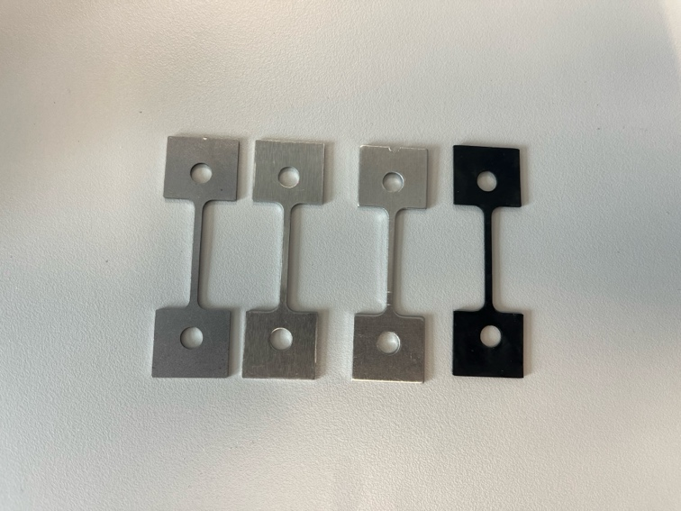

Figure 1: Photograph showing the specimen before testing
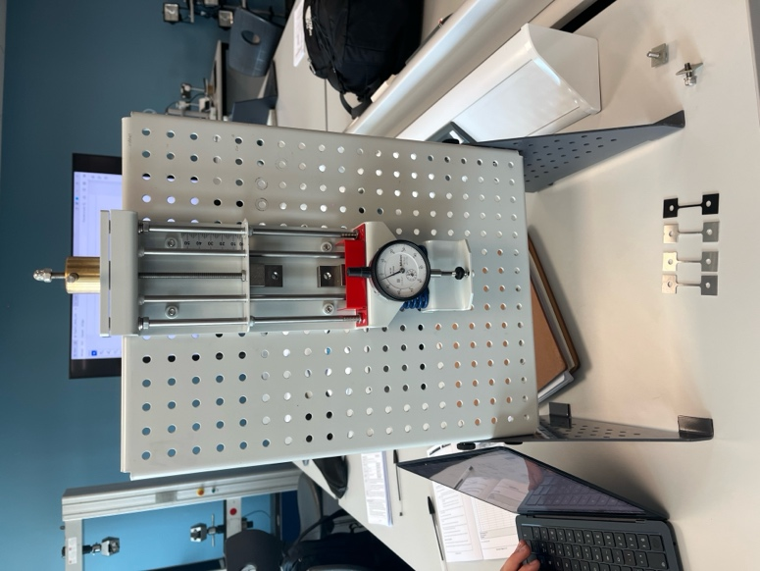

Figure 2:Photograph of the tensile testing machine
The tensile testing machine was then started, applying an increasing tensile load at a constant rate. As the force increased, the specimen elongated while the software continuously recorded the load and extension. Throughout the test, the specimen was observed for signs of deformation, including the onset of necking before fracture.
The applied force continued to increase until the specimen reached its ultimate tensile strength. Beyond this point, the specimen experienced significant plastic deformation before finally fracturing. Now of failure, the maximum load, extension, and fracture behaviour were automatically recorded by the testing software.
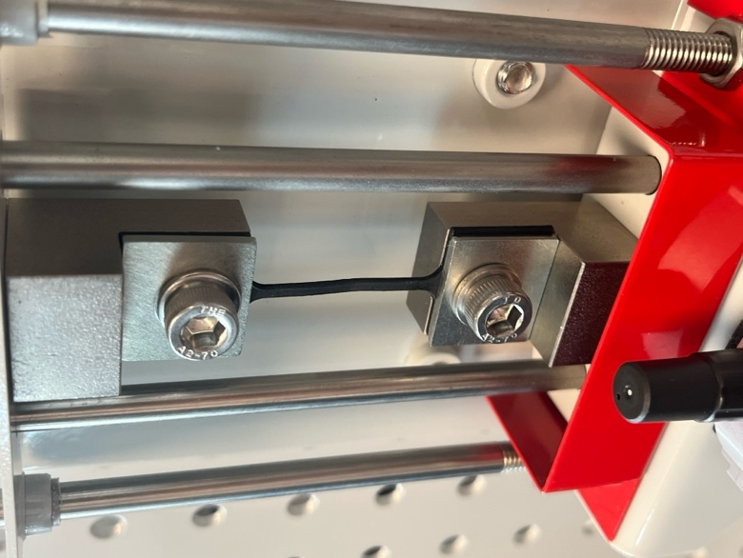

Figure 3:Photograph of the specimen during the tensile testing
After fracture, the two halves of the specimen were removed from the testing machine. The fracture surface was visually examined to identify the type of failure and any noticeable characteristics such as necking or brittle fracture. The broken specimen was photographed for inclusion in the report.
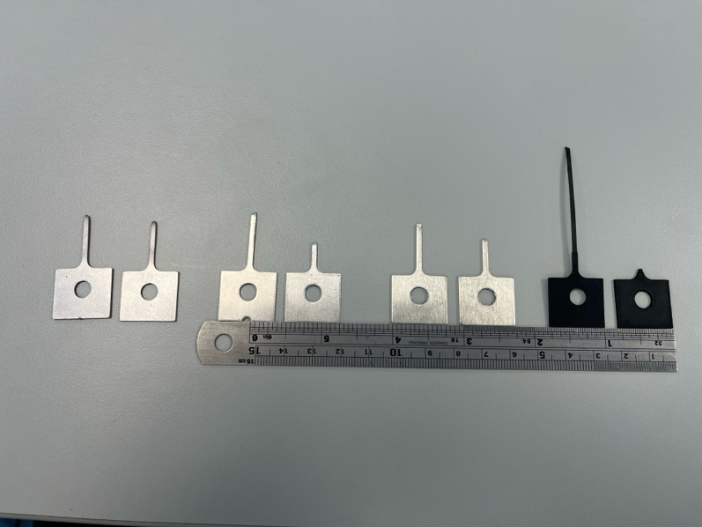

Figure 4:photograph of the fractured specimen after testing
The entire testing procedure was repeated for each unknown metal specimen using the same equipment and testing conditions. This ensured consistency between tests and allowed direct comparison of the mechanical properties of each material. The recorded data were later used to produce stress-strain graphs and calculate important material properties, including Young's Modulus, yield strength, ultimate tensile strength (UTS), and percentage elongation. These results formed the basis for identifying the unknown materials by comparing the experimental values with published material property data.

Results

Table 1:Initial Specimen Measurement
Specimen | Width (mm) | Thickness | Cross-sectional area (mm²) | Original Guage Length (mm)
A – Steel | 1 | 2 | 2 | 67
B – Aluminium | 1 | 2 | 2 | 67
C – Duralumin | 1 | 2 | 2 | 67
D - PVC | 1 | 2 | 2 | 67

Table 2: Raw experimental data – Steel
Load nut Movement  (mm) | Dial indicator (mm) | Force (N) | Extension (mm)
0 | 0 | 0 | 0
0.2 | 0.165 | 16.5 | 0.035
0.4 | 0.345 | 34.5 | 0.055
0.6 | 0.53 | 53 | 0.070
0.8 | 0.72 | 72 | 0.080
1 | 0.95 | 95 | 0.050
1.2 | 1.1 | 110 | 0.100
1.4 | 1.2 | 120 | 0.200
1.6 | 1.39 | 139 | 0.210
1.8 | 1.58 | 158 | 0.220
2 | 1.76 | 176 | 0.240
2.2 | 1.95 | 195 | 0.250
2.4 | 2.15 | 215 | 0.250
2.6 | 2.33 | 233 | 0.270
2.8 | 2.52 | 252 | 0.280
3 | 2.69 | 269 | 0.310
3.2 | 2.87 | 287 | 0.330
3.4 | 3.05 | 305 | 0.350
3.6 | 3.21 | 321 | 0.390
3.8 | 3.34 | 334 | 0.460
4 | 3.47 | 347 | 0.530
4.2 | 3.59 | 359 | 0.610
4.4 | 3.7 | 370 | 0.700
4.6 | 3.85 | 385 | 0.750
4.8 | 3.98 | 398 | 0.820
5 | 4.09 | 409 | 0.910
6 | 4.6 | 460 | 1.400
7 | 5.01 | 501 | 1.990
8 | 5.34 | 534 | 2.660
9 | 5.49 | 549 | 3.510
10 | 5.61 | 561 | 4.390
13 | 6.7 | 670 | 6.300

Table 3:Raw experimental data – Duralumin
Load nut Movement  (mm) | Dial indicator (mm) | Force (N) | Extension (mm)
0 | 0 | 0 | 0
0.2 | 0.005 | 0.5 | 0.195
0.4 | 0.03 | 3.0 | 0.370
0.6 | 0.135 | 13.5 | 0.465
0.8 | 0.33 | 33.0 | 0.470
1 | 0.48 | 48.0 | 0.520
1.2 | 0.65 | 65.0 | 0.550
1.4 | 0.83 | 83.0 | 0.570
1.6 | 1.03 | 103.0 | 0.570
1.8 | 1.22 | 122.0 | 0.580
2 | 1.31 | 131.0 | 0.690
2.2 | 1.6 | 160.0 | 0.600
2.4 | 1.78 | 178.0 | 0.620
2.6 | 1.97 | 197.0 | 0.630
2.8 | 2.165 | 216.5 | 0.635
3 | 2.35 | 235.0 | 0.650
3.2 | 2.54 | 254.0 | 0.660
3.4 | 2.73 | 273.0 | 0.670
3.6 | 2.92 | 292.0 | 0.680
3.8 | 3.1 | 310.0 | 0.700
4 | 3.29 | 329.0 | 0.710
4.2 | 3.485 | 348.5 | 0.715
4.4 | 3.67 | 367.0 | 0.730
4.6 | 3.855 | 385.5 | 0.745
4.8 | 4.045 | 404.5 | 0.755
5 | 4.9 | 490.0 | 0.100
6 | 5.29 | 529.0 | 0.710

Table 4: Raw experimental data – PVC
Load Nut Movement (mm) | Dial Indicator (mm) | Force (N) | Extension (mm)
0.0 | 0.000 | 0.0 | 0.000
0.2 | 0.060 | 6.0 | 0.140
0.4 | 0.120 | 12.0 | 0.280
0.6 | 0.180 | 18.0 | 0.420
0.8 | 0.210 | 21.0 | 0.590
1.0 | 0.210 | 21.0 | 0.790
1.2 | 0.205 | 20.5 | 0.995
1.4 | 0.210 | 21.0 | 1.190
1.6 | 0.220 | 22.0 | 1.380
1.8 | 0.220 | 22.0 | 1.580
2.0 | 0.220 | 22.0 | 1.780
2.2 | 0.220 | 22.0 | 1.980
2.4 | 0.220 | 22.0 | 2.180
2.6 | 0.220 | 22.0 | 2.380
2.8 | 0.220 | 22.0 | 2.580
3.0 | 0.220 | 22.0 | 2.780
3.2 | 0.220 | 22.0 | 2.980
3.4 | 0.240 | 24.0 | 3.160
3.6 | 0.220 | 22.0 | 3.380
3.8 | 0.223 | 22.3 | 3.577
4.0 | 0.223 | 22.3 | 3.777
4.2 | 0.220 | 22.0 | 3.980
4.4 | 0.220 | 22.0 | 4.180
4.6 | 0.230 | 23.0 | 4.370
4.8 | 0.230 | 23.0 | 4.570
5.0 | 0.230 | 23.0 | 4.770
6.0 | 0.250 | 25.0 | 5.750
7.0 | 0.250 | 25.0 | 6.750
8.0 | 0.250 | 25.0 | 7.750
9.0 | 0.250 | 25.0 | 8.750
10.0 | 0.250 | 25.0 | 9.750
20.0 | 0.220 | 22.0 | 19.780
27.5 | 0.220 | 22.0 | 27.280

Table 5: Raw experimental data – Aluminium
Load Nut Movement (mm) | Dial Indicator (mm) | Force (N) | Extension (mm)
0.0 | 0.000 | 0.0 | 0.000
0.2 | 0.175 | 17.5 | 0.025
0.4 | 0.370 | 37.0 | 0.030
0.6 | 0.560 | 56.0 | 0.040
0.8 | 0.740 | 74.0 | 0.060
1.0 | 0.935 | 93.5 | 0.065
1.2 | 1.100 | 110.0 | 0.100
1.4 | 1.295 | 129.5 | 0.105
1.6 | 1.475 | 147.5 | 0.125
1.8 | 1.640 | 164.0 | 0.160
2.0 | 1.780 | 178.0 | 0.220
2.2 | 1.900 | 190.0 | 0.300
2.4 | 2.000 | 200.0 | 0.400
2.6 | 2.090 | 209.0 | 0.510
2.8 | 2.200 | 220.0 | 0.600
3.0 | 2.280 | 228.0 | 0.720
3.2 | 2.330 | 233.0 | 0.870
3.4 | 2.400 | 240.0 | 1.000
3.6 | 2.450 | 245.0 | 1.150
3.8 | 2.490 | 249.0 | 1.310
4.0 | 2.560 | 256.0 | 1.440
4.2 | 2.560 | 256.0 | 1.640
4.4 | 2.560 | 256.0 | 1.840
4.6 | 2.575 | 257.5 | 2.025
4.8 | 2.590 | 259.0 | 2.210

Analysis
To evaluate how each material sample responds to external axial loading independent of its physical dimensions, the raw experimental datasets (Force and Extension) were processed using standard engineering formulas.
The original cross-sectional area (A0​) for all tested specimens was calculated based on the initial geometry measurements provided in the briefing guidelines. Each specimen possessed a uniform nominal width of 1 mm and a thickness of 2 mm, yielding a constant original cross-sectional area:
A0​=Width × Thickness=1 mm×2 mm=2 mm2
The uniform original gauge length (L0​) for every sample was verified as 67 mm.
To map the mechanical journey of each material, two core governing equations were systematically applied to every data interval:
- Engineering Stress (σ): This represents the instantaneous normal pulling force (F) acting per unit of the specimen's un-deformed cross-sectional area (A0​). It is measured in Megapascals (MPa), where 1 MPa=1 N/mm2:
σ=A0​F​
- Engineering Strain (ϵ): This is a dimensionless quantity that scales the recorded elongation or extension (ΔL) against the original baseline gauge length (L0​) of the specimen:
ϵ=L0​ΔL​
From the calculated stress-strain curves, the critical mechanical milestones were determined:
- Young’s Modulus (E): Determined from the gradient of the initial linear-elastic zone (Δσ/Δϵ), which indicates material stiffness.
- Ultimate Tensile Strength (UTS): The maximum stress value achieved on the curve prior to failure or localized necking.
- Ductility (% Elongation): The total permanent extension recorded at the exact moment of fracture, converted into a percentage of the original gauge length:
% Elongation=(L0​ΔL fracture​​)×100

Processed Experimental Spreadsheet Data
Table 6:Summary of processed mechanical properties
Specimen Material | Peak Load (Fmax​, N) | Ultimate Tensile Strength (UTS, MPa) | Final Extension at Fracture (ΔL, mm) | Ductility (% Elongation)
A – Steel | 670.0 | 335.0 | 6.300 | 9.40%
B – Aluminium | 259.0 | 129.5 | 2.210 | 3.30%
C – Duralumin | 529.0 | 264.5 | 0.755 | 1.13%
D – PVC | 25.0 | 12.5 | 27.280 | 40.72%
Table 6 provides the compiled engineering metrics calculated from the raw datasets for all four specimens. These values serve as the mathematical foundation for the structural graphs.

Detailed Material Behaviour and Deformation Analysis

Steel
The structural steel sample exhibited the highest strength and a clear elastic region, indicating high stiffness and strong atomic bonding (Ashby, 2010). The material displayed a well-defined initial linear-elastic slope, representing high structural stiffness. Upon passing its yield point, it underwent stable, progressive plastic deformation before finally fracturing at an extension of 6.300 mm. This corresponds to a ductility rating of 9.40% elongation, proving that the steel specimen possesses a balanced blend of high yield resistance and reliable structural toughness.

Figure 5: Steel Stress-Strain Graph

Aluminium
The unalloyed aluminium specimen reached a peak tensile load of 259.0 N, yielding a calculated UTS of 129.5 MPa. Its stress-strain progression showed a visibly lower elastic slope compared to steel, highlighting its lower stiffness. The sample entered a sweeping, parabolic plastic deformation zone relatively early in the test cycle, displaying work-hardening behaviours before failing at a maximum elongation of 2.210 mm (3.30% ductility). This reflects a low-to-moderate strength profile when unalloyed.

Figure 6: Aluminium Stress-Strain Graph

Duralumin
In contrast to pure aluminium, the alloyed Duralumin specimen demonstrated a significantly enhanced peak load capacity of 529.0 N, resulting in a high UTS of 264.5 MPa. This highlights how alloying elements increase a metal's ultimate strength. However, this increase in strength resulted in a severe trade-off in structural ductility; the specimen fractured abruptly at an extension of just 0.755 mm, yielding a low ductility rating of 1.13% elongation. The complete absence of a prolonged plastic yielding zone classifies this failure mode as highly brittle under these operational conditions. Duralumin showed a much higher strength than pure aluminium (264.5 MPa), confirming strengthening due to alloying (Ashby, 2010)

Figure 7: Duralumin Stress-Strain Graph
PVC
The Polyvinyl Chloride (PVC) specimen behaved in a manner characteristic of an amorphous thermoplastic polymer. PVC exhibited very low strength (12.5 MPa) but extremely high ductility (Rethwisch, 2018)It showed minimal resistance to the pulling load, peaking at a maximum force of only 25.0 N, which equates to a very low UTS of 12.5 MPa. However, after its initial yield, the polymer molecules underwent major Visco-plastic drawing. The specimen stretched extensively under a virtually constant low load, surviving up to an extreme final extension of 27.280 mm. This results in a massive ductility profile of 40.72% elongation, demonstrating a classic high-ductility, low-strength polymer signature.

Figure 8: PVC Stress-Strain Graph

Conclusion
This experiment successfully determined the key mechanical properties of four different materials (steel, aluminium, duralumin and PVC) using tensile testing. The stress–strain behaviour of each specimen was used to evaluate Young’s Modulus, Ultimate Tensile Strength (UTS), and ductility, allowing direct comparison of their mechanical performance.
Steel demonstrated the highest overall structural performance, combining a high UTS (335 MPa) with moderate ductility (9.40%). This indicates a strong, tough material capable of sustaining significant loads before failure, making it suitable for structural applications. Aluminium showed significantly lower strength and strength (UTS = 129.5 MPa) (Ashby, 2010)but retained some ductility (3.30%), reflecting a softer and more easily deformable metal.
Duralumin displayed a much higher strength than pure aluminium (264.5 MPa), confirming the strengthening effect of alloying. However, this came at the cost of ductility (1.13%), indicating a more brittle failure mode under the test conditions. PVC behaved very differently from the metals, showing very low strength (12.5 MPa) but extremely high ductility (40.72%), characteristic of a polymer undergoing large plastic deformation before fracture.
Overall, the results demonstrate a clear trade-off between strength and ductility across the materials tested, and confirm that material selection in engineering applications must balance these properties depending on design requirements.

Evaluation
The experiment produced clear and generally consistent trends across all four materials; however, several sources of error and uncertainty may have influenced the accuracy of the calculated results.
One key limitation is the accuracy of the extension measurements. The dial gauge readings were recorded manually and may have been affected by parallax error or small reading delays, particularly during rapid deformation near failure. This would directly affect both strain calculations and the gradient of the stress–strain curve used to estimate Young’s Modulus. The stress–strain behaviour aligns with established material science theory, confirming the validity of the experimental approach (Hibbeler, 2017)
A second limitation relates to the assumption of constant cross-sectional area. The analysis assumes uniform geometry (1 mm × 2 mm) for all specimens. In reality, slight manufacturing variations in thickness or width would alter the true cross-sectional area, introducing systematic error into all stress calculations.
There is also evidence of data inconsistency in some datasets (particularly aluminium and duralumin), where extension values do not increase perfectly monotonically. This suggests either instrument noise, recording error, or slight slippage in the grips during loading.
Additionally, energy losses due to machine compliance were not accounted for. Some of the recorded extension may include deformation of the testing apparatus itself rather than the specimen, leading to an overestimation of strain.
Finally, the resolution of the load measurements limits the precision of UTS values, especially for low-strength materials like PVC, where small absolute errors represent a large percentage uncertainty.

Further work
Several improvements could significantly increase the reliability and accuracy of the experiment:
First, using a digital extensometer directly attached to the gauge length would improve strain accuracy and remove machine deformation effects. This would produce a more precise Young’s Modulus calculation, especially in the initial elastic region.
Second, measuring each specimen’s diameter (or thickness and width) at multiple points and using an average cross-sectional area would reduce systematic stress errors caused by manufacturing inconsistencies.
Third, ensuring automated digital data logging for both force and extension at high sampling rates would eliminate manual reading errors and improve curve smoothness, particularly near yield and fracture points.
Fourth, using lubricated or self-aligning grips would reduce the risk of specimen slippage and bending stresses, improving test repeatability.
Finally, repeating each test at least three times per material and averaging results would allow statistical analysis (mean, standard deviation), improving confidence in the calculated mechanical properties.

References

Bibliography
Ashby. (2010).
Hibbeler. (2017).
Hibbeler. (2017).
Rethwisch, C. a. (2018).

